# Attribute Evaluation :

Evaluator: weka.attributeSelection.InfoGainAttributeEval

Search: weka.attributeSelection.Ranker -T -1.7976931348623157E308 -N -1

Relation: filebalancedWEKAfinal-weka.filters.unsupervised.attribute.Remove-R2-13,15-18,20-22-weka.filters.unsupervised.attribute.Remove-R4-19-weka.filters.unsupervised.attribute.Remove-R11,13,16,19-20,22-27-weka.filters.unsupervised.attribute.Remove-R1-weka.filters.unsupervised.attribute.Remove-R11-weka.filters.unsupervised.attribute.Remove-R9-weka.filters.unsupervised.attribute.Remove-R23-24-weka.filters.unsupervised.attribute.Remove-R10-weka.filters.unsupervised.attribute.Remove-R9-weka.filters.unsupervised.attribute.Remove-R11-12,15-weka.filters.unsupervised.attribute.Remove-R11,14-15-weka.filters.unsupervised.attribute.Remove-R5-weka.filters.unsupervised.attribute.Remove-R1

Instances: 186

Attributes: 12

Attack

DissolvedO2discretize

salinitydiscretize

temperaturediscretize

precipitationdiscretize

pressurediscretize

Direction

MoonPhase3daysextended

WindSpeed_minmax

Turbidity_minmax

Turtle_minmax

Crablandings_minmax

Evaluation mode: evaluate on all training data

=== Attribute Selection on all input data ===

Search Method:

Attribute ranking.

Attribute Evaluator (supervised, Class (nominal): 1 Attack):

Information Gain Ranking Filter

**Ranked attributes:**

**0.2592 9 WindSpeed_minmax**

**0.18318 12 Crablandings_minmax**

**0.13589 11 Turtle_minmax**

**0.12141 7 Direction**

**0.10815 10 Turbidity_minmax**

# 0.04195 8 MoonPhase3daysextended

**0.03895 3 salinitydiscretize**

**0.02755 2 DissolvedO2discretize**

**0.01122 4 temperaturediscretize**

**0.01052 5 precipitationdiscretize**

**0.00901 6 pressurediscretize**

Selected attributes: 9,12,11,7,10,8,3,2,4,5,6 : 11

Screenshot from weka:

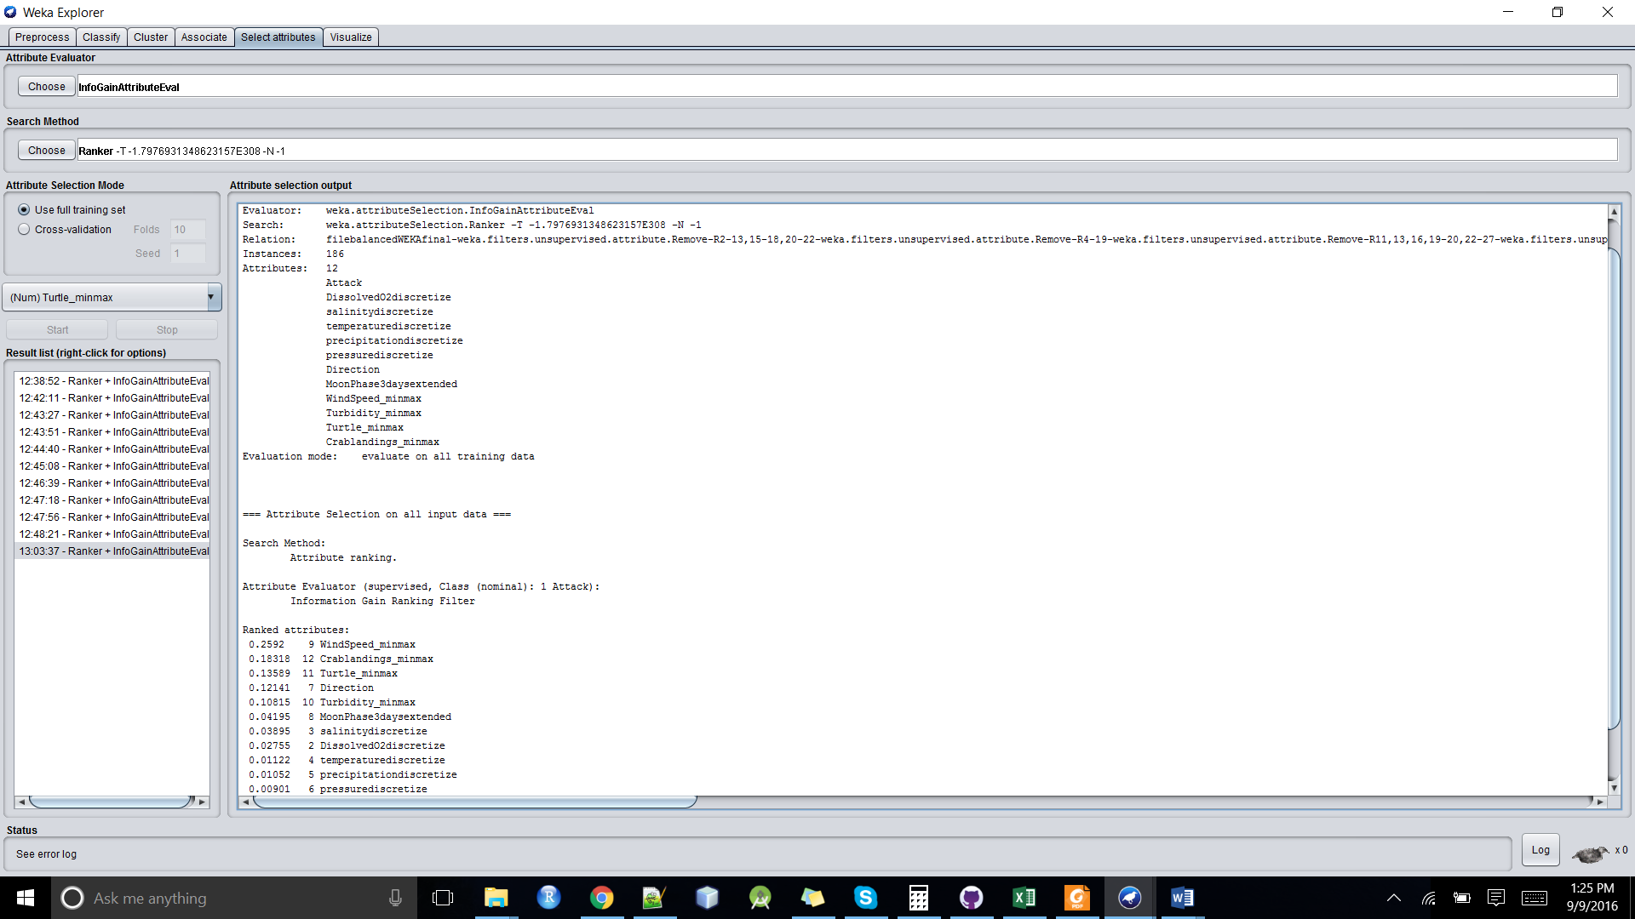

# Classification :

=== Run information ===

Scheme: weka.classifiers.trees.J48 -O -U -M 2

Relation: filebalancedWEKAfinal-weka.filters.unsupervised.attribute.Remove-R2-13,15-18,20-22-weka.filters.unsupervised.attribute.Remove-R4-19-weka.filters.unsupervised.attribute.Remove-R11,13,16,19-20,22-27-weka.filters.unsupervised.attribute.Remove-R1-weka.filters.unsupervised.attribute.Remove-R11-weka.filters.unsupervised.attribute.Remove-R9-weka.filters.unsupervised.attribute.Remove-R23-24-weka.filters.unsupervised.attribute.Remove-R10-weka.filters.unsupervised.attribute.Remove-R9-weka.filters.unsupervised.attribute.Remove-R11-12,15-weka.filters.unsupervised.attribute.Remove-R11,14-15-weka.filters.unsupervised.attribute.Remove-R5-weka.filters.unsupervised.attribute.Remove-R1-weka.filters.unsupervised.attribute.Remove-R6-weka.filters.unsupervised.attribute.Remove-R9-weka.filters.unsupervised.attribute.Remove-R10

Instances: 186

Attributes: 9

Attack

DissolvedO2discretize

salinitydiscretize

temperaturediscretize

precipitationdiscretize

Direction

MoonPhase3daysextended

WindSpeed_minmax

Turtle_minmax

Test mode: 10-fold cross-validation

=== Classifier model (full training set) ===

J48 unpruned tree

------------------

WindSpeed_minmax <= 0.424837

| salinitydiscretize = Medium

| | Direction = SW

| | | WindSpeed_minmax <= 0.300654: No (2.0)

| | | WindSpeed_minmax > 0.300654: No (2.0/1.0)

| | Direction = SSW

| | | MoonPhase3daysextended = New

| | | | Turtle_minmax <= 0.196172: No (3.0/1.0)

| | | | Turtle_minmax > 0.196172: Yes (2.0)

| | | MoonPhase3daysextended = First quarter: No (2.0)

| | | MoonPhase3daysextended = Full: No (4.0/2.0)

| | | MoonPhase3daysextended = Waning gibbous: No (0.0)

| | | MoonPhase3daysextended = Third quarter: No (1.0)

| | | MoonPhase3daysextended = Waxing gibbous: No (1.0)

| | | MoonPhase3daysextended = Waning crescent: No (0.0)

| | | MoonPhase3daysextended = Waxing crescent: No (0.0)

| | Direction = NE: No (1.0)

| | Direction = SSE: No (3.0)

| | Direction = S

| | | MoonPhase3daysextended = New: No (4.0)

| | | MoonPhase3daysextended = First quarter: No (2.0/1.0)

| | | MoonPhase3daysextended = Full: No (2.0)

| | | MoonPhase3daysextended = Waning gibbous: No (2.0)

| | | MoonPhase3daysextended = Third quarter: No (0.0)

| | | MoonPhase3daysextended = Waxing gibbous: No (0.0)

| | | MoonPhase3daysextended = Waning crescent: No (0.0)

| | | MoonPhase3daysextended = Waxing crescent: No (0.0)

| | Direction = NNE: No (1.0)

| | Direction = ESE: No (4.0)

| | Direction = E: No (3.0/1.0)

| | Direction = ENE: No (1.0)

| | Direction = WSW: No (1.0)

| | Direction = SE: Yes (1.0)

| | Direction = W: No (1.0)

| salinitydiscretize = High

| | Direction = SW

| | | MoonPhase3daysextended = New: No (3.0)

| | | MoonPhase3daysextended = First quarter: No (3.0/1.0)

| | | MoonPhase3daysextended = Full: No (4.0)

| | | MoonPhase3daysextended = Waning gibbous: No (0.0)

| | | MoonPhase3daysextended = Third quarter: No (0.0)

| | | MoonPhase3daysextended = Waxing gibbous: No (1.0)

| | | MoonPhase3daysextended = Waning crescent: No (0.0)

| | | MoonPhase3daysextended = Waxing crescent: No (0.0)

| | Direction = SSW

| | | MoonPhase3daysextended = New: No (6.0)

| | | MoonPhase3daysextended = First quarter: No (2.0)

| | | MoonPhase3daysextended = Full

| | | | WindSpeed_minmax <= 0.222222: No (2.0/1.0)

| | | | WindSpeed_minmax > 0.222222: No (3.0)

| | | MoonPhase3daysextended = Waning gibbous: Yes (1.0)

| | | MoonPhase3daysextended = Third quarter: No (2.0)

| | | MoonPhase3daysextended = Waxing gibbous: No (0.0)

| | | MoonPhase3daysextended = Waning crescent: No (0.0)

| | | MoonPhase3daysextended = Waxing crescent: No (0.0)

| | Direction = NE: No (3.0)

| | Direction = SSE

| | | MoonPhase3daysextended = New: No (4.0)

| | | MoonPhase3daysextended = First quarter: No (1.0)

| | | MoonPhase3daysextended = Full

| | | | Turtle_minmax <= 0.033493: No (2.0/1.0)

| | | | Turtle_minmax > 0.033493: Yes (2.0)

| | | MoonPhase3daysextended = Waning gibbous: No (0.0)

| | | MoonPhase3daysextended = Third quarter: No (2.0)

| | | MoonPhase3daysextended = Waxing gibbous: No (1.0)

| | | MoonPhase3daysextended = Waning crescent: No (1.0)

| | | MoonPhase3daysextended = Waxing crescent: No (0.0)

| | Direction = S

| | | Turtle_minmax <= 0.272727: No (7.0)

| | | Turtle_minmax > 0.272727: Yes (2.0)

| | Direction = NNE: No (1.0)

| | Direction = ESE: No (3.0/1.0)

| | Direction = E

| | | WindSpeed_minmax <= 0.215686: No (7.0)

| | | WindSpeed_minmax > 0.215686

| | | | WindSpeed_minmax <= 0.30719: Yes (4.0)

| | | | WindSpeed_minmax > 0.30719

| | | | | WindSpeed_minmax <= 0.366013: No (2.0/1.0)

| | | | | WindSpeed_minmax > 0.366013: No (2.0)

| | Direction = ENE: No (9.0)

| | Direction = WSW: No (3.0/1.0)

| | Direction = SE

| | | MoonPhase3daysextended = New: Yes (2.0)

| | | MoonPhase3daysextended = First quarter: No (1.0)

| | | MoonPhase3daysextended = Full: No (3.0)

| | | MoonPhase3daysextended = Waning gibbous: No (0.0)

| | | MoonPhase3daysextended = Third quarter: Yes (1.0)

| | | MoonPhase3daysextended = Waxing gibbous: No (0.0)

| | | MoonPhase3daysextended = Waning crescent: No (0.0)

| | | MoonPhase3daysextended = Waxing crescent: No (0.0)

| | Direction = W: No (1.0)

| salinitydiscretize = Low: Yes (2.0)

WindSpeed_minmax > 0.424837

| MoonPhase3daysextended = New: Yes (12.0)

| MoonPhase3daysextended = First quarter

| | Direction = SW: Yes (4.0)

| | Direction = SSW: Yes (1.0)

| | Direction = NE: No (1.0)

| | Direction = SSE: Yes (0.0)

| | Direction = S: Yes (1.0)

| | Direction = NNE: Yes (0.0)

| | Direction = ESE: Yes (1.0)

| | Direction = E: Yes (0.0)

| | Direction = ENE: Yes (0.0)

| | Direction = WSW: Yes (3.0)

| | Direction = SE: Yes (0.0)

| | Direction = W: Yes (0.0)

| MoonPhase3daysextended = Full

| | Direction = SW: Yes (10.0)

| | Direction = SSW

| | | temperaturediscretize = High: Yes (5.0)

| | | temperaturediscretize = Medium: No (2.0/1.0)

| | | temperaturediscretize = Low: Yes (0.0)

| | Direction = NE: Yes (0.0)

| | Direction = SSE: Yes (0.0)

| | Direction = S: Yes (0.0)

| | Direction = NNE: Yes (0.0)

| | Direction = ESE: Yes (0.0)

| | Direction = E: No (2.0)

| | Direction = ENE: Yes (0.0)

| | Direction = WSW: Yes (5.0)

| | Direction = SE: Yes (0.0)

| | Direction = W: Yes (0.0)

| MoonPhase3daysextended = Waning gibbous: Yes (0.0)

| MoonPhase3daysextended = Third quarter: No (3.0)

| MoonPhase3daysextended = Waxing gibbous: Yes (0.0)

| MoonPhase3daysextended = Waning crescent: Yes (0.0)

| MoonPhase3daysextended = Waxing crescent: Yes (0.0)

Number of Leaves : 107

Size of the tree : 129

Time taken to build model: 0 seconds

=== Stratified cross-validation ===

=== Summary ===

**Correctly Classified Instances 149 80.1075 %**

Incorrectly Classified Instances 37 19.8925 %

Kappa statistic 0.5686

Mean absolute error 0.2172

Root mean squared error 0.4178

Relative absolute error 45.7399 %

Root relative squared error 85.7572 %

Total Number of Instances 186

=== Detailed Accuracy By Class ===

TP Rate FP Rate Precision Recall F-Measure MCC ROC Area PRC Area Class

0.886 0.333 0.808 0.886 0.845 0.573 0.818 0.829 No

0.667 0.114 0.787 0.667 0.722 0.573 0.818 0.719 Yes

Weighted Avg. 0.801 0.248 0.800 0.801 0.797 0.573 0.818 0.786

**=== Confusion Matrix ===**

**a b <-- classified as**

**101 13 | a = No**

**24 48 | b = Yes**

# Clustering :

=== Run information ===

Scheme: weka.clusterers.SimpleKMeans -init 0 -max-candidates 100 -periodic-pruning 10000 -min-density 2.0 -t1 -1.25 -t2 -1.0 -N 2 -A "weka.core.EuclideanDistance -R first-last" -I 500 -num-slots 1 -S 10

Relation: filebalancedWEKAfinal-weka.filters.unsupervised.attribute.Remove-R2-13,15-18,20-22-weka.filters.unsupervised.attribute.Remove-R4-19-weka.filters.unsupervised.attribute.Remove-R11,13,16,19-20,22-27-weka.filters.unsupervised.attribute.Remove-R1-weka.filters.unsupervised.attribute.Remove-R11-weka.filters.unsupervised.attribute.Remove-R9-weka.filters.unsupervised.attribute.Remove-R23-24-weka.filters.unsupervised.attribute.Remove-R10-weka.filters.unsupervised.attribute.Remove-R9-weka.filters.unsupervised.attribute.Remove-R11-12,15-weka.filters.unsupervised.attribute.Remove-R11,14-15-weka.filters.unsupervised.attribute.Remove-R5-weka.filters.unsupervised.attribute.Remove-R1-weka.filters.unsupervised.attribute.Remove-R6-weka.filters.unsupervised.attribute.Remove-R9-weka.filters.unsupervised.attribute.Remove-R10

Instances: 186

Attributes: 9

Attack

DissolvedO2discretize

salinitydiscretize

temperaturediscretize

precipitationdiscretize

Direction

MoonPhase3daysextended

WindSpeed_minmax

Turtle_minmax

Test mode: evaluate on training data

=== Clustering model (full training set) ===

kMeans

======

Number of iterations: 3

Within cluster sum of squared errors: 406.2214960418787

Initial starting points (random):

Cluster 0: No,Low,Medium,High,Low,SSW,New,0.346405,0.148325

Cluster 1: Yes,Medium,High,Medium,Low,SW,'First quarter',0.431373,0

Missing values globally replaced with mean/mode

Final cluster centroids:

Cluster#

Attribute Full Data 0 1

(186.0) (99.0) (87.0)

==========================================================

Attack No No Yes

DissolvedO2discretize Medium Medium Medium

salinitydiscretize High Medium High

temperaturediscretize High High High

precipitationdiscretize Low Low Low

Direction SSW SSW SW

MoonPhase3daysextended Full New Full

WindSpeed_minmax 0.3456 0.2704 0.4311

Turtle_minmax 0.156 0.1013 0.2182

Time taken to build model (full training data) : 0.01 seconds

=== Model and evaluation on training set ===

**Clustered Instances**

**0 99 ( 53%)**

**1 87 ( 47%)**