For normalized Variables :

# Attribute Evaluation :

Method : InfoGainAttributeEval

Search : Ranker

Instances: 186

Attributes: 10

1. Attack
2. Precipitation_minmax
3. StationPressure_minmax
4. WindSpeed_minmax
5. Salinity_minmax
6. Turbidity_minmax
7. Dissolved02_minmax
8. WaterTemp_minmax
9. Turtle_minmax
10. Crablandings_minmax

Evaluation mode: evaluate on all training data

=== Attribute Selection on all input data ===

Search Method: Attribute ranking.

Attribute Evaluator (supervised, Class (nominal): 1 Attack):

Information Gain Ranking Filter

Ranked attributes:

0.259 4 WindSpeed_minmax

0.183 10 Crablandings_minmax

0.136 9 Turtle_minmax

0.108 6 Turbidity_minmax

0 7 Dissolved02_minmax

0 3 StationPressure_minmax

0 8 WaterTemp_minmax

0 5 Salinity_minmax

0 2 Precipitation_minmax

Selected attributes: 4,10,9,6,7,3,8,5,2 : 9

Screenshot: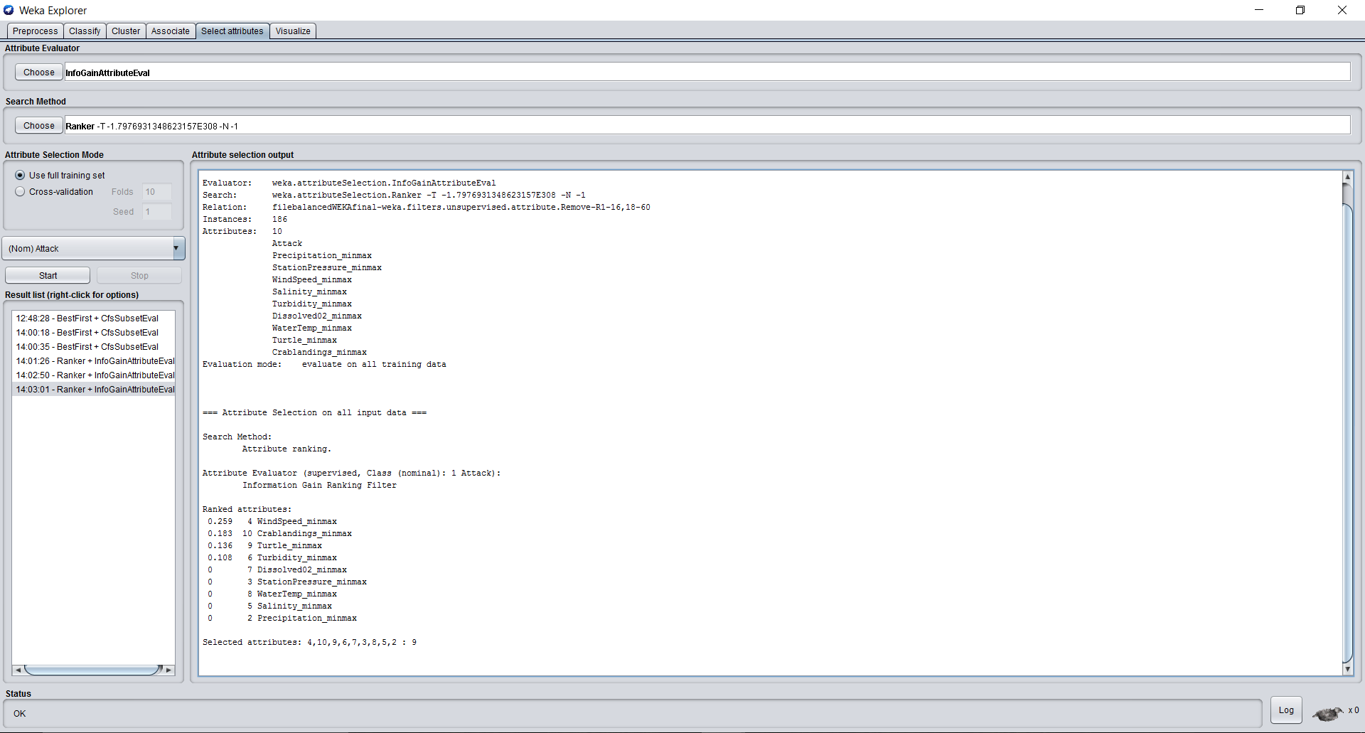

# Classification:

=== Run information ===

Scheme: weka.classifiers.trees.J48 -O -U -M 2

Relation: filebalancedWEKAfinal-weka.filters.unsupervised.attribute.Remove-R1-16,18-60

Instances: 186

Attributes: 10

Attack

Precipitation_minmax

StationPressure_minmax

WindSpeed_minmax

Salinity_minmax

Turbidity_minmax

Dissolved02_minmax

WaterTemp_minmax

Turtle_minmax

Crablandings_minmax

Test mode: evaluate on training data

=== Classifier model (full training set) ===

J48 unpruned tree

------------------

WindSpeed_minmax <= 0.424837

| Turtle_minmax <= 0.315789

| | WindSpeed_minmax <= 0.137255: No (22.0)

| | WindSpeed_minmax > 0.137255

| | | Precipitation_minmax <= 0.088571

| | | | Turbidity_minmax <= 0.101499

| | | | | Turbidity_minmax <= 0.007427

| | | | | | Turtle_minmax <= 0.062201

| | | | | | | StationPressure_minmax <= 0.877193: Yes (6.0)

| | | | | | | StationPressure_minmax > 0.877193: No (2.0/1.0)

| | | | | | Turtle_minmax > 0.062201: No (4.0)

| | | | | Turbidity_minmax > 0.007427: No (70.0/10.0)

| | | | Turbidity_minmax > 0.101499

| | | | | StationPressure_minmax <= 0.596491: No (2.0/1.0)

| | | | | StationPressure_minmax > 0.596491: Yes (4.0)

| | | Precipitation_minmax > 0.088571: No (16.0)

| Turtle_minmax > 0.315789

| | Salinity_minmax <= 0.728224: Yes (7.0)

| | Salinity_minmax > 0.728224: No (3.0)

WindSpeed_minmax > 0.424837

| Turtle_minmax <= 0.090909: Yes (14.0/6.0)

| Turtle_minmax > 0.090909: Yes (36.0/1.0)

Number of Leaves : 12

Size of the tree : 23

Time taken to build model: 0.01 seconds

=== Evaluation on training set ===

Time taken to test model on training data: 0 seconds

=== Summary ===

**Correctly Classified Instances 167 89.7849 %**

Incorrectly Classified Instances 19 10.2151 %

Kappa statistic 0.7819

Mean absolute error 0.1502

Root mean squared error 0.2741

Relative absolute error 31.6441 %

Root relative squared error 56.269 %

Total Number of Instances 186

=== Detailed Accuracy By Class ===

TP Rate FP Rate Precision Recall F-Measure MCC ROC Area PRC Area Class

0.939 0.167 0.899 0.939 0.918 0.783 0.945 0.942 No

0.833 0.061 0.896 0.833 0.863 0.783 0.945 0.908 Yes

Weighted Avg. 0.898 0.126 0.898 0.898 0.897 0.783 0.945 0.929

=== Confusion Matrix ===

**a b <-- classified as**

**107 7 | a = No**

**12 60 | b = Yes**

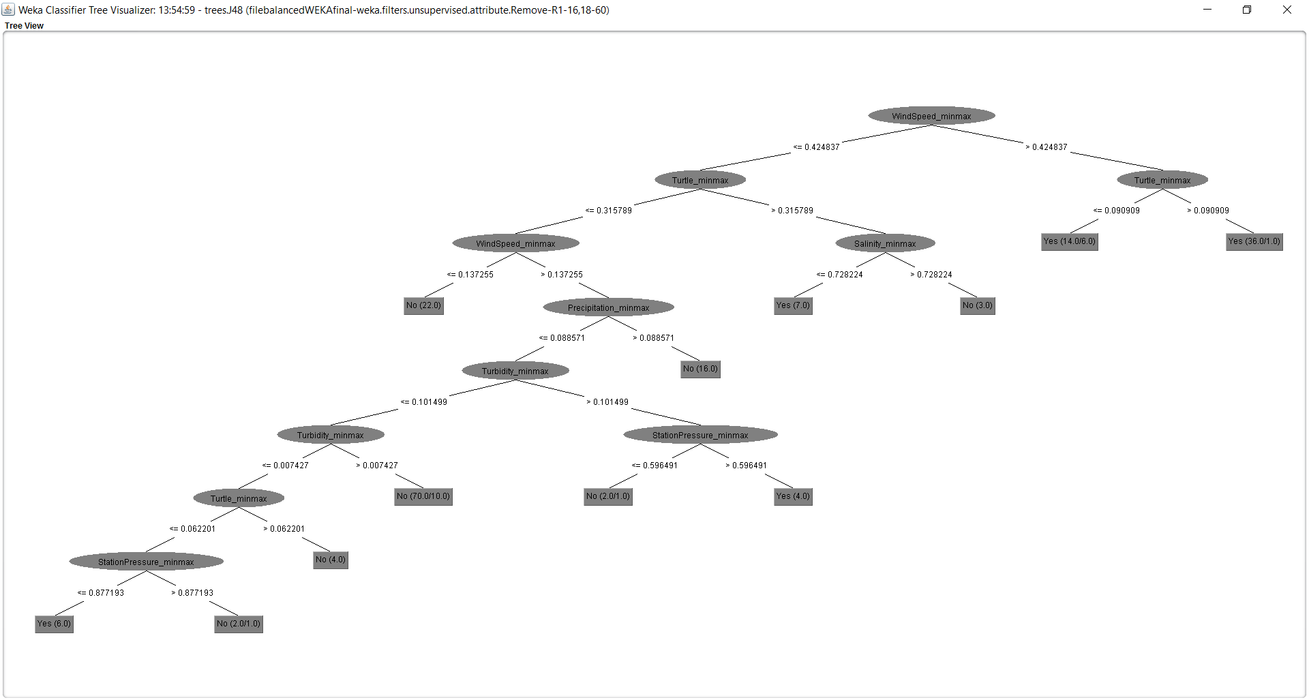

Classification using the following attributes :

Predictors: WindSpeed

Turbidity

Turtle activity

Crab landings

Target variable : Attack(yes/no)

Results :

=== Run information ===

Scheme: weka.classifiers.trees.J48 -O -U -M 2

Relation: filebalancedWEKAfinal-weka.filters.unsupervised.attribute.Remove-R1-16,18-60-weka.filters.unsupervised.attribute.Remove-R2-3,5,7-weka.filters.unsupervised.attribute.Remove-R4

Instances: 186

Attributes: 5

Attack

WindSpeed_minmax

Turbidity_minmax

Turtle_minmax

Crablandings_minmax

Test mode: evaluate on training data

=== Classifier model (full training set) ===

J48 unpruned tree

------------------

WindSpeed_minmax <= 0.424837

| Turtle_minmax <= 0.315789

| | WindSpeed_minmax <= 0.137255: No (22.0)

| | WindSpeed_minmax > 0.137255

| | | Turbidity_minmax <= 0.101499

| | | | Turbidity_minmax <= 0.007427

| | | | | Turtle_minmax <= 0.062201

| | | | | | Crablandings_minmax <= 0.19493: No (2.0/1.0)

| | | | | | Crablandings_minmax > 0.19493: Yes (6.0)

| | | | | Turtle_minmax > 0.062201: No (5.0)

| | | | Turbidity_minmax > 0.007427: No (84.0/10.0)

| | | Turbidity_minmax > 0.101499

| | | | Crablandings_minmax <= 0.719406: No (2.0)

| | | | Crablandings_minmax > 0.719406: Yes (5.0)

| Turtle_minmax > 0.315789

| | Turtle_minmax <= 0.502392

| | | Turtle_minmax <= 0.344498: Yes (3.0/1.0)

| | | Turtle_minmax > 0.344498: No (2.0)

| | Turtle_minmax > 0.502392: Yes (5.0)

WindSpeed_minmax > 0.424837

| Turtle_minmax <= 0.090909: Yes (14.0/6.0)

| Turtle_minmax > 0.090909: Yes (36.0/1.0)

Number of Leaves : 12

Size of the tree : 23

Time taken to build model: 0 seconds

=== Evaluation on training set ===

Time taken to test model on training data: 0 seconds

=== Summary ===

Correctly Classified Instances 167 **89.7849 %**

Incorrectly Classified Instances 19 10.2151 %

Kappa statistic 0.7831

Mean absolute error 0.1546

Root mean squared error 0.278

Relative absolute error 32.5608 %

Root relative squared error 57.0782 %

Total Number of Instances 186

=== Detailed Accuracy By Class ===

TP Rate FP Rate Precision Recall F-Measure MCC ROC Area PRC Area Class

0.930 0.153 0.906 0.930 0.918 0.784 0.936 0.931 No

0.847 0.070 0.884 0.847 0.865 0.784 0.936 0.901 Yes

Weighted Avg. 0.898 0.121 0.897 0.898 0.897 0.784 0.936 0.919

**=== Confusion Matrix ===**

**a b <-- classified as**

**106 8 | a = No**

**11 61 | b = Yes**

**Tree visualization:**

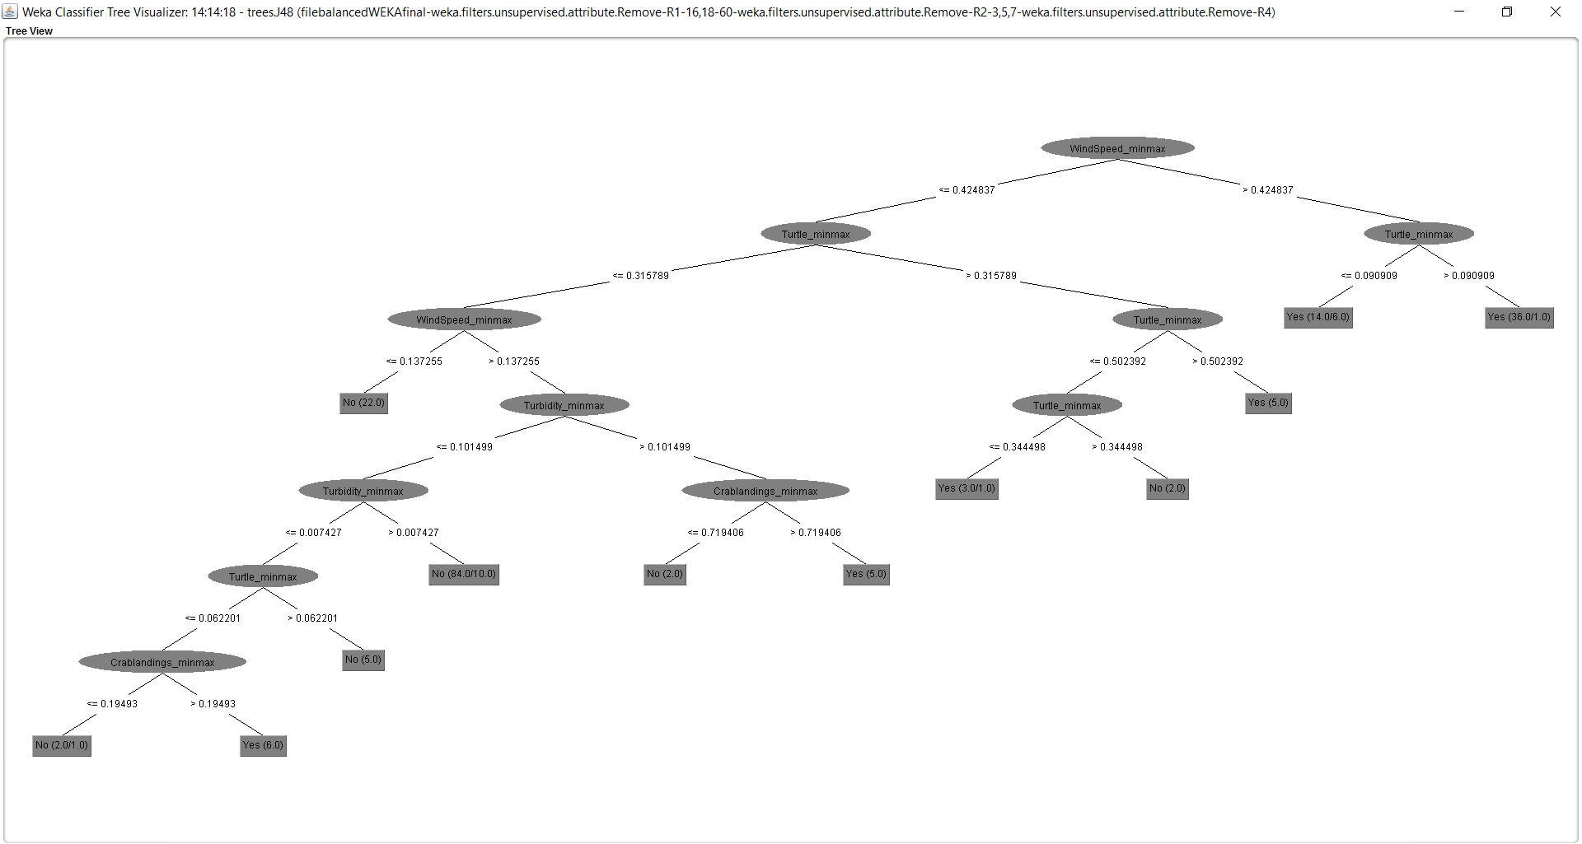

Clustering :

Method : K-Means Clustering :

Result:

=== Run information ===

Scheme: weka.clusterers.SimpleKMeans -init 0 -max-candidates 100 -periodic-pruning 10000 -min-density 2.0 -t1 -1.25 -t2 -1.0 -N 2 -A "weka.core.EuclideanDistance -R first-last" -I 500 -num-slots 1 -S 10

Relation: filebalancedWEKAfinal-weka.filters.unsupervised.attribute.Remove-R1-16,18-60-weka.filters.unsupervised.attribute.Remove-R2,5,8-weka.filters.unsupervised.attribute.Remove-R2

Instances: 186

Attributes: 6

Attack

WindSpeed_minmax

Turbidity_minmax

Turtle_minmax

Crablandings_minmax

Ignored:

Dissolved02_minmax

Test mode: evaluate on training data

=== Clustering model (full training set) ===

kMeans

======

Number of iterations: 2

**Within cluster sum of squared errors: 29.830319899212967**

Initial starting points (random):

Cluster 0: No,0.346405,0.020567,0.148325,0.277972

Cluster 1: Yes,0.431373,0.010181,0,0.785839

Missing values globally replaced with mean/mode

Final cluster centroids:

Cluster#

**Attribute Full Data 0 1**

**(186.0) (114.0) (72.0)**

**======================================================**

**Attack No No Yes**

**WindSpeed_minmax 0.3456 0.2574 0.4852**

**Turbidity_minmax 0.0558 0.0313 0.0946**

**Turtle_minmax 0.156 0.0905 0.2596**

**Crablandings_minmax 0.5171 0.463 0.6029**

Time taken to build model (full training data) : 0.01 seconds

=== Model and evaluation on training set ===

Clustered Instances

0 114 ( 61%)

1 72 ( 39%)