Qatar University
College of Engineering
Department of Computer Science and Engineering
CMPS 350 — Web Development
Course Project — Phase 2
TheyChat
A Social Media Platform built with Next.js, React, and Prisma (SQLite)
Submitted to:
Dr. Fadi Yilmaz
Submitted by:
Eissa Alkathiri — 202307530
Abdulla Khalifa Al-Fadhala — 202308229
Abdulrahman Ahmed — 202207709
Ismail Hashem — 201906204
Spring 2026 — May 2026

1. Introduction
TheyChat is a Twitter-like social media platform allowing users to register, log in, post, comment, like, and follow each other. Phase 1 delivered the front-end and JSON-backed prototype; Phase 2 replaces JSON storage with a real relational database accessed through Prisma, exposes the data through a REST API built on the Next.js App Router, and adds a new Statistics Dashboard powered by eight database queries. The stack is Next.js 16 + React 19 + Prisma 7 + SQLite (libSQL adapter); all aggregation, sorting, and filtering is performed by the database, never in the application layer.

2. Data Model
Five entities — User, Post, Comment, Like, and Follow — capture the application’s domain. Likes and Follows are modelled as join entities with composite uniqueness so a user cannot like the same post twice or follow the same person twice. cuid identifiers are used as primary keys, username and email are unique on User, and Post / Comment timestamps default to the database time, which is what powers the “most active user in the last 3 months” statistic.
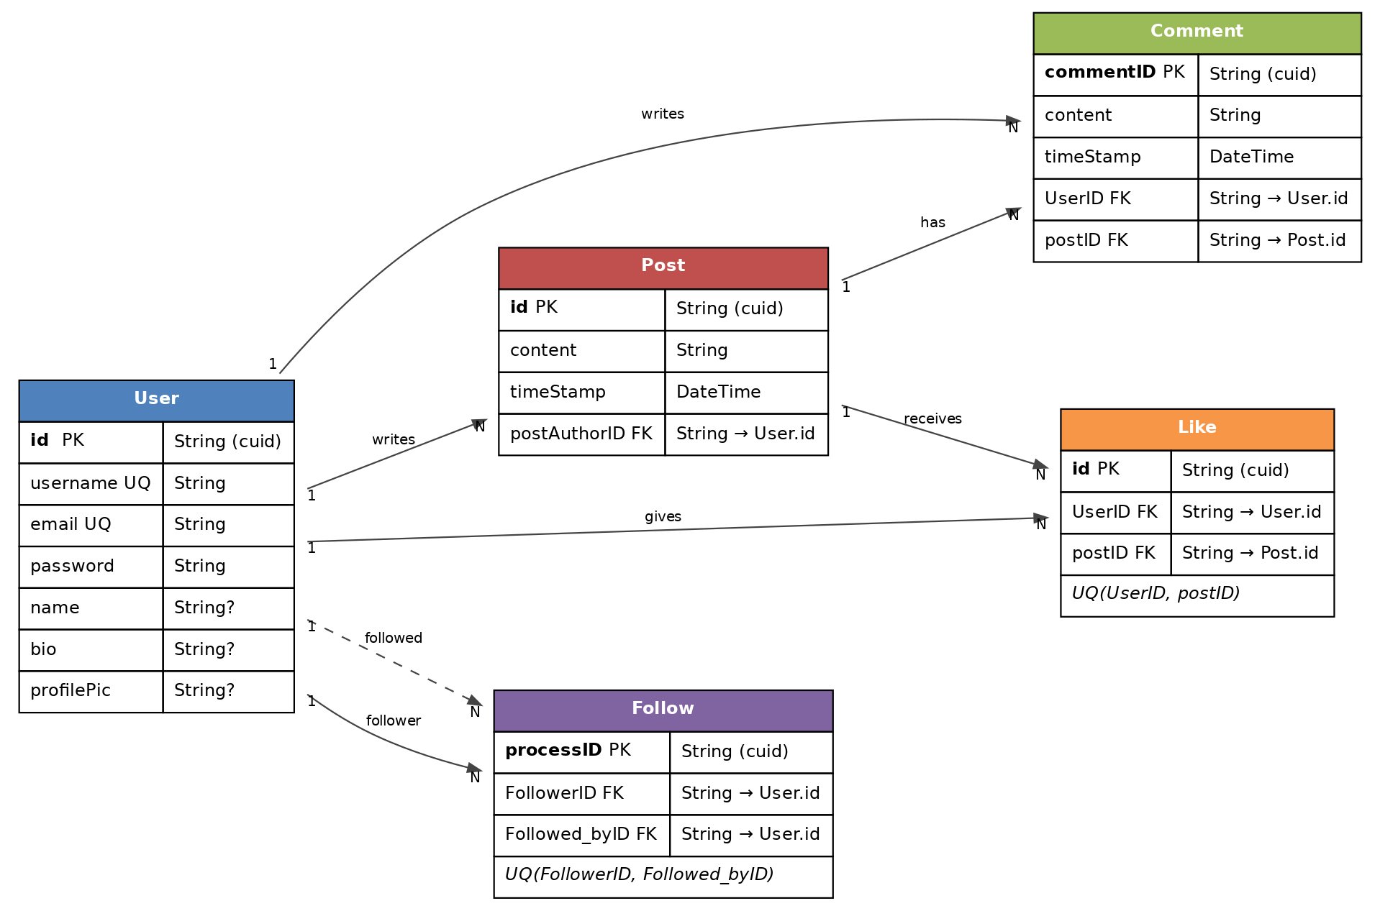
Figure 1 — TheyChat Entity–Relationship Diagram

3. Data Repository and Next.js APIs
A Data Repository (repos/) wraps every Prisma query, and Next.js Route Handlers (app/api/) call those repository functions. Handlers never speak to Prisma directly. Filtering, sorting, counting, and aggregation are expressed in the repository’s Prisma queries (where, orderBy, take, _count, groupBy) so SQLite executes them — the application never loads a whole table to filter or count it in JavaScript.
Resource | Endpoints | Notes
Users | GET / POST / PATCH /api/users | List, register, update profile. Unique username/email enforced by DB.
Posts | GET / POST /api/posts; GET / DELETE /api/posts/{id} | List feed, create, fetch one with comments, delete (cascades likes & comments).
Comments | GET / POST /api/comments | Filter by ?postID or ?UserID at DB level.
Likes | GET / POST /api/likes | Composite UQ(UserID, postID) blocks duplicate likes (P2002 → HTTP 400).
Follow | GET / POST / DELETE /api/follow | Two named relations on User; UQ(FollowerID, Followed_byID) blocks duplicates.
Stats | GET /api/stats | Returns all 8 statistics in a single response (Promise.all dispatch).

4. Statistics Use-Case
The new /stats page issues one fetch to /api/stats on mount and renders eight cards. Each statistic is a Prisma query in repos/stats.js — implemented with groupBy, _count, where (date-bounded for the 3-month window), orderBy, take, and the posts: { none: {} } predicate for inactive users. The five overview counters use Promise.all to run in parallel.
# | Statistic | How it is computed
1 | Average followers per user | groupBy(Follow, Followed_byID) + _count, divided by user count.
2 | Average posts per user | count(Post) / count(User), two parallel COUNTs.
3 | Most active user in last 3 months | Two date-bounded groupBy queries on Post and Comment merged by user.
4 | Top 5 most liked posts | findMany with orderBy: { likes: { _count: "desc" } } and take: 5.
5 | Top 5 most followed users | groupBy(Follow, Followed_byID) sorted desc, take: 5.
6 | Top 10 most used words in posts | select content only, then in-app token + stop-word filter + count.
7 | Users with zero posts | findMany with where: { posts: { none: {} } }.
8 | Platform overview counters | Five count() queries dispatched via Promise.all.
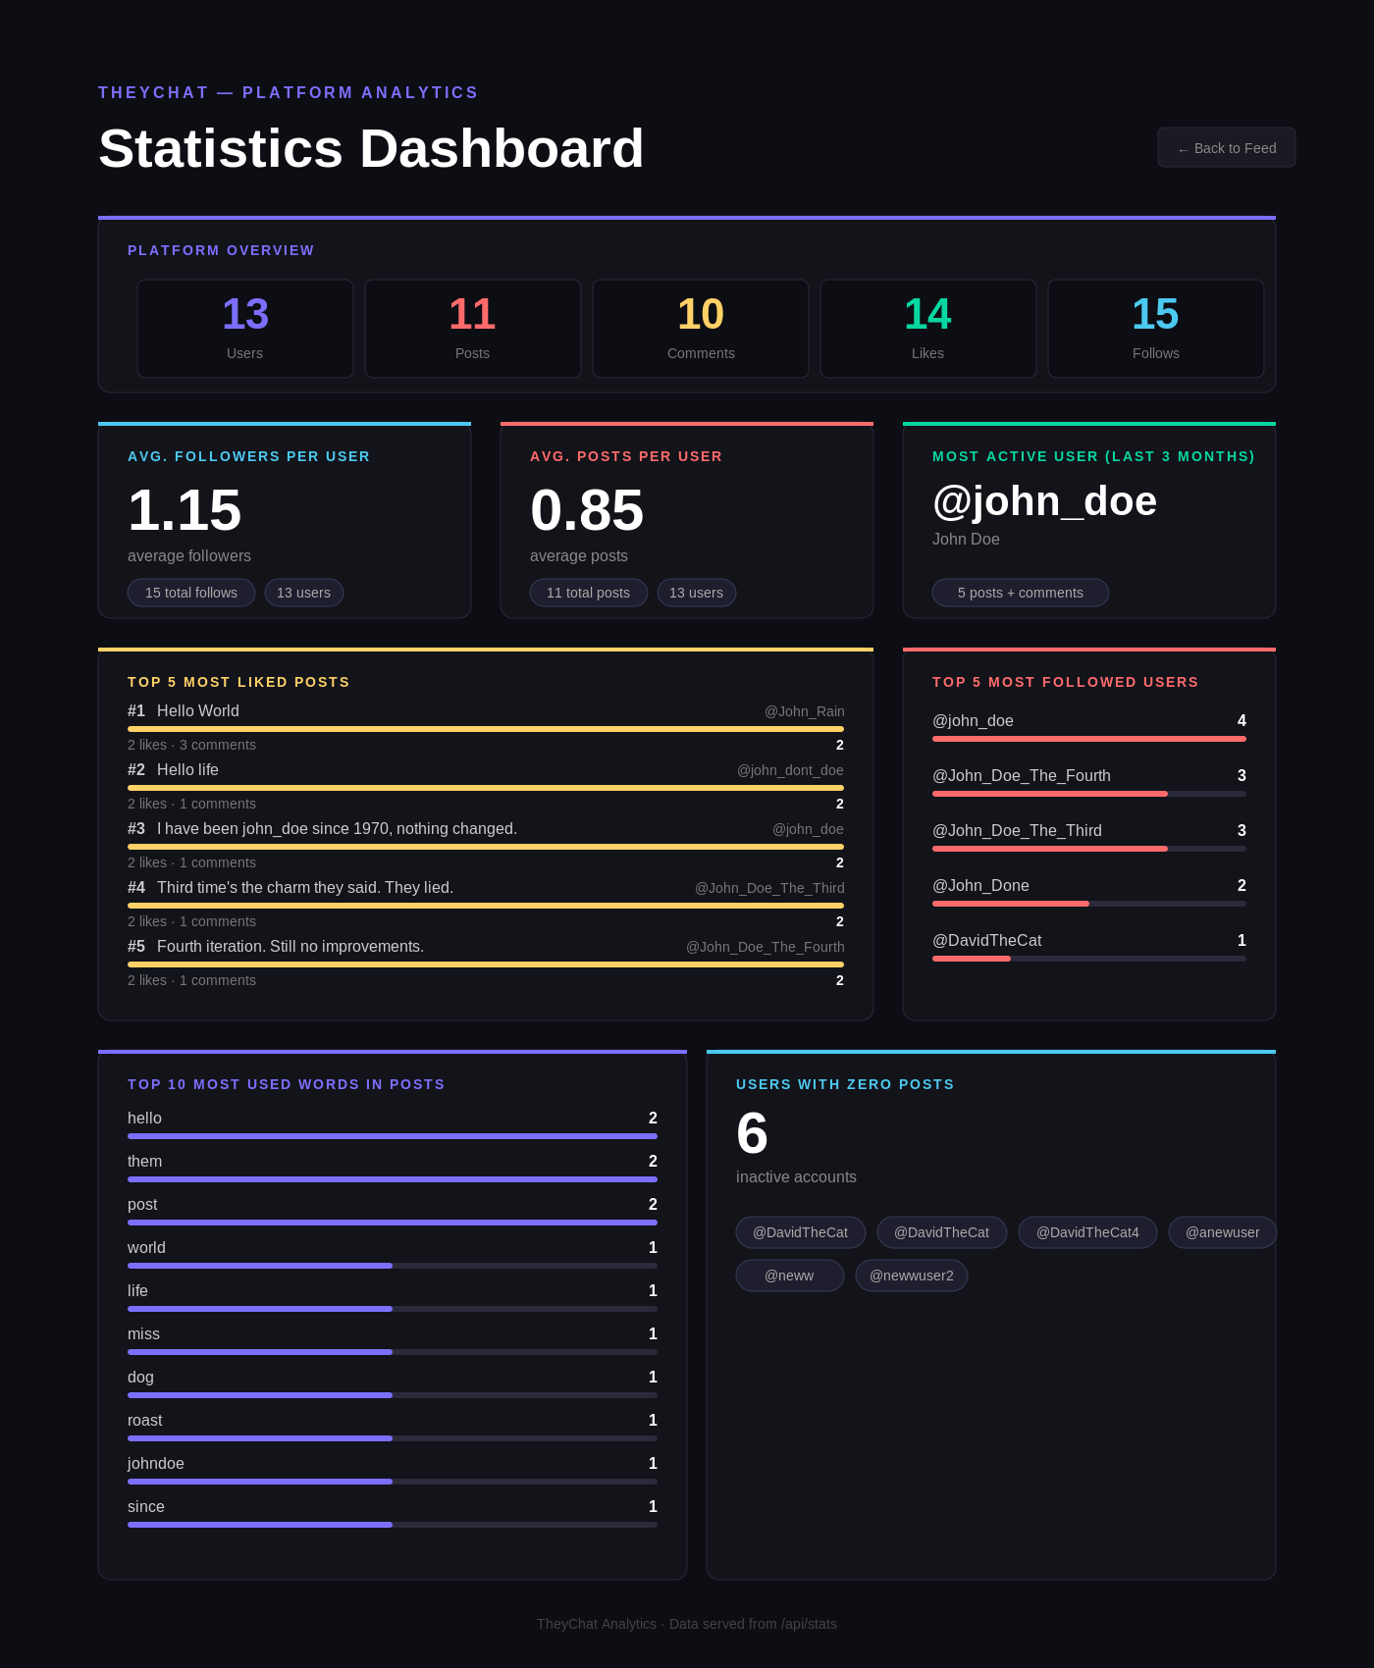
Figure 2 — Statistics Dashboard at /stats

5. Conducted Tests
The API endpoints were tested manually with Postman against a freshly seeded database. For each endpoint we verified the response status, body shape, and that DB-level constraints behave as expected — duplicate likes return 400 (Prisma P2002), missing fields return 400, deleting an unknown ID returns 404 (P2025), and successful creates return 201. The Statistics Dashboard was reloaded and its eight values cross-checked against the Postman response of GET /api/stats. Below is the all-stats endpoint response which directly drives the dashboard.
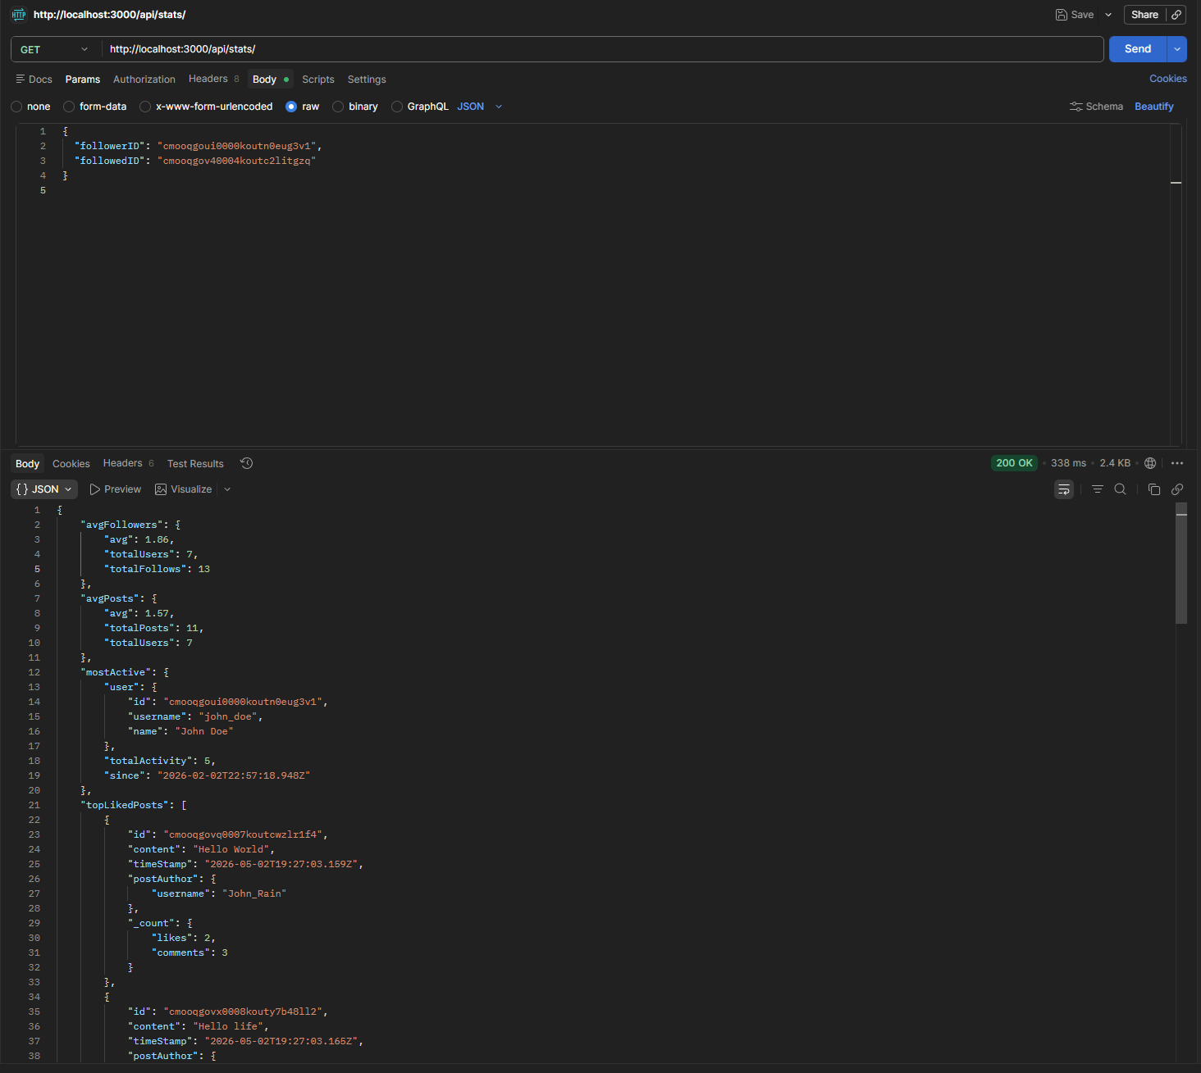
Figure 3 — GET /api/stats (200 OK) — feeds the dashboard in Figure 2
Additional Postman screenshots covering POST /api/posts, POST /api/comments, POST /api/likes, POST /api/follow, and GET /api/users are kept in the project repository under /postman results/.

6. Team Contributions
The four equal and separate roles below were agreed at the start of Phase 2. Documentation, testing, GitHub commits, and demo preparation were shared by all four members.
Member | Role | Deliverables
Eissa Alkathiri | Data modelling & database setup | Conceptual model and ERD; Prisma schema; SQLite database configuration; tables and relations.
Abdulla Khalifa Al-Fadhala | Database initialization & seeding | Conversion of JSON data into DB inserts; seed.js script; populated users, posts, comments, likes, follows with enough records for meaningful statistics.
Abdulrahman Ahmed | APIs & Data repository | Repository layer (repos/) using Prisma Client; Next.js API routes for users, posts, comments, likes, follows; ensured filtering, sorting, and aggregation run in the database.
Ismail Hashem | Statistics page & frontend integration | Statistics use-case page (/stats) with eight statistics; API integration; results display (cards, bars, leaderboards).

7. Conclusion
Phase 2 migrates TheyChat from JSON-file storage to a Prisma-backed SQLite database, exposes a clean REST API through Next.js Route Handlers, and adds a Statistics Dashboard powered by eight database queries. The repository layer keeps Prisma calls in one place, the API handlers stay thin, and every aggregation is computed by the database — so the dashboard remains fast as data grows. Together these pieces satisfy the Phase 2 requirements end-to-end.

8. Link:
GitHub: https://github.com/AKF3816/Web-Dev-project.git
Demo Video: Call with Abdulla and 2 others-20260503_032715-Meeting Recording.mp4

