Natural Join

* + **The NATURAL JOIN clause is based on all columns in the two tables that have the same name.**
  + **It selects rows from the two tables that have equal values in all matched columns.**
  + **If the columns having the same names have different data types, an error is returned.**

SELECT department_id, department_name,

location_id, city

FROM departments

NATURAL JOIN locations ;

**Using Clause**

**SELECT employees.employee_id, employees.last_name,**

**departments.location_id, department_id**

**FROM employees JOIN departments**

**USING (department_id) ;**

**SELECT e.employee_id, e.last_name,**

**d.location_id, department_id**

**FROM employees e JOIN departments d**

**USING (department_id) ;**

On Clause

* + **The join condition for the natural join is basically an equijoin of all columns with the same name.**
  + **Use the ON clause to specify arbitrary conditions or specify columns to join.**
  + **The join condition is separated from other search conditions.**
  + **The ON clause makes code easy to understand.**

SELECT e.employee_id, e.last_name, e.department_id,

d.department_id, d.location_id

FROM employees e JOIN departments d

ON (e.department_id = d.department_id);

Self join

**SELECT e.last_name emp, m.last_name mgr**

**FROM employees e JOIN employees m**

**ON (e.manager_id = m.employee_id);**

**EMPLOYEES (WORKER)**

**EMPLOYEES (MANAGER)**

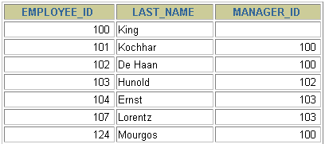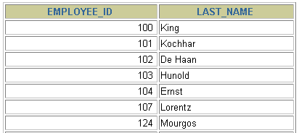

**…**

**…**

3 tables join

**SELECT employee_id, city, department_name**

**FROM employees e**

**JOIN departments d**

**ON d.department_id = e.department_id**

**JOIN locations l**

**ON d.location_id = l.location_id;**

**Or**

mysql> SELECT employee_id, city, department_name

-> FROM employees e

-> JOIN departments d

-> using ( department_id)

-> JOIN locations l

-> using ( location_id);

Left Outer Join

**SELECT e.last_name, e.department_id, d.department_name**

**FROM employees e LEFT OUTER JOIN departments d**

**ON (e.department_id = d.department_id) ;**

Right Outer Join

**SELECT e.last_name, e.department_id, d.department_name**

**FROM employees e RIGHT OUTER JOIN departments d**

**ON (e.department_id = d.department_id) ;**

Outer Join

**SELECT e.last_name, d.department_id, d.department_name**

**FROM employees e FULL OUTER JOIN departments d**

**ON (e.department_id = d.department_id) ;**

Cross Join

* + **The CROSS JOIN clause produces the cross-product of two tables.**
  + **This is also called a Cartesian product between the two tables.**
* **SELECT last_name, department_name**
* **FROM employees**
* **CROSS JOIN departments ;**