Name of the Student | CH.Akhil
Reg. No | 192525250
GitHub Link

SIMATS ENGINEERING CO2 - ASSESSMENT TOOL 2
Scenario-Based Questions
COURSE NAME: Deep Learning COURSE CODE: MLA04
Faculty : Dr. Arul Raj A.M Slot :

COURSE OUTCOME COVERED

CO 2:Students will be able to apply supervised learning algorithms such as linear regression, classification models, decision trees, neural networks, support vector machines, and ensemble methods to solve real-world prediction and classification problems. They will gain the ability to select appropriate models, train them using datasets, and evaluate their performance. Students will also understand the strengths and limitations of different supervised learning approaches.(BTL-4)

CO Weightage : 15%
Assessment Tool Weightage: 40%
Duration: 90 minutes
Marks: 25

Code of Conduct:
I CH.Akhil 192525250 certify that this submission is my original work and that I have adhered to the guidelines specified for this assessment.
I understand that any violation of academic integrity rules will result in disciplinary action.

Signature of the student:  Name of the student: CH.Akhil

Scenario-Based Questions
CO-AT2
QUESTIONS: 05 Total Marks:25
- Unsupervised Training of Neural Networks, Auto Encoders
A hospital wants to identify abnormal ECG patterns from thousands of unlabeled records. Which deep learning technique from the syllabus would you recommend? Justify your choice and explain the workflow.

- Auto Encoders, Representation Learning
A retail company wants to reduce the dimensionality of customer purchase data before performing customer segmentation. Explain how an autoencoder can be used to solve this problem.

- Width and Depth of Neural Networks, Activation Functions
A facial recognition system performs poorly when trained using a shallow neural network. Recommend architectural changes involving network depth and activation functions.

- Restricted Boltzmann Machines (RBMs), Unsupervised Training of Neural Networks
A streaming service wants to recommend movies to users based on their viewing history without using labeled data. Explain how RBMs can be applied to build the recommendation engine.

- Deep Learning Applications, Representation Learning

A manufacturing company wants to detect defective products from sensor readings collected every second. Design a deep learning solution using concepts from representation learning and neural networks.

ANSWERS:

1. Unsupervised Training of Neural Networks – Autoencoders

Problem
A hospital wants to identify abnormal ECG patterns from thousands of unlabeled records.
Recommended Technique
Autoencoder (Unsupervised Learning)
Justification
- ECG data is mostly unlabeled.
- Autoencoders learn the normal ECG patterns without requiring labels.
- When an abnormal ECG is given, the reconstruction error becomes high, helping detect anomalies.
Workflow
- Collect unlabeled ECG records.
- Train an autoencoder using normal ECG signals.
- The encoder compresses the ECG into important features.
- The decoder reconstructs the original ECG.
- Compare the reconstructed ECG with the original.
- If the reconstruction error is high, classify it as an abnormal ECG.
Advantages
- No labeled data required.
- Detects hidden abnormalities.
- Reduces manual work for doctors.

2. Autoencoders – Representation Learning

Problem
A retail company wants to reduce the dimensionality of customer purchase data before customer segmentation.
Solution
Use an Autoencoder for dimensionality reduction.
Explanation
- The encoder converts high-dimensional purchase data into a smaller feature vector.
- The decoder reconstructs the original data.
- The compressed features preserve important customer buying patterns.
Workflow
- Input customer purchase data.
- Encoder compresses the data.
- Bottleneck layer stores important features.
- Decoder reconstructs the input.
- Use the compressed features for customer segmentation (e.g., K-Means clustering).
Benefits
- Reduces storage.
- Removes noise.
- Improves clustering accuracy.
- Faster processing.

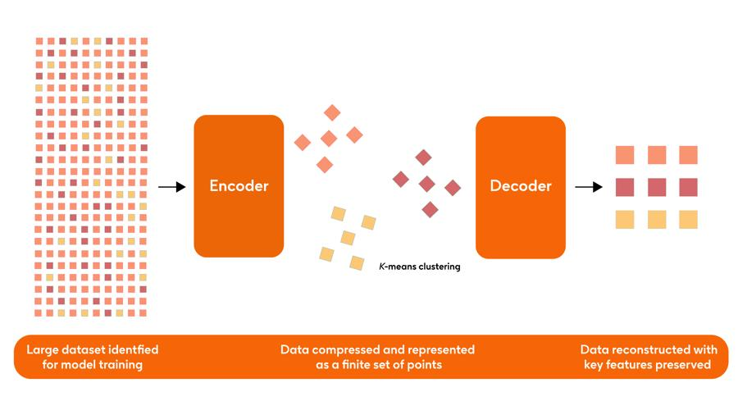

3. Width and Depth of Neural Networks – Activation Functions

Problem
A facial recognition system performs poorly when trained using a shallow neural network.
Recommended Changes
- Increase the depth of the network.
  - Add more hidden layers.
  - Deeper networks learn complex facial features.
- Use better activation functions.
  - Replace Sigmoid with ReLU.
  - ReLU reduces the vanishing gradient problem.
  - Use Softmax in the output layer for classification.
Result
- Better feature extraction.
- Higher recognition accuracy.
- Faster training.
- Improved performance on complex images.

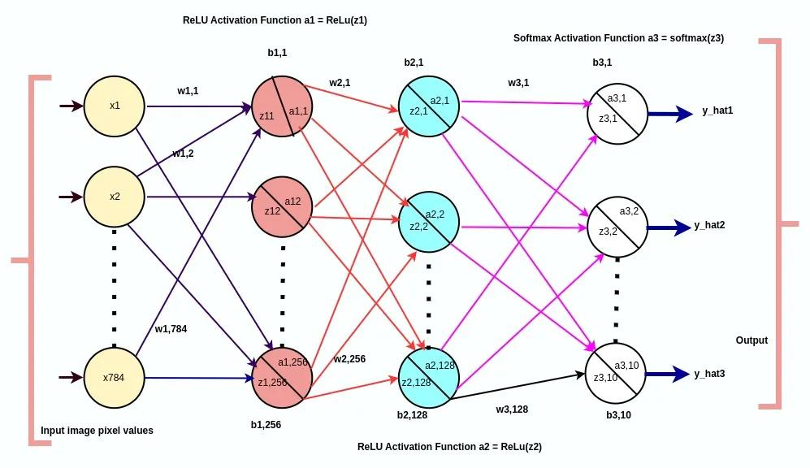

4. Restricted Boltzmann Machines (RBMs) – Unsupervised Learning

Problem
A streaming service wants to recommend movies based on users' viewing history without labeled data.
Solution
Use a Restricted Boltzmann Machine (RBM).
Explanation
- RBM learns hidden relationships between users and movies.
- It discovers viewing patterns without labeled data.
- Movies watched together are learned automatically.
Workflow
- Input user-movie viewing history.
- Visible layer represents users' watched movies.
- Hidden layer learns user preferences.
- RBM identifies similar viewing patterns.
- Recommend movies that match the learned preferences.
Advantages
- No labeled data required.
- Learns hidden user interests.
- Improves recommendation quality.

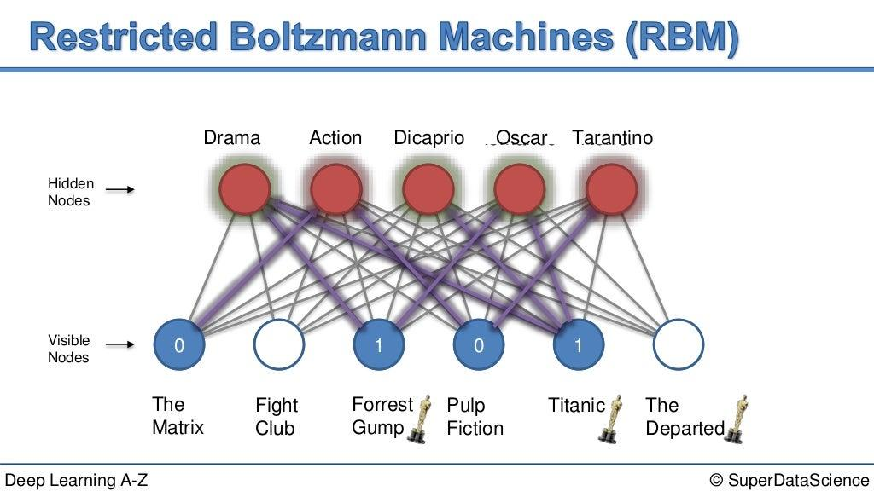

5. Deep Learning Applications – Representation Learning

Problem
A manufacturing company wants to detect defective products from sensor readings collected every second.
Deep Learning Solution
Use a Neural Network with Representation Learning (Autoencoder).
Working
- Collect sensor readings continuously.
- Train an autoencoder using normal product data.
- Encoder learns important sensor features.
- Decoder reconstructs the sensor data.
- Calculate reconstruction error.
- High reconstruction error indicates a defective product.
Advantages
- Detects defects automatically.
- Works with large sensor datasets.
- Reduces manual inspection.
- Improves product quality.
- Provides real-time monitoring.

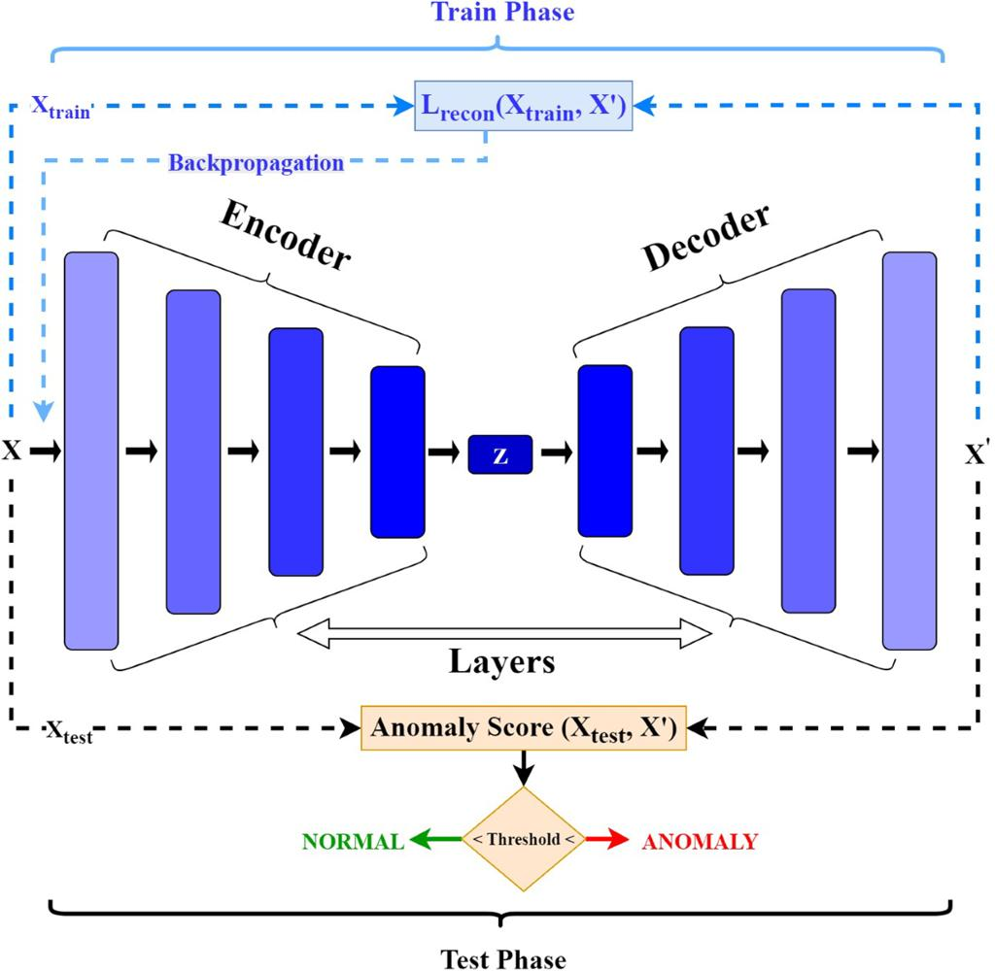

RUBRICS FOR CALCULATION:

Criteria | Weightag e | Level 4 – Exemplary | Level 3 – Proficient | Level 2 – Developing | Level 1 – Beginning
Concept Identification | 25% | Identifies all key concepts from literature accurately and comprehensively | Identifies most key concepts with minor omissions | Identifies limited concepts; some are irrelevant or missing | Fails to identify essential concepts

Linkages | 25% | Establishes clear, meaningful, and accurate relationships between concepts | Shows correct relationships with minor gaps | Relationships are weak, unclear, or partially incorrect | No meaningful relationships established
Organization | 20% | Concepts are well-structured  hierarchically with logical flow and grouping | Mostly organized with minor structural issues | Some organization but lacks clear hierarchy | No logical organization or structure
Integration of Literature | 20% | Integrates multiple studies effectively to show connections and comparisons | Shows some integration of literature | Limited integration; mostly isolated concepts | No integration of literature evidence
Clarity | 10% | Concept map is clear, neat, visually structured, and easy to interpret | Generally clear with minor readability issues | Clarity is reduced; difficult to interpret in parts | Poorly presented and hard to understand

