24SDCS02E – FSAD WORKBOOK
Name: AKHIL BELLANA

Id:2400030433

DEPARTMENT OF CSE, CS&IT, AI&DS
COURSE CODE: 24SDCS02E
FULL STACK APPLICATION DEVELOPMENT
Date of the Session: 1-1-2026
#SKILL - 1 ➔
Git Version Control
Prerequisites:
• Basic knowledge of Git commands
• Ability to create and edit project files
• Understanding of version control basics
The development team wants to manage their project using Git to maintain a structured and
collaborative workflow. In this lab, you will simulate a real-world version control process: creating
project files, tracking and committing changes, using GitHub as remote storage, working with multiple
branches, and handling merge conflicts. This helps you understand how developers work together
efficiently in software projects.
Tasks:
1. Create a new project folder, initialize Git using git init, and configure Git with your
username and email.
2. Create two files (example: main.java, notes.txt) with sample content, check the repository
status, and add them to staging.
3. Commit the staged files with a meaningful commit message.
4. Create a new repository on GitHub, connect your local repo using the remote URL and push
the committed changes.
5. Create the first branch (example: feature-update), make modifications, and add + commit
the changes.
6. Create a second branch (example: bug-fix), apply changes, and add + commit them.
7. Switch back to the main branch and merge both branches one after the other.
8. If any merge conflict occurs, resolve it manually, commit the fix, and complete the merge.

CODES:
Main.java:
class Main {
public static void main(String[] args) {
System.out.println("Bug fixed");
}
}

notes.txt:
Git Version Control Lab

Outputs:

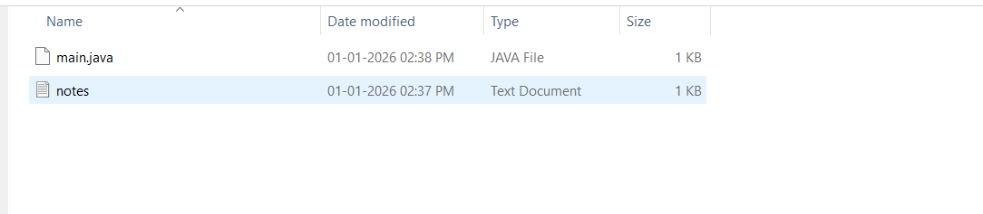

Github repo:

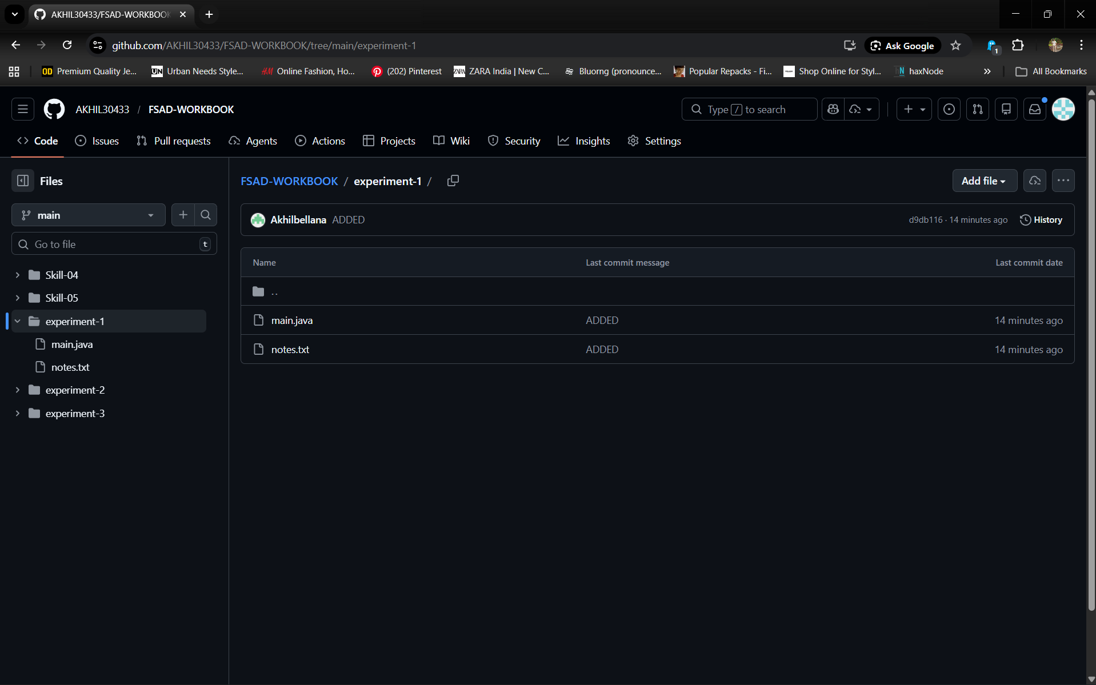
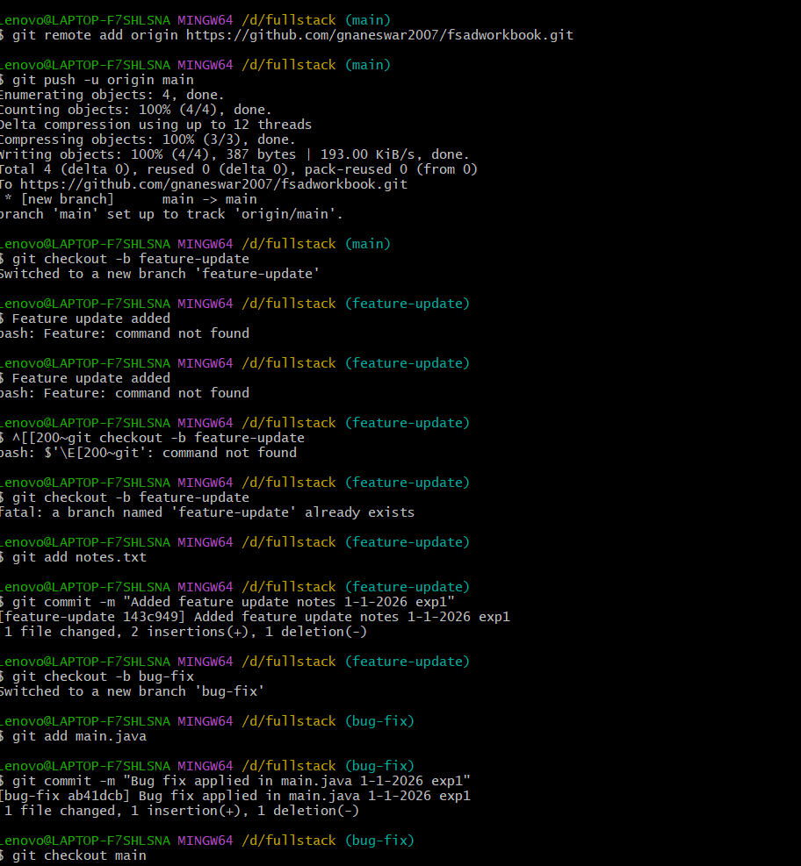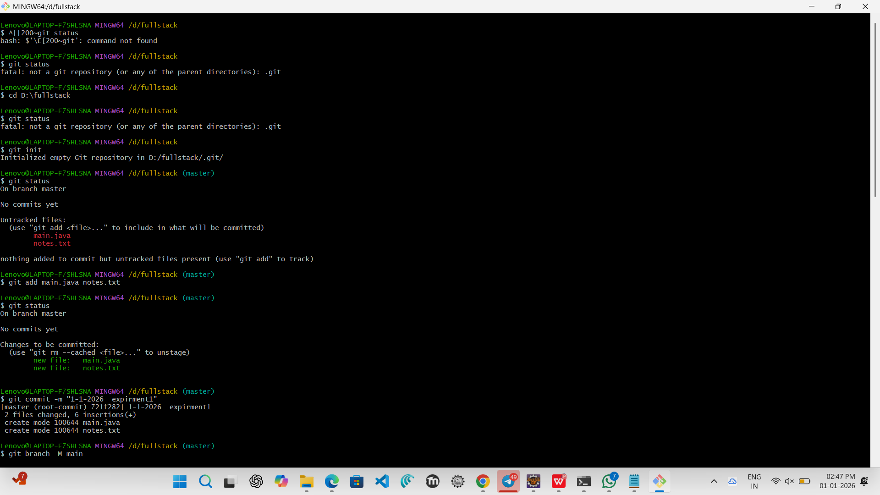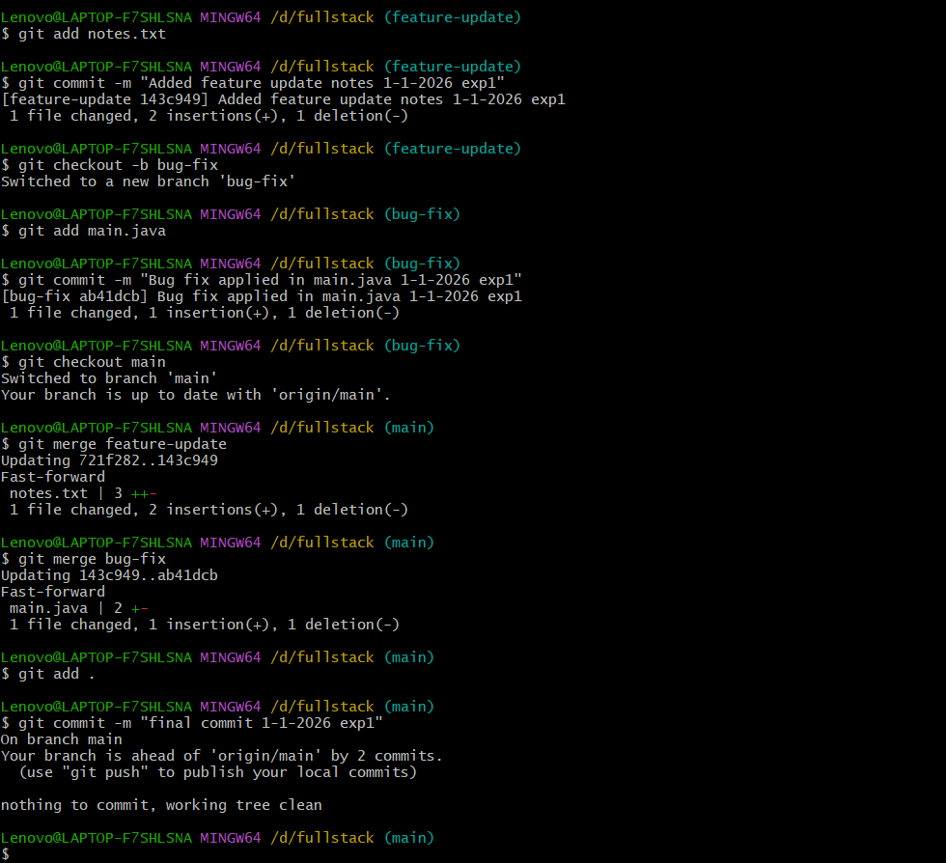

VIVA QUESTIONS:

- Why is Git used in development?

- Git is used to track changes in source code and manage versions of a project.
It helps developers collaborate safely, revert mistakes, and work on features in parallel using branches.

- What information is stored in Git configuration?

- Git configuration stores user details (username, email), default editor, and repository settings.
These settings control how Git behaves for the user, system, or a specific project.

- What is Maven and why is it used?
• Maven is a project management and build automation tool mainly used for Java applications.
• It helps developers compile source code, manage external libraries (dependencies), run tests, and generate deployable files automatically.

- What is the role of the POM.xml file?
• pom.xml (Project Object Model) file is the central configuration file in a Maven project.
• It contains information such as project name, version, dependencies, plugins, and build settings.
- Explain Maven Build Life Cycle.

• The Maven build life cycle is a well-defined series of steps that Maven follows to build and manage a project.
• Each phase performs a specific task in order, starting from checking the project structure to deploying the final output.

