24SDCS02E – FSAD WORKBOOK
NAME:BELLANA AKHIL
STUDENT ID:2400030433
DEPARTMENT OF CSE, CS&IT, AI&DS
COURSE CODE: 24SDCS02E FULL STACK APPLICATION DEVELOPMENT
Date of the Session:6-01-2026
#SKILL - 2 ➔ Hibernate CRUD Operations
Prerequisites:
• Basic knowledge of Java
• Understanding of classes, objects, and OOP
• Familiarity with SQL basics
A retail inventory system needs to store product details such as productId, name, description, price,
and quantity. The admin should be able to add new products, retrieve product information, update
price or quantity, and delete discontinued products.
Your task is to implement complete CRUD operations using Hibernate with proper entity mapping
using JPA annotations.
1. Create a Product entity with fields: id (primary key), name, description, price, quantity.
2. Configure Hibernate and map the Product entity to a table using JPA annotations.
3. Insert multiple Product records into the database.
4. Retrieve a product using its id.
5. Update the price or quantity of any selected product.
6. Delete a product record by id if it is discontinued.
7. Note:
a. Implement Hibernate ID generation strategies (AUTO, IDENTITY, SEQUENCE)
inside the entity to observe how primary key values differ.
b. The ID can be manual or auto generated, based on your chosen strategy.
8. Push the Hibernate project into a single GitHub repository.

Structure:

Codes:
ProductApp.java
package app;

import entity.Product;
import org.hibernate.Session;
import org.hibernate.Transaction;
import util.HibernateUtil;

public class ProductApp {

public static void main(String[] args) {

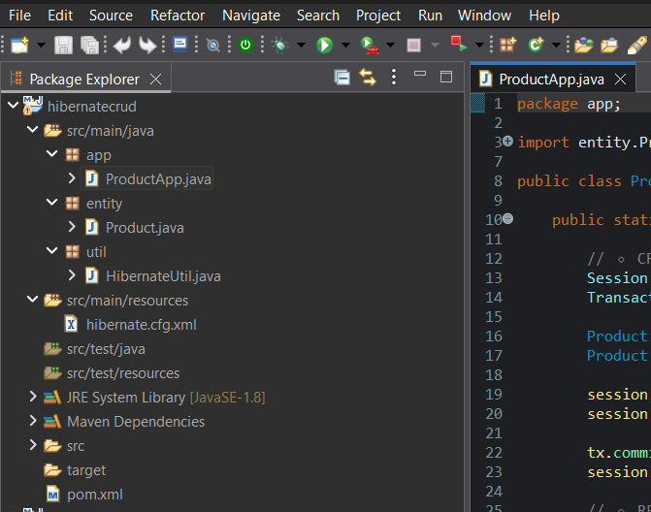
// 🔹 CREATE
Session session = HibernateUtil.getSessionFactory().openSession();
Transaction tx = session.beginTransaction();

Product p1 = new Product("Laptop", "Gaming Laptop", 75000, 10);
Product p2 = new Product("Mouse", "Wireless Mouse", 1200, 50);

session.save(p1);
session.save(p2);

tx.commit();
session.close();

// 🔹 READ
session = HibernateUtil.getSessionFactory().openSession();
Product product = session.get(Product.class, 1);
System.out.println("Product Name: " + product.getName());
session.close();

// 🔹 UPDATE
session = HibernateUtil.getSessionFactory().openSession();
tx = session.beginTransaction();

product = session.get(Product.class, 1);
product.setPrice(70000);
product.setQuantity(8);

session.update(product);
tx.commit();
session.close();

// 🔹 DELETE
session = HibernateUtil.getSessionFactory().openSession();
tx = session.beginTransaction();

Product deleteProduct = session.get(Product.class, 2);
session.delete(deleteProduct);

tx.commit();
session.close();

System.out.println("CRUD operations completed successfully.");
}
}

Product.java:
package entity;

import javax.persistence.*;

@Entity
@Table(name = "product")
public class Product {

@Id
// 🔁 Change strategy to AUTO / IDENTITY / SEQUENCE to observe difference
@GeneratedValue(strategy = GenerationType.IDENTITY)
private int id;

private String name;
private String description;
private double price;
private int quantity;

// Constructors
public Product() {}

public Product(String name, String description, double price, int quantity) {
this.name = name;
this.description = description;
this.price = price;
this.quantity = quantity;
}

// Getters & Setters
public int getId() { return id; }

public String getName() { return name; }
public void setName(String name) { this.name = name; }

public String getDescription() { return description; }
public void setDescription(String description) { this.description = description; }

public double getPrice() { return price; }
public void setPrice(double price) { this.price = price; }

public int getQuantity() { return quantity; }
public void setQuantity(int quantity) { this.quantity = quantity; }
}

HibernateUtil.java:
package util;

import org.hibernate.SessionFactory;
import org.hibernate.cfg.Configuration;

public class HibernateUtil {

private static SessionFactory factory;

static {
factory = new Configuration()
.configure("hibernate.cfg.xml")
.buildSessionFactory();
}

public static SessionFactory getSessionFactory() {
return factory;
}
}

Hibernate.cfg,xml:
<hibernate-configuration>
<session-factory>

<property name="hibernate.connection.driver_class">
com.mysql.cj.jdbc.Driver
</property>

<property name="hibernate.connection.url">
jdbc:mysql://localhost:3306/db1
</property>

<property name="hibernate.connection.username">root</property>
<property name="hibernate.connection.password">Mahesh@31164</property>

<property name="hibernate.dialect">
org.hibernate.dialect.MySQL8Dialect
</property>

<property name="hibernate.hbm2ddl.auto">update</property>
<property name="hibernate.show_sql">true</property>

<mapping class="entity.Product"/>

</session-factory>
</hibernate-configuration>

pom.xml:
<project xmlns="http://maven.apache.org/POM/4.0.0" xmlns:xsi="http://www.w3.org/2001/XMLSchema-instance" xsi:schemaLocation="http://maven.apache.org/POM/4.0.0 http://maven.apache.org/xsd/maven-4.0.0.xsd">
<modelVersion>4.0.0</modelVersion>
<groupId>org.hibernate</groupId>
<artifactId>hibernatecrud</artifactId>
<version>0.0.1-SNAPSHOT</version>
<dependencies>
<!-- Hibernate Core -->
<dependency>
<groupId>org.hibernate</groupId>
<artifactId>hibernate-core</artifactId>
<version>5.6.15.Final</version>
</dependency>

<!-- MySQL Connector -->
<dependency>
<groupId>mysql</groupId>
<artifactId>mysql-connector-java</artifactId>
<version>8.0.33</version>
</dependency>

<!-- JPA API -->
<dependency>
<groupId>javax.persistence</groupId>
<artifactId>javax.persistence-api</artifactId>
<version>2.2</version>
</dependency>
</dependencies>
</project>

OutPut: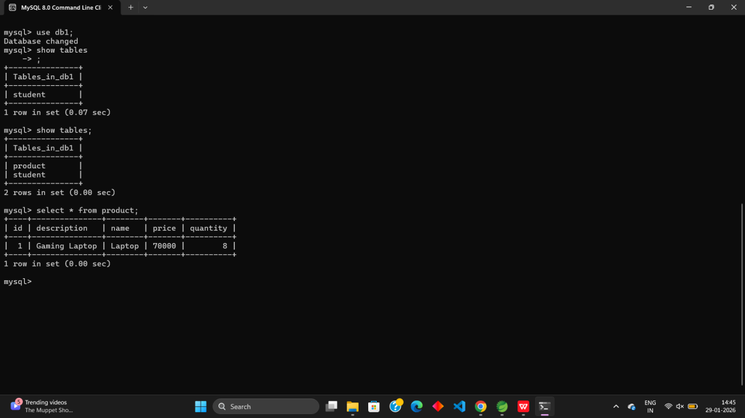

VIVA-VOCE:

- What is ORM and why is it used in application development?
Ans: ORM (Object Relational Mapping) is a technique that allows developers to map Java objects to database tables and vice versa.

Why ORM is used:
- Eliminates writing complex SQL queries
- Enables database-independent code
2. Which annotation is used to mark a class as a JPA entity?
Ans: @Entity
3. Why must every Hibernate entity have a primary key?
Ans: Every Hibernate entity must have a primary key because:
· Hibernate uses it to uniquely identify each object
· Required for CRUD operations
4. How do you update an existing record using Hibernate?
Ans: Method 1: Update using update()
- Student s = session.get(Student.class, 1);
- s.setName("Updated Name");
- session.update(s);
Method 2: Update using merge()
session.merge(studentObject);

- What is the difference between get() and load() in Hibernate?
Ans:
Feature | get() | Load()
Data base hit | Actual object | Proxy object
Use case | When data may not exist | When data is sure to exist

