**TASK 1**

**Java and Jenkins Version**

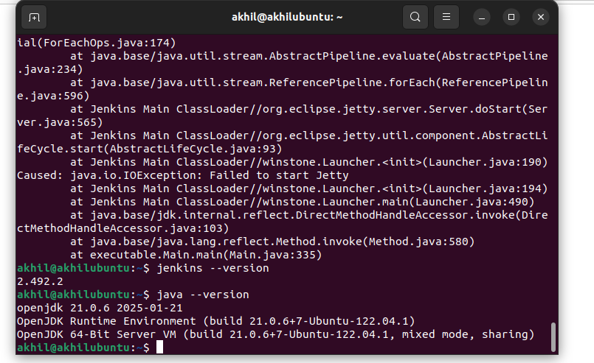

**Jenkins opened on port 8080**

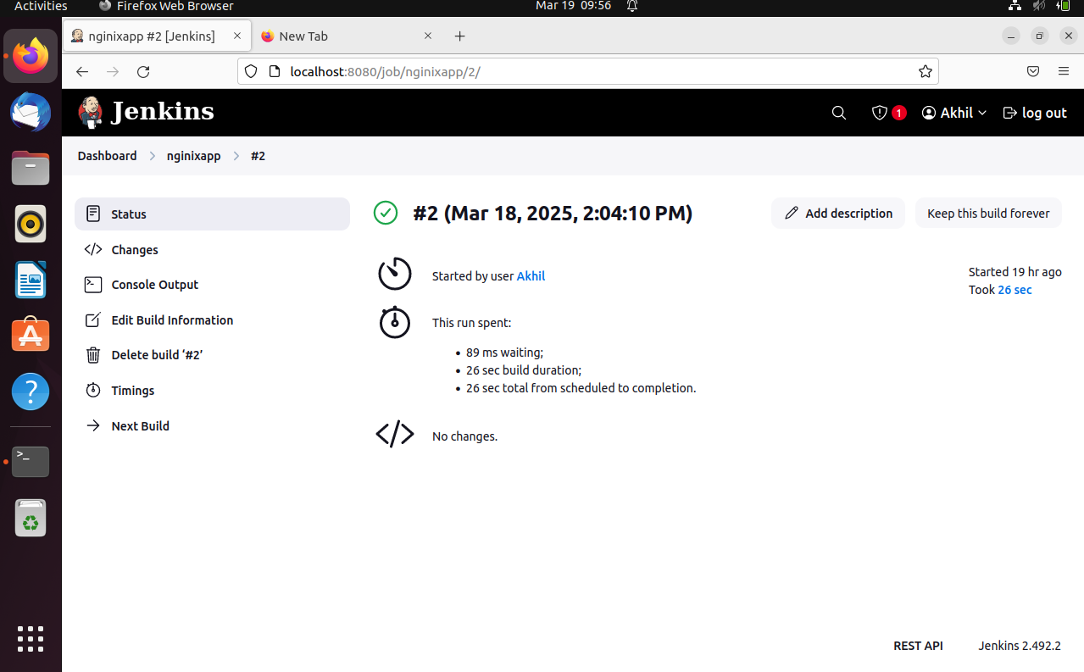

**Docker version checking and starting docker**

