**DAY-3**

**LOCALHOST:**

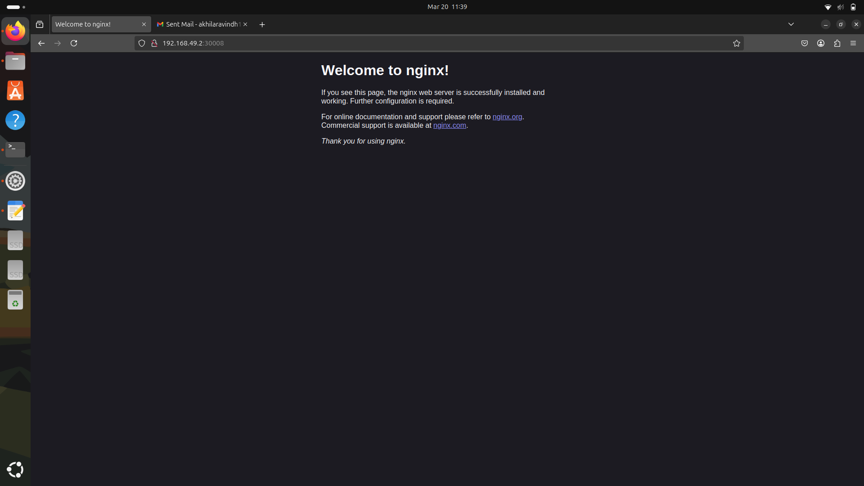

**PORTSCRIPT:**

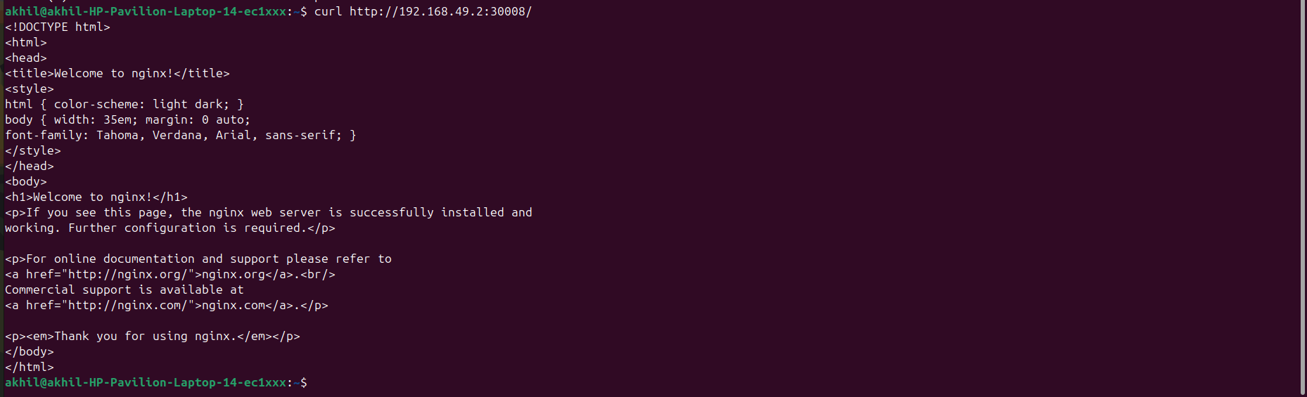

**CREATING FILE:**

