**DAY-5**

**PROJECT STATUS:**

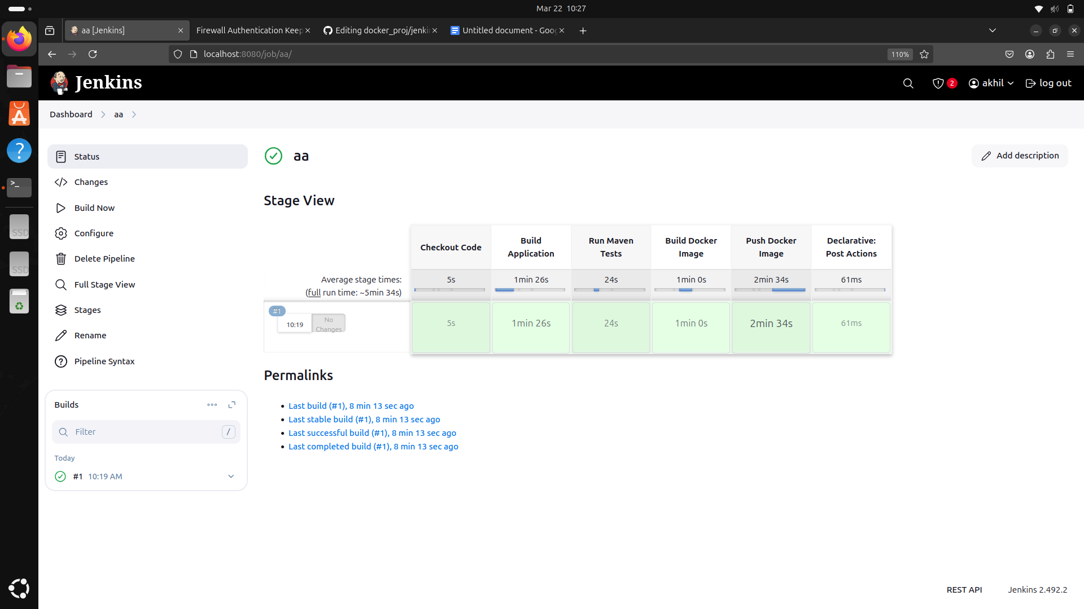

COMPLETED BUILDING: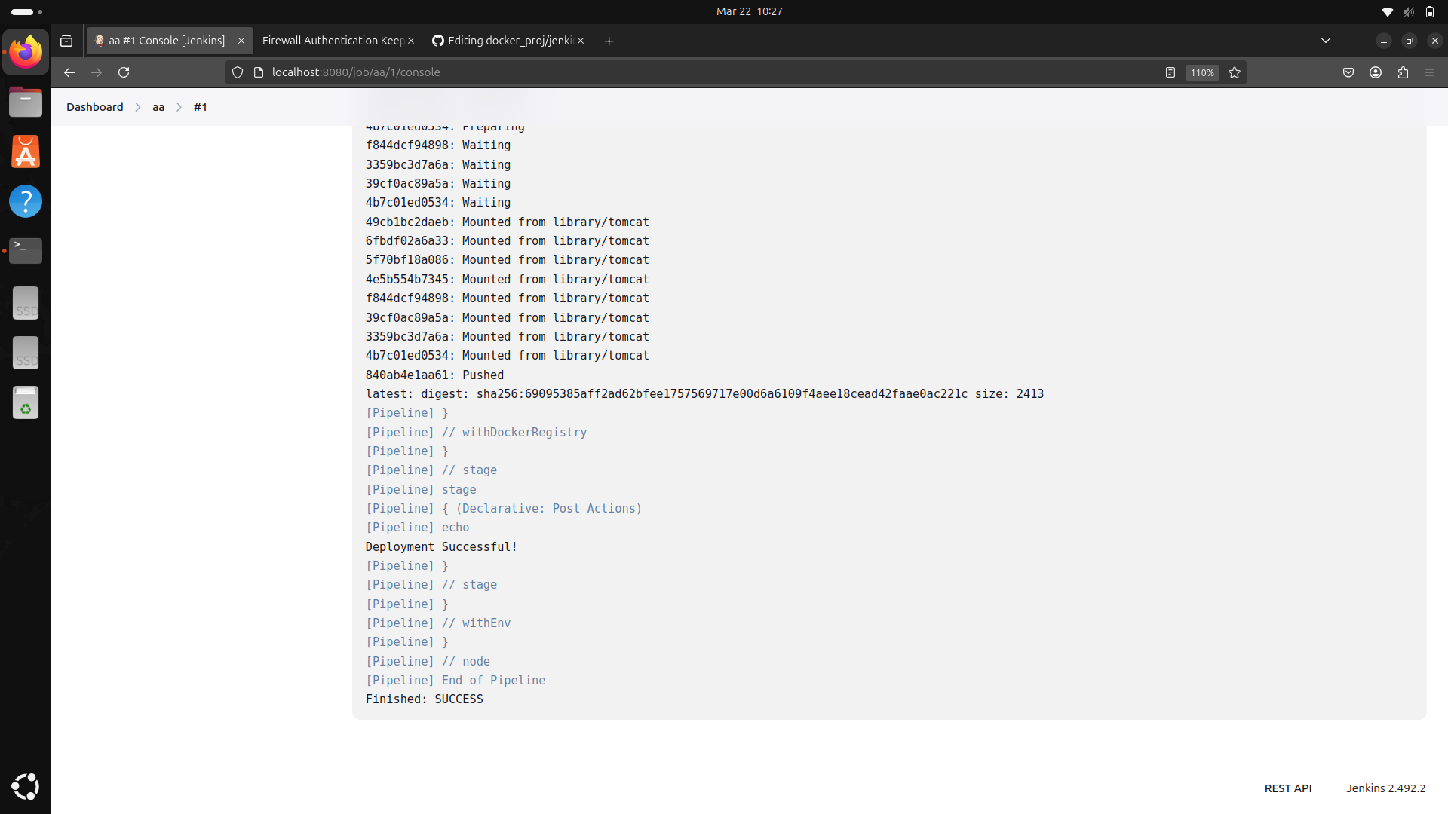

**OUTPUT IN PORT:**

