KPR INSTITUTE OF ENGINEERING AND TECHNOLOGY
Department of Artificial Intelligence and Data Science
ASSIGNMENT II
EXPLORATORY DATA ANALYSIS AND VISUALIZATION
Credit Card Default Prediction Using EDA, Visualization and Deep Learning
Detail | Information
Course code and title | U21ADP05 — Exploratory Data Analysis and Visualization
Name | AKHILASH S
Roll number | 24AD008
Department | Artificial Intelligence and Data Science
Year / Semester | III-YR/V Semester
Academic year | 2026–2027 (Odd Semester)
Submission date | 15 October 2026

Abstract
This project applies exploratory data analysis, statistical analysis, visualization and deep learning to the UCI Default of Credit Card Clients dataset, which describes 30,000 bank customers through 23 features and a target showing whether a customer defaults on the next payment. Preprocessing removed 35 duplicate rows, merged undocumented category codes, reduced the skew of money columns with a signed-log transform and added six behavioural features. Nineteen visualizations, distribution fitting and hypothesis tests show that repayment behaviour, not demographics, drives default. A PyTorch multilayer perceptron, tuned over twelve configurations, reached a test ROC-AUC of 0.785, slightly above logistic regression and random forest baselines. Recall for defaulters was 54.6 %, so further work is needed to identify more risky customers.
Keywords: exploratory data analysis, credit default, data visualization, probability distributions, multilayer perceptron, PyTorch, permutation importance.

Report Organization
1. Introduction and Objectives
2. Dataset Description
3. EDA and Preprocessing
4. Data Visualization (statistical and distribution-based analysis)
5. Deep Learning Model
6. Result Visualization and Interpretation
7. Conclusion and Future Scope
8. Literature Review
9. References
Appendix A. Code Section

1. Introduction and Objectives

1.1 Introduction
Credit-card issuers lend money without collateral, so every customer who fails to pay a monthly bill becomes a direct financial loss. Banks therefore try to estimate, from a customer’s past behaviour, who is likely to default next month. These estimates support credit-limit decisions, early-warning calls and collection planning. The data used here was collected from a Taiwanese card issuer between April and September 2005 and was published by Yeh and Lien [1] in the context of the card-debt problems of that period.

1.2 Problem Statement
Given a customer’s credit limit, demographics and six months of repayment status, bill amounts and payment amounts, predict whether the customer will default on the next monthly payment, and explain which factors are associated with default.

1.3 Aim
To apply data visualization, statistical analysis, exploratory data analysis and a deep learning model to a real-world financial dataset and to derive meaningful, evidence-based insights.

1.4 Objectives
- Inspect the dataset structure, fields, data types and descriptive statistics.
- Handle missing values, duplicates, invalid category codes and outliers; engineer informative features.
- Perform univariate, bivariate and multivariate analysis, including fitting continuous and discrete probability distributions and hypothesis tests.
- Create at least five (here nineteen) well-labelled visualizations, each with its purpose and interpretation, covering all seven stages of the visualization pipeline.
- Encode and scale the data and split it into stratified training, validation and test sets without leakage.
- Build, tune and evaluate a deep learning model (MLP) with loss/accuracy curves, confusion matrix, ROC/AUC and feature importance, and compare it with simple baselines.
- Summarise findings, limitations and future scope.

2. Dataset Description
The project uses the Default of Credit Card Clients dataset from the UCI Machine Learning Repository [1], [2]. Each row is one credit-card customer.
Item | Description
Dataset name | Default of Credit Card Clients
Source | UCI Machine Learning Repository – https://archive.ics.uci.edu/dataset/350/default+of+credit+card+clients
Rows / records | 30,000 (29,965 after removing 35 duplicates)
Columns / fields | 25 in the file: ID + 23 input features + target (24 usable columns after dropping ID)
Target variable | default payment next month (renamed DEFAULT): 1 = default, 0 = pays
Task | Binary classification (imbalanced: 22.1 % default)
Data type | Structured / tabular, numerical and categorical-coded fields
Period / region | April–September 2005, Taiwan; amounts in New Taiwan dollars (NT$)

2.1 Fields
Group | Fields | Meaning
Credit limit | LIMIT_BAL | Credit limit in NT$ (including family supplementary credit)
Demographics | SEX, EDUCATION, MARRIAGE, AGE | Gender (1 male, 2 female); education (1 graduate school … 4 other); marital status (1 married, 2 single, 3 other); age in years
Repayment status | PAY_1 … PAY_6 | Status for Sep → Apr 2005: −1 = paid duly, 1–9 = months of delay (−2 and 0 are used but undocumented)
Bill statements | BILL_AMT1 … BILL_AMT6 | Amount of bill statement for Sep → Apr 2005 (NT$)
Previous payments | PAY_AMT1 … PAY_AMT6 | Amount paid in Sep → Apr 2005 (NT$)
Target | DEFAULT | 1 = defaulted on the next monthly payment

The first repayment-status column is called PAY_0 in the source file; it was renamed PAY_1 for consistency. The ID column is only a row identifier and was excluded from all analysis and from the model.

2.2 Basic Statistics (raw data, n = 30,000)
Statistic | LIMIT_BAL | AGE | BILL_AMT1 | PAY_AMT1
Mean | 167,484 | 35.49 | 51,223 | 5,664
Std. deviation | 129,748 | 9.22 | 73,636 | 16,563
Minimum | 10,000 | 21 | −165,580 | 0
25th percentile | 50,000 | 28 | 3,559 | 1,000
Median | 140,000 | 34 | 22,382 | 2,100
75th percentile | 240,000 | 41 | 67,091 | 5,006
Maximum | 1,000,000 | 79 | 964,511 | 873,552
Skewness | 0.99 | 0.73 | 2.66 | 14.67

3. EDA and Preprocessing

3.1 Data Inspection
The data was loaded with Pandas and its shape, data types, summary statistics, missing values and duplicates were examined. All 24 columns are integers. The target is imbalanced: 6,636 of 30,000 customers (22.1 %) defaulted, so a classifier that always predicts “no default” would already be 77.9 % accurate. Accuracy alone is therefore not a sufficient evaluation metric.

3.2 Missing Values and Duplicates
There were no missing values. After dropping ID, 35 exact duplicate rows were found and removed, leaving 29,965 records.

3.3 Invalid and Undocumented Category Codes
EDUCATION contains the undocumented codes 0, 5 and 6 (345 rows) and MARRIAGE contains 0 (54 rows). These are not in the data dictionary, so they were merged into the existing Other category. PAY_x also contains the undocumented values -2 and 0, which are kept because they are frequent and behave like real states (no consumption / revolving credit).
Column | Before | After
EDUCATION | 0: 14, 1: 10,563, 2: 14,019, 3: 4,915, 4: 123, 5: 280, 6: 51 | 1: 10,563, 2: 14,019, 3: 4,915, 4 (other): 468
MARRIAGE | 0: 54, 1: 13,643, 2: 15,945, 3: 323 | 1: 13,643, 2: 15,945, 3 (other): 377

3.4 Outlier Detection and Treatment
Outliers were identified with the 1.5 × IQR rule. Every bill and payment column has roughly 8-10 % IQR outliers and extreme skew (PAY_AMT columns up to 30). These are genuine high-value customers, not data errors, so they are kept and handled with a signed-log transform in the preprocessing step. Deleting them would remove exactly the customers a bank cares about.
Column | Outliers | % of rows | Skewness
BILL_AMT1 | 2,386 | 7.96 | 2.66
BILL_AMT2 | 2,390 | 7.98 | 2.70
BILL_AMT3 | 2,469 | 8.24 | 3.09
BILL_AMT4 | 2,616 | 8.73 | 2.82
BILL_AMT5 | 2,724 | 9.09 | 2.87
BILL_AMT6 | 2,688 | 8.97 | 2.85
PAY_AMT1 | 2,742 | 9.15 | 14.66
PAY_AMT2 | 2,723 | 9.09 | 30.44
PAY_AMT3 | 2,596 | 8.66 | 17.21
PAY_AMT4 | 2,993 | 9.99 | 12.90
PAY_AMT5 | 2,944 | 9.82 | 11.12
PAY_AMT6 | 2,960 | 9.88 | 10.64
LIMIT_BAL | 167 | 0.56 | 0.99

3.5 Feature Engineering
Domain knowledge from credit-risk analysis was used to create six features. Credit-risk practice looks at how much of the limit is used (UTILIZATION), how much of the bill is actually repaid (PAY_RATIO) and how often/how badly the customer was late (N_DELAY, MAX_DELAY). They compress six months of columns into a few behavioural signals.
New feature | Definition | Interpretation
AVG_BILL | mean of BILL_AMT1–6 | typical monthly balance
AVG_PAY_AMT | mean of PAY_AMT1–6 | typical monthly repayment
UTILIZATION | BILL_AMT1 / LIMIT_BAL (clipped to −1–3) | share of the credit limit in use
PAY_RATIO | sum(PAY_AMT1–6) / sum(BILL_AMT1–5), clipped to 0–3 | share of billed money actually repaid
N_DELAY | number of months with PAY_x > 0 | how often the customer was late (0–6)
MAX_DELAY | max of PAY_1…PAY_6 | worst delay

3.6 Transformation, Encoding, Scaling and Data Split
- Signed-log transform sign(x)·log(1+|x|) on all bill, payment, average and limit columns (bills can be negative). The mean absolute skew of these columns fell from 8.8 to 1.5.
- One-hot encoding (drop-first) of the nominal columns SEX, EDUCATION and MARRIAGE.
- Standardization (z-score) of all numerical columns, including the ordinal PAY_x columns.
- Stratified split 70 / 15 / 15 with a fixed random seed (42).
- The ColumnTransformer was fitted on the training set only and then applied to validation and test sets, preventing preprocessing leakage.
Partition | Rows | Default rate | Purpose
Training set (70 %) | 20,975 | 22.1 % | Fit model parameters
Validation set (15 %) | 4,495 | 22.1 % | Select hyperparameters, early stopping, decision threshold
Test set (15 %) | 4,495 | 22.1 % | Final evaluation on unseen records

The 29 input features (23 original + 6 engineered) expand to 32 model inputs after one-hot encoding.

4. Data Visualization
Nineteen visualizations were created with Matplotlib, Seaborn and Plotly (the assignment requires at least five). Each is explained by what it shows, why it was created and the insights obtained. Because the data is numerical, the chosen chart types are histograms, boxplots, violin plots, bar charts, scatterplots, a correlation heatmap, a pairplot and heatmaps. All figures were exported at 150 dpi to the figures/ folder of the repository.

4.1 The Seven Stages of Visualization
Stage | Application in this project
1. Acquire | Download the dataset from the documented UCI source and store a CSV copy.
2. Parse | Load with Pandas, inspect shape, data types, data dictionary, rename PAY_0 and drop ID.
3. Filter | Remove duplicates, merge invalid category codes, detect outliers, engineer features.
4. Mine | Descriptive statistics, distribution fitting (AIC, KS), chi-square and Mann-Whitney tests, Spearman correlations.
5. Represent | Select histograms, boxplots, bar charts, violin plots, scatterplots, heatmaps and a pairplot according to the data type and question.
6. Refine | Titles, axis labels, legends, consistent colours (teal = paid, orange = default), log scales for skewed data, sampling to avoid overplotting.
7. Interact | A Plotly scatterplot with hover details, zoom and filtering (figures/13_interactive_scatter.html).

4.2 Univariate Analysis and Distribution Exploration
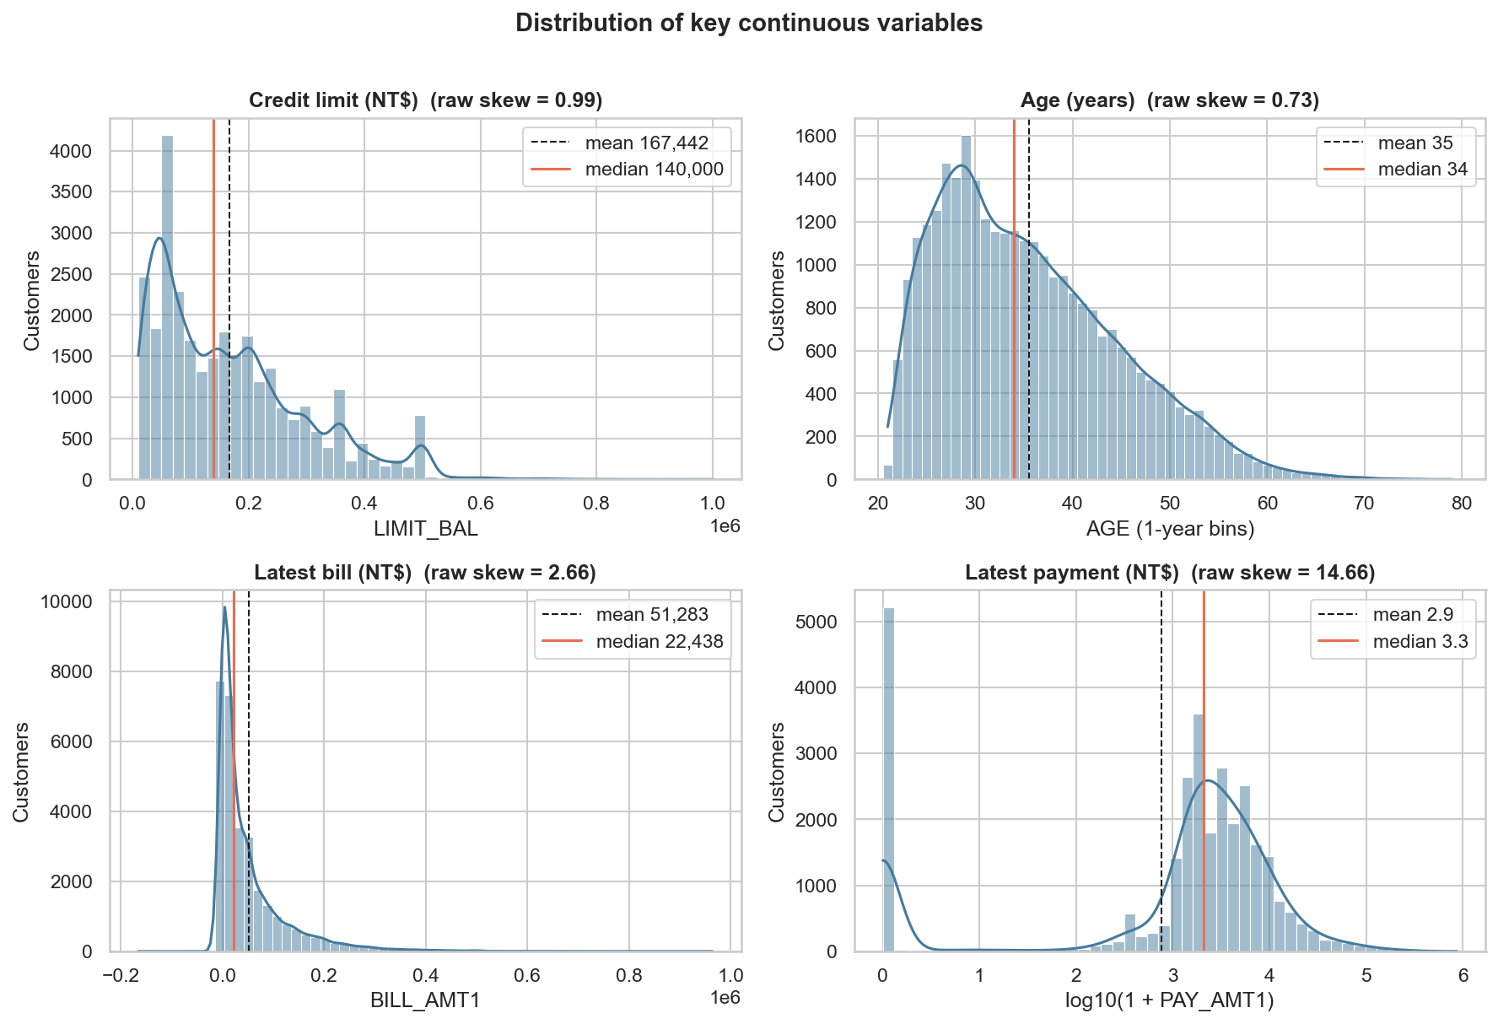
Figure 1. Histograms with KDE of credit limit, age, latest bill and latest payment (log scale).
What it shows: Distribution (histogram + KDE) of credit limit, age, latest bill and latest payment, with mean (dashed) and median (solid) lines.
Purpose: To see the shape, centre and skew of each continuous variable before choosing transformations.
Insights
- All four variables are right-skewed: mean (167,442) > median (140,000) for the credit limit, and mean 51,283 > median 22,438 for the bill. The payment is so skewed (raw skew 14.7) that it is drawn on a log10 scale; its raw median is only NT$2,102 against a mean of 5,670.
- Credit limits cluster on round numbers (a spike near NT$50,000 and a smaller one at NT$500,000), so they behave like a discrete, 'bucketed' variable.
- Most customers are young: the bulk of the age distribution lies between 25 and 45 (median 34).
- Heavy skew means linear/neural models would be dominated by a few huge values -> log transform + standardization is justified.
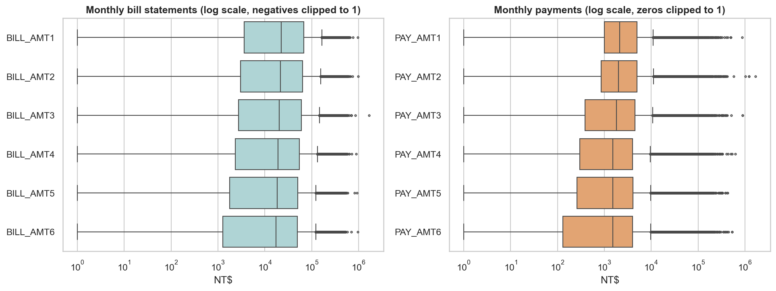
Figure 2. Boxplots of monthly bill statements and payments (log scale).
What it shows: Boxplots (log scale) of the six monthly bill statements and six monthly payments.
Purpose: To compare spread and detect outliers across months and to confirm that the problem is the same in every month.
Insights
- The six months look almost identical: median bill about NT$17-22k, median payment about NT$1.5-2.1k - a customer typically repays roughly a tenth of the bill.
- A dense cloud of high outliers (8-10 % of rows) appears on every month; payments reach NT$1-1.7 million.
- Bills can be negative (customer overpaid), which is why a signed log transform is used later.
- The payment boxes extend far down to ~NT$0: many customers pay nothing in a given month.
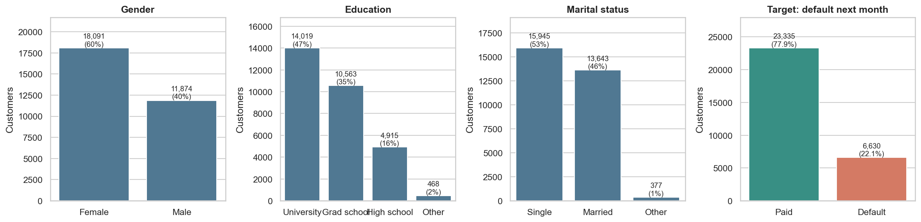
Figure 3. Counts and percentages of gender, education, marital status and the target.
What it shows: Bar charts with counts and percentages for gender, education, marital status and the target.
Purpose: To check category balance and whether the target is imbalanced (this decides the metrics to use).
Insights
- Roughly 60 % of customers are women; university (47 %) and graduate school (35 %) dominate education; about 53 % are single.
- The target is imbalanced: only 22.1 % defaulted. A model that always predicts 'pays' would already be 77.9 % accurate, so accuracy alone is misleading and we also use AUC, precision, recall and F1.

4.3 Discrete and Continuous Probability Distributions
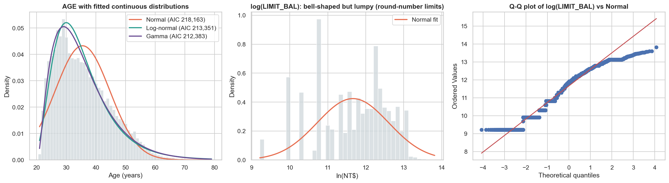
Figure 4. Continuous distribution fitting: AGE (Normal, Log-normal, Gamma) and the log-normality check of LIMIT_BAL.
Distribution fitted to AGE | AIC (lower is better) | KS statistic (lower is better)
Normal | 218,163.5 | 0.0943
Log-normal | 213,351.2 | 0.0509
Gamma (best) | 212,382.8 | 0.0461

What it shows: Left: AGE with fitted Normal, Log-normal and Gamma curves. Middle/right: histogram and Q-Q plot of log(LIMIT_BAL) against a Normal distribution.
Purpose: To identify the continuous probability distribution each variable follows (CO4) and test it with AIC and the KS statistic.
Insights
- Gamma is the best fit for AGE (lowest AIC 212,383 and KS 0.046), then Log-normal (AIC 213,351, KS 0.051); the Normal fit is clearly worst (AIC 218,163, KS 0.094) because age is right-skewed (skew 0.73) and bounded below at 21.
- Taking the log of LIMIT_BAL reduces the skew from +0.99 to -0.51 and gives a roughly bell-shaped histogram, so a log-normal is a reasonable first approximation.
- The Q-Q plot shows the approximation is not perfect: a hard floor at NT$10,000 and a cluster at the top (round-number limits) bend both tails away from the line. With 30,000 rows any formal test would reject exact normality, so we describe it as 'approximately log-normal'.
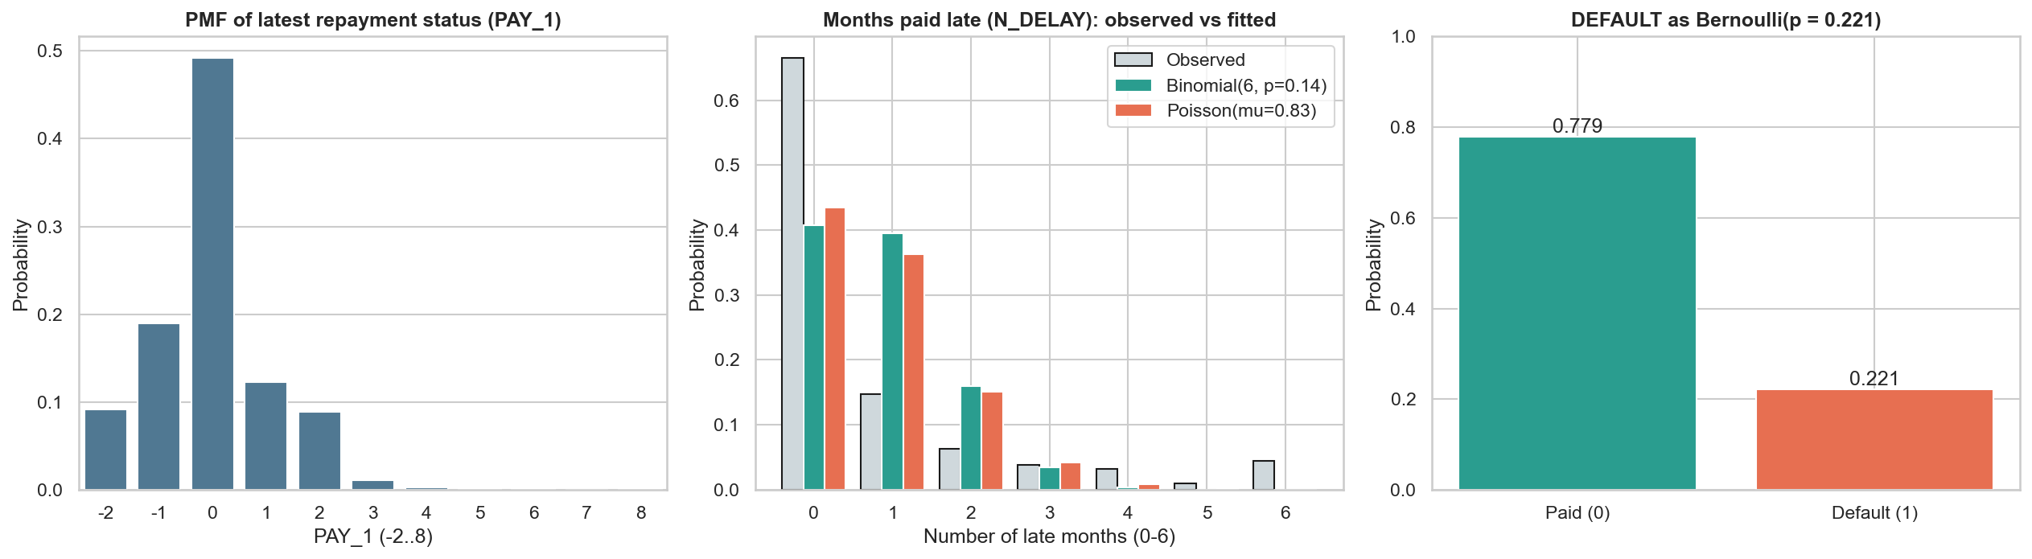
Figure 5. Discrete distributions: PAY_1 PMF, N_DELAY versus Binomial and Poisson, and DEFAULT as a Bernoulli variable.
What it shows: Left: probability mass function of the latest repayment status (PAY_1). Middle: observed number of late months (N_DELAY) vs fitted Binomial and Poisson. Right: the target as a Bernoulli variable.
Purpose: To study the discrete distributions in the data (CO4) and check whether textbook models describe them.
Insights
- PAY_1 is dominated by 0 (revolving credit, ~49 %), followed by -1 (paid duly, ~19 %), 1 (~12 %), -2 (~9 %) and 2 (~9 %); delays of 3+ months are rare (~1.5 %).
- N_DELAY has mean 0.83 but variance 2.42 (variance/mean = 2.9). Binomial would predict 0.86 and Poisson 1.0, so the data is strongly over-dispersed; neither model fits (total-variation distance 0.344 Binomial, 0.306 Poisson).
- Why: about two thirds of customers are never late (67 %), while ~4.5 % were late in all six months. The population is a mixture of two behaviours (reliable payers vs chronic late payers), which a single Binomial/Poisson cannot represent.
- DEFAULT is Bernoulli with p = 0.221.

4.4 Bivariate Analysis
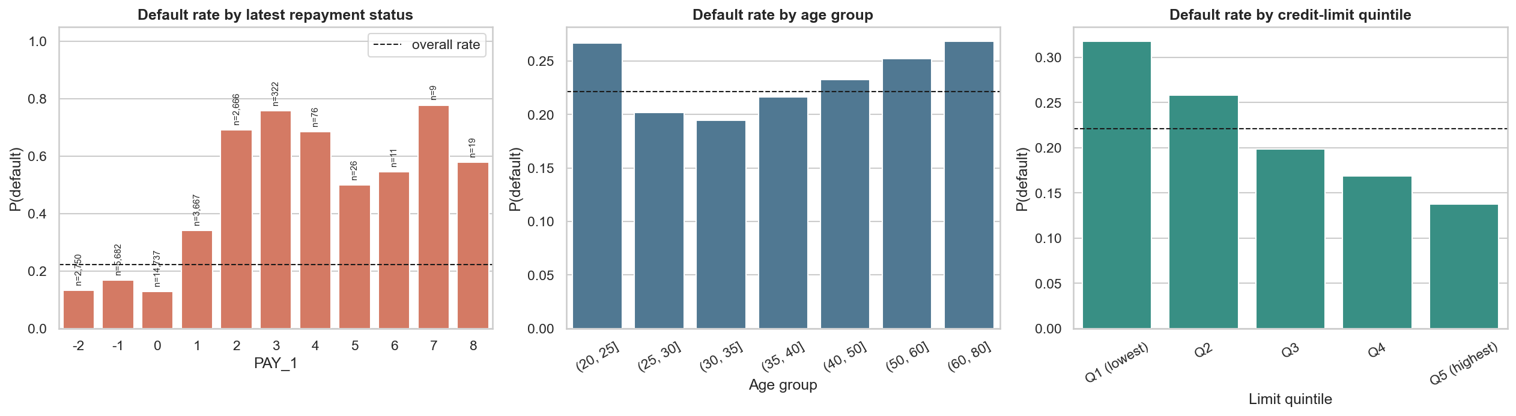
Figure 6. Default rate by latest repayment status, age group and credit-limit quintile.
What it shows: Default probability for each repayment-status value, each age group and each credit-limit quintile (dashed line = overall 22.1 %).
Purpose: Bivariate analysis of the three most promising drivers against the target.
Insights
- Repayment status is by far the strongest driver: customers who paid on time or used revolving credit (PAY_1 <= 0) default 13-17 % of the time, those one month late 34 %, two months late 69 % and three months late 76 %.
- Higher credit limit -> lower default: 31.7 % in the lowest limit quintile falling to 13.7 % in the highest (banks give high limits to reliable customers).
- Age has a U-shape: the youngest (20-25, 26.7 %) and oldest (60+, 26.8 %) default most, ages 30-35 least (19.4 %).
- Small groups (n shown above bars, e.g. PAY_1 = 5-8) give noisy rates, so conclusions are drawn mainly from groups with hundreds of customers.
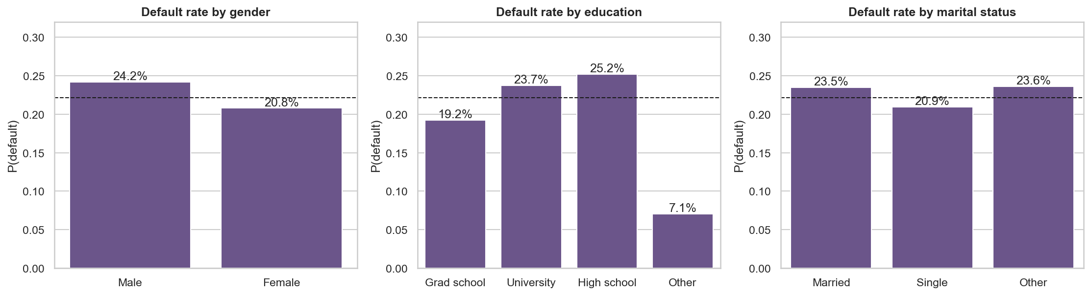
Figure 7. Default rate by gender, education and marital status.
Variable | Chi-square | dof | p-value | Cramér’s V
SEX | 47.1 | 1 | 6.64e-12 | 0.040
EDUCATION | 160.5 | 3 | 1.46e-34 | 0.073
MARRIAGE | 27.5 | 2 | 1.07e-06 | 0.030

What it shows: Default rate by gender, education and marital status, plus chi-square tests of independence with Cramer's V (effect size).
Purpose: To test whether demographic variables are associated with default.
Insights
- Differences are small: men 24.2 % vs women 20.8 %; high school 25.2 %, university 23.7 %, graduate school 19.2 %; single 20.9 % vs married 23.5 %.
- All three chi-square tests are statistically significant (p < 1e-5) because n is large, but Cramer's V is tiny (0.03-0.07), so the practical effect is weak. Education has the largest effect (V = 0.073).
- The 'Other' education bar (7.1 %) is mostly the merged undocumented codes and is a data-quality artefact, not a real group.
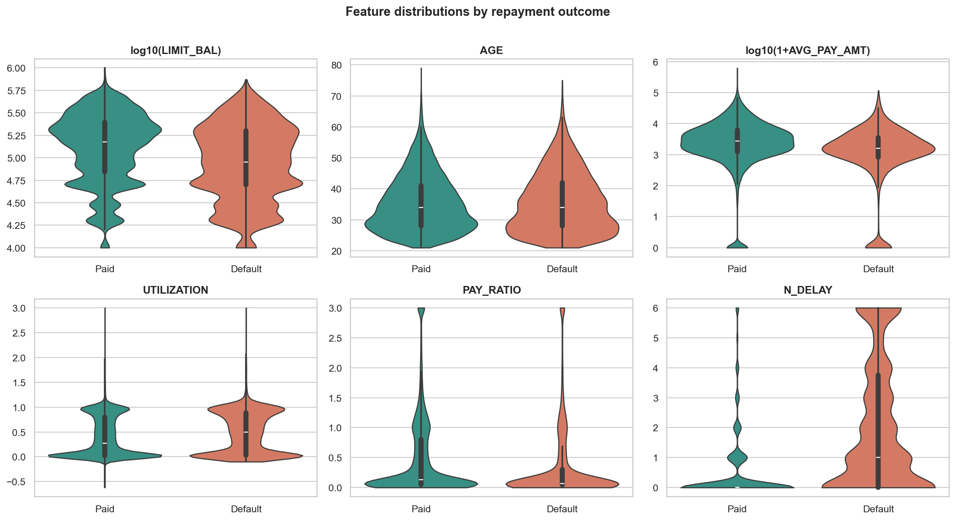
Figure 8. Violin and box plots of six numeric features split by repayment outcome.
Feature | Median (paid) | Median (default) | p-value | Rank-biserial effect
LIMIT_BAL | 150,000 | 90,000 | 6.15e-190 | 0.236
AGE | 34 | 34 | 0.404 | 0.007
AVG_BILL | 21,494 | 19,802 | 2.71e-06 | 0.038
AVG_PAY_AMT | 2,762 | 1,615 | 7.66e-201 | 0.243
UTILIZATION | 0.269 | 0.494 | 1.74e-36 | 0.101
PAY_RATIO | 0.130 | 0.067 | 1.92e-125 | 0.191
N_DELAY | 0 | 1 | 0.00 | 0.452

What it shows: Violin + box plots of six numeric features split by outcome, with Mann-Whitney U tests (median, p-value and rank-biserial effect size) for seven features.
Purpose: To see how the entire distribution - not just the mean - differs between customers who paid and those who defaulted.
Insights
- N_DELAY separates the groups best (effect size 0.45): paid customers almost always have 0 late months, defaulters have a median of 1 and a long tail up to 6.
- Defaulters have lower limits (median NT$90,000 vs 150,000, effect 0.24), repay less (median average payment NT$1,615 vs 2,762, effect 0.24) and use more of their limit (utilization 0.49 vs 0.27).
- AGE has no effect (medians equal at 34, p = 0.40) and AVG_BILL only a very small one (0.04): how big the bill is matters less than how much of it is repaid and when.
- Several violins are bimodal (e.g. utilization has peaks near 0 and near 1), hinting at distinct customer groups.
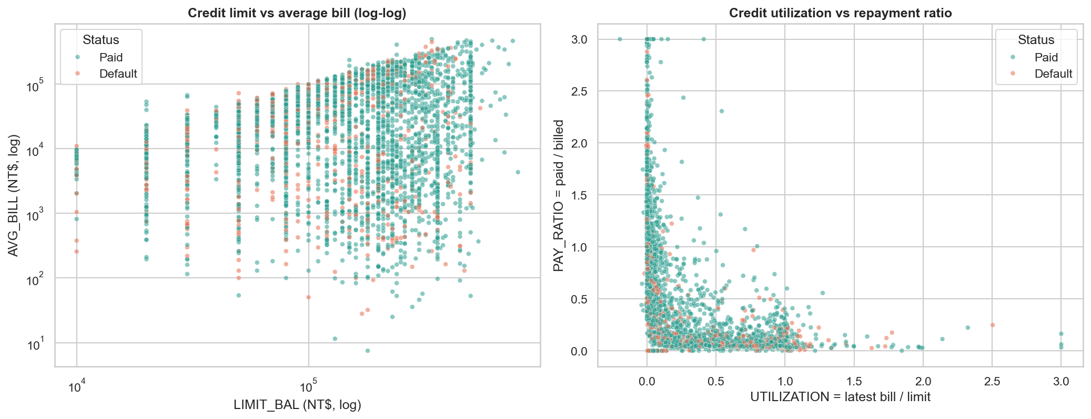
Figure 9. Scatterplots: credit limit vs average bill and utilization vs repayment ratio (4,000-customer sample).
What it shows: Left: credit limit vs average bill (both log axes). Right: credit utilization vs repayment ratio. Colour = outcome; random sample of 4,000 customers.
Purpose: To inspect the relationship between two continuous variables and where defaulters sit.
Insights
- The bill grows with the credit limit but is capped by it; vertical stripes are the round-number limits.
- Utilization and repayment ratio show a clear L-shaped inverse relationship (Spearman -0.6): customers who use little credit repay a large share, those who max out their limit repay almost nothing.
- Defaulters (orange) lean towards high utilization and low repayment but overlap heavily with paid customers, which warns that no single pair of variables will separate the classes cleanly.

4.5 Multivariate Analysis
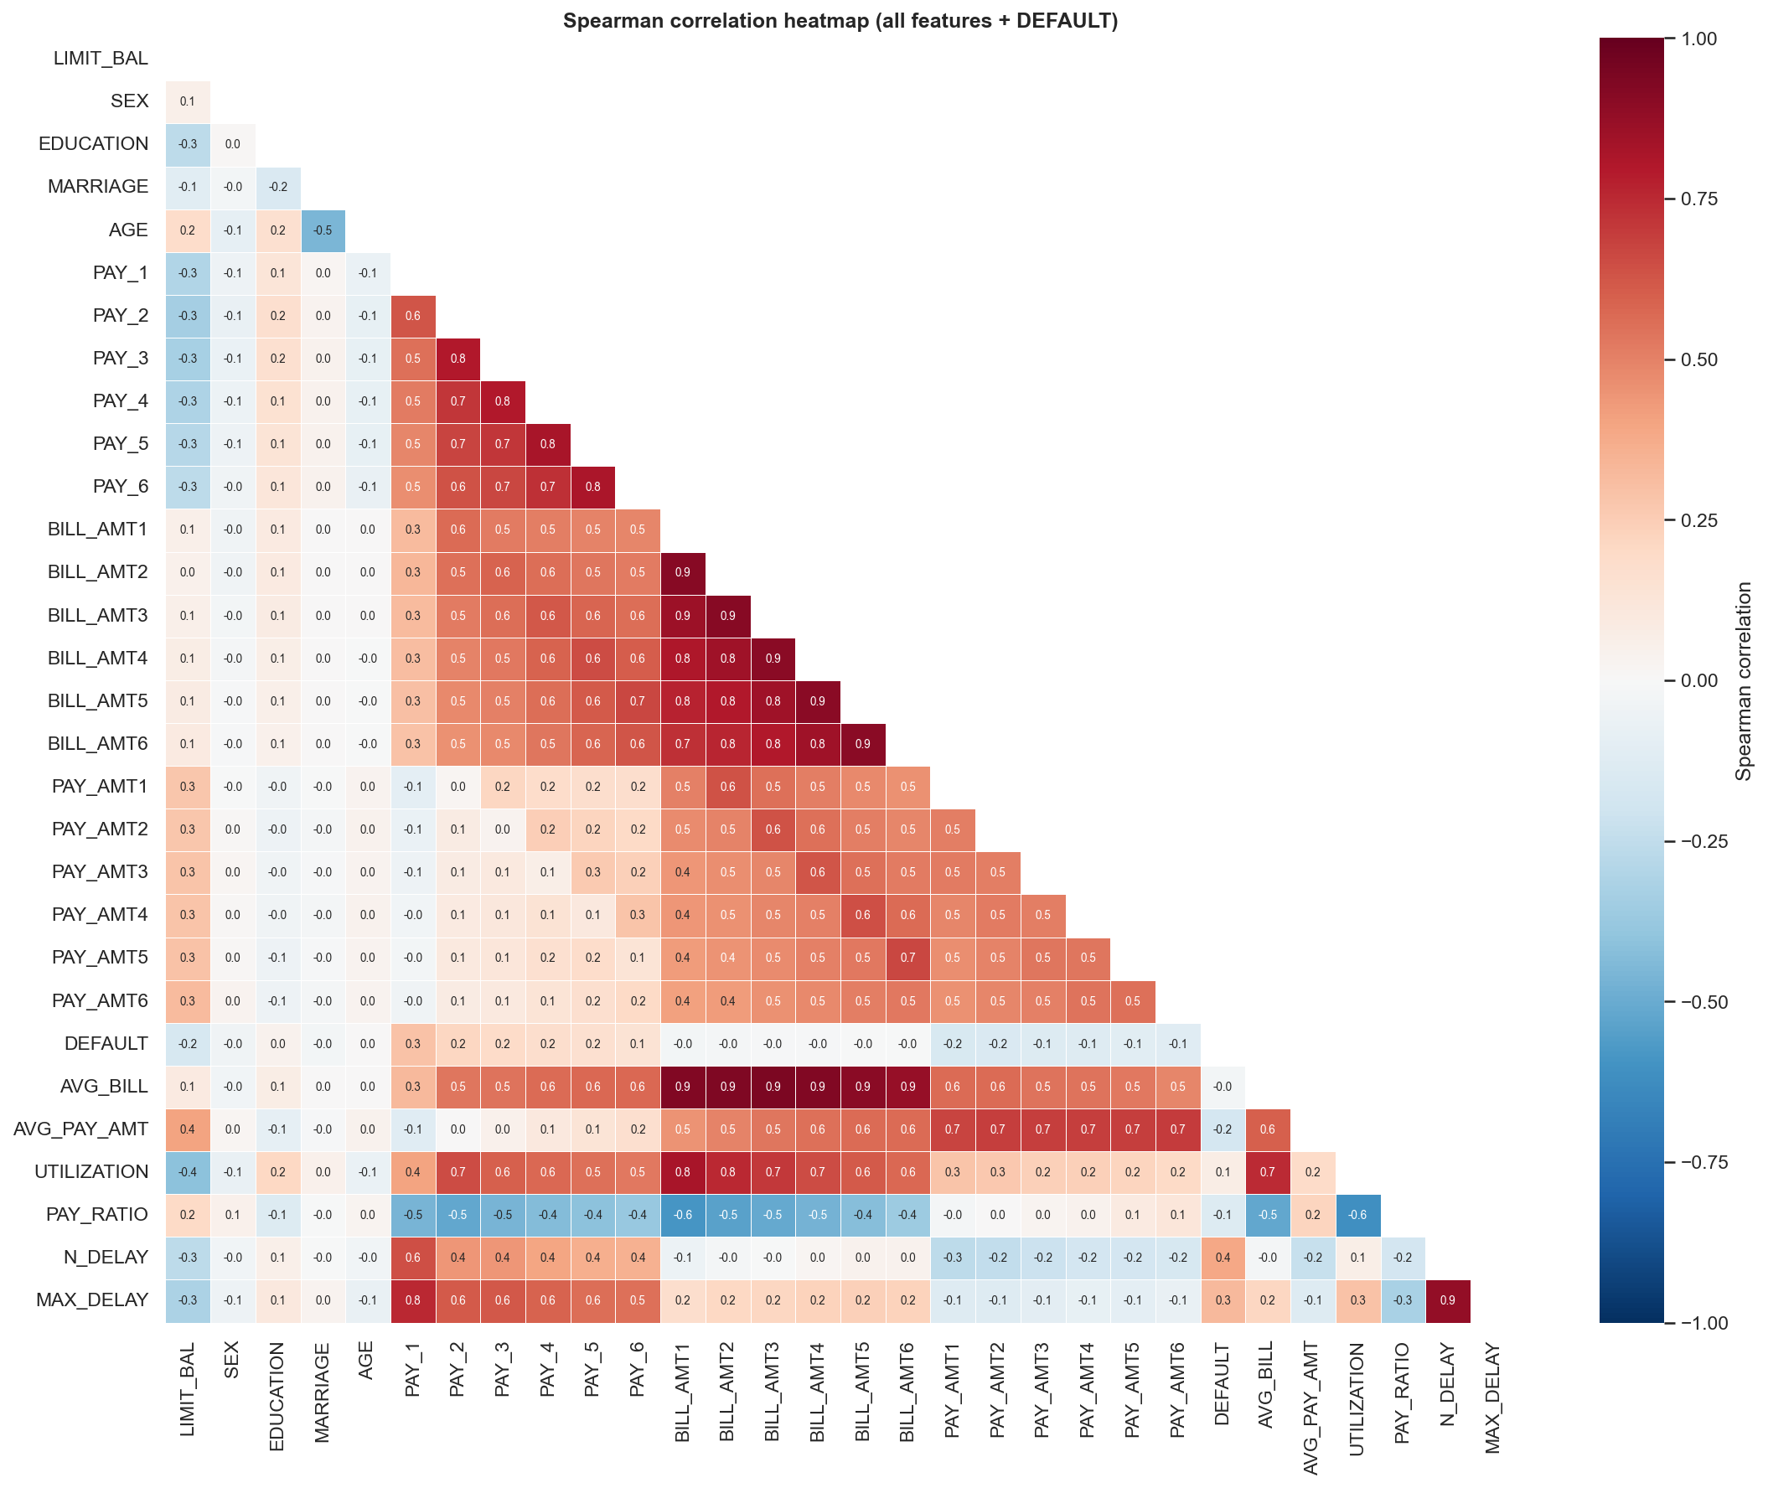
Figure 10. Spearman correlation heatmap of all numeric features and the target.
What it shows: Spearman correlation matrix of all numeric features and the target (lower triangle).
Purpose: Multivariate overview: which features move together and which relate to default. Spearman is used because the money columns are skewed.
Insights
- Strong multicollinearity: the six BILL_AMT columns correlate 0.7-0.9 with each other, PAY_1..PAY_6 form a chain of 0.5-0.8 and AVG_BILL is almost the same variable as the bills (0.9).
- Correlation with DEFAULT is highest for N_DELAY (0.39), MAX_DELAY (0.32), PAY_1 (0.29), PAY_2 (0.22); negative for AVG_PAY_AMT (-0.18), LIMIT_BAL (-0.17) and PAY_AMT1 (-0.16).
- The bill amounts have essentially zero correlation with default (about 0.0), even though they correlate strongly with everything else.
- Other structure: UTILIZATION vs PAY_RATIO = -0.6, MARRIAGE vs AGE = -0.5, EDUCATION vs LIMIT_BAL = -0.3. The collinearity is a reason to prefer regularised models and to interpret feature importance carefully.
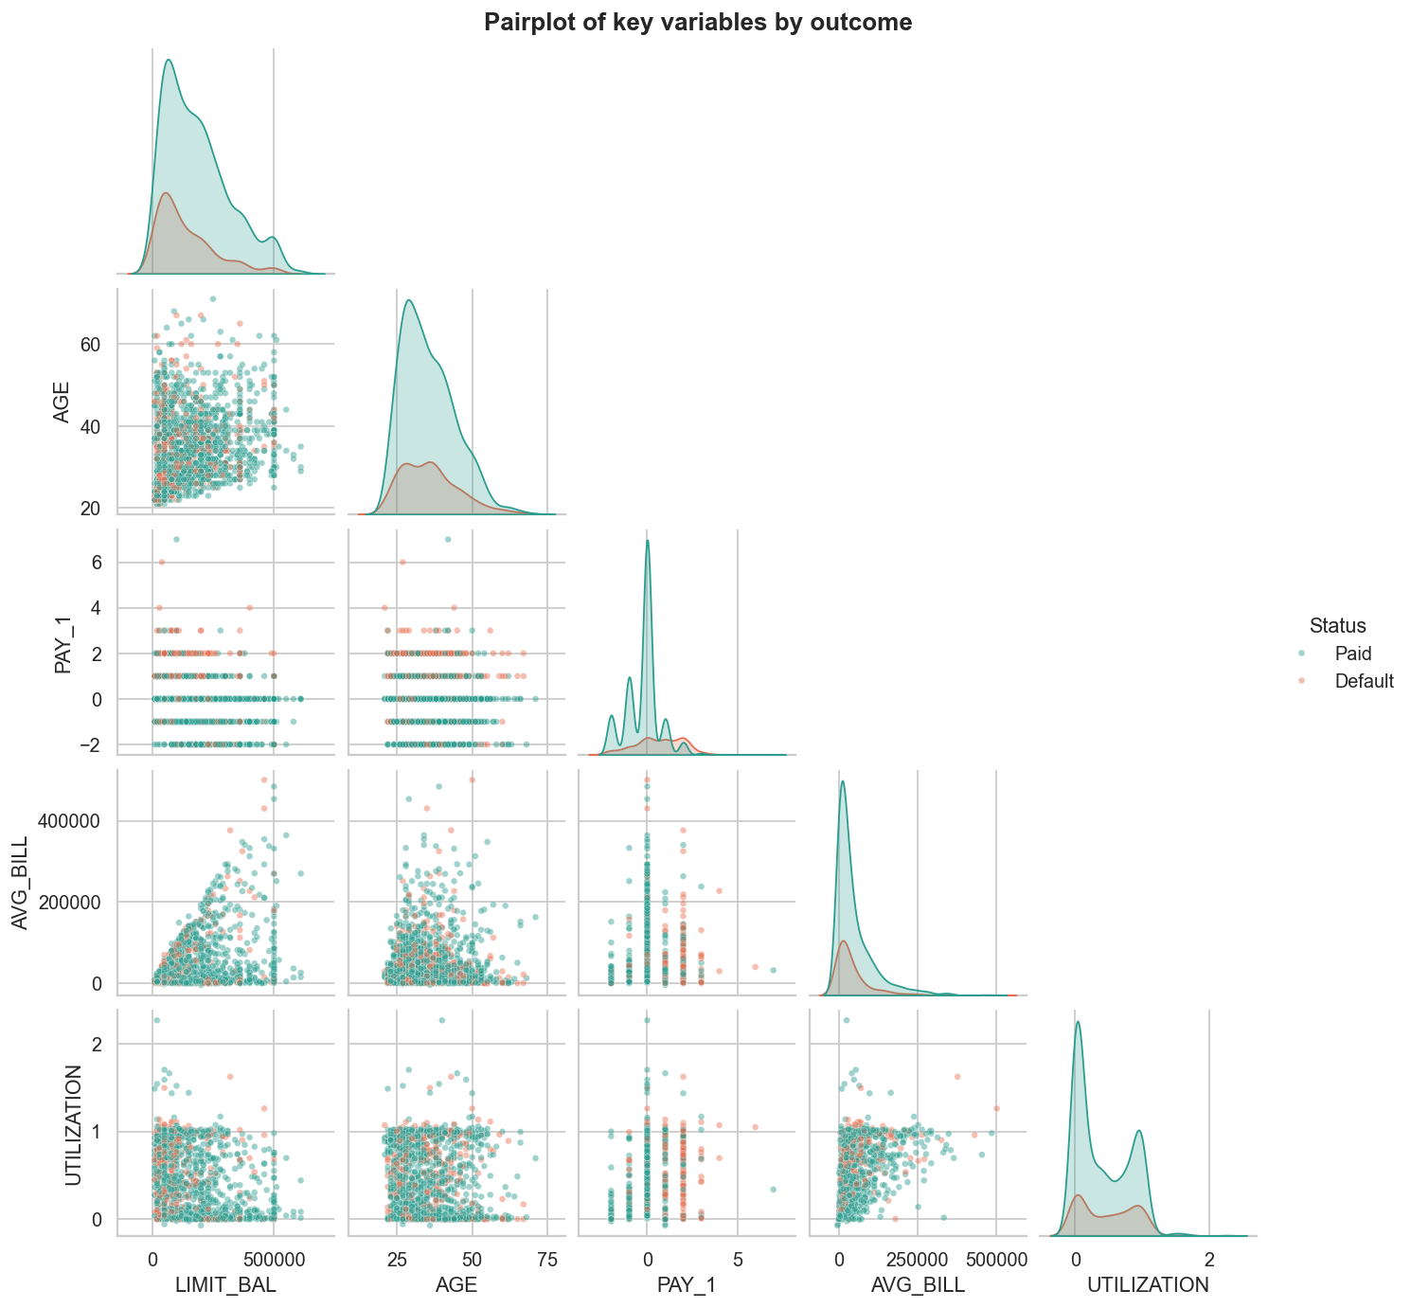
Figure 11. Pairplot of key variables coloured by outcome (1,500-customer sample).
What it shows: Scatter matrix and KDE of credit limit, age, latest repayment status, average bill and utilization, coloured by outcome.
Purpose: A compact multivariate view of how the most informative variables relate to each other and to the outcome.
Insights
- In the PAY_1 panels the orange (default) points concentrate at PAY_1 = 1, 2, 3, while 0, -1 and -2 are mostly teal, i.e. PAY_1 separates the classes better than any other variable shown.
- AVG_BILL fans out with LIMIT_BAL (a higher limit allows higher bills) but the two colours overlap almost completely - consistent with bills being weak predictors.
- The KDE of UTILIZATION is bimodal, with peaks near 0 (unused card) and near 1 (limit maxed out).
- AGE and LIMIT_BAL show heavy overlap between the classes, so these are only weak predictors on their own.
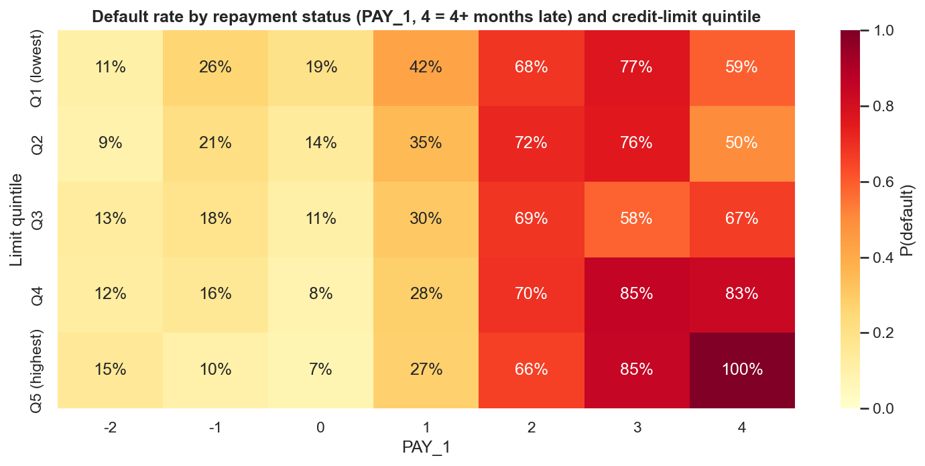
Figure 12. Default rate by repayment status and credit-limit quintile.
What it shows: Default rate for each combination of repayment status (columns) and credit-limit quintile (rows).
Purpose: To check an interaction: does the limit still matter once repayment behaviour is known?
Insights
- Repayment status dominates: default rates are 7-26 % for PAY_1 <= 0, 27-42 % one month late, and 50-100 % from two months late onwards, in every limit quintile.
- Among customers in good standing (PAY_1 = 0) the limit still matters: default falls from 19 % (lowest quintile) to 7 % (highest).
- For seriously late customers the pattern reverses: in the top two limit quintiles those 3+ months late default 83-100 % (small cells, minimum n = 9, so treat with caution).
- Counter-intuitive: 'paid duly' (-1) has a higher default rate (10-26 %) than 'revolving credit' (0, 7-19 %); customers who pay in full may include more volatile or low-balance accounts.

4.6 Interactive Visualization
The interactive chart (figures/13_interactive_scatter.html) allows hover, zoom and toggling of paid/default points, completing the Interact stage of the visualization pipeline.

5. Deep Learning Model

5.1 Task and Model Choice
The task is binary classification: predict whether a customer defaults. Because the data is structured and tabular, a Multilayer Perceptron (MLP) was chosen. It was implemented in PyTorch [3]. Baselines (logistic regression and a random forest, scikit-learn [4]) were trained on the same processed features to judge whether the deep model is worthwhile.

5.2 Architecture
Layer | Details
Input | 32 processed features
Hidden block 1 | Linear(32 → 128) → BatchNorm → ReLU → Dropout(0.2)
Hidden block 2 | Linear(128 → 64) → BatchNorm → ReLU → Dropout(0.2)
Hidden block 3 | Linear(64 → 32) → BatchNorm → ReLU → Dropout(0.2)
Output | Linear(32 → 1) producing a logit; sigmoid gives P(default)
Trainable parameters | 15,041

5.3 Training Parameters
Parameter | Value
Loss function | Binary cross-entropy with logits
Optimizer | Adam (weight decay 1e-4)
Learning rate | 0.001 (selected)
Batch size | 256
Maximum epochs / early stopping | 40 epochs, patience 6 on validation loss; best weights restored (training stopped after 23 epochs, best epoch 17)
Dropout / batch normalization | 0.2 (selected) / after every linear layer
Random seed / device | 42 / CPU (fully reproducible)
Decision threshold | 0.327, chosen to maximise F1 on the validation set (not the test set)

5.4 Hyperparameter Tuning
Result: the 12 configurations reach validation AUC between 0.777 and 0.781, a spread of only 0.004. Architecture, dropout and learning rate matter very little - the performance ceiling comes from the information in the data, not from the network design. The best configuration (128-64-32 hidden units, dropout 0.2, lr 0.001) was selected on validation AUC, never on the test set.
Rank | Hidden layers | Dropout | Learning rate | Best epoch | Val. loss | Val. AUC
1 (selected) | 128-64-32 | 0.2 | 0.001 | 17 | 0.4273 | 0.7811
2 | 64-32 | 0.2 | 0.001 | 18 | 0.4270 | 0.7809
3 | 128-64-32 | 0.4 | 0.003 | 18 | 0.4276 | 0.7807
4 | 128-64-32 | 0.2 | 0.003 | 16 | 0.4278 | 0.7805
5 | 64-32 | 0.4 | 0.001 | 39 | 0.4269 | 0.7803
6 | 128-64-32 | 0.4 | 0.001 | 18 | 0.4290 | 0.7800
7 | 64-32 | 0.4 | 0.003 | 24 | 0.4275 | 0.7800
8 | 128-64 | 0.2 | 0.003 | 17 | 0.4282 | 0.7796
9 | 64-32 | 0.2 | 0.003 | 13 | 0.4280 | 0.7794
10 | 128-64 | 0.4 | 0.003 | 17 | 0.4288 | 0.7793
11 | 128-64 | 0.4 | 0.001 | 25 | 0.4288 | 0.7786
12 | 128-64 | 0.2 | 0.001 | 10 | 0.4287 | 0.7772

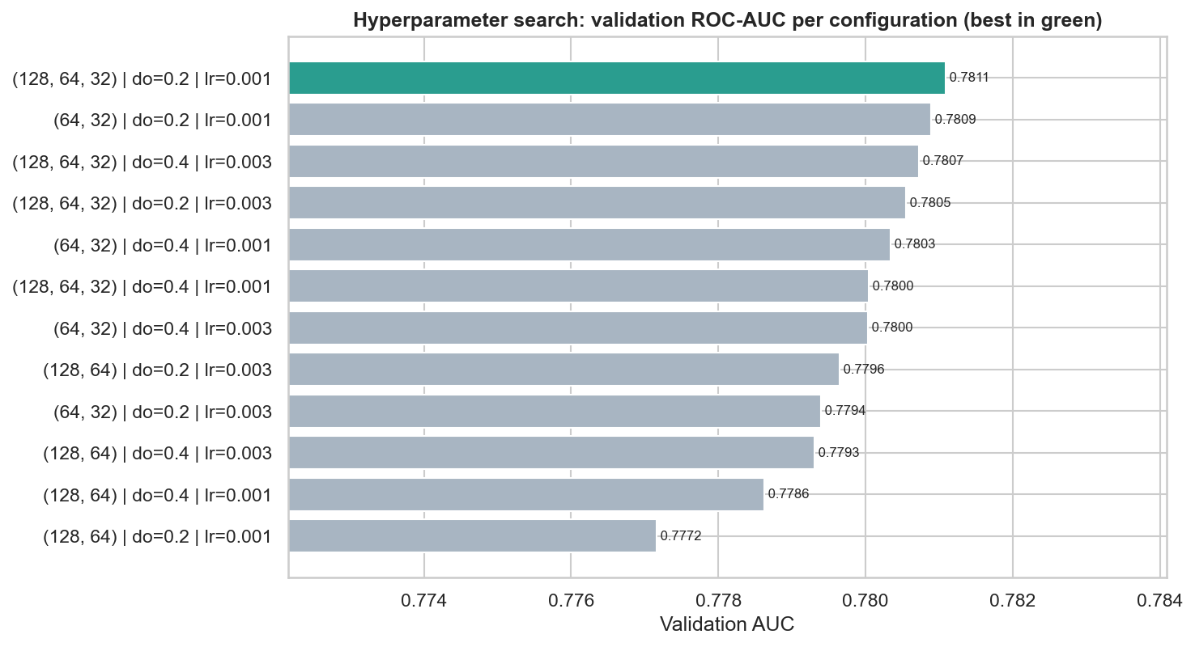
Figure 13. Validation AUC for each of the 12 hyperparameter configurations.
What it shows: Validation AUC of every hyperparameter combination (best in green).
Purpose: To document the tuning and to show how sensitive the model is to the chosen hyperparameters.
Insights
- All 12 bars are within 0.004 AUC of each other: the model is robust to hyperparameter choices.
- The selected network has 3 hidden layers (128-64-32), dropout 0.2, learning rate 0.001 and 15,041 trainable parameters.

6. Result Visualization and Interpretation

6.1 Training Curves
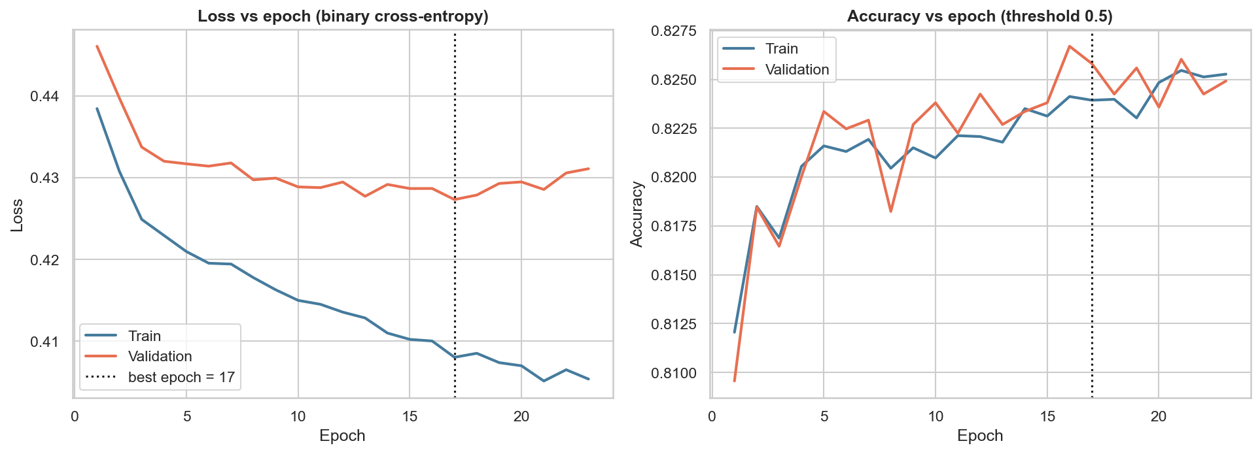
Figure 14. Loss versus epoch and accuracy versus epoch for the selected model.
What it shows: Training and validation loss (left) and accuracy (right) after every epoch of the selected model.
Purpose: To diagnose under/over-fitting and justify early stopping.
Insights
- Training loss keeps falling (to ~0.405) while validation loss flattens at ~0.427 around epoch 17 and then drifts upward: the typical start of over-fitting. Early stopping restored the weights of epoch 17.
- The train-validation gap is small (~0.02), so the model generalises reasonably; there is no sign of severe over-fitting.
- Accuracy at a 0.5 threshold plateaus at about 82-83 % for both sets. That is only ~4-5 points above the 77.9 % majority-class baseline, which is why AUC and recall are the more informative metrics here.

6.2 Final Test Metrics
Model | ROC-AUC | PR-AUC | Accuracy | Precision | Recall | F1
MLP (PyTorch) | 0.785 | 0.556 | 0.792 | 0.528 | 0.546 | 0.537
Logistic Regression | 0.766 | 0.526 | 0.780 | 0.502 | 0.574 | 0.536
Random Forest | 0.779 | 0.560 | 0.799 | 0.549 | 0.504 | 0.526
MLP @ threshold 0.5 | 0.785 | 0.556 | 0.819 | 0.662 | 0.371 | 0.476

Precision, recall and F1 refer to the default class. Thresholds were tuned on validation data for the first three rows; the last row shows the MLP at the conventional 0.5 threshold.
On the untouched test set the MLP reaches ROC-AUC 0.785, slightly above Random Forest (0.779) and Logistic Regression (0.766). The threshold chosen on validation data (0.327) trades some accuracy for recall: at the default 0.5 the MLP would be more 'accurate' (81.9 %) but would catch only 37 % of defaulters (recall), against 54.6 % at the tuned threshold. In a bank, missing a defaulter usually costs more than a false alarm, so the tuned threshold is the more sensible operating point.

6.3 Confusion Matrix
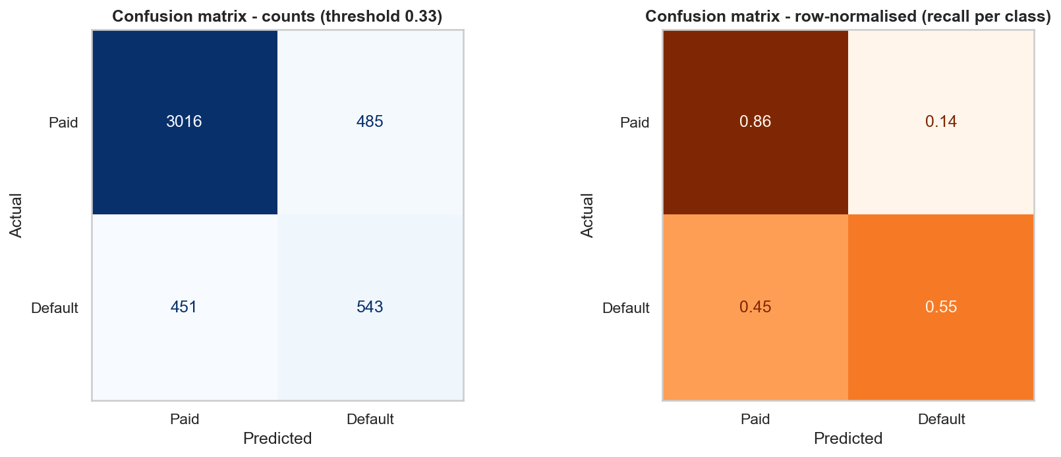
Figure 15. Confusion matrix of the MLP on the test set (counts and row-normalised).
What it shows: Test-set confusion matrix of the MLP, as counts (left) and row-normalised percentages (right).
Purpose: To see the types of mistakes made, not just the overall accuracy.
Insights
- Of 994 real defaulters the model catches 543 (recall 55 %) and misses 451; of 3,501 good customers it correctly clears 3,016 (86 %) and wrongly flags 485.
- Precision for defaults is 53 % (543 of 1,028 flagged customers really default), F1 = 0.54; overall accuracy 79.2 %.
- Roughly half of the defaulters cannot be identified from the data, which is consistent with the overlapping score distributions below.
Actual / Predicted | Paid | Default
Paid | 3,016 (true negative) | 485 (false positive)
Default | 451 (false negative) | 543 (true positive)

6.4 ROC Curve and AUC
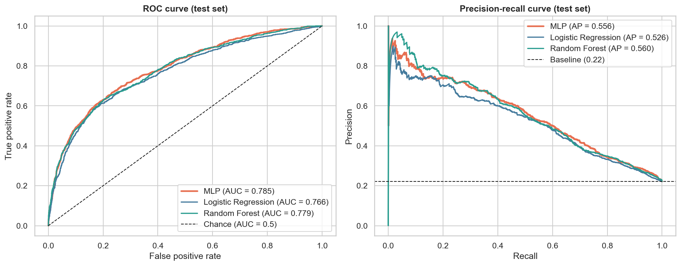
Figure 16. ROC and precision-recall curves for the MLP, logistic regression and random forest on the test set.
What it shows: ROC curves with AUC (left) and precision-recall curves with average precision (right) for the MLP, Logistic Regression and Random Forest on the test set.
Purpose: ROC/AUC measure ranking quality independent of any threshold; the PR curve is more informative for an imbalanced target.
Insights
- AUC = 0.785 for the MLP (0.5 = random, 1 = perfect): a randomly chosen defaulter receives a higher risk score than a randomly chosen payer 78.5 % of the time.
- The three curves almost coincide; the MLP is marginally better than Logistic Regression (0.766) and level with Random Forest (0.779) within noise. A deep model brings little gain over simple models on this tabular dataset.
- In the PR plot all models are far above the 0.22 baseline, but precision drops quickly as recall increases: catching most defaulters means many false alarms.

6.5 Distribution of Predicted Probabilities
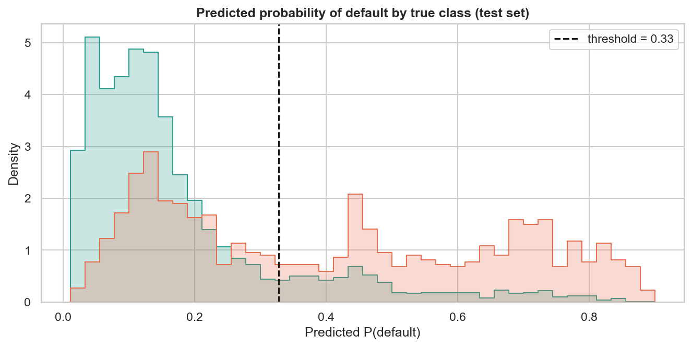
Figure 17. Predicted default probability by true class on the test set.
What it shows: Histogram of the predicted default probability for each true class on the test set, with the decision threshold.
Purpose: To understand why the model performs as it does by looking at how well the scores separate the classes.
Insights
- Paid customers (teal) are concentrated at low predicted probabilities (mostly 0.03-0.2); defaulters (orange) form two groups: a large one at 0.6-0.8+ that the model identifies confidently, and another that sits in the same low-probability range as good customers. That second group looks like reliable payers in the data (for example, a sudden income shock) and cannot be detected - this overlap is the cause of the AUC ceiling at about 0.78.

6.6 Feature Analysis and Importance
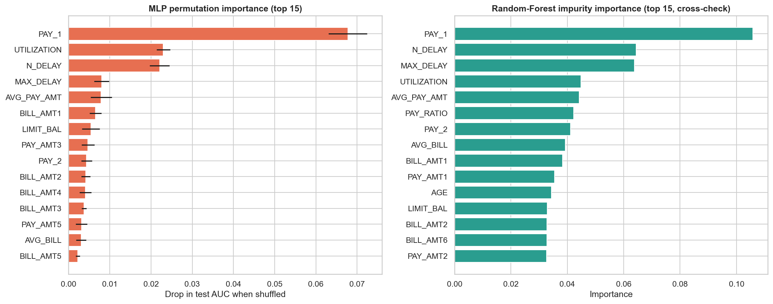
Figure 18. Permutation importance of the MLP (left) and random-forest importance (right).
What it shows: Left: permutation importance of the MLP - how much the test AUC drops when one feature is randomly shuffled (mean +/- std over 5 repeats). Right: Random-Forest impurity importance as a cross-check.
Purpose: Feature analysis: which inputs the model really relies on.
Insights
- PAY_1 (latest repayment status) is the most important feature in both models - shuffling it costs 0.068 AUC, about three times more than any other feature.
- Next come UTILIZATION (0.023), N_DELAY (0.022), MAX_DELAY and AVG_PAY_AMT (0.008 each), BILL_AMT1 and LIMIT_BAL: the engineered behavioural features are among the top predictors, validating the feature engineering.
- Demographics (SEX, EDUCATION, MARRIAGE, AGE) have almost no importance, in line with the weak Cramer's V values found in EDA.
- Caveat: correlated features (PAY_1..6, BILL_AMT1..6) share credit, so each individually looks less important than the group does.
This is a classification problem, so an error-distribution chart (used for regression) does not apply; the confusion matrix, ROC/PR curves and score distribution describe the errors instead.

7. Conclusion and Future Scope

7.1 Conclusion
- The dataset contains 30,000 credit-card customers; after removing 35 duplicates 22.1 % defaulted, so the problem is imbalanced and accuracy alone is misleading.
- Cleaning showed no missing values but undocumented category codes, duplicates and heavy right-skew in every money column. These were handled by merging codes and applying a signed-log transform instead of deleting valid high-value customers.
- Distribution analysis: AGE follows a Gamma-like distribution (best AIC and KS), credit limit is approximately log-normal, and the number of late months is strongly over-dispersed (variance/mean = 2.9) so neither Binomial nor Poisson fits – customers are a mixture of reliable and chronic late payers.
- Payment behaviour is far more informative than demographics: default rises from about 13 % for customers paying on time to 69 % for those two months late. Higher credit limits go with lower default (31.7 % → 13.7 % across limit quintiles). Gender, education and marital status are statistically significant but have very small effect sizes (Cramér’s V ≤ 0.07), and age and bill size have almost none.
- The tuned MLP reached a test ROC-AUC of 0.785, average precision 0.556, accuracy 79.2 %, precision 52.8 %, recall 54.6 % and F1 0.537 at a validation-selected threshold of 0.33. It is slightly better than logistic regression (0.766) and level with random forest (0.779).
- The most important model features are the latest repayment status (PAY_1), credit utilization, the number of late months and the average payment – the engineered behavioural features rank among the leading predictors.

7.2 Challenges and Limitations
- Class imbalance: the default threshold of 0.5 gives only 37 % recall; threshold tuning was required.
- Strong multicollinearity (BILL_AMT1–6, PAY_1–6) and skewed amounts required transformation and careful interpretation of feature importance.
- Overlapping classes: roughly half of the defaulters look like reliable payers in the data, which limits any model to an AUC of about 0.78 on these features.
- The data covers one issuer and six months in 2005; results may not generalise to other banks or periods. EDA associations and permutation importance do not establish causation.
- Several codes (PAY_x = −2 and 0, EDUCATION 0/5/6, MARRIAGE 0) are undocumented and had to be interpreted.

7.3 Future Scope
- Cost-sensitive learning, class weights, resampling (SMOTE) or focal loss; probability calibration; a threshold chosen from the bank’s actual cost of a missed default versus a false alarm.
- Gradient-boosting models (XGBoost, LightGBM) and ensembles with the MLP; structured tuning with Optuna.
- Additional data: income, employment, transaction categories, month-on-month trends and macro-economic indicators; sequence models (LSTM/Transformer) on the six-month history.
- Explainability with SHAP, fairness checks across gender and age, and validation on an independent time period before any deployment.

8. Literature Review
Yeh and Lien [1] collected and analysed this dataset to compare six data-mining techniques (discriminant analysis, logistic regression, naive Bayes, nearest neighbour, artificial neural network and classification trees) for estimating the probability of default of credit-card clients. Their study argued that estimating the probability of default is more useful for risk management than a simple yes/no classification, and reported that the artificial neural network was the technique that best estimated the real probability of default. The data is distributed through the UCI repository [2], which makes it a widely used benchmark for tabular classification with imbalanced classes. The present project follows the same line of enquiry with a modern PyTorch MLP and simple baselines: the MLP is slightly better than logistic regression, which is consistent with a modest advantage for neural networks, although the gain here is small.
Fry’s visualization workflow [5] describes seven stages – acquire, parse, filter, mine, represent, refine and interact – and was used here to structure the visualization work (Section 4.1). Charts were produced with Matplotlib [6] and Seaborn, and the interactive stage used Plotly.
The MLP was implemented in PyTorch [3] and trained with the Adam optimizer [7] and dropout regularization [8]. Logistic regression, random forest [9], permutation importance, the ROC/AUC metrics and the stratified splitting used scikit-learn [4]. Permutation importance measures how much a fitted model relies on a feature and is not evidence of causation, which is why it was cross-checked against random-forest importance.

9. References
[1] Yeh, I. C., & Lien, C. H. (2009). The comparisons of data mining techniques for the predictive accuracy of probability of default of credit card clients. Expert Systems with Applications, 36(2), 2473–2480.
[2] UCI Machine Learning Repository. (n.d.). Default of Credit Card Clients [Data set]. https://archive.ics.uci.edu/dataset/350/default+of+credit+card+clients
[3] Paszke, A., et al. (2019). PyTorch: An imperative style, high-performance deep learning library. Advances in Neural Information Processing Systems, 32.
[4] Pedregosa, F., et al. (2011). Scikit-learn: Machine learning in Python. Journal of Machine Learning Research, 12, 2825–2830.
[5] Fry, B. (2008). Visualizing Data: Exploring and Explaining Data with the Processing Environment. O’Reilly Media.
[6] Hunter, J. D. (2007). Matplotlib: A 2D graphics environment. Computing in Science & Engineering, 9(3), 90–95.
[7] Kingma, D. P., & Ba, J. (2015). Adam: A method for stochastic optimization. International Conference on Learning Representations (ICLR).
[8] Srivastava, N., et al. (2014). Dropout: A simple way to prevent neural networks from overfitting. Journal of Machine Learning Research, 15, 1929–1958.
[9] Breiman, L. (2001). Random forests. Machine Learning, 45(1), 5–32.

Appendix A. Code Section and Reproducibility
The complete, commented Python code is in the notebook notebooks/eda_dl_case_study.ipynb of the GitHub repository https://github.com/AKHILASH-SK/EDA-Assignment (data loading, cleaning, EDA, distribution fitting, visualizations, preprocessing, model creation and training, hyperparameter search, evaluation and feature importance). The dataset is included as data/credit_default.csv. The full code of every notebook cell is reproduced below.
# ---- Cell 1 ----
# ---------- Imports & global configuration ----------
import os, random, json, warnings
warnings.filterwarnings("ignore")

import numpy as np
import pandas as pd
import matplotlib.pyplot as plt
import seaborn as sns
from scipy import stats
import plotly.express as px

import torch, torch.nn as nn
from torch.utils.data import TensorDataset, DataLoader

from sklearn.model_selection import train_test_split
from sklearn.preprocessing import StandardScaler, OneHotEncoder
from sklearn.compose import ColumnTransformer
from sklearn.linear_model import LogisticRegression
from sklearn.ensemble import RandomForestClassifier
from sklearn.metrics import (accuracy_score, precision_score, recall_score, f1_score,
roc_auc_score, roc_curve, precision_recall_curve,
average_precision_score, confusion_matrix,
ConfusionMatrixDisplay, classification_report)

SEED = 42
random.seed(SEED); np.random.seed(SEED); torch.manual_seed(SEED)
torch.set_num_threads(4)
DEVICE = torch.device("cpu") # CPU: fully reproducible results for this small network

DATA_PATH = "../data/credit_default.csv"
FIG_DIR = "../figures"
REPORT_DIR = "../report"
os.makedirs(FIG_DIR, exist_ok=True); os.makedirs(REPORT_DIR, exist_ok=True)

sns.set_theme(style="whitegrid", context="notebook", palette="deep")
plt.rcParams.update({"figure.dpi": 100, "axes.titleweight": "bold", "axes.titlesize": 12})
C_OK, C_DEF = "#2a9d8f", "#e76f51" # colours: paid (teal) vs default (orange-red)

def save_fig(name):
"""Save the current matplotlib figure to ../figures (used in the report)."""
plt.savefig(f"{FIG_DIR}/{name}.png", dpi=150, bbox_inches="tight")

print("Device:", DEVICE)
# ---- Cell 2 ----
df_raw = pd.read_csv(DATA_PATH)
# Tidy names: the first payment-status column is called PAY_0 in the source (no PAY_1) -> rename for consistency
df = (df_raw.rename(columns={"PAY_0": "PAY_1", "default payment next month": "DEFAULT"})
.drop(columns="ID")) # ID is just a row identifier, not a feature
print("Shape (rows, columns):", df.shape)
print("Input features:", df.shape[1] - 1, "| Target: DEFAULT (1 = defaulted next month)")
df.head()
# ---- Cell 3 ----
dictionary = pd.DataFrame({
"field": df.columns,
"dtype": df.dtypes.astype(str).values,
"n_unique": df.nunique().values,
"meaning": [
"Credit limit (NT$) incl. family supplementary credit",
"Gender (1 = male, 2 = female)",
"Education (1 grad school, 2 university, 3 high school, 4 other)",
"Marital status (1 married, 2 single, 3 other)",
"Age in years",
"Repayment status Sep-2005 (-1 paid duly, 1..9 = months of delay)",
"Repayment status Aug-2005", "Repayment status Jul-2005", "Repayment status Jun-2005",
"Repayment status May-2005", "Repayment status Apr-2005",
"Bill statement Sep-2005 (NT$)", "Bill statement Aug-2005", "Bill statement Jul-2005",
"Bill statement Jun-2005", "Bill statement May-2005", "Bill statement Apr-2005",
"Amount paid Sep-2005 (NT$)", "Amount paid Aug-2005", "Amount paid Jul-2005",
"Amount paid Jun-2005", "Amount paid May-2005", "Amount paid Apr-2005",
"TARGET: 1 = default next month, 0 = pays"]})
dictionary
# ---- Cell 4 ----
summary = df.describe().T
summary["skew"] = df.skew()
summary["kurtosis"] = df.kurtosis()
summary.round(2)
# ---- Cell 5 ----
vc = df["DEFAULT"].value_counts()
print(vc.to_string()); print(f"\nDefault rate: {df['DEFAULT'].mean():.2%}")
# ---- Cell 6 ----
print("Missing values per column (total):", int(df.isna().sum().sum()))
dups = df.duplicated().sum()
print("Duplicate rows (ID already removed):", dups)
df = df.drop_duplicates().reset_index(drop=True)
print("Shape after removing duplicates:", df.shape)
# ---- Cell 7 ----
# Some category codes are undocumented in the data dictionary (EDUCATION 0,5,6 ; MARRIAGE 0) -> merge into "other"
print("EDUCATION before:", df["EDUCATION"].value_counts().sort_index().to_dict())
print("MARRIAGE before:", df["MARRIAGE"].value_counts().sort_index().to_dict())
df["EDUCATION"] = df["EDUCATION"].replace({0: 4, 5: 4, 6: 4})
df["MARRIAGE"] = df["MARRIAGE"].replace({0: 3})
print("EDUCATION after :", df["EDUCATION"].value_counts().sort_index().to_dict())
print("MARRIAGE after :", df["MARRIAGE"].value_counts().sort_index().to_dict())
print("\nPAY_x values seen:", sorted(df["PAY_1"].unique()),
"(-2 = no consumption, -1 = paid duly, 0 = revolving credit, 1-8 = months late)")
# ---- Cell 8 ----
# Outlier detection with the 1.5*IQR rule on the money columns
money = [c for c in df.columns if c.startswith(("BILL_AMT", "PAY_AMT"))] + ["LIMIT_BAL"]
rows = []
for c in money:
q1, q3 = df[c].quantile([.25, .75]); iqr = q3 - q1
n = ((df[c] < q1 - 1.5 * iqr) | (df[c] > q3 + 1.5 * iqr)).sum()
rows.append((c, n, 100 * n / len(df), df[c].skew()))
outlier_tbl = pd.DataFrame(rows, columns=["column", "n_outliers", "pct_outliers", "skew"]).round(2)
print("Rows are NOT dropped: large balances/limits are genuine customers. They are tamed by a signed log transform later.")
outlier_tbl
# ---- Cell 9 ----
# ---------- Feature engineering (domain-driven) ----------
bill = [f"BILL_AMT{i}" for i in range(1, 7)]; pay_amt = [f"PAY_AMT{i}" for i in range(1, 7)]
pay_st = [f"PAY_{i}" for i in range(1, 7)]
df["AVG_BILL"] = df[bill].mean(axis=1) # typical monthly balance
df["AVG_PAY_AMT"] = df[pay_amt].mean(axis=1) # typical monthly repayment
df["UTILIZATION"] = (df["BILL_AMT1"] / df["LIMIT_BAL"]).clip(-1, 3) # how much of the limit is used
df["PAY_RATIO"] = (df[pay_amt].sum(axis=1) / df[bill[:5]].clip(lower=1).sum(axis=1)).clip(0, 3) # repaid / billed
df["N_DELAY"] = (df[pay_st] > 0).sum(axis=1) # months (of 6) paid late
df["MAX_DELAY"] = df[pay_st].max(axis=1) # worst delay
print("Engineered 6 new features ->", df.shape[1] - 1, "input features now")
df[["AVG_BILL", "AVG_PAY_AMT", "UTILIZATION", "PAY_RATIO", "N_DELAY", "MAX_DELAY"]].describe().round(2)
# ---- Cell 10 ----
# Human-readable labels, used only for plotting
SEX_L = {1: "Male", 2: "Female"}
EDU_L = {1: "Grad school", 2: "University", 3: "High school", 4: "Other"}
MAR_L = {1: "Married", 2: "Single", 3: "Other"}
vis = df.copy()
vis["Status"] = vis["DEFAULT"].map({0: "Paid", 1: "Default"})
PAL = {"Paid": C_OK, "Default": C_DEF}
# ---- Cell 11 ----
# VIS 1 - Histograms + KDE of the key continuous variables
fig, ax = plt.subplots(2, 2, figsize=(12, 8))
panels = [("LIMIT_BAL", "Credit limit (NT$)", df["LIMIT_BAL"], 50, "LIMIT_BAL"),
("AGE", "Age (years)", df["AGE"], np.arange(20.5, 80, 1), "AGE (1-year bins)"),
("BILL_AMT1", "Latest bill (NT$)", df["BILL_AMT1"], 60, "BILL_AMT1"),
("PAY_AMT1", "Latest payment (NT$)", df["PAY_AMT1"], 50, "PAY_AMT1")]
for a, (col, title, x, bins, xl) in zip(ax.ravel(), panels):
sk = x.skew()
if col == "PAY_AMT1": # raw scale is unreadable (skew > 14): show log10(1 + payment)
x = np.log10(1 + x); xl = "log10(1 + PAY_AMT1)"
sns.histplot(x, kde=True, bins=bins, color="#457b9d", ax=a)
a.axvline(x.mean(), color="k", ls="--", lw=1, label=f"mean {x.mean():,.1f}" if col == "PAY_AMT1" else f"mean {x.mean():,.0f}")
a.axvline(x.median(), color=C_DEF, ls="-", lw=1.5, label=f"median {x.median():,.1f}" if col == "PAY_AMT1" else f"median {x.median():,.0f}")
a.set(title=f"{title} (raw skew = {sk:.2f})", xlabel=xl, ylabel="Customers"); a.legend()
plt.suptitle("Distribution of key continuous variables", fontsize=14, fontweight="bold", y=1.01)
plt.tight_layout(); save_fig("01_histograms"); plt.show()
# ---- Cell 12 ----
# VIS 2 - Boxplots of the money columns (log scale so the heavy tails stay readable)
fig, ax = plt.subplots(1, 2, figsize=(13, 5))
sns.boxplot(data=df[bill].clip(lower=1), orient="h", color="#a8dadc", fliersize=2, ax=ax[0])
ax[0].set(xscale="log", title="Monthly bill statements (log scale, negatives clipped to 1)", xlabel="NT$")
sns.boxplot(data=df[pay_amt].clip(lower=1), orient="h", color="#f4a261", fliersize=2, ax=ax[1])
ax[1].set(xscale="log", title="Monthly payments (log scale, zeros clipped to 1)", xlabel="NT$")
plt.tight_layout(); save_fig("02_boxplots_money"); plt.show()
# ---- Cell 13 ----
# VIS 3 - Bar charts of the categorical variables and the target
fig, ax = plt.subplots(1, 4, figsize=(16, 4))
for a, (col, lab, t) in zip(ax[:3], [("SEX", SEX_L, "Gender"), ("EDUCATION", EDU_L, "Education"), ("MARRIAGE", MAR_L, "Marital status")]):
s = df[col].map(lab).value_counts()
sns.barplot(x=s.index, y=s.values, color="#457b9d", ax=a)
for i, v in enumerate(s.values): a.text(i, v, f"{v:,}\n({v/len(df):.0%})", ha="center", va="bottom", fontsize=9)
a.set(title=t, xlabel="", ylabel="Customers"); a.set_ylim(0, s.max() * 1.2)
s = vis["Status"].value_counts()
sns.barplot(x=s.index, y=s.values, palette=PAL, ax=ax[3])
for i, v in enumerate(s.values): ax[3].text(i, v, f"{v:,}\n({v/len(df):.1%})", ha="center", va="bottom", fontsize=9)
ax[3].set(title="Target: default next month", xlabel="", ylabel="Customers"); ax[3].set_ylim(0, s.max() * 1.2)
plt.tight_layout(); save_fig("03_categorical_counts"); plt.show()
# ---- Cell 14 ----
# VIS 4 - Continuous distribution fitting (AGE) + lognormality check (LIMIT_BAL)
age = df["AGE"].values.astype(float)
fits = {"Normal": stats.norm, "Log-normal": stats.lognorm, "Gamma": stats.gamma}
rows = []
fig, ax = plt.subplots(1, 3, figsize=(17, 4.8))
sns.histplot(age, stat="density", bins=np.arange(20.5, 80, 1), color="#cfd8dc", ax=ax[0])
xs = np.linspace(age.min(), age.max(), 400)
for (name, dist), c in zip(fits.items(), ["#e76f51", "#2a9d8f", "#6a4c93"]):
p = dist.fit(age)
ll = dist.logpdf(age, *p).sum(); aic = 2 * len(p) - 2 * ll
ks = stats.kstest(age, dist.cdf, args=p)
rows.append((name, round(aic, 1), round(ks.statistic, 4)))
ax[0].plot(xs, dist.pdf(xs, *p), color=c, lw=2, label=f"{name} (AIC {aic:,.0f})")
ax[0].set(title="AGE with fitted continuous distributions", xlabel="Age (years)", ylabel="Density"); ax[0].legend()
fit_tbl = pd.DataFrame(rows, columns=["distribution", "AIC (lower=better)", "KS statistic (lower=better)"])
lb = np.log(df["LIMIT_BAL"].values.astype(float))
sns.histplot(lb, stat="density", bins=40, color="#cfd8dc", ax=ax[1])
xs2 = np.linspace(lb.min(), lb.max(), 300)
ax[1].plot(xs2, stats.norm.pdf(xs2, lb.mean(), lb.std()), color="#e76f51", lw=2, label="Normal fit")
ax[1].set(title="log(LIMIT_BAL): bell-shaped but lumpy (round-number limits)", xlabel="ln(NT$)", ylabel="Density"); ax[1].legend()
stats.probplot(lb, dist="norm", plot=ax[2]); ax[2].set_title("Q-Q plot of log(LIMIT_BAL) vs Normal")
plt.tight_layout(); save_fig("04_continuous_distributions"); plt.show()
print(fit_tbl.to_string(index=False))
print(f"\nAGE: skew={stats.skew(age):.2f}; log(LIMIT_BAL): skew={stats.skew(lb):.2f}, raw LIMIT_BAL skew={df['LIMIT_BAL'].skew():.2f}")
# ---- Cell 15 ----
# VIS 5 - Discrete distributions: PAY_1 (ordinal PMF), N_DELAY vs Binomial/Poisson, DEFAULT as Bernoulli
fig, ax = plt.subplots(1, 3, figsize=(17, 4.8))
pmf = df["PAY_1"].value_counts(normalize=True).sort_index()
sns.barplot(x=pmf.index, y=pmf.values, color="#457b9d", ax=ax[0])
ax[0].set(title="PMF of latest repayment status (PAY_1)", xlabel="PAY_1 (-2..8)", ylabel="Probability")
k = np.arange(0, 7); obs = df["N_DELAY"].value_counts(normalize=True).reindex(k, fill_value=0).values
m, v = df["N_DELAY"].mean(), df["N_DELAY"].var()
binom_pmf = stats.binom.pmf(k, 6, m / 6); pois_pmf = stats.poisson.pmf(k, m)
w = 0.27
ax[1].bar(k - w, obs, w, label="Observed", color="#cfd8dc", edgecolor="k")
ax[1].bar(k, binom_pmf, w, label=f"Binomial(6, p={m/6:.2f})", color="#2a9d8f")
ax[1].bar(k + w, pois_pmf, w, label=f"Poisson(mu={m:.2f})", color="#e76f51")
ax[1].set(title="Months paid late (N_DELAY): observed vs fitted", xlabel="Number of late months (0-6)", ylabel="Probability"); ax[1].legend()
p = df["DEFAULT"].mean()
ax[2].bar(["Paid (0)", "Default (1)"], [1 - p, p], color=[C_OK, C_DEF])
ax[2].set(title=f"DEFAULT as Bernoulli(p = {p:.3f})", ylabel="Probability"); ax[2].set_ylim(0, 1)
for i, val in enumerate([1 - p, p]): ax[2].text(i, val + 0.01, f"{val:.3f}", ha="center")
plt.tight_layout(); save_fig("05_discrete_distributions"); plt.show()
tv_b = 0.5 * np.abs(obs - binom_pmf).sum(); tv_p = 0.5 * np.abs(obs - pois_pmf).sum()
print(f"N_DELAY mean = {m:.3f}, variance = {v:.3f} (variance/mean = {v/m:.2f}; Binomial expects {1-m/6:.2f}, Poisson expects 1.00)")
print(f"Total-variation distance: Binomial = {tv_b:.3f}, Poisson = {tv_p:.3f} (smaller = better fit)")
# ---- Cell 16 ----
# VIS 6 - Default rate vs the strongest candidate drivers
fig, ax = plt.subplots(1, 3, figsize=(17, 4.8))
r = df.groupby("PAY_1")["DEFAULT"].agg(["mean", "size"])
sns.barplot(x=r.index, y=r["mean"], color="#e76f51", ax=ax[0])
for i, (m_, n_) in enumerate(zip(r["mean"], r["size"])): ax[0].text(i, m_ + 0.02, f"n={n_:,}", ha="center", fontsize=7, rotation=90, va="bottom")
ax[0].axhline(df["DEFAULT"].mean(), color="k", ls="--", lw=1, label="overall rate"); ax[0].legend()
ax[0].set(title="Default rate by latest repayment status", xlabel="PAY_1", ylabel="P(default)"); ax[0].set_ylim(0, 1.05)
df["AGE_GRP"] = pd.cut(df["AGE"], [20, 25, 30, 35, 40, 50, 60, 80])
r2 = df.groupby("AGE_GRP")["DEFAULT"].mean()
sns.barplot(x=r2.index.astype(str), y=r2.values, color="#457b9d", ax=ax[1])
ax[1].axhline(df["DEFAULT"].mean(), color="k", ls="--", lw=1)
ax[1].set(title="Default rate by age group", xlabel="Age group", ylabel="P(default)")
df["LIMIT_Q"] = pd.qcut(df["LIMIT_BAL"], 5, labels=["Q1 (lowest)", "Q2", "Q3", "Q4", "Q5 (highest)"])
r3 = df.groupby("LIMIT_Q")["DEFAULT"].mean()
sns.barplot(x=r3.index.astype(str), y=r3.values, color="#2a9d8f", ax=ax[2])
ax[2].axhline(df["DEFAULT"].mean(), color="k", ls="--", lw=1)
ax[2].set(title="Default rate by credit-limit quintile", xlabel="Limit quintile", ylabel="P(default)")
for a in ax[1:]: a.tick_params(axis="x", rotation=30)
plt.tight_layout(); save_fig("06_default_rate_drivers"); plt.show()
# ---- Cell 17 ----
# VIS 7 - Default rate by categorical groups
fig, ax = plt.subplots(1, 3, figsize=(15, 4.2))
for a, (col, lab, t) in zip(ax, [("SEX", SEX_L, "Gender"), ("EDUCATION", EDU_L, "Education"), ("MARRIAGE", MAR_L, "Marital status")]):
rr = df.groupby(col)["DEFAULT"].mean().rename(index=lab)
sns.barplot(x=rr.index, y=rr.values, color="#6a4c93", ax=a)
a.axhline(df["DEFAULT"].mean(), color="k", ls="--", lw=1)
for i, v_ in enumerate(rr.values): a.text(i, v_ + 0.003, f"{v_:.1%}", ha="center")
a.set(title=f"Default rate by {t.lower()}", xlabel="", ylabel="P(default)"); a.set_ylim(0, 0.32)
plt.tight_layout(); save_fig("07_default_rate_categorical"); plt.show()
# Chi-square test of independence + Cramer's V
rows = []
for col in ["SEX", "EDUCATION", "MARRIAGE"]:
ct = pd.crosstab(df[col], df["DEFAULT"]); chi2, pv, dof, _ = stats.chi2_contingency(ct)
rows.append((col, round(chi2, 1), dof, f"{pv:.2e}", round(np.sqrt(chi2 / (ct.values.sum() * (min(ct.shape) - 1))), 3)))
chi_tbl = pd.DataFrame(rows, columns=["variable", "chi2", "dof", "p-value", "Cramer's V"]); chi_tbl
# ---- Cell 18 ----
# VIS 8 - Numeric features split by outcome (violin + box) and Mann-Whitney U tests
vis["log10(LIMIT_BAL)"] = np.log10(vis["LIMIT_BAL"]); vis["log10(1+AVG_PAY_AMT)"] = np.log10(1 + vis["AVG_PAY_AMT"])
cols = ["log10(LIMIT_BAL)", "AGE", "log10(1+AVG_PAY_AMT)", "UTILIZATION", "PAY_RATIO", "N_DELAY"]
fig, ax = plt.subplots(2, 3, figsize=(15, 8))
for a, c in zip(ax.ravel(), cols):
sns.violinplot(data=vis, x="Status", y=c, order=["Paid", "Default"], palette=PAL, inner="box", cut=0, ax=a)
a.set(title=c, xlabel="", ylabel="")
plt.suptitle("Feature distributions by repayment outcome", fontsize=14, fontweight="bold", y=1.01)
plt.tight_layout(); save_fig("08_violin_by_outcome"); plt.show()
rows = []
for c in ["LIMIT_BAL", "AGE", "AVG_BILL", "AVG_PAY_AMT", "UTILIZATION", "PAY_RATIO", "N_DELAY"]: # rank test: monotone transforms do not matter
a_, b_ = df.loc[df.DEFAULT == 0, c], df.loc[df.DEFAULT == 1, c]
u, pv = stats.mannwhitneyu(a_, b_)
rows.append((c, round(a_.median(), 3), round(b_.median(), 3), f"{pv:.2e}", round(abs(1 - 2 * u / (len(a_) * len(b_))), 3)))
mw_tbl = pd.DataFrame(rows, columns=["feature", "median (paid)", "median (default)", "p-value", "rank-biserial effect"]); mw_tbl
# ---- Cell 19 ----
# VIS 9 - Scatterplot: credit limit vs average bill, coloured by outcome (sample of 4,000 for readability)
samp = vis[vis["AVG_BILL"] > 0].sample(4000, random_state=SEED) # positive average bills only so a log axis can be used
fig, ax = plt.subplots(1, 2, figsize=(14, 5.5))
sns.scatterplot(data=samp, x="LIMIT_BAL", y="AVG_BILL", hue="Status", palette=PAL, alpha=.55, s=18, ax=ax[0])
ax[0].set(xscale="log", yscale="log", title="Credit limit vs average bill (log-log)", xlabel="LIMIT_BAL (NT$, log)", ylabel="AVG_BILL (NT$, log)")
sns.scatterplot(data=samp, x="UTILIZATION", y="PAY_RATIO", hue="Status", palette=PAL, alpha=.55, s=18, ax=ax[1])
ax[1].set(title="Credit utilization vs repayment ratio", xlabel="UTILIZATION = latest bill / limit", ylabel="PAY_RATIO = paid / billed")
plt.tight_layout(); save_fig("09_scatterplots"); plt.show()
# ---- Cell 20 ----
# VIS 10 - Correlation heatmap (Spearman is robust to the skewed money columns)
num_cols = [c for c in df.columns if c not in ("AGE_GRP", "LIMIT_Q")]
corr = df[num_cols].corr(method="spearman")
mask = np.triu(np.ones_like(corr, dtype=bool))
fig, ax = plt.subplots(figsize=(15, 12))
sns.heatmap(corr, mask=mask, cmap="RdBu_r", center=0, vmin=-1, vmax=1, annot=True, fmt=".1f", annot_kws={"size": 6.5},
linewidths=.3, cbar_kws={"label": "Spearman correlation"}, ax=ax)
ax.set_title("Spearman correlation heatmap (all features + DEFAULT)"); ax.grid(False)
plt.tight_layout(); save_fig("10_correlation_heatmap"); plt.show()
print("Correlation with DEFAULT (top 10 by |rho|):")
print(corr["DEFAULT"].drop("DEFAULT").reindex(corr["DEFAULT"].drop("DEFAULT").abs().sort_values(ascending=False).index).head(10).round(3).to_string())
# ---- Cell 21 ----
# VIS 11 - Pairplot of the most informative variables (1,500-row sample)
cols = ["LIMIT_BAL", "AGE", "PAY_1", "AVG_BILL", "UTILIZATION", "Status"]
g = sns.pairplot(vis.sample(1500, random_state=SEED)[cols], hue="Status", palette=PAL, corner=True, plot_kws={"alpha": .45, "s": 14},
diag_kind="kde", height=2.1)
g.figure.suptitle("Pairplot of key variables by outcome", y=1.01, fontweight="bold")
g.savefig(f"{FIG_DIR}/11_pairplot.png", dpi=130, bbox_inches="tight"); plt.show()
# ---- Cell 22 ----
# VIS 12 - Multivariate: default rate by latest repayment status x credit-limit quintile
tmp = df.assign(PAY_1c=df["PAY_1"].clip(upper=4))
piv = tmp.pivot_table(index="LIMIT_Q", columns="PAY_1c", values="DEFAULT", aggfunc="mean")
cnt = tmp.pivot_table(index="LIMIT_Q", columns="PAY_1c", values="DEFAULT", aggfunc="size")
fig, ax = plt.subplots(figsize=(10, 4.8))
sns.heatmap(piv, annot=True, fmt=".0%", cmap="YlOrRd", vmin=0, vmax=1, cbar_kws={"label": "P(default)"}, ax=ax)
ax.set(title="Default rate by repayment status (PAY_1, 4 = 4+ months late) and credit-limit quintile", xlabel="PAY_1", ylabel="Limit quintile")
plt.tight_layout(); save_fig("12_multivariate_heatmap"); plt.show()
print("Smallest cell size:", int(cnt.min().min()))
# ---- Cell 23 ----
fig = px.scatter(vis.sample(5000, random_state=SEED), x="LIMIT_BAL", y="AVG_BILL", color="Status", color_discrete_map=PAL,
size="N_DELAY", size_max=14, opacity=.6, log_x=True,
hover_data=["AGE", "PAY_1", "UTILIZATION", "EDUCATION"],
title="Interactive: credit limit vs average bill (bubble size = months paid late)")
fig.update_layout(template="plotly_white", xaxis_title="LIMIT_BAL (NT$, log)", yaxis_title="AVG_BILL (NT$)")
fig.write_html(f"{FIG_DIR}/13_interactive_scatter.html", include_plotlyjs="cdn")
print("Saved interactive chart ->", f"{FIG_DIR}/13_interactive_scatter.html (open in a browser)")
# ---- Cell 24 ----
TARGET = "DEFAULT"
cat_cols = ["SEX", "EDUCATION", "MARRIAGE"]
money_cols = bill + pay_amt + ["LIMIT_BAL", "AVG_BILL", "AVG_PAY_AMT"]
num_cols = [c for c in df.columns if c not in cat_cols + [TARGET, "AGE_GRP", "LIMIT_Q"]]

X = df[cat_cols + num_cols].copy()
y = df[TARGET].values
X[money_cols] = np.sign(X[money_cols]) * np.log1p(np.abs(X[money_cols])) # signed log1p

X_tr, X_tmp, y_tr, y_tmp = train_test_split(X, y, test_size=0.30, stratify=y, random_state=SEED)
X_va, X_te, y_va, y_te = train_test_split(X_tmp, y_tmp, test_size=0.50, stratify=y_tmp, random_state=SEED)

pre = ColumnTransformer([("cat", OneHotEncoder(drop="first", sparse_output=False), cat_cols),
("num", StandardScaler(), num_cols)])
Xtr = pre.fit_transform(X_tr); Xva = pre.transform(X_va); Xte = pre.transform(X_te) # fit on TRAIN only
feat_names = [n.split("__")[1] for n in pre.get_feature_names_out()]
print(f"Train {Xtr.shape} | Val {Xva.shape} | Test {Xte.shape} -> {len(feat_names)} model input features")
print("Default rate train/val/test: %.3f / %.3f / %.3f" % (y_tr.mean(), y_va.mean(), y_te.mean()))
print(f"Mean |skew| of money columns: before = {df[money_cols].skew().abs().mean():.2f}, after log+scale = {pd.DataFrame(Xtr, columns=feat_names)[money_cols].skew().abs().mean():.2f}")
# ---- Cell 25 ----
class MLP(nn.Module):
"""Fully connected network for tabular binary classification."""
def __init__(self, in_dim, hidden=(64, 32), dropout=0.2):
super().__init__()
layers, d = [], in_dim
for h in hidden:
layers += [nn.Linear(d, h), nn.BatchNorm1d(h), nn.ReLU(), nn.Dropout(dropout)]
d = h
layers.append(nn.Linear(d, 1))
self.net = nn.Sequential(*layers)
def forward(self, x):
return self.net(x).squeeze(1) # raw logits

def to_t(a, dtype=torch.float32): return torch.tensor(np.asarray(a), dtype=dtype, device=DEVICE)
Xtr_t, Xva_t, Xte_t = to_t(Xtr), to_t(Xva), to_t(Xte)
ytr_t, yva_t = to_t(y_tr), to_t(y_va)

@torch.no_grad()
def predict_proba(model, X_t):
model.eval(); return torch.sigmoid(model(X_t)).cpu().numpy()

def train_model(hidden, dropout, lr, weight_decay=1e-4, epochs=40, batch=256, patience=6):
"""Train one MLP; returns (best model, history dict). Early stopping on validation loss."""
torch.manual_seed(SEED)
model = MLP(Xtr.shape[1], hidden, dropout).to(DEVICE)
opt = torch.optim.Adam(model.parameters(), lr=lr, weight_decay=weight_decay)
crit = nn.BCEWithLogitsLoss()
g = torch.Generator().manual_seed(SEED)
loader = DataLoader(TensorDataset(Xtr_t, ytr_t), batch_size=batch, shuffle=True, generator=g)
hist = {k: [] for k in ["train_loss", "val_loss", "train_acc", "val_acc", "val_auc"]}
best, best_state, wait = np.inf, None, 0
for ep in range(epochs):
model.train(); tot = 0
for xb, yb in loader:
opt.zero_grad(); loss = crit(model(xb), yb); loss.backward(); opt.step(); tot += loss.item() * len(xb)
with torch.no_grad():
model.eval()
ltr = crit(model(Xtr_t), ytr_t).item(); lva = crit(model(Xva_t), yva_t).item()
ptr, pva = predict_proba(model, Xtr_t), predict_proba(model, Xva_t)
hist["train_loss"].append(ltr); hist["val_loss"].append(lva)
hist["train_acc"].append(accuracy_score(y_tr, ptr > .5)); hist["val_acc"].append(accuracy_score(y_va, pva > .5))
hist["val_auc"].append(roc_auc_score(y_va, pva))
if lva < best - 1e-4:
best, wait = lva, 0; best_state = {k: v.clone() for k, v in model.state_dict().items()}
else:
wait += 1
if wait >= patience: break
model.load_state_dict(best_state)
return model, hist
# ---- Cell 26 ----
# ---------- Hyperparameter tuning: 3 architectures x 2 dropouts x 2 learning rates = 12 runs ----------
import itertools, time
grid = list(itertools.product([(64, 32), (128, 64), (128, 64, 32)], [0.2, 0.4], [1e-3, 3e-3]))
results, models, hists = [], {}, {}
t0 = time.time()
for hidden, dr, lr in grid:
m_, h_ = train_model(hidden, dr, lr)
key = (hidden, dr, lr); models[key] = m_; hists[key] = h_
best_ep = int(np.argmin(h_["val_loss"]))
results.append({"hidden": str(hidden), "dropout": dr, "lr": lr, "epochs_run": len(h_["val_loss"]),
"best_epoch": best_ep + 1, "val_loss": min(h_["val_loss"]), "val_auc": h_["val_auc"][best_ep]})
tune = pd.DataFrame(results).sort_values("val_auc", ascending=False).reset_index(drop=True)
print(f"Tuning finished in {time.time()-t0:.0f}s")
tune.round(4)
# ---- Cell 27 ----
# VIS 14 - Hyperparameter tuning results (validation AUC)
t = tune.copy(); t["config"] = t["hidden"] + " | do=" + t["dropout"].astype(str) + " | lr=" + t["lr"].astype(str)
fig, ax = plt.subplots(figsize=(10, 5.5))
colors = [C_OK if i == 0 else "#a8b5c2" for i in range(len(t))]
ax.barh(t["config"][::-1], t["val_auc"][::-1], color=colors[::-1])
ax.set_xlim(t["val_auc"].min() - 0.005, t["val_auc"].max() + 0.003)
for i, v_ in enumerate(t["val_auc"][::-1]): ax.text(v_, i, f" {v_:.4f}", va="center", fontsize=8)
ax.set(title="Hyperparameter search: validation ROC-AUC per configuration (best in green)", xlabel="Validation AUC")
plt.tight_layout(); save_fig("14_hyperparameter_tuning"); plt.show()
best_cfg = (eval(tune.loc[0, "hidden"]), tune.loc[0, "dropout"], tune.loc[0, "lr"])
model, hist = models[best_cfg], hists[best_cfg]
print("Best configuration -> hidden:", best_cfg[0], "| dropout:", best_cfg[1], "| lr:", best_cfg[2])
print("Trainable parameters:", sum(p.numel() for p in model.parameters()))
# ---- Cell 28 ----
# VIS 15 - Learning curves of the best model (loss and accuracy vs epoch)
ep = np.arange(1, len(hist["train_loss"]) + 1); be = int(np.argmin(hist["val_loss"])) + 1
fig, ax = plt.subplots(1, 2, figsize=(13, 4.8))
ax[0].plot(ep, hist["train_loss"], label="Train", color="#457b9d", lw=2); ax[0].plot(ep, hist["val_loss"], label="Validation", color=C_DEF, lw=2)
ax[0].axvline(be, color="k", ls=":", label=f"best epoch = {be}"); ax[0].set(title="Loss vs epoch (binary cross-entropy)", xlabel="Epoch", ylabel="Loss"); ax[0].legend()
ax[1].plot(ep, hist["train_acc"], label="Train", color="#457b9d", lw=2); ax[1].plot(ep, hist["val_acc"], label="Validation", color=C_DEF, lw=2)
ax[1].axvline(be, color="k", ls=":"); ax[1].set(title="Accuracy vs epoch (threshold 0.5)", xlabel="Epoch", ylabel="Accuracy"); ax[1].legend()
plt.tight_layout(); save_fig("15_learning_curves"); plt.show()
# ---- Cell 29 ----
# Baselines on the same features, to judge whether the MLP is actually worthwhile
lr_m = LogisticRegression(max_iter=2000).fit(Xtr, y_tr)
rf_m = RandomForestClassifier(n_estimators=300, min_samples_leaf=5, n_jobs=-1, random_state=SEED).fit(Xtr, y_tr)
p_mlp_va, p_mlp = predict_proba(model, Xva_t), predict_proba(model, Xte_t)
p_lr, p_rf = lr_m.predict_proba(Xte)[:, 1], rf_m.predict_proba(Xte)[:, 1]

# Decision threshold: the 0.5 default is poor for a 22 % minority class -> pick the F1-optimal one on VALIDATION data
prec, rec, thr = precision_recall_curve(y_va, p_mlp_va)
f1s = 2 * prec[:-1] * rec[:-1] / (prec[:-1] + rec[:-1] + 1e-12)
THR = float(thr[np.argmax(f1s)]); print(f"Chosen decision threshold (max validation F1): {THR:.3f}")

def metrics(name, p, thr):
yhat = (p >= thr).astype(int)
return {"model": name, "accuracy": accuracy_score(y_te, yhat), "precision": precision_score(y_te, yhat),
"recall": recall_score(y_te, yhat), "f1": f1_score(y_te, yhat), "roc_auc": roc_auc_score(y_te, p),
"pr_auc": average_precision_score(y_te, p)}
def best_thr(p_val):
pr, rc, th = precision_recall_curve(y_va, p_val); f = 2 * pr[:-1] * rc[:-1] / (pr[:-1] + rc[:-1] + 1e-12); return th[np.argmax(f)]
res = pd.DataFrame([metrics("MLP (PyTorch)", p_mlp, THR),
metrics("Logistic Regression", p_lr, best_thr(lr_m.predict_proba(Xva)[:, 1])),
metrics("Random Forest", p_rf, best_thr(rf_m.predict_proba(Xva)[:, 1])),
metrics("MLP @ threshold 0.5", p_mlp, 0.5)]).round(4)
res.to_csv(f"{REPORT_DIR}/test_metrics.csv", index=False)
print("TEST-SET RESULTS (threshold tuned on validation data)"); res
# ---- Cell 30 ----
# VIS 16 - Confusion matrix of the MLP on the unseen test set
yhat = (p_mlp >= THR).astype(int)
cm = confusion_matrix(y_te, yhat)
fig, ax = plt.subplots(1, 2, figsize=(12, 4.8))
ConfusionMatrixDisplay(cm, display_labels=["Paid", "Default"]).plot(ax=ax[0], cmap="Blues", colorbar=False, values_format="d")
ax[0].set_title(f"Confusion matrix - counts (threshold {THR:.2f})")
ConfusionMatrixDisplay(confusion_matrix(y_te, yhat, normalize="true"), display_labels=["Paid", "Default"]).plot(ax=ax[1], cmap="Oranges", colorbar=False, values_format=".2f")
ax[1].set_title("Confusion matrix - row-normalised (recall per class)")
for a in ax: a.set(xlabel="Predicted", ylabel="Actual"); a.grid(False)
plt.tight_layout(); save_fig("16_confusion_matrix"); plt.show()
print(classification_report(y_te, yhat, target_names=["Paid", "Default"], digits=3))
# ---- Cell 31 ----
# VIS 17 - ROC curves (with AUC) and precision-recall curves, MLP vs baselines
fig, ax = plt.subplots(1, 2, figsize=(13, 5.2))
for name, p, c in [("MLP", p_mlp, C_DEF), ("Logistic Regression", p_lr, "#457b9d"), ("Random Forest", p_rf, "#2a9d8f")]:
fpr, tpr, _ = roc_curve(y_te, p); ax[0].plot(fpr, tpr, color=c, lw=2.2 if name == "MLP" else 1.6, label=f"{name} (AUC = {roc_auc_score(y_te, p):.3f})")
pr_, rc_, _ = precision_recall_curve(y_te, p); ax[1].plot(rc_, pr_, color=c, lw=2.2 if name == "MLP" else 1.6, label=f"{name} (AP = {average_precision_score(y_te, p):.3f})")
ax[0].plot([0, 1], [0, 1], "k--", lw=1, label="Chance (AUC = 0.5)")
ax[0].set(title="ROC curve (test set)", xlabel="False positive rate", ylabel="True positive rate"); ax[0].legend(loc="lower right")
ax[1].axhline(y_te.mean(), color="k", ls="--", lw=1, label=f"Baseline ({y_te.mean():.2f})")
ax[1].set(title="Precision-recall curve (test set)", xlabel="Recall", ylabel="Precision"); ax[1].legend()
plt.tight_layout(); save_fig("17_roc_pr_curves"); plt.show()
# ---- Cell 32 ----
# VIS 18 - Distribution of predicted default probabilities (how well the model separates the classes)
fig, ax = plt.subplots(figsize=(9, 4.6))
sns.histplot(x=p_mlp, hue=np.where(y_te == 1, "Default", "Paid"), palette=PAL, bins=40, stat="density", common_norm=False, element="step", ax=ax)
ax.axvline(THR, color="k", ls="--", label=f"threshold = {THR:.2f}"); ax.legend()
ax.set(title="Predicted probability of default by true class (test set)", xlabel="Predicted P(default)", ylabel="Density")
plt.tight_layout(); save_fig("18_score_distribution"); plt.show()
# ---- Cell 33 ----
# Permutation importance of the MLP: drop in test AUC when one feature is shuffled (5 repeats)
rng = np.random.default_rng(SEED)
base = roc_auc_score(y_te, p_mlp); imp = np.zeros((len(feat_names), 5))
for j in range(len(feat_names)):
for r in range(5):
Xp = Xte.copy(); Xp[:, j] = rng.permutation(Xp[:, j])
imp[j, r] = base - roc_auc_score(y_te, predict_proba(model, to_t(Xp)))
imp_df = pd.DataFrame({"feature": feat_names, "mlp_auc_drop": imp.mean(1), "mlp_std": imp.std(1), "rf_importance": rf_m.feature_importances_})
top = imp_df.sort_values("mlp_auc_drop", ascending=False).head(15)
fig, ax = plt.subplots(1, 2, figsize=(15, 6))
ax[0].barh(top["feature"][::-1], top["mlp_auc_drop"][::-1], xerr=top["mlp_std"][::-1], color="#e76f51")
ax[0].set(title="MLP permutation importance (top 15)", xlabel="Drop in test AUC when shuffled")
top2 = imp_df.sort_values("rf_importance", ascending=False).head(15)
ax[1].barh(top2["feature"][::-1], top2["rf_importance"][::-1], color="#2a9d8f")
ax[1].set(title="Random-Forest impurity importance (top 15, cross-check)", xlabel="Importance")
plt.tight_layout(); save_fig("19_feature_importance"); plt.show()
imp_df.sort_values("mlp_auc_drop", ascending=False).head(10).round(4)
# ---- Cell 34 ----
summary_dict = {
"rows_after_cleaning": int(len(df)), "n_features_raw": 23, "n_features_model": len(feat_names), "duplicates_removed": int(dups),
"default_rate": float(df["DEFAULT"].mean()), "best_config": {"hidden": list(best_cfg[0]), "dropout": best_cfg[1], "lr": best_cfg[2]},
"best_epoch": int(np.argmin(hist["val_loss"]) + 1), "epochs_run": len(hist["val_loss"]), "threshold": THR,
"params": int(sum(p.numel() for p in model.parameters())),
"test": res.set_index("model").to_dict(orient="index"),
}
json.dump(summary_dict, open(f"{REPORT_DIR}/summary_numbers.json", "w"), indent=2)
print(json.dumps(summary_dict, indent=2))

