**JavaScript Engine**

* Java Script code is executed by Java script Engine.
* Every web browser has it’s own JS Engine to execute the JS code.
* The use of JavaScript engines is not limited to browsers. For example, the [Chrome V8](https://en.wikipedia.org/wiki/Chrome_V8) engine is a core component of the popular Node.js runtime system
* [Apple](https://en.wikipedia.org/wiki/Apple_Inc.) developed the [Nitro](https://en.wikipedia.org/wiki/WebKit#JavaScriptCore) engine for its [Safari](https://en.wikipedia.org/wiki/Safari_(web_browser)) browser
* [Mozilla](https://en.wikipedia.org/wiki/Mozilla) leveraged portions of Nitro to improve its own Spider Monkey engine
* [Chakra](https://en.wikipedia.org/wiki/Chakra_(JScript_engine)) is the JavaScript engine of the [Internet Explorer](https://en.wikipedia.org/wiki/Internet_Explorer) browser
* Edge was later rebuilt as a Chromium-based browser and thus now uses V8.

This is a list of popular projects that are implementing a JavaScript engine:

* [**V8**](https://en.wikipedia.org/wiki/V8_(JavaScript_engine)) — open source, developed by Google, written in C++
* [**Rhin**](https://en.wikipedia.org/wiki/Rhino_(JavaScript_engine))**o** — managed by the Mozilla Foundation, open source, developed entirely in Java
* [**SpiderMonkey**](https://en.wikipedia.org/wiki/SpiderMonkey_(JavaScript_engine)) — the first JavaScript engine, which back in the days powered Netscape Navigator, and today powers Firefox
* [**JavaScriptCore**](https://en.wikipedia.org/wiki/JavaScriptCore) — open source, marketed as Nitro and developed by Apple for Safari
* [**KJS**](https://en.wikipedia.org/wiki/KJS_(KDE)) — KDE’s engine originally developed by Harri Porten for the KDE project’s Konqueror web browser
* [**Chakra** (JScript9)](https://en.wikipedia.org/wiki/Chakra_(JScript_engine)) — Internet Explorer
* [**V8**](https://en.wikipedia.org/wiki/V8_(JavaScript_engine))  — Microsoft Edge
* [**Nashorn**](https://en.wikipedia.org/wiki/Nashorn_(JavaScript_engine)), open source as part of OpenJDK, written by Oracle Java Languages and Tool Group
* [**JerryScript**](https://en.wikipedia.org/wiki/JerryScript) — is a lightweight engine for the Internet of Things.

**Keycode ::** [**http://keycodes.atjayjo.com/#charcode**](http://keycodes.atjayjo.com/#charcode) **(display the keycode , charcode, which values)**

––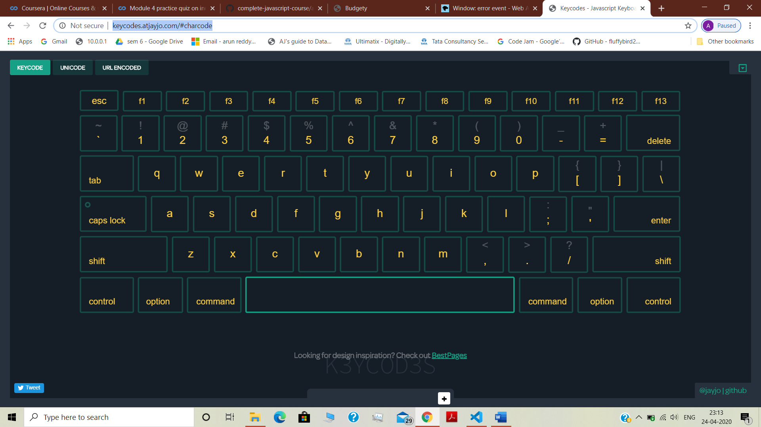

Event Refrence’s :: <https://developer.mozilla.org/en-US/docs/web/events> (describes all about the event’s takes place)

**position**

A [DOMString](https://developer.mozilla.org/en-US/docs/Web/API/DOMString) representing the position relative to the element; must be one of the following strings:

* 'beforebegin': Before the element itself.
* 'afterbegin': Just inside the element, before its first child.
* 'beforeend': Just inside the element, after its last child.
* 'afterend': After the element itself.

**text**

The string to be parsed as HTML or XML and inserted into the tree.

<!-- **beforebegin** -->

**<p>**

<!-- **afterbegin** -->

foo

<!-- **beforeend** -->

**</p>**

<!-- **afterend** -->

.splice 🡺 is used to remove/ deleted an element from the data structure

* The original array is affected
* It return the list of element deleted from the original array
* var array = [1,2,3,4,5,6];
* console.log(`original array ${array}`) // 123456
* console.log("splice array",array.splice(2,1)); // 3
* console.log(" array after splice",...array) // 12456

.slice 🡺 provide a copy of an array

* The original is not affected
* It returns the content copy list of the element from the original array
* var array = [1,2,3,4,5,6];
* console.log(`original array ${array}`);//123456
* console.log("splice array”, array.slice(2));//3456
* console.log(" array after splice",...array)//123456

.split 🡺 is used to split the value based on the character we passed thru it in to array format