CO5

*PGM1:*

f1=open("firstfile.txt","r")

ff=f1.readlines()

print(ff)

*OUTPUT:*

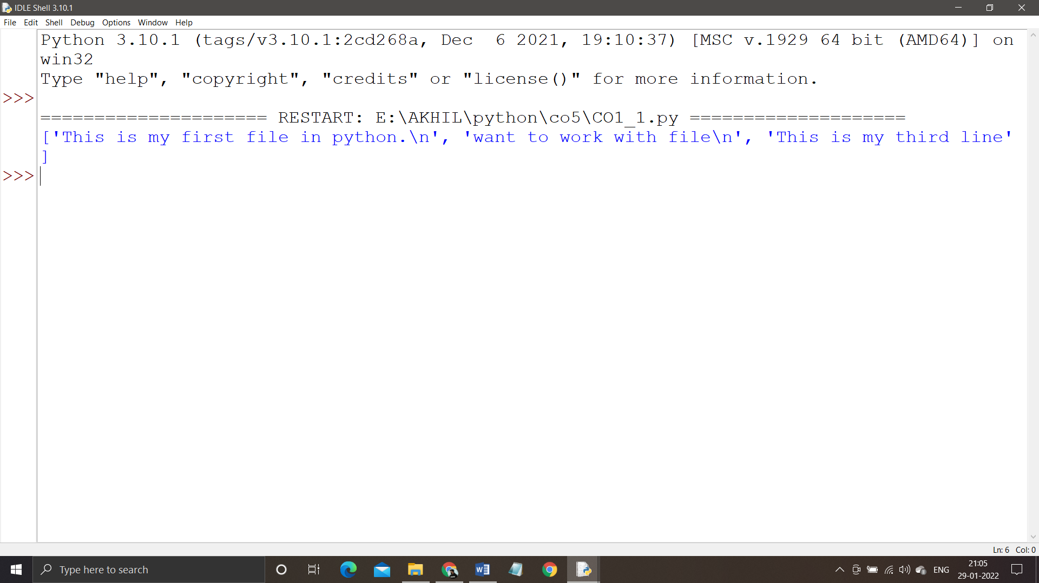

*PGM2:*

f1=open("firstfile.txt","r")

ff=f1.readlines()

with open("odd.txt","w") as f2:

for x in range(0,len(ff)):

if(x%2!=0):

f2.write(ff[x])

*OUTPUT:*

