CREDIT CARD FRAUD DETECTION
End-to-End Data Engineering Pipeline Flow
Purpose. This guide explains how transaction data travels from the Kaggle source file to a Snowflake fraud-risk queue for analyst review. The scope is data ingestion, transformation, feature engineering, validation, orchestration, and analytics—not fraud-model training.
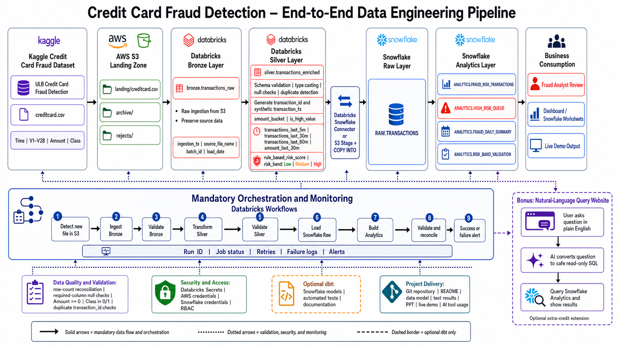
Figure 1. Required pipeline architecture and Databricks Workflows orchestration.

At a Glance
Kaggle CSV → AWS S3 → Databricks Bronze → Databricks Silver → Snowflake Raw → Snowflake Analytics → Analyst / Dashboard
Data Source  Kaggle creditcard.csv | Processing and Storage  S3, Databricks, Snowflake | Business Outcome  High-risk queue, daily summary, demo

Step-by-Step Data Flow
1. Source dataset — Download the ULB Credit Card Fraud Detection dataset from Kaggle. The file contains Time, V1–V28, Amount, and Class. Class is the known fraud label used for validation.
2. AWS S3 landing zone — Upload creditcard.csv to landing/ in the S3 bucket. Archive successfully processed files in archive/ and place invalid or rejected records in rejects/.
3. Databricks Bronze ingestion — A Databricks job reads the S3 file and writes bronze.transactions_raw. The source columns are preserved and audit columns are added: ingestion_ts, source_file_name, batch_id, and load_date.
4. Bronze validation — Check that the source row count equals the Bronze row count, required columns exist, and the input schema is valid. Stop the workflow if this checkpoint fails.
5. Databricks Silver transformation — Clean and enrich Bronze data into silver.transactions_enriched. Cast data types, check nulls, detect duplicates, generate transaction_id, create a synthetic transaction timestamp from Time, and route invalid records to S3 rejects/.
6. Fraud-risk feature engineering — Create amount_bucket, is_high_value, 5/30/60-minute transaction counts, 30-minute rolling amount, rule_based_risk_score, and Low/Medium/High risk_band. The dataset has no real card or account ID, so rolling features must be global time-window features or use clearly labelled synthetic demonstration IDs.
7. Silver validation — Confirm valid data types, no duplicate transaction IDs, Amount >= 0, Class is 0 or 1, required analytics columns are populated, and Bronze-to-Silver counts reconcile.
8. Snowflake Raw load — Transfer enriched Silver data through the Databricks Snowflake Connector or an S3 stage with COPY INTO. Store the result in RAW.TRANSACTIONS.
9. Snowflake Analytics build — Create ANALYTICS.FRAUD_RISK_TRANSACTIONS, ANALYTICS.HIGH_RISK_QUEUE, ANALYTICS.FRAUD_DAILY_SUMMARY, and ANALYTICS.RISK_BAND_VALIDATION.
10. Business consumption — Fraud analysts review the High-Risk Queue, teams use Snowflake Worksheets or a dashboard for daily summaries, and the live demo traces a single transaction from the source file to its final risk result.

Mandatory Orchestration and Monitoring
Databricks Workflows is mandatory. It controls the sequence below so that a downstream task starts only after the upstream task succeeds.
- Detect a new file in S3 landing/.
- Ingest the file into Bronze and validate Bronze.
- Transform Bronze into Silver and validate Silver.
- Load RAW.TRANSACTIONS in Snowflake.
- Build Snowflake analytics objects.
- Run final validation and row-count reconciliation.
- Record run ID, status, start/end time, retries, failure logs, and alerts.
- Mark the workflow successful or send a failure alert.

Validation, Security, and Deliverables
Data quality checks  Row-count reconciliation; required-column null checks; Amount >= 0; Class in 0/1; duplicate transaction_id checks; at least one automated test. | Security and access  Use Databricks Secrets or AWS Secrets Manager for AWS and Snowflake credentials. Apply role-based access control.
Optional dbt  Use dbt, if implemented, for Snowflake transformation models, automated tests, and documentation. | Project delivery  Git repository, README, data model, architecture diagram, test results, presentation deck, live demo, and AI tool usage write-up.

Demo Narrative
“We upload creditcard.csv to S3. Databricks ingests it into Bronze, cleans and enriches it in Silver, validates every stage, loads Snowflake Raw, builds analyst-ready analytics tables, and automatically orchestrates the full sequence through Databricks Workflows. Analysts then review the High-Risk Queue and daily risk summary.”

Bonus Extension: Natural-Language Query Website
This is an optional extra-credit extension within the same fraud-detection project. It is built only after the core pipeline is working and reads from Snowflake Analytics tables; it does not replace the required analyst queue or dashboard.
1. User question — A user types a plain-English question, for example: “Show today’s highest-risk transactions.”
2. Safe SQL generation — An AI service converts the question into read-only SQL using only approved analytics tables and views.
3. Snowflake query and results — The website runs the approved query against Snowflake Analytics and displays a table, chart, or short answer to the user.

