HPC-CCP Deliverable 03
Group: Akif Jawad (23i-0583) | Saim Ahmad (23i-0781) | Faran Azam (23i-0075)

Previous Implementation
In deliverable 1, it was analysed to find which of the functions were supposed to be implemented on the gpu. Based on this, the identified functions were implemented onto the gpu. After some code tweaking, a speed up of around 1.73 times was achieved for the entire program.

Follow through
Following the Naive gpu implementation, it was aimed to optimise the code even further with multiple different techniques taught throughout the course. These techniques were implemented stand alone as well as together to achieve the highest level of speed up. The techniques were used and implemented after identifying the limitations in the code inhibiting the speed up to reach its full potential.

Limitations (Problems)
- Large number of cudamemcpy() calls
- Uncoalesced memory accesses
- Independant Memory (opposite of shared memory)
- Convolve Kernel in global memory (moved to constant memory)

Optimizations

Communication Optimization
Before:
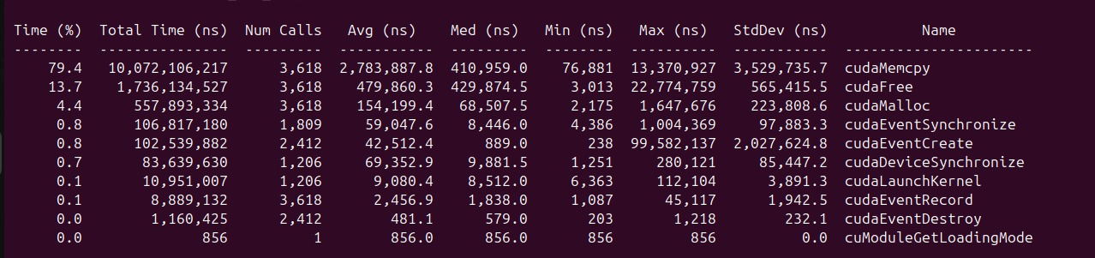
After Optimisation:
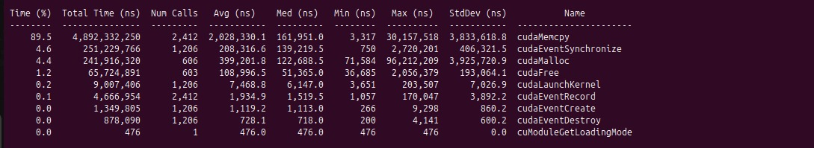

Coalesced Memory
The thought process to implement this was to take the matrix transpose for coalesced memory access in both the convolvevert() and convolvehoriz() functions for easier memory access; The convolvehoriz() was successfully implemented however convolvevert() was not as successful so we moveed towards shared memory.

Shared Memory
Sent the image frames to shared memory. This increased the speed of accessing frames and brought an overall speed up in the process.

Convolve kernel transferred to constant memory
Convolve kernel was only required for reading and not writing. Hence, it was moved to constant memory which improved and optimised our code.
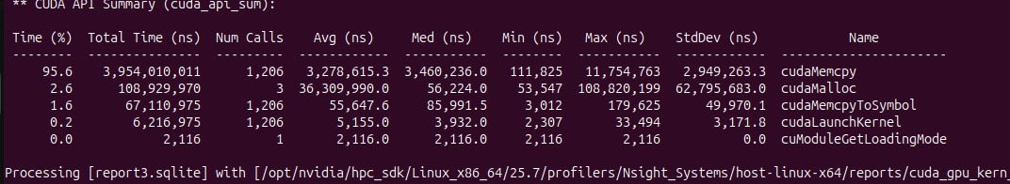

fwrite() Calls
Through debugging it was identified that the fwrite calls called repeatedly increasing program time, which was also optimised to reduce fwrite calls.

Launch Configurations
After testing various launch configurations, (32,8) provided the best results.

Speed up
Track features time on cpu:
Track features time on gpu:
Speed up = 81289.998 / 7493.039
= 10.85x

