STYLE HUB MENS FASHION E-COMMERCE PLATFORM
23CS54C – MODERN WEB TECHNOLOGIES
Submitted by
AKILANETHRAN 2403957610421121
In partial fulfillment for the award of the degree
of
BACHELOR OF ENGINEERING
in
COMPUTER SCIENCE AND ENGINEERING

NATIONAL ENGINEERING COLLEGE
(An Autonomous Institution affiliated to Anna University, Chennai)
K.R.NAGAR, KOVILPATTI - 628503
OCTOBER - 2026

NATIONAL ENGINEERING COLLEGE
(An Autonomous Institution affiliated to Anna University, Chennai)
K.R.NAGAR, KOVILPATTI - 628503
BONAFIDE CERTIFICATE
This is to certify that this project report, “Style Hub A Mens Fashion E-commerce Platform”, is the bonafide work of AKILANETHRAN (2403957610421121) who carried out the project work under my supervision.
Course Instructor/Guide
Submitted to the 23CS54C – MODERN WEB TECHNOLOGIES Viva-Voce examination held at National Engineering College, K.R.Nagar, Kovilpatti on ____________
Internal Examiner Co Examiner

TABLE OF CONTENTS
Chapter | Title | Page
1 | Introduction | 4
2 | Objectives | 5
3 | Description | 6
4 | Class Diagram | 8
5 | Table Structures | 9
6 | ER Diagram | 16
7 | Tech Stack and Architecture | 17
8 | Modules | 18
9 | Conclusion | 54
CHAPTER 1

INTRODUCTION
Online fashion shopping gives customers access to many products, but choosing a suitable garment from pictures and product descriptions can still be difficult. A shopper must compare price, size, appearance, availability, and matching pieces while moving between multiple pages. A conventional catalogue provides the product record but does little to connect the selection, purchase, and personal styling decisions. StyleHub addresses this need through one men fashion web application that brings those activities together.
The system allows a registered user to browse a catalogue, inspect product details, view recently accessed items, save favourites, manage a cart, and purchase individual products, a coordinated outfit, or cart contents. It also adds social features: users can find friends, share selected wishlist products privately, and exchange reactions and comments. A rule based recommendation component suggests complementary garments for eligible products, while a deterministic chatbot answers common product and shopping questions. These two components use defined application logic rather than a trained conversational model.
For supported garments, StyleHub can send a customer photograph and a product garment image to a separate local FASHN VTON service and display the resulting virtual try-on image. This feature depends on the Python service, its model weights, and available hardware. The core shopping application continues to provide catalogue and purchase functions even when try-on is unavailable. Settings cover language, appearance, and notification preferences. An administrator has a restricted dashboard for product updates and operational summaries.
The application is implemented with a React and Vite frontend, a Node.js and Express REST API, and an SQLite database. JWT authentication identifies the user on protected requests, while the database records products, carts, purchases, social relationships, notifications, and try-on results. Optional provider integrations support Google sign-in and purchase communication when configured. This report documents the implemented modules, their data structures and APIs, and the interfaces to be illustrated by screenshots during final submission.
CHAPTER 2

OBJECTIVES
• To provide secure registration, login, profile management, and protected user and administrator pages.
• To offer a men fashion catalogue with product details, stock, prices, and recently accessed items.
• To support size aware cart management, applicable rewards, checkout, and purchase history.
• To let users save favourites and revisit products without repeating a catalogue search.
• To allow users to connect with friends and privately share selected wishlist products.
• To record reactions and comments on shared selections for collaborative style decisions.
• To generate rule based complementary outfit suggestions for eligible products.
• To answer common product and shopping questions through a deterministic assistant.
• To offer virtual try-on for supported garments through a local Python service when available.
• To maintain notification records and user communication preferences.
• To give administrators a restricted dashboard for metrics, users, purchases, and product updates.
• To support English, Tamil, and Hindi interface options with a saved language choice.
• To keep user purchases and social records separated by authenticated account.
CHAPTER 3

DESCRIPTION
StyleHub is a full stack men fashion application consisting of the following major functional areas. Each area is connected through the same user account and product catalogue.

User Authentication and Access Control
Registration and sign-in establish an account identity. Passwords are checked against stored hashes, and a JWT protects customer API requests. Profile editing and username completion support account maintenance, including Google-created accounts when that integration is configured. An ADMIN role controls access to the management dashboard.

Product Discovery and Personal Shopping
The catalogue displays product names, descriptions, images, categories, prices, stock, and applicable virtual try-on support. Product detail pages expose purchase, cart, wishlist, and outfit suggestion actions. Recently accessed records help a signed-in shopper return to previously viewed products. The cart retains selected products, sizes, and quantities before checkout.

Purchase and Communication
The purchase functions handle a single product, a coordinated combination, or all eligible cart items. They create purchase and purchase item records, calculate totals and applicable cart rewards, and update stock. A purchase history page lets the customer review saved transactions. In-app notifications and channel delivery records support purchase communication; external email, SMS, or WhatsApp delivery depends on configured providers.

Social Wishlist and Style Assistance
Wishlists store favourites separately from a cart. A user can send a friend request, accept a connection, share selected products, and respond to a shared list with feedback. Rule based outfit suggestions pair eligible products with complementary items. The chatbot answers defined styling and catalogue questions using application rules and product data.

Virtual Try-On and Administration
Virtual try-on accepts an uploaded customer image for a supported garment and requests local FASHN VTON inference. The generated result is saved for later viewing when the service succeeds. The administrator dashboard provides restricted access to metrics, catalogue updates, user summaries, purchase records, and try-on activity.

Technology and Preferences
React and Vite render the browser interface, Express exposes REST endpoints, and SQLite persists the application data. The interface supports English, Tamil, and Hindi and keeps the selected language. Appearance and communication settings are stored through the user settings flow. The optional Google sign-in and messaging integrations require separate provider credentials.
CHAPTER 4

CLASS DIAGRAM
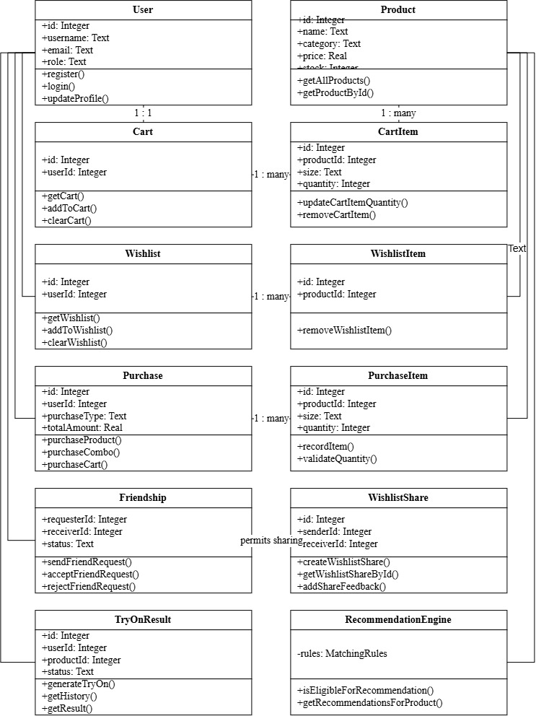
Fig 4.1 StyleHub Class Diagram
The class diagram shows the principal entities of StyleHub, including users, products, carts, purchases, wishlists and try-on results, together with their attributes and the relationships between them.
CHAPTER 5

TABLE STRUCTURES
The following entries are taken from the SQLite schema in the project. PK denotes primary key and FK denotes foreign key. The tables store both shopping records and optional feature records such as social sharing and virtual try-on.

Cart
Field | Type | Key | Required
id | INTEGER | PK | No
user_id | INTEGER | FK → users | Yes
created_at | DATETIME |  | No
updated_at | DATETIME |  | No

Cart Items
Field | Type | Key | Required
id | INTEGER | PK | No
cart_id | INTEGER | FK → cart | Yes
product_id | INTEGER | FK → products | Yes
size | TEXT |  | No
quantity | INTEGER |  | Yes
created_at | DATETIME |  | No
updated_at | DATETIME |  | No

Friendships
Field | Type | Key | Required
id | INTEGER | PK | No
requester_id | INTEGER | FK → users | Yes
receiver_id | INTEGER | FK → users | Yes
status | TEXT |  | Yes
created_at | DATETIME |  | No
updated_at | DATETIME |  | No

Notification Deliveries
Field | Type | Key | Required
id | INTEGER | PK | No
purchase_id | INTEGER | FK → purchases | Yes
user_id | INTEGER | FK → users | Yes
channel | TEXT |  | Yes
status | TEXT |  | Yes
recipient | TEXT |  | No
provider_message_id | TEXT |  | No
error_message | TEXT |  | No
event_type | TEXT |  | No
subject | TEXT |  | No
created_at | DATETIME |  | No

Notifications
Field | Type | Key | Required
id | INTEGER | PK | No
user_id | INTEGER | FK → users | Yes
type | TEXT |  | Yes
title | TEXT |  | Yes
message | TEXT |  | Yes
is_read | INTEGER |  | Yes
created_at | DATETIME |  | No
related_id | INTEGER |  | No

Order Items
Field | Type | Key | Required
id | INTEGER | PK | No
order_id | INTEGER | FK → orders | Yes
product_id | INTEGER | FK → products | Yes
product_name | TEXT |  | Yes
product_image | TEXT |  | No
quantity | INTEGER |  | Yes
unit_price | REAL |  | Yes
discount | REAL |  | Yes
final_price | REAL |  | Yes
size | TEXT |  | No

Orders
Field | Type | Key | Required
id | INTEGER | PK | No
order_number | TEXT |  | Yes
user_id | INTEGER | FK → users | Yes
status | TEXT |  | Yes
subtotal | REAL |  | Yes
discount_total | REAL |  | Yes
shipping_fee | REAL |  | Yes
other_charges | REAL |  | Yes
total_amount | REAL |  | Yes
delivery_address | TEXT |  | Yes
created_at | DATETIME |  | No
updated_at | DATETIME |  | No
delivery_date | DATETIME |  | No
cancelled_at | DATETIME |  | No

Outfit Recommendations
Field | Type | Key | Required
id | INTEGER | PK | No
base_product_id | INTEGER | FK → products | Yes
recommended_product_id | INTEGER | FK → products | Yes
slot_type | TEXT |  | Yes
reason | TEXT |  | No
created_at | DATETIME |  | No
combination_signature | TEXT |  | No

Products
Field | Type | Key | Required
id | INTEGER | PK | No
name | TEXT |  | Yes
description | TEXT |  | No
brand | TEXT |  | No
category | TEXT |  | Yes
cloth_type | TEXT |  | No
color | TEXT |  | No
price | REAL |  | Yes
original_price | REAL |  | Yes
discount_percent | REAL |  | No
stock | INTEGER |  | Yes
status | TEXT |  | Yes
image | TEXT |  | No
garment_image | TEXT |  | No
vton_supported | INTEGER |  | No
vton_garment_category | TEXT |  | No
created_at | DATETIME |  | No
updated_at | DATETIME |  | No

Purchase Items
Field | Type | Key | Required
id | INTEGER | PK | No
purchase_id | INTEGER | FK → purchases | Yes
product_id | INTEGER | FK → products | Yes
quantity | INTEGER |  | Yes
unit_price | REAL |  | Yes
created_at | DATETIME |  | No
size | TEXT |  | No

Purchases
Field | Type | Key | Required
id | INTEGER | PK | No
user_id | INTEGER | FK → users | Yes
purchase_type | TEXT |  | Yes
total_amount | REAL |  | Yes
delivery_name | TEXT |  | Yes
delivery_phone | TEXT |  | Yes
delivery_address | TEXT |  | Yes
delivery_city | TEXT |  | Yes
delivery_state | TEXT |  | Yes
delivery_pincode | TEXT |  | Yes
created_at | DATETIME |  | No
cart_reward_percent | REAL |  | No
cart_reward_amount | REAL |  | No
subtotal | REAL |  | No

Recently Accessed
Field | Type | Key | Required
id | INTEGER | PK | No
user_id | INTEGER | FK → users | Yes
product_id | INTEGER | FK → products | Yes
accessed_at | DATETIME |  | No

Try On Results
Field | Type | Key | Required
id | INTEGER | PK | No
user_id | INTEGER | FK → users | Yes
product_id | INTEGER | FK → products | Yes
user_image_path | TEXT |  | Yes
garment_image_path | TEXT |  | Yes
generated_image_path | TEXT |  | No
category | TEXT |  | Yes
status | TEXT |  | Yes
created_at | DATETIME |  | No

Users
Field | Type | Key | Required
id | INTEGER | PK | No
username | TEXT |  | No
full_name | TEXT |  | Yes
email | TEXT |  | Yes
password_hash | TEXT |  | Yes
role | TEXT |  | Yes
phone | TEXT |  | No
age | INTEGER |  | No
address | TEXT |  | No
city | TEXT |  | No
state | TEXT |  | No
pincode | TEXT |  | No
created_at | DATETIME |  | No
updated_at | DATETIME |  | No
google_id | TEXT |  | No
avatar_url | TEXT |  | No
email_notifications | INTEGER |  | Yes
sms_notifications | INTEGER |  | Yes
whatsapp_notifications | INTEGER |  | Yes
theme_preference | TEXT |  | Yes
language_preference | TEXT |  | Yes

Wishlist Feedback
Field | Type | Key | Required
id | INTEGER | PK | No
share_id | INTEGER | FK → wishlist_shares | Yes
user_id | INTEGER | FK → users | Yes
reaction | TEXT |  | No
comment | TEXT |  | No
created_at | DATETIME |  | No
updated_at | DATETIME |  | No

Wishlist Items
Field | Type | Key | Required
id | INTEGER | PK | No
wishlist_id | INTEGER | FK → wishlists | Yes
product_id | INTEGER | FK → products | Yes
created_at | DATETIME |  | No

Wishlist Share Items
Field | Type | Key | Required
id | INTEGER | PK | No
share_id | INTEGER | FK → wishlist_shares | Yes
product_id | INTEGER | FK → products | Yes
created_at | DATETIME |  | No

Wishlist Shares
Field | Type | Key | Required
id | INTEGER | PK | No
sender_id | INTEGER | FK → users | Yes
receiver_id | INTEGER | FK → users | Yes
wishlist_id | INTEGER | FK → wishlists | No
share_type | TEXT |  | No
created_at | DATETIME |  | No

Wishlists
Field | Type | Key | Required
id | INTEGER | PK | No
user_id | INTEGER | FK → users | Yes
created_at | DATETIME |  | No
updated_at | DATETIME |  | No
CHAPTER 6

ER DIAGRAM
The accompanying editable Draw.io ER diagram summarizes the main foreign key relationships. It includes shopping, social, recommendation, notification, recently accessed, and try-on data. One user can have many purchases; each purchase has many purchase items. Product references link items and feature records back to the catalogue.
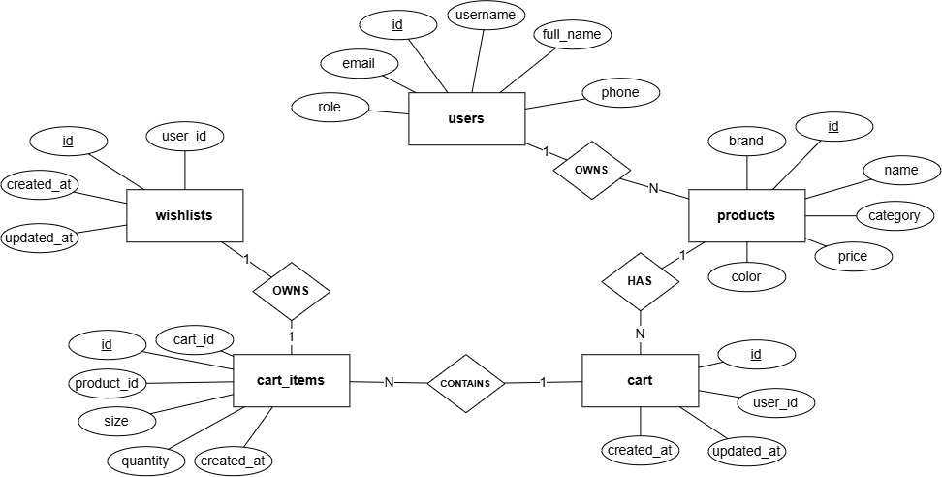
Fig 6.1 StyleHub Entity Relationship Diagram
The ER diagram shows how users, products, carts, purchases, wishlists, outfit recommendations, notifications, recently accessed records and try-on results are linked through foreign keys.
CHAPTER 7

TECH STACK AND ARCHITECTURE

Technology Stack
Layer | Technology | Purpose
Frontend | React 18, Vite 6, React Router | Screens, navigation, user state
Backend | Node.js, Express 4 | REST API and business rules
Database | SQLite, better-sqlite3 | Persistent records and transactions
Authentication | JWT, bcryptjs | Tokens and password hashing
Virtual try-on | Python Flask, FASHN VTON 1.5 | Local image inference for supported garments
Communication | Nodemailer, Twilio SMS, Meta WhatsApp API | Optional configured purchase notifications

Architecture Overview
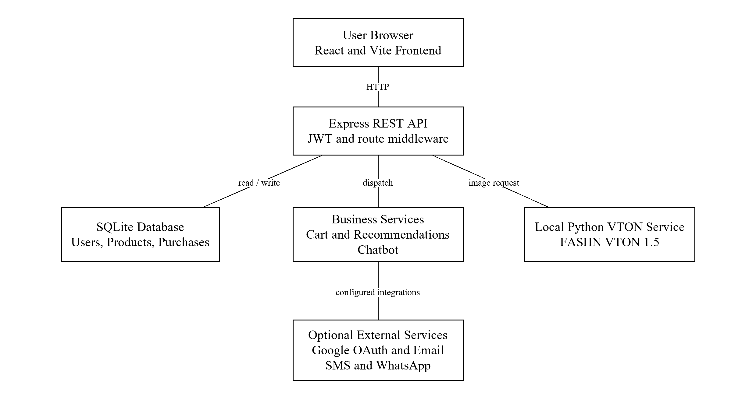
Fig 7.1 StyleHub System Architecture
The architecture diagram shows the React frontend, the Express REST API, the SQLite database, and the optional local VTON service and communication providers, along with the direction of requests between them.
CHAPTER 8

MODULES

8.1 Folder Structure
stylehub/stylehub-frontend contains React pages, reusable components, contexts, and frontend service calls. stylehub/stylehub-backend contains Express routes, controllers, services, middleware, database configuration, and tests. The VTON service is housed under the backend vton-service directory.
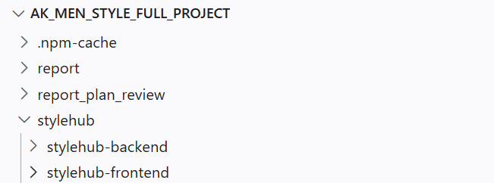
Fig 8.1 Overall Project Folder
The project folder view shows the top-level separation between the frontend and backend applications. Keeping these areas distinct makes it easier to find the browser interface, server APIs and related project resources. The structure shown here is the starting point for the more detailed module folders below.
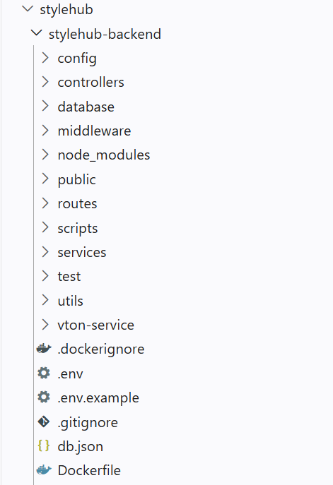 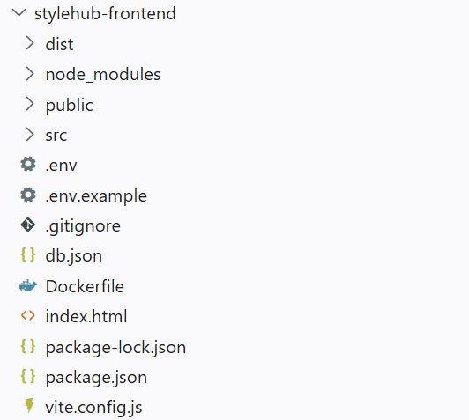
Fig 8.2 Backend Folder Structure Fig 8.3 Frontend Folder Structure
The backend folder groups its configuration, routes, controllers and services around API responsibilities, while the frontend folder holds the React application and its assets. These side-by-side views explain where the report’s browser pages and server operations are implemented. They also make the boundary between the two parts of the project visible.

8.2 Authentication and Profile
Purpose and Scope
This module creates and maintains customer identities, protects account data and distinguishes an administrator from a customer. It covers registration, credential login, profile updates, username availability and the optional Google sign-in path.

Functional Requirements
• Register a user with required identity and credential details.
• Authenticate a returning user and return a signed session token.
• Load and update only the signed-in user profile.
• Allow a Google-created account to complete a unique username.
• Restrict administrator pages and APIs to accounts with the ADMIN role.

Non Functional Requirements
• Store password hashes rather than plaintext passwords.
• Reject missing or invalid tokens on protected endpoints.
• Keep one user from editing another user profile.

API Design
Method | Endpoint | Purpose
POST | /api/auth/register | Create customer account
POST | /api/auth/login | Authenticate credentials
GET | /api/auth/me | Return current user
PUT | /api/auth/profile | Update current profile
GET | /api/auth/check-username | Check username availability
PUT | /api/auth/username | Save username

DB Design
Table | Key Fields | Use
users | id; email; username; password_hash; role | Account and access attributes

Screenshots

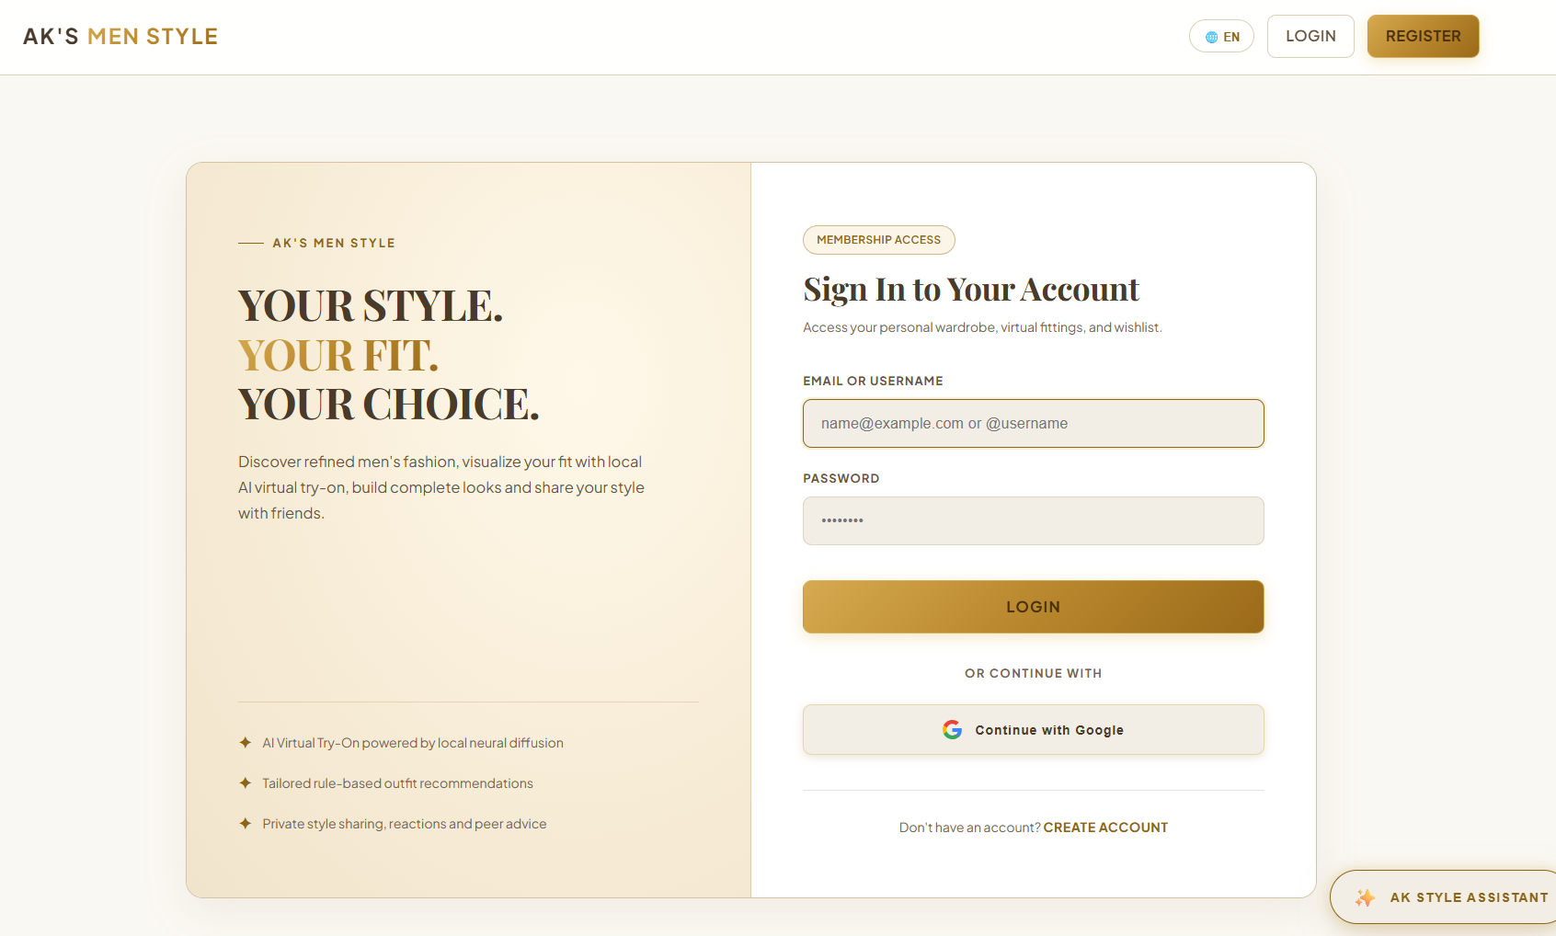
Fig 8.4 Login Page
The login page accepts account credentials and, on success, receives the JWT that opens protected pages. Google sign-in is available only when its provider credentials are configured. The form keeps account access separate from the shopping pages until authentication succeeds. This screenshot also illustrates the entry point for users who already have an account and need to return to their saved activity.
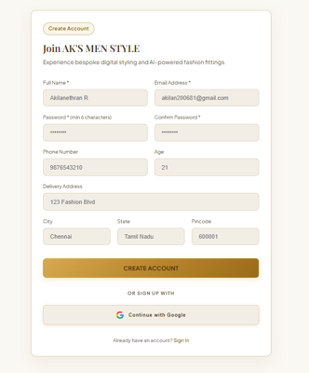
Fig 8.5 Registration Page
The registration page collects the details needed to create a customer account, such as name, email and password, and submits them to the registration API. Required identity and contact fields are grouped in one form so the customer can create a profile before using protected features. The page also offers a path back to sign-in for an existing account.

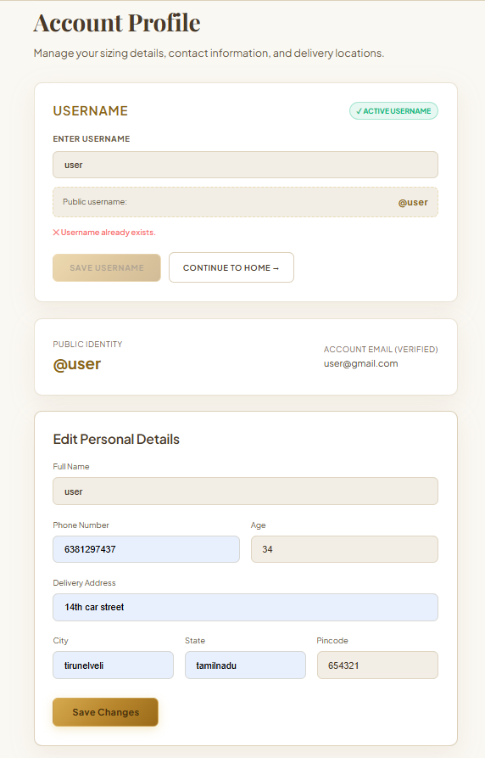
Fig 8.6 Profile and Username Page
The profile page lets the signed-in user review and update personal and delivery details, and lets a Google-created account complete a unique username. The account information is organized into editable sections rather than mixed with shopping controls. A completed username identifies the account in the application and enables access to account-specific features.
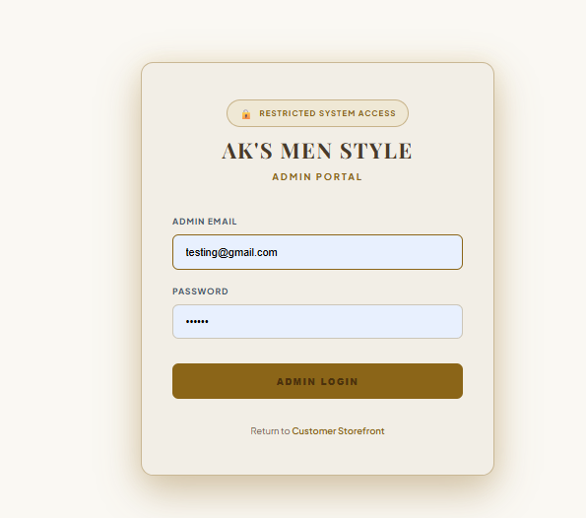
Fig 8.7 Admin Login Page
Administrators sign in through a dedicated page. Access to the management dashboard is granted only to accounts that hold the ADMIN role. Its separate sign-in form makes the administrative entry point clear. The screen itself is only the first step; the backend role check determines whether the signed-in account may use management functions.

8.3 Product Catalogue and Recent Views

Purpose and Scope
This module presents products for discovery and records which items a signed-in user has viewed. Product records include catalogue text, images, prices, available stock and virtual try-on eligibility.

Functional Requirements
• List available catalogue products for browsing.
• Open a detail page for a selected product.
• Show category, price, discount, stock and garment imagery.
• Record and retrieve recently accessed items per user.
• Expose the selected product to cart, wishlist, recommendation and try-on actions.

Non Functional Requirements
• Return a clear result for an invalid product identifier.
• Keep recently accessed records isolated by user.
• Show stock and availability from persisted product data.

API Design
Method | Endpoint | Purpose
GET | /api/products | List products
GET | /api/products/:id | Get product detail
GET | /api/recently-accessed | List user recent views
POST | /api/recently-accessed | Record a product view

DB Design
Table | Key Fields | Use
products | id; name; category; price; stock; image; vton_supported | Catalogue source
recently_accessed | user_id; product_id; accessed_at | Per-user viewing history

Screenshots
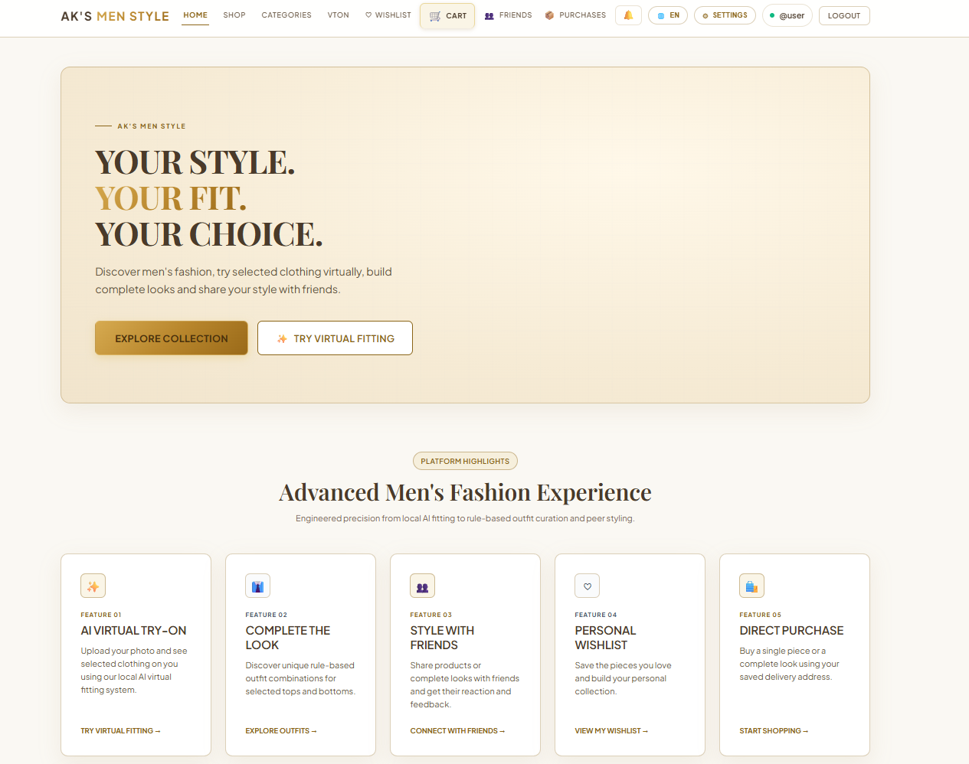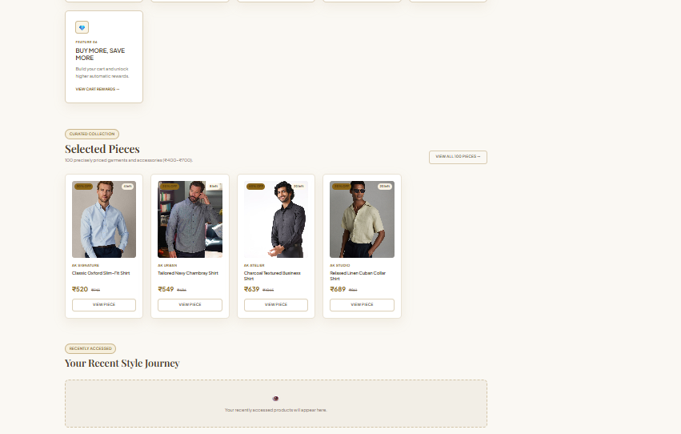
Fig 8.8 Home and Featured Products
The home page introduces the store and highlights featured products, giving shoppers an entry point into the catalogue. The featured-product area provides visual cards that connect the introductory page to individual product records. A shopper can use the navigation and featured selections to continue toward the full catalogue.
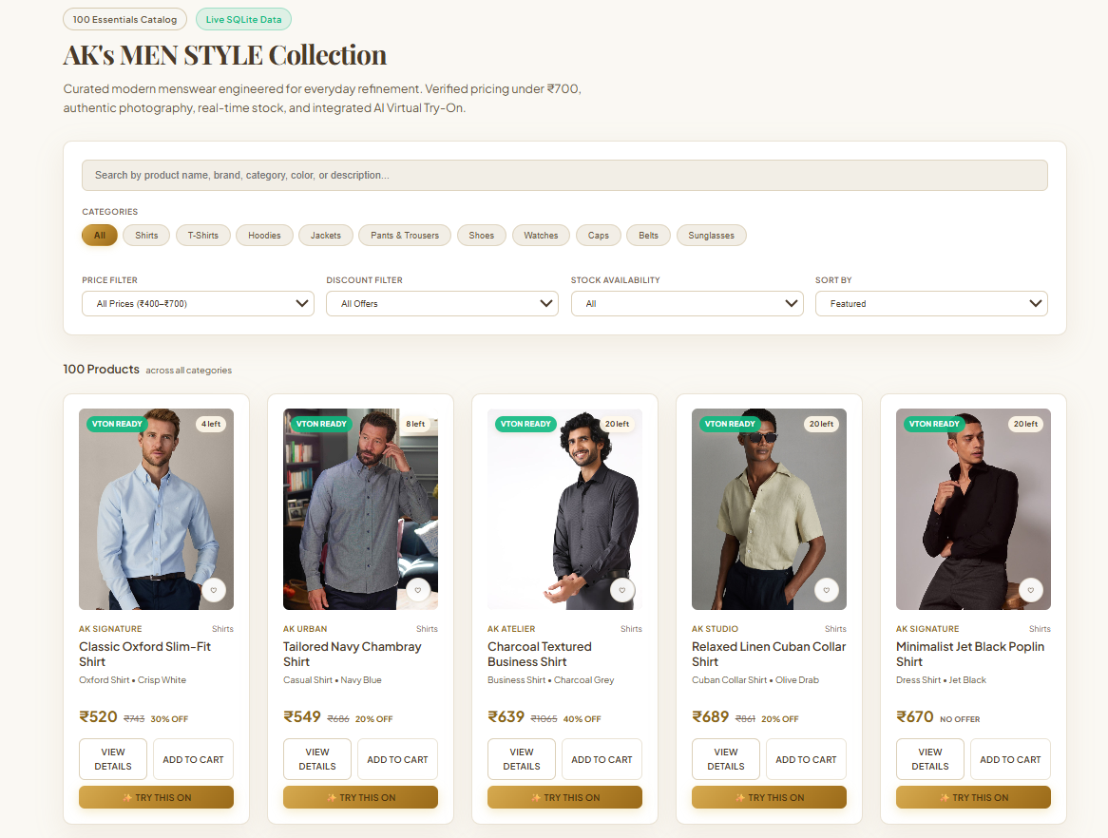

Fig 8.9 Product Catalogue
The catalogue lists available products with their image, name, price and stock information so that shoppers can browse and open a product. Filters and product cards help narrow the visible selection before a product is opened. Each card gives enough information for an initial comparison, while the detail page holds the size and purchase controls.
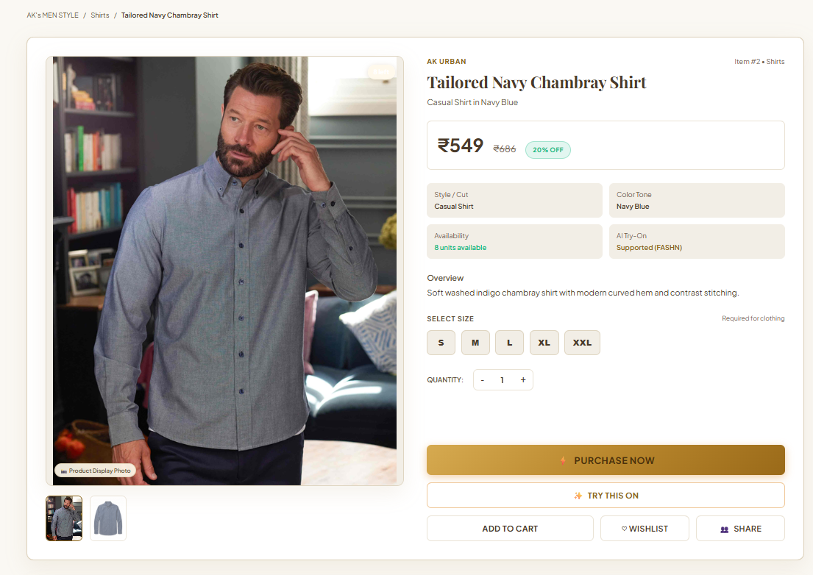
Fig 8.10 Product Detail
The detail page presents a single product with its price, sizes and stock, and offers cart, wishlist, purchase and outfit-suggestion actions. Opening it also updates the recently accessed list. The larger garment image and product information support a closer inspection before a decision is made. The available actions connect the same catalogue record to the customer’s shopping and styling workflows.

8.4 Cart and Checkout

Purpose and Scope
The cart groups selected products and size variants before purchase. Checkout calculates an order summary and applies the implemented Buy More Save More reward when the cart meets its rule conditions.

Functional Requirements
• Add a product and available size to the active cart.
• Change quantity or remove an item.
• Show subtotal and applicable cart reward.
• Submit eligible cart contents with delivery details.
• Create purchase records and decrement stock through the purchase path.

Non Functional Requirements
• Do not allow nonpositive quantities or unavailable stock to be purchased.
• Keep each cart tied to its authenticated owner.
• Perform stock and purchase updates in the same transaction where implemented.

API Design
Method | Endpoint | Purpose
GET | /api/cart | Read current cart
POST | /api/cart/items | Add a cart item
PUT | /api/cart/items/:productId | Change quantity
DELETE | /api/cart/items/:productId | Remove item
POST | /api/purchases/cart | Purchase cart contents

DB Design
Table | Key Fields | Use
cart | id; user_id | One active user cart
cart_items | cart_id; product_id; size; quantity | Selected variants
purchases | user_id; total_amount; cart_reward_amount | Completed purchase
purchase_items | purchase_id; product_id; size; quantity | Purchased units

Screenshots
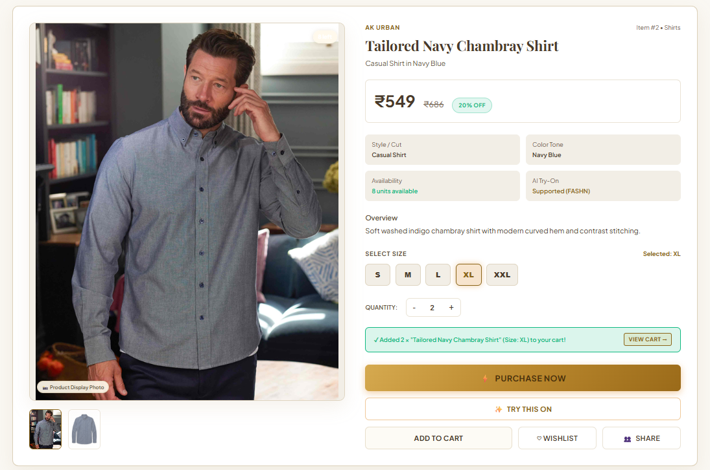
Fig 8.11 Add to Cart Action
A product is added to the cart after an available size is chosen. The cart is stored against the authenticated account. This view shows the purchase options on the product page and the size selection needed for a clothing item. The user can confirm the selection before continuing to the cart and later checkout.
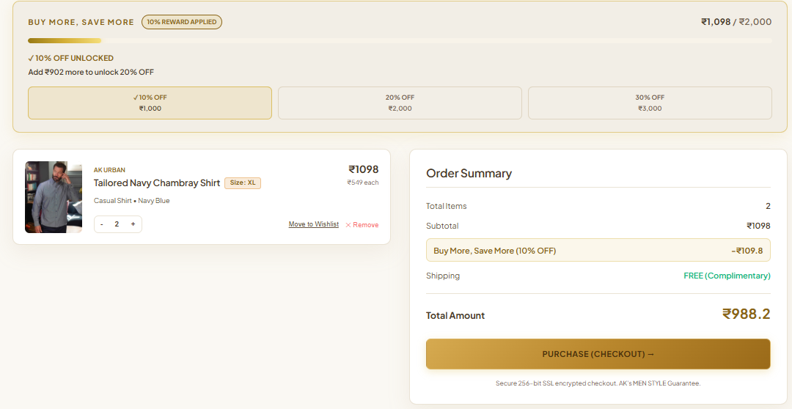
Fig 8.12 Cart Items and Quantities
The cart page lists the selected products with their size and quantity, and allows a quantity to be changed or an item to be removed. Item rows keep the chosen product and quantity visible while the order is being prepared. The shopper can revise the cart rather than restarting the product search when a size or quantity needs adjustment.
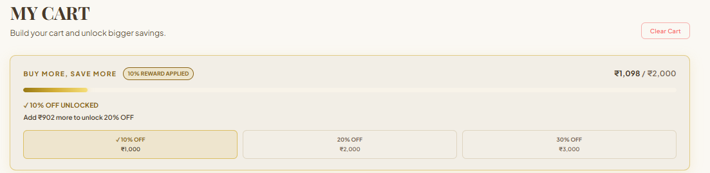
Fig 8.13 Cart Reward Summary
The summary shows the cart subtotal together with any applicable cart reward before the shopper proceeds to checkout. The reward area makes the applicable discount visible next to the order calculation. This helps the shopper understand the amount payable before moving from cart review to the secure checkout form.
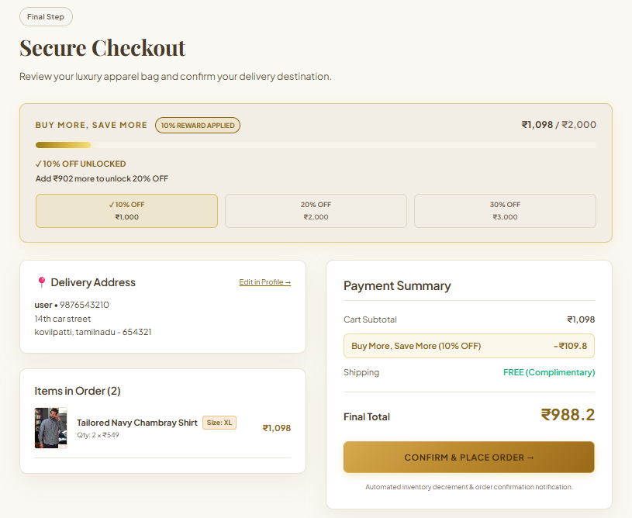
Fig 8.14 Checkout Page
The checkout page collects delivery details and shows the computed total before the cart purchase is submitted. Delivery information and the payment summary are presented together for a final review. The screenshot documents the last customer-facing step before the backend creates the purchase and its item records.

8.5 Purchases and Notifications

Purpose and Scope
This module stores completed purchases and their items, provides a purchase history and records in-app and configured channel communication. Single, combination and cart purchase routes share the saved purchase model.

Functional Requirements
• Purchase one product, an eligible combination or a cart.
• Save delivery data, purchased items and final amount.
• Retrieve a signed-in user purchase history and one purchase detail.
• Create and mark in-app notifications as read.
• Record email, SMS or WhatsApp delivery attempts and outcomes.

Non Functional Requirements
• Return only purchases owned by the authenticated user.
• Preserve the purchase when a nonessential external notification fails.
• Record configured, disabled or failed delivery states accurately.

API Design
Method | Endpoint | Purpose
POST | /api/purchases/product | Purchase one product
POST | /api/purchases/combo | Purchase an outfit
POST | /api/purchases/cart | Purchase cart
GET | /api/purchases | List own purchases
GET | /api/purchases/:id | Get one purchase
GET | /api/notifications | List notifications
PUT | /api/notifications/:id/read | Mark notification read

DB Design
Table | Key Fields | Use
purchases | id; user_id; purchase_type; total_amount | Purchase header
purchase_items | purchase_id; product_id; quantity; unit_price | Purchase lines
notifications | user_id; title; message; is_read | In-app messages
notification_deliveries | purchase_id; channel; status; provider_message_id | Channel delivery audit

Screenshots
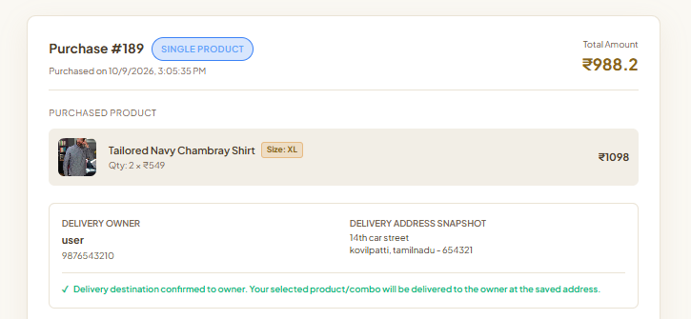
Fig 8.15 Purchase History
The purchase history page lists the customer’s saved transactions with their items, delivery details and totals. Each purchase entry connects an order identifier with its amount and saved delivery information. This gives the customer a record of completed transactions without exposing the purchases of another signed-in user.
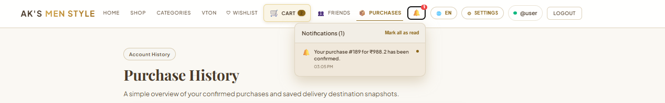
Fig 8.16 Notification Panel
The notification panel shows in-app messages created by purchases and other events, so the user can review what has happened and mark messages as read. The panel keeps short status messages accessible from the main interface. It distinguishes the in-app record from an external email, SMS or WhatsApp attempt, which may have a separate delivery outcome.

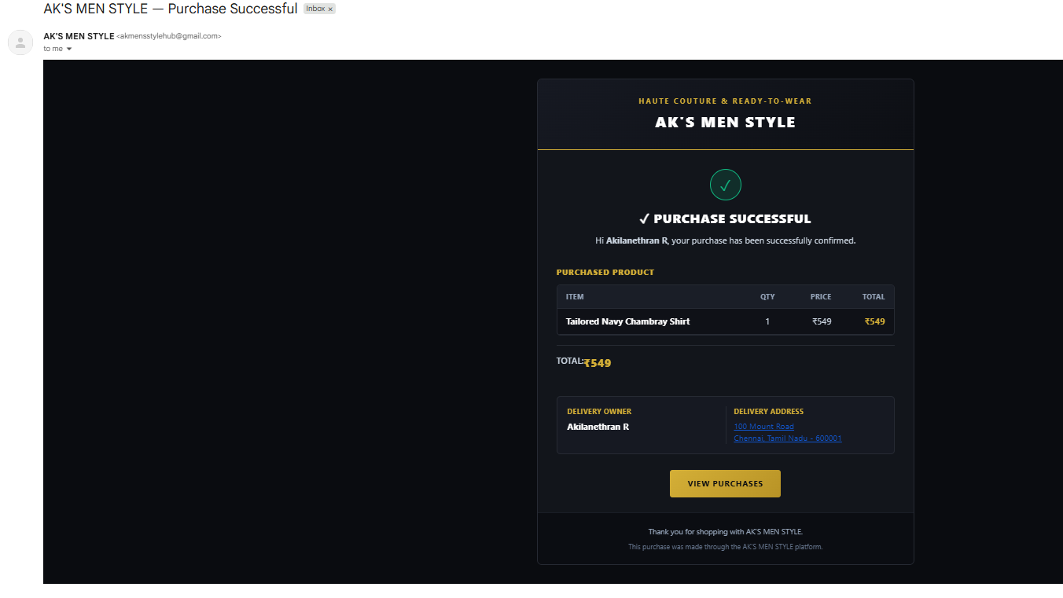
Fig 8.17 Gmail Notification
The purchase receipt delivered by email, showing the item details and delivery details of the order. The email presents the purchase as a readable receipt with the confirmed products and recipient details. It is an example of the customer communication produced after the purchase record is created.
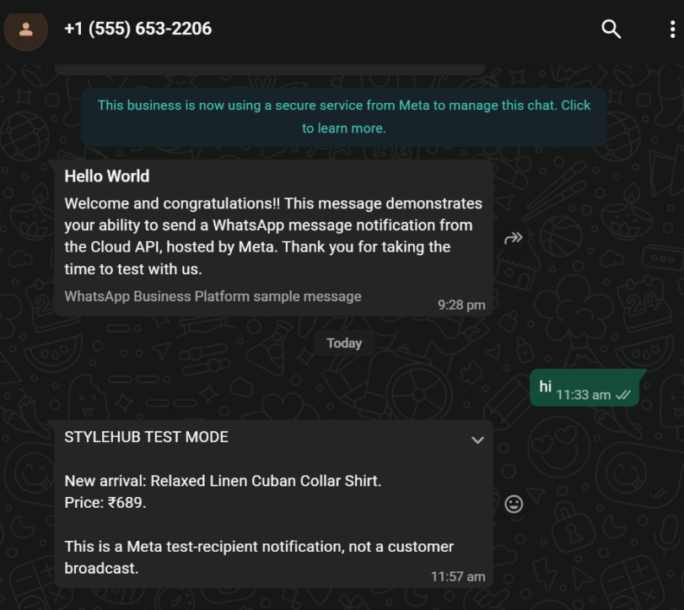
Fig 8.18 WhatsApp Notification
The screenshot shows a Meta sample message confirming the test API connection, followed by a StyleHub new-product alert with its price. This is a test-recipient notification rather than a purchase receipt or customer broadcast. It illustrates the WhatsApp channel and the kind of product information a configured integration can deliver.

8.6 Wishlist and Friends

Purpose and Scope
The social module stores favourite products, manages friendship requests and supports private sharing with feedback. It keeps a user wishlist separate from the cart and limits sharing to permitted relationships.

Functional Requirements
• Add and remove products from the personal wishlist.
• Find users and send, accept or reject friend requests.
• Share selected wishlist items with a friend.
• Open received shares and respond with reactions or comments.
• Show the current friend and request lists.

Non Functional Requirements
• Restrict wishlist and share access to the relevant user.
• Prevent duplicate wishlist items and invalid self-friendship records.
• Show a clear status for pending, accepted or rejected requests.

API Design
Method | Endpoint | Purpose
GET | /api/wishlist | Read wishlist
POST | /api/wishlist/items | Save product
DELETE | /api/wishlist/items/:productId | Remove product
POST | /api/friends/request | Send request
POST | /api/friends/:id/accept | Accept request
POST | /api/wishlist/shares | Create share
POST | /api/wishlist/shares/:shareId/feedback | Add feedback

DB Design
Table | Key Fields | Use
wishlists; wishlist_items | user_id; wishlist_id; product_id | Saved products
friendships | requester_id; receiver_id; status | Relationship state
wishlist_shares; wishlist_share_items | sender_id; receiver_id; share_id; product_id | Private share
wishlist_feedback | share_id; user_id; reaction; comment | Feedback

Screenshots
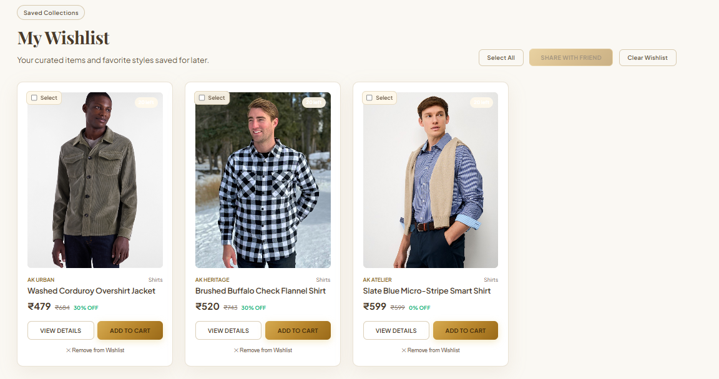
Fig 8.19 Personal Wishlist
The personal wishlist keeps saved favourites separate from the cart, so products can be revisited without a new catalogue search. Product cards let the user compare saved items and reopen a product from the personal list. Saving an item here does not place it in the cart or create a purchase; those actions remain separate.
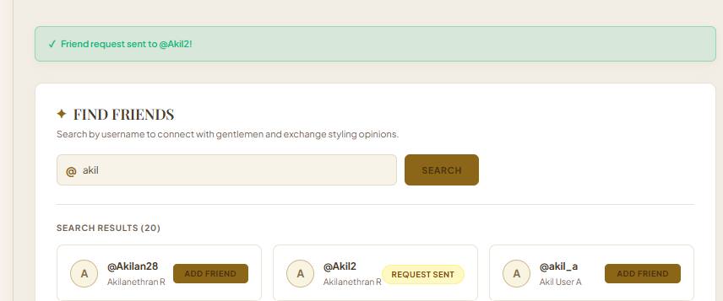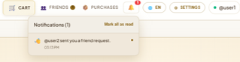
Fig 8.20 Friend Search and Requests
Users search for other members and send, accept or reject friend requests from this page. Search results show matching accounts and the available request action. A sent request remains distinct from an accepted friendship, so sharing controls are based on the relationship state.
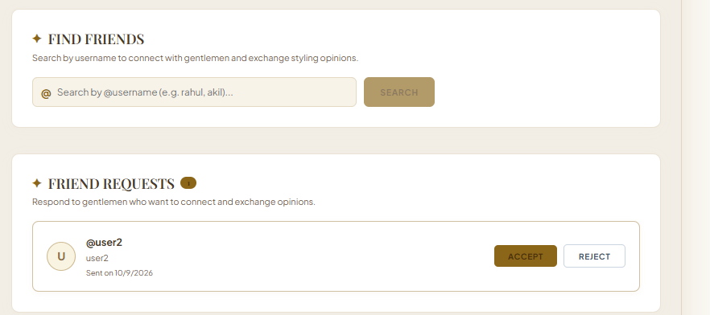
Fig 8.21 Friends List
The friends list shows accepted connections with whom selected wishlist products can be shared. Accepted connections are shown together in the social area. This gives the user a clear destination for selecting a friend before sharing one or more saved fashion items.
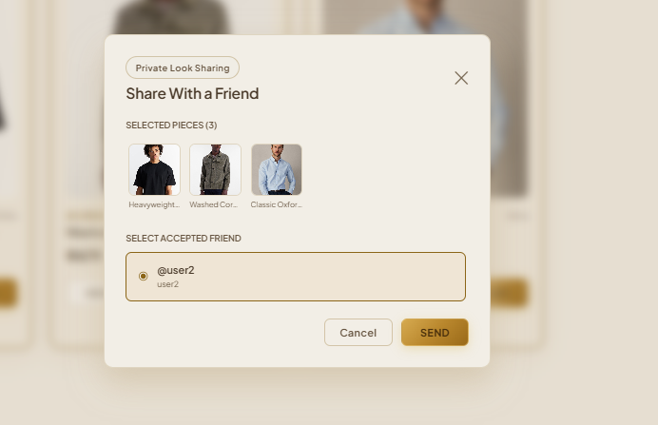
Fig 8.22 Shared Wishlist
A shared wishlist shows the products a friend has chosen to share, and lets the receiver respond to the share. The dialog identifies the chosen wishlist products and the intended recipient before the share is sent. Keeping that choice explicit helps prevent a personal wishlist from being exposed to the wrong account.
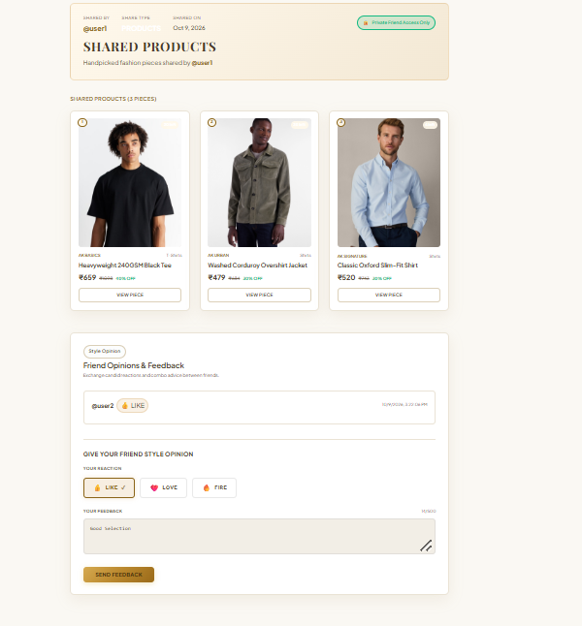
Fig 8.23 Share Feedback
The receiver of a share can leave a reaction and a comment. Both are stored against the share and are visible for the collaborative style decision. The screenshot also shows how the receiver can evaluate the shared selection in context. Reactions and written feedback support a style discussion without altering the sender’s original wishlist items.

8.7 Recommendations and Chatbot

Purpose and Scope
` This module helps shoppers discover complementary clothing and obtain quick fashion guidance. Outfit suggestions use predefined matching rules for eligible products; the chatbot uses deterministic intent and catalogue logic.

Functional Requirements
• Return a complementary outfit for an eligible base product.
• Explain when an item is not eligible for outfit recommendations.
• Answer supported product, stock, styling and shopping questions.
• Offer links or guidance toward relevant catalogue and try-on pages.

Non Functional Requirements
• Do not present rule based results as learned predictions.
• Use current catalogue values when answering product questions.
• Return a controlled response for unsupported input or invalid product IDs.

API Design
Method | Endpoint | Purpose
GET | /api/recommendations/product/:productId | Get outfit suggestions
POST | /api/chatbot/message | Get assistant response

DB Design
Table | Key Fields | Use
products | id; category; color; price; stock | Current catalogue source
outfit_recommendations | base_product_id; recommended_product_id; slot_type | Stored recommendation links

Screenshots
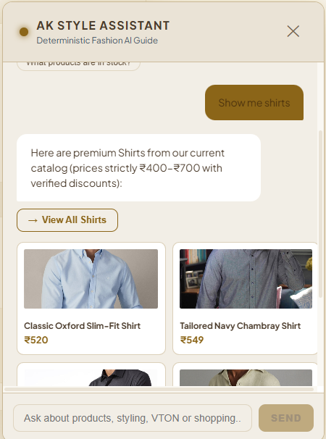
Fig 8.24 Style Assistant Chat
The style assistant answers common product and shopping questions using application rules and catalogue data, and offers suggested prompts to start a conversation. The conversation panel presents suggested prompts and product-oriented responses in one place. Its answers are based on application rules and catalogue information rather than on a trained conversational model.
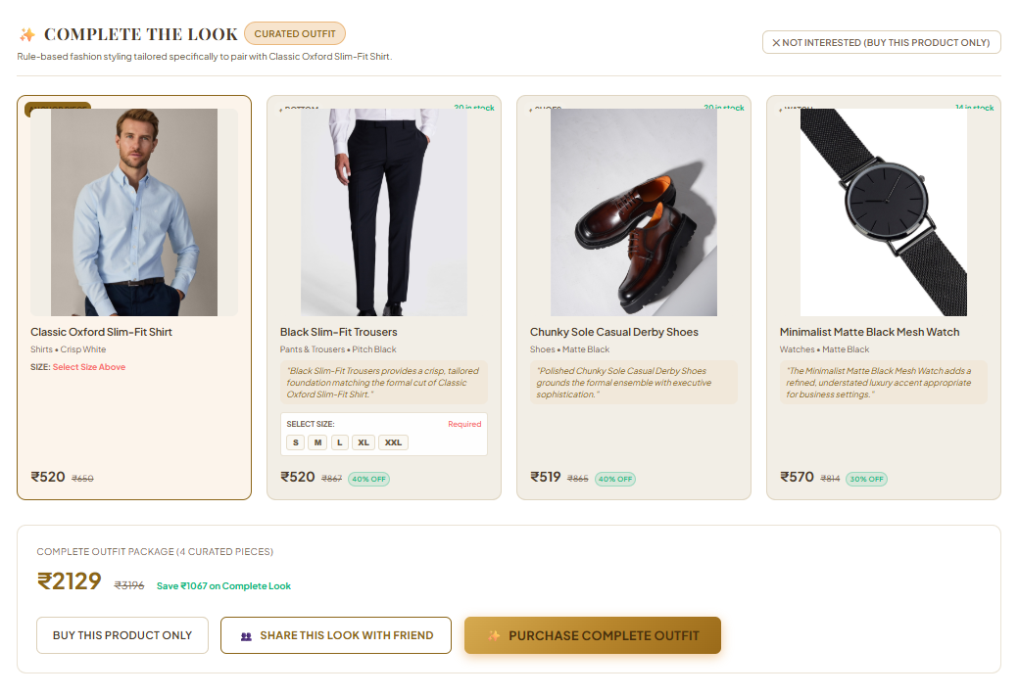
Fig 8.25 Outfit Recommendation
Opening an eligible product shows suggested matching garments with their images, names and prices. The recommendation area displays complementary products beside the selected base item. Images, prices and product names let the shopper inspect the suggested outfit before choosing any additional action.

8.8 Virtual Try-On

Purpose and Scope
Virtual try-on generates a preview of a supported garment on a user photograph. The Express API validates the request and contacts a separate local Python service that runs FASHN VTON 1.5.
The React frontend (VirtualTryOnPage.jsx and vtonService.js) guides photo upload and result viewing. The Express backend (vtonRoutes.js) validates requests and saves results in SQLite, and a Python service in vton-service runs the model. Garment-only images ensure that only the selected item changes.

Functional Requirements
• Report whether the local try-on service is ready.
• Accept a supported photo and selected product.
• Check garment eligibility and local garment image availability.
• Send the person and garment images to the Python service.
• Save and retrieve successful results for the authenticated user.

Non Functional Requirements
• Reject unsupported image types and missing uploads.
• Accept JPG, JPEG, PNG or WEBP files up to 15 MB; protect results by owner.
• Report service unavailability without blocking ordinary shopping.

Implementation Details
Frontend Implementation
• Page: VirtualTryOnPage.jsx in the frontend pages folder opens from the Virtual Try-On navigation link or from the Try This On action on a product.
• Service calls: vtonService.js in the frontend services folder sends the status, try-on and history requests through the shared API service with the JWT.
• Readiness: the page checks /api/vton/status when it loads and shows the FASHN VTON v1.5 engine badge and the CUDA Online indicator. If the service is not ready, the page reports it and ordinary shopping continues.
• Guided steps: a progress strip shows Your Photo, Selected Garment, Generate Virtual Try-On and AI Generated Result.
• Upload panel: Step 1 accepts JPG, JPEG, PNG or WEBP photographs up to 15 MB, shows a preview with a Change Photo button and keeps Generate disabled until a photograph is ready.
• Garment panel: Step 2 shows the garment-only image with brand, name, category, type, colour, price and stock status.
• Result panel: Step 3 shows the generated image with Download Result, Try Another Photo and Try Another Product actions.
Backend Implementation
• Routes: vtonRoutes.js exposes the four /api/vton endpoints and identifies the user from the JWT on protected requests.
• Upload handling: Multer receives the multipart request and rejects missing files, unsupported image types and files above the size limit.
• Validation: the handler confirms that the product exists, that vton_supported is set, that a vton_garment_category is present and that the local garment image is available.
• Inference: Express sends the person and garment images to the Flask service in the backend vton-service directory, which runs FASHN VTON 1.5 and returns the output image.
• Persistence: the output path is saved in try_on_results with user_id, product_id, user_image_path, garment_image_path, generated_image_path, category, status and created_at.
• Error handling: an unavailable service, an unsupported garment or a failed generation returns an error response without affecting the cart, purchase or other modules.

API Design
Method | Endpoint | Purpose
GET | /api/vton/status | Check service readiness
POST | /api/vton/try-on | Generate try-on result
GET | /api/vton/history | List own results
GET | /api/vton/results/:id | Get one owned result

DB Design
Table | Key Fields | Use
products | id; garment_image; vton_supported; vton_garment_category | Eligible garment metadata
try_on_results | user_id; product_id; generated_image_path; status | Generated result record

Screenshots
The screenshots follow one complete try-on for each garment type. In every case the user uploads a clear full-body photograph, the selected product appears as a garment-only image, and the generated preview applies only the chosen clothing item to that photograph.
Garment | Brand | Category | Result
Classic Oxford Slim-Fit Shirt | AK Signature | Shirts | Fig 8.28
Denim Shirt | US Polo Assn. | Shirts | Fig 8.30
Black Slim-Fit Trousers | AK Signature | Pants & Trousers | Fig 8.32
Shirt Try-On
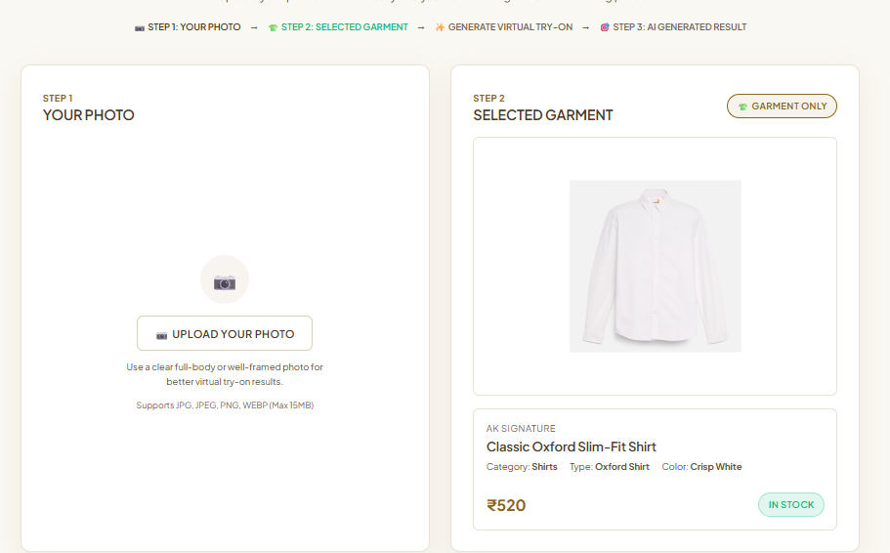
Fig 8.26 Virtual Try-On Entry
The fitting room is shown before a photograph is selected. Its progress strip marks the photo upload as the active first step, while the garment-only shirt image identifies the product chosen for try-on. The upload panel accepts JPG, JPEG, PNG or WEBP images up to 15 MB. Generation remains unavailable until the customer adds a suitable photograph.
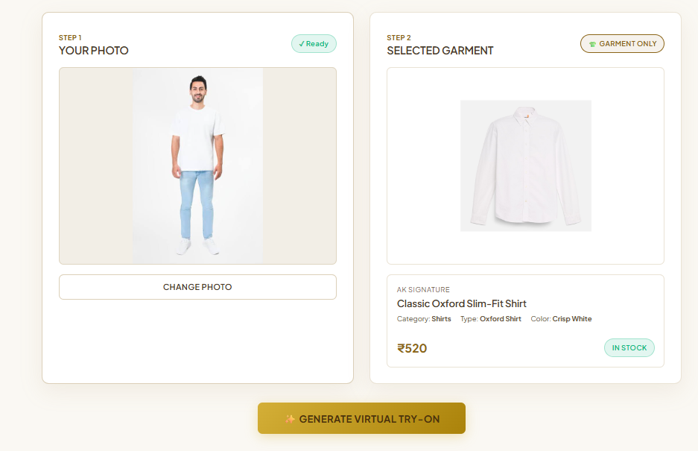
Fig 8.27 Photo and Garment Selection
After the upload, Step 1 shows the Ready status and a Change Photo button. Step 2 shows the garment-only image of the selected shirt with its brand, category, type, colour, price and stock status. The two panels keep the uploaded person photograph separate from the garment reference used for inference. This lets the user verify both inputs before asking the local try-on service to generate a preview.
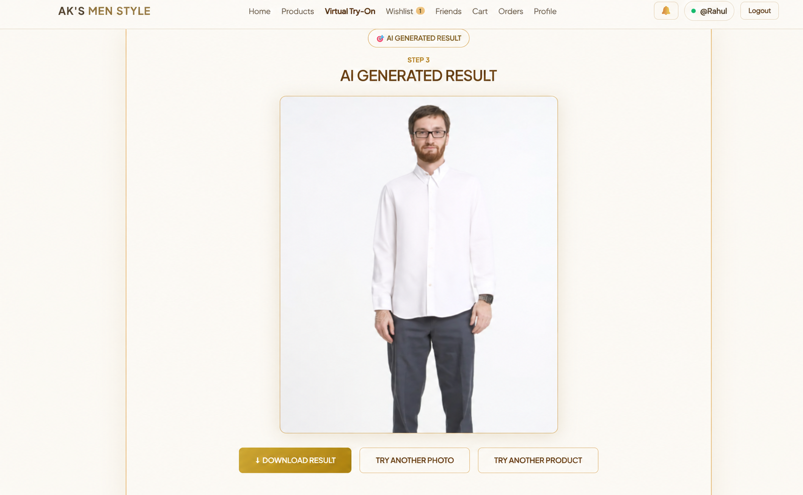
Fig 8.28 Generated Try-On Result
Step 3 shows the generated preview with the selected shirt applied to the uploaded photograph. Download Result, Try Another Photo and Try Another Product let the user save the image or repeat the try-on. The result remains connected to the photograph and selected garment shown in the preceding step. These controls make it possible to keep the output or repeat the process with a different input.
Additional Shirt Example
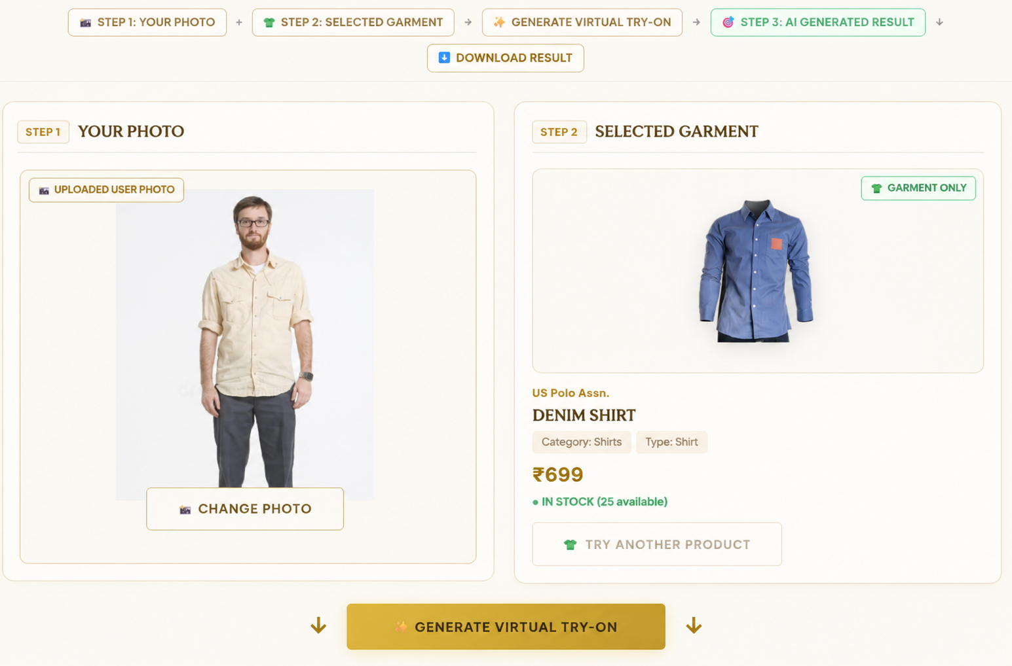
Fig 8.29 Denim Shirt Selected for Try-On
A second shirt example. Step 1 shows the uploaded photograph with its Uploaded User Photo label, and Step 2 shows the US Polo Assn. Denim Shirt with its category, type, price and available stock. The Generate Virtual Try-On button is enabled. This selection view records the second shirt test before generation. Showing the original photo next to the isolated denim shirt makes the intended clothing change clear without changing the person input.
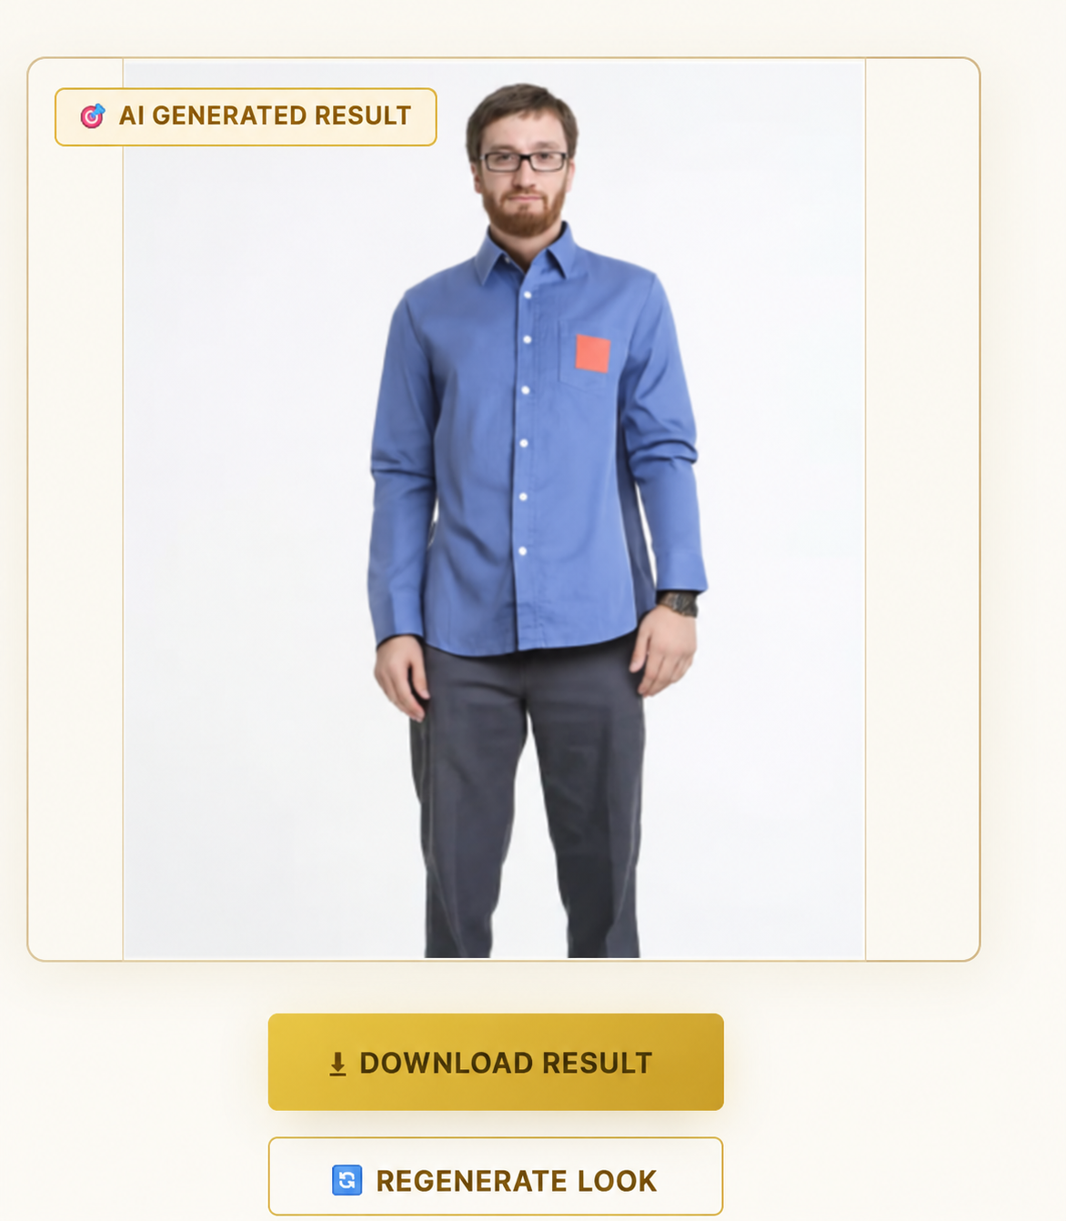
Fig 8.30 Denim Shirt Try-On Result
The generated preview shows the denim shirt on the same photograph. Download Result and Regenerate Look buttons appear below the image so the user can save the result or request another generation. The shirt colour and shape can be compared with the garment-only image from the selection screen. The available actions document how the generated preview can be retained or produced again.
Trousers Try-On
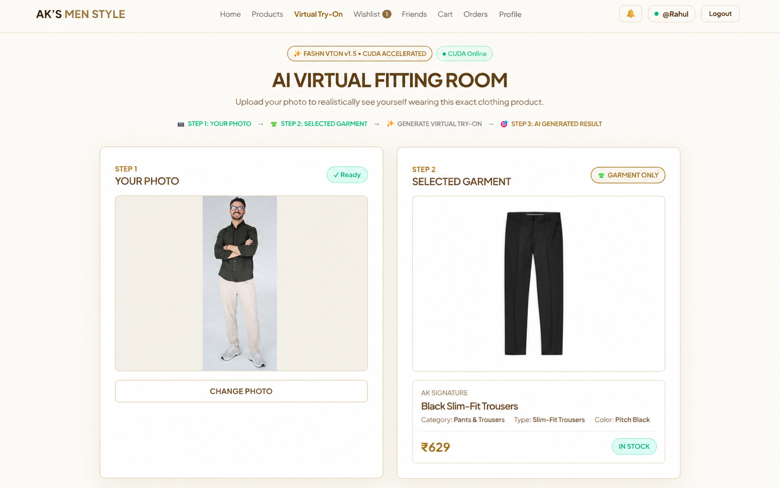
Fig 8.31 Trousers Selected for Try-On
A lower-body example. The Black Slim-Fit Trousers (AK Signature, Pants & Trousers, Pitch Black) appear as a garment-only image beside the uploaded full-body photograph, and the header badges show that the try-on engine is online. This screenshot demonstrates the lower-body input path: the uploaded person is shown beside a trouser-only product image. The product details and service-status badges help confirm that the correct garment and engine are selected.
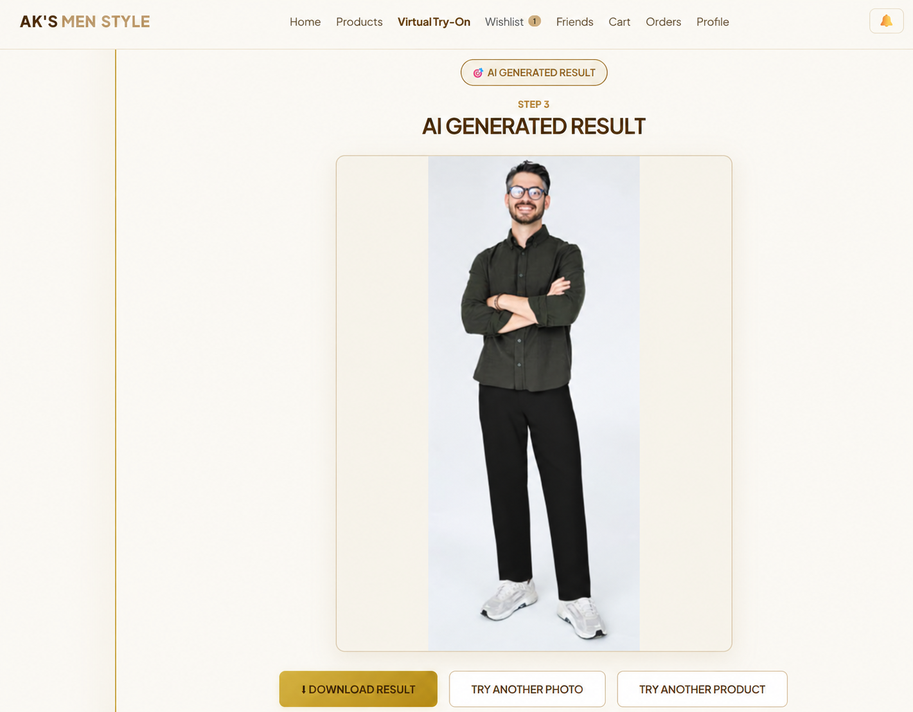
Fig 8.32 Trousers Try-On Result
The generated preview shows the black trousers worn in place of the original pants while the shirt and background from the uploaded photograph are kept. Download Result, Try Another Photo and Try Another Product are available below the result. The result can be compared with the input photograph to see the clothing change while the person and surrounding scene remain recognizable. The controls support saving this preview or beginning another try-on.

8.9 Admin Dashboard

Purpose and Scope
The administrator module provides an account restricted view of catalogue and application activity. It offers summary metrics, users, purchases, virtual try-on activity and limited product updates.

Functional Requirements
• Require an ADMIN role before exposing routes.
• Display metrics and recent activity.
• List products, users and purchases for administration.
• Update supported product fields through the admin route.
• Show virtual try-on and email status information.

Non Functional Requirements
• Enforce the role on the backend even if a page route is hidden.
• Avoid exposing password hashes in user summaries.
• Validate editable product fields before writing them.

API Design
Method | Endpoint | Purpose
GET | /api/admin/metrics | Read dashboard metrics
GET | /api/admin/products | List products
PATCH | /api/admin/products/:id | Update product
GET | /api/admin/users | List users
GET | /api/admin/purchases | List purchases
GET | /api/admin/vton-stats | Read try-on metrics

DB Design
Table | Key Fields | Use
users | id; role; email | Role and user summary
products | id; price; stock; status | Catalogue editing
purchases | id; user_id; total_amount | Purchase summary
try_on_results | user_id; product_id; status | Try-on activity

Screenshots
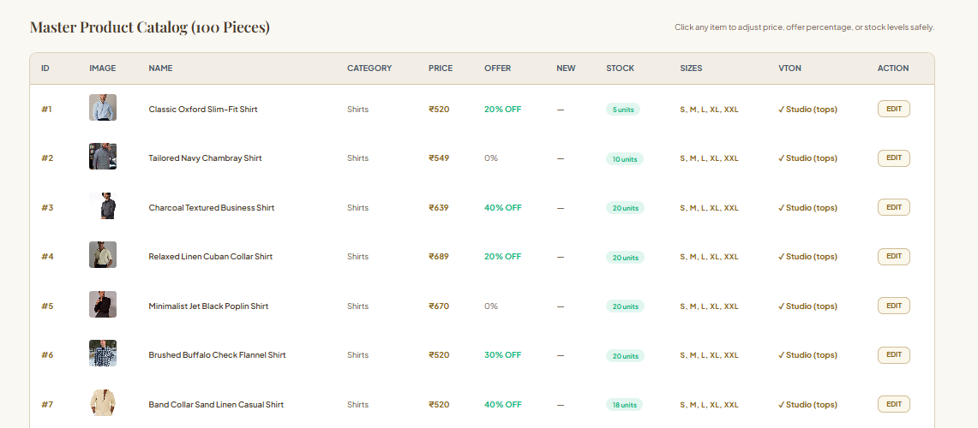
Fig 8.33 Admin Product Management
The product management view lets the administrator review the catalogue and update product records such as price and stock. Product rows bring catalogue information and edit actions into one administrative view. The screenshot illustrates that management is performed on stored products rather than through the customer-facing detail page.
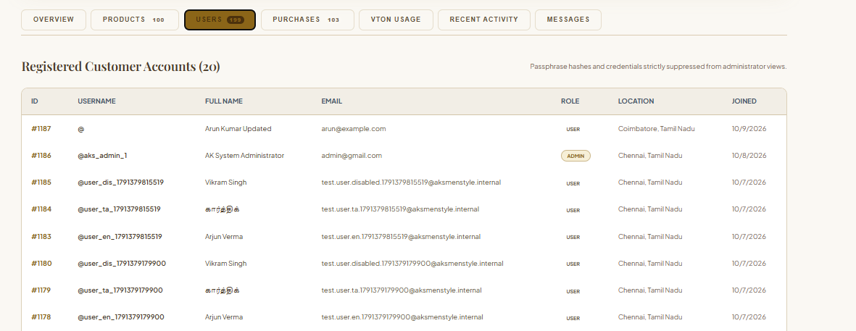
Fig 8.34 Admin Users and Purchases
These views list registered customer accounts and purchase records so that the administrator can review them. Separate lists allow the administrator to inspect account records and completed purchases. These views support oversight of the same users and transactions that appear in the application’s customer workflows.
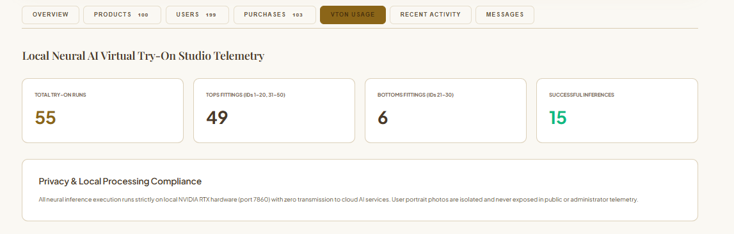
Fig 8.35 Admin Activity and VTON Metrics
The metrics panel summarises recent virtual try-on activity, including attempt counts and their results, for administrative monitoring. The counts provide a compact status summary instead of showing individual generated images. This helps an administrator see recent usage and outcomes while keeping the detailed try-on flow on the customer side.

8.10 Theme and Language Preferences

Purpose and Scope
This module lets a user select the application appearance, interface language and communication preferences. English, Tamil and Hindi translations are provided by the current frontend language context.

Functional Requirements
• Switch between available interface languages.
• Remember the selected language across page reloads.
• Change among supported appearance themes.
• Save email, SMS and WhatsApp notification preferences.
• Retrieve the signed-in user settings and delivery history.

Non Functional Requirements
• Use a supported language when a saved value is unavailable.
• Keep account preferences associated with the correct user.
• Avoid claiming external delivery from a preference switch alone.

API Design
Method | Endpoint | Purpose
GET | /api/settings | Read user settings
PUT | /api/settings | Save preferences
GET | /api/settings/notifications/history | Read delivery history

DB Design
Table | Key Fields | Use
users | id; theme_preference; language_preference; email_notifications; sms_notifications; whatsapp_notifications | Saved user choices
notification_deliveries | user_id; channel; status | Communication history

Screenshots

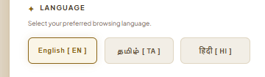
Fig 8.36 Language Selector
The language selector switches the interface between English, Tamil and Hindi, and the choice is remembered when the page is reloaded. The three choices are visible together so a user can select a preferred interface language. The active choice is indicated in the control, making the current language easy to check before leaving Settings.
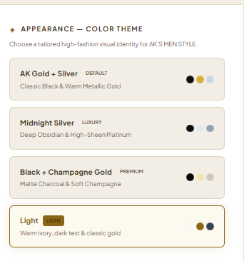
Fig 8.37 Theme Selector
The theme selector changes the appearance of the application between the supported themes and keeps the selection. The available colour themes are presented as separate selectable options. This screen demonstrates the appearance preference control, while the selected theme is also applied across the shopping interface.
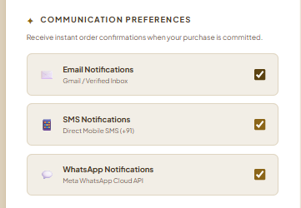
Fig 8.38 Communication Preferences
Email, SMS and WhatsApp notification preferences are switched on or off here and saved to the user account. Each communication channel has its own control, allowing the user to choose which purchase-related notifications are enabled. The preference is saved to the account, but actual delivery still depends on provider configuration.
CHAPTER 9

CONCLUSION
StyleHub combines protected accounts, product discovery, carts and purchases, wishlists, friend sharing, rule-based styling assistance, administration and saved preferences in one men’s fashion shopping platform. A shared product catalogue and authenticated account connect these modules, while React pages, Express APIs and SQLite records keep customer actions and data organized. Password hashes, role checks and account-scoped queries support the security of shopping and social features.
Virtual try-on adds an optional preview through a separate local FASHN VTON service, and external sign-in or messaging works only when its provider configuration is available. The current recommender and chatbot use defined rules rather than learned predictions, and SQLite suits the documented single-server project more than heavy concurrent deployment. Within these limits, the implemented modules support a complete path from finding a garment to considering it with friends, trying it on and purchasing it.

9.1 Future Enhancement
Future work could add an online payment gateway and order tracking, migrate the primary database to a server-based system for larger deployments, and improve outfit recommendations using responsibly collected browsing and purchase history. A hosted GPU service could make virtual try-on available beyond a local machine. A broader automated test suite, additional interface languages and more robust provider monitoring would further improve reliability and accessibility. These are proposed enhancements, not features claimed as part of the current implementation.

