STYLE HUB MENS FASHION E-COMMERCE PLATFORM
23CS54C – MODERN WEB TECHNOLOGIES
Submitted by
AKILANETHRAN 24104121
In partial fulfillment for the award of the degree
of
BACHELOR OF ENGINEERING/TECHNOLOGY
in
COMPUTER SCIENCE AND ENGINEERING/ INFORMATION TECHNOLOGY

NATIONAL ENGINEERING COLLEGE
(An Autonomous Institution affiliated to Anna University, Chennai)
K.R.NAGAR, KOVILPATTI - 628503
OCTOBER - 2026

NATIONAL ENGINEERING COLLEGE
(An Autonomous Institution affiliated to Anna University, Chennai)
K.R.NAGAR, KOVILPATTI - 628503
BONAFIDE CERTIFICATE
This is to certify that this project report, “Style Hub A Mens Fashion E-commerce Platform”, is the bonafide work of R AKILANETRAN (24104121) who carried out the project work under my supervision.
Course Instructor/Guide
Submitted to the 23CS54C – MODERN WEB TECHNOLOGIES Viva-Voce examination held at National Engineering College, K.R.Nagar, Kovilpatti on ____________
Internal Examiner Co Examiner
‘

TABLE OF CONTENTS
Chapter | Title
1 | Introduction
2 | Objectives
3 | Description
4 | Class Diagram
5 | Table Structures
6 | ER Diagram
7 | Tech Stack and Architecture
8 | Modules
9 | Conclusion

CHAPTER 1

INTRODUCTION
Online fashion shopping gives customers access to many products, but choosing a suitable garment from pictures and product descriptions can still be difficult. A shopper must compare price, size, appearance, availability, and matching pieces while moving between multiple pages. A conventional catalogue provides the product record but does little to connect the selection, purchase, and personal styling decisions. StyleHub addresses this need through one men fashion web application that brings those activities together.
The system allows a registered user to browse a catalogue, inspect product details, view recently accessed items, save favourites, manage a cart, and purchase individual products, a coordinated outfit, or cart contents. It also adds social features: users can find friends, share selected wishlist products privately, and exchange reactions and comments. A rule based recommendation component suggests complementary garments for eligible products, while a deterministic chatbot answers common product and shopping questions. These two components use defined application logic rather than a trained conversational model.
For supported garments, StyleHub can send a customer photograph and a product garment image to a separate local FASHN VTON service and display the resulting virtual try-on image. This feature depends on the Python service, its model weights, and available hardware. The core shopping application continues to provide catalogue and purchase functions even when try-on is unavailable. Settings cover language, appearance, and notification preferences. An administrator has a restricted dashboard for product updates and operational summaries.
The application is implemented with a React and Vite frontend, a Node.js and Express REST API, and an SQLite database. JWT authentication identifies the user on protected requests, while the database records products, carts, purchases, social relationships, notifications, and try-on results. Optional provider integrations support Google sign-in and purchase communication when configured. This report documents the implemented modules, their data structures and APIs, and the interfaces to be illustrated by screenshots during final submission.
CHAPTER 2

OBJECTIVES
• To provide secure registration, login, profile management, and protected user and administrator pages.
• To offer a men fashion catalogue with product details, stock, prices, and recently accessed items.
• To support size aware cart management, applicable rewards, checkout, and purchase history.
• To let users save favourites and revisit products without repeating a catalogue search.
• To allow users to connect with friends and privately share selected wishlist products.
• To record reactions and comments on shared selections for collaborative style decisions.
• To generate rule based complementary outfit suggestions for eligible products.
• To answer common product and shopping questions through a deterministic assistant.
• To offer virtual try-on for supported garments through a local Python service when available.
• To maintain notification records and user communication preferences.
• To give administrators a restricted dashboard for metrics, users, purchases, and product updates.
• To support English, Tamil, and Hindi interface options with a saved language choice.
• To keep user purchases and social records separated by authenticated account.
CHAPTER 3

DESCRIPTION
StyleHub is a full stack men fashion application consisting of the following major functional areas. Each area is connected through the same user account and product catalogue.

1 User Authentication and Access Control
Registration and sign-in establish an account identity. Passwords are checked against stored hashes, and a JWT protects customer API requests. Profile editing and username completion support account maintenance, including Google-created accounts when that integration is configured. An ADMIN role controls access to the management dashboard.

2 Product Discovery and Personal Shopping
The catalogue displays product names, descriptions, images, categories, prices, stock, and applicable virtual try-on support. Product detail pages expose purchase, cart, wishlist, and outfit suggestion actions. Recently accessed records help a signed-in shopper return to previously viewed products. The cart retains selected products, sizes, and quantities before checkout.

3 Purchase and Communication
The purchase functions handle a single product, a coordinated combination, or all eligible cart items. They create purchase and purchase item records, calculate totals and applicable cart rewards, and update stock. A purchase history page lets the customer review saved transactions. In-app notifications and channel delivery records support purchase communication; external email, SMS, or WhatsApp delivery depends on configured providers.

4 Social Wishlist and Style Assistance
Wishlists store favourites separately from a cart. A user can send a friend request, accept a connection, share selected products, and respond to a shared list with feedback. Rule based outfit suggestions pair eligible products with complementary items. The chatbot answers defined styling and catalogue questions using application rules and product data.

5 Virtual Try-On and Administration
Virtual try-on accepts an uploaded customer image for a supported garment and requests local FASHN VTON inference. The generated result is saved for later viewing when the service succeeds. The administrator dashboard provides restricted access to metrics, catalogue updates, user summaries, purchase records, and try-on activity.

6 Technology and Preferences
React and Vite render the browser interface, Express exposes REST endpoints, and SQLite persists the application data. The interface supports English, Tamil, and Hindi and keeps the selected language. Appearance and communication settings are stored through the user settings flow. The optional Google sign-in and messaging integrations require separate provider credentials.
CHAPTER 4

CLASS DIAGRAM
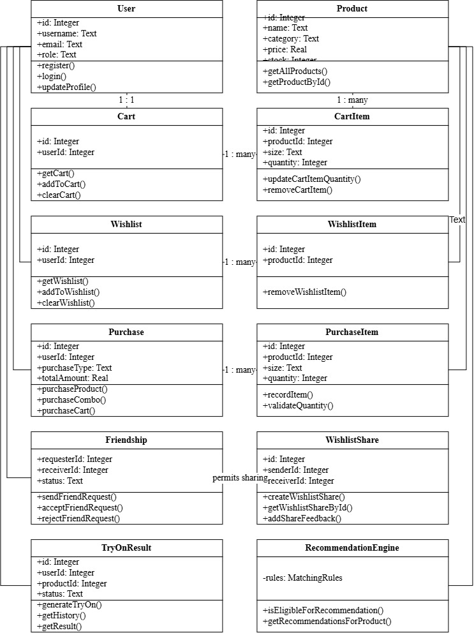
Fig 4.1 StyleHub Class Diagram
This figure shows the main screen or structure used by the module. It identifies the principal components visible in the workflow. These components process the relevant request and return a result. It links the implemented design to the documented module behaviour.
CHAPTER 5

TABLE STRUCTURES
The following entries are taken from the SQLite schema in the project. PK denotes primary key and FK denotes foreign key. The tables store both shopping records and optional feature records such as social sharing and virtual try-on.

Cart
Field | Type | Key | Required
id | INTEGER | PK | No
user_id | INTEGER | FK → users | Yes
created_at | DATETIME |  | No
updated_at | DATETIME |  | No

Cart Items
Field | Type | Key | Required
id | INTEGER | PK | No
cart_id | INTEGER | FK → cart | Yes
product_id | INTEGER | FK → products | Yes
size | TEXT |  | No
quantity | INTEGER |  | Yes
created_at | DATETIME |  | No
updated_at | DATETIME |  | No

Friendships
Field | Type | Key | Required
id | INTEGER | PK | No
requester_id | INTEGER | FK → users | Yes
receiver_id | INTEGER | FK → users | Yes
status | TEXT |  | Yes
created_at | DATETIME |  | No
updated_at | DATETIME |  | No

Notification Deliveries
Field | Type | Key | Required
id | INTEGER | PK | No
purchase_id | INTEGER | FK → purchases | Yes
user_id | INTEGER | FK → users | Yes
channel | TEXT |  | Yes
status | TEXT |  | Yes
recipient | TEXT |  | No
provider_message_id | TEXT |  | No
error_message | TEXT |  | No
event_type | TEXT |  | No
subject | TEXT |  | No
created_at | DATETIME |  | No

Notifications
Field | Type | Key | Required
id | INTEGER | PK | No
user_id | INTEGER | FK → users | Yes
type | TEXT |  | Yes
title | TEXT |  | Yes
message | TEXT |  | Yes
is_read | INTEGER |  | Yes
created_at | DATETIME |  | No
related_id | INTEGER |  | No

Order Items
Field | Type | Key | Required
id | INTEGER | PK | No
order_id | INTEGER | FK → orders | Yes
product_id | INTEGER | FK → products | Yes
product_name | TEXT |  | Yes
product_image | TEXT |  | No
quantity | INTEGER |  | Yes
unit_price | REAL |  | Yes
discount | REAL |  | Yes
final_price | REAL |  | Yes
size | TEXT |  | No

Orders
Field | Type | Key | Required
id | INTEGER | PK | No
order_number | TEXT |  | Yes
user_id | INTEGER | FK → users | Yes
status | TEXT |  | Yes
subtotal | REAL |  | Yes
discount_total | REAL |  | Yes
shipping_fee | REAL |  | Yes
other_charges | REAL |  | Yes
total_amount | REAL |  | Yes
delivery_address | TEXT |  | Yes
created_at | DATETIME |  | No
updated_at | DATETIME |  | No
delivery_date | DATETIME |  | No
cancelled_at | DATETIME |  | No

Outfit Recommendations
Field | Type | Key | Required
id | INTEGER | PK | No
base_product_id | INTEGER | FK → products | Yes
recommended_product_id | INTEGER | FK → products | Yes
slot_type | TEXT |  | Yes
reason | TEXT |  | No
created_at | DATETIME |  | No
combination_signature | TEXT |  | No

Products
Field | Type | Key | Required
id | INTEGER | PK | No
name | TEXT |  | Yes
description | TEXT |  | No
brand | TEXT |  | No
category | TEXT |  | Yes
cloth_type | TEXT |  | No
color | TEXT |  | No
price | REAL |  | Yes
original_price | REAL |  | Yes
discount_percent | REAL |  | No
stock | INTEGER |  | Yes
status | TEXT |  | Yes
image | TEXT |  | No
garment_image | TEXT |  | No
vton_supported | INTEGER |  | No
vton_garment_category | TEXT |  | No
created_at | DATETIME |  | No
updated_at | DATETIME |  | No

Purchase Items
Field | Type | Key | Required
id | INTEGER | PK | No
purchase_id | INTEGER | FK → purchases | Yes
product_id | INTEGER | FK → products | Yes
quantity | INTEGER |  | Yes
unit_price | REAL |  | Yes
created_at | DATETIME |  | No
size | TEXT |  | No

Purchases
Field | Type | Key | Required
id | INTEGER | PK | No
user_id | INTEGER | FK → users | Yes
purchase_type | TEXT |  | Yes
total_amount | REAL |  | Yes
delivery_name | TEXT |  | Yes
delivery_phone | TEXT |  | Yes
delivery_address | TEXT |  | Yes
delivery_city | TEXT |  | Yes
delivery_state | TEXT |  | Yes
delivery_pincode | TEXT |  | Yes
created_at | DATETIME |  | No
cart_reward_percent | REAL |  | No
cart_reward_amount | REAL |  | No
subtotal | REAL |  | No

Recently Accessed
Field | Type | Key | Required
id | INTEGER | PK | No
user_id | INTEGER | FK → users | Yes
product_id | INTEGER | FK → products | Yes
accessed_at | DATETIME |  | No

Try On Results
Field | Type | Key | Required
id | INTEGER | PK | No
user_id | INTEGER | FK → users | Yes
product_id | INTEGER | FK → products | Yes
user_image_path | TEXT |  | Yes
garment_image_path | TEXT |  | Yes
generated_image_path | TEXT |  | No
category | TEXT |  | Yes
status | TEXT |  | Yes
created_at | DATETIME |  | No

Users
Field | Type | Key | Required
id | INTEGER | PK | No
username | TEXT |  | No
full_name | TEXT |  | Yes
email | TEXT |  | Yes
password_hash | TEXT |  | Yes
role | TEXT |  | Yes
phone | TEXT |  | No
age | INTEGER |  | No
address | TEXT |  | No
city | TEXT |  | No
state | TEXT |  | No
pincode | TEXT |  | No
created_at | DATETIME |  | No
updated_at | DATETIME |  | No
google_id | TEXT |  | No
avatar_url | TEXT |  | No
email_notifications | INTEGER |  | Yes
sms_notifications | INTEGER |  | Yes
whatsapp_notifications | INTEGER |  | Yes
theme_preference | TEXT |  | Yes
language_preference | TEXT |  | Yes

Wishlist Feedback
Field | Type | Key | Required
id | INTEGER | PK | No
share_id | INTEGER | FK → wishlist_shares | Yes
user_id | INTEGER | FK → users | Yes
reaction | TEXT |  | No
comment | TEXT |  | No
created_at | DATETIME |  | No
updated_at | DATETIME |  | No

Wishlist Items
Field | Type | Key | Required
id | INTEGER | PK | No
wishlist_id | INTEGER | FK → wishlists | Yes
product_id | INTEGER | FK → products | Yes
created_at | DATETIME |  | No

Wishlist Share Items
Field | Type | Key | Required
id | INTEGER | PK | No
share_id | INTEGER | FK → wishlist_shares | Yes
product_id | INTEGER | FK → products | Yes
created_at | DATETIME |  | No

Wishlist Shares
Field | Type | Key | Required
id | INTEGER | PK | No
sender_id | INTEGER | FK → users | Yes
receiver_id | INTEGER | FK → users | Yes
wishlist_id | INTEGER | FK → wishlists | No
share_type | TEXT |  | No
created_at | DATETIME |  | No

Wishlists
Field | Type | Key | Required
id | INTEGER | PK | No
user_id | INTEGER | FK → users | Yes
created_at | DATETIME |  | No
updated_at | DATETIME |  | No

CHAPTER 6

ER DIAGRAM
The accompanying editable Draw.io ER diagram summarizes the main foreign key relationships. It includes shopping, social, recommendation, notification, recently accessed, and try-on data. One user can have many purchases; each purchase has many purchase items. Product references link items and feature records back to the catalogue.
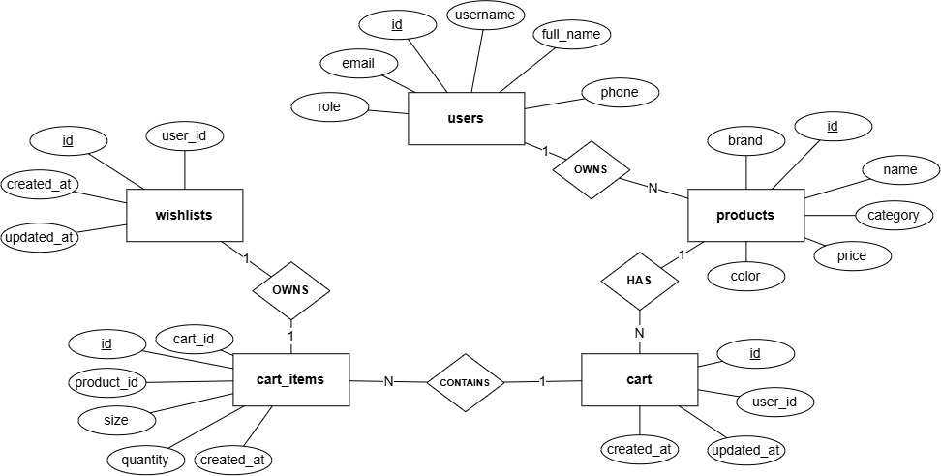

Fig 6.1 StyleHub Entity Relationship Diagram
This figure shows the main screen or structure used by the module. It identifies the principal components visible in the workflow. These components process the relevant request and return a result. It links the implemented design to the documented module behaviour.
CHAPTER 7

TECH STACK AND ARCHITECTURE

Technology Stack
Layer | Technology | Purpose
Frontend | React 18, Vite 6, React Router | Screens, navigation, user state
Backend | Node.js, Express 4 | REST API and business rules
Database | SQLite, better-sqlite3 | Persistent records and transactions
Authentication | JWT, bcryptjs | Tokens and password hashing
Virtual try-on | Python Flask, FASHN VTON 1.5 | Local image inference for supported garments
Communication | Nodemailer, Twilio SMS, Meta WhatsApp API | Optional configured purchase notifications

Architecture Overview
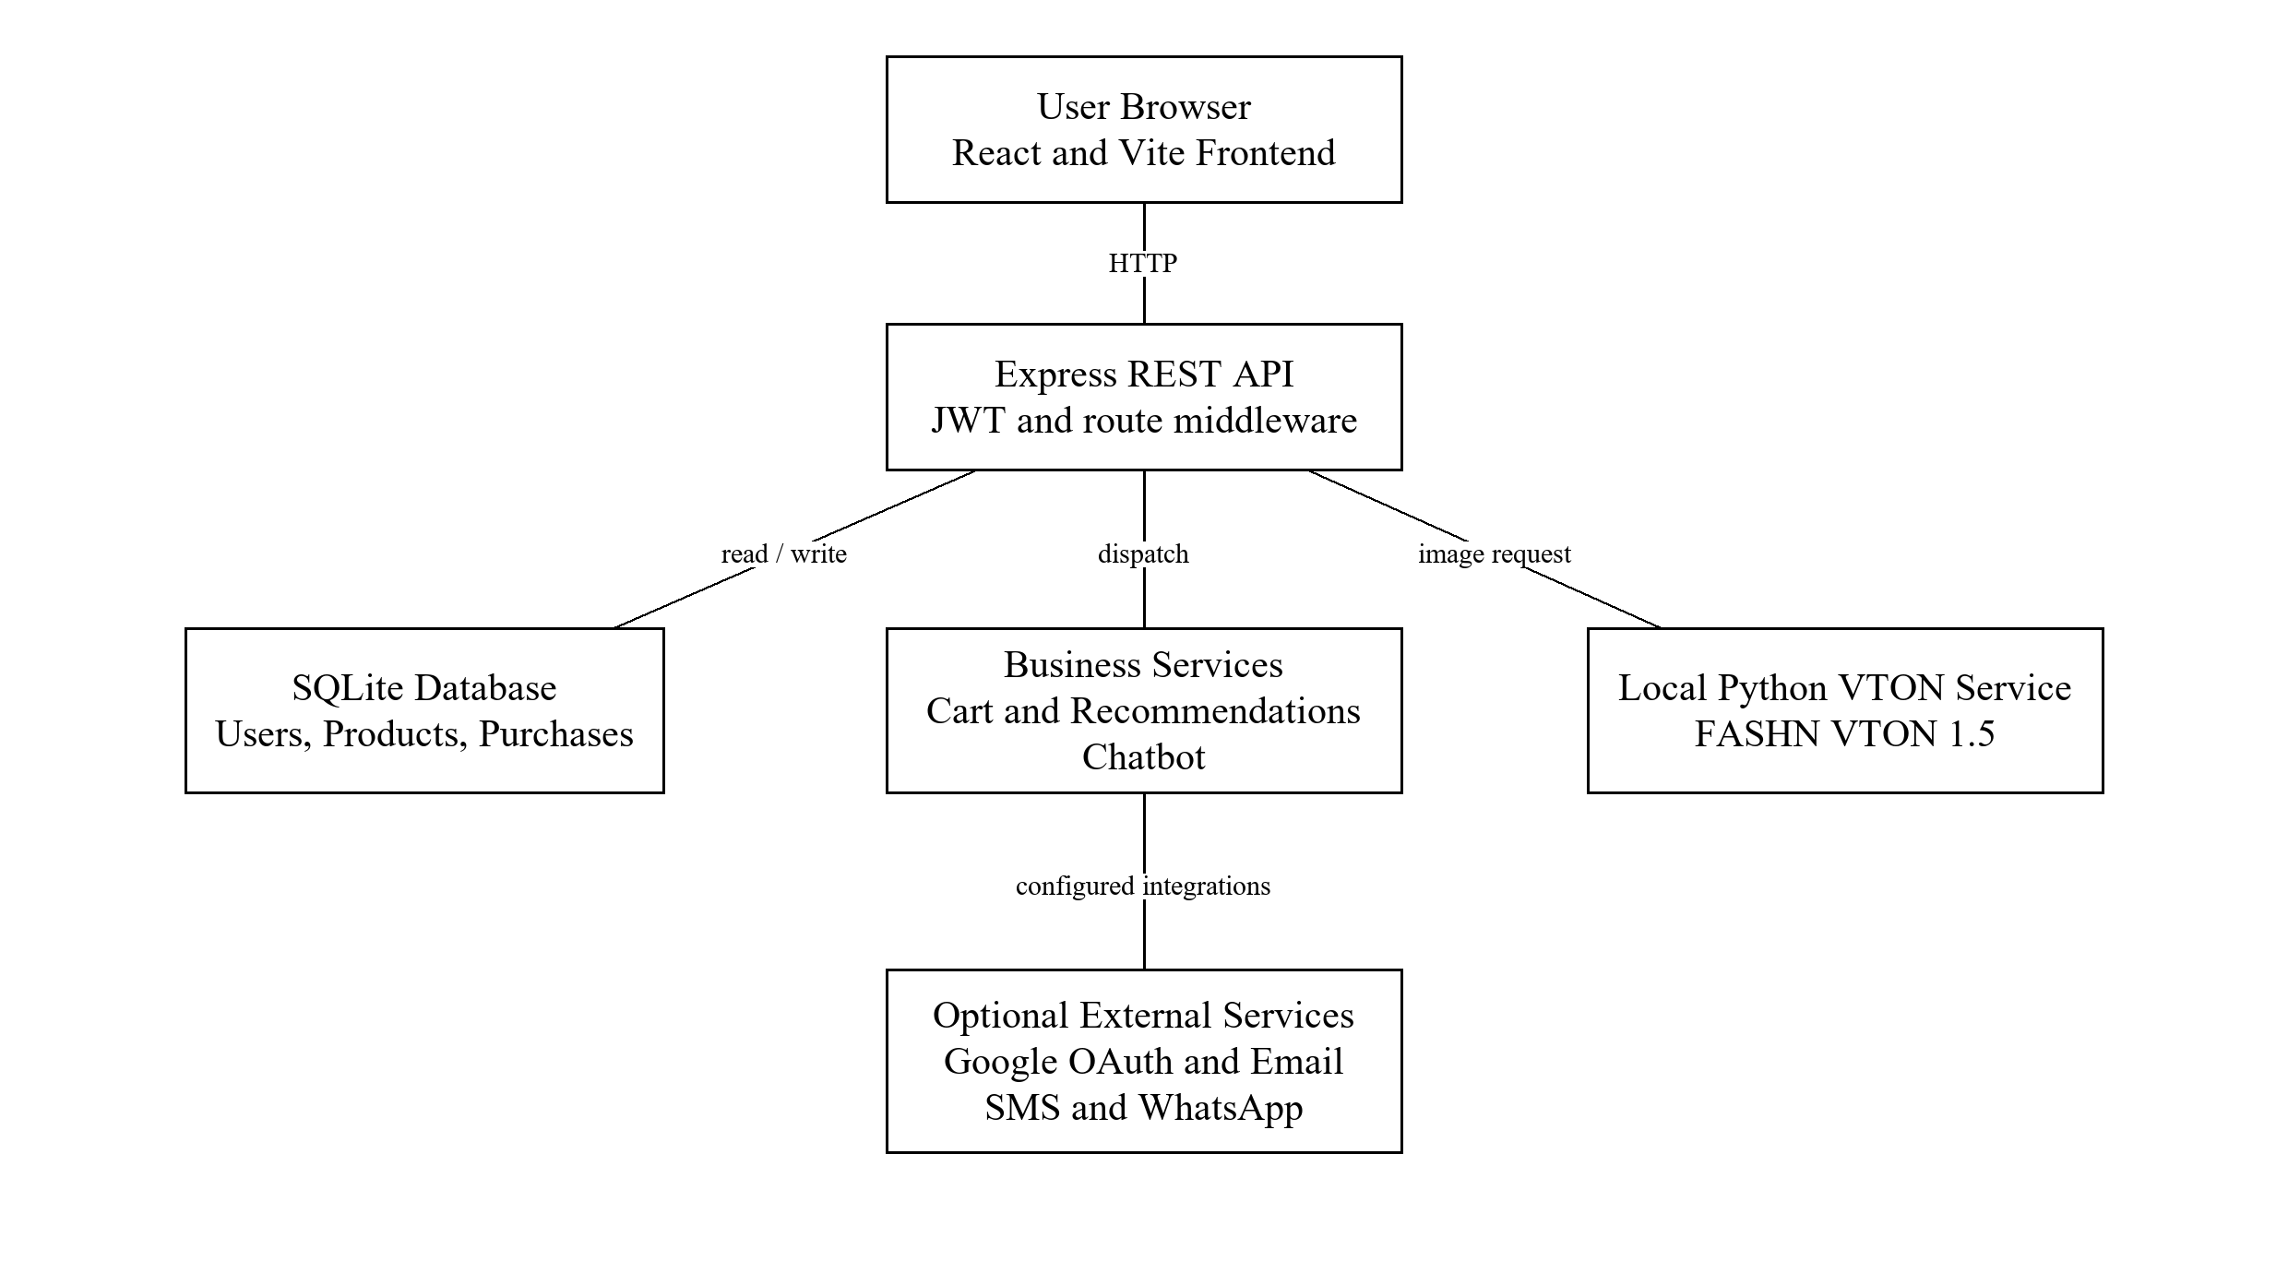
Fig 7.1 StyleHub System Architecture
This figure shows the main screen or structure used by the module. It identifies the principal components visible in the workflow. These components process the relevant request and return a result. It links the implemented design to the documented module behaviour.

CHAPTER 8

MODULES

8.0 Design Approach
The modules are described in a consistent order so that their responsibilities and implementation can be compared. Each section starts with its purpose, then lists observable functions, quality requirements, technologies, request flow, API endpoints, database design, and interfaces. The descriptions are based on the project routes, screens, and SQLite schema.
Design concern | Approach used in StyleHub
Identity | JWT identifies the user on protected requests; ADMIN routes require an administrator role.
Data integrity | SQLite foreign keys connect user, product, cart, purchase, social, and try-on records.
Modularity | React pages call frontend services; Express routes delegate application operations.
User isolation | The backend uses the authenticated user ID for account-specific records.
Optional services | VTON and provider communication report availability or delivery outcome separately.

Overall Request Flow
A user action begins in a React page. The frontend sends an HTTP request through its API service. Express selects a route, checks authentication where required, then performs validation and database or service work. The API returns a status and data to the page, which updates the displayed state. The local VTON service and external providers are called only for features that need them.
Step | Component | Result
1 | React page or component | Collects input and starts an action
2 | Frontend API service | Sends request and JWT when protected
3 | Express route and middleware | Selects handler and checks access
4 | Controller and service | Validates and applies business rules
5 | SQLite or optional service | Reads, writes, or generates a result
6 | API response and React state | Shows data, confirmation, or an error

Fig 8.0.1 Overall Request Flow of StyleHub
This figure shows the main screen or structure used by the module. It identifies the principal components visible in the workflow. These components process the relevant request and return a result. It links the implemented design to the documented module behaviour.

8.1 Folder Structure
stylehub/stylehub-frontend contains React pages, reusable components, contexts, and frontend service calls. stylehub/stylehub-backend contains Express routes, controllers, services, middleware, database configuration, and tests. The VTON service is housed under the backend vton-service directory.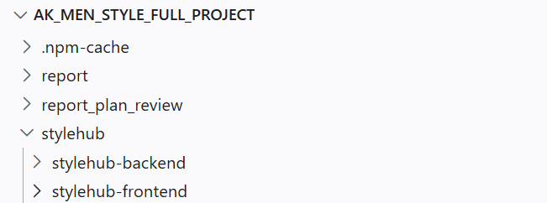
Fig 8.1.1 Overall Project Folder

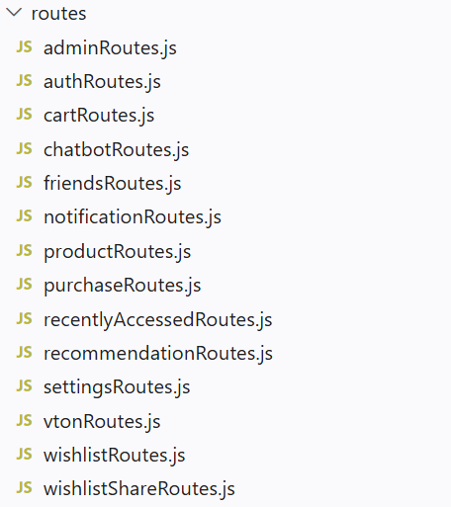
Fig 8.1.4 Backend Routes Folder
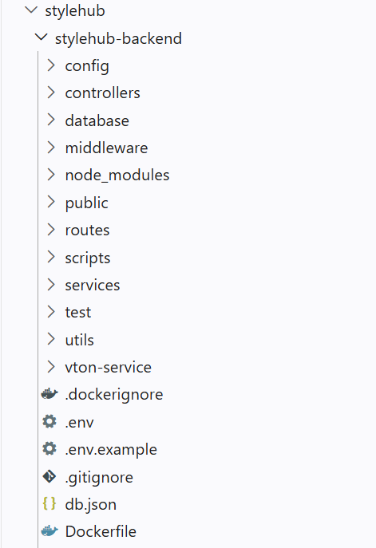
Fig 8.1.2 Backend Folder

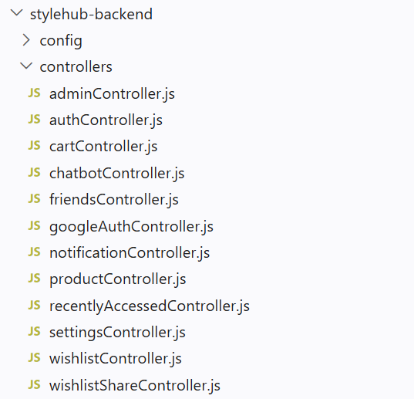

Fig 8.1.5 Backend Controllers Folder
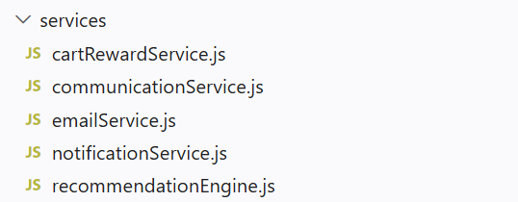

Fig 8.1.6 Backend Services Folder
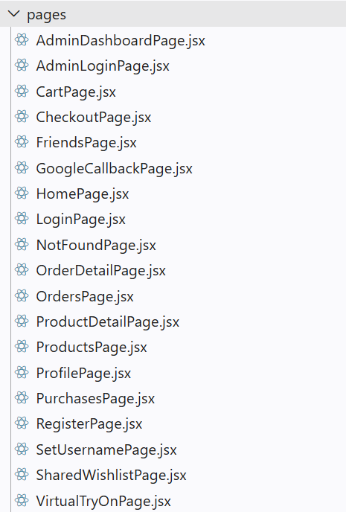
Fig 8.1.9 Frontend Pages Folder

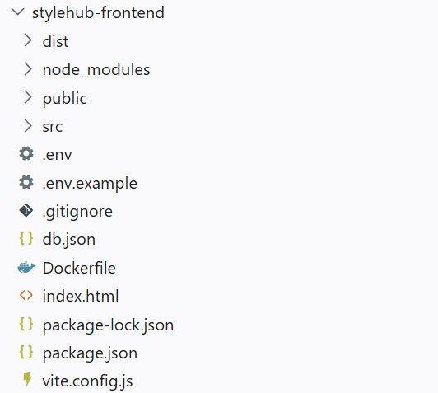
Fig 8.1.7 Frontend Folder
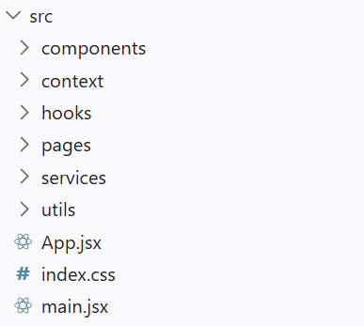
Fig 8.1.8 Frontend Source Folder
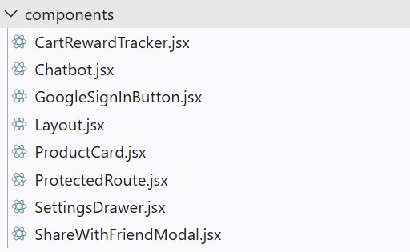
Fig 8.1.10 Frontend Components Folder
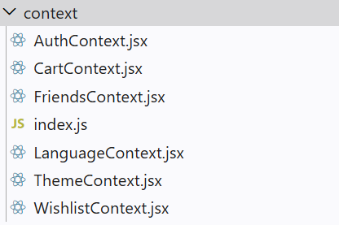
Fig 8.1.11 Frontend Context Folder
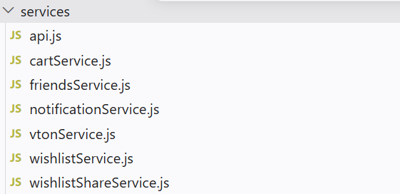
Fig 8.1.12 Frontend Services Folder

8.2 Authentication and Profile

8.2.0 Purpose and Scope
This module creates and maintains customer identities, protects account data and distinguishes an administrator from a customer. It covers registration, credential login, profile updates, username availability and the optional Google sign-in path.

8.2.1 Functional Requirements
• Register a user with required identity and credential details.
• Authenticate a returning user and return a signed session token.
• Load and update only the signed-in user profile.
• Allow a Google-created account to complete a unique username.
• Restrict administrator pages and APIs to accounts with the ADMIN role.

8.2.2 Non Functional Requirements
• Store password hashes rather than plaintext passwords.
• Reject missing or invalid tokens on protected endpoints.
• Keep one user from editing another user profile.

8.2.3 Tech Stack
Concern | Choice | Why it fits this module
User interface and navigation | React and React Router | Provides registration, login, profile pages and protected navigation.
Authentication API | Node.js and Express | Validates account requests and exposes authentication and profile endpoints.
Session and role checks | jsonwebtoken (JWT) | Identifies the signed-in account and supports protected customer and administrator operations.
Password protection | bcryptjs | Hashes passwords and verifies credentials without storing plaintext passwords.
Account persistence | SQLite and better-sqlite3 | Stores user identities, password hashes, usernames and account roles.

8.2.4 Low Level Architecture
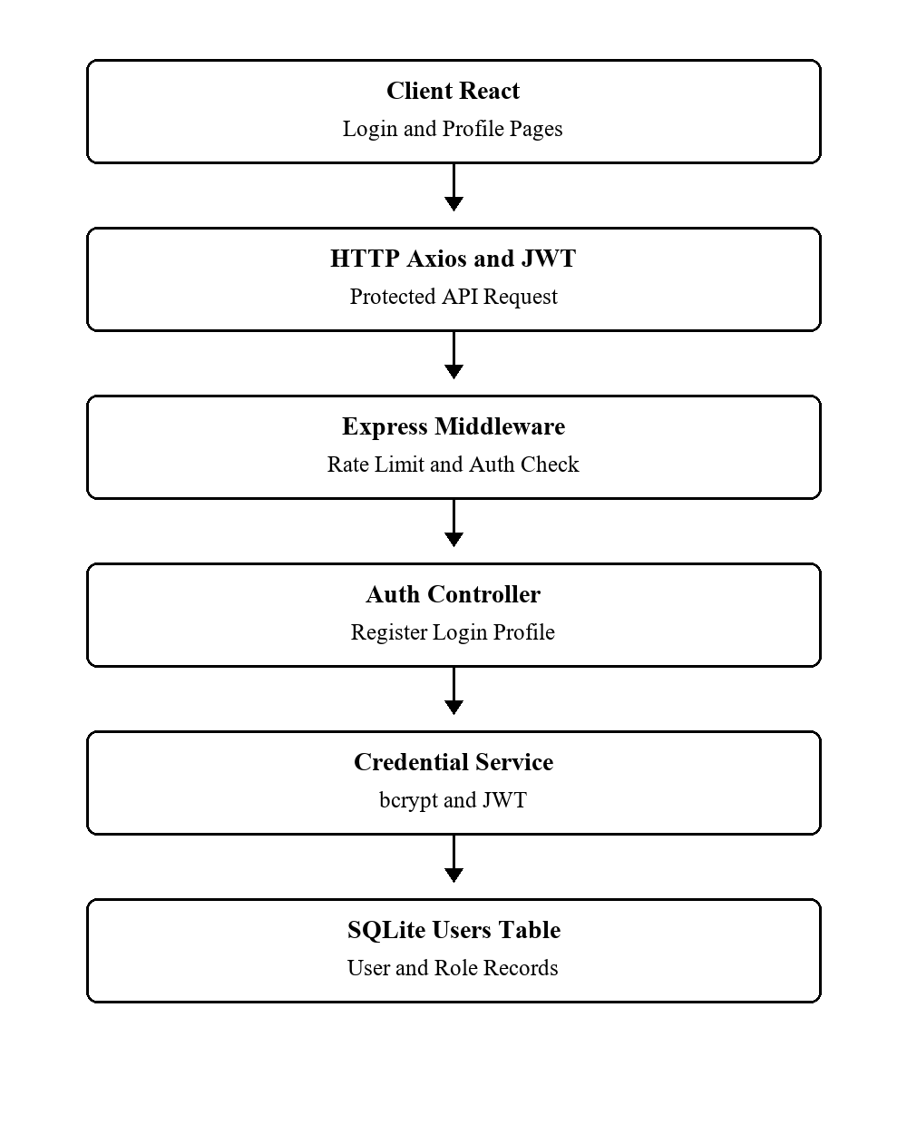
Fig 8.2.4.1 Authentication and Profile Low Level Architecture
Request Flow
1. The registration or login page sends form data to an auth route.
2. The controller validates input, checks the users table and creates or verifies credentials.
3. A successful login returns a JWT; ProtectedRoute and API middleware use it on later requests.
4. An ADMIN role is checked again on the backend before dashboard operations.

8.2.5 API Design
Method | Endpoint | Purpose
POST | /api/auth/register | Create customer account
POST | /api/auth/login | Authenticate credentials
GET | /api/auth/me | Return current user
PUT | /api/auth/profile | Update current profile
GET | /api/auth/check-username | Check username availability
PUT | /api/auth/username | Save username

8.2.6 DB Design
Table | Key Fields | Use
users | id; email; username; password_hash; role | Account and access attributes

8.2.7 Screenshots
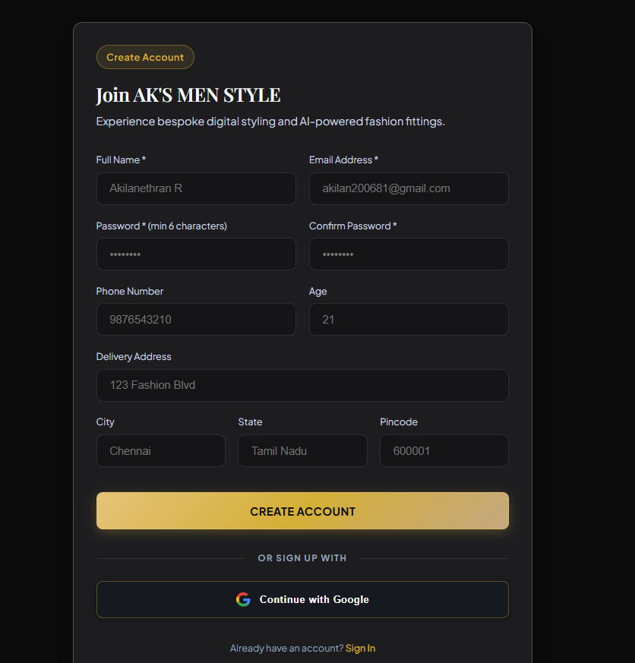
Fig 8.2.1 Registration Page
This figure shows the main screen or structure used by the module. It identifies the principal components visible in the workflow. These components process the relevant request and return a result. It links the implemented design to the documented module behaviour.
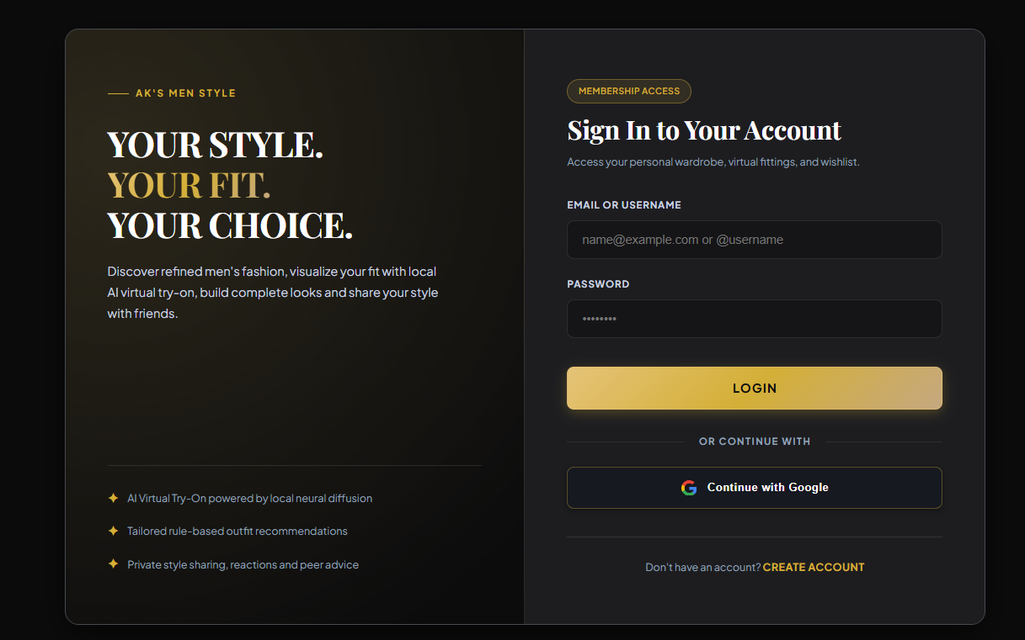
Fig 8.2.2 Login Page
This figure shows the main screen or structure used by the module. It identifies the principal components visible in the workflow. These components process the relevant request and return a result. It links the implemented design to the documented module behaviour.

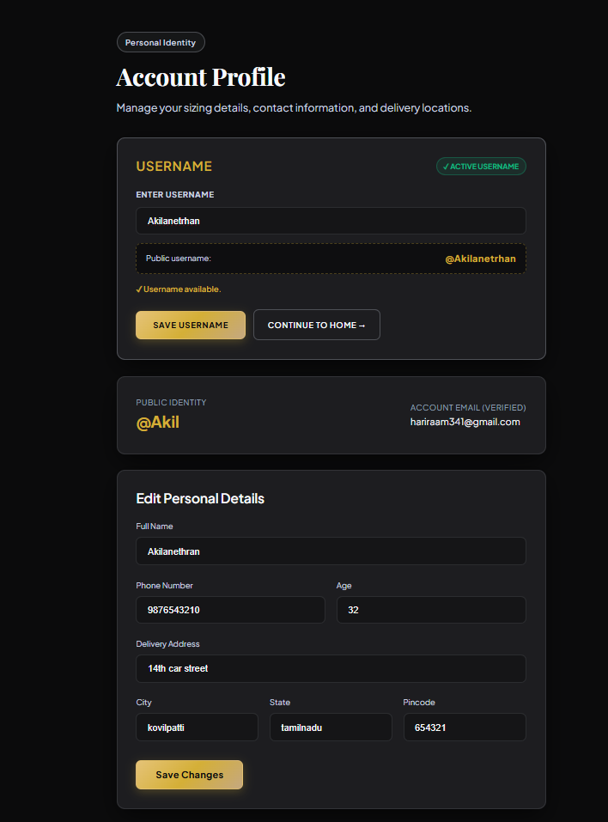
Fig 8.2.3 Profile and Username Page
This figure shows the main screen or structure used by the module. It identifies the principal components visible in the workflow. These components process the relevant request and return a result. It links the implemented design to the documented module behaviour.
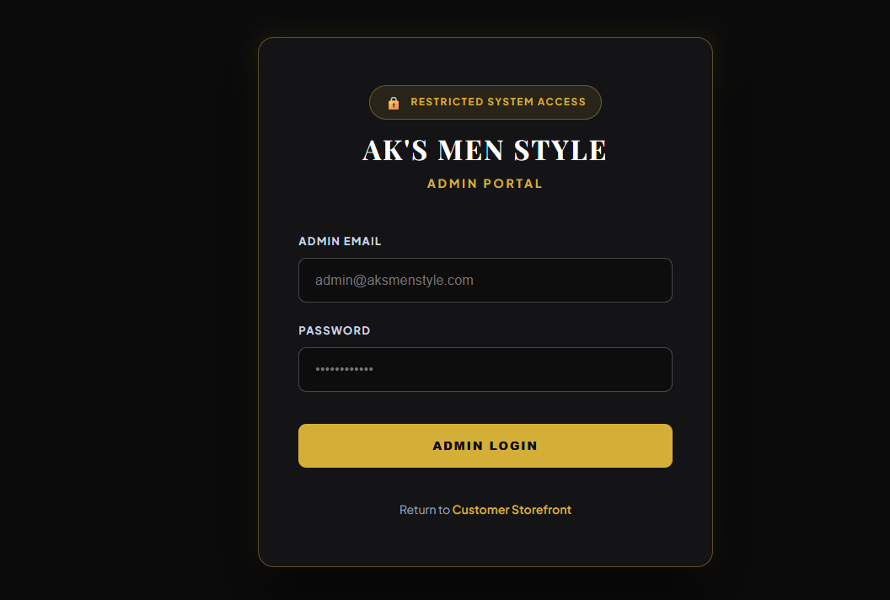Fig 8.2.4 Admin Login Page
This figure shows the main screen or structure used by the module. It identifies the principal components visible in the workflow. These components process the relevant request and return a result. It links the implemented design to the documented module behaviour.

8.3 Product Catalogue and Recent Views

8.3.0 Purpose and Scope
This module presents products for discovery and records which items a signed-in user has viewed. Product records include catalogue text, images, prices, available stock and virtual try-on eligibility.

8.3.1 Functional Requirements
• List available catalogue products for browsing.
• Open a detail page for a selected product.
• Show category, price, discount, stock and garment imagery.
• Record and retrieve recently accessed items per user.
• Expose the selected product to cart, wishlist, recommendation and try-on actions.

8.3.2 Non Functional Requirements
• Return a clear result for an invalid product identifier.
• Keep recently accessed records isolated by user.
• Show stock and availability from persisted product data.

8.3.3 Tech Stack
Concern | Choice | Why it fits this module
Catalogue interface | React | Renders product lists, details and recently viewed products.
Product API | Node.js and Express | Serves catalogue data and records authenticated product views.
Catalogue persistence | SQLite and better-sqlite3 | Stores product information, prices, stock and recent views per account.

8.3.4 Low Level Architecture
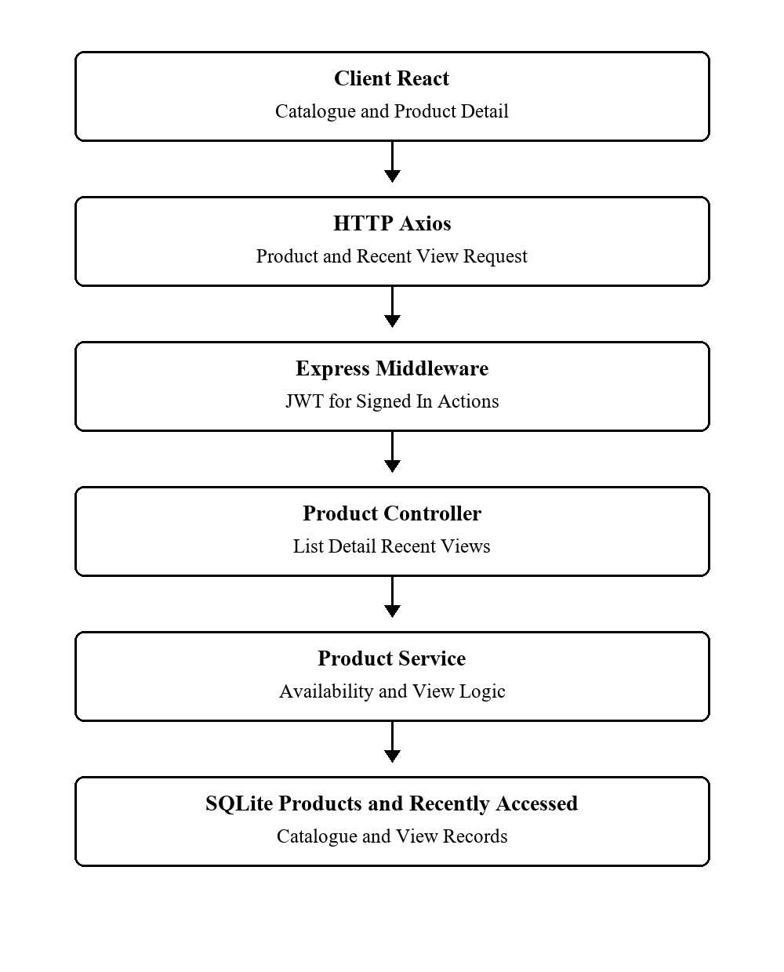
Fig 8.3.4.1 Product Catalogue Low Level Architecture
Request Flow
1. The catalogue page requests the product list from the Express API.
2. Selecting an item requests its detailed record.
3. The recent-access route updates the signed-in user and product pair.
4. The page renders available actions based on the returned product fields.

8.3.5 API Design
Method | Endpoint | Purpose
GET | /api/products | List products
GET | /api/products/:id | Get product detail
GET | /api/recently-accessed | List user recent views
POST | /api/recently-accessed | Record a product view

8.3.6 DB Design
Table | Key Fields | Use
products | id; name; category; price; stock; image; vton_supported | Catalogue source
recently_accessed | user_id; product_id; accessed_at | Per-user viewing history

8.3.7 Screenshot 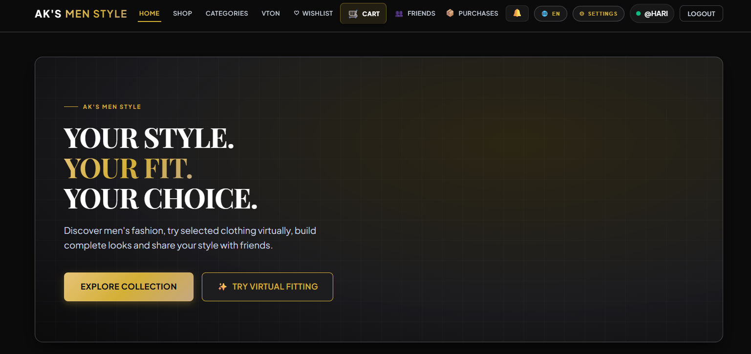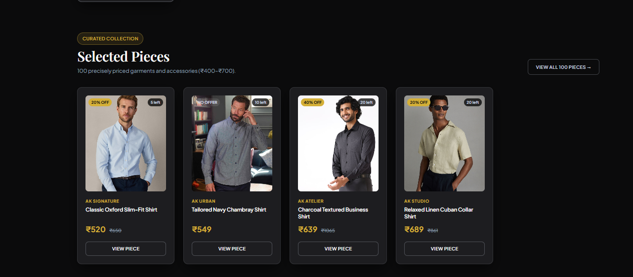

Fig 8.3.1 Home and Featured Products
This figure shows the main screen or structure used by the module. It identifies the principal components visible in the workflow. These components process the relevant request and return a result. It links the implemented design to the documented module behaviour.

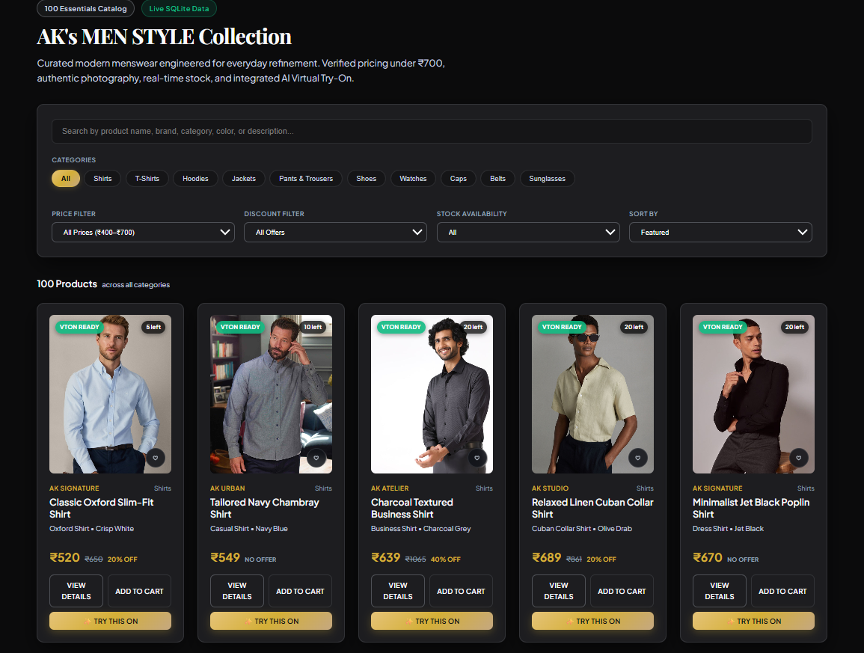
Fig 8.3.2 Product Catalogue
This figure shows the main screen or structure used by the module. It identifies the principal components visible in the workflow. These components process the relevant request and return a result. It links the implemented design to the documented module behaviour.
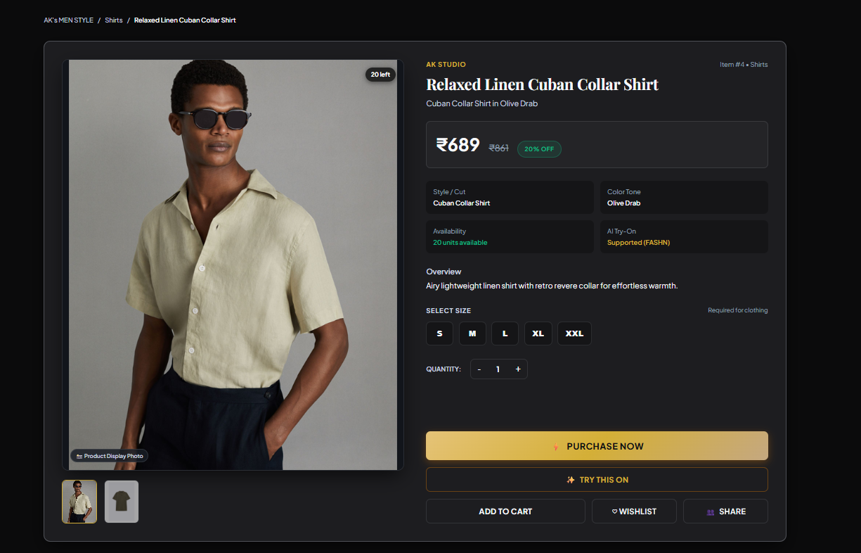
Fig 8.3.3 Product Detail
This figure shows the main screen or structure used by the module. It identifies the principal components visible in the workflow. These components process the relevant request and return a result. It links the implemented design to the documented module behaviour.

8.4 Cart and Checkout

8.4.0 Purpose and Scope
The cart groups selected products and size variants before purchase. Checkout calculates an order summary and applies the implemented Buy More Save More reward when the cart meets its rule conditions.

8.4.1 Functional Requirements
• Add a product and available size to the active cart.
• Change quantity or remove an item.
• Show subtotal and applicable cart reward.
• Submit eligible cart contents with delivery details.
• Create purchase records and decrement stock through the purchase path.

8.4.2 Non Functional Requirements
• Do not allow nonpositive quantities or unavailable stock to be purchased.
• Keep each cart tied to its authenticated owner.
• Perform stock and purchase updates in the same transaction where implemented.

8.4.3 Tech Stack
Concern | Choice | Why it fits this module
Cart state and checkout interface | React and CartContext | Keeps cart contents available across pages and displays checkout totals.
Cart and checkout API | Node.js and Express | Handles item changes and validates checkout requests.
Owner identification | JWT authentication | Associates cart operations with the signed-in user.
Cart and purchase persistence | SQLite and better-sqlite3 | Stores cart items and purchase records and supports transactional stock updates.

8.4.4 Low Level Architecture
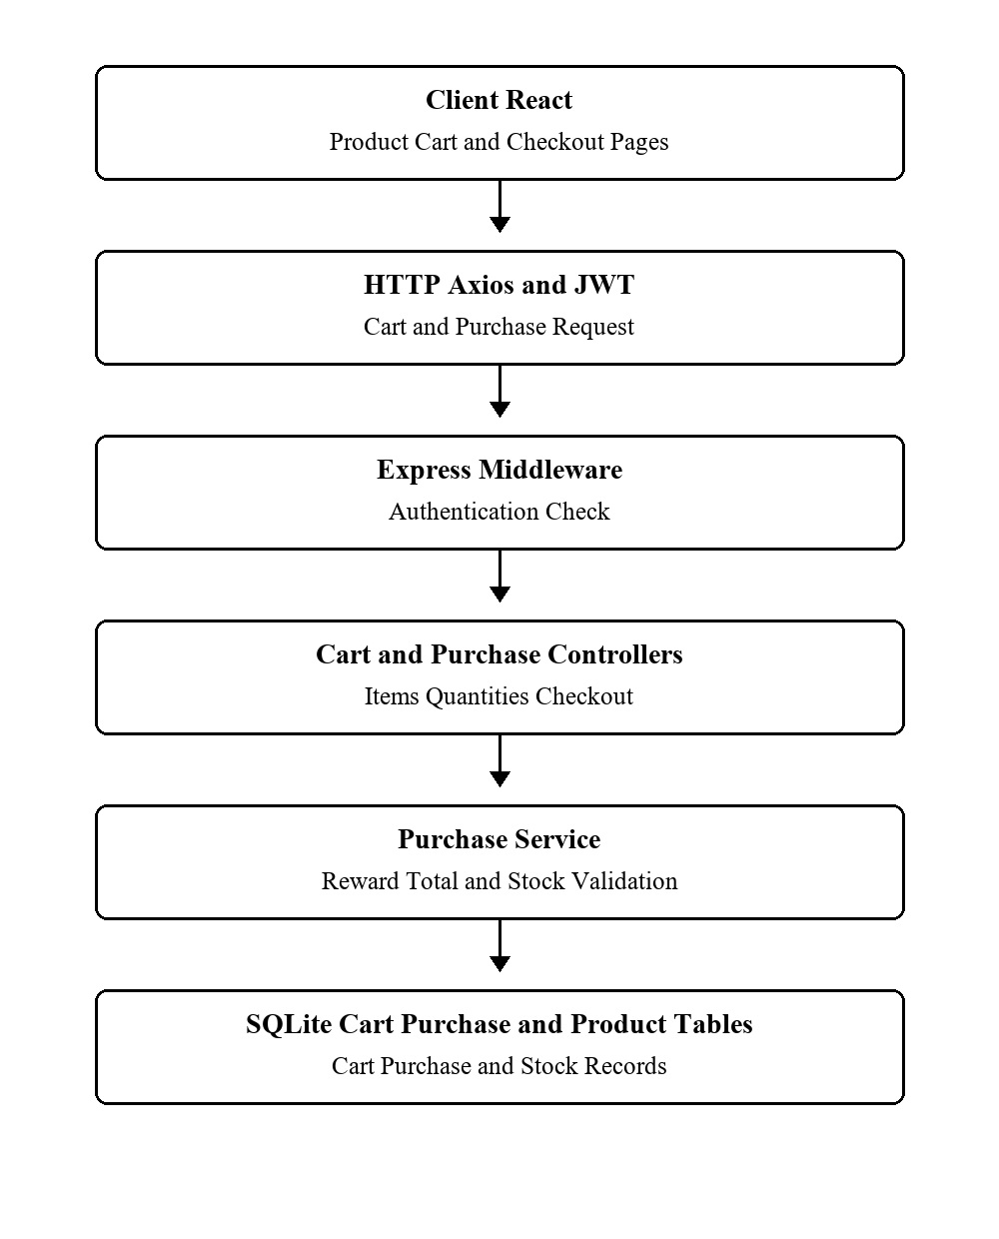
Fig 8.4.4.1 Cart and Checkout Low Level Architecture
Request Flow
1. The product page adds an item to the authenticated user cart.
2. Cart routes return current items and accept quantity or removal changes.
3. Checkout presents delivery details and computed totals.
4. The cart purchase route validates items, records the purchase and updates stock.

8.4.5 API Design
Method | Endpoint | Purpose
GET | /api/cart | Read current cart
POST | /api/cart/items | Add a cart item
PUT | /api/cart/items/:productId | Change quantity
DELETE | /api/cart/items/:productId | Remove item
POST | /api/purchases/cart | Purchase cart contents

8.4.6 DB Design
Table | Key Fields | Use
cart | id; user_id | One active user cart
cart_items | cart_id; product_id; size; quantity | Selected variants
purchases | user_id; total_amount; cart_reward_amount | Completed purchase
purchase_items | purchase_id; product_id; size; quantity | Purchased units

8.4.7 Screenshots
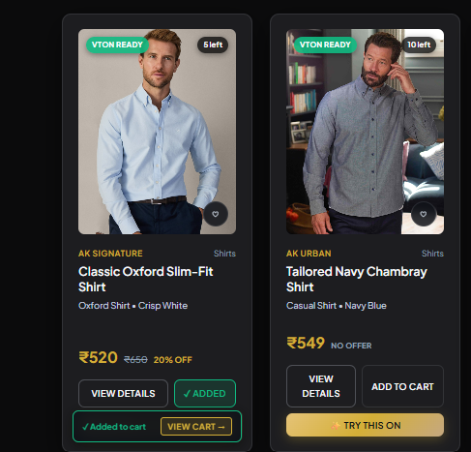
Fig 8.4.1 Add to Cart Action
This figure shows the main screen or structure used by the module. It identifies the principal components visible in the workflow. These components process the relevant request and return a result. It links the implemented design to the documented module behaviour.

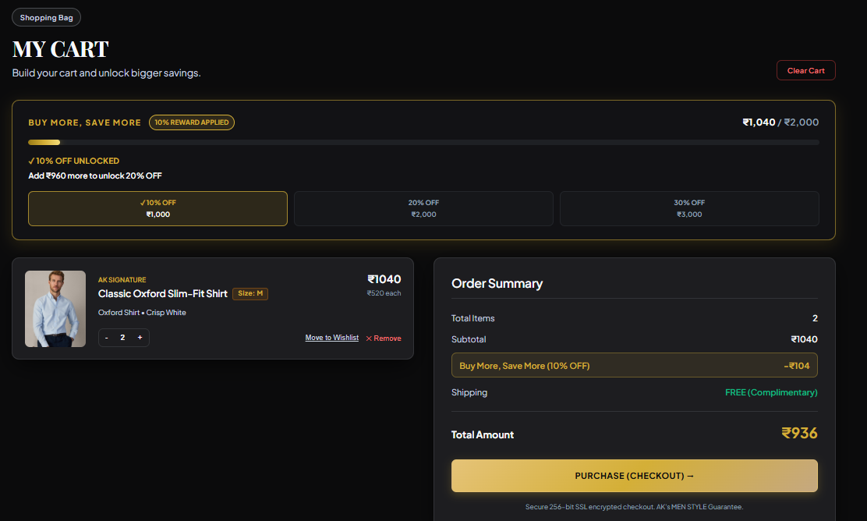
Fig 8.4.2 Cart Items and Quantities
This figure shows the main screen or structure used by the module. It identifies the principal components visible in the workflow. These components process the relevant request and return a result. It links the implemented design to the documented module behaviour.

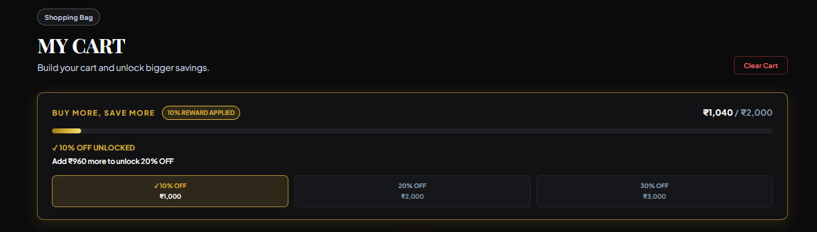
Fig 8.4.3 Cart Reward Summary
This figure shows the main screen or structure used by the module. It identifies the principal components visible in the workflow. These components process the relevant request and return a result. It links the implemented design to the documented module behaviour.
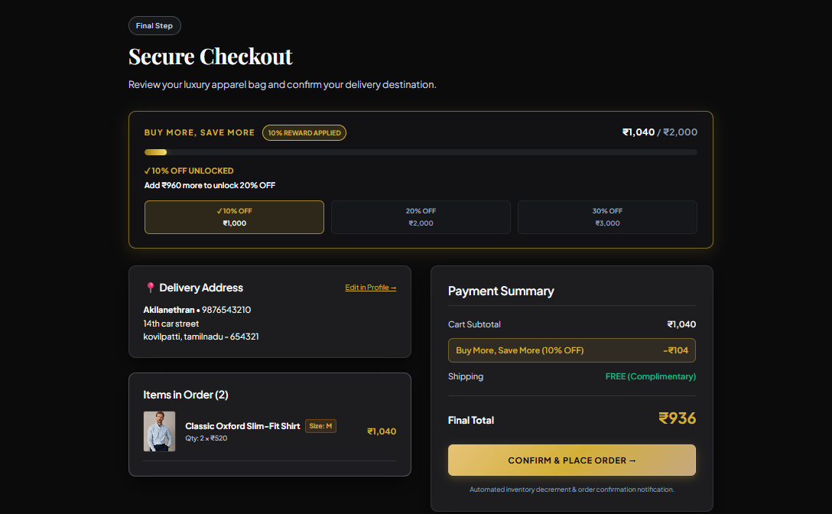
Fig 8.4.4 Checkout Page
This figure shows the main screen or structure used by the module. It identifies the principal components visible in the workflow. These components process the relevant request and return a result. It links the implemented design to the documented module behaviour.

8.5 Purchases and Notifications

8.5.0 Purpose and Scope
This module stores completed purchases and their items, provides a purchase history and records in-app and configured channel communication. Single, combination and cart purchase routes share the saved purchase model.

8.5.1 Functional Requirements
• Purchase one product, an eligible combination or a cart.
• Save delivery data, purchased items and final amount.
• Retrieve a signed-in user purchase history and one purchase detail.
• Create and mark in-app notifications as read.
• Record email, SMS or WhatsApp delivery attempts and outcomes.

8.5.2 Non Functional Requirements
• Return only purchases owned by the authenticated user.
• Preserve the purchase when a nonessential external notification fails.
• Record configured, disabled or failed delivery states accurately.

8.5.3 Tech Stack
Concern | Choice | Why it fits this module
History and notification interface | React | Displays saved purchases and in-app notification status.
Purchase and notification API | Node.js and Express | Processes purchases and retrieves account-specific history and messages.
Transaction and delivery records | SQLite and better-sqlite3 | Stores purchases, line items, notifications and channel delivery outcomes.
Email communication | Nodemailer | Sends purchase email through a configured mail provider.
SMS communication | Twilio | Sends purchase SMS when credentials and recipient settings are configured.
WhatsApp communication | Meta WhatsApp Cloud API | Sends configured WhatsApp purchase messages and records delivery outcomes.

8.5.4 Low Level Architecture
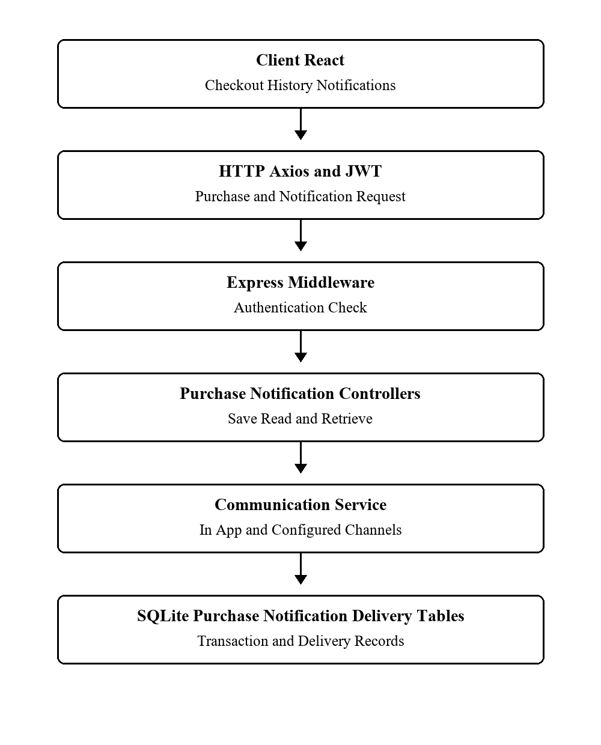
Fig 8.5.4.1 Purchases and Notifications Low Level Architecture
Request Flow
1. A purchase route validates product selection, stock and delivery fields.
2. The database stores a purchase and its line items, with associated stock changes.
3. The notification service creates an in-app message and attempts enabled channels.
4. History routes return records for the authenticated account.

8.5.5 API Design
Method | Endpoint | Purpose
POST | /api/purchases/product | Purchase one product
POST | /api/purchases/combo | Purchase an outfit
POST | /api/purchases/cart | Purchase cart
GET | /api/purchases | List own purchases
GET | /api/purchases/:id | Get one purchase
GET | /api/notifications | List notifications
PUT | /api/notifications/:id/read | Mark notification read

8.5.6 DB Design
Table | Key Fields | Use
purchases | id; user_id; purchase_type; total_amount | Purchase header
purchase_items | purchase_id; product_id; quantity; unit_price | Purchase lines
notifications | user_id; title; message; is_read | In-app messages
notification_deliveries | purchase_id; channel; status; provider_message_id | Channel delivery audit

8.5.7 Screenshots
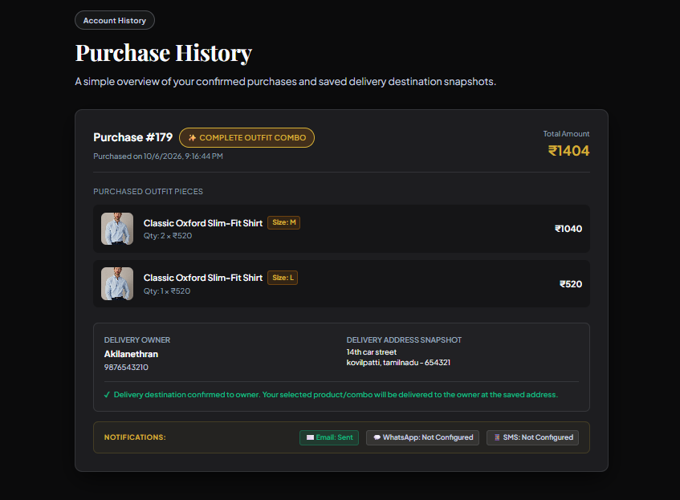
Fig 8.5.3 Purchase History
This figure shows the main screen or structure used by the module. It identifies the principal components visible in the workflow. These components process the relevant request and return a result. It links the implemented design to the documented module behaviour. 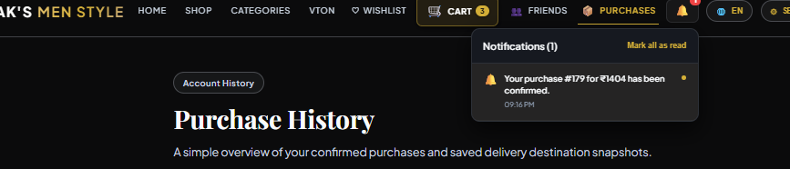Fig 8.5.4 Notification Panel
This figure shows the main screen or structure used by the module. It identifies the principal components visible in the workflow. These components process the relevant request and return a result. It links the implemented design to the documented module behaviour.
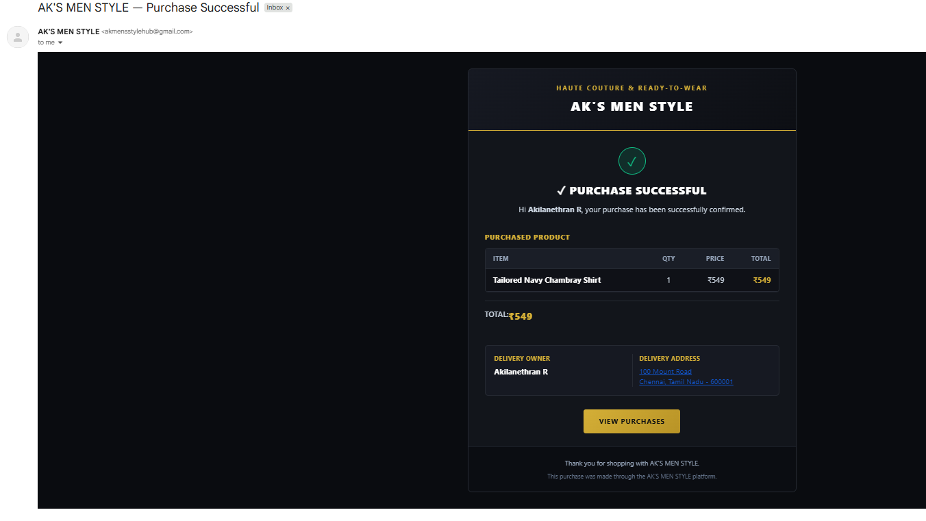
fig 8.5.5 Gmail Notification
This figure shows the gmail notification of purchase receipt with purchase details such as item details, delivery details etc

8.6 Wishlist and Friends

8.6.0 Purpose and Scope
The social module stores favourite products, manages friendship requests and supports private sharing with feedback. It keeps a user wishlist separate from the cart and limits sharing to permitted relationships.

8.6.1 Functional Requirements
• Add and remove products from the personal wishlist.
• Find users and send, accept or reject friend requests.
• Share selected wishlist items with a friend.
• Open received shares and respond with reactions or comments.
• Show the current friend and request lists.

8.6.2 Non Functional Requirements
• Restrict wishlist and share access to the relevant user.
• Prevent duplicate wishlist items and invalid self-friendship records.
• Show a clear status for pending, accepted or rejected requests.

8.6.3 Tech Stack
Concern | Choice | Why it fits this module
Social shopping interface | React | Displays wishlists, friend requests, shared products and feedback.
Social API and access checks | Node.js, Express and JWT | Processes wishlist and friend actions with checks for owners and share participants.
Relationship persistence | SQLite and better-sqlite3 | Stores wishlists, friendships, shared items, reactions and comments.

8.6.4 Low Level Architecture
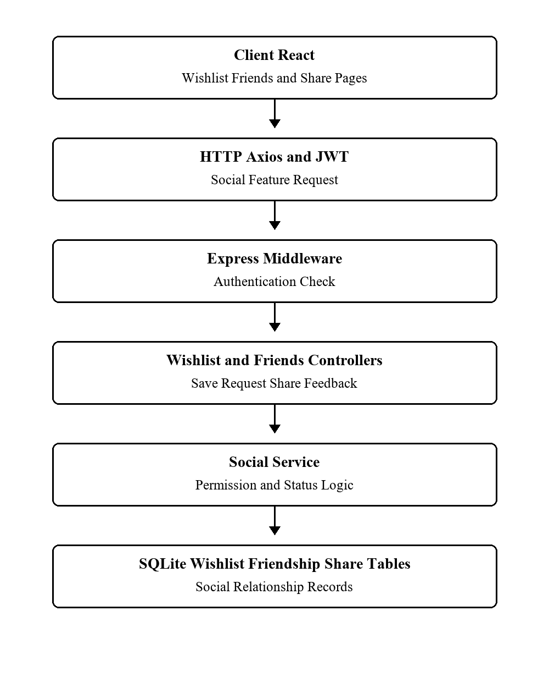
Fig 8.6.4.1 Wishlist and Friends Low Level Architecture
Request Flow
1. A user saves a product through the wishlist route.
2. The friends route stores a request and later updates its status.
3. An accepted connection can receive a selected product share.
4. Feedback is stored against the share and returned to its participants.

8.6.5 API Design
Method | Endpoint | Purpose
GET | /api/wishlist | Read wishlist
POST | /api/wishlist/items | Save product
DELETE | /api/wishlist/items/:productId | Remove product
POST | /api/friends/request | Send request
POST | /api/friends/:id/accept | Accept request
POST | /api/wishlist/shares | Create share
POST | /api/wishlist/shares/:shareId/feedback | Add feedback

8.6.6 DB Design
Table | Key Fields | Use
wishlists; wishlist_items | user_id; wishlist_id; product_id | Saved products
friendships | requester_id; receiver_id; status | Relationship state
wishlist_shares; wishlist_share_items | sender_id; receiver_id; share_id; product_id | Private share
wishlist_feedback | share_id; user_id; reaction; comment | Feedback

8.6.7 Screenshots
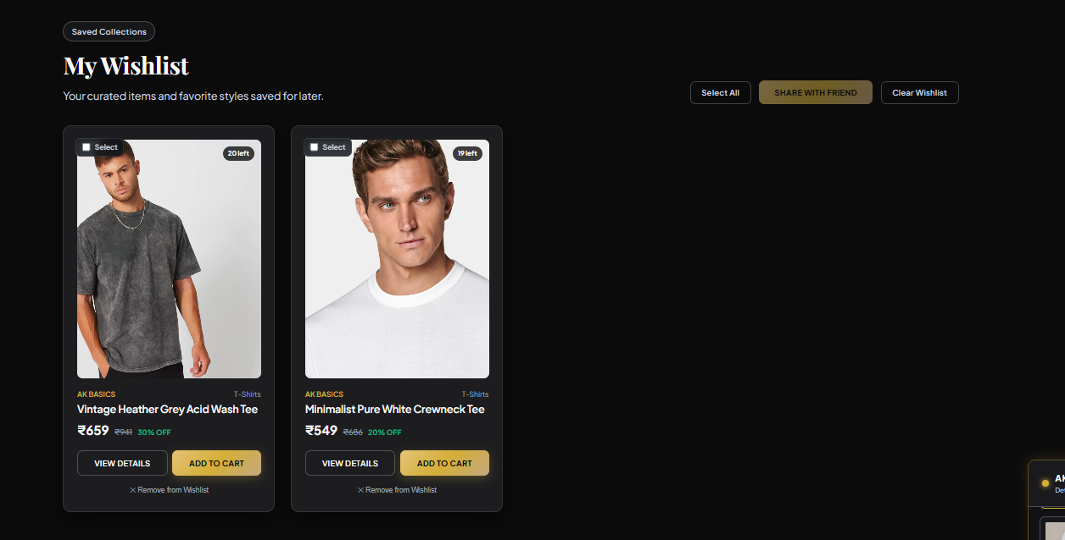
Fig 8.6.1 Personal Wishlist
This figure shows the main screen or structure used by the module. It identifies the principal components visible in the workflow. These components process the relevant request and return a result. It links the implemented design to the documented module behaviour.
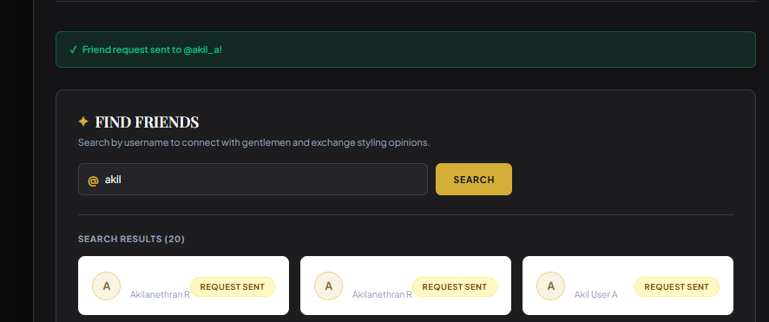Fig 8.6.2 Friend Search and Requests
This figure shows the main screen or structure used by the module. It identifies the
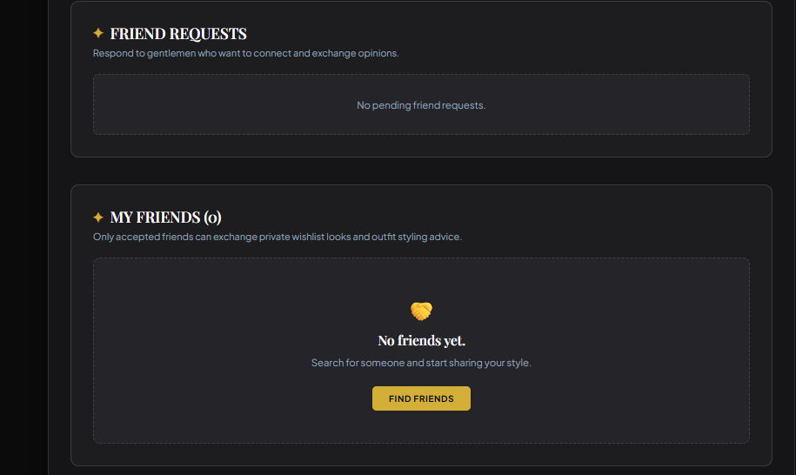
Fig 8.6.3 Friends List
This figure shows the main screen or structure used by the module. It identifies the principal components visible in the workflow. These components process the relevant request and return a result. It links the implemented design to the documented module behaviour.
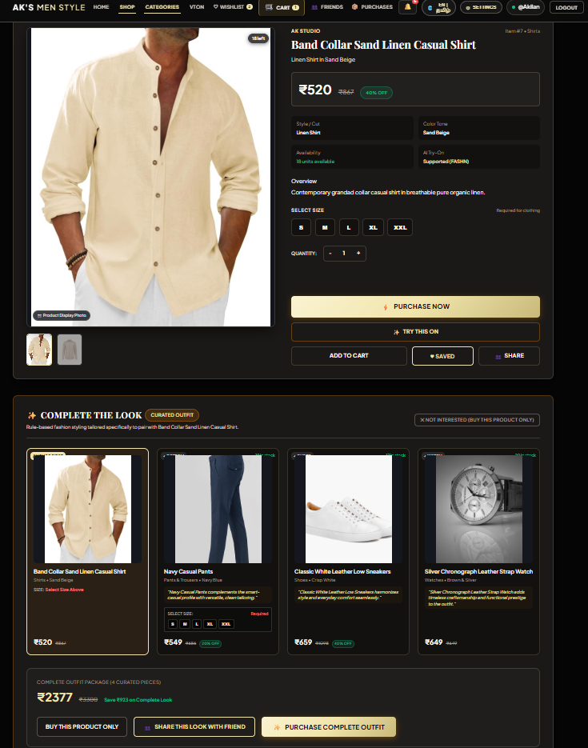
Fig 8.6.4 Shared Wishlist
This figure shows the main screen or structure used by the module. It identifies the principal components visible in the workflow. These components process the relevant request and return a result. It links the implemented design to the documented module behaviour.

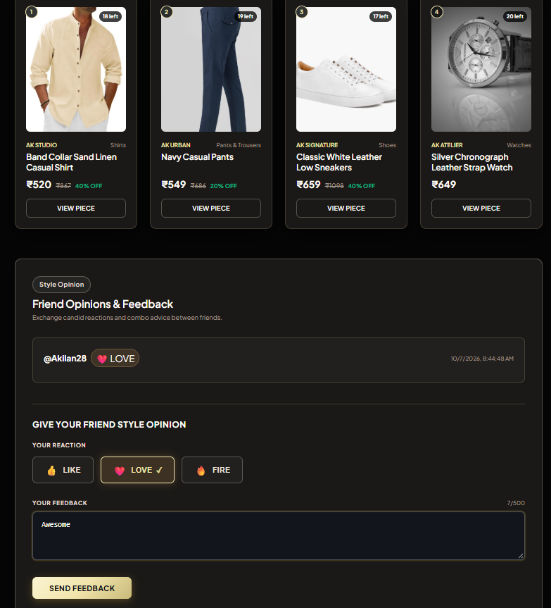
Fig 8.6.5 Share Feedback
This figure shows the main screen or structure used by the module.

8.7 Recommendations and Chatbot

8.7.0 Purpose and Scope
This module helps shoppers discover complementary clothing and obtain quick fashion guidance. Outfit suggestions use predefined matching rules for eligible products; the chatbot uses deterministic intent and catalogue logic.

8.7.1 Functional Requirements
• Return a complementary outfit for an eligible base product.
• Explain when an item is not eligible for outfit recommendations.
• Answer supported product, stock, styling and shopping questions.
• Offer links or guidance toward relevant catalogue and try-on pages.

8.7.2 Non Functional Requirements
• Do not present rule based results as learned predictions.
• Use current catalogue values when answering product questions.
• Return a controlled response for unsupported input or invalid product IDs.

8.7.3 Tech Stack
Concern | Choice | Why it fits this module
Suggestions and chat interface | React | Shows complementary garments and supported assistant responses.
Recommendation and chatbot API | Node.js and Express | Accepts product identifiers and chat messages and returns structured results.
Matching and intent logic | JavaScript rule-based engine | Selects eligible outfit combinations and matches supported chat intents deterministically.
Catalogue and recommendation data | SQLite and better-sqlite3 | Supplies product attributes and stores recommendation records.

8.7.4 Low Level Architecture
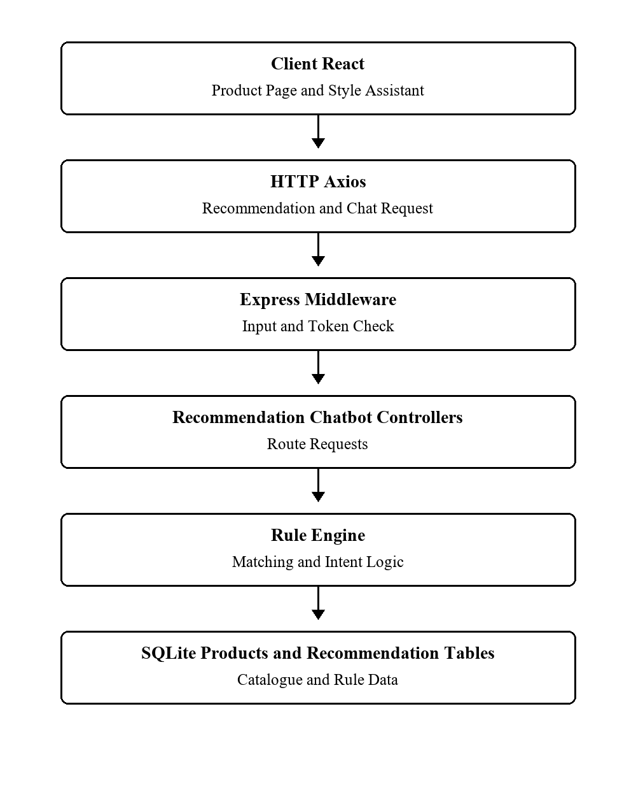
Fig 8.7.4.1 Recommendations and Chatbot Low Level Architecture
Request Flow
1. The product page requests recommendations using the current product ID.
2. The recommendation engine checks eligibility and selects complementary product slots.
3. The chatbot receives a text message and matches supported intents.
4. The API returns suggestions or a bounded fallback response for display.

8.7.5 API Design
Method | Endpoint | Purpose
GET | /api/recommendations/product/:productId | Get outfit suggestions
POST | /api/chatbot/message | Get assistant response

8.7.6 DB Design
Table | Key Fields | Use
products | id; category; color; price; stock | Current catalogue source
outfit_recommendations | base_product_id; recommended_product_id; slot_type | Stored recommendation links

8.7.7 Screenshots
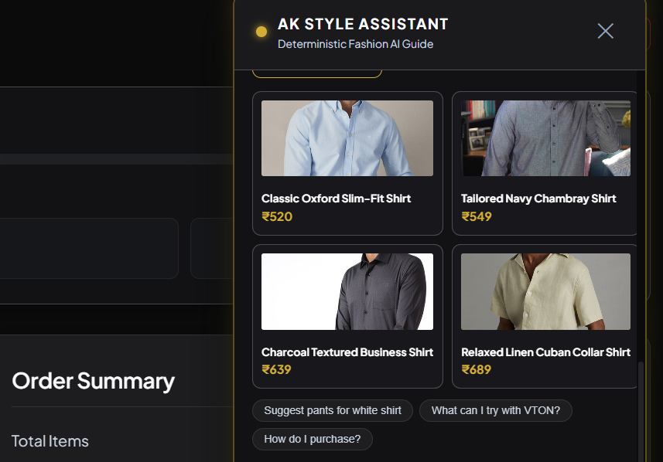Fig 8.7.1 Style Assistant Chat
This figure shows the main screen or structure used by the module. It identifies the principal components visible in the workflow. These components process the relevant request and return a result. It links the implemented design to the documented module behaviour. 8.7.2 Outfit Recommendation
Open an eligible product and show the suggested matching garments with their images, names and prices.

8.8 Virtual Try-On

8.8.0 Purpose and Scope
Virtual try-on generates a preview of a supported garment on a user photograph. The Express API validates the request and contacts a separate local Python service that runs FASHN VTON 1.5.

8.8.1 Functional Requirements
• Report whether the local try-on service is ready.
• Accept a supported photo and selected product.
• Check garment eligibility and local garment image availability.
• Send the person and garment images to the Python service.
• Save and retrieve successful results for the authenticated user.

8.8.2 Non Functional Requirements
• Reject unsupported image types and missing uploads.
• Limit upload size and protect result access by owner.
• Report service unavailability without blocking ordinary shopping.

8.8.3 Tech Stack
Concern | Choice | Why it fits this module
Image selection and results | React | Lets users select a photograph and garment and view generated results.
Upload and request handling | Node.js, Express and Multer | Accepts multipart uploads and validates image and product inputs.
Inference service interface | Python and Flask | Exposes the local service used by Express to request try-on generation.
Virtual try-on generation | FASHN VTON 1.5 | Generates a supported garment preview when model weights and hardware are available.
Result persistence | SQLite and better-sqlite3 | Stores result paths and ownership for account-specific try-on history.

8.8.4 Low Level Architecture
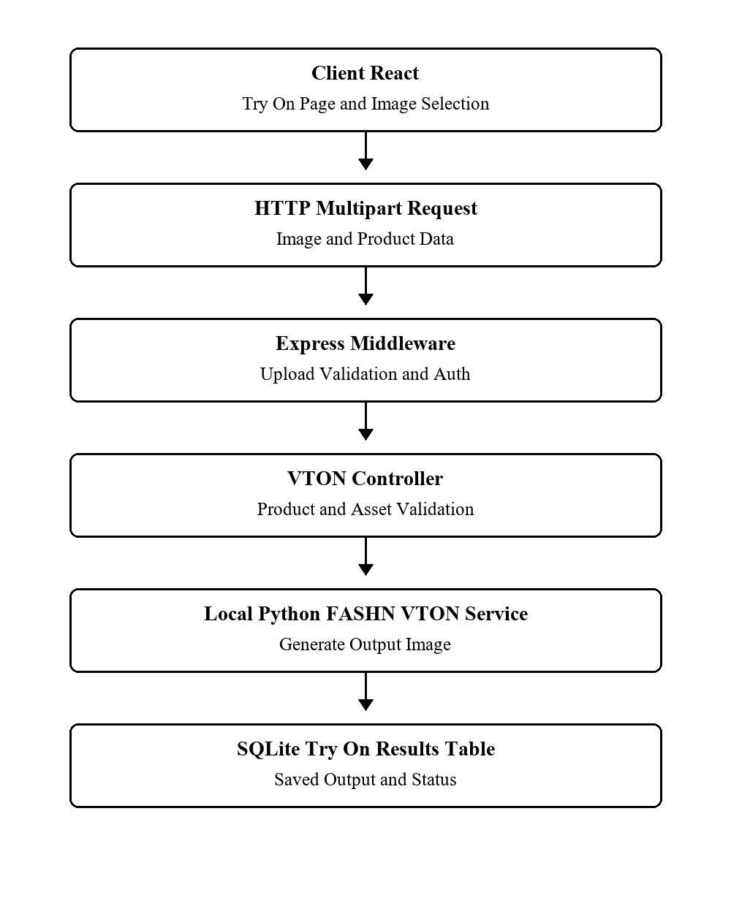
Fig 8.8.4.1 Virtual Try On Low Level Architecture
Request Flow
1. The page checks VTON status and accepts an image upload.
2. Express validates the product, garment asset and person image.
3. The Python service generates an output image when ready.
4. Express saves the output path and result record, then returns it to the page.

8.8.5 API Design
Method | Endpoint | Purpose
GET | /api/vton/status | Check service readiness
POST | /api/vton/try-on | Generate try-on result
GET | /api/vton/history | List own results
GET | /api/vton/results/:id | Get one owned result

8.8.6 DB Design
Table | Key Fields | Use
products | id; garment_image; vton_supported; vton_garment_category | Eligible garment metadata
try_on_results | user_id; product_id; generated_image_path; status | Generated result record

8.8.7 Screenshots
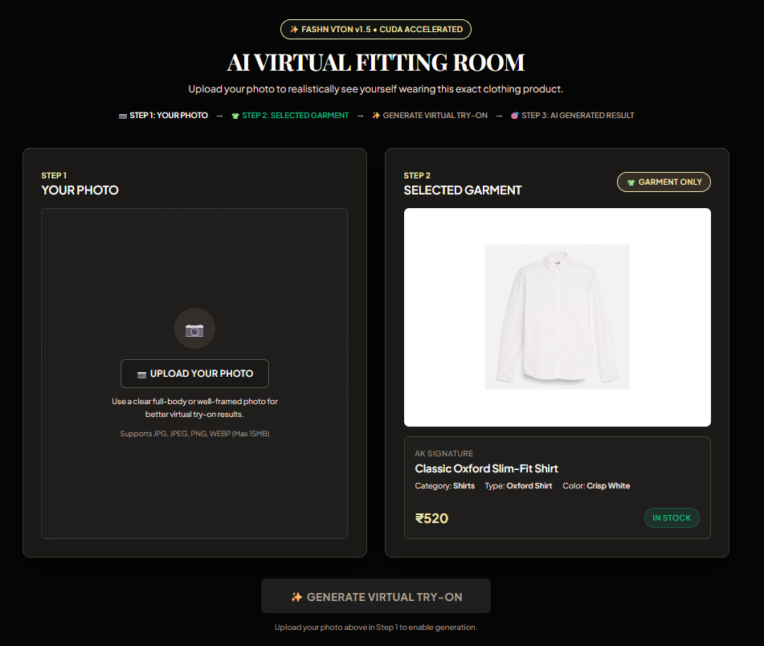
Fig 8.8.1 Virtual Try On Entry
This figure shows the main screen or structure used by the module. It identifies the principal components visible in the workflow. These components process the relevant request and return a result. It links the implemented design to the documented module behaviour.
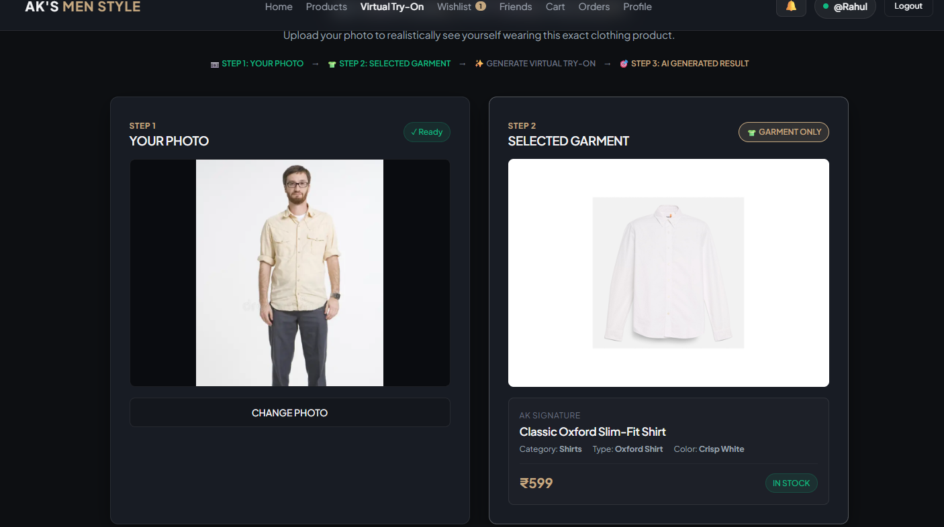
This figure shows the main screen or structure used by the module. It identifies the principal components visible in the workflow. These components process the relevant request and return a result. It links the implemented design to the documented module behaviour.

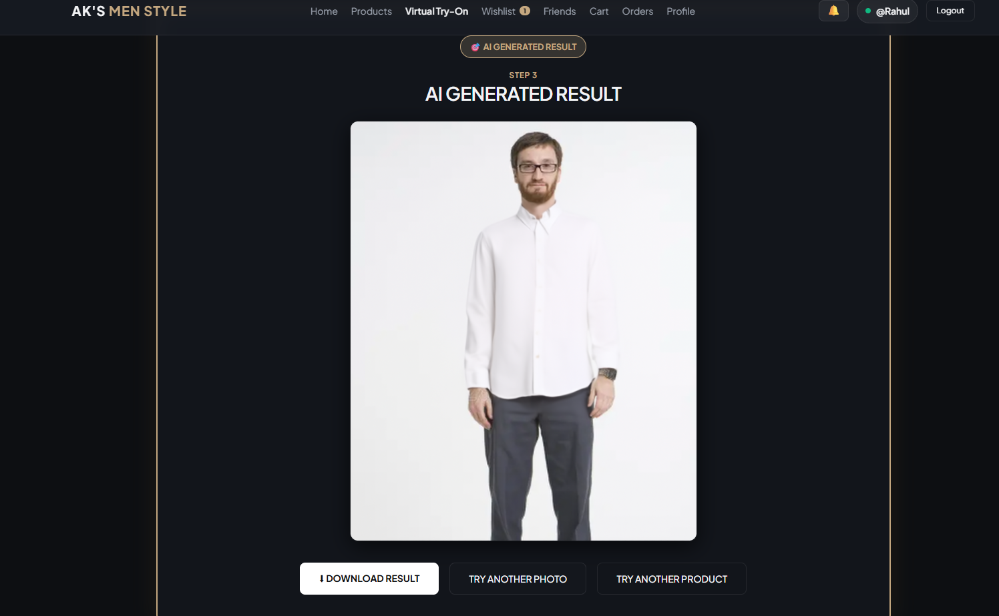Fig 8.8.3 Generated Try On Result
This figure shows the main screen or structure used by the module. It identifies the principal components visible in the workflow. These components process the relevant request and return a result. It links the implemented design to the documented module behaviour.

8.9 Admin Dashboard

8.9.0 Purpose and Scope
The administrator module provides an account restricted view of catalogue and application activity. It offers summary metrics, users, purchases, virtual try-on activity and limited product updates.

8.9.1 Functional Requirements
• Require an ADMIN role before exposing routes.
• Display metrics and recent activity.
• List products, users and purchases for administration.
• Update supported product fields through the admin route.
• Show virtual try-on and email status information.

8.9.2 Non Functional Requirements
• Enforce the role on the backend even if a page route is hidden.
• Avoid exposing password hashes in user summaries.
• Validate editable product fields before writing them.

8.9.3 Tech Stack
Concern | Choice | Why it fits this module
Administration interface | React | Presents metrics, catalogue management and account activity.
Administration API | Node.js and Express | Provides summary queries and validates supported product updates.
Administrator authorization | JWT and requireAdmin middleware | Checks the authenticated account role before allowing management operations.
Operational data | SQLite and better-sqlite3 | Supplies product, user, purchase and try-on records for dashboard summaries.

8.9.4 Low Level Architecture
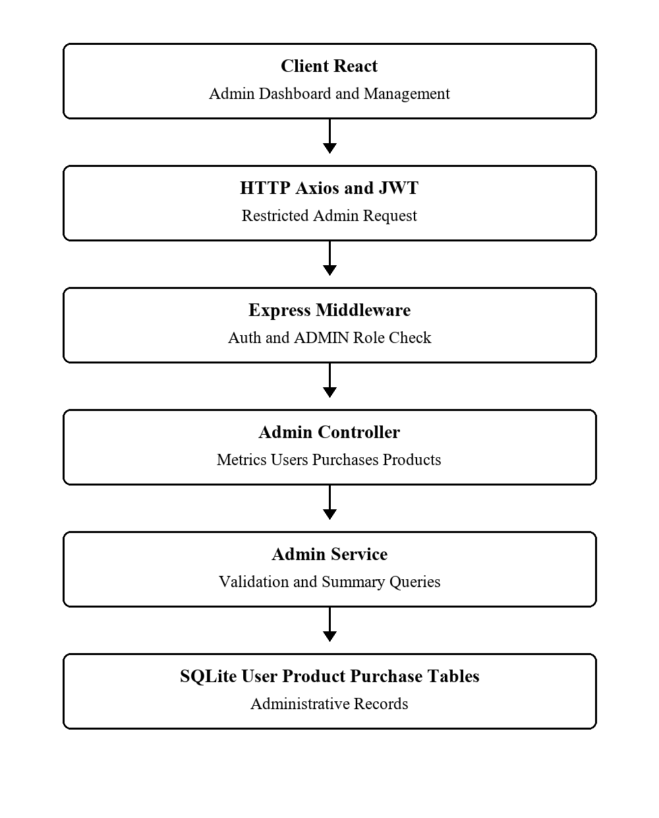
Fig 8.9.4.1 Admin Dashboard Low Level Architecture
Request Flow
1. The admin page sends a JWT with dashboard requests.
2. The requireAdmin middleware verifies the account role.
3. Controller queries summarize current database records.
4. Product changes are validated and written through the admin endpoint.

8.9.5 API Design
Method | Endpoint | Purpose
GET | /api/admin/metrics | Read dashboard metrics
GET | /api/admin/products | List products
PATCH | /api/admin/products/:id | Update product
GET | /api/admin/users | List users
GET | /api/admin/purchases | List purchases
GET | /api/admin/vton-stats | Read try-on metrics

8.9.6 DB Design
Table | Key Fields | Use
users | id; role; email | Role and user summary
products | id; price; stock; status | Catalogue editing
purchases | id; user_id; total_amount | Purchase summary
try_on_results | user_id; product_id; status | Try-on activity

8.9.7 Screenshots

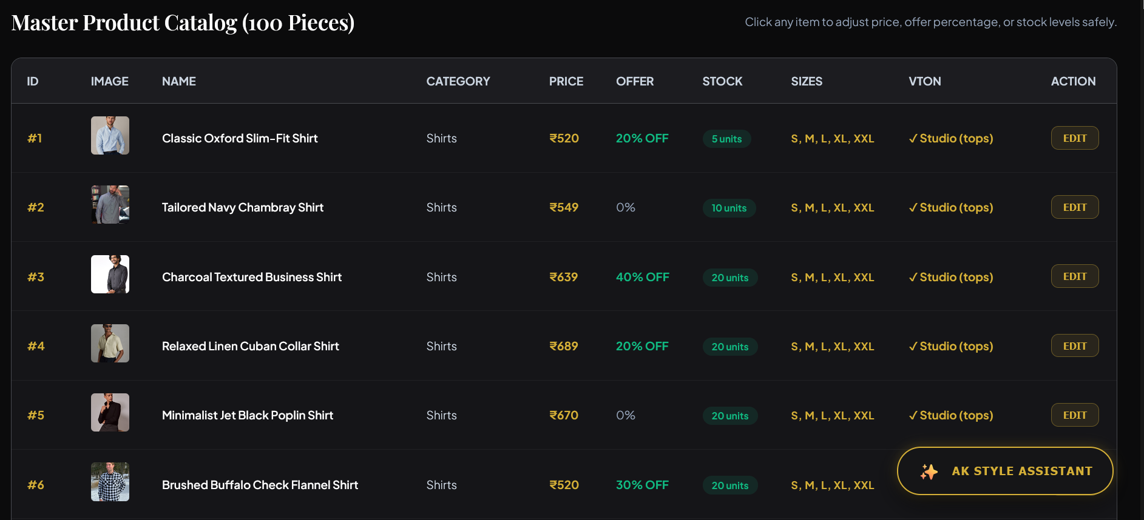.
Fig 8.9.2 Admin Product Management
This figure shows the main screen or structure used by the module. It identifies the principal components visible in the workflow. These components process the relevant request and return a result. It links the implemented design to the documented module behaviour.
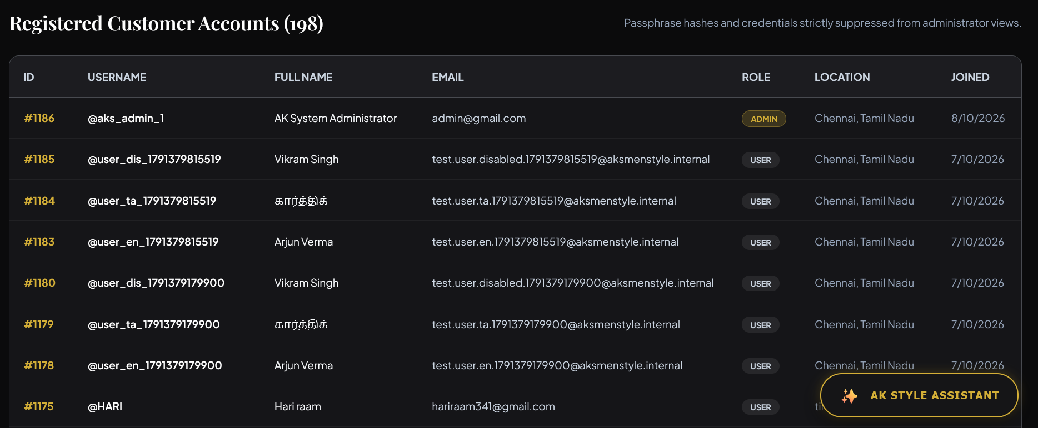Fig 8.9.3 Admin Users and Purchases
This figure shows the main screen or structure used by the module. It identifies the principal components visible in the workflow. These components process the relevant request and return a result. It links the implemented design to the documented module behaviour.
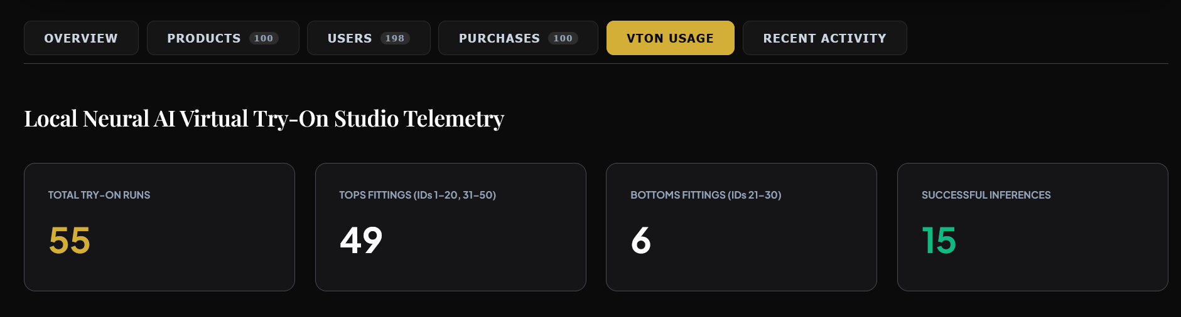Fig 8.9.4 Admin Activity and VTON Metrics

8.10 Theme and Language Preferences

8.10.0 Purpose and Scope
This module lets a user select the application appearance, interface language and communication preferences. English, Tamil and Hindi translations are provided by the current frontend language context.

8.10.1 Functional Requirements
• Switch between available interface languages.
• Remember the selected language across page reloads.
• Change among supported appearance themes.
• Save email, SMS and WhatsApp notification preferences.
• Retrieve the signed-in user settings and delivery history.

8.10.2 Non Functional Requirements
• Use a supported language when a saved value is unavailable.
• Keep account preferences associated with the correct user.
• Avoid claiming external delivery from a preference switch alone.

8.10.3 Tech Stack
Concern | Choice | Why it fits this module
Language selection | React LanguageContext | Applies English, Tamil or Hindi translations to the interface.
Appearance selection | React ThemeContext | Applies the selected appearance across components.
Settings interface | React SettingsDrawer | Groups language, theme and communication controls in one place.
Browser persistence | Web Storage | Remembers supported interface choices across page reloads.
Account settings API | Node.js, Express and JWT | Reads and saves communication preferences for the signed-in user.
Account preference persistence | SQLite and better-sqlite3 | Stores supported user preferences and channel delivery history.

8.10.4 Low Level Architecture
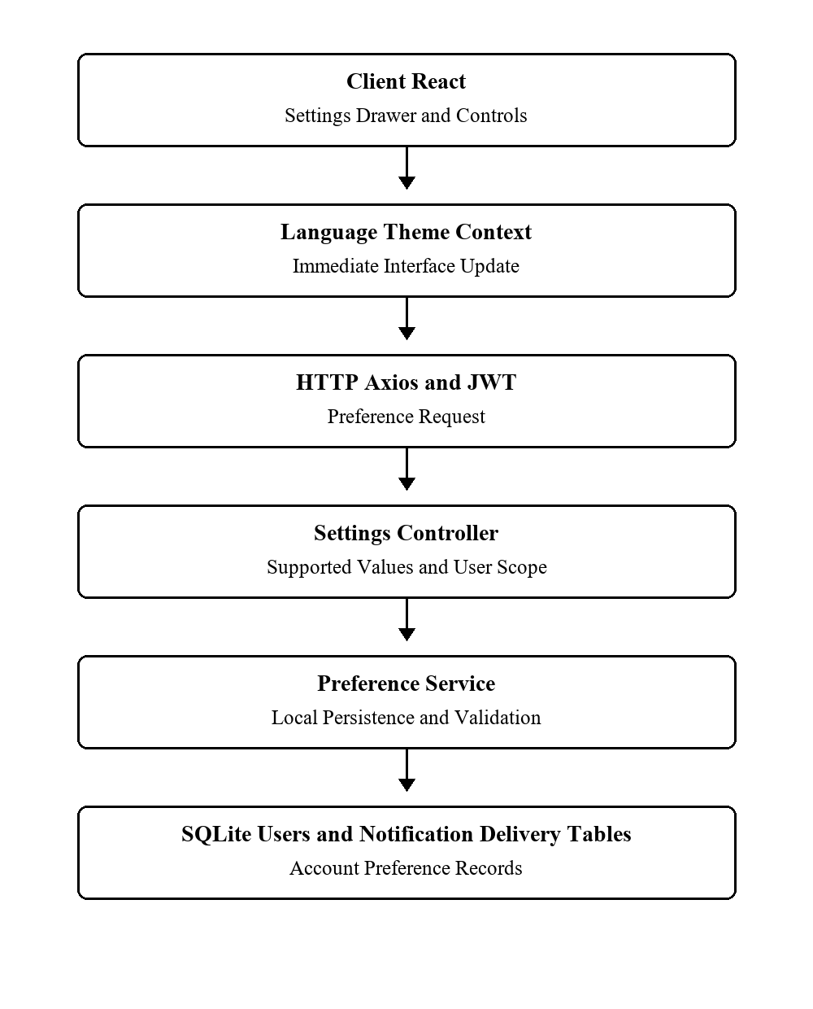
Fig 8.10.4.1 Theme Language and Preferences Low Level Architecture
Request Flow
1. The user opens settings and changes a language or appearance choice.
2. The frontend updates its context and local persistence for immediate display.
3. Account communication preferences are sent to the protected settings API.
4. The database stores the supported user preference fields.

8.10.5 API Design
Method | Endpoint | Purpose
GET | /api/settings | Read user settings
PUT | /api/settings | Save preferences
GET | /api/settings/notifications/history | Read delivery history

8.10.6 DB Design
Table | Key Fields | Use
users | id; theme_preference; language_preference; email_notifications; sms_notifications; whatsapp_notifications | Saved user choices
notification_deliveries | user_id; channel; status | Communication history

8.10.7 Screenshots
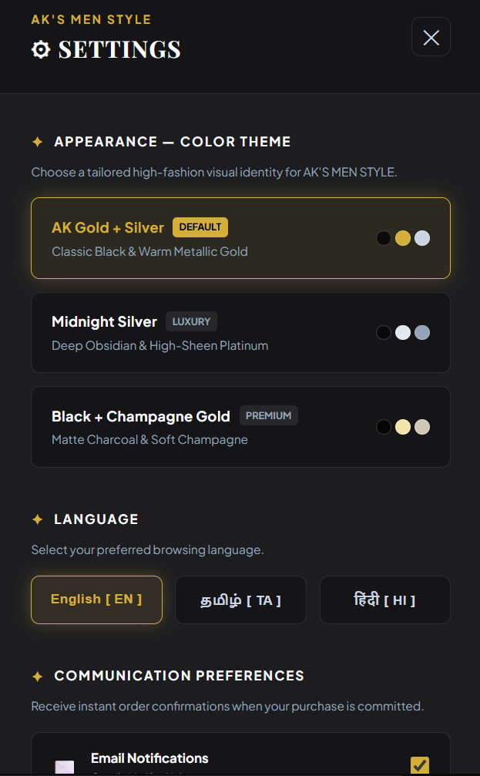
Fig 8.10.1 Settings Drawer
This figure shows the main screen or structure used by the module. It identifies the principal components visible in the workflow.
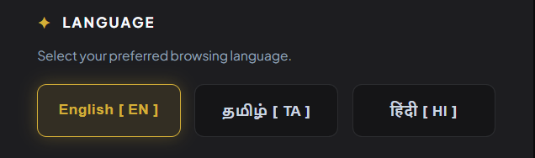
Fig 8.10.2 Language Selector
This figure shows the main screen or structure used by the module. It identifies the principal components visible in the workflow. These components process the relevant request and return a result. It links the implemented design to the documented module behaviour.
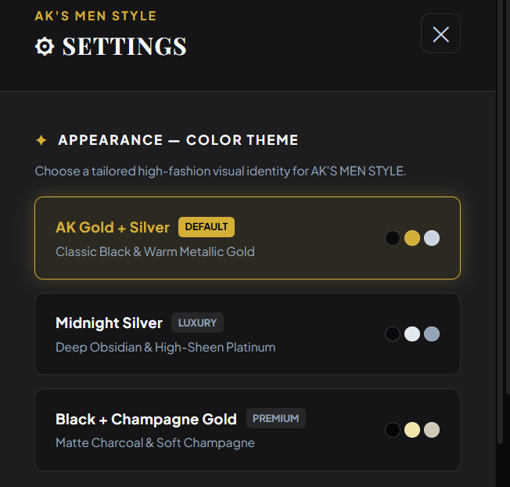
Fig 8.10.3 Theme Selector
This figure shows the main screen or structure used by the module. It identifies the principal components visible in the workflow. These components process the relevant request and return a result. It links the implemented design to the documented module behaviour.
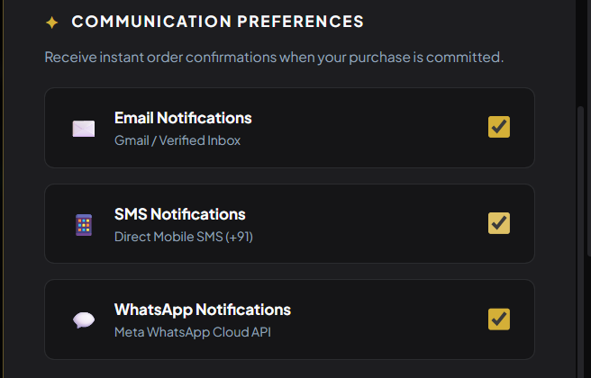
Fig 8.10.4 Communication Preferences
This figure shows the main screen or structure used by the module. It identifies the principal components visible in the workflow. These components process the relevant request and return a result. It links the implemented design to the documented module behaviour.
CHAPTER 9

CONCLUSION
StyleHub brings the main operations of a men fashion shopping application into one system: protected accounts, product browsing, cart and purchase handling, wishlists, friend sharing, rule based suggestions, administration, and saved preferences. The SQLite schema and REST routes provide a coherent basis for these modules.
Virtual try-on extends the project through a local third party model, while Google sign-in and communication channels depend on external configuration. The report diagrams and screenshot spaces support later submission updates without changing the underlying technical description.

