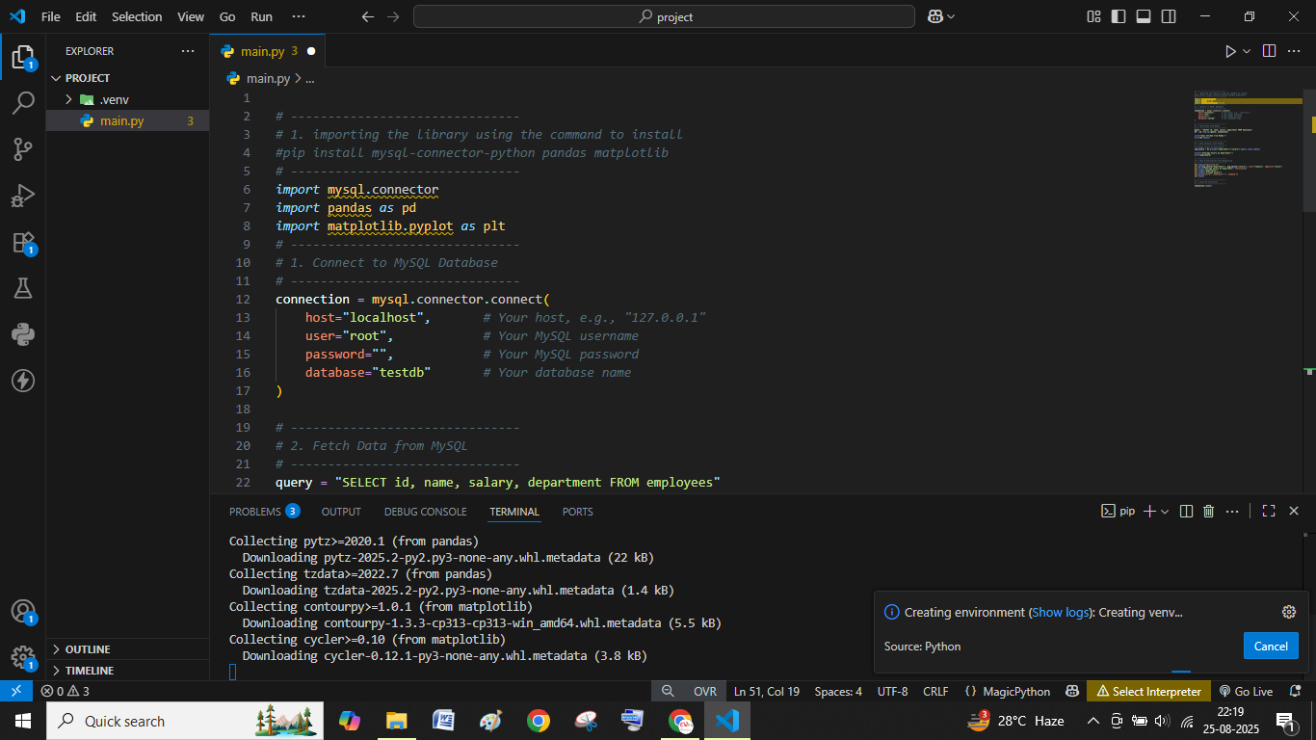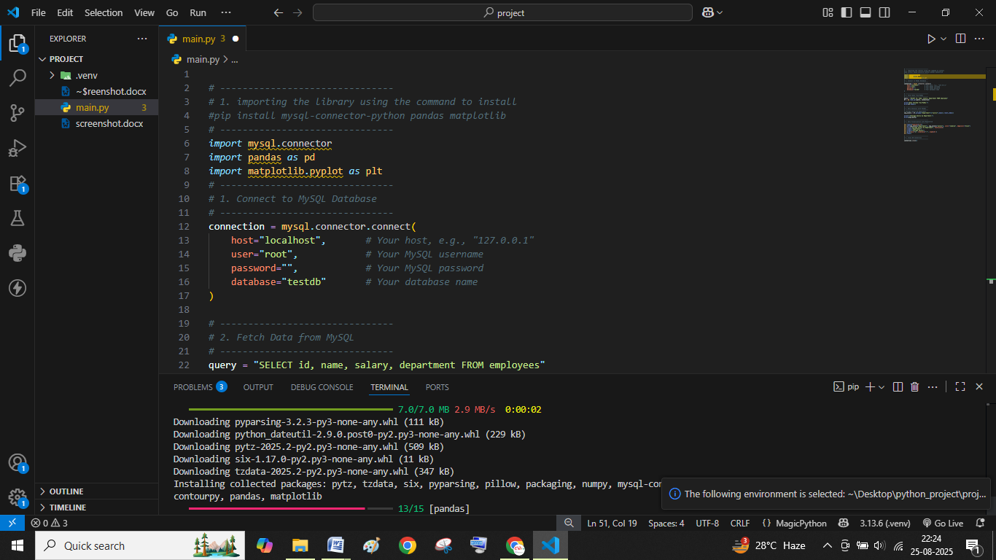

Screen shot of installing dependencies at first install XAMPP server and start it then dump the sql file into your db

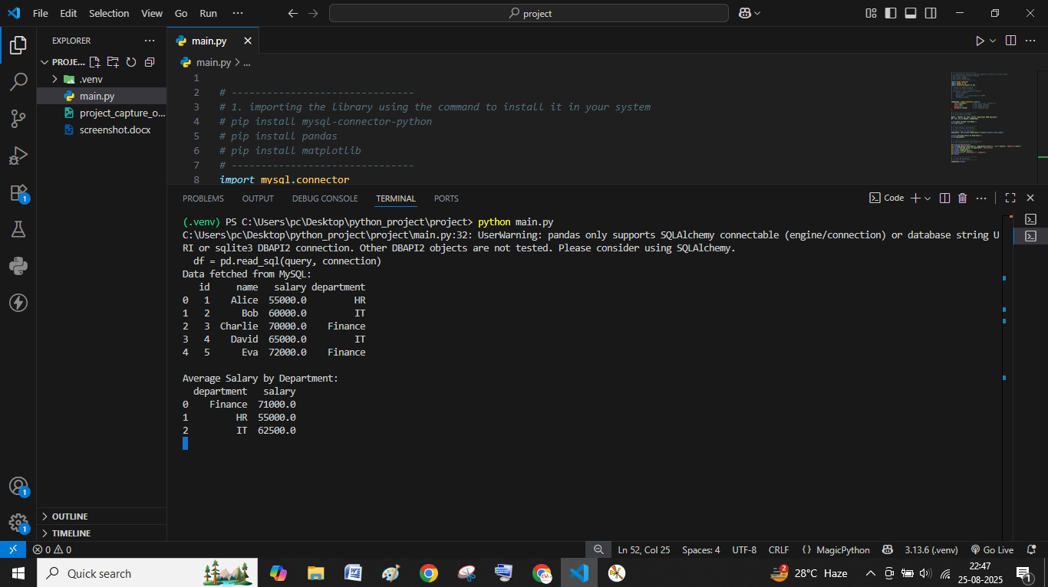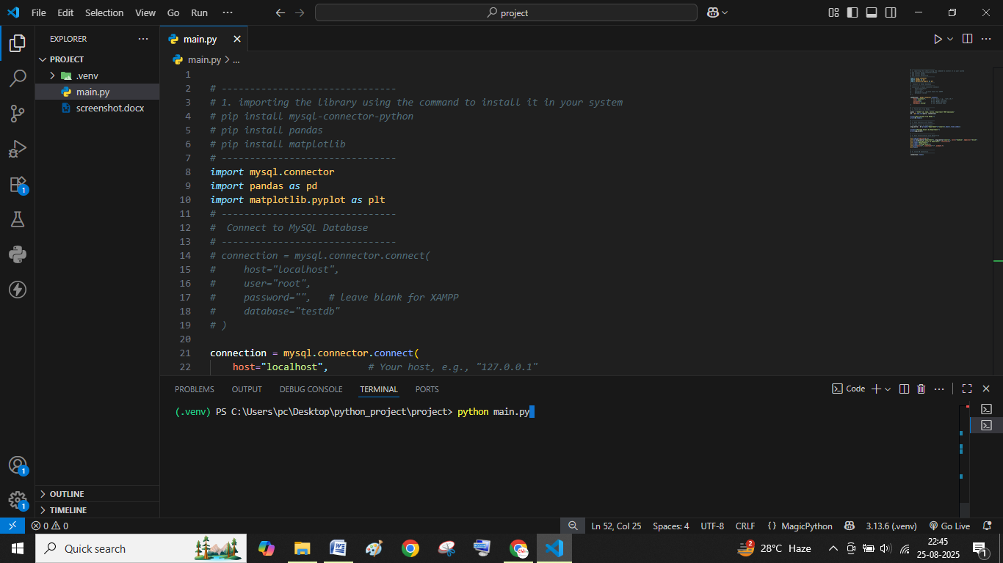Execute the program with this code

Make it advance based project as a day day 2 purpose make it industry use

Output

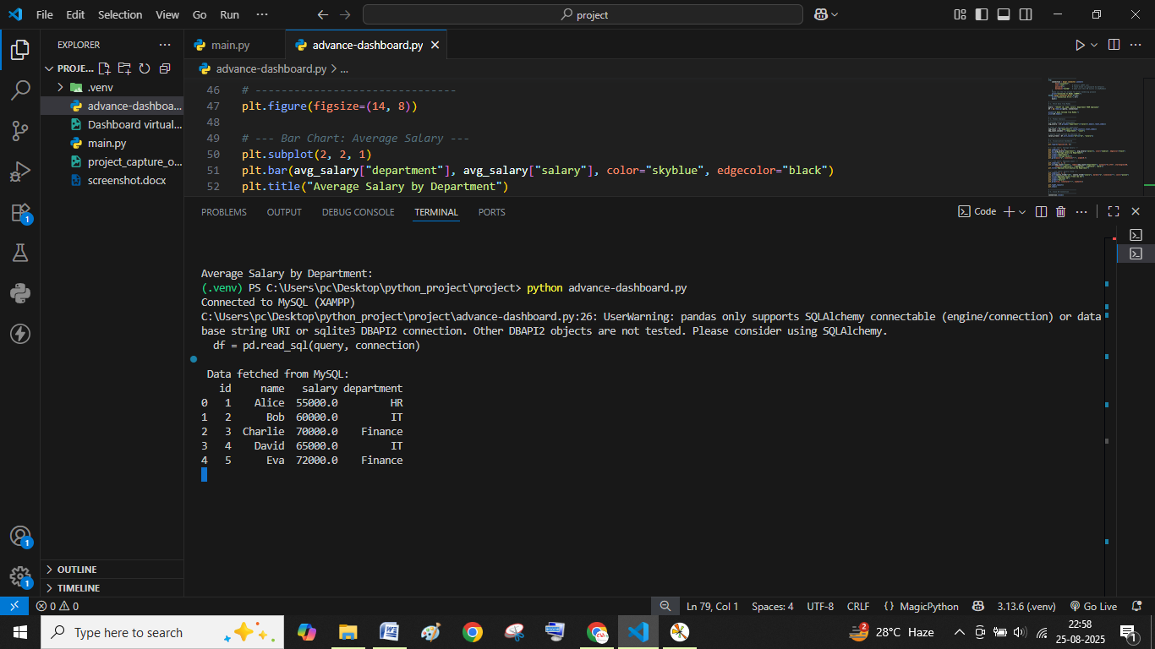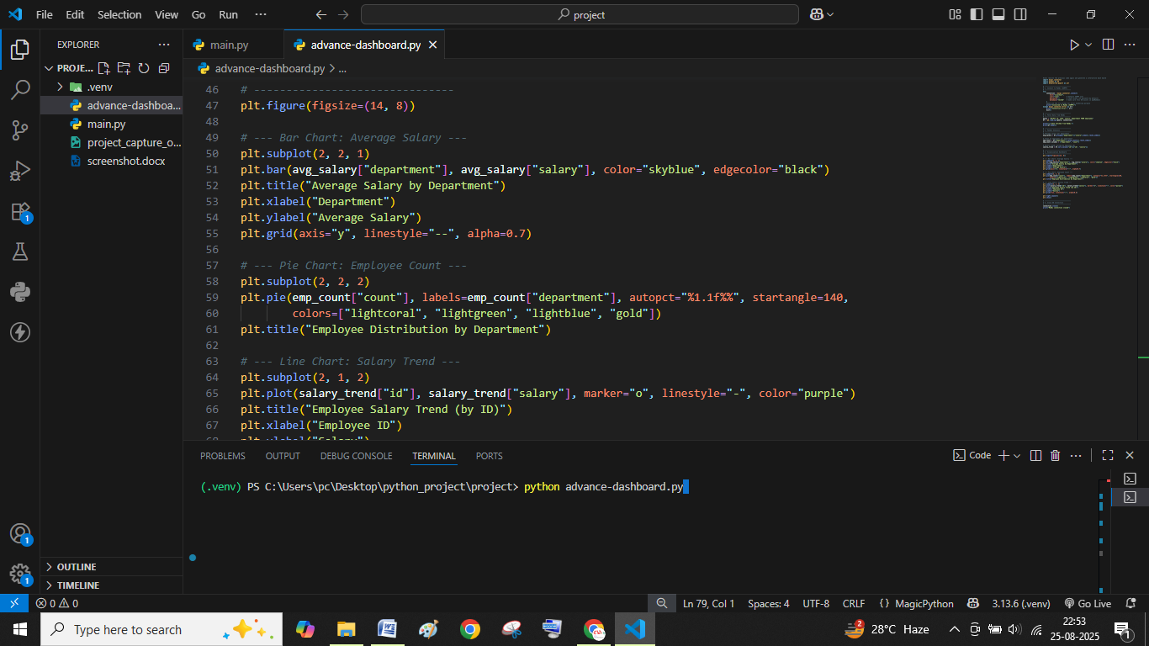

#day 1 code Beginning-project.py file name

*# -------------------------------*

*# 1. importing the library using the command to install it in your system*

*# pip install mysql-connector-python*

*# pip install pandas*

*# pip install matplotlib*

*# -------------------------------*

*import* mysql.connector

*import* pandas *as* pd

*import* matplotlib.pyplot *as* plt

*# -------------------------------*

*#  Connect to MySQL Database*

*# -------------------------------*

*# connection = mysql.connector.connect(*

*#     host="localhost",*

*#     user="root",*

*#     password="",   # leave blank for XAMPP*

*#     database="testdb"*

*# )*

connection = mysql.connector.connect(

    host="localhost",       *# Your host, e.g., "127.0.0.1"*

    user="root",            *# Your MySQL username*

    password="",            *# Your MySQL password*

    database="testdb"       *# Your database name*

)

*# -------------------------------*

*# 2. Fetch Data from MySQL*

*# -------------------------------*

query = "SELECT id, name, salary, department FROM employees"

df = pd.read_sql(query, connection)

print("Data fetched from MySQL:")

print(df.head())

*# -------------------------------*

*# 3. Data Analysis with Pandas*

*# -------------------------------*

*# Average salary by department*

avg_salary = df.groupby("department")["salary"].mean().reset_index()

print("\nAverage Salary by Department:")

print(avg_salary)

*# -------------------------------*

*# 4. Data Visualization with Matplotlib*

*# -------------------------------*

plt.figure(figsize=(8,5))

plt.bar(avg_salary["department"], avg_salary["salary"], color="skyblue", edgecolor="black")

plt.title("Average Salary by Department", fontsize=14)

plt.xlabel("Department")

plt.ylabel("Average Salary")

plt.grid(axis="y", linestyle="--", alpha=0.7)

plt.show()

*# -------------------------------*

*# 5. Close DB Connection*

*# -------------------------------*

connection.close()

Advance-dashboard.py

Code

*#lets rewrite the previous code again and generate a interactive dash board*

*import* mysql.connector

*import* pandas *as* pd

*import* matplotlib.pyplot *as* plt

*# -------------------------------*

*# 1. Connect to MySQL (XAMPP)*

*# -------------------------------*

*try*:

    connection = mysql.connector.connect(

        host="localhost",

        user="root",        *# default XAMPP user*

        password="",        *# leave blank (no password by default)*

        database="testdb"   *# make sure this DB exists in phpMyAdmin*

    )

*#make use the try except for error handeling purpose*

    print("Connected to MySQL (XAMPP)")

*except* mysql.connector.Error *as* err:

    print("Connection Error:", err)

    exit()

*# -------------------------------*

*# 2. Fetch Data from MySQL*

*# -------------------------------*

query = "SELECT id, name, salary, department FROM employees"

df = pd.read_sql(query, connection)

print("\n Data fetched from MySQL:")

print(df.head())

*# -------------------------------*

*# 3. Pandas Analysis*

*# -------------------------------*

*# Average salary per department*

avg_salary = df.groupby("department")["salary"].mean().reset_index()

*# Count of employees per department*

emp_count = df["department"].value_counts().reset_index()

emp_count.columns = ["department", "count"]

*# Salary trend (sorted by employee id)*

salary_trend = df.sort_values("id")[["id", "salary"]]

*# -------------------------------*

*# 4. Visualization Dashboard*

*# -------------------------------*

plt.figure(figsize=(14, 8))

*# --- Bar Chart: Average Salary ---*

plt.subplot(2, 2, 1)

plt.bar(avg_salary["department"], avg_salary["salary"], color="skyblue", edgecolor="black")

plt.title("Average Salary by Department")

plt.xlabel("Department")

plt.ylabel("Average Salary")

plt.grid(axis="y", linestyle="--", alpha=0.7)

*# --- Pie Chart: Employee Count ---*

plt.subplot(2, 2, 2)

plt.pie(emp_count["count"], labels=emp_count["department"], autopct="%1.1f%%", startangle=140,

        colors=["lightcoral", "lightgreen", "lightblue", "gold"])

plt.title("Employee Distribution by Department")

*# --- Line Chart: Salary Trend ---*

plt.subplot(2, 1, 2)

plt.plot(salary_trend["id"], salary_trend["salary"], marker="o", linestyle="-", color="purple")

plt.title("Employee Salary Trend (by ID)")

plt.xlabel("Employee ID")

plt.ylabel("Salary")

plt.grid(True, linestyle="--", alpha=0.6)

plt.tight_layout()

plt.show()

*# -------------------------------*

*# 5. Close DB Connection*

*# -------------------------------*

connection.close()

print("MySQL connection closed")

Thank you