aNIS Subba: 21302329 - jEnnifer odonog: 21256488 - Nazir Mohammmad: 21286634 - bENJAMIN Mapamboli: 21257710

FCEPH – Group 3

Contents

Table of Figures 5

**Project** 6

**Project Team** 6

**Introduction** 6

**Project Plan** 6

**Software Requirements** 7

**Charts** 0

**Risk Register** 1

**Group Meetings/Schedule** 1

**Technology used for meetings/collaboration** 1

**Project Lifecycle** 1

**Week 1** 1

**Week 2** 2

**Week 3** 2

**Week 4** 2

**Week 5** 2

**Week 6** 2

**Week 7** 3

**Week 8** 3

**Week 9** 3

**Week 10** 3

**Week 11** 3

**Week 12** 3

**Week 13** 3

**Core Software** 4

**Website** 4

**Website Testing** 4

**Anis – Supplier Interface – Project Manager** 4

**Project Manager** 4

**Sub Project Plan** 4

**Risk Register** 4

**Requirements** 4

**Software** 4

**Component Integration** 4

**Testing** 4

**Jennifer – Loyalty Scheme – Documentation** 4

**Documentation** 4

**Sub Project Plan** 5

**WBS** 5

**Gantt chart** 5

**Network Diagram** 5

**Risk Register** 5

**Requirements** 5

**Software** 5

**Component Integration** 5

**Testing** 6

**Nazir – Payment – Integration** 6

**Integration Planner** 6

**Sub Project Plan** 6

**Risk Register** 6

**Requirements** 6

**Software** 6

**Component Integration** 6

**Testing** 6

**Benjamin – Marketing - QA** 6

**Quality Assurance** 6

**Sub Project Plan** 6

**Risk Register** 6

**Requirements** 6

**Software** 7

**Component Integration** 7

**Testing** 7

**Appendix** 7

**Website** 7

**Style.css** 7

**Index.html** 7

**item.html** 7

**Groceries.html** 7

**freshfood.html** 7

**fruit.html** 7

**vegetable.html** 7

**salad.html** 7

**dips.html** 7

**smoothies.html** 7

**milk.html** 7

**yoghurts.html** 7

**cheese.html** 8

**dairyfree.html** 8

**meat.html** 8

**fish.html** 8

**cookedmeat.html** 8

**slicedcookedm.html** 8

**pies.html** 8

**readymeal.html** 8

**bakery.html** 8

**bread.html** 8

**wraps.html** 8

**pancake.html** 8

**muffins.html** 8

**croissant.html** 8

**scones.html** 8

**doughnuts.html** 8

**cake.html** 8

**frozenfood.html** 8

**frozenmeat.html** 8

**frozenfish.html** 9

**icecream.html** 9

**frozendesserts.html** 9

**frozenpizza.html** 9

**frozenchips.html** 9

**frozenpuddings.html** 9

**frozenpies.html** 9

**frozenreadymeal.html** 9

**foodcupboard.html** 9

**tins.html** 9

**biscuits.html** 9

**cracker.html** 9

**crisps.html** 9

**snacks.html** 9

**chocolate.html** 9

**sweets.html** 9

**gum.html** 9

**cereal.html** 9

**ingredients.html** 9

**mealkit.html** 10

**spaghetti.html** 10

**homebaking.html** 10

**jams.html** 10

**drinks.html** 10

**ghousehold.html** 10

**baby.html** 10

**pets.html** 10

**Clothing.html** 10

**Electronics.html** 10

**Pharmacy.html** 10

**Household.html** 10

**Application** 10

**Main page** 10

# Table of Figures

**Figure 1 – Work Breakdown Structure 0**

**Figure 2 – Network Diagram 1**

**Figure 3 – Activity Diagram 0**

**Figure 4 – Critical Path Analysis 1**

**Figure 5 - Earned Value Analysis 2**

**Figure 6 – Risk Register 2**

# **Project**

## **Project Team**

FCEPH is a team with four members. Anis, Jennifer, Nazir and Benjamin.

Anis’s non-technical role in the team is project manager. As project manager, Anis was in charge of taking the group minutes. His technical role was to develop the suppliers interface component.

Jennifer’s non-technical role is documenting. This involved keeping track of the planning and development processes of this project. Her technical role was to develop the loyalty scheme component.

Nazir’s non-technical role is integration planner. This involved coming up with a way to integrate our individual components into the core software. His technical role was to develop the payment component.

Benjamin’s non-technical role is quality assurance. This involved checking over the work being produced and giving any suggestions on things that can be done to improve it. His technical role was to develop the marketing component.

## **Introduction**

The software we decided to develop was a website for a supermarket. The core is all the items for sale on view with a basket to store their items and check out. The payment component allows the user to pay for their items. The marketing component gives users sales. The supplier component lets a user buy more supplies and the loyalty scheme component lets a user get points for purchasing certain items.

## **Project Plan**

Our original plan had been to create two pieces of software for a supermarket. The two pieces of software would be an application and a website. The team would split so that Anis and Nazir would create the app and Jennifer and Benjamin would create the website. Anis and Nazir were chosen for the app as they had had experience with that. Jennifer and Benjamin were chosen for the website as they both had previous experience with that. This had not been a good idea because the project ended up being bigger than expected and there were not enough people for certain activities. Because of this many things had to be cut out of our software, requirements were changed and the app had to be ditched.

**Software and resources**

We used a number of software and resources in the planning and creation of our software.

To create the website, we decided to use Dreamweaver. We chose this program because of the split screen it provided. Dreamweaver allows you to view your code and your design at the same time. You get a live update for any code you add without having to open the website on a web browser to see what the code has done.

**Name**

The name of our group and supermarket is FCEPH. It stands for Food, Clothing, Electronics, Pharmacy and Household. This is because we wanted our supermarket to be one that sells all these things so we chose a name that would reflect this.

**Colour Scheme**

We chose the colours green, blue and white as our projects colour scheme. We used these colours throughout our project on charts and in our website. We chose these colours because we felt that they would be appropriate for a supermarket.

**Logo**



Jennifer designed this logo for the website.

### **Software Requirements**

We created a list of user requirements for each component of the software to help break down the tasks we needed to do. With this we were able to get the most important aspects of the software completed first leaving us with enough time to add any extra features we wanted. Because we had originally decided to create a website and an application, we wrote down three sets of core requirements. One was the overall requirement for the supermarket. The second was for the website and the third was for the application. We removed the application requirements when it we decided that we should stick to the website.

**Overall Requirement**

* A customer should be able to register/login or use software as a guest.
* A customer should be able to view a list of items on offer.
* A customer should be able to filter through the items on view.
* A customer should be able to select an item.
* A customer should be able to increase or decrease the quantity of items.
* A customer should be able to add items to a basket.
* A customer should be able to checkout.
* A customer should be able to set a delivery date

**Website Requirement**

Home Page

* Navigation bar (Groceries, Clothing, Electronics, Pharmacy and Home & Furniture)
* Slideshow
* Promo items
* Utility bar at the top (Login, settings, help, basket, account etc)
* Footer (Help, contact us etc)

Groceries Page

* Utility bar at the top (Login, settings, help, basket, account etc)
* Navigation bar (Groceries, Clothing, Electronics, Pharmacy and Home & Furniture)
* Sub navigation bar (Fresh food, frozen food, drinks etc)
* Footer (Help, contact us etc)
* View items
* Filter items
* Add item to basket
* Select items

Clothing Page

* Utility bar at the top (Login, settings, help, basket, account etc)
* Navigation bar (Groceries, Clothing, Electronics, Pharmacy and Home & Furniture)
* Sub navigation bar (Fresh food, frozen food, drinks etc)
* Footer (Help, contact us etc)
* View items
* Filter items
* Add item to basket
* Select items

Electronics Page

* Utility bar at the top (Login, settings, help, basket, account etc)
* Navigation bar (Groceries, Clothing, Electronics, Pharmacy and Home & Furniture)
* Sub navigation bar (Fresh food, frozen food, drinks etc)
* Footer (Help, contact us etc)
* View items
* Filter items
* Add item to basket
* Select items

Pharmacy Page

* Utility bar at the top (Login, settings, help, basket, account etc)
* Navigation bar (Groceries, Clothing, Electronics, Pharmacy and Home & Furniture)
* Sub navigation bar (Fresh food, frozen food, drinks etc)
* Footer (Help, contact us etc)
* View items
* Filter items
* Add item to basket
* Select items

Home & Furniture Page

* Utility bar at the top (Login, settings, help, basket, account etc)
* Navigation bar (Groceries, Clothing, Electronics, Pharmacy and Home & Furniture)
* Sub navigation bar (Fresh food, frozen food, drinks etc)
* Footer (Help, contact us etc)
* View items
* Filter items
* Add item to basket
* Select items

Item Page

* Utility bar at the top (Login, settings, help, basket, account etc)
* Navigation bar (Groceries, Clothing, Electronics, Pharmacy and Home & Furniture)
* Footer (Help, contact us etc)
* Item name
* Item image
* Item description
* Item price
* Change quantity
* Add item to basket

Basket Page

* Utility bar at the top (Login, settings, help, basket, account etc)
* Navigation bar (Groceries, Clothing, Electronics, Pharmacy and Home & Furniture)
* Footer (Help, contact us etc)
* View basket items
* Change quantity
* Remove item
* Checkout

Checkout Page

* Confirm order
* Cancel order

Login/Register Page

* Fields to enter Login/register details

Contact Us Page

* Utility bar at the top (Login, settings, help, basket, account etc)
* Navigation bar (Groceries, Clothing, Electronics, Pharmacy and Home & Furniture)
* Footer (Help, contact us etc)
* Contact us form
* Address
* Phone number

As time went by, we realised that we would have to remove some things from the requirement due to time running out. The last time we had to demonstrate we lost marks for having things that did not work so we saw it was better if those things were just removed so we would not have the same problems as last time. We removed the basket page and turned into a popup. We removed the login/register page because there was not enough time to get it to work.

### **Charts and Diagrams**

**Work Breakdown Structure**

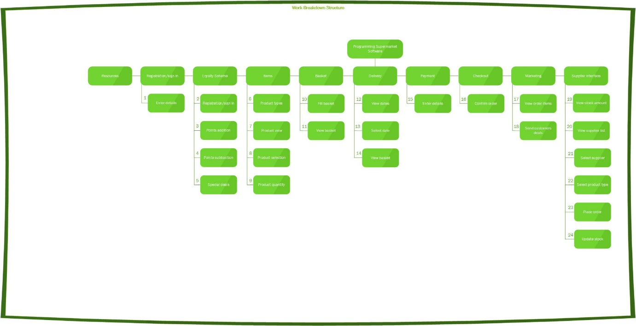

Figure – Work Breakdown Structure

This diagram shows all the functions on our website that needs to be done. This is an image for the overall software, core and components. We used a work breakdown structure so that we could break down the project into manageable chunks. This made the project look much more manageable so we wouldn’t feel overwhelmed by the workload.

**Network Diagram**

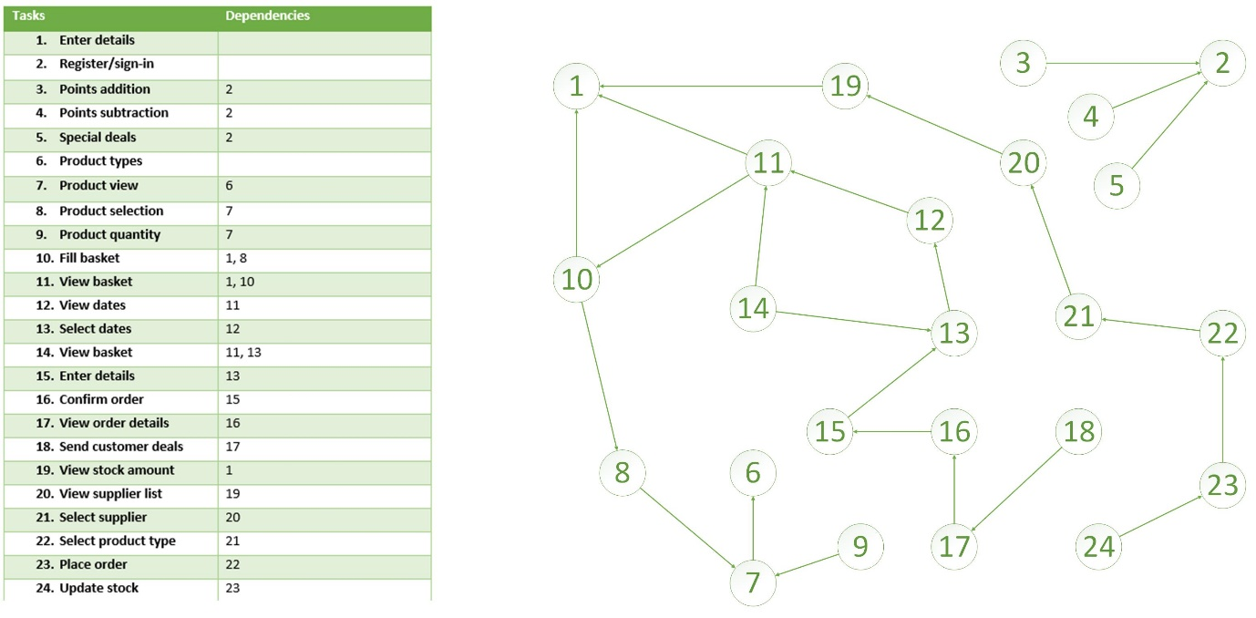

Figure – Network Diagram

The network diagram is a more detailed version of the WBS, Work Breakdown Structure. It helps with identifying critical activities and the dependencies. The tasks with empty dependencies do not depend on any other tasks. 1 is for registration. 2 is for registration for a loyalty scheme. 3, 4 and 5 rely on 2 because a user has to be registered to get these benefits. 6 which is having different products does not depend on anything. 7 depends on 6 because there needs to be a product type for the re to be a view. 8 and 9 depend on 7 because a user needs to be able to view a product before they can select or choose quantity. 10 depends on 1 and 8 because user needs to be logged in to fill basket and they need to be able to select an item. 11 depends on 1 and 10 because user needs to be logged in and the basket needs to have some items. 12 depends on 11 because the basket needs to be filled before they can get to choose a delivery date. 13 depends on 12 because the user needs to be able to view the dates before they can select one. 14, the confirmation, depends on 11 and 13 because the basket needs to be filled and a date has to have been chosen.15 depends on 13 because a date has to have been chose. 16 depends on 15 because payment details have to be there. 17 depends on 16 because the order has to have been confirmed. 18 depends on 17 because the customer has to have placed an order before. 19 depends on 1 because the staff needs to be logged in to access the stock. 20 depends on 19 because there has to be low stock for the staff to want to update the stock. 21 depends on 20 because user needs to be able to view supplier before they can select. 22 depends on 21 because the user needs to select a supplier first. 23 depends on 22 because the user needs to select a product before they can place an order. 24 depends on 23 because an order needs to have been placed before the stock can be updated.

**Activity Diagram**

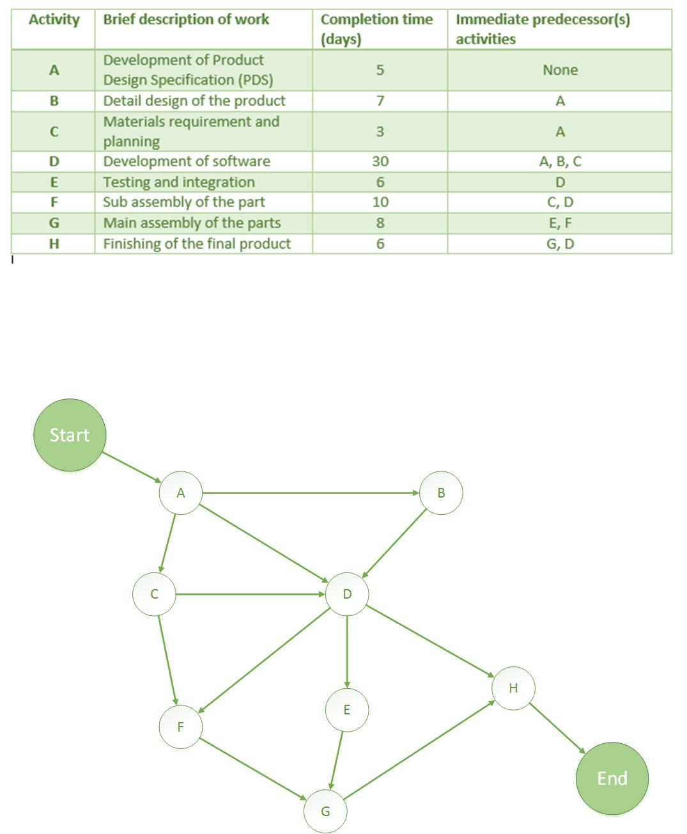

Figure – Activity Diagram

Activity diagram shows the number of activities and its predecessors. This diagram shows that B is the predecessor of A as design specifications are needed for there to be a detail design for the software. C precedes A because it needs the design specification for the material planning to be done. D precedes A, B and C as it needs all of these before it can start. E precedes D because the software needs to have been developed for testing and integration to happen. F precedes D and C because the main component need to be completed and the material requirements and planning is needed to start it. G precedes E and F because the sup parts have to be finished and the program needs to be integrated for the main assembly. H precedes G and D because everything needs to have been completed.

**Critical Path**

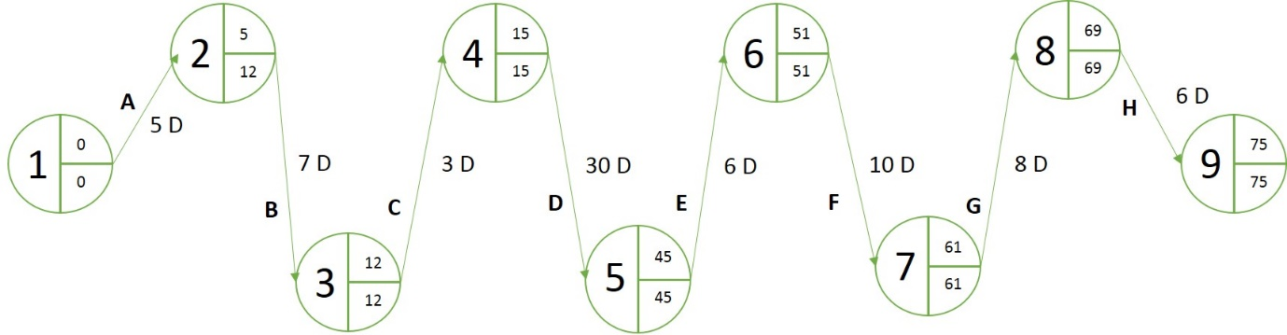

Figure – Critical Path Analysis

The critical path analysis uses projects activities, duration time for those activities and dependencies to help with managing the project. This is done by estimating the earliest finishing time, EFT, and the latest finishing time, LFT.

The first activity, development of product design specification, would take an estimate of 5 days to complete. The second activity, detail design of the product, would take an estimate of 7 days to complete. This would be 12 days into the project. The third activity, materials requirement and planning, would take an estimate of 3 days to complete. This would be 15 days into the project. The fourth activity, development of software, would take an estimate of 30 days to complete. This would be 45 days into the project. The fifth activity, testing and integration, would take an estimate of 6 days to complete. This would be 51 days into the project. The sixth activity, sub assembly of the part, would take an estimate of 10 days to complete. This would be 61 days into the project. The seventh activity, main assembly of the parts, would take an estimate of 8 days to complete. This would be 69 days into the project. The last activity, finishing of the final product, would take an estimate of 6 days to complete. The 75 day would be the earliest finish time.

The LFT for the first activity is the 12th day. The LFT for the second activity is also the 12th day. The LFT for the third activity is the 15th day. The LFT for the fourth activity is the 45th day. The LFT for the fifth activity is the 51st day. The LFT for the sixth activity is the 61st day. The LFT for the seventh day is the 69th day and the LFT for that last activity is the 75th day.

Since the EST and the LFT are the same for most of the activities, those times would be the length of the activity. This also means that all the activities are critical.

**Earned Value Analysis**

Earned value analysis, EVA, is a system that allows you to see the relationship between the accomplishments that were planned and the accomplishments that were actually achieved. Planned value, PV, is the planned work. Earned value, EV, is the actual work and actual cost, AC, is the cost of completing that work.

Using the example given in the week 10 lecture, this software project is £30,000. This is for 6 weeks, as the core should be finished by then.

By fifth week core was only 30% complete so the actual cost is £50,000.

**Planned Value** = £25,000

**Earned Value** = £9,000

**Actual Cost** = £50,000

**Schedule Variance** = -£16,000

**Schedule Performance Index** = .36

**Cost Variance** = -£41,000

**Cost Performance Index** = .18

The total cost of the project will be £166,666.66

Figure - Earned Value Analysis

The core was supposed to be completed by the 6th week but this did not happen. The main reason for this is because there had not been enough people assigned to the core development so progress fell behind drastically.

### **Risk Register**

We created a risk register so that we could keep track of all the things we think can possibly go wrong or right in our project.

|  |  |  |  |  |  |  |  |  |
| --- | --- | --- | --- | --- | --- | --- | --- | --- |
| No. | Rank | Risk | Description | Category | Root | Triggers | Potential Responses | Status |
| R1 | 1 | incompletion | Not finishing the core on time | negative | Not enough people working on an activity | Passing a deadline for an activity | Assign more people to task | ongoing |
| R2 | 2 | communication |  |  |  |  |  |  |
|  | 3 | Resources |  |  |  |  |  |  |
|  | 4 |  |  |  |  |  |  |  |
|  | 5 |  |  |  |  |  |  |  |
|  | 6 |  |  |  |  |  |  |  |
|  | 7 |  |  |  |  |  |  |  |

Figure – Risk Register

Risk 1 was the highest negative risk because our software was a website and some of our team members did not have enough web design skills. It had been decided that two software’s were going to be developed. An application and a website. As time went on the team decided to stick with the website because time was running out and the website was more developed than the app. Anis and Nazir, the two developing the app, did not have the same amount of web developing experience as Jennifer and Benjamin. Assigning more people to the development of the core, which was now the website, would have been difficult.

### **Group Meetings/Schedule**

Initially we created a schedule where we would meet twice a week. The first meeting would be during the practical sessions on Tuesdays and the second would be on a Thursday. We had also planned that at the end of each week we would check up on everyone’s work to see what they have done and if they have completed things on time.

It had been hard to get everyone to meet outside of normal university hours so we decided having one meeting a week would be fine and those meetings would be during the practical sessions on Tuesdays.

**Group meetings**

As time went by

### **Technology used for meetings/collaboration**

For collaboration we used Github. All the work that we produced was uploaded onto Github. This allowed us to collaborate as we did not need to be in the same room to see what another team member has done.

# **Project Lifecycle**

## **Week 1**

The first week of our project was spent on establishment. This involved recognising software requirements, defining roles, making a project plan and creating a schedule for the whole team to follow.

For the requirements, we read the case study, looked at the core and different components then used both of these resources to write down what we thought the software requirements would be. Things like customer being able to view items and placing items in baskets.

In defining roles, we looked at a list of roles, technical and non-technical, provided for us and discussed which roles we would be comfortable with. For the non-technical roles, it was decided that Anis would be the Project Manager because he know how to take minutes, something that was part of the role for a Project Manager. Jennifer took the role of Documenting as she felt she would be able to do this. Nazir was assigned the role of Integration and Benjamin was given the role of Quality Assurance. For the technical roles We decided that Anis would develop the Suppliers Interface component, Jennifer would develop the Loyalty Scheme component, Nazir would develop the Payment component and Benjamin would develop the Marketing component.

We created a project plan

We created a schedule

## **Week 2**

The goal of week was to name our supermarket, create a logo, choose a colour scheme and create templates for diagrams we were going to include. For example, Work Breakdown structure, Gantt Chart and other charts.

We were able to come up with a name for our supermarket. The name that we chose was FCEPH. We chose this name because it stands for Food, Clothing, Electronics, Pharmacy and Household.

What acc happened

any changes?

Name, logo, colour scheme, templates

## **Week 3**

In this week we in the class looked at the WBS where we as a team work on how to divide the work needed to finish the project while looking at all the elements of the project such as the function, activities and tasks in hand.

We build our WBS for the whole project as well web and app separately. On how the web is going to be structured and start on identifying the core of the assignment. Also who is going to be working on which element for the core like : Nazir – Integration, Anis - Supplier Interface, Ben – Marketing, Jennifer - loyalty schemer.

For this we planned on Jennifer and ben to work in the website which is our main core project as they have much more experience on the making website and me and nazir will start on the mobile app which in the time looked good plan. For the website they used Note++ and for the mobile app we have used Android studio.

We had a meeting on how the design will be looking also what to add in the system and what will not be added.

We also started looking on making the gantt chart for the following week until week 6 as that was our first deadline and predicting how much we can finish until then and beyond.

WBS, Charts, development

The goal of week

What acc happened

any changes?

## **Week 4**

In this week, we started off with the lecture which was basked I the project estimations and scheduling. Which is to basically to see how the project planning was going on also to estimate how it been compared to how you thought it was going to be from the beginning. Also, estimating the process of how long it will take to finish based on the schedule we have with other assignment and their deadlines.

After that we had some looks on the Gantt chat and updated in it too also started with the development on web and app. At the same time, we have been thinking of the presentation which is due in the week 6 in which we must present what we have achieved so far from week 1 to week 6.

Again, that included finishing of the Gantt chart. Also, we arranged the specification on the roles which will be towards the core of the assignment which was discussed in week 3.

## **Week 5**

This week was mostly based on the presentation as we only have a week left. In this we had to basically get the brief idea of how to present the presentation.

We had to look that there isn’t too much explanation on the slides or else they could find it abit boring and less professional. Make sure the font and colour is presentable, reasonable sliding action. Had a chat on what each team member is going to present in the presentation and how they are going to present it (like the body language, eye contact, speed while speaking and many more).

As all of us are abit of stage fright we planned on practising a lot.

As far as the development was going me and nazir were having a bit of graphing problem with the app so we decided show a prototype on how it will look but in the Jennifer and ben website it was going fantastic which was ready to be presented. Which is what we went for as well.

Development, Presentation

The goal of week

What acc happened

any changes?

## **Week 6**

Presentation, Development, individual development

This week’s goal was to deliver our presentation, finish the development of our core software and layout the plans for our individual development.

We prepared for our presentation by using Power Point, Excel and visulo.

Our core software was not finished

Because our core software was not finished, we did not start planning to begin our individual development.

any changes?

## **Week 7**

Development, individual development

This week we studied the network diagrams which can be designed by recap of the WBS, estimations and Gantt charts. It is also called the activity diagram which is more detailed WBS and supporting explanations.

Also, it is need to finish the assignment as it is a requirement.

The goal of week was to get start with the core software of the assignments . meaning each team mate with it own roal which they must finish.

What acc happened

any changes?

After the presentation we had a meeting regarding if we should still go with having both the app and website as the part of the project as we looked in the presentation we were far behind in the development of the website or app. So we discussed on leaving one or the another, looking at how the website was going ahead of the app we decide on focusing all the team member on the website and starting to focus in the core.

## **Week 8**

Development, individual development

The lecture was about the critical path analysis which the basic mathematically based algorithm for scheduling a set of project activities. In here we are to indentify which activities msut be done before the other and which can be done later as well. Like for us we have to finish the role which we have been given on the website like me making the supplier webpage.

The goal of week

What acc happened

any changes?

## **Week 9**

Development, individual development

The lecture was based on monitoring the project progress so far and making the project evaluation on what has change so far and how much went according to the plan.

We also started on the seeing how we are going on with the group documentation also getting ready to get the presentation which is in week 13.

The goal of week

What acc happened

any changes?

## **Week 10**

Development, individual development

The goal of week

What acc happened

any changes?

## **Week 11**

Development, individual development

The goal of week

What acc happened

any changes?

## **Week 12**

Documentation group/individual

The goal of week

What acc happened

any changes?

## **Week 13**

Documentation group/individual

The goal of week

What acc happened

any changes?

# **Core Software**

## **Website**

E

## **Website Testing**

e

# **Anis – Supplier Interface – Project Manager**

## **Project Manager**

T

## **Sub Project Plan**

T

## **Risk Register**

The

## **Requirements**

T

**Supplier Interface Requirements**

* User should be able to view stock amount.
* There should be a list of suppliers with their details.
* User should be able to select a supplier.
* User should be able to select type of product from supplier.
* User should be able to place order with supplier.
* Stock should be updated.

## **Software**

E

## **Component Integration**

e

## **Testing**

E

# **Jennifer – Loyalty Scheme – Documentation**

## **Documentation**

T

I created the wbs, network diagram,

## **Sub Project Plan**

T

### **WBS**

egi

### **Gantt chart**

egi

### **Network Diagram**

egi

## **Risk Register**

T

|  |  |  |  |  |  |  |  |  |
| --- | --- | --- | --- | --- | --- | --- | --- | --- |
| No. | Rank | Risk | Description | Category | Root | Triggers | Potential Responses | Status |
| R1 |  |  |  |  |  |  |  |  |
|  |  |  |  |  |  |  |  |  |
|  |  |  |  |  |  |  |  |  |
|  |  |  |  |  |  |  |  |  |
|  |  |  |  |  |  |  |  |  |
|  |  |  |  |  |  |  |  |  |
|  |  |  |  |  |  |  |  |  |

s

## **Requirements**

At the beginning of my sub project the requirements had been:

**Loyalty Scheme Requirements**

* A customer should be able to register to a loyalty company.
* A customer should be assigned a loyalty card. **- removed**
* Points should be added to a loyalty card when the customer shops.
* Points should be removed from a loyalty card when customers use their loyalty card as payment. **- removed**
* A customer should receive special deals for loyalty points and discounts.

As time went by, I realised that I could not fulfil all the requirements on time so I had to remove the assignment of a loyalty card and just implied to the user that there was some kind of card. I did not have enough time to program the removal of points so that was removed. I only implied that points would be added if certain products were purchased.

## **Software**

E

## **Component Integration**

I added a Clubcard link to the website so that a user would always see it and could go there straight away.

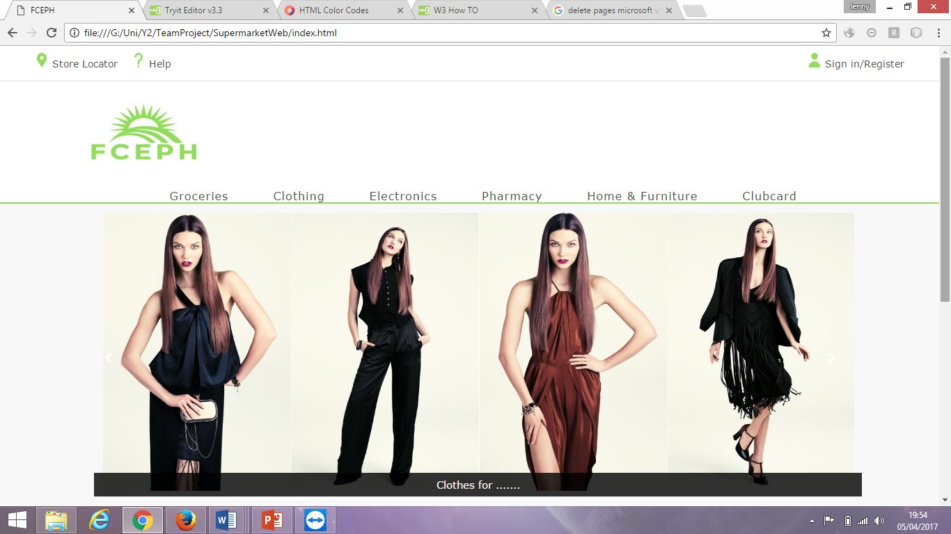

## **Testing**

When I

# **Nazir – Payment – Integration**

## **Integration Planner**

T

## **Sub Project Plan**

T

## **Risk Register**

The

## **Requirements**

T

**Payment Requirement**

* A customer should receive payment request when attempting to check out.
* Customer should receive a confirmation or denial for their payment.

## **Software**

E

## **Component Integration**

e

## **Testing**

E

# **Benjamin – Marketing - QA**

## **Quality Assurance**

T

## **Sub Project Plan**

T

## **Risk Register**

The

## **Requirements**

T

**Marketing Requirements**

* User should be able to view the types of items purchased by a customer.
* User should be able to send recommendations/deals to customers.

## **Software**

E

## **Component Integration**

e

## **Testing**

E

# **Appendix**

## **Website**

### **Style.css**

jksa

### **Index.html**

Sjdajksa

### **item.html**

sjdajksa

### **Groceries.html**

Sjdajksa

### **freshfood.html**

sjdajksa

### **fruit.html**

sjdajksa

### **vegetable.html**

sjdajksa

### **salad.html**

sjdajksa

### **dips.html**

sjdajksa

### **smoothies.html**

sjdajksa

### **milk.html**

sjdajksa

### **yoghurts.html**

sjdajksa

### **cheese.html**

sjdajksa

### **dairyfree.html**

sjdajksa

### **meat.html**

sjdajksa

### **fish.html**

sjdajksa

### **cookedmeat.html**

sjdajksa

### **slicedcookedm.html**

sjdajksa

### **pies.html**

sjdajksa

### **readymeal.html**

sjdajksa

### **bakery.html**

sjdajksa

### **bread.html**

sjdajksa

### **wraps.html**

sjdajksa

### **pancake.html**

sjdajksa

### **muffins.html**

sjdajksa

### **croissant.html**

sjdajksa

### **scones.html**

sjdajksa

### **doughnuts.html**

sjdajksa

### **cake.html**

sjdajksa

### **frozenfood.html**

sjdajksa

### **frozenmeat.html**

sjdajksa

### **frozenfish.html**

sjdajksa

### **icecream.html**

sjdajksa

### **frozendesserts.html**

sjdajksa

### **frozenpizza.html**

sjdajksa

### **frozenchips.html**

sjdajksa

### **frozenpuddings.html**

sjdajksa

### **frozenpies.html**

sjdajksa

### **frozenreadymeal.html**

sjdajksa

### **foodcupboard.html**

sjdajksa

### **tins.html**

sjdajksa

### **biscuits.html**

sjdajksa

### **cracker.html**

sjdajksa

### **crisps.html**

sjdajksa

### **snacks.html**

sjdajksa

### **chocolate.html**

sjdajksa

### **sweets.html**

sjdajksa

### **gum.html**

sjdajksa

### **cereal.html**

sjdajksa

### **ingredients.html**

sjdajksa

### **mealkit.html**

sjdajksa

### **spaghetti.html**

sjdajksa

### **homebaking.html**

sjdajksa

### **jams.html**

sjdajksa

### **drinks.html**

sjdajksa

### **ghousehold.html**

sjdajksa

### **baby.html**

sjdajksa

### **pets.html**

sjdajksa

### **Clothing.html**

sjdajksa

### **Electronics.html**

sjdajksa

### **Pharmacy.html**

sjdajksa

### **Household.html**

sjdajksa