Vocational school for computer programming and innovation



School project

Theme:

Struct project

|  |  |
| --- | --- |
| Prepared by:  Aleksander Patrashkov  Kaloqn Dinev  Stanislav Todorov  Martin Bakalov |  |
| Burgas 2021 | |

1. Authors 3

2. Purpose of the project 3

3. Used technology 3

4. Level of difficulty 4

5. Block diagram 4

6. Main functions description 4

6.1. Data layer 4

6.2. Presentation layer 4

# Authors

* Kaloyan Dinkov Dinev
  + BackEnd Developer
  + [kddinev@codingburgas.bg](mailto:kddinev@codingburgas.bg)
* Aleksander Kostadinov Patrashkov
  + Scrum Trainer
  + [AKPatrashkov18@codingburgas.bg](mailto:AKPatrashkov18@codingburgas.bg)
* Stanislav Angelov Todorov
  + FrontEnd Developer
  + [SATodorov18@codingburgas.bg](mailto:SATodorov18@codingburgas.bg)
* Martin Todorov Bakalov
  + Quality Engineer
  + [MTBakalov18@codingburgas.bg](mailto:MTBakalov18@codingburgas.bg)

# Purpose of the project

The purpose of our project is to create a program which will help teachers to create teams and to make report about the current and the previous students, teachers and teams.

# Used technology

* + Visual Studio is an integrated development environment which our developers used to create out project
  + C++ is the programming language we used for the development of our project
  + In Git Hub monitored the progress of our project and submitted our changes.
  + We used Microsoft PowerPoint to create a presentation, with which we could show you our work.
  + The documentation was made using Microsoft Word.
  + We used Microsoft Teams as means of communication.

# Level of difficulty

# Block diagram

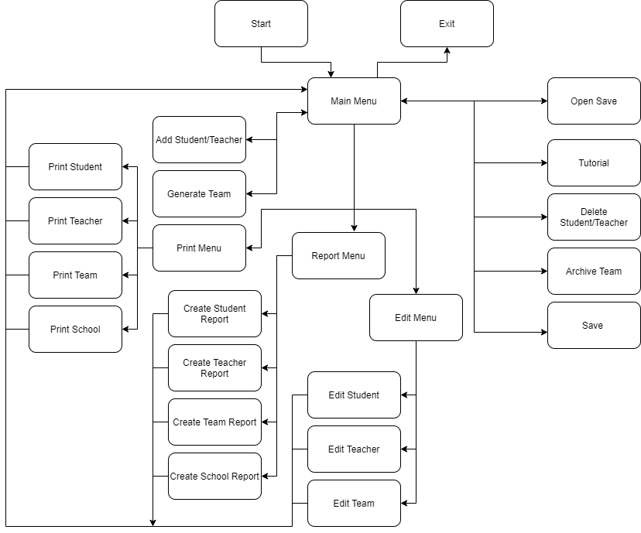

# Main functions description

# Data layer

|  |  |  |
| --- | --- | --- |
| Function name | Parameters | Description |
| String checkRole | none | Constraints about your role. It makes the user to choose only back end, front end and scrum |
| String checkEmail | none | Constraints that check if your email contains “@” symbol |
| int inputValidation | none | Constraints that won't let you to enter character when you have to enter numbers |
| Void addStudent/addTeachers | vector<STUDENT>& students, SCHOOL& school/ vector<TEACHER>& teachers, SCHOOL& school | Enter a student/ Enter a teacher |
| int findRole | vector<STUDENT>& students, const string wantedRole, const string teamName | Select random student with certain role |
| int findNotOccupiedStudents | vector<STUDENT>& students | Find the students that don’t have team |
| void generateTeam | vector<STUDENT>& students, vector<TEACHER>& teachers, vector<TEAM>& teams | Chose random name, task, teacher and 4 students that correspond curtain criteria and generate the team |
| void saveFiles | vector<STUDENT>& students, vector<TEACHER>& teachers, vector<TEAM>& teams | Function that saves your data |
| int stringConvertor | string& text | Convert form string to numbers |
| void openSave | vector<STUDENT>& students, vector<TEACHER>& teachers, vector<TEAM>& teams, SCHOOL& school | Accesses your saved data and open it |
| bool checkId | const vector<TEAM>& teams, const int wantedId | Checks if an id exist |
| int findTeamIndex / findStudentIndex /  findTeacherIndex | const vector<TEAM>& teams, const int wantedId / const vector<STUDENT>& students, const int wantedId / const vector<TEACHER>& teachers, const int wantedId | Find the index of the teams / stedent / teacher the user what to use |
| void archiveTeam | vector<STUDENT>& students, vector<TEACHER>& teachers, vector<TEAM>& teams, bool removedPersonOrEditedPerson = false, int indexOfremovedPersonOrEditedPerson = 0 | Delete the teams that the user want to delete and then save it |
| void deleteStudent/ deleteTeacher | vector<STUDENT>& students, vector<TEACHER>& teachers, vector<TEAM>& teams / vector<STUDENT>& students, vector<TEACHER>& teachers, vector<TEAM>& teams | Delete student / teacher |
| void editStuden / editTeacher | vector<STUDENT>& students, vector<TEACHER>& teachers, vector<TEAM>& teams / vector<STUDENT>& students, vector<TEACHER>& teachers, vector<TEAM>& teams | Edit student / teacher |

# Presentation layer

|  |  |  |
| --- | --- | --- |
| Function name | Parameters | Description |
| string makeStudentsReport / makeTeachersReport / makeTeamsReport / makeSchoolReport | const vector<STUDENT>& students, int wantedIndex / const vector<TEACHER>& teachers, int wantedIndex / const vector<TEAM>& teams, int wantedIndex / const SCHOOL& school | Make report about student / teacher / teams / school |
| void printMenu | const vector<STUDENT>& students, const vector<TEACHER>& teachers, const vector<TEAM>& teams, const SCHOOL& school | Display all students, teachers, teams or schools |
| void reportsMenu | const vector<STUDENT>& students, const vector<TEACHER>& teachers, const vector<TEAM>& teams, const SCHOOL& school | Menu where you can make report about student, teacher or team |
| void tutorial | none | Displays tutorial |
| void editMenu | vector<STUDENT>& students, vector<TEACHER>& teachers, vector<TEAM>& teams | Menu where you can edit student, teacher or team |
| bool mainMenu | vector<STUDENT>& students, vector<TEACHER>& teachers, vector<TEAM>& teams, SCHOOL& school | Displays the main menu |