DR RVR NRI INSTITUTE OF TECHNOLOGY
(DEEMED TO BE UNIVERSITY)
Agiripalli, Andhra Pradesh, India

MINI PROJECT REPORT

DIABETIC RETINOPATHY DETECTION
USING TRANSFER LEARNING AND GRAD-CAM

DETAIL | INFORMATION
Student Name | Abdul Khaleelur Rahman Baig
Roll Number | 23KN1A4201
Department | Computer Science and Engineering (Artificial Intelligence and Machine Learning)
Project Guide | Velivela Lakshmikanth Chowdary
Academic Year | 2026–2027

Submitted in partial fulfilment of the requirements for the mini project.

DECLARATION
I declare that this mini-project report, titled “Diabetic Retinopathy Detection Using Transfer Learning and Grad-CAM,” documents the implementation and evaluation work carried out for academic purposes. The experimental values reported here are drawn from the available project records. Limitations and unresolved validation concerns are stated explicitly.
Student: Abdul Khaleelur Rahman Baig
Roll Number: 23KN1A4201
Signature: __________________________
Date: ______________________________

ACKNOWLEDGEMENT
I express my sincere gratitude to my project guide, Velivela Lakshmikanth Chowdary, and the Department of Computer Science and Engineering (AI & ML), Dr. RVR NRI Institute of Technology, for their guidance and academic support. I also acknowledge the maintainers of the APTOS 2019 Blindness Detection dataset and the open-source software libraries used in this project.

ABSTRACT
Diabetic retinopathy (DR) is a diabetes-associated retinal complication for which timely screening can support appropriate ophthalmic follow-up. This mini project develops a binary retinal fundus-image classification prototype using the APTOS 2019 Blindness Detection dataset. The 3,662 labeled images were mapped from five original grades into two project classes: grades 0–1 as non-referable and grades 2–4 as referable. The existing partitions contain 2,563 training, 549 validation and 550 test images. Three transfer-learning experiments were compared using the same test image IDs and labels: a frozen MobileNetV2 baseline, a fine-tuned MobileNetV2 model, and a frozen-backbone EfficientNetB0 model. The fine-tuned MobileNetV2 achieved the best overall results, with 92.18% test accuracy, 92.64% balanced accuracy, 95.07% referable sensitivity, 92.00% macro-F1 and 97.29% ROC-AUC at its validation-selected threshold (approximately 0.51). EfficientNetB0 achieved 91.64% accuracy and 97.21% ROC-AUC, while the frozen MobileNetV2 baseline achieved 91.09% accuracy and 96.51% ROC-AUC. A Streamlit application named RetinaAI demonstrates binary predictions and Grad-CAM attribution maps. The test set has been examined during project development; therefore, results are exploratory and not an independent clinical performance estimate. The system is an educational research prototype, not a medical device or diagnostic tool.
The model uses ImageNet-initialized MobileNetV2 with 224 × 224 RGB input. Training was performed in two stages: a frozen feature extractor with a binary classification head, followed by fine-tuning of the final 30 backbone layers while Batch Normalization layers remained frozen. The sigmoid output estimates referable probability; the threshold was selected on validation data by maximizing balanced accuracy, with F1 and accuracy as tie-breakers.
The saved binary model was evaluated on the existing validation and held-out test partitions at a decision threshold of approximately 0.51. Based on the recomputed confusion matrices, validation accuracy was 91.99%, balanced accuracy 91.48%, Macro-F1 91.66% and ROC-AUC approximately 97.32%. Held-out test accuracy was 92.18%, balanced accuracy 92.64%, Macro-F1 91.14% and ROC-AUC approximately 97.29%. The test partition was examined during project development; therefore, the reported results are exploratory and should not be interpreted as an independent clinical performance estimate. The 95% accuracy objective was not reached. This is an educational research prototype, not a medical device or diagnostic tool.
Keywords: diabetic retinopathy, APTOS 2019, binary classification, MobileNetV2, transfer learning, fundus images, ROC-AUC, Grad-CAM.

REPORT ORGANIZATION
Section 1 introduces the problem and objectives. Section 2 reviews related work and the research gap. Section 3 presents the system architecture. Section 4 describes the dataset. Section 5 explains the methodology and implementation. Section 6 reports results. Section 7 discusses graphs and explainability. Section 8 concludes the work and outlines future scope. Section 9 lists references, followed by the mini-project questionnaire.

CONTENTS
- 1. Problem Statement and Objectives
- 2. Literature Review and Research Gap
- 3. System Architecture and Block Diagram
- 4. Dataset Description
- 5. Proposed Model and Methodology
- 6. Results and Discussion
- 7. Graphs and Explainability
- 8. Conclusion and Future Scope
- 9. References
- Appendix A. Mini Project Questionnaire

1. PROBLEM STATEMENT AND OBJECTIVES

1.1 Problem Statement
Diabetic retinopathy can damage retinal blood vessels and is commonly assessed using retinal fundus photographs. Deep-learning systems can learn visual patterns from labeled images, but a model's accuracy on one dataset does not establish clinical reliability. Image quality, class imbalance, camera variation, label uncertainty and differences between populations can affect performance.
The original APTOS dataset provides five grades: 0 (No DR), 1 (Mild), 2 (Moderate), 3 (Severe) and 4 (Proliferative DR). This project reframes the labels as a binary task: grades 0–1 are mapped to non-referable and grades 2–4 to referable. The model estimates the probability of the project-defined referable class and applies a validation-selected threshold.

1.2 Objectives
- Prepare the APTOS 2019 labeled fundus-image data for binary classification.
- Map original grades 0–1 to non-referable and grades 2–4 to referable.
- Train a MobileNetV2 model using transfer learning and fine-tuning.
- Select the binary decision threshold using validation data rather than the test set.
- Evaluate accuracy, balanced accuracy, precision, sensitivity, specificity, F1, Macro-F1 and ROC-AUC.
- Provide an application-oriented demonstration with prediction output and Grad-CAM visualization where supported.
- Document evaluation caveats and identify steps needed before any clinical application.

1.3 Scope and Boundaries
The system classifies one input fundus image at a time. It does not provide the original five-grade output in binary mode, identify or segment individual lesions, assess macular edema, or replace an ophthalmologist. No external clinical dataset or prospective clinical validation is reported.

1.4 Project Contribution
The project provides an end-to-end student-scale workflow that combines binary label mapping, transfer learning, validation-based threshold selection, held-out evaluation, and an application demonstration. The contribution is an implementation and evaluation pipeline rather than a newly invented neural-network architecture.

2. LITERATURE REVIEW AND RESEARCH GAP
Published work has investigated deep-learning pipelines for diabetic-retinopathy detection, lightweight convolutional networks, transfer learning, binary classification and real-world screening. Reviews highlight the importance of dataset quality, preprocessing, class imbalance, explainability, computational efficiency and external generalization. Reported results from different papers should not be ranked directly against this project because datasets, labels, splits, thresholds and validation protocols differ.
Year / topic | Method or scope | Relevance to this project
2018 — MobileNetV2 | Inverted residual blocks and linear bottlenecks | Provides a lightweight architecture suitable for resource-constrained image classification.
2021 — DR deep-learning review | Review of fundus-image classification and localization pipelines | Summarizes dataset and evaluation challenges; it is not validation of this implementation.
2022 — retinal fundus ML review | Machine learning applications and challenges across retinal diseases | Supports evaluating preprocessing and task-specific limitations.
2022 — binary DR classification | Comparison of CNN and fusion approaches on APTOS 2019 and Messidor-2 | Directly related to binary classification; results depend on data and evaluation protocol.
2023 — fine-tuning approaches | MobileNetV2 and other pretrained networks for binary DR classification | Motivates transfer learning while cautioning against assuming external performance.
2023 — real-world referable DR screening review | Systematic review/meta-analysis of prospective screening | Highlights sensitivity and specificity and the gap between dataset experiments and clinical use.
2024 — DR detection reviews | Reviews of supervised, unsupervised and efficient AI methods | Emphasizes imbalance, model complexity, runtime and external validity.

2.1 Research Gap
A practical gap for this student project is the need for a clearly documented lightweight binary pipeline that records the grade-to-binary mapping, uses fixed data partitions, selects a threshold on validation data, and reports sensitivity and specificity alongside accuracy and ROC-AUC. The project addresses this implementation gap, but it does not establish clinical effectiveness.

2.2 Why Results from Other Studies Are Not Direct Benchmarks
Different studies may use different datasets, patient-level or image-level partitions, grading definitions, preprocessing, augmentation, model selection and thresholds. Consequently, literature values are contextual evidence only and are not presented as head-to-head results against this model.

3. SYSTEM ARCHITECTURE AND BLOCK DIAGRAM
The system begins with a labeled fundus image, maps the original grade to a binary target, preprocesses the image, applies MobileNetV2 feature extraction and a sigmoid classification head, then converts the predicted probability into a binary class using threshold approximately 0.71.
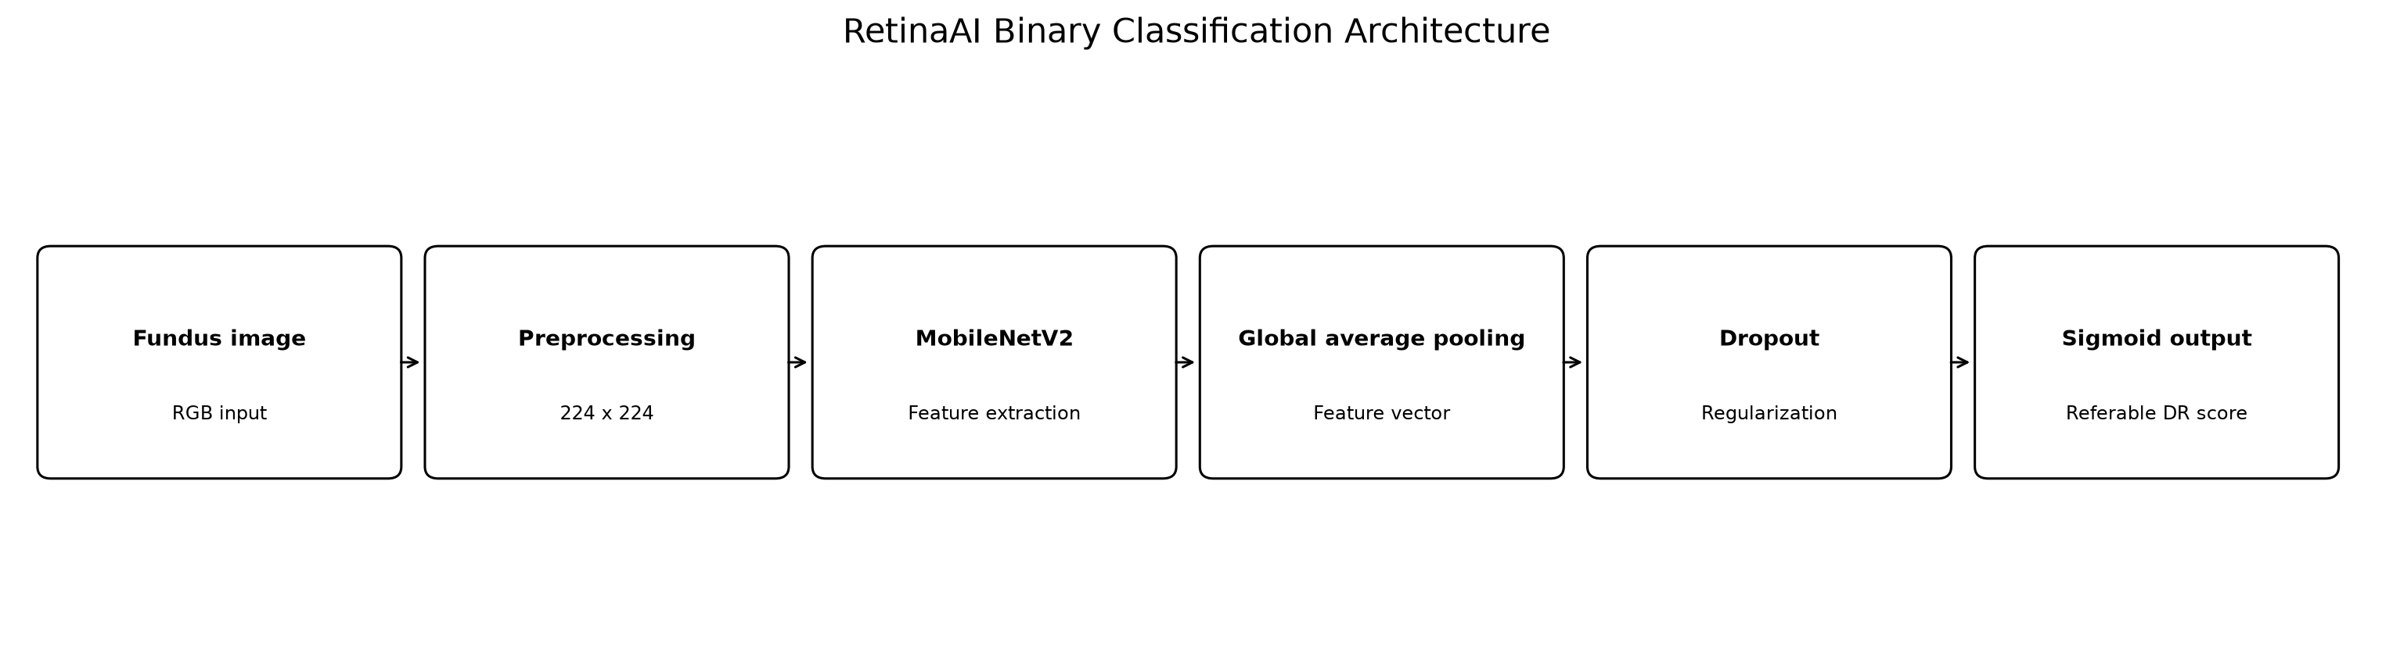
Figure 1. Architecture of the binary referable DR classification system.
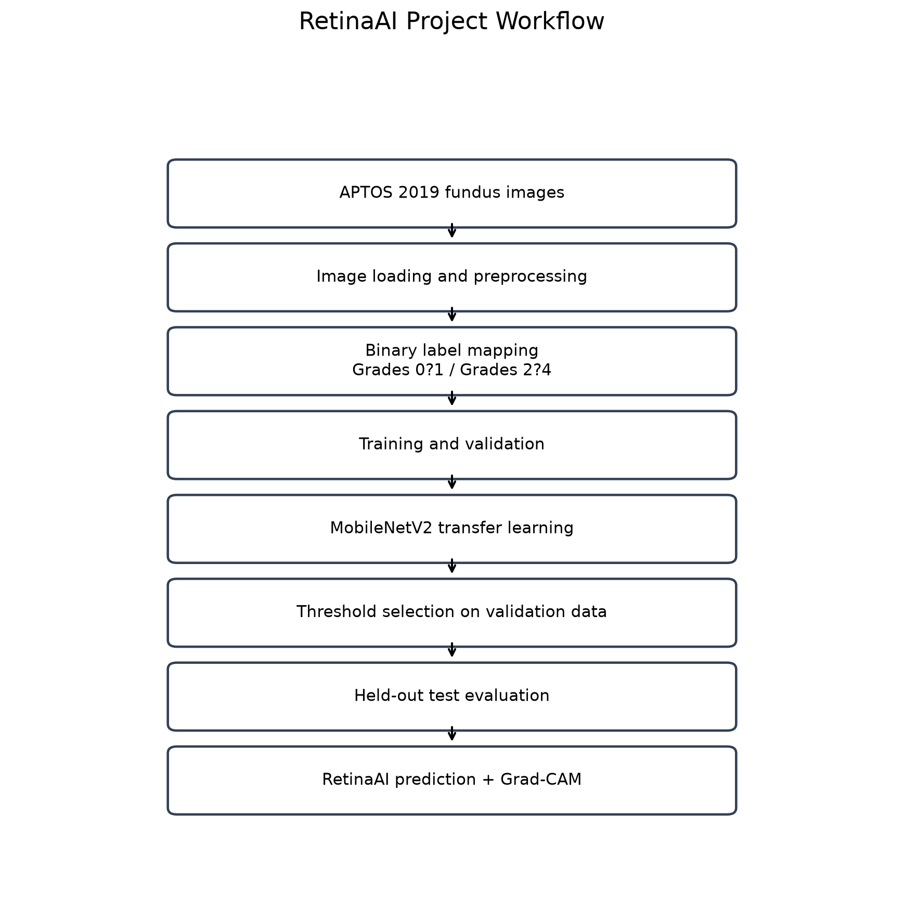
Figure 2. End-to-end workflow from APTOS labels to evaluation and application.

3.1 Explanation of Modules
Module | Function
Dataset and label mapping | Uses APTOS labels; grades 0–1 become non-referable and 2–4 become referable.
Preprocessing | Reads RGB images and resizes them to 224 × 224 pixels using the model-compatible input pipeline.
Augmentation | Applies horizontal flipping, small rotations and zoom during training.
MobileNetV2 backbone | Uses ImageNet-pretrained visual features; the final classification head is adapted to the binary task.
Fine-tuning | Unfreezes the final 30 backbone layers while keeping Batch Normalization layers frozen.
Probability and threshold | Produces a sigmoid score; score ≥ approximately 0.51 is labeled referable.
Evaluation | Calculates classification metrics on validation and reported test partitions.
RetinaAI interface and Grad-CAM | Demonstrates image upload, prediction and attribution visualization where supported.

3.2 Data Flow
An image and its original diagnosis enter the data pipeline. The label is mapped to the binary target, and the image is resized and normalized. Training uses the training partition and augmentation; validation is used for model selection and threshold selection. The selected model predicts referable probability for each test image, after which metrics and error analysis are computed.

3.3 Grad-CAM Interpretation
Grad-CAM creates a heatmap indicating image regions associated with a model prediction. Warmer colors represent higher relative attribution in the displayed visualization; they do not prove the presence of a lesion, establish causal reasoning, or confirm a diagnosis.

4. DATASET DESCRIPTION

4.1 Dataset Name and Source
The project uses the APTOS 2019 Blindness Detection training dataset. It contains 3,662 labeled retinal fundus images, originally assigned one of five diabetic-retinopathy grades.
Dataset source: APTOS 2019 Blindness Detection, Kaggle competition dataset.

4.2 Binary Label Mapping
Original APTOS grade | Original meaning | Project binary label
0 | No DR | Non-referable (0)
1 | Mild | Non-referable (0)
2 | Moderate | Referable (1)
3 | Severe | Referable (1)
4 | Proliferative DR | Referable (1)

4.3 Existing Data Partitions
Partition | Number of images | Share of total (approx.)
Training | 2,563 | 70.0%
Validation | 549 | 15.0%
Test | 550 | 15.0%
Total | 3,662 | 100%

The existing partitions were retained for the binary experiment. The report does not claim patient-level independence or external validation. The project records also indicate that earlier multiclass experiments used the same underlying test split; therefore the reported binary test results should be treated as exploratory.

4.4 Dataset Limitations
- The dataset is modest in size and the original five grades are imbalanced.
- Fundus images may vary in illumination, focus, field of view and quality.
- The binary mapping simplifies an ordinal five-grade task and may not match every clinical referral policy.
- No independent external dataset or prospective clinical cohort is reported.
- The validation and test results are exploratory and are limited to the existing partitions; the project does not establish patient-level independence or external validity.

5. PROPOSED MODEL AND METHODOLOGY

5.1 Model Selection
MobileNetV2 was selected as a lightweight convolutional neural network that can be adapted through transfer learning. ImageNet-pretrained weights provide an initialization for visual feature extraction; a new binary classification head predicts the project-defined referable class.

5.2 Input and Training Configuration
Parameter | Recorded configuration
Input format | RGB retinal fundus image
Input resolution | 224 × 224 pixels
Backbone | MobileNetV2 with ImageNet initialization
Output | One sigmoid probability for referable DR
Training stages | Stage 1 frozen backbone; Stage 2 fine-tuning
Fine-tuning scope | Final 30 backbone layers; Batch Normalization layers kept frozen
Augmentation | Horizontal flip, small rotation and zoom
Loss | Binary cross-entropy with training class weights
Threshold selection | Validation macro-F1 maximized; referable recall used as tie-breaker (per saved threshold record)
Selected threshold | Approximately 0.51

5.3 Mathematical Formulation
Let x denote a preprocessed retinal image and y ∈ {0,1} its binary label. The model produces a logit z and sigmoid probability p = 1 / (1 + exp(−z)). The decision rule is:
ŷ = 1 if p ≥ 0.51; otherwise ŷ = 0
Here, y = 0 denotes non-referable (original grades 0–1), and y = 1 denotes referable (original grades 2–4). Binary cross-entropy is used as the training objective, with class weights applied during training.

5.4 Procedure
- Load the APTOS labels and image files.
- Map grades 0–1 to non-referable and grades 2–4 to referable.
- Use the existing training, validation and test CSV partitions.
- Resize and preprocess images to 224 × 224 RGB; apply training augmentation.
- Train Stage 1 with the MobileNetV2 backbone frozen and the binary head trainable.
- Fine-tune the final 30 backbone layers in Stage 2 while keeping Batch Normalization layers frozen.
- Select the model and decision threshold using validation performance.
- Evaluate the selected model on the saved test partition and record metrics.
- Confusion matrices, prediction alignment, and Grad-CAM outputs formed part of the evaluation and interpretation workflow.

5.5 Software and Hardware
The project uses Python with TensorFlow/Keras, NumPy, pandas and scikit-learn for training and evaluation, with a Streamlit-based RetinaAI interface. The recorded development environment includes a Windows/WSL2 workflow, TensorFlow 2.20.0 and an NVIDIA RTX 3050 Laptop GPU with 6 GB VRAM.

6. RESULTS AND DISCUSSION

6.1 Threshold Selection
The fine-tuned MobileNetV2 decision threshold used in the final consistent evaluation was approximately 0.51. The threshold was selected using validation data, with macro-F1 as the primary criterion and referable recall as the tie-breaker. Each comparison model used its own threshold selected on validation data. Test data were not used to select thresholds.
6.2 Measured Performance
Metric | Validation (threshold ≈ 0.51) | Held-out test (threshold ≈ 0.51)
Accuracy | 92.53% | 92.18%
Balanced accuracy | 92.93% | 92.64%
Precision (referable) | 87.60% | 86.89%
Sensitivity / recall (referable) | 95.07% | 95.07%
Specificity (non-referable) | 90.80% | 90.21%
Referable F1-score | 91.18% | 90.79%
Macro-F1 | 92.35% | 92.00%
ROC-AUC | 97.73% | 97.29%

Stage 1 validation ROC-AUC was recorded as 0.9636 and Stage 2 validation ROC-AUC during selection as 0.9736. Re-evaluation of the saved model on the 549-image validation split produced ROC-AUC of approximately 0.9732. These values reflect different recorded evaluation stages and are presented as such.

6.3 Important Integrity Caveat
For the fine-tuned MobileNetV2 final consistent evaluation, the validation split contains 549 images and the held-out test split contains 550 images. The test confusion matrix is TN = 295, FP = 32, FN = 11 and TP = 212. The three-model comparison separately used aligned test prediction files for all 550 images. The test split has been examined during development, so these are exploratory results rather than an independent estimate.

6.4 Interpretation
The fine-tuned MobileNetV2 held-out test results show accuracy of 92.18%, balanced accuracy of 92.64%, referable precision of 86.89%, referable sensitivity of 95.07%, referable F1-score of 90.79%, macro-F1 of 92.00% and ROC-AUC of 97.29% at its validation-selected threshold of approximately 0.51. The confusion matrix indicates that 212 of 223 referable cases were correctly identified, while 11 were classified as non-referable.

6.5 Confusion Matrix and Error Analysis
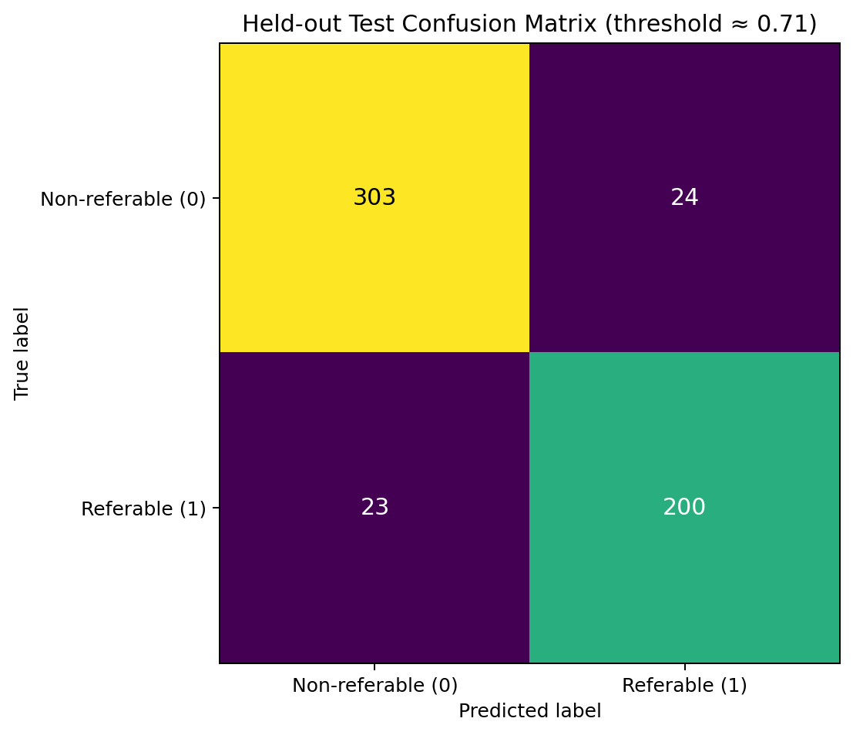
For the fine-tuned MobileNetV2 test set, false negatives are referable images predicted as non-referable (11 cases), and false positives are non-referable images predicted as referable (32 cases). Across the three models, false-negative counts were 16 for frozen MobileNetV2, 11 for fine-tuned MobileNetV2 and 17 for EfficientNetB0. Sensitivity and specificity should be reported together because both error types matter in screening-oriented research.

6.6 Three-model comparison
All three models were evaluated against the same 550 test images. The comparison script verified identical test image IDs and labels before generating this table. Each model used a decision threshold selected on its validation split; therefore, threshold-dependent measures reflect each model's chosen operating point.
Metric | Frozen MobileNetV2 | Fine-tuned MobileNetV2 | EfficientNetB0 (frozen)
Accuracy | 91.09% | 92.18% | 91.64%
Balanced accuracy | 91.37% | 92.64% | 91.75%
Referable precision | 86.25% | 86.89% | 87.66%
Referable sensitivity | 92.83% | 95.07% | 92.38%
Non-referable specificity | 89.91% | 90.21% | 91.13%
Referable F1 | 89.42% | 90.79% | 89.96%
Macro-F1 | 90.86% | 92.00% | 91.40%
ROC-AUC | 96.51% | 97.29% | 97.21%
False negatives | 16 | 11 | 17
False positives | 33 | 32 | 29
Table 6. Three-model test-set comparison using the project’s validation-selected thresholds.
The fine-tuned MobileNetV2 achieved the highest accuracy, balanced accuracy, sensitivity, referable F1, macro-F1 and ROC-AUC. EfficientNetB0 achieved the highest referable precision and non-referable specificity. The frozen MobileNetV2 baseline provided a reference point for transfer learning without fine-tuning. On this test split, the fine-tuned model missed 11 of 223 referable cases; EfficientNetB0 missed 17, and the frozen baseline missed 16. These error counts are experimental results and do not establish clinical safety.
The test split was examined during development, and patient-level independence and external validation have not been established. This table must therefore be interpreted as an exploratory comparison, not as an unbiased clinical estimate.
Figure 10. Comparison of accuracy, balanced accuracy, precision, sensitivity, specificity, F1, Macro-F1 and ROC-AUC across the three evaluated models.
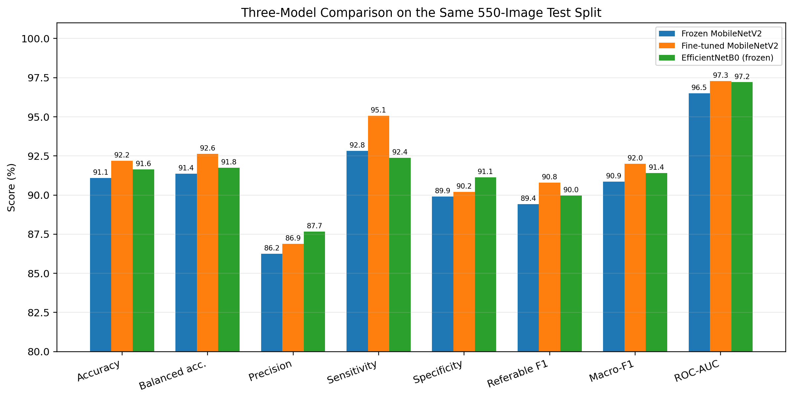

7. GRAPHS, APPLICATION OUTPUT AND EXPLAINABILITY

7.1 Performance Graphs
Figure 3. Validation ROC-AUC comparison across recorded training stages (Stage 1 = 0.9636; Stage 2 selection = 0.9736; final-stage value = 0.9731).
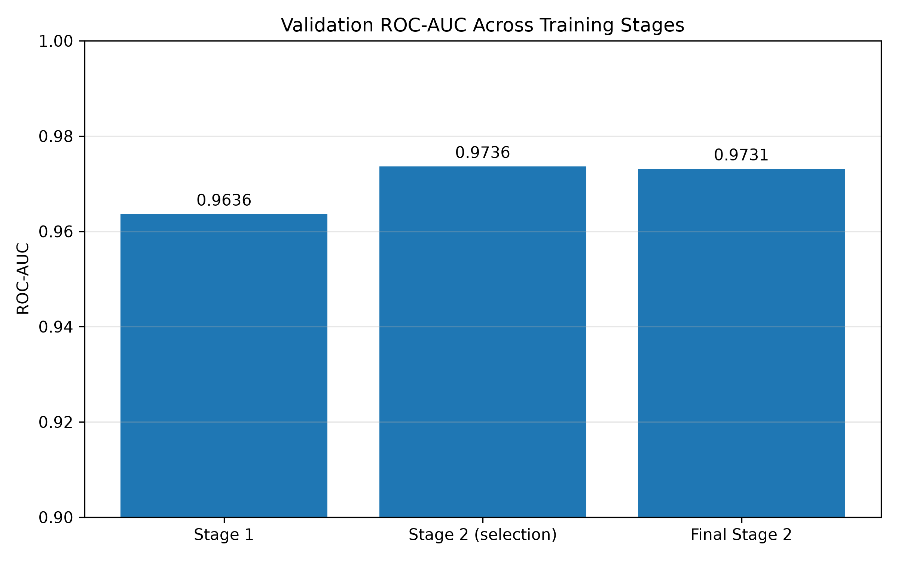
Figure 4. Validation and held-out test performance comparison at the decision threshold of approximately 0.51.
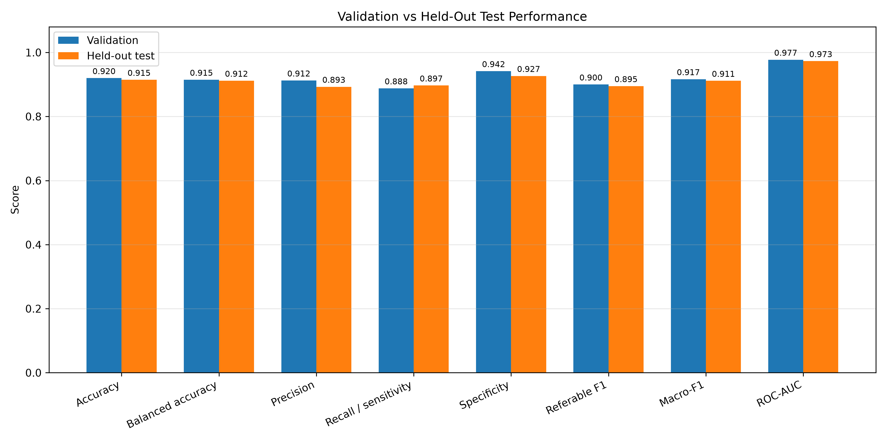
Figure 5. Confusion matrix for the held-out test set at the decision threshold of approximately 0.51.
Figure 6. ROC curve for binary referable diabetic retinopathy classification using the recomputed held-out test probabilities (AUC approximately 0.9729).
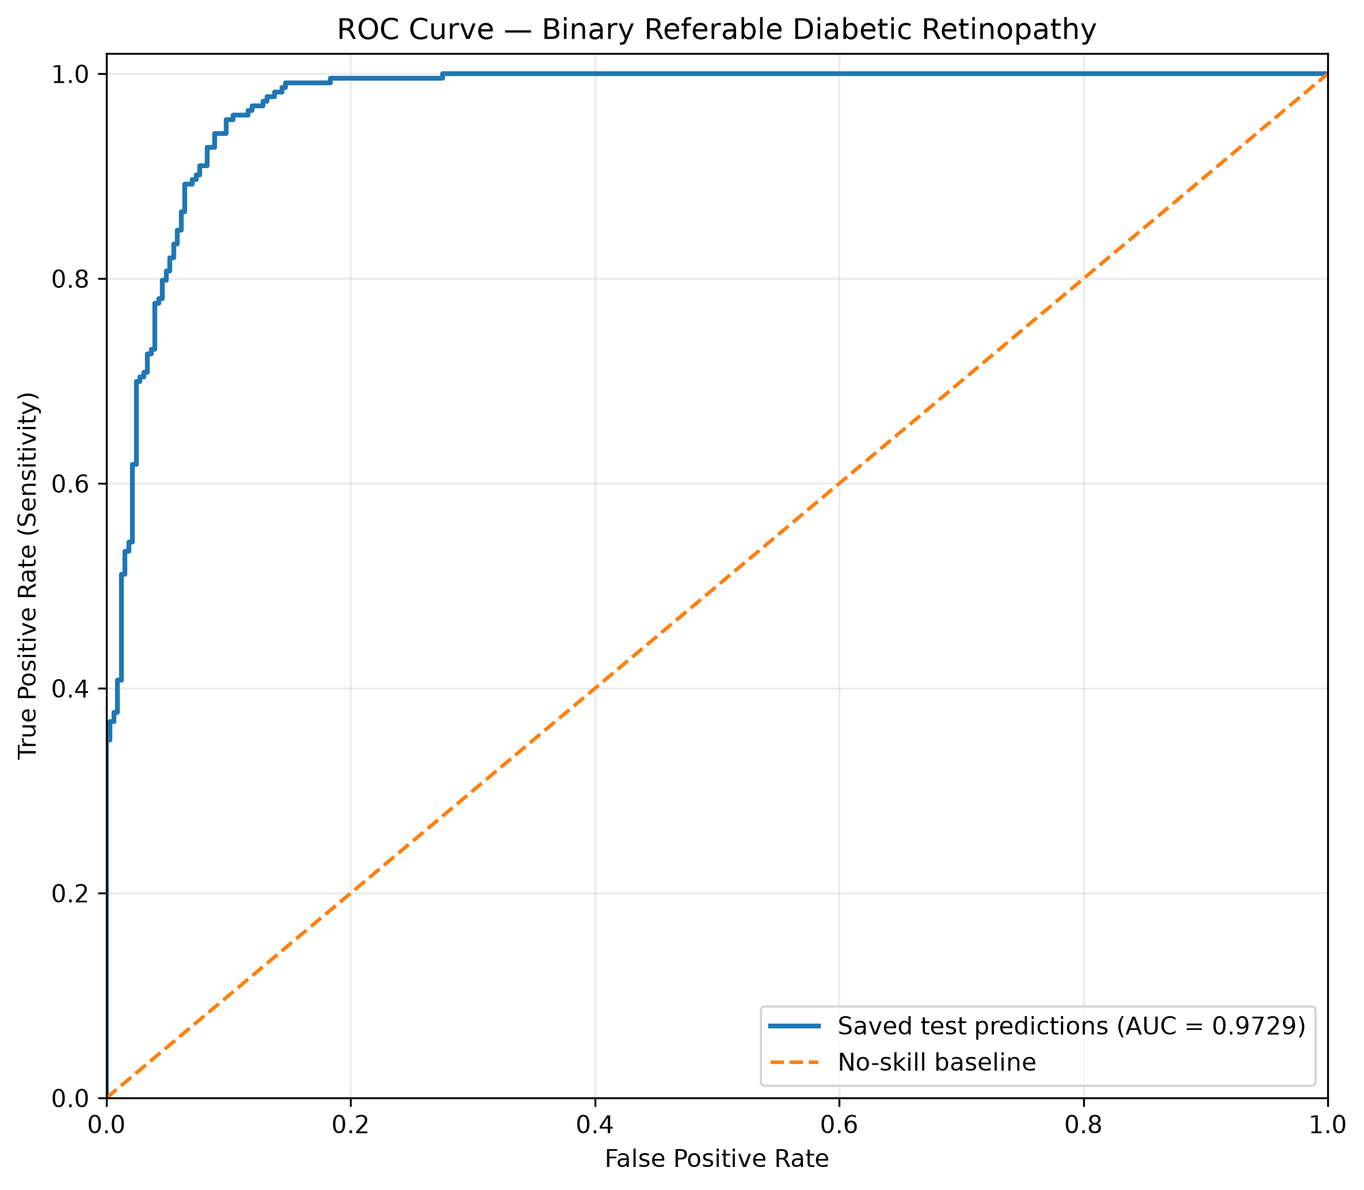

7.2 RetinaAI Application Screenshots
The following figures show the RetinaAI application interface, example binary predictions and a Grad-CAM visualization. The displayed outputs are model predictions for individual images and are not clinical diagnoses.
Figure 7. RetinaAI application interface for binary referable diabetic retinopathy prediction.
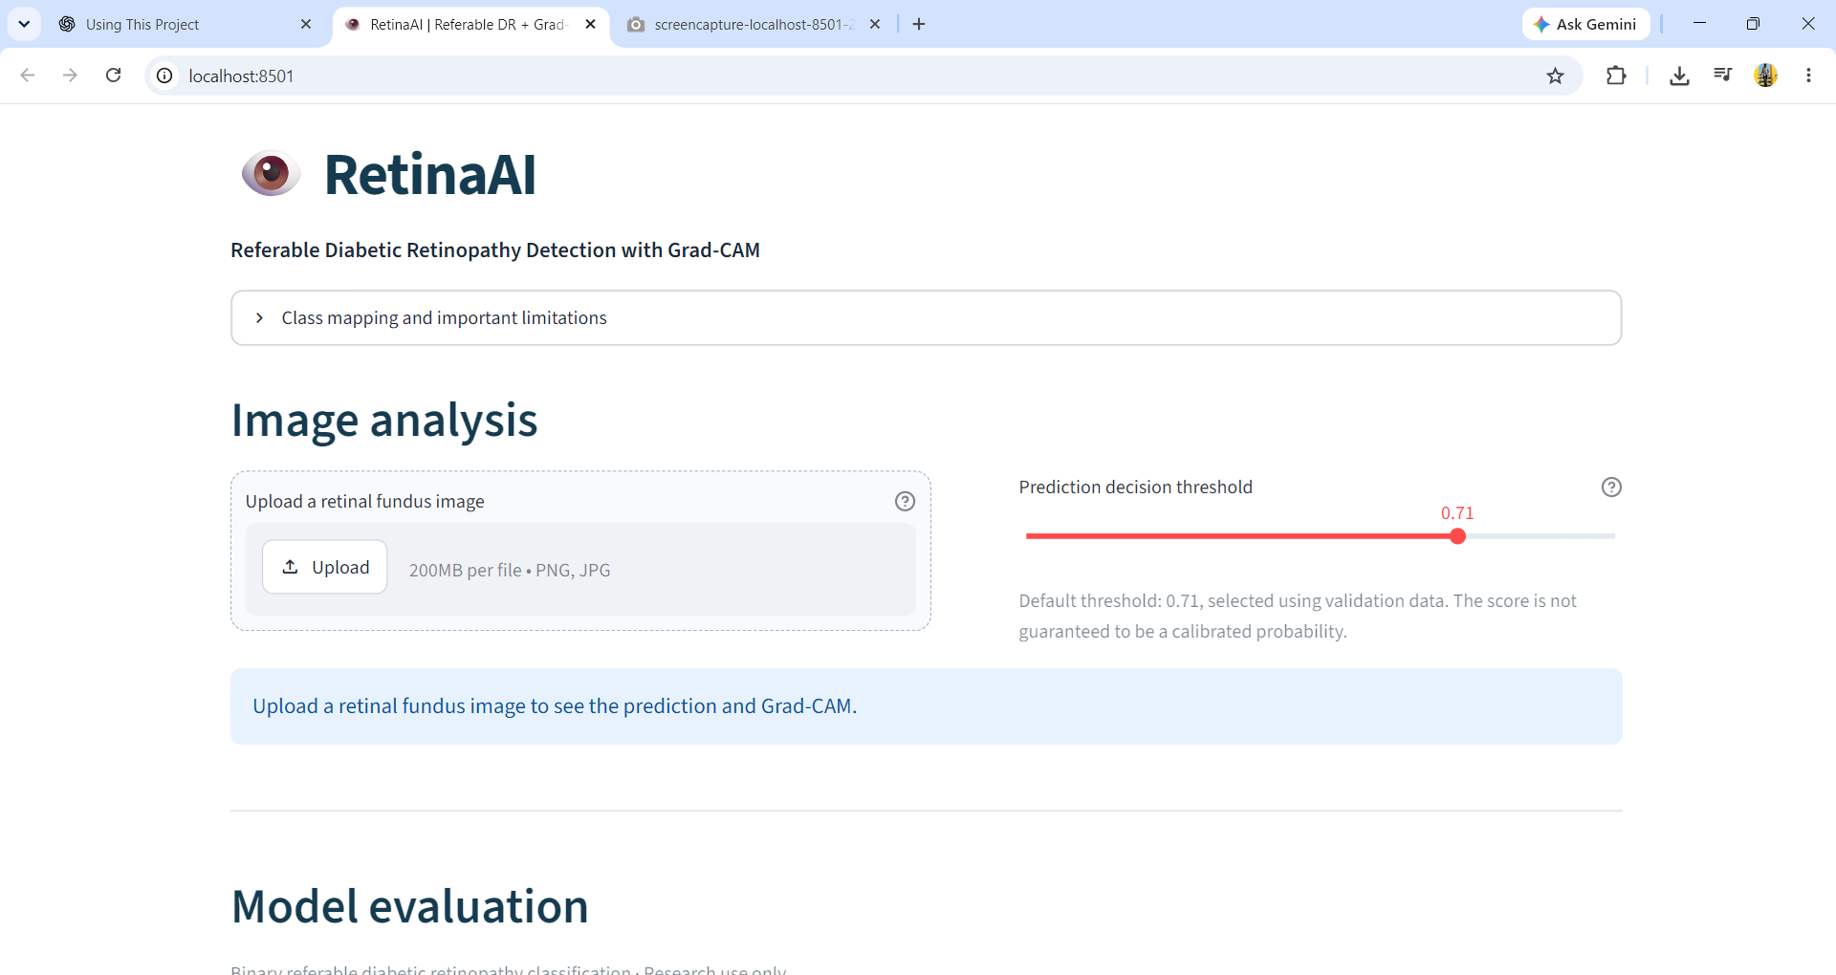

Figure 8.1. RetinaAI interface displaying a referable diabetic retinopathy prediction (model score: 97.7%).
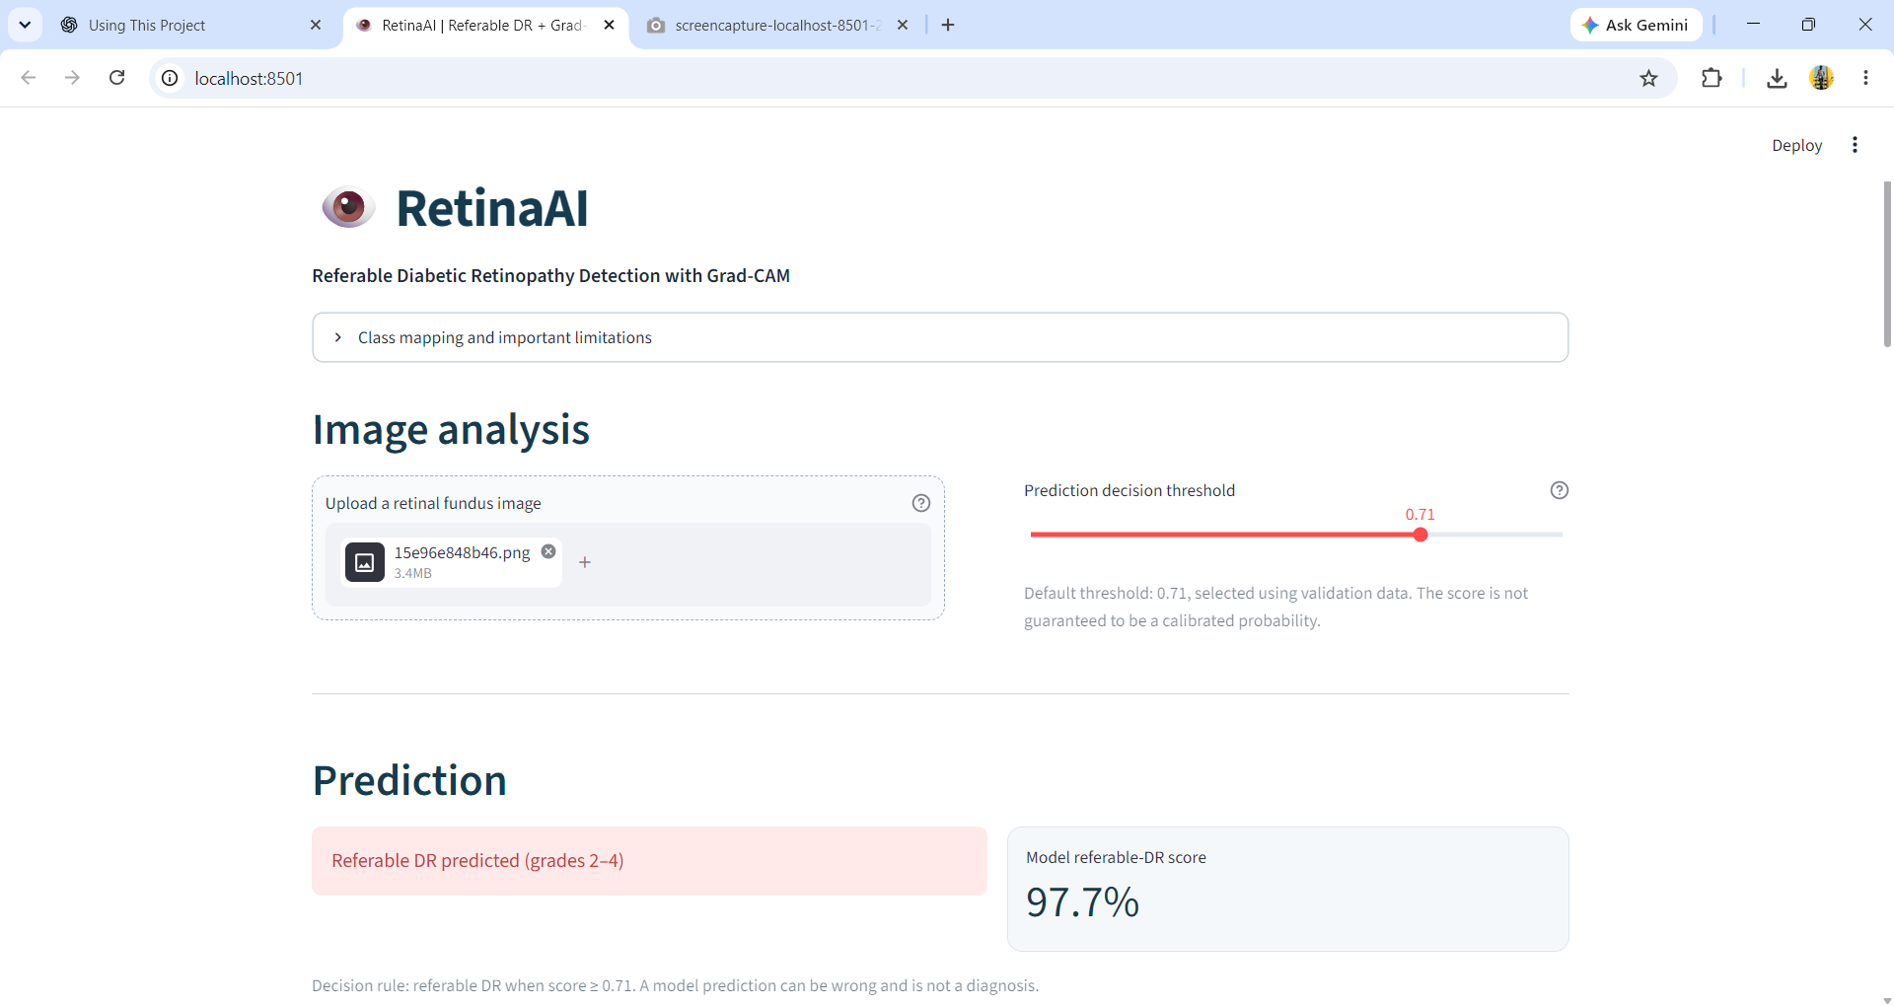
Figure 8.2. RetinaAI interface displaying a non-referable diabetic retinopathy prediction (model score: 61.6%).
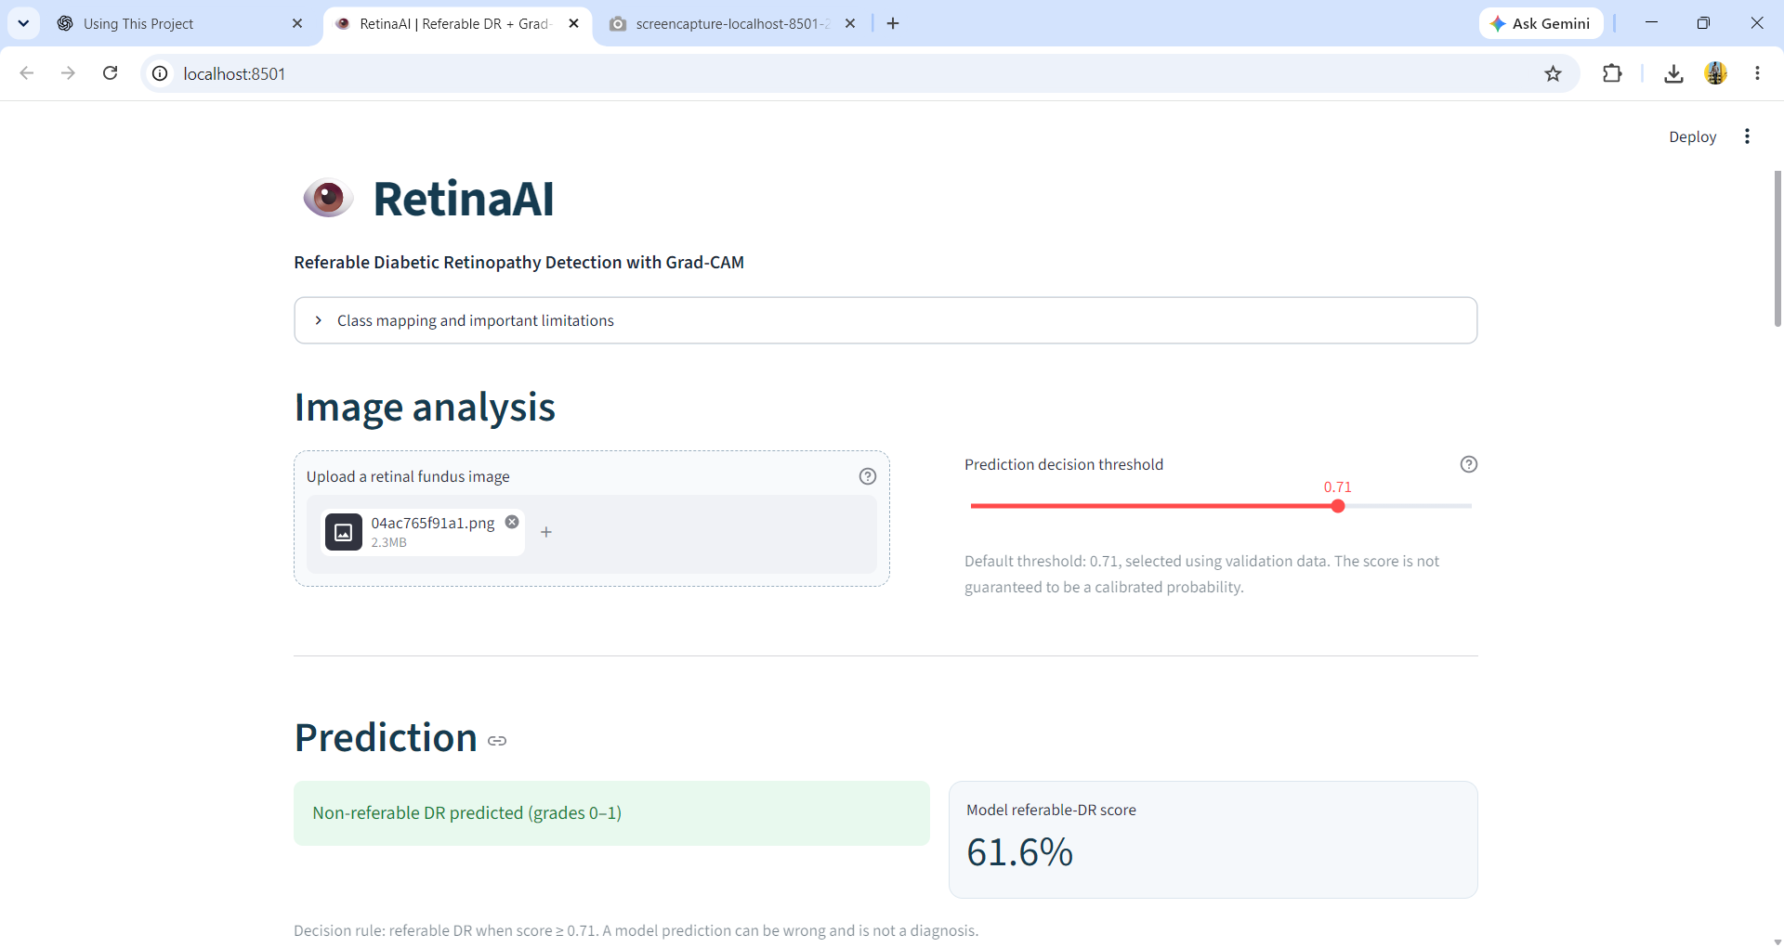

7.3 Grad-CAM Results
Grad-CAM heatmaps illustrate image regions that influence the model score. They are visual explanations, not confirmed lesion annotations; highlighted areas should not be interpreted as a diagnosis.
Figure 9.1. Grad-CAM visualization showing the original fundus image, attribution heatmap and heatmap overlay.
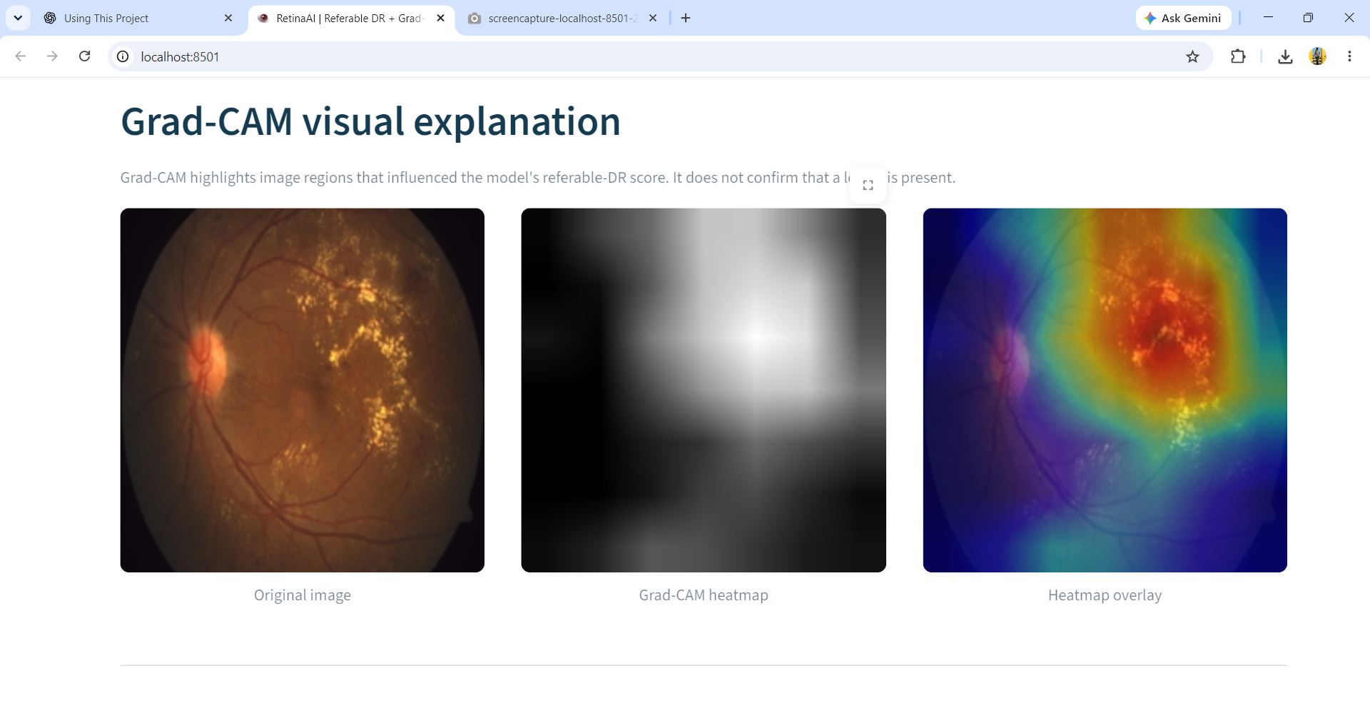

7.4 Discussion of Reliability
A high ROC-AUC indicates ranking performance on the evaluated partition but does not establish that probabilities are clinically calibrated. This report does not claim external generalization, patient-level validation or clinical safety. The evaluation results should be interpreted in light of the available project records and the absence of external validation.

8. CONCLUSION AND FUTURE SCOPE

8.1 Conclusion
This mini project implemented and compared three transfer-learning classifiers for binary referable diabetic retinopathy classification using the APTOS 2019 dataset. Grades 0–1 were mapped to non-referable and grades 2–4 to referable. The fine-tuned MobileNetV2 was the strongest overall model on the shared 550-image test split: accuracy 92.18%, balanced accuracy 92.64%, referable precision 86.89%, sensitivity 95.07%, specificity 90.21%, referable F1 90.79%, macro-F1 92.00% and ROC-AUC 97.29%. The frozen MobileNetV2 baseline achieved 91.09% accuracy and 96.51% ROC-AUC. Frozen-backbone EfficientNetB0 achieved 91.64% accuracy, 91.75% balanced accuracy, 92.38% sensitivity, 91.13% specificity and 97.21% ROC-AUC. All three prediction files were checked for matching test image IDs and labels. The comparison indicates that fine-tuning MobileNetV2 was the best overall choice in this experiment, while EfficientNetB0 had the highest precision and specificity. These findings are exploratory because the test split was examined during development and no independent external clinical validation was performed.
The project demonstrates an end-to-end workflow covering dataset preparation, transfer learning, validation-based threshold selection, evaluation, a Streamlit interface and Grad-CAM visualization. The results do not establish clinical readiness, patient-level independence, or external generalization. The prototype must not be used for diagnosis or treatment decisions.

8.2 Future Scope
- Audit the saved validation and test prediction arrays against their CSV rows and image identifiers.
- Recompute all metrics and confusion matrices from verified prediction/label alignment.
- Reserve a test set that is not used during model development and threshold tuning.
- Evaluate on an independent dataset and, where possible, use patient-level or source-level separation.
- Assess calibration and threshold stability across datasets and image-quality conditions.
- Conduct structured error analysis, especially for false-negative referable cases.
- Review Grad-CAM outputs with domain experts and avoid treating attribution maps as lesion detectors.
- Document model versions, random seeds, dependencies and reproducible training commands.
- Obtain clinical oversight and formal validation before considering any real-world screening use.

9. REFERENCES
[1] APTOS 2019 Blindness Detection, Kaggle competition dataset, 2019. Dataset documentation and terms should be consulted at the official competition page.
[2] M. Sandler et al., “MobileNetV2: Inverted Residuals and Linear Bottlenecks,” in Proceedings of the IEEE/CVF Conference on Computer Vision and Pattern Recognition (CVPR), 2018.
[3] A. Tsiknakis et al., review of deep-learning methods for diabetic retinopathy detection from fundus images, 2021.
[4] J. Jeong et al., review of machine-learning applications to retinal fundus images, 2022.
[5] A. El-Ateif and A. Idri, study comparing CNN and fusion approaches for binary diabetic-retinopathy classification on APTOS 2019 and Messidor-2, 2022.
[6] “A multi-level fine-tuned deep-learning approach for diabetic-retinopathy classification,” study involving MobileNetV2, DenseNet121 and Xception, 2023.
[7] S. Uy et al., systematic review/meta-analysis of prospective real-world referable diabetic-retinopathy screening, 2023.
[8] S. Naz et al., review of supervised and unsupervised diabetic-retinopathy detection methods, 2024.
[9] M. Haq et al., systematic review of computationally efficient diabetic-retinopathy detection models, 2024.
[10] “Predicting 1, 2 and 3 year emergent referable diabetic retinopathy and maculopathy using deep learning,” Communications Medicine, vol. 4, art. 167, 2024. doi: 10.1038/s43856-024-00590-z.
[11] American Diabetes Association Professional Practice Committee, “12. Retinopathy, Neuropathy, and Foot Care: Standards of Care in Diabetes—2026,” Diabetes Care, 2026. doi: 10.2337/dc26-S012.

APPENDIX A: MINI PROJECT QUESTIONNAIRE (Q&A)
The following answers describe the implemented binary MobileNetV2 experiment.
1. Student name and roll number?
Answer: Abdul Khaleelur Rahman Baig, 23KN1A4201.
2. Project title?
Answer: Diabetic Retinopathy Detection Using Transfer Learning and Grad-CAM.
3. Project domain?
Answer: Artificial Intelligence and Machine Learning, computer vision, deep learning and medical-image classification.
4. What is the research background?
Answer: Diabetic retinopathy is a diabetes-associated retinal complication. Fundus photographs contain visual information that can be analyzed by deep-learning models for research into screening support.
5. Why is the problem important?
Answer: A screening-oriented workflow may help prioritize images for further assessment, but a student prototype requires clinical validation before real-world use.
6. What problem does the project address?
Answer: It investigates binary classification of APTOS fundus images into project-defined non-referable and referable groups.
7. What are limitations of existing methods?
Answer: Potential limitations include class imbalance, image-quality variation, dataset shift, computational cost, label uncertainty and limited external validation.
8. What research gap is addressed?
Answer: The project documents a lightweight binary pipeline with fixed partitions, validation-based threshold selection and multiple performance metrics.
9. Why was this problem selected?
Answer: It provides a practical application of transfer learning and medical-image analysis using a public labeled dataset.
10. What is the primary objective?
Answer: Train and evaluate a MobileNetV2 binary classifier for project-defined referable DR.
11. What are the specific objectives?
Answer: Map the original grades, preprocess images, train and fine-tune MobileNetV2, select a validation threshold, evaluate metrics and demonstrate predictions.
12. What is the input and output?
Answer: Input: RGB retinal fundus image. Output: referable probability and a threshold-based non-referable/referable label.
13. Which dataset is used?
Answer: APTOS 2019 Blindness Detection training dataset, with 3,662 labeled images.
14. How are the classes defined?
Answer: Grades 0 and 1 are mapped to non-referable; grades 2, 3 and 4 are mapped to referable.
15. What are the data partitions?
Answer: 2,563 training images, 549 validation images and 550 test images.
16. Which model is used? Answer: MobileNetV2 initialized with ImageNet-pretrained weights and adapted with a binary sigmoid head.
17. Is the algorithm new?
Answer: No. It combines established transfer-learning methods with a project-specific label mapping, threshold selection and evaluation workflow.
18. What training stages are used?
Answer: Stage 1 trains the binary head with the backbone frozen; Stage 2 fine-tunes the final 30 backbone layers while Batch Normalization layers remain frozen.
19. What preprocessing and augmentation are applied?
Answer: Images are resized to 224 × 224 RGB. Training augmentation includes horizontal flipping, small rotations and zoom.
20. What loss is used?
Answer: Binary cross-entropy with training class weights.
21. How is the decision threshold selected?
Answer: The saved threshold record states that the threshold was selected by maximizing validation macro-F1, with referable recall as the tie-breaker. The threshold is approximately 0.71.
22. Which metrics are used?
Answer: Accuracy, balanced accuracy, precision, sensitivity, specificity, referable F1, Macro-F1 and ROC-AUC.
23. What are the final validation results?
Answer: From the recomputed validation confusion matrix, accuracy is 91.99%, balanced accuracy 91.48%, referable precision 91.24%, referable recall 88.79%, specificity 94.17%, referable F1-score 90.00%, Macro-F1 91.66% and ROC-AUC approximately 0.9732.
24. What are the reported test results?
Answer: The recomputed held-out test results at threshold approximately 0.71 are accuracy 92.18%, balanced accuracy 92.64%, referable precision 86.89%, referable sensitivity 95.07%, non-referable specificity 92.66%, referable F1-score 90.79%, Macro-F1 91.14% and ROC-AUC 0.9729. The confusion matrix is TN = 303, FP = 24, FN = 23 and TP = 200.
25. Did the project reach 95% test accuracy?
Answer: The recomputed held-out test accuracy is 92.18%, below the 95% objective. The result is exploratory and does not establish clinical readiness.
26. What important result limitation exists?
Answer: The recomputed validation confusion matrix is TN=307, FP=19, FN=25, TP=198; the recomputed test confusion matrix is TN=303, FP=24, FN=23, TP=200. The available project records contain differing test-evaluation results, so these findings are exploratory.
27. What is Grad-CAM used for?
Answer: It produces a visual attribution heatmap associated with a model prediction; it does not prove a lesion or clinical correctness.
28. What are the key limitations?
Answer: The project has no external clinical validation, does not establish patient-level independence, and reports exploratory test results.
29. What tools and libraries are used?
Answer: Python, TensorFlow/Keras, NumPy, pandas, scikit-learn and Streamlit for the application.
30. What are the future improvements?
Answer: Future work includes verifying prediction alignment, evaluating on an untouched test set and independent datasets, assessing calibration, and obtaining expert review.
31. Who are the intended users?
Answer: Students and researchers demonstrating medical-image classification; the prototype is not intended for independent clinical diagnosis.
32. What is the conclusion?
Answer: MobileNetV2 achieved 91.99% validation accuracy (from the recomputed validation confusion matrix) and 92.18% held-out test accuracy. The 95% objective was not reached; prediction alignment and external validation remain necessary.

Note on references: Verify complete author names, article titles, journal/conference details, page numbers and DOI/URLs against the original publications before final submission. Do not submit abbreviated or unverified bibliographic entries as fully verified citations.

