Alaska Pak v3.0

If you are installing AlaskaPak for personal use on a single computer then follow the standalone installation instructions. If you want to use AlaskaPak on multiple computers (either by the same or different users), then follow the network installation instructions.

Alaska Pak v3.0 will only operate properly on a computer with ArcGIS 10 Desktop (any license level). The installation does not check for this, so it is up to you to know that you have the correct version of ArcGIS.

# Standalone Installation Instruction

1. Unzip the download file (*AlaskaPakV3.0.zip*) into a stable local folder (for example *C:\Users\MyName\GisTools*). There should a new folder (*AlaskaPakV3.0*) with two files (*AlaskaPak3* and *ConfigurationEditor*) and one subfolder (*GPTools*).
2. In the windows explorer, double click the *ConfigurationEditor* file and you will see a configuration screen similar to the following
   1. 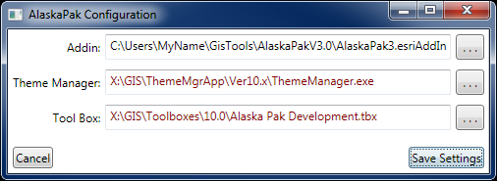The first line will probably be different and should reflect your location of the AlaskaPak3 addin file. If it does go to step 2b. The configuration editor assumes it is located adjacent to the *AlaskaPak3* addin file, if this is not the case then fix the first line by browsing to the correct location of the *AlaskaPak3* addin file.
   2. If you have NPS Theme Manager v3.0[1] installed, correct the second line by browsing to the location of NPS Theme Manager, if not, then ignore this line.
   3. Correct the third line by browsing to the location of the Alaska Pak Toolbox. For our example, the path would be *C:\Users\MyName\GisTools\AlaskaPakV3.0\GPTools\Alaska Pak.tbx*.
   4. Once you have the correct file locations, click the Save Settings button. This will embed your configuration settings inside the *AlaskaPak3* addin file.
3. 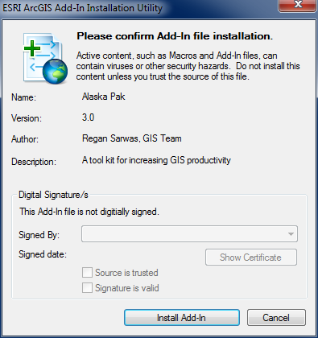In the windows explorer, double click the *AlaskaPak3* addin file and you will see the following screen.
4. 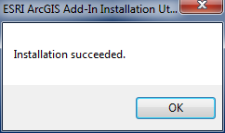 Click the Install Add-In button, and you should see the following
5. Start ArcMap
6. If you do not see the following toolbar then go to Customize->Toolbars in the main ArcMap menu, and ensure that there is a check box next to NPS Alaska.

# Network Installation Instruction

## Administrators

The following steps only need to be done once by someone with write permission to a suitable network folder. A suitable network folder is one that is accessible to all AlaskaPak users as the same mapped drive (**UNC paths are currently not supported. I hope to correct this soon**). In addition, it is a good idea to make this location read only to prevent unwanted changes to the AlaskaPak files.

1. Unzip the download file (*AlaskaPak3.zip*) into a suitable network folder. There should a new folder (*AlaskaPakV3.0*) with two files (*AlaskaPak3* and *ConfigurationEditor*) and one subfolder (*GPTools*).
2. Follow step 2 in the standalone installation instructions to embed the appropriate paths into the AlaskaPak3 addin file. These paths should be the same as those used by all users of AlaskaPak.

## ArcMap Users

The following steps need to be done by each person that wants to use AlaskaPak.

1. 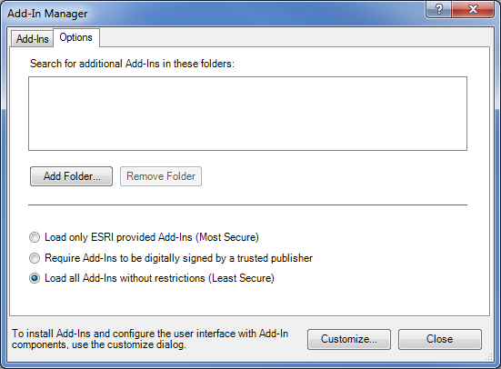Open ArcMap.
2. From the main menu, select Customize->Add-In Manager…
3. Click on the options tab
4. Click the Add Folder… button, and browse to the folder where the administrator installed the AlaskaPak3 addin file.
5. When the AlaskaPak3 addin folder is listed in search list, then click the Close button.
6. On the main menu, select Customize->Toolbars and ensure that there is a check box next to NPS Alaska. If NPS Alaska is not there, try closing and restarting ArcMap.
7. ArcMap may forget the location of your addin folders. This is a known bug, and there are two workarounds listed on GIS Stack Exchange (<http://gis.stackexchange.com/questions/2406/why-are-my-additional-add-in-folders-disappearing>).

1. <http://science.nature.nps.gov/NRGIS/applications/gisapps/gis_tools/8x/thememanager.aspx>