NexTurn
AI-powered returns and sustainable resale

1. Problem Statement & Relevance

The Problem
Millions of online purchases are returned even when the products are still usable. Customers lose time, wait for refunds, and rarely know whether their item will be resold, refurbished, donated, recycled, or discarded.
Second-hand buyers also hesitate because condition, authenticity, cleaning, and warranty signals are hard to trust. NexTurn solves this customer-facing uncertainty by turning a return into an explainable resolution flow.

Why It Matters
- Customers lose time, clarity, and trust during returns and refurbished purchases.
- Sellers and marketplaces absorb avoidable reverse-logistics costs.
- Usable products lose value when they are delayed, discarded, or routed without demand-aware decisions.

Theme Alignment
The solution integrates naturally with Amazon-style order, return, marketplace, and refurbished-commerce flows. It uses AWS for the deployable backend while keeping the customer experience focused on return confidence, value recovery, and lower-waste choices.

What Makes This Novel
Most resale ideas begin after an item is manually listed. NexTurn begins at the return moment and combines scan-based quality signals, next-best-action route ranking, buyer demand, green-credit incentives, predictive return prevention, and a Trust Passport in one customer decision surface.

2. Customer & Solution

Target Customer
The primary user is an online shopper returning a usable product who wants a fast refund or exchange, fair value, and confidence that the product gets a meaningful second life.

How NexTurn Solves It
- Smart condition grading from image/video-derived scan signals, represented in the prototype through deterministic, explainable scoring.
- Next-best-action comparison across resell, exchange, donate, and recycle, with payout, convenience, green credits, and impact surfaced clearly.
- Trust Passport for authenticity, functional test, cleaning, warranty, and route-lock status so second-life buyers can trust the item.
- Personalized refurbished alternatives ranked by low-return fit to prevent the next avoidable return before checkout.

User Workflow
1. Customer opens connected return case and scans item | 2. NexTurn grades quality and ranks routes | 3. Customer locks route, earns credits, and sees trusted next-owner path

Working Prototype Evidence
The prototype includes an interactive React return-resolution studio, Lambda-compatible API handler, DynamoDB persistence adapter, CDK infrastructure, and generated product assets for realistic demo flow.
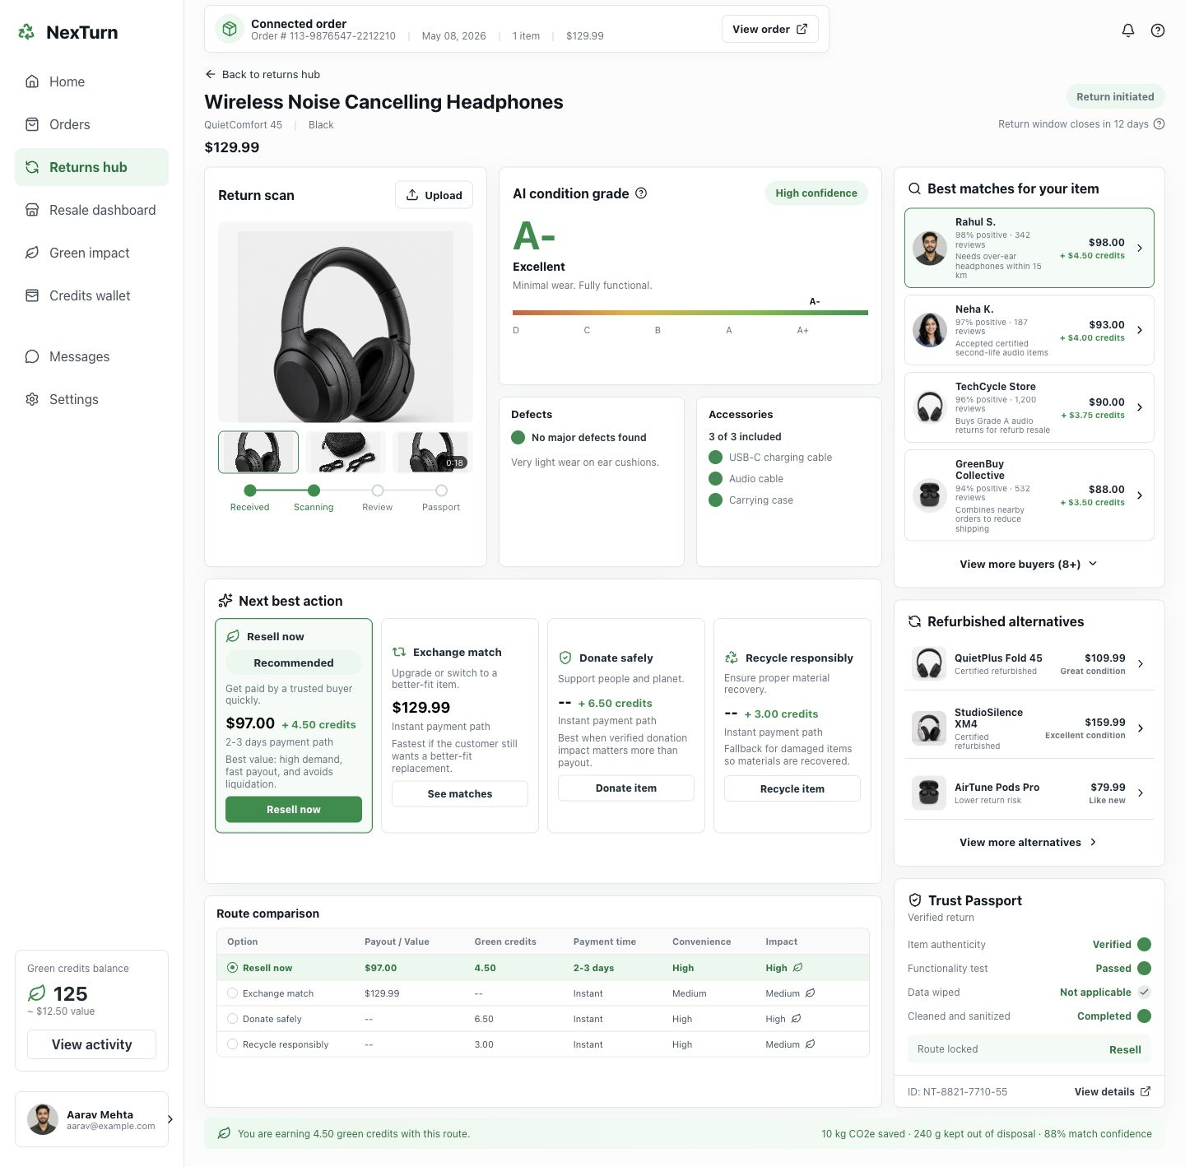
Return Resolution Studio with route ranking and trust passport
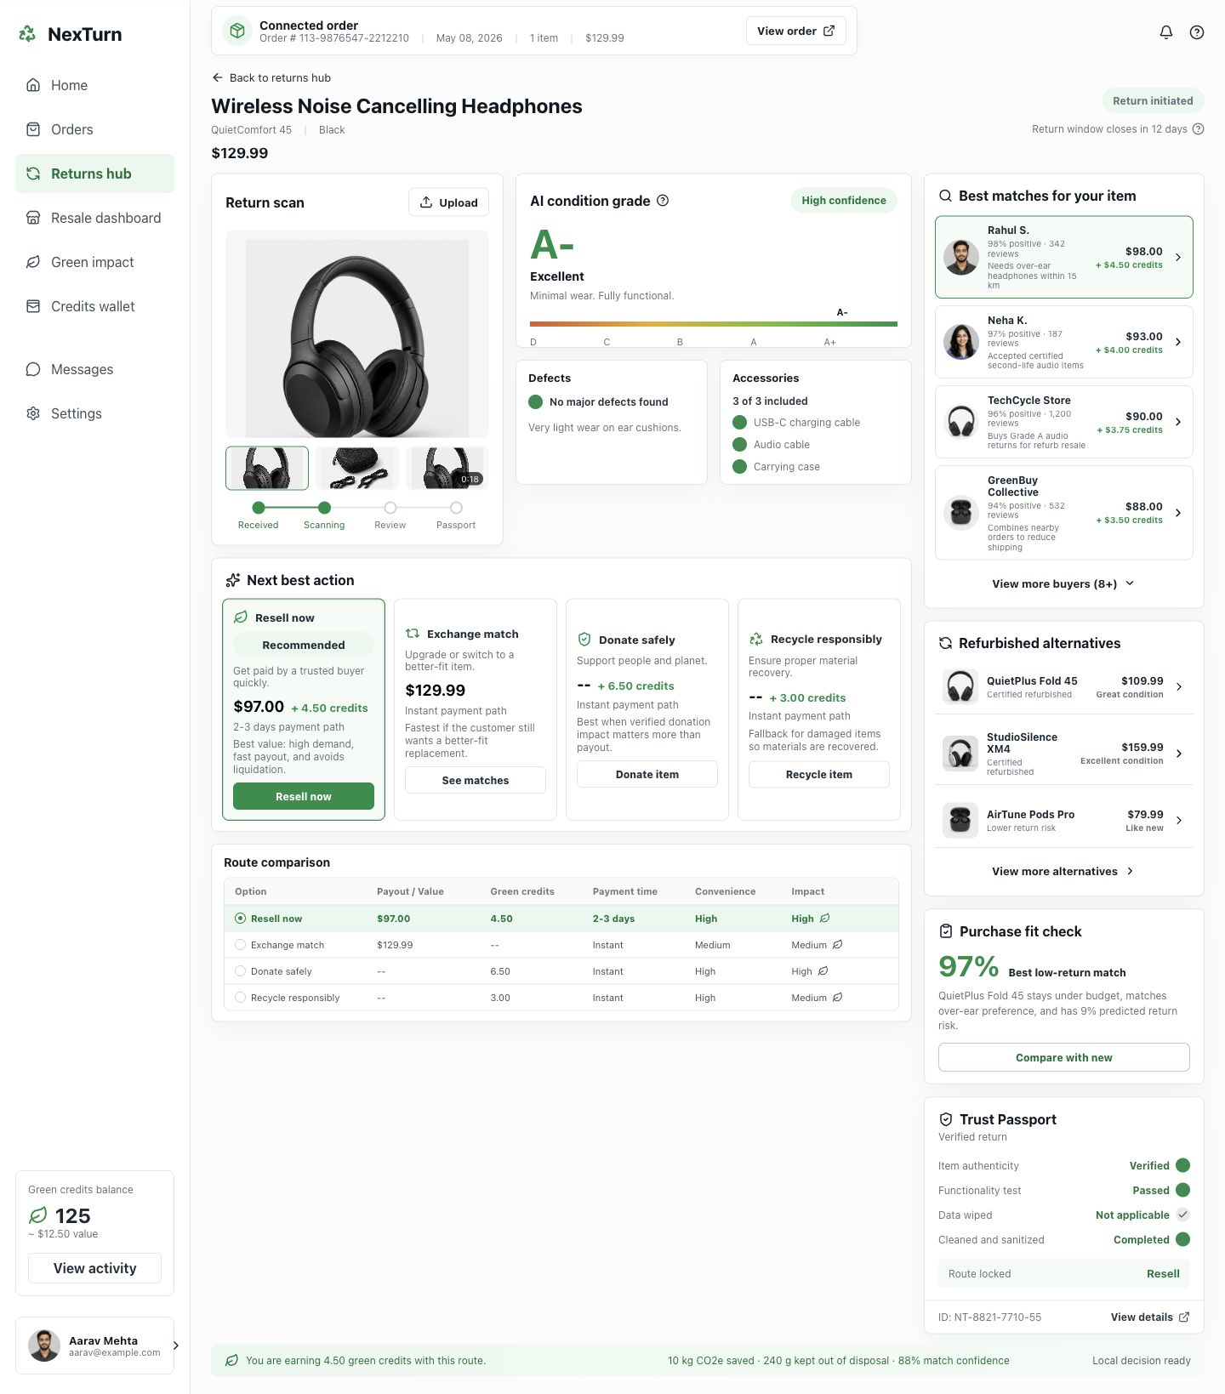
Predictive purchase-fit check for refurbished alternatives

3. Tech Architecture & Scaling

Architecture
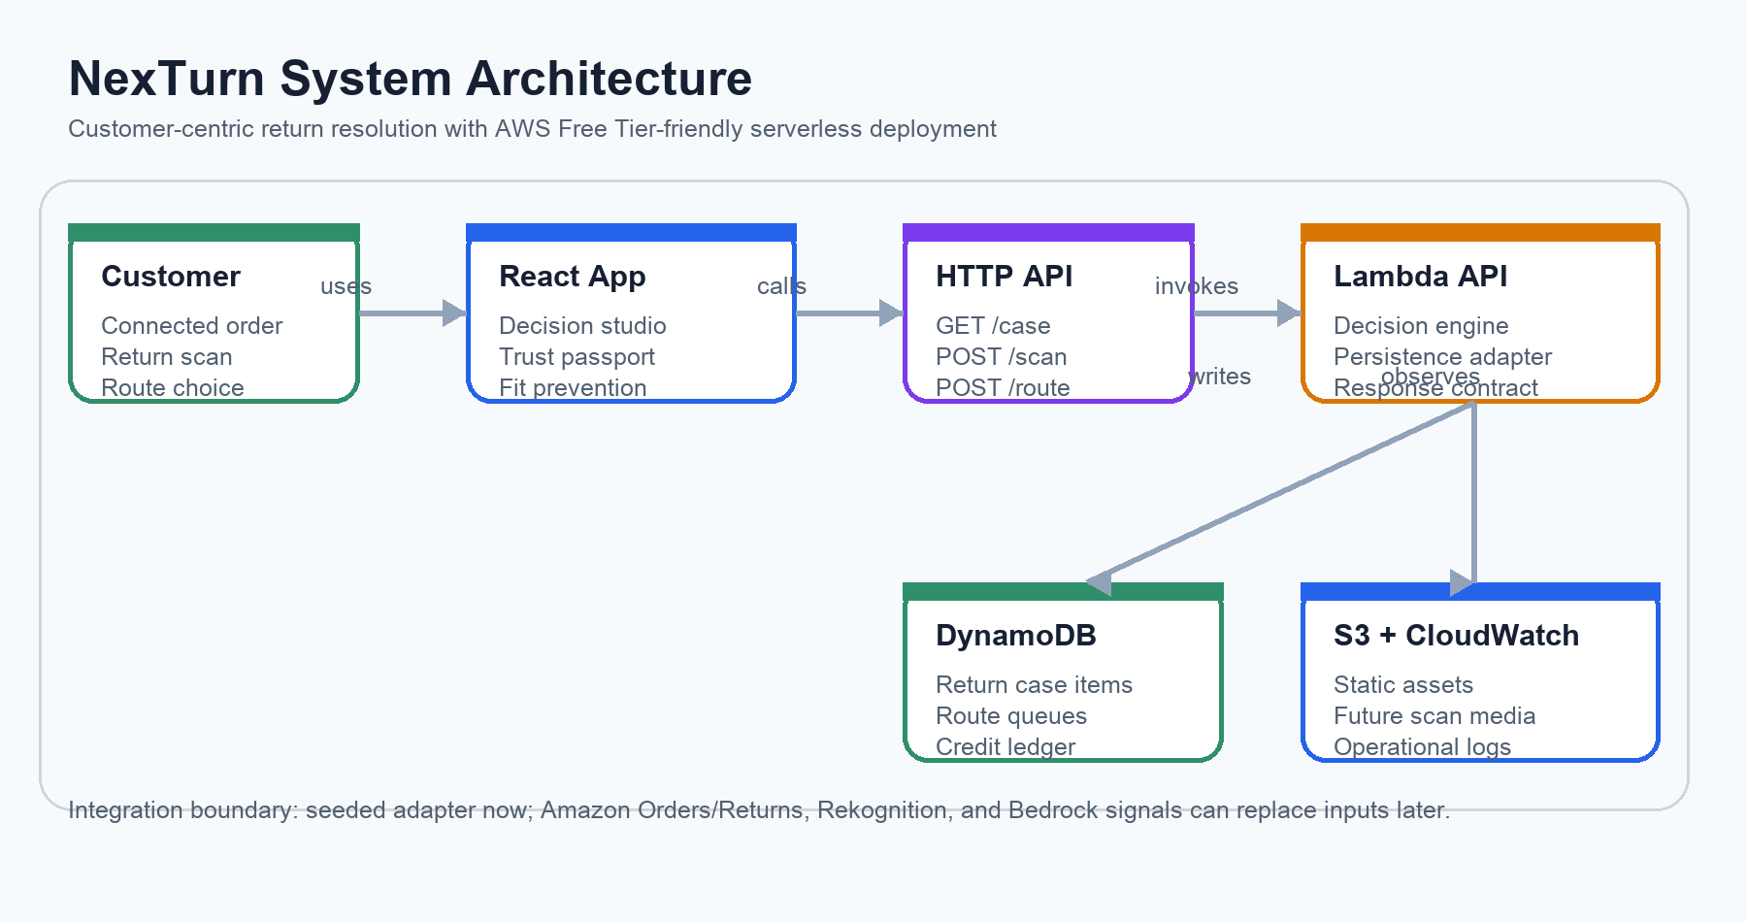

Tech Stack
Layer | Technology | Reason
Frontend | React + Vite | Fast interactive customer studio with production-style component boundaries
Backend | AWS Lambda + HTTP API | Low-cost serverless API for route evaluation and selection
Data | DynamoDB | Bounded return-case item collections, customer activity, route queues, and green credits
Infrastructure | AWS CDK in us-east-1 | Repeatable Free Tier-friendly deployment
Assets | S3-ready static build | Durable path for product assets and future scan media

Key Algorithms
- Condition grade combines functional score, cosmetic wear, accessories, hygiene, packaging, and fraud risk into a repeatable score.
- Route ranking weighs condition, demand, payout, convenience, sustainability, and risk to recommend the best customer-visible action.
- Purchase-fit ranking compares budget, form factor, comfort priority, sustainability preference, and return risk to reduce future returns.

Scaling Strategy
- DynamoDB partitions by return ID and customer ID; route queues use sparse GSIs and can be sharded if one route becomes hot.
- Lambda and HTTP API scale horizontally while keeping prototype cost low under Free Tier traffic.
- Media belongs in S3; DynamoDB stores keys, scan signals, and decision summaries instead of large files.
- Amazon integration is isolated behind data adapters so real order, return, Rekognition, and marketplace inputs can replace seeded data later.

4. Future Vision

Where This Goes
In 3-6 months, NexTurn can connect to real order/return events, customer upload media, S3 storage, and Rekognition image signals. In 6-12 months, it can support certified resale workflows, seller operations queues, localized peer-to-peer matching, and personalized second-life recommendations at marketplace scale.

Multi-Segment Expansion
- Consumer electronics: fast resale and refurb routing for high-value returns.
- Fashion and footwear: size-fit prevention plus verified condition passports.
- Home appliances: repair/refurb routing and local pickup optimization.

Value Impact
- Customers get clearer choices, faster confidence, green credits, and lower-risk refurbished recommendations.
- Sellers recover more value from usable returns and reduce manual inspection burden.
- The marketplace builds trust in certified second-life products while reducing unnecessary waste.

Links
- GitHub: https://github.com/AKSHATSPAR/nexturn
- Live app: pending deployment
- Demo video: pending recording
- Local prototype: http://127.0.0.1:5173/

