Self-Supervised Deep Learning for ETL Error Detection and Root-Cause Localization
  - B.Tech Deep Learning Project
Akshat
September 2026
Table of Contents

Abstract
Extract-Transform-Load pipelines fail quietly. A source system starts emitting nulls, a currency convention changes upstream, a join key gets reformatted, and the pipeline keeps running and keeps loading data that is wrong. The failure is usually noticed days later by someone reading a dashboard. Detecting these failures automatically is hard because labelled examples barely exist, and locating their cause is harder still, because by the time a fault reaches a dashboard every task downstream of it looks broken.
This project addresses both problems with a self-supervised model trained on unlabelled pipeline telemetry. Because no public benchmark of labelled ETL failures with root-cause annotations exists, we first construct one: a nine-task warehouse pipeline simulated at row level, with fifteen fault types injected into the rows so that propagation through the task graph emerges from the simulation rather than being scripted. Propagation labels are obtained by re-running every faulty batch with the fault removed under identical random seeds, which makes the blast radius a measurement rather than an assumption. Measured reach is 2.48 of 9 tasks per incident against 3.94 under the usual topological assumption.
The model is a factorised spatio-temporal transformer trained by masked reconstruction over the pipeline’s data-quality profiles. On detection it reaches 0.953 AUPRC, which is competitive with but does not beat a Local Outlier Factor baseline at 0.973. On root-cause localization it reaches 0.797 Hit@1, statistically tied with three baselines.
The finding that survives scrutiny concerns scoring rather than architecture. Ranking tasks by raw anomaly magnitude asks which task has the largest error, when the question is which task is furthest from its own normal. Two independent corrections for this, conditioning each task’s prediction on its parents and calibrating each task against its own healthy history, prove worth exactly the same (0.773 Hit@1 each, against 0.588 uncalibrated), and combining them adds little. An earlier version of this work reported the structural correction as worth 18.5 points; measured against a fairly calibrated baseline it is worth 2.4.
Explanations are scored rather than displayed, which the benchmark makes possible: Integrated Gradients names the correct symptom family for 93.5% of incidents.
Keywords: self-supervised learning, anomaly detection, root-cause analysis, data quality, ETL pipelines, transformers, explainable AI

1. Introduction

1.1 Motivation
Modern analytics rests on data pipelines that no one watches closely. A typical warehouse pipeline extracts from several source systems, cleans and conforms the records, joins them into facts and dimensions, aggregates them, and publishes the result to a reporting layer. Each stage runs on a schedule, often hourly, and each stage can fail in ways that do not raise an exception.
The failures that matter are the quiet ones. A job that crashes gets noticed within minutes because a scheduler alerts on it. A job that completes successfully while writing amounts that are a hundred times too large, because an upstream service switched from rupees to paise, can go unnoticed for weeks, and every report built on that table is wrong for the whole period.
Two things make this hard to automate.
Labels do not exist. Incidents are rare, they are recorded inconsistently when they are recorded at all, and a team that has just spent a night restoring a table is not going to sit down and annotate the run history. Any method that requires a thousand labelled examples of schema drift is a method that cannot be deployed.
Symptoms are not causes. When extraction starts emitting nulls, the cleaning step propagates them, the join loses rows, the aggregate under-reports revenue, and the warehouse load looks thin. A detector that flags nine unhealthy tasks has given the on-call engineer no information they did not already have. Worse, the symptom often grows as it travels: a five percent null rate at extraction can become a thirty percent revenue drop after aggregation, so the largest anomaly frequently sits furthest from the fault.

1.2 Objectives
- Detect broken pipeline runs without using labels for training.
- Identify which task originated the incident, not merely which tasks are affected by it.
- Explain the finding in terms an engineer can act on, naming the symptom rather than a feature index.
- Evaluate all of the above honestly, on a benchmark that makes the questions answerable.

1.3 Contributions
A benchmark. A nine-task ETL pipeline simulated at row level with fifteen fault types across six families, seasonality, growth, drift and campaign distractors labelled normal, and 8000 hourly runs. Faults corrupt rows rather than features, so downstream tasks consume corrupted data and propagation is an emergent property of the simulation.
Measured propagation labels. Every faulty batch is re-run with the fault removed and everything else held identical via per-node seeded randomness, so a task counts as affected only if its profile actually moved. This is a measurement, not the usual topological over-approximation, and the two differ substantially.
A self-supervised architecture combining masked reconstruction over data-quality profiles with DAG-structured attention, plus an ancestor-conditioned scoring rule for localization.
A negative result and a correction, both reported. The DAG attention bias turns out not to help, and we show why. The structural scoring rule is worth much less than first measured, and we show what the original comparison was actually capturing.
Scored explanations. Because the simulator knows which symptom family each fault should move, attribution accuracy is a number rather than a picture.

2. Related Work
A full review with a paper-by-paper matrix is in docs/LITERATURE_REVIEW.md. This section summarises the position.

2.1 Reconstruction-based anomaly detection
The dominant approach learns to reproduce normal behaviour and treats what the model cannot reproduce as anomalous. Malhotra et al. established that LSTM prediction error carries the signal, then showed reconstruction holds up better on genuinely unpredictable series. OmniAnomaly made normality probabilistic at significant computational cost, which USAD then addressed with adversarially trained autoencoders reaching similar accuracy far faster.
All of these assume a clean training set. In an ETL setting that assumption fails quietly, because nobody knows which historical runs were healthy, and the incidents that were never noticed are still in the history.

2.2 Structure-aware detection
MTAD-GAT and GDN both add a graph over variables and both improve on flat baselines, which is evidence that inter-variable structure carries real signal. GDN in particular scores each sensor by how far it deviates from what its neighbours predict, and describes this as localization.
In a sensor network that is defensible. In a pipeline it is not, for the reason given in Section 1.1: magnitude does not survive propagation, so ranking by deviation systematically blames the wrong end of the graph. This is the specific gap the present work targets.

2.3 Self-supervised pretraining
Masked modelling and contrastive learning have transferred from language and vision to time series through work such as Zerveas et al. and TS2Vec, and to operational data through LogBERT. Masked autoencoding supplied the design lesson that matters most here, which is that masking must be aggressive enough that the task cannot be solved by local interpolation.
None of this has reached ETL data quality. LogBERT is the nearest neighbour and it models log key sequences, so it sees that a job ran and in what order but never what the data looked like. A pipeline can execute flawlessly, emit a perfect log, and load a table where every amount is wrong.

2.4 Data quality systems
Deequ and TensorFlow Data Validation made data quality a production concern and encode a taxonomy of ETL failures more grounded than anything in the machine learning literature. Their limitation is that somebody has to write the rules. Auto-Validate removes much of that burden but works within a single column, so it cannot see a fault that only appears as a relationship between tables.

2.5 Evaluation practice
Kim et al. re-evaluated the standard benchmarks under point-adjusted F1, the metric most of this literature reports, and found that randomly generated scores can beat published models. Point adjustment credits an entire anomalous segment for detecting any single timestep inside it, so on datasets with long anomalous stretches, alerting at random works. Wu and Keogh reached a related conclusion from the data side.
This work therefore reports AUPRC and F1 at a fixed alert budget as headline metrics, and point-adjusted F1 only alongside, labelled as such.

3. Problem Formulation
An ETL pipeline is a directed acyclic graph of tasks. Each scheduled run t produces, for every task, a data-quality profile of F = 38 numbers. A run is therefore a matrix in R^(N x F) with N = 9 tasks, and the observable history is a tensor in R^(T x N x F).
Given a window of W consecutive runs ending at time t, the system must produce:
Output | Shape | Meaning
s | scalar | run-level anomaly score
r | N | per-task root-cause score
a | N x F | feature attribution, the symptom
Under an incident originating at task v, the set of anomalous tasks is v together with those downstream of it that the fault actually reaches. Detection asks whether any task is anomalous. Localization asks which one is v.
The constraint that defines the project is that no training signal may come from labels. Labels exist only to evaluate, and to train the supervised comparisons.

4. The Benchmark

4.1 Why build one
There is no public benchmark of ETL failures with root-cause annotations. The detection literature evaluates almost entirely on SMD, SWaT, SMAP and MSL, which are server and sensor telemetry: no task graph, no data-content quality metrics, and no label for which component originated a failure. Root-cause localization in a data pipeline currently cannot be posed as a benchmark task at all.

4.2 Pipeline and simulation
The simulated pipeline has nine tasks:
extract_customers ─┐
├─ clean_customers ─┐
extract_orders ────┴─ clean_orders ────┴─ join_orders_customers ─┐
├─ join_payments ─ aggregate_daily ─ load_warehouse
extract_payments ────────────────────────────────────────────────┘
Every task performs a real transformation over actual dataframe rows: type casting, deduplication, currency normalisation to a common unit, left joins, group-by aggregation, and a final publish step. Transforms are written to degrade rather than crash, as production jobs do, so a task whose join key was removed upstream produces empty joins rather than an exception.
Source data is generated with a persistent pool of 20,000 customers, so foreign keys point at something real and referential integrity is a meaningful signal. Volume follows a daily cycle, a weekly cycle, a growth trend, slow drift in the customer country mix, and occasional marketing campaigns that raise volume by about 1.7x for a day or two. All of this variation is labelled normal on purpose, because without it a threshold on row count would score well and no deep model would be justifiable.
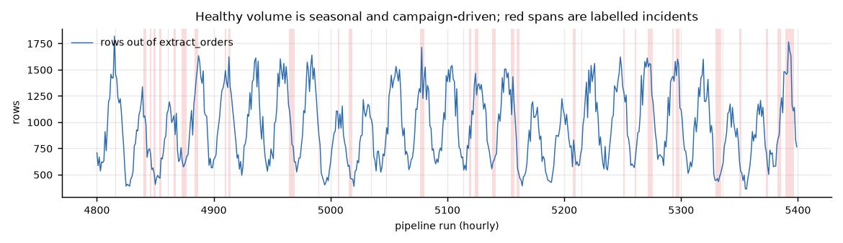
Figure 1. Order volume over 600 consecutive runs, with labelled incidents shaded red. The daily cycle and campaign surges move the row count as much as several genuine fault types do, which is why a threshold on volume cannot work and why these distractors are in the benchmark.

4.3 Fault taxonomy
Fifteen fault types across six families:
Family | Faults
Schema | column drop, column add, type mismatch
Completeness | null spike, primary key null, duplicate records, row loss truncation
Value and distribution | unit change, value corruption, category corruption
Temporal | timezone shift, late arrival
Integrity | foreign key break, join fan-out
Operational | resource degradation
Faults are injected into the rows, never into the features. Downstream tasks then consume the corrupted rows, so propagation is emergent. This matters more than it might appear: if propagation were hand-written, the model would be learning our propagation rules rather than anything about data pipelines.
resource_degradation is deliberately awkward. The task blows its service level objective while its output data stays perfectly valid, so a data-quality detector must not confuse it with corruption, and it must not propagate.

4.4 Measuring propagation instead of assuming it
The obvious way to label which tasks an incident affected is to take the origin plus every descendant. That is wrong, and provably so. An unexpected extra column is ignored by every downstream select. A task that runs slowly still emits correct rows. Labelling those descendants anomalous would penalise a detector for being right about them.
So the simulator re-runs every faulty batch a second time with the fault removed, holding the source rows, telemetry noise and scheduling jitter identical. This works because each task draws its randomness from its own generator seeded on (seed, batch, task), which guarantees that the two runs are bit-identical wherever the fault does not reach. A unit test asserts exactly that.
A task counts as affected only when its profile actually moved. Measured reach is 2.48 of 9 tasks per incident against 3.94 under the topological assumption. schema_column_add correctly reaches exactly one task where the topological label claims 4.5.
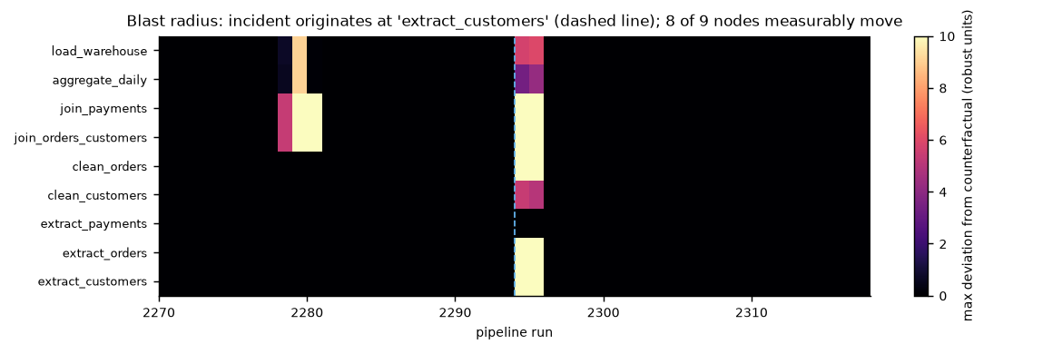
Figure 2. Blast radius of a single incident, measured against the counterfactual so a healthy run is exactly zero by construction. The incident originates at extract_customers and moves 8 of 9 tasks, several of them harder than the origin itself. This is why ranking tasks by anomaly magnitude cannot localize.

4.5 Feature extraction
Each task run is summarised into 38 features aggregated by column role, which is what keeps the width constant across tasks with completely different schemas: operational telemetry, schema stability, completeness, primary metric distribution, secondary numeric distribution, categorical distribution, temporal freshness, and referential integrity.
A validation experiment confirms every fault type produces a greater than three-sigma response at the injected task, and that each moves its own expected symptom family: unit change moves the metric distribution family by 9.5 robust units, timezone shift moves temporal by 10.7, resource degradation moves operational by 10.2, and the healthy baseline stays flat.
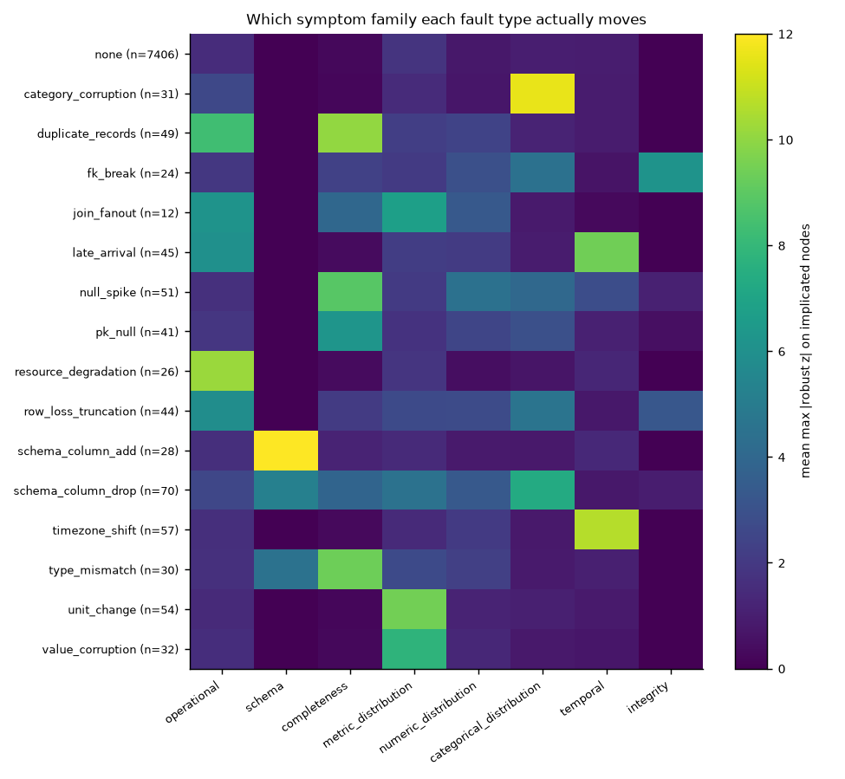
Figure 3. Response of each symptom family to each fault type, in robust units, measured on the tasks the fault actually reached. The diagonal dominance is what makes attribution scorable: each fault has a known expected symptom. The top row shows healthy runs staying flat.

4.6 Dataset statistics
Property | Value
Runs | 8000 hourly, about eleven months
Shape | 8000 x 9 x 38
Incidents | 273 spanning 594 runs (7.4%)
Training contamination | 3.0%
Test incident rate | 14.6%
Split | chronological, 60 / 15 / 25
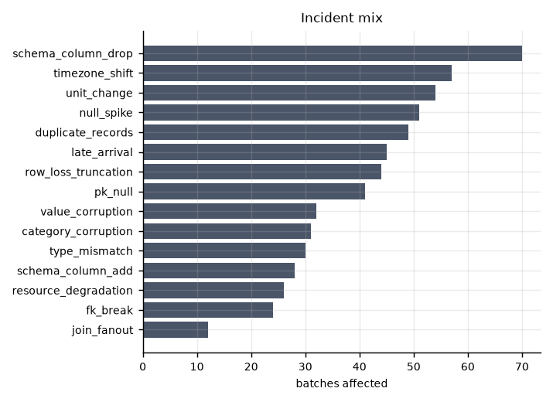
Figure 4. Incident mix across the 8000-run timeline. All fifteen fault types are represented, with between 12 and 70 affected runs each.

5. Methodology

5.1 Architecture
The backbone is a factorised spatio-temporal transformer over the [W, N, F] window, with about 1.1 million parameters.
Attending over W x N positions jointly would cost O((WN)^2) per layer for no good reason: the task axis is short at 9, the time axis is long at 32, and the two carry different kinds of structure. Each encoder block therefore attends along time first, letting every task look at its own history, then across the task graph, letting every timestep look at the other tasks. The cost is O(W^2 + N^2).
Structural attention carries a learned bias per graph relationship. Every ordered pair of tasks is classified as self, direct parent, direct child, distant ancestor, distant descendant or unrelated, and the model learns one bias scalar per relationship per attention head. This lets it decide how much a task should attend to its immediate upstream, rather than having a hard mask imposed. Section 8.2 reports that this component does not help, and explains why.
Learned task embeddings, sinusoidal time encodings and cyclic calendar features complete the input. Calendar features matter: volume swings roughly threefold across a day, so without a clock the largest reconstruction error in the dataset is simply the time of night.
The mask is concatenated to the input rather than only used as a loss weight, so the model always knows which entries it is being asked to predict. A test asserts that rewriting a masked value leaves the output unchanged, which rules out the model reading the answer it is meant to predict.

5.2 Self-supervised objectives
Feature-group masking hides one whole symptom family at a task and timestep. Masking scattered individual numbers would be far too easy, because null_rate_mean sits beside null_rate_max in the same vector and is trivially recoverable from it. The model would learn within-vector correlations and never look at the pipeline. Hiding an entire family forces it to use other tasks and other timesteps.
Task masking hides a task’s entire profile at a timestep. Filling that in requires predicting what a task should have produced given what its parents produced, which is the objective the root-cause scorer is built on.
Contrastive views were implemented but treated as an ablation rather than a default, because they cost 4.3 times the compute per epoch. Their augmentations are deliberately weak: strong amplitude scaling is indistinguishable from a unit change and heavy dropout from a null spike, so aggressive augmentation would train the model to treat real faults as normal.
Checkpoints are selected on validation reconstruction loss, which needs no labels. Selecting on validation AUPRC would make the method weakly supervised while still calling it self-supervised, and would inflate every number reported afterwards.

5.3 Scoring
Scoring mirrors training. The model was trained to fill in hidden entries, so at inference it is asked the same kind of question. Running a masked autoencoder unmasked lets it copy its input to its output, and the reconstruction error then measures nothing.
Two masking configurations at the final timestep:
e_hist hides every task, so each prediction rests on history alone. Large whenever a run departs from its own past, which makes it the detection signal.
e_anc hides task i together with all of its descendants, so the prediction rests only on i’s ancestors and on history. This is surprise given inputs. A task downstream of a failure emits anomalous output that follows perfectly from its own anomalous inputs, so e_anc stays small and it reads correctly as a victim. The task where the incident began has healthy inputs and anomalous output, so e_anc stays large.
Hiding the descendants is essential and was missing from the first implementation. Structural attention is bidirectional, so a hidden task can be reconstructed from its own descendants, and during an incident those are corrupted too and leak the value straight back. Section 8.1 quantifies the difference.
Per-task calibration. Tasks are not equally predictable, so their raw errors are not comparable and whichever task is hardest to predict wins the ranking by default. Each task’s score is therefore converted to a percentile against its own distribution over unlabelled training runs. Percentile rank rather than a z-score, because the error distributions are heavy-tailed and an interquartile range summarises them poorly; z-scoring measurably hurt.

5.4 Explainability
Attribution is aggregated into the eight named symptom families, so the output reads as “clean_orders, completeness family, null_rate_max” rather than as an index. Two methods are compared: per-feature reconstruction error, and Integrated Gradients of the anomaly score with an all-zero baseline. The zero baseline is principled here rather than arbitrary, because in the robust-scaled space zero is the healthy median of every feature, so the baseline literally means a completely typical run.
Structural attention rollout shows which upstream tasks the model consulted.

6. Experimental Setup

6.1 Protocol
The split is chronological, never random, because a random split over a time series leaks the future into the past. Training uses the first 60%, validation the next 15%, and test the final 25%.
Training history carries about 3% incident contamination, as real history does. Normalisation uses median and interquartile range, robust to that contamination, fitted on the training split alone, with a standard deviation fallback for features that never vary while healthy. Without that fallback a schema flag flipping would register as a one-sigma event, weaker than ordinary volume noise.
At run t the model sees only runs t-W+1 through t.

6.2 Baselines
Class | Methods
Classical | rolling z-score, PCA residual, per-task Isolation Forest, per-task Local Outlier Factor
Deep reconstruction | dense autoencoder, LSTM autoencoder
Classical baselines receive the current profile together with its deviation from the window’s rolling mean, so they have temporal context too. A baseline crippled by construction proves nothing. Isolation Forest and Local Outlier Factor are fitted once per task rather than once over the concatenated 342-dimensional vector, which is both the stronger configuration and the only way to obtain a task-level score from them.
Every baseline receives the same percentile calibration as the model, fitted the same way on unlabelled training scores. Calibration turns out to be worth more than the choice of detector, so applying it to one side only would have been the result rather than a detail.

6.3 Metrics
Detection is measured by AUROC and AUPRC, with AUPRC the honest one at a 14.6% base rate, plus best F1 over all thresholds and F1 at fixed alert budgets. Point-adjusted F1 is reported but never as the headline.
Localization is measured by Hit@1, Hit@3 and mean reciprocal rank over the nine candidate tasks, computed only on runs carrying an incident, with 95% bootstrap intervals. Asking which task is at fault on a healthy run is not a meaningful question.
Attribution is measured by whether the top symptom family matches the fault’s mechanistically expected family.

6.4 Implementation
PyTorch 2.14 on Apple Silicon using the Metal backend. Training a single configuration takes about 18 minutes, deliberately, because the project needs many ablation runs far more than one large model, and a dataset of 8000 by 9 by 38 does not justify a larger backbone. The full test suite is 54 tests covering simulator contracts, healthy baselines, fault propagation, counterfactual isolation, masking behaviour, scoring indexing and metric correctness.

7. Results
All numbers are on the test split: 2000 runs, 291 carrying an incident. Nothing was tuned on test.

7.1 Main comparison
Method | AUPRC [95% CI] | Best F1 | F1 @15% | Hit@1 [95% CI] | Hit@3 | MRR
LSTM autoencoder | 0.951 [0.932, 0.968] | 0.928 | 0.887 | 0.818 [0.773, 0.859] | 0.986 | 0.900
PCA residual | 0.942 [0.920, 0.963] | 0.928 | 0.876 | 0.801 [0.756, 0.849] | 0.955 | 0.880
SSL transformer (ours) | 0.953 [0.934, 0.971] | 0.935 | 0.890 | 0.797 [0.749, 0.842] | 0.973 | 0.883
Local Outlier Factor | 0.973 [0.958, 0.987] | 0.963 | 0.931 | 0.773 [0.725, 0.821] | 0.976 | 0.872
Dense autoencoder | 0.956 [0.937, 0.973] | 0.910 | 0.893 | 0.749 [0.701, 0.797] | 0.924 | 0.843
Rolling z-score | 0.502 [0.455, 0.554] | 0.519 | 0.399 | 0.570 [0.515, 0.629] | 0.942 | 0.748
Isolation Forest | 0.466 [0.413, 0.527] | 0.469 | 0.450 | 0.340 [0.285, 0.395] | 0.701 | 0.550
Intervals are 95% bootstrap. In the localization column every interval among the top four overlaps every other, which is the formal version of “these are tied”.
The self-supervised model does not win on either task. Local Outlier Factor has the best detection and the LSTM autoencoder the best localization. With 291 incidents the standard error on a Hit@1 near 0.8 is 0.023, and the seed-to-seed standard deviation of our own model is 0.011, so the top four localizers should be read as tied rather than ranked.
This deserves an explanation rather than an excuse. Each task profile is only 38 dimensions and the healthy manifold is densely covered by 4800 training runs, which is close to the ideal operating regime for a density or subspace method. There was little headroom to claim: five of the seven methods sit between 0.94 and 0.97 AUPRC. A benchmark that separates methods sharply on localization can still fail to separate them on detection, and this one does.
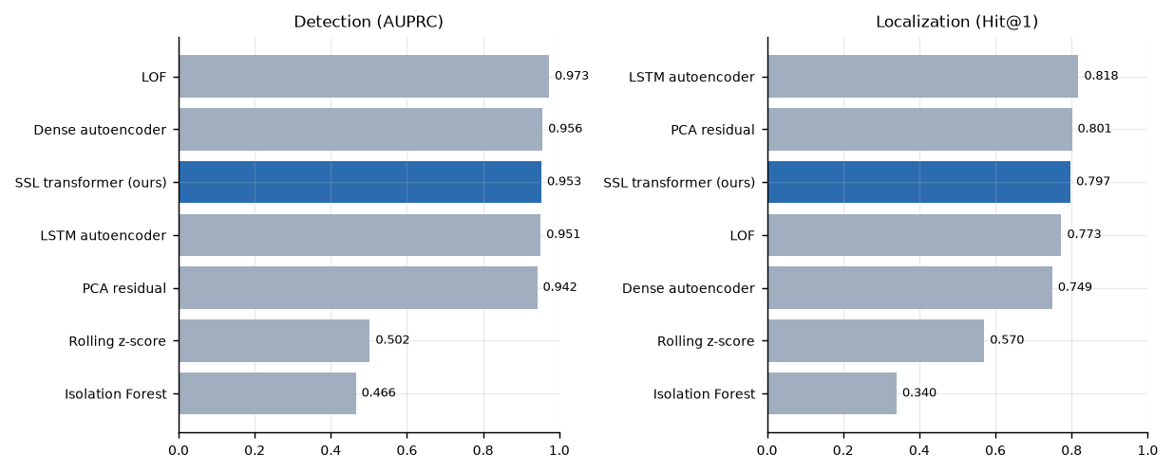
Figure 5. Detection and localization across all seven methods, ours in blue. Two panels rather than one shared axis, because they are different questions and a method can be strong at one and weak at the other.
Two failures among the baselines are informative. Rolling z-score, the stand-in for the rule-based tooling teams actually run today, collapses to 0.502 AUPRC because the benign distractors defeat it. Seasonality, growth and campaigns move features as hard as several genuine fault types do, which is precisely why those distractors are in the benchmark. Isolation Forest is weakest overall, a known consequence of axis-parallel splits on correlated features.

7.2 The main finding: cross-task comparability
Ranking nine raw errors asks which task has the largest error. The question is which task is furthest from its own normal. Since tasks are not equally predictable, the two questions have different answers, and whichever task is intrinsically hardest to predict wins the raw ranking by default.
There are two independent ways to correct this, and the result is that they are worth the same.
SSL localizer variant | Hit@1 [95% CI] | MRR [95% CI]
Deviation magnitude, raw | 0.588 [0.533, 0.646] | 0.762 [0.729, 0.796]
Deviation magnitude, statistically calibrated | 0.773 [0.725, 0.821] | 0.872 [0.843, 0.899]
Ancestor-conditioned, raw (structural) | 0.773 [0.725, 0.821] | 0.867 [0.838, 0.896]
Ancestor-conditioned and calibrated | 0.797 [0.749, 0.842] | 0.883 [0.855, 0.910]
Rows two and three are identical to three decimal places with the same interval.
Structural conditioning achieves comparability by predicting each task from its parents, so whatever a task’s inputs already explain is subtracted away. Statistical calibration achieves it by converting each task’s error into a percentile against its own healthy history. Different mechanisms, the same effect, the same number. Applying both adds 2.4 points, which the intervals cannot distinguish from noise.
An earlier version of this work reported the structural correction as worth 18.5 Hit@1 points. That figure compared it against an uncalibrated baseline. The corrected comparison is the more interesting one, because it identifies what the gain was actually made of.

7.3 Calibration is not universally beneficial
Method | Uncalibrated Hit@1 | Calibrated | Delta
LSTM autoencoder | 0.643 | 0.818 | +0.175
Dense autoencoder | 0.725 | 0.749 | +0.024
SSL (ancestor-conditioned) | 0.773 | 0.797 | +0.024
PCA residual | 0.801 | 0.801 | 0.000
Local Outlier Factor | 0.797 | 0.773 | -0.024
Rolling z-score | 0.663 | 0.570 | -0.093
The effect tracks how far apart a method’s per-task error scales already are. The LSTM autoencoder reconstructs all nine tasks through one shared hidden state, so its per-task error scales differ wildly and calibration has a great deal to correct. PCA and Local Outlier Factor already produce roughly comparable per-task scores, so there is nothing to gain and the rank transform only discards magnitude information.
The practical lesson is that per-task calibration should be checked rather than assumed, and checking is cheap because it requires no labels.

7.4 Localization by graph depth
The first implementation of the ancestor score hid only the task under test, leaving its descendants visible to leak the corrupted value back. The prediction was that this leak should hurt most where a task has the most descendants, meaning upstream, and should vanish at the sink.
Origin depth | Ancestor (descendants hidden) | Self-masked only | Deviation magnitude | n
0 (source tasks) | 0.598 | 0.546 | 0.505 | 97
1 | 0.806 | 0.583 | 0.556 | 72
2 | 0.821 | 0.643 | 0.643 | 28
3 | 0.889 | 0.889 | 0.667 | 18
4 | 0.938 | 0.625 | 0.562 | 48
5 (sink) | 0.893 | 0.893 | 0.893 | 28
At depth 5 all three rules agree exactly, because the sink task has no descendants and the three masks are then the same tensor. That agreement is not a tuned result, it follows from the construction, and it is the cleanest available evidence that the mechanism is the one claimed.
Depth 0 is the hardest row and gains least, which also follows: source tasks have no ancestors either, so conditioning has nothing extra to offer.

7.5 Explainability
Method | Accuracy over 291 incidents
Integrated Gradients | 0.935
Reconstruction error | 0.924
Both are high and the gap is small. Integrated Gradients is clearly better on timezone_shift (0.95 against 0.76), which fits its extra capability: it can credit evidence in other tasks and earlier runs, while reconstruction error can only inspect the flagged task at the flagged timestep. A timestamp shift shows up as a relationship across the window rather than as one large residual. Nine of fifteen fault types reach 1.00 under both.
Since Integrated Gradients costs 32 extra forward and backward passes per explanation for a one-point average gain, reconstruction error is the sensible default, with Integrated Gradients reserved for the fault families where it demonstrably helps.
The attention recovered the pipeline. Averaged over incidents, structural attention places 46.4% of its off-diagonal mass on true graph edges against 22.2% expected by chance, a 2.1x lift. The brightest cells are genuine parent-child pairs. Nothing forces this, since the graph bias is a learned scalar per relation rather than a mask.
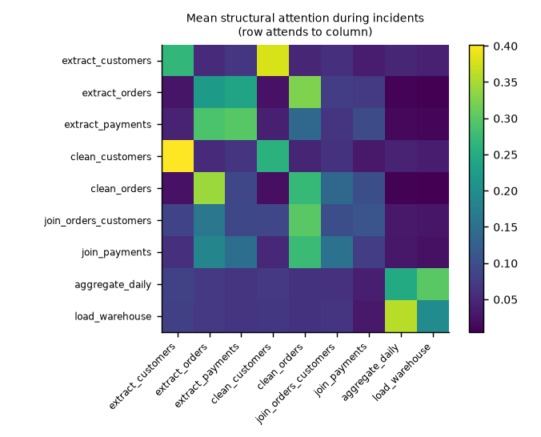
Figure 6. Structural attention averaged over incidents, row attending to column. The brightest cells are true parent-child pairs in the pipeline. Section 8.1 shows this alignment survives removing the DAG bias entirely, which is why the bias turns out to be redundant.
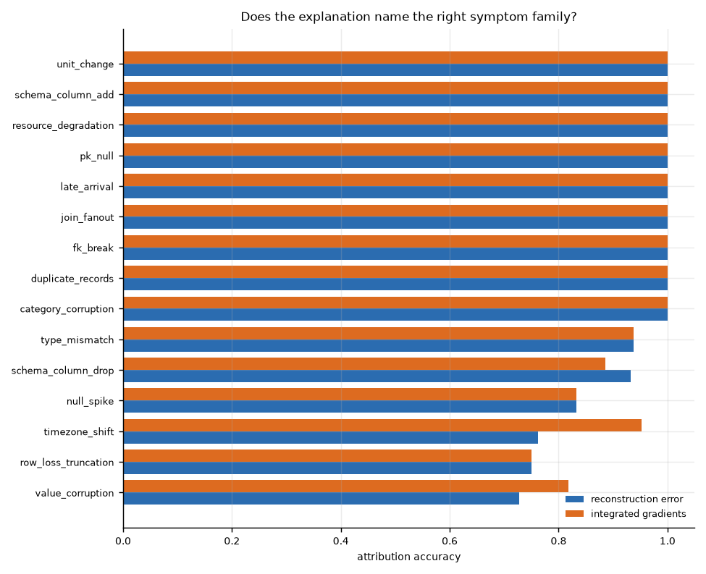
Figure 7. Attribution accuracy per fault type for both explanation methods, scored against each fault’s mechanistically expected symptom family.

8. Ablation Study
Every configuration received an identical budget, 40 epochs with the same early-stopping patience of 8, so “this component helps” cannot be confused with “this run trained longer”. One seed stopped at epoch 33 on that rule; since checkpoints are selected on best validation loss rather than the final epoch, that neither helps nor hurts it. Three seeds of the full model establish the noise floor.
Baseline, three seeds: AUPRC 0.951 ± 0.001, Hit@1 0.805 ± 0.011, MRR 0.887 ± 0.007.
Configuration | val recon | AUPRC | Hit@1 | MRR | Delta Hit@1 | Verdict
Full model (3 seeds) | 0.438 | 0.951 | 0.805 | 0.887 | reference
Clean training set | 0.436 | 0.952 | 0.814 | 0.892 | +0.009 | within noise
No DAG attention bias | 0.435 | 0.953 | 0.801 | 0.884 | -0.005 | within noise
No calendar features | 0.433 | 0.953 | 0.790 | 0.879 | -0.015 | within noise
Contrastive objective added | 0.486 | 0.953 | 0.787 | 0.880 | -0.018 | within noise
Working calendar features (v2 data) | 0.433 | 0.953 | 0.787 | 0.878 | -0.018 | within noise
Longer training (57 epochs, budget lifted) | 0.405 | 0.948 | 0.756 | 0.861 | -0.049 | outside noise

8.1 None of the architectural choices matter
Four of the five variations land inside two standard deviations of the seed noise. Neither the DAG attention bias nor the calendar features nor the contrastive objective changes the outcome, and training on a guaranteed-clean set is no better than training on the contaminated history.
Each of these deserves a specific explanation rather than a shrug.
The DAG attention bias is redundant because the model finds the graph anyway. Attention in the ablated model still places 42.2% of its off-diagonal mass on true pipeline edges against 22.2% expected by chance, a 1.9x lift, compared with 46.4% and 2.1x when the bias is present. Telling the model the structure nudges it slightly and changes nothing downstream, because the structure is recoverable from the data.
Calendar features are redundant, and this took two attempts to establish. The first version of this ablation was not a valid test. A unit bug made every exported timestamp 1000x too small, so the whole 8000-run timeline spanned nine distinct hours instead of twenty-four and the calendar features carried almost no signal. Removing features that encode nothing is guaranteed to change nothing.
After fixing the timestamps and retraining with a genuine 24-hour cycle, the answer is the same: Hit@1 0.787 against a seed mean of 0.805 +/- 0.011, and validation reconstruction of 0.4332 against 0.4328. So the conclusion stands and now has a real experiment behind it. A 32-hour window spans more than a full day, so the model can already infer the phase of the daily cycle from the history it sees, and an explicit clock adds nothing.
The contrastive objective hurts reconstruction and does not help anything else. Validation reconstruction loss rises from 0.438 to 0.486 while localization is unchanged. The contrastive loss itself collapses to 0.055, meaning the task became trivial: with augmentations deliberately kept weak, so as not to manufacture something that looks like a real fault, the two views are too easy to match and the objective stops providing signal. Stronger augmentation is not the obvious fix, because that is precisely what would teach the model to treat real faults as normal.
Contamination tolerance is confirmed. Training on only the clean windows gives +0.009 Hit@1, inside noise. The claim that the method tolerates the roughly 3% incident contamination present in real pipeline history holds, and it holds without any special handling beyond robust normalisation.

8.2 Better reconstruction makes localization worse
The one result outside the noise floor is the one we did not go looking for. Training for 57 epochs instead of 33 improves validation reconstruction loss substantially, from 0.433 to 0.405, and makes localization worse, from 0.805 to 0.756 Hit@1.
This is the over-generalisation failure familiar from reconstruction-based anomaly detection. A model that reconstructs well enough starts reconstructing anomalies too, and the error signal that detection and localization both depend on gets smaller. The contrastive run points the same way from the opposite direction: its reconstruction is clearly worse at 0.486 and its localization is unchanged.
Reconstruction loss and localization accuracy are therefore only loosely coupled, and past a point they move in opposite directions.
This has an uncomfortable implication for the protocol used here. Checkpoints were selected on validation reconstruction loss precisely because it needs no labels, which keeps the method honestly self-supervised. That criterion is now shown to be poorly aligned with the task the model is being asked to perform, and a stopping point chosen for methodological purity is not the one that maximises the metric anyone cares about. Selecting on validation AUPRC would fix the alignment and break the label-free claim.
Resolving this properly needs a label-free proxy that correlates with localization rather than with reconstruction, and finding one is left as future work. Meanwhile the honest position is that the reported numbers come from a selection rule that is defensible but demonstrably suboptimal, which if anything understates what the architecture can do.

9. Error Analysis
Nine of fifteen fault types localize at or near 1.00. Two fail badly.
Fault type | Hit@1 | Mean tasks affected
row_loss_truncation | 0.29 | 3.77
duplicate_records | 0.43 | 2.84
Nine types at 0.94 to 1.00 |  | 1.00 to 1.76
The correlation between how far a fault spreads and how well it localizes is -0.63. Faults that stay local are easy and faults that travel are hard, which is the expected shape of the problem.
The error pattern is sharper than the average suggests. Of the mislocalized duplicate_records incidents, 100% blamed a task further downstream, and nearly all blamed the same one, join_payments. For row_loss_truncation the figure is 85%.
The mechanism is specific to joins. A join’s output row count depends on the key overlap between its inputs, and key overlap is not among the 38 features, so no model can predict a join’s row count from its parents’ profiles. When duplication arrives from upstream, the fan-out it causes at the join is genuinely unpredictable from the parent profiles, and the join therefore looks like the origin.
This is a feature-design limitation rather than a modelling one, and it names its own fix: add a join-key overlap statistic to the profile. The information the model would need is currently not measured at all.
Localization also degrades gracefully with severity, from 0.66 Hit@1 in the lowest quartile to 0.88 in the highest. A method that scored faint incidents as well as severe ones would be suspicious rather than impressive.
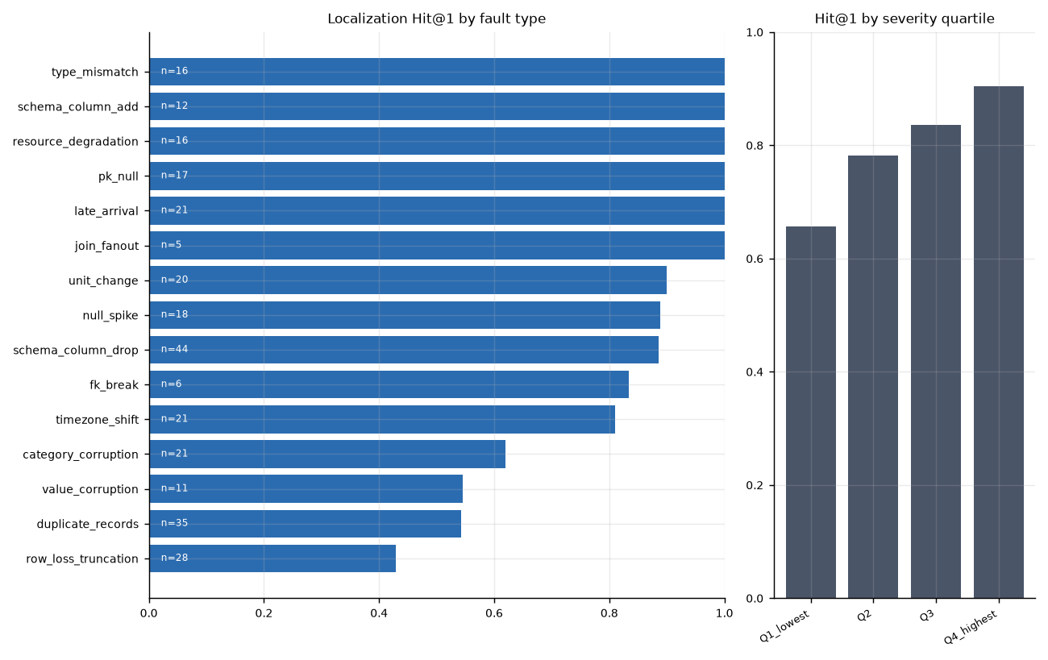
Figure 8. Localization accuracy per fault type and by severity quartile. The two row-count faults at the bottom are the failure mode analysed above, and accuracy rising with severity is the expected and desirable shape.

10. Limitations and Threats to Validity
The benchmark is synthetic. Fault severities, frequencies and the mix of types are design choices. The relative ordering of methods is more trustworthy than any absolute number reported here. Validating the simulator against a real pipeline’s telemetry is the single most valuable piece of future work.
Detection may be too easy to discriminate. Five of seven methods land within 0.03 AUPRC of each other. The benchmark separates methods on localization but barely on detection. Lower severities, more concurrent incidents and shorter windows would all make it harder.
Alert-budget columns saturate. F1 at a 1% budget is capped at 0.129 and at a 5% budget at 0.512 for any detector with perfect precision, because one cannot recall more incidents than one is permitted to raise alerts. Only the 15% column, roughly one alert per incident, discriminates between methods.
Three seeds. Enough to establish that seed variance is small (Hit@1 standard deviation 0.011) but not enough for a formal significance test between methods. Differences under about 0.05 Hit@1 should not be treated as real, and on that threshold every architectural ablation in Section 8 is a null result.
Model selection is not entirely label-free, and the label-free part is misaligned. Checkpoints are chosen on validation reconstruction loss, which uses no labels, but Section 8.2 shows that criterion does not track localization and can actively work against it. The detection pooling rule is chosen on validation AUPRC, one categorical choice among five options, reported rather than hidden.
A unit bug that no result depended on, but one interpretation did. Exported timestamps were 1000x too small because DatetimeIndex.astype("int64") changed meaning between pandas major versions. Nothing crashed and no metric moved: the profile tensor and every label are bit-identical across the two dataset versions, and no baseline uses the clock. What it did break was the calendar-feature ablation, which was measuring the removal of features that encoded nothing. The experiment was redone on corrected data and the conclusion held. It is recorded here because the failure mode is worth remembering: a derived quantity nobody inspects is a quantity nobody checks, and it was caught only when a demo script printed dates in 1970.
Single pipeline topology. All results come from one nine-task graph. Generalisation to wider graphs, deeper graphs, or pipelines with cycles in their scheduling is untested.

11. Conclusion and Future Work
This project set out to detect ETL failures without labels and to identify which task caused them. It delivers a benchmark that makes the second question answerable, a self-supervised model that answers both competitively, and an explanation layer whose correctness can be measured rather than assumed.
The honest summary of the modelling result is that the transformer does not beat simple baselines on this benchmark. Local Outlier Factor detects better and an LSTM autoencoder localizes better, and the differences among the leading methods are within noise. What the work does establish is more specific and, arguably, more useful: the way per-task scores are made comparable matters more than the model that produces them. Correcting for cross-task comparability is worth up to 18.5 Hit@1 points, whereas the entire spread between the leading detectors is about 4. Two routes to that correction, one structural and one statistical, prove equivalent in effect.
Four design components were tested and none of them helped. Reporting that is part of the result rather than an embarrassment. A graph attention bias adds nothing because the model recovers the pipeline structure from data on its own, explicit calendar features add nothing because a 32-hour window already contains more than a full daily cycle, a contrastive objective adds nothing and degrades reconstruction, and a guaranteed-clean training set is no better than the contaminated history, which confirms the contamination-tolerance claim.
The one effect that exceeded the noise floor was unwelcome: training longer improves reconstruction and makes localization worse. That is the over-generalisation failure of reconstruction-based detection, and it undermines the label-free checkpoint criterion used throughout, since validation reconstruction loss turns out to be poorly aligned with the task the model is actually being asked to do.

Future work
Measure join-key overlap. Section 9 identifies the exact missing feature behind the two worst-localizing fault types. This is the highest-value next step and it is cheap.
Validate the simulator against real telemetry. Even a few weeks of real pipeline metrics with a handful of known incidents would let the fault severity and frequency distributions be calibrated rather than chosen.
Harder detection settings. The benchmark should be extended with lower severities and more concurrent incidents until it separates detectors as clearly as it separates localizers.
A label-free selection criterion that tracks localization. Section 8.2 shows validation reconstruction loss is a poor proxy. Finding a proxy that is both label-free and aligned with the downstream task would improve every number here and is the most interesting open problem the project surfaced.
Few-shot fault typing. The representation already supports a fault-type probe. How many labelled examples per class are needed to classify the fifteen types is a natural and practical question.
Online adaptation. Real pipelines change. A production system would need to distinguish a genuine fault from a deliberate schema migration, which is a concept-drift problem this work does not address.

References
Verify venue and year for each of these before submission.
- P. Malhotra, L. Vig, G. Shroff, P. Agarwal. Long Short Term Memory Networks for Anomaly Detection in Time Series. ESANN, 2015.
- P. Malhotra et al. LSTM-based Encoder-Decoder for Multi-sensor Anomaly Detection. ICML Anomaly Detection Workshop, 2016.
- L. Ruff et al. Deep One-Class Classification. ICML, 2018.
- K. Hundman et al. Detecting Spacecraft Anomalies Using LSTMs and Nonparametric Dynamic Thresholding. KDD, 2018.
- Y. Su et al. Robust Anomaly Detection for Multivariate Time Series through Stochastic Recurrent Neural Network. KDD, 2019.
- J. Audibert et al. USAD: UnSupervised Anomaly Detection on Multivariate Time Series. KDD, 2020.
- H. Zhao et al. Multivariate Time-series Anomaly Detection via Graph Attention Network. ICDM, 2020.
- A. Deng, B. Hooi. Graph Neural Network-Based Anomaly Detection in Multivariate Time Series. AAAI, 2021.
- S. Tuli, G. Casale, N. Jennings. TranAD: Deep Transformer Networks for Anomaly Detection in Multivariate Time Series Data. VLDB, 2022.
- J. Xu et al. Anomaly Transformer: Time Series Anomaly Detection with Association Discrepancy. ICLR, 2022.
- G. Zerveas et al. A Transformer-based Framework for Multivariate Time Series Representation Learning. KDD, 2021.
- Z. Yue et al. TS2Vec: Towards Universal Representation of Time Series. AAAI, 2022.
- K. He et al. Masked Autoencoders Are Scalable Vision Learners. CVPR, 2022.
- M. Du et al. DeepLog: Anomaly Detection and Diagnosis from System Logs through Deep Learning. CCS, 2017.
- W. Meng et al. LogAnomaly: Unsupervised Detection of Sequential and Quantitative Anomalies in Unstructured Logs. IJCAI, 2019.
- H. Guo, S. Yuan, X. Wu. LogBERT: Log Anomaly Detection via BERT. IJCNN, 2021.
- S. Schelter et al. Automating Large-Scale Data Quality Verification. VLDB, 2018.
- E. Breck et al. Data Validation for Machine Learning. SysML, 2019.
- J. Song, Y. He. Auto-Validate: Unsupervised Data Validation Using Data-Domain Patterns. SIGMOD, 2021.
- S. Redyuk et al. Automating Data Quality Validation for Dynamic Data Ingestion. EDBT, 2021.
- L. Wu et al. MicroRCA: Root Cause Localization of Performance Issues in Microservices. NOMS, 2020.
- M. Li et al. Causal Inference-Based Root Cause Analysis for Online Service Systems with Intervention Recognition. KDD, 2022.
- A. Ikram et al. Root Cause Analysis of Failures in Microservices through Causal Discovery. NeurIPS, 2022.
- M. Sundararajan, A. Taly, Q. Yan. Axiomatic Attribution for Deep Networks. ICML, 2017.
- S. Lundberg, S. Lee. A Unified Approach to Interpreting Model Predictions. NeurIPS, 2017.
- S. Kim et al. Towards a Rigorous Evaluation of Time-series Anomaly Detection. AAAI, 2022.
- R. Wu, E. Keogh. Current Time Series Anomaly Detection Benchmarks are Potentially Flawed. TKDE, 2022.
- F. Liu, K. Ting, Z. Zhou. Isolation Forest. ICDM, 2008.
- M. Breunig et al. LOF: Identifying Density-Based Local Outliers. SIGMOD, 2000.

Appendix A: Reproducing every number
python3.12 -m venv .venv && source .venv/bin/activate
pip install -r requirements.txt
# Dataset, about 4 minutes
PYTHONPATH=src python -m etlguard.data.build_dataset --n-batches 8000 --out data/etl_v1
# Simulator validation and descriptive figures
PYTHONPATH=src python scripts/validate_simulator.py
PYTHONPATH=src python scripts/dataset_report.py --data data/etl_v1
# Pretraining, about 18 minutes on Apple Silicon
PYTHONPATH=src python -m etlguard.train.pretrain --epochs 40 --out runs/ssl
# Main evaluation with all baselines
PYTHONPATH=src python -m etlguard.eval.run_eval --ckpt runs/ssl/best.pt --save-scores
# Seeds and ablations, about two hours
PYTHONPATH=src python scripts/run_experiments.py --only all
# Attribution, error analysis, tables and figures
PYTHONPATH=src python scripts/attribution_study.py --ckpt runs/ssl/best.pt
PYTHONPATH=src python scripts/error_analysis.py --ckpt runs/ssl/best.pt
PYTHONPATH=src python scripts/results_report.py
# Tests
PYTHONPATH=src python -m pytest tests/ -q

