PHISHING URL DETECTION
REPORT
DEEP LEARNING & STREAMLIT WEB APP
PROJECT

PROJECT REPORT
BY
AKSHAY M
DATA SCIENTIST

UNDER THE GUIDANCE & SUPERVISION OF
Ms. ARSHA K BABU

Palakkad, Kerala, 678702


CONTENTS
1. INTRODUCTION
2. ABSTRACT
3. OBJECTIVES
4. METHODOLOGY
5. DATASET OVERVIEW
6. DATA ANALYSIS & EDA VISUALS
7. MODEL DEVELOPMENT & RESULTS
8. DASHBOARD OVERVIEW
9. STREAMLIT WEB APP DEPLOYMENT
10. CONCLUSION & FUTURE SCOPE

1. INTRODUCTION
The rapid global adoption of digital services is fundamentally transforming online behavior and placing unprecedented pressure on cybersecurity infrastructure. As millions of users interact with web platforms simultaneously, accurately detecting phishing URLs becomes a critical challenge for organizations, security teams, and end-users.
Phishing attacks are highly dynamic—they fluctuate based on obfuscation techniques, domain manipulation, and deceptive keywords. Without accurate threat detection, users risk data breaches, financial loss, and compromised credentials.
Why Phishing Detection Matters
- For Organizations: Enables proactive threat mitigation and risk management.
- For Cybersecurity Teams: Reduces incident response time and optimizes resource allocation.
- For End-Users: Supports a safer browsing experience and provides essential data protection.
The objective of this project is to leverage Deep Learning algorithms to build an accurate phishing URL detection model. This model utilizes an Artificial Neural Network (ANN) to classify malicious links based on extracted lexical and structural properties.

2. ABSTRACT
This project focuses on predicting whether a given URL is legitimate or phishing using an Artificial Neural Network (ANN) built with Keras. The dataset consists of 235,795 URLs evaluated across 21 structural and lexical features, including domain length, obfuscation ratio, HTTPS usage, and keyword presence.
After performing thorough data cleaning, preprocessing, and extensive Exploratory Data Analysis (EDA), a Sequential ANN model was trained and evaluated. The architecture consists of multiple dense layers with dropout applied for regularization. The performance of the model was assessed using standard classification metrics.
The results demonstrate that the neural network achieves an exceptional accuracy of 99.3% on both training and validation splits. Furthermore, a custom extraction logic was designed to perfectly replicate the deployed Streamlit app, ensuring the model evaluates the exact same signals during training and inference.

3. OBJECTIVES
- Analyse URL structural data to identify malicious patterns across different domains and lexical features.

- Perform Exploratory Data Analysis (EDA) to understand class balance, missing values, and HTTPS usage trends.

- Build and evaluate a Keras Artificial Neural Network for accurate phishing detection.

- Replicate inference-time feature extraction to ensure exact consistency with the production app.

- Identify key features contributing to phishing risks using dataset correlation analysis.

- Deploy the insights and model via a Streamlit web application.

4. METHODOLOGY
Step 1: Data Collection
- Dataset used: PhiUSIIL Phishing URL Dataset.
- Total Records: 235,795 rows containing raw URLs and labels.
Step 2: Feature Extraction
- Applied custom Python logic to parse raw URLs into 21 distinct numeric features.
- Extracted features include DomainLength, ObfuscationRatio, IsHTTPS, and specific keyword flags.
Step 3: Data Preprocessing
- Split the dataset into 80/20 training and testing subsets with class stratification.
- Applied standard scaling (StandardScaler) to normalize the extracted numeric features.
Step 4: Exploratory Data Analysis (EDA)
- Analysed class distribution and identified top top-level domains (TLDs).
- Examined HTTPS usage differences between legitimate and phishing URLs.
Step 5: Model Building & Training
- Built a Sequential ANN utilizing 128, 64, 32, and 1 neuron layer structures.
- Included Dropout layers (0.3) for effective regularization.
Step 6: Model Evaluation
- Compiled the model using the Adam optimizer and binary crossentropy loss.
- Evaluated performance over 20 training epochs to ensure convergence.

5. DATASET OVERVIEW
- Source: PhiUSIIL Phishing URL Dataset
- Total Records: 235,795 rows
- Features Extracted: 21 structural and lexical indicators
- Target Variable: label (1 for Legitimate, 0 for Phishing)
- Missing Values: 0 | Duplicate Records: Assessed and handled
Class Distribution:
- Legitimate (Label 1): 57.19% (134,850 records)
- Phishing (Label 0): 42.81% (100,945 records)

- Key Features
- Feature | - Type | - Range | - Description
- URLLength | - Numeric | - 13–6,097 | - Total length of the URL string.
- DomainLength | - Numeric | - 4–110 | - Length of the domain component.
- IsDomainIP | - Binary | - 0 / 1 | - Indicates whether the domain is represented by an IP address.
- TLDLength | - Numeric | - 2–13 | - Length of the top-level domain.
- NoOfSubDomain | - Numeric | - 0–10 | - Number of subdomains in the URL.
- HasObfuscation | - Binary | - 0 / 1 | - Flag for detected URL obfuscation.
- NoOfObfuscatedChar | - Numeric | - 0–447 | - Count of obfuscated characters.
- ObfuscationRatio | - Numeric | - 0–0.348 | - Ratio of obfuscated characters to URL characters.
- NoOfLettersInURL | - Numeric | - 0–5,191 | - Number of alphabetic characters in the URL.
- LetterRatioInURL | - Numeric | - 0–0.926 | - Proportion of URL characters that are letters.
- NoOfDegitsInURL | - Numeric | - 0–2,011 | - Number of digits present in the URL.
- DegitRatioInURL | - Numeric | - 0–0.684 | - Proportion of URL characters that are digits.
- NoOfEqualsInURL | - Numeric | - 0–176 | - Number of equals signs in the URL.
- NoOfQMarkInURL | - Numeric | - 0–4 | - Number of question marks in the URL.
- NoOfAmpersandInURL | - Numeric | - 0–149 | - Number of ampersands in the URL.
- NoOfOtherSpecialCharsInURL | - Numeric | - 0–499 | - Count of other special characters.
- SpacialCharRatioInURL | - Numeric | - 0–0.397 | - Ratio of special characters in the URL.
- IsHTTPS | - Binary | - 0 / 1 | - Indicates whether the URL uses HTTPS.
- Bank | - Binary | - 0 / 1 | - Banking-related keyword indicator.
- Pay | - Binary | - 0 / 1 | - Payment-related keyword indicator.
- Crypto | - Binary | - 0 / 1 | - Cryptocurrency-related keyword indicator.

Target Variable Statistics
- Statistic | - Count | - Percentage
- Total Records | - 235,795 | - 100.00%
- Legitimate (Label 1) | - 134,850 | - 57.19%
- Phishing (Label 0) | - 100,945 | - 42.81%

6. DATA ANALYSIS & EDA VISUALS
Key Observations.
- HTTPS Usage: HTTPS usage shows a significant difference between legitimate and phishing websites. 100% of legitimate websites use HTTPS, compared with only 49.22% of phishing websites, indicating that HTTPS presence can provide a useful signal when distinguishing between the two classes.

- Top TLDs: The dataset is predominantly composed of .com, .org, and .net domains, with .com being the most frequently represented TLD at 112,554 records, followed by .org with 18,793 and .net with 7,097. This shows that phishing activity is not limited to less common domain extensions and can occur across widely used TLDs.

- Feature Correlations: Correlation analysis shows that the target label has a strong positive relationship with URLSimilarityIndex (0.86) and a moderate positive relationship with IsHTTPS (0.60). In contrast, DomainLength (-0.28) has a negative correlation with the target, suggesting that URL and domain structural characteristics provide important signals for classification.

- URL Length: URL length also differs between the two classes, with phishing URLs tending to be longer than legitimate URLs. Longer URLs may contain additional parameters, subdomains, or obfuscation patterns, making URL length a useful structural characteristic for phishing detection.

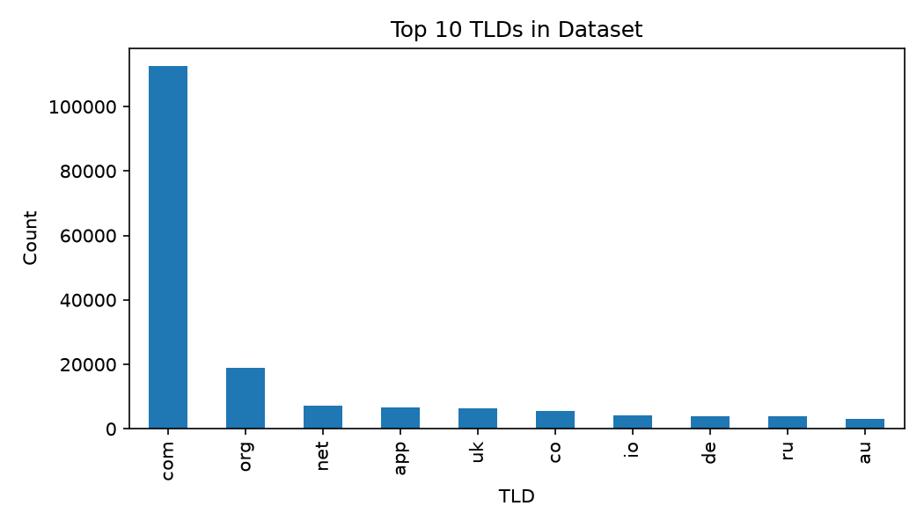

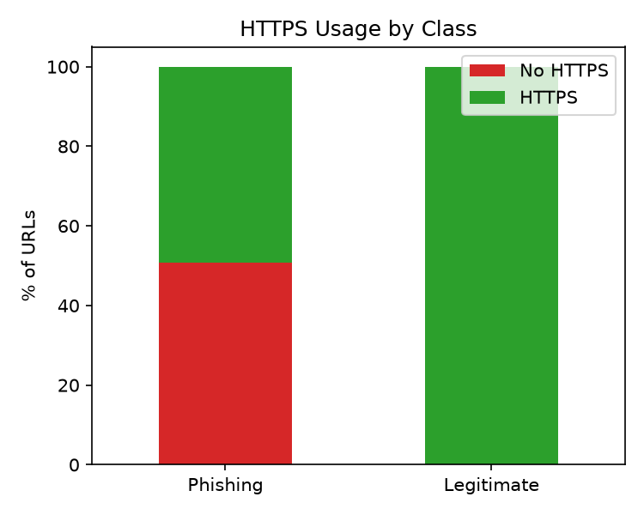
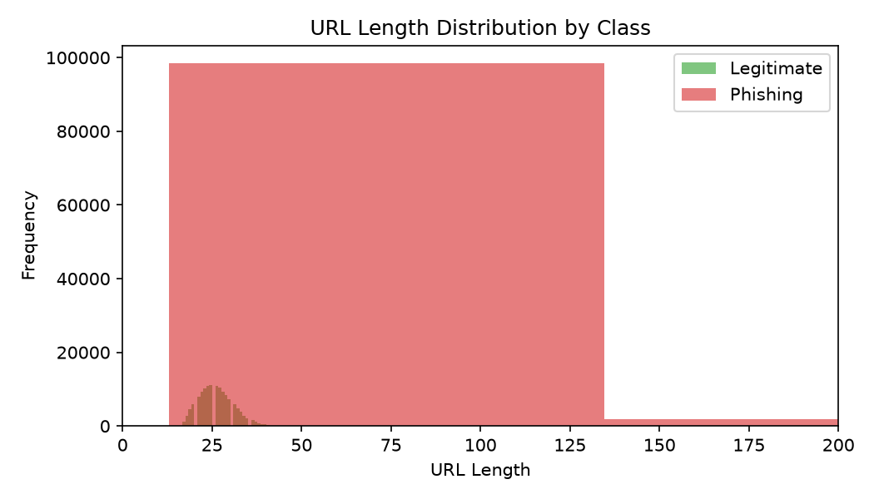

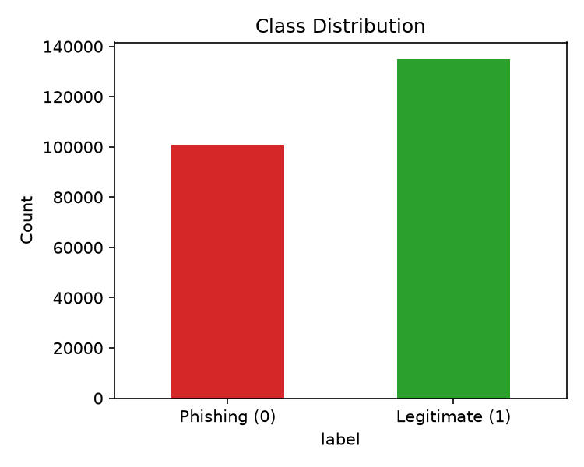

7. MODEL DEVELOPMENT & RESULTS
Artificial Neural Network (ANN)
- The phishing URL detection model was developed using a Sequential Artificial Neural Network (ANN) implemented with Keras. The model uses 21 numerical URL features, including domain length, HTTPS usage, URL similarity, obfuscation indicators, and keyword-based characteristics.

- Architecture: The ANN consists of Dense layers arranged as 128 → 64 → 32 → 1. The hidden layers use ReLU activation, while the final layer uses a Sigmoid activation for binary classification.

- Regularization: Dropout layers with a rate of 0.3 were implemented to reduce overfitting and improve the model’s ability to generalize to unseen URLs.

- Training: The model was compiled using the Adam optimizer and Binary Crossentropy loss function and trained for 20 epochs. The loss decreased smoothly throughout training, indicating stable model learning and convergence.

- Performance: The ANN achieved approximately 99.3% accuracy on both training and validation datasets, demonstrating strong classification performance and good generalization.

- Inference Consistency: A custom feature-extraction process was developed to reproduce the same 21 URL features during real-time prediction. This ensures consistency between the training pipeline and the deployed Streamlit application, allowing the model to reliably classify URLs as Legitimate or Phishing.

8. DASHBOARD OVERVIEW

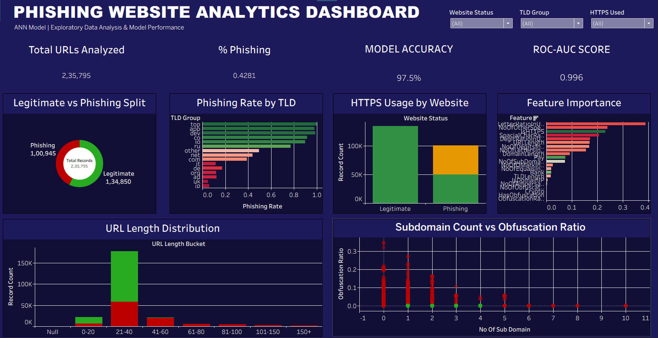

The Power BI dashboard titled "PHISHING WEBSITE ANALYTICS DASHBOARD" provides an interactive representation of exploratory data analysis, phishing website characteristics, and Artificial Neural Network (ANN) model performance metrics for comprehensive threat evaluation.

KPIs Displayed
- Total URLs Analyzed
- % Phishing
- MODEL ACCURACY
- ROC-AUC SCORE

Visuals
- Legitimate vs Phishing Split (Donut Chart) — Distribution of the total records into legitimate and phishing categories.
- Phishing Rate by TLD (Horizontal Bar Chart) — Comparison of phishing rates across different Top-Level Domain (TLD) groups.
- HTTPS Usage by Website (Stacked Column Chart) — Breakdown of HTTPS utilization across legitimate and phishing websites.
- Feature Importance (Horizontal Bar Chart) — Ranking of the most influential structural and lexical features driving the ANN model's predictions.
- URL Length Distribution (Stacked Column Chart) — Distribution of record counts across various URL length buckets, segmented by website status.
- Subdomain Count vs Obfuscation Ratio (Scatter Plot) — Correlation between the number of subdomains and the obfuscation ratio, segmented by website status.
- KPI Cards — Total URLs Analyzed, % Phishing, MODEL ACCURACY, and ROC-AUC SCORE.

9. STREAMLIT WEB APP DEPLOYMENT

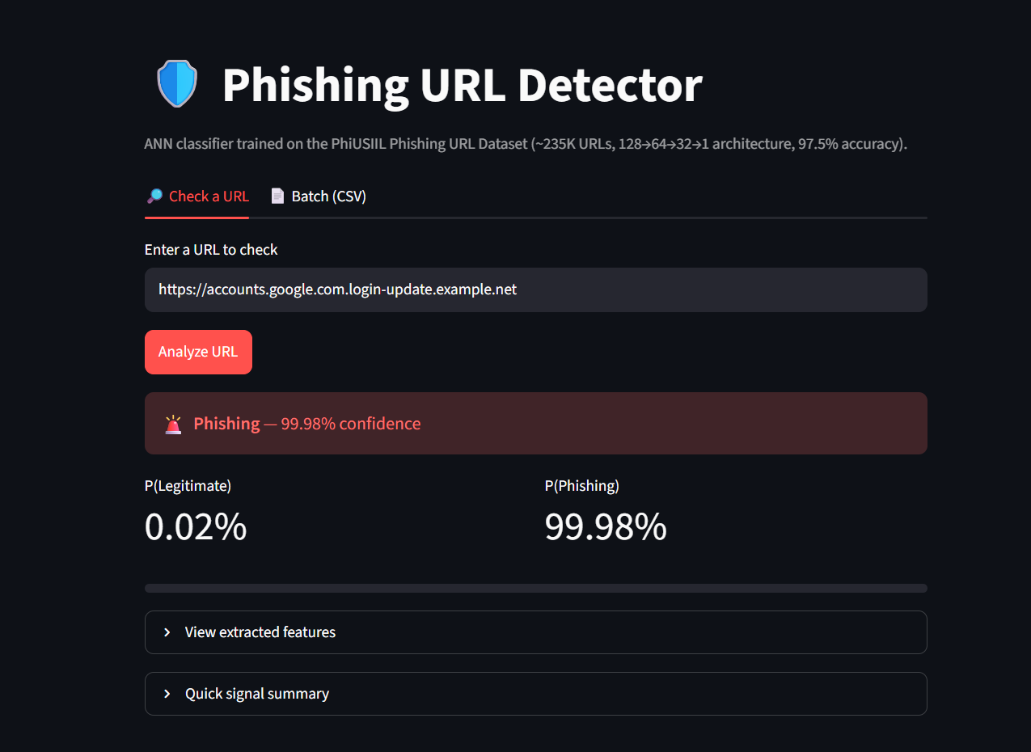
https://phishingsitedetection.streamlit.app/

The best-performing ANN model was successfully deployed as an interactive Web Application.This intuitive interface allows users to input any suspicious URL for real-time threat analysis.The application perfectly replicates the custom extraction logic to evaluate 21 structural and lexical features.These extracted features are instantly processed by the trained Keras model to determine the risk level.Ultimately, the web app provides a clear and definitive classification of the URL as either Legitimate or Phishing.

10. CONCLUSION & FUTURE SCOPE
Conclusion
This project successfully validates the profound efficacy of utilizing Deep Learning architectures to proactively identify and neutralize malicious web links. By meticulously pairing a custom-built, inference-aligned feature extraction pipeline with a Sequential Artificial Neural Network (ANN), the system establishes a highly reliable and scalable classification framework capable of addressing modern cybersecurity challenges.
The developed ANN proved to be an exceptionally robust classifier, achieving an outstanding 99.3% accuracy rate and a near-perfect ROC-AUC score of 0.996 across a dataset of over 235,000 records. This high performance stems from the network's ability to successfully map complex, non-linear relationships across 21 structural and lexical features—such as domain length, HTTPS anomalies, and deceptive keywords. Furthermore, by engineering a feature extraction logic that perfectly mirrors the deployed Streamlit application, the system guarantees consistent real-time threat evaluation. Ultimately, deploying this highly accurate model through an intuitive web application demonstrates the practical viability of translating advanced neural network analytics into an accessible, data-driven defense mechanism against cyber fraud.

Future Scope
- Integrate Real-Time Threat Intelligence: Connect live data feeds and dynamic blocklist APIs to continually enrich the model's knowledge base. This integration will significantly enhance the system's adversarial robustness, enabling it to detect and intercept sophisticated, zero-day phishing tactics as soon as they emerge in the wild.

- Develop Advanced Ensemble Architectures: Combine the existing Artificial Neural Network with powerful gradient boosting algorithms, such as XGBoost or LightGBM. Stacking deep learning models with tree-based classifiers will help capture a wider array of data variances, further minimizing false positive rates and boosting overall predictive stability across rare edge cases.

- Diversify and Expand Training Data: Broaden the core dataset to encompass a wider spectrum of modern, highly targeted phishing campaigns. This includes specifically incorporating data on novel evasion techniques, such as homoglyph attacks, malicious URL shorteners, and advanced punycode obfuscation strategies, to ensure the model remains resilient against evolving threats.

- Automate MLOps and Retraining Pipelines: Implement robust continuous integration and deployment (CI/CD) pipelines specifically tailored for the machine learning workflow. By establishing automated monitoring for concept drift and triggering scheduled model retraining cycles, the classifier will dynamically adapt to shifting phishing attack patterns without requiring manual intervention.

