*In this project , a small application of picture gallery is made using frontend web technologies such as* **HTML5,CSS3 and Javascript.** *Using HTML,input box and search button is created in which user has to enter some keywords for e.g* **cat, pizza,birds etc**. With the help of those keywords , the relevant data will be retrived from **unsplash.com** *and will be displayed below input box as shown below.*

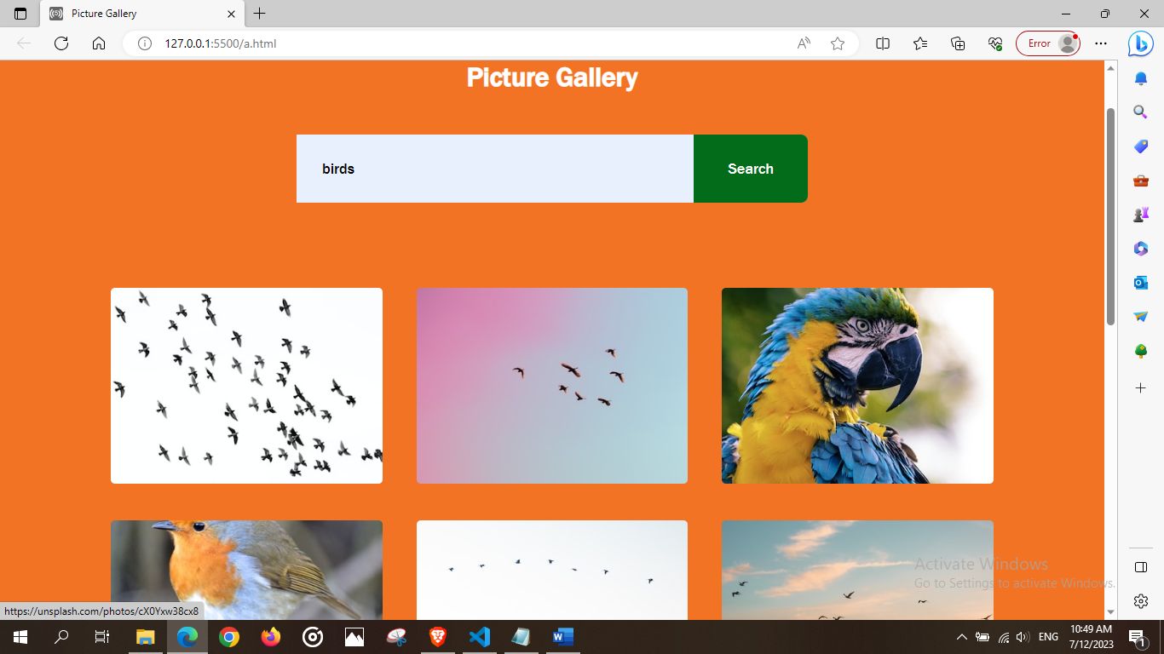

*To get a data from unsplash , we have to register first. After a successful registration, we’ll get an access key. With the help of this* **API key***, desired result will be fetched from unsplash and displayed on screen as shown in above image***.**

*This process can be done using* **javascript.** *To get images with a constant size i.e same height and width for each image ,* **CSS** *can be used for styling* purpose.

To get a perfect arrangement in desired way is the main task in this project i.e for e.g if we want to display 12 images on our screen when user enters some keyword, for that we have to make some changes inside API using javascript as shown below.

