

|  |  |
| --- | --- |
| **QUOTE** | |
| **INVOICE NUMBER**  000000  **BILLED TO** | **DATE OF ISSUE**  20/01/2020 |
| Meghna Soni |
| Lamington Road, 6th floor Sunville Building, Mumbai, MH 400004  +91 9820202145  [meghnasoni@confluence-r.com](mailto:meghnasoni@confluence-r.com) [www.confluence-r.com](http://www.confluence-r.com/) |

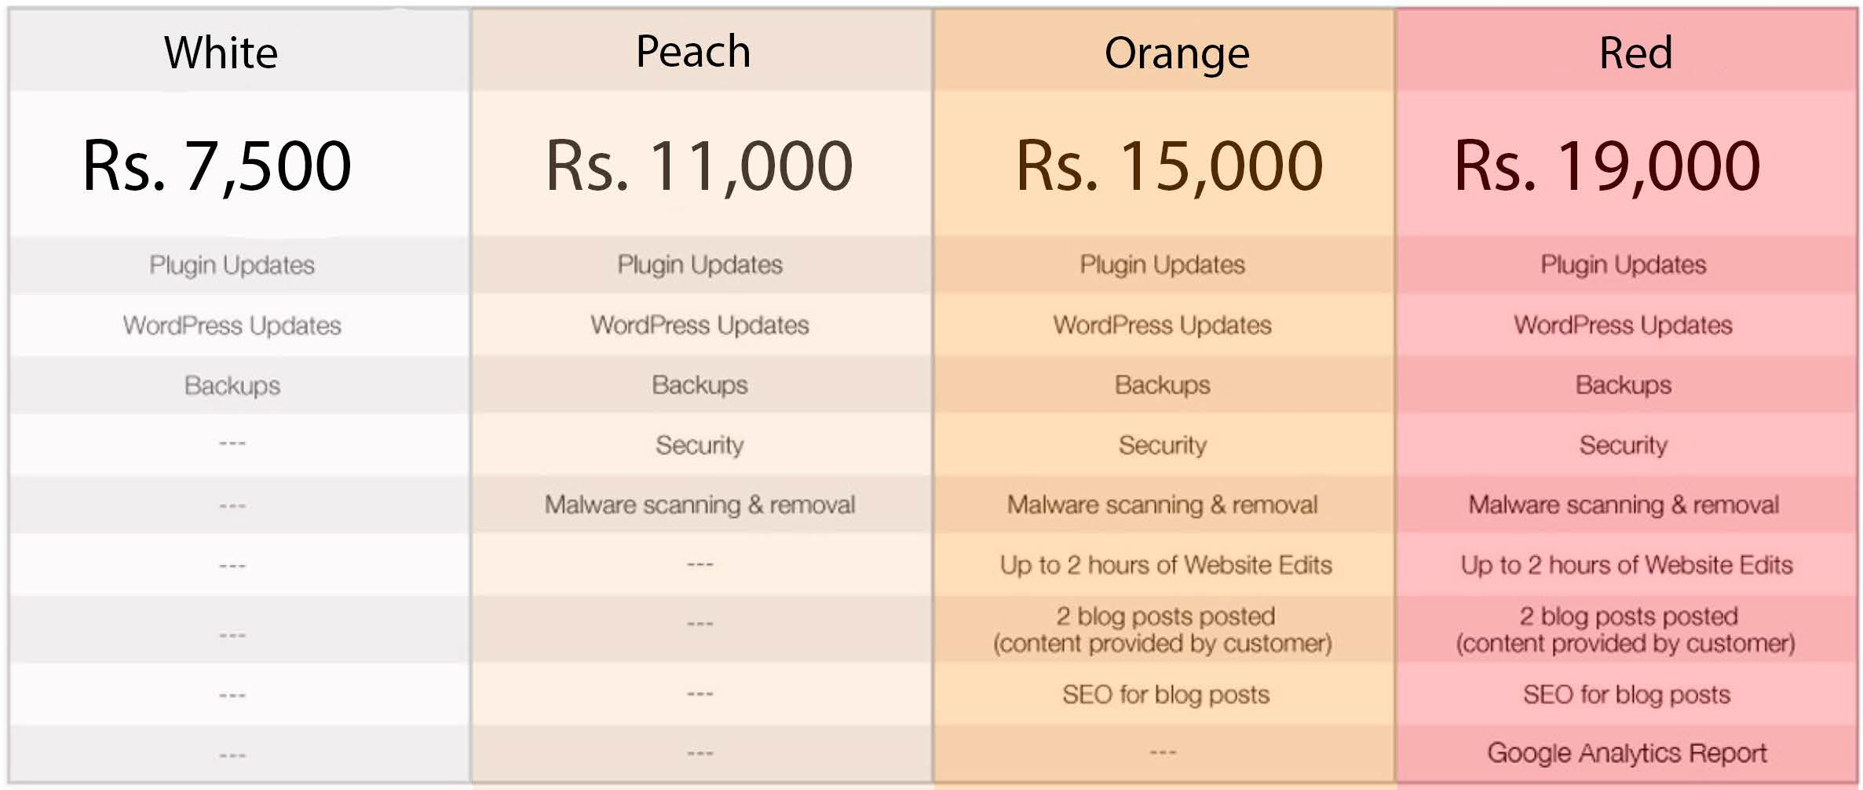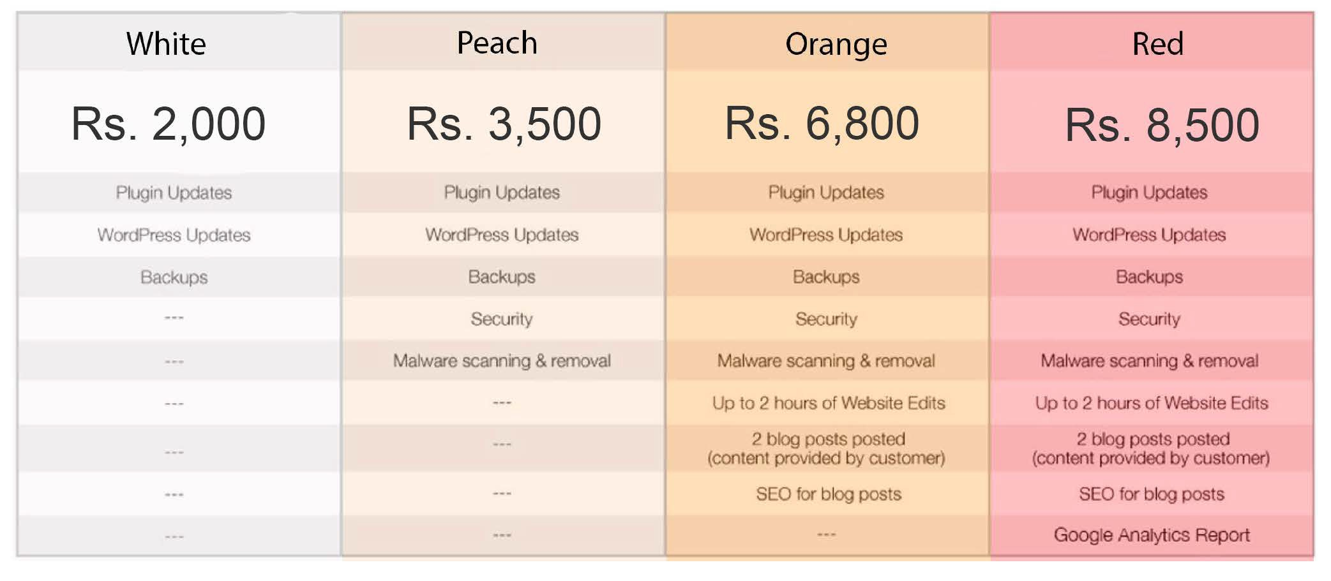

All prices are per month, non inclusive of tax.

*Wordpress above can refer to any hosting portal / company.