**ARCHANA – 1GA18CS029**

**1b Write YACC program to evaluate arithmetic expression involving operators: +, -, *, and /**

**1b.l**

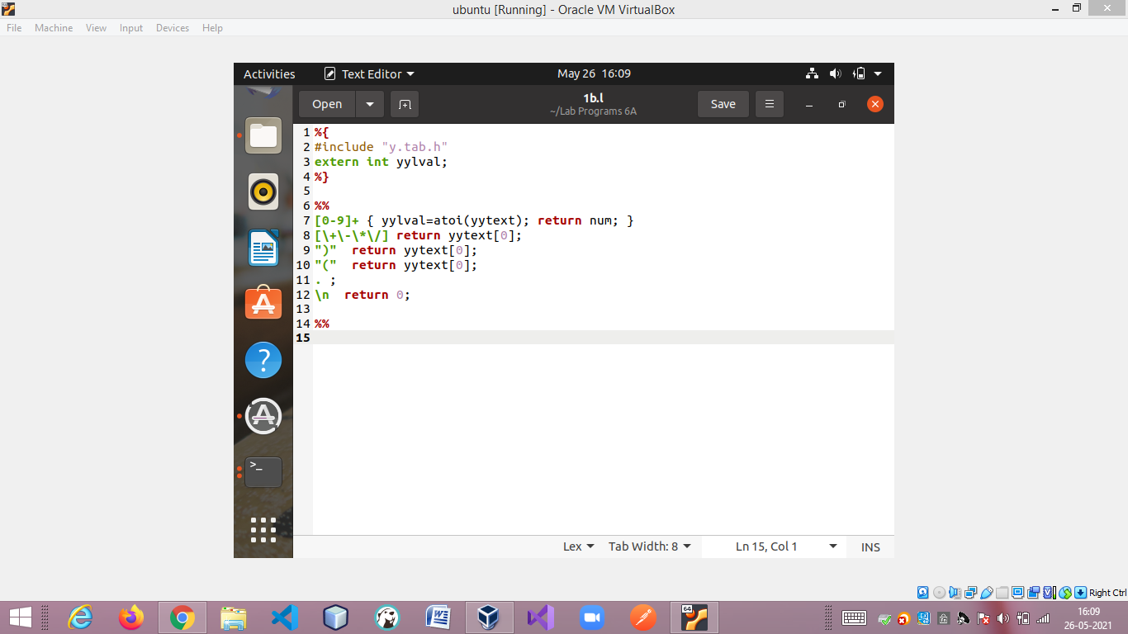

**1b.y**

