**Lab Exercise 1- Working with Git Revert**

**Prerequisites**

1. Install Git on your system.
2. Set up a Git repository: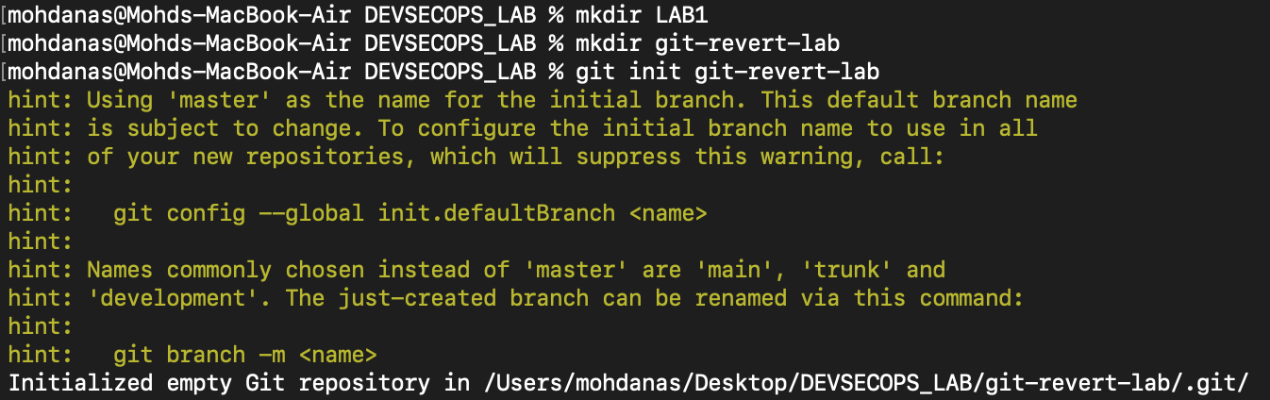

**1. Set Up the Repository**

1. Create a file:
2. Stage and commit the file:pasted-movie.png
3. Add more changes: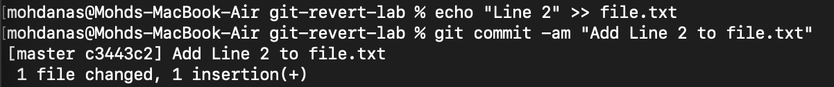
4. Add another change: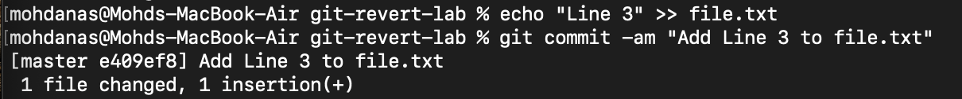
5. Verify the commit history: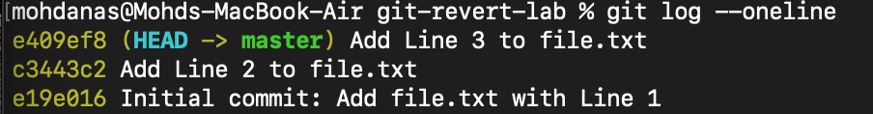

**2. Revert the Last Commit**

1. Revert the most recent commit: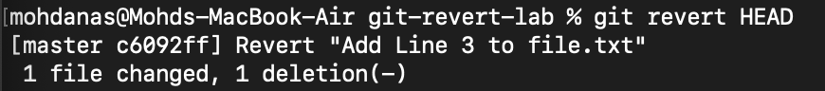
2. Verify the contents of file.txt: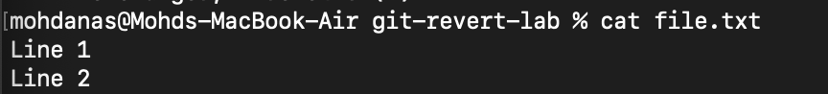
3. Check the commit history: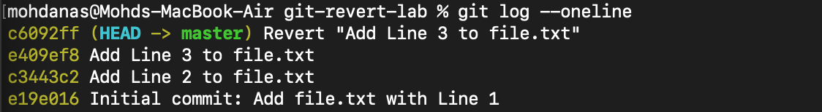

**3. Handle Merge Conflicts During Revert**

1. Modify file.txt:
2. Revert the second commit (c3443c2 again) to trigger a conflict: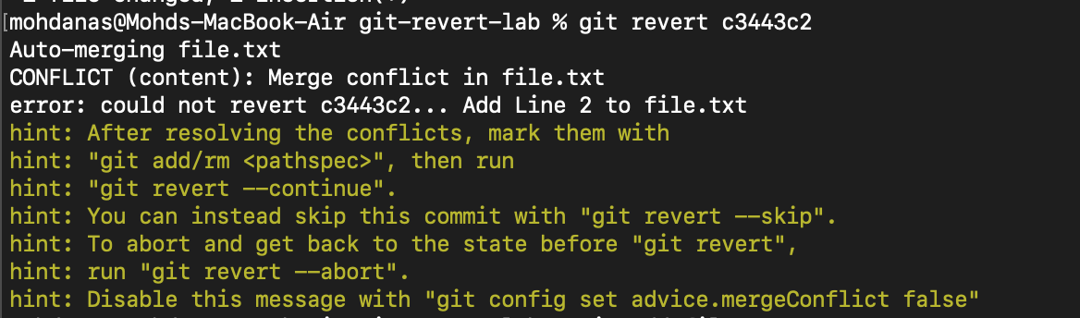
3. Stage the resolved file:pasted-movie.png
4. Complete the revert: