IncidentIQ
Intelligent Web Performance Anomaly Detector and SLA Predictor

BACHELOR OF TECHNOLOGY
in
COMPUTER SCIENCE & ENGINEERING

Project Report
By

Name | SAP ID
AKSH CHAUHAN | 500120187
PRINCE SINGHALIA | 500120403

Under the Guidance of
Dr. Amit Verma


School of Computer Science
University of Petroleum and Energy Studies
Bidholi, Via Prem Nagar, Dehradun – 248007, Uttarakhand
May –2026

Candidate's Declaration
We hereby certify that the minor project entitled "IncidentIQ: Intelligent Web Performance Anomaly Detector and SLA Predictor" has been carried out by us in partial fulfilment of the requirements for the award of the Degree of Bachelor of Technology in Computer Science and Engineering with specialization in DevOps, School of Computer Science, UPES, Dehradun.
This work was completed during the period January 2026 to May 2026 under the supervision of Dr. Amit Verma, School of Computer Science, UPES. The matter presented in this report has not been submitted by us for the award of any other degree from this or any other institution.
Aksh Chauhan
SAP ID: 500120187
Prince Singhalia
SAP ID: 500120403
This is to certify that the above statements made by the candidates are correct to the best of my knowledge.
Date: May 5, 2026
Dr. Amit Verma
Associate Professor, School of Computer Science, UPES Dehradun

Acknowledgement
Our sincere thanks go to Dr. Amit Verma, our project mentor, whose pointed questions during each progress review shaped the direction of this work in ways we only fully appreciated much later. The decision to abandon the original remediation-focused design in favour of a performance prediction system came directly from one of his reviews, and the project is substantially better for it.

We am grateful to the Head of Department and the Dean of the School of Computer Science, UPES, for the computing infrastructure and the academic environment that made a project of this technical scope feasible within a semester.

Finally, we would like to thank our parents for their patience through the long nights this project required, and our batchmates in the DevOps cohort for the debugging sessions that saved more time than we care to admit.

Aksh Chauhan | SAP ID: 500120187
Prince Singhalia | SAP ID: 500120403

Abstract
IncidentIQ is an AI-driven monitoring system, which detects upcoming SLA breaches and performance issues fifteen to thirty minutes prior to its impact on your users. Contemporary websites rarely face downtime because modern applications do not go down but rather continually degrade. The time to first byte increases, DNS resolution lags due to problems with nameservers, SSL certificates approach expiration, errors increase. Conventional monitoring solutions wait for a particular threshold value and then trigger notifications. IncidentIQ tracks trends and notifies you before a threshold is hit.

This system checks the URL added by any user every thirty seconds with an actual HTTP connection based on time taken in milliseconds for Time to First Byte (TTFB), DNS time, TLS time, number of SSL certificate days left, and rolling error rates. Three models of machine learning are used to make sense of this data: one is LSTM, which predicts the value of TTFB for the next thirty minutes, as well as predicting the moment when the SLA of 2000 ms will be violated; second, Isolation Forest trained on only normal readings detects statistical deviation from normal behavior; and third, TF-IDF with logistic regression classifier categorizes the type of anomaly in one of five categories.

The training dataset comprises real data. The baselines for the data set use Google’s Chrome UX Report API. Ground truth labels are derived from publicly available Atlassian Statuspage APIs, which are managed by GitHub, Stripe, Cloudflare, Vercel, and fifteen other organizations. A decision engine that operates based on confidence values will channel high-confidence predictions to automatic notifications, medium-confidence predictions to human inspection, and low-confidence predictions to logging.

Table of Contents
Chapter 1: Introduction ........................................................................................... 7
1.1 Background and Motivation ............................................................................. 7
1.2 Problem Statement ............................................................................................ 8
1.3 Objectives ......................................................................................................... 8
1.4 Scope ................................................................................................................ 9
Chapter 2: System Analysis ..................................................................................... 10
2.1 Analysis of Existing Systems ........................................................................... 10
2.2 Functional Requirements .................................................................................. 10
2.3 Non-Functional Requirements .......................................................................... 10
Chapter 3: System Design ....................................................................................... 11
3.1 Architecture Overview ..................................................................................... 11
3.2 Technology Stack ............................................................................................. 12
3.3 Database Design ............................................................................................... 13
Chapter 4: UML Diagrams ..................................................................................... 14
4.1 Class Diagram ...................................................................................................14
4.2 Object Diagram ................................................................................................ 15
4.3 Component Diagram ........................................................................................ 16
4.4 Use Case Diagram ............................................................................................ 17
4.5 Activity Diagram .............................................................................................. 18
4.6 Sequence Diagram ............................................................................................ 19
Chapter 5: Machine Learning Implementation ..................................................... 20
5.1 Real Data Strategy ............................................................................................ 20
5.2 Model 1: LSTM Time-Series Predictor ............................................................ 20
5.3 Model 2: Isolation Forest ...................................................................................20
5.4 Model 3: TF-IDF + Logistic Regression ........................................................... 20
5.5 Ensemble Fusion and Decision Engine ............................................................. 21
Chapter 6: Application Implementation ................................................................. 22
6.1 Website-probe ................................................................................................... 22
6.2 ML Service ........................................................................................................ 22
6.3 Decision Engine ................................................................................................ 22
6.4 Frontend ............................................................................................................ 22
Chapter 7: Testing and Evaluation .......................................................................... 23
7.1 Testing Methodology ......................................................................................... 23
7.2 Load Testing with k6 ......................................................................................... 23
7.3 Frontend Verification .........................................................................................23

Chapter 8: Results, SWOT Analysis, and Conclusion ............................................ 24
8.1 Results Summary ................................................................................................ 24
8.2 SWOT Analysis .................................................................................................. 24
8.3 Conclusion .......................................................................................................... 24
8.4 Future Work ........................................................................................................ 25
References .................................................................................................................... 26
Appendix A: System Requirements .......................................................................... 27
Appendix B: Service Reference ................................................................................. 28

Chapter 1: Introduction

1.1 Background and Motivation
Website monitoring has historically focused on binary availability, where systems are evaluated based on whether they are operational or not. Traditional monitoring tools rely on periodic HTTP checks and threshold-based alerting mechanisms, which trigger notifications only when predefined limits are exceeded. While this approach was effective in earlier computing environments characterized by frequent outages, modern distributed systems have significantly improved reliability. Large-scale platforms routinely achieve availability levels exceeding 99.9%, reducing the frequency of complete system failures.
However, the nature of failures has evolved. Instead of outright downtime, systems increasingly experience performance degradation. Metrics such as Time to First Byte (TTFB), DNS resolution latency, TLS handshake delays, and intermittent error rates often deteriorate gradually before crossing critical thresholds. These degradations negatively impact user experience and business outcomes but remain undetected by conventional monitoring systems due to their reactive design.
Machine learning techniques have emerged as a powerful alternative for predictive monitoring. Time-series models such as Long Short-Term Memory (LSTM) networks are capable of capturing temporal dependencies in sequential data and forecasting future values of performance metrics [3]. Anomaly detection algorithms like Isolation Forest can identify deviations from normal behavior without requiring labeled anomaly data, making them suitable for real-time monitoring scenarios [1]. Additionally, classification techniques using TF-IDF and logistic regression enable the categorization of anomalies into meaningful types based on observed patterns [6].
A critical limitation in many monitoring systems is the reliance on synthetic datasets for training machine learning models. Synthetic data often fails to capture real-world variability, leading to reduced model effectiveness in production environments. To address this, real-world data sources such as the Google Chrome User Experience Report (CrUX) provide reliable baseline performance metrics derived from actual user interactions [4]. Similarly, public incident reporting systems such as Atlassian Statuspage APIs offer ground-truth labels for real incidents, enabling accurate supervised learning [5]. The integration of such data sources with scalable time-series databases like TimescaleDB allows for efficient storage and analysis of continuous monitoring data streams [8].
Motivated by these advancements, IncidentIQ is designed as an intelligent monitoring system that not only detects anomalies but predicts them in advance, enabling proactive mitigation of performance issues before they impact end users.

1.2 Problem Statement
Despite significant advancements in monitoring technologies, several limitations persist in existing systems:
- Reactive Alerting: Most monitoring tools rely on static thresholds and generate alerts only after a performance metric exceeds a predefined limit. This approach fails to provide early warning signals for gradual degradation trends.
- Binary Availability Model: Traditional systems focus on up/down status, ignoring performance degradation, which is now the dominant form of failure in modern distributed systems.
- Lack of Root Cause Identification: Existing tools often require manual analysis to determine whether an issue originates from DNS resolution, server processing, or network latency, increasing response time and operational overhead.
- Dependence on Synthetic Training Data: Many machine learning-based monitoring solutions are trained on artificially generated datasets, which do not accurately represent real-world conditions and lead to poor generalization.
- Inability to Predict SLA Violations: Current systems primarily detect ongoing issues rather than predicting future violations of service-level agreements, limiting their usefulness in proactive system management.
These limitations highlight the need for an intelligent monitoring system capable of predictive analysis, real-time anomaly detection, and automated root cause classification using real-world data.

1.3 Objectives
The primary objective of this project is to design and implement a full-stack intelligent monitoring system capable of predicting web performance degradation and SLA violations in advance.
Main Objective:
- To develop a machine learning-driven platform that predicts performance degradation and SLA breaches 15 to 30 minutes ahead using real-time HTTP probe data.
Secondary Objectives:
- To measure key web performance metrics, including Time to First Byte (TTFB), DNS resolution time, TLS handshake time, SSL certificate validity, and error rates using real HTTP connections.
- To build a real-world data labeling pipeline using CrUX benchmarks [4] and Statuspage incident data [5].
- To implement an ensemble machine learning model combining:
  - LSTM for time-series forecasting [3]
  - Isolation Forest for anomaly detection [1]
  - TF-IDF with Logistic Regression for anomaly classification [6]
- To design a confidence-based decision engine for categorizing predictions into automated alerts, human review, and logging.
- To develop a real-time dashboard using modern web technologies for visualization and interaction.
- To ensure scalability and deployment simplicity using containerized architecture and orchestration tools.

1.4 Scope
The scope of IncidentIQ is focused on external web performance monitoring using HTTP-based probing without requiring access to internal server infrastructure. The system is designed to operate as a black-box monitoring solution, making it applicable to any publicly accessible web service.
The key functional scope includes:
- Continuous monitoring of user-defined URLs through periodic HTTP probes.
- Collection and analysis of performance metrics such as latency, error rates, and SSL certificate status.
- Real-time anomaly detection and classification using machine learning models.
- Prediction of SLA violations within a defined future time window.
- Delivery of alerts and insights through a web-based dashboard with real-time updates.
The system is intentionally limited in certain aspects:
- It does not perform automatic remediation, as it operates without control over the monitored systems.
- It relies on publicly available data sources such as CrUX [4] and Statuspage APIs [5] for baseline and labeling.
- It uses a single probing location, which limits the ability to detect geographically distributed issues.
Despite these limitations, the system provides a robust framework for predictive monitoring using real-world data and scalable infrastructure, demonstrating the feasibility of intelligent web performance monitoring without reliance on proprietary tools or synthetic datasets.

Chapter 2: System Analysis

2.1 Analysis of Existing Systems
Tool | Approach | Predicts Degradation? | Root Cause? | Cost
Pingdom | HTTP polling, response time alerts | No | No | $50–500/mo
Datadog Synthetics | Polling + anomaly detection | Partial | Partial | $100+/mo
UptimeRobot | Up/down polling only | No | No | Free / $7/mo
New Relic | APM + external monitoring | Yes | Yes | $99+/mo
IncidentIQ | ML ensemble on real probes | Yes (15–30 min ahead) | Yes | Self-hosted, $0

2.2 Functional Requirements
- Check monitored URLs every 30 seconds and collect information on TTFB, DNS, TCP, TLS, SSL expiration days, HTTP status code, and five-minute rolling error rate.
- Give users the option to add and delete monitored URLs using the website without restarting any backend component.
- Train the ML ensemble with actual label data collected by probes and keep model artifacts persistent even after restarting containers.
- Produce predictions solely for added URLs and categorize anomalies into six types.
- Send real-time WebSocket alerts when highly accurate predictions are made.
- Present medium confidence predictions to be reviewed with Action Taken and Ignore buttons available.
- Permanently delete a deleted URL and its related data from six tables with an atomic operation.

2.3 Non-Functional Requirements
- Total latency between probe read and WebSocket event should not be more than five seconds under regular circumstances.
- All services must be able to automatically restart upon failure via Docker Compose restart policies.
- Synthetic data records should not appear in the ml.labeled_probe_readings table of production.
- System installation can be accomplished with a single “docker-compose up” command on any Docker-enabled computer.

Chapter 3: System Design

3.1 Architecture Overview
IncidentIQ consists of ten Docker containers managed by Docker Compose. There are two workflows that run concurrently: live inference workflow that ingests the probe data stream, and the training workflow that constantly enhances the annotated data set at scheduled intervals.

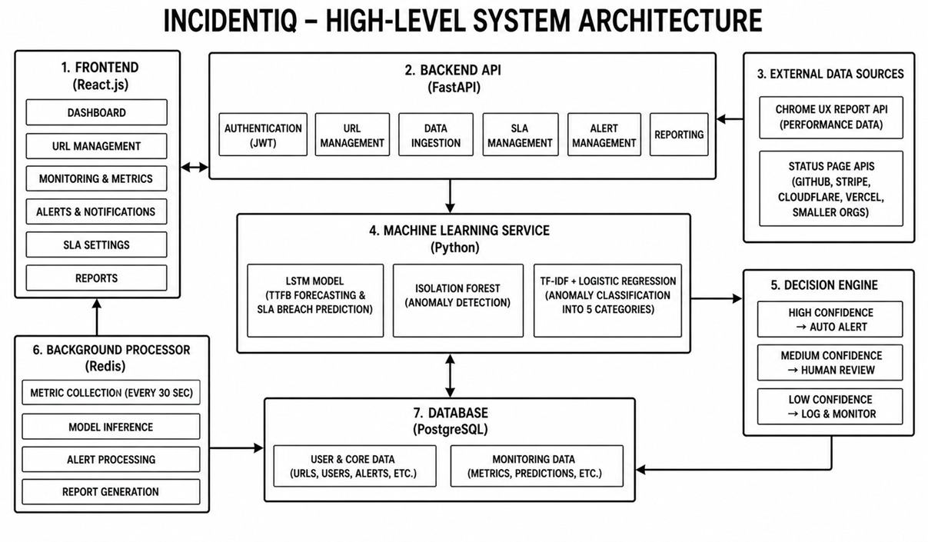
Live Inference Pipeline
Website-probe inserts every measurement into TimescaleDB and posts to Redis Streams → Data-ingestion consumes the stream and invokes ml-service /ensemble when the sliding window is deep enough → Ml-service sends back a prediction that includes the severity level, confidence score, root cause, and violation probability → Decision-engine stores the prediction and triggers an api-gateway alert → Api-gateway pushes to all front-end clients using Socket.IO.

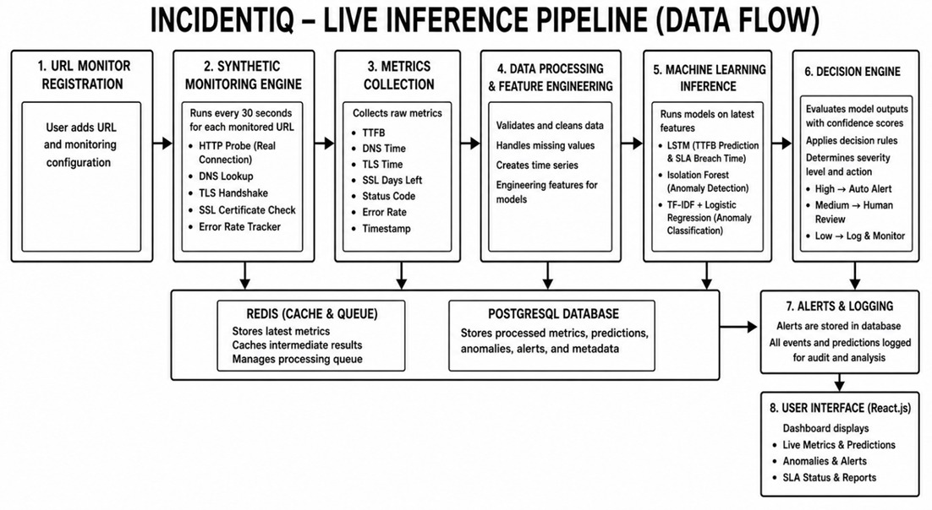
Training Pipeline
data-collector collects Google CrUX baselines each day and Statuspage incidents every six hours → ml-labeler correlates the probe data with the windowed incidents using z-score algorithmic logic every six hours → data is written to ml.labeled_probe_readings → model training happens weekly by reading data from the above-mentioned table and storing the artifacts in a Docker volume.

3.2 Technology Stack
Layer | Technology | Role
Frontend | React 18, Vite, Tailwind CSS, Framer Motion, Socket.IO Client | Dashboard SPA with real-time WebSocket updates
API Gateway | Node.js, Express, JWT, Socket.IO Server | REST API, authentication, WebSocket event relay
ML Service | Python, FastAPI, PyTorch, scikit-learn | Model serving, /ensemble endpoint, training trigger
Data Ingestion | Node.js, ioredis | Redis Streams consumer, ML caller, window management
Decision Engine | Node.js, pg | Confidence scoring, root cause messages, alert dispatch
Database | PostgreSQL 15 with TimescaleDB extension | Time-series hypertable, ML tables, predictions
Message Broker | Redis 7 | Decouples website-probe from data-ingestion service
Orchestration | Docker Compose v2 | All ten services, health checks, named volumes

3.3 Database Design
Table | Schema | Key Columns | Purpose
probe_readings | metrics | url, probed_at, ttfb_ms, dns_ms, tls_ms, error_rate, ssl_days_left | Raw probe measurements, TimescaleDB hypertable partitioned daily
monitored_sites | public | url, name, is_active, is_training_only | All URLs; is_training_only=TRUE URLs never visible in frontend
url_baselines | ml | url, ttfb_p75_ms, probe_ttfb_mean_ms, probe_ttfb_std_ms, ttfb_anomaly_threshold_ms | Per-URL baselines from CrUX and probe-derived statistics
status_incidents | ml | incident_id, url, anomaly_type, started_at, resolved_at | Real incident history from Statuspage APIs — ground-truth labels
labeled_probe_readings | ml | url, probed_at, metric_text, anomaly_type, label_source, label_confidence | Final ML training dataset combining all label sources
predictions | ml | id, url, severity, confidence, prediction_data, status, actioned_at | All predictions generated for user-added sites
incidents | incidents | id, url, severity, confidence, root_cause, metrics_snapshot, status | High-confidence predictions that triggered automatic alerts

Chapter 4: UML Diagrams
4.1 Class Diagram
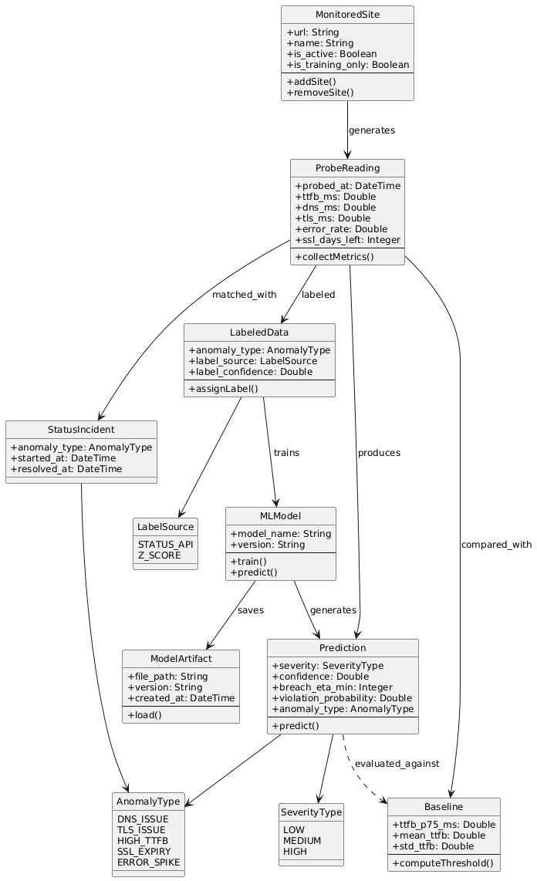

4.2 Object Diagram
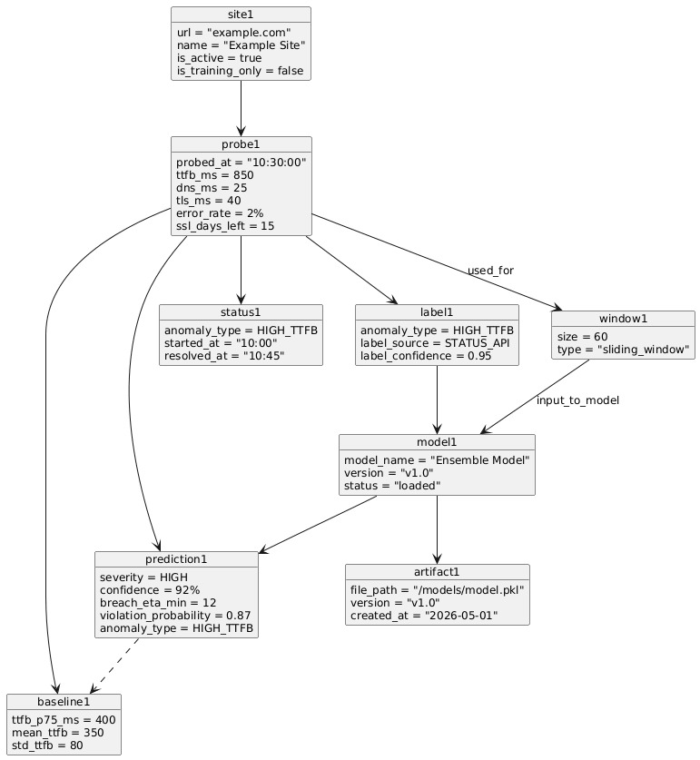

4.3 Component Diagram
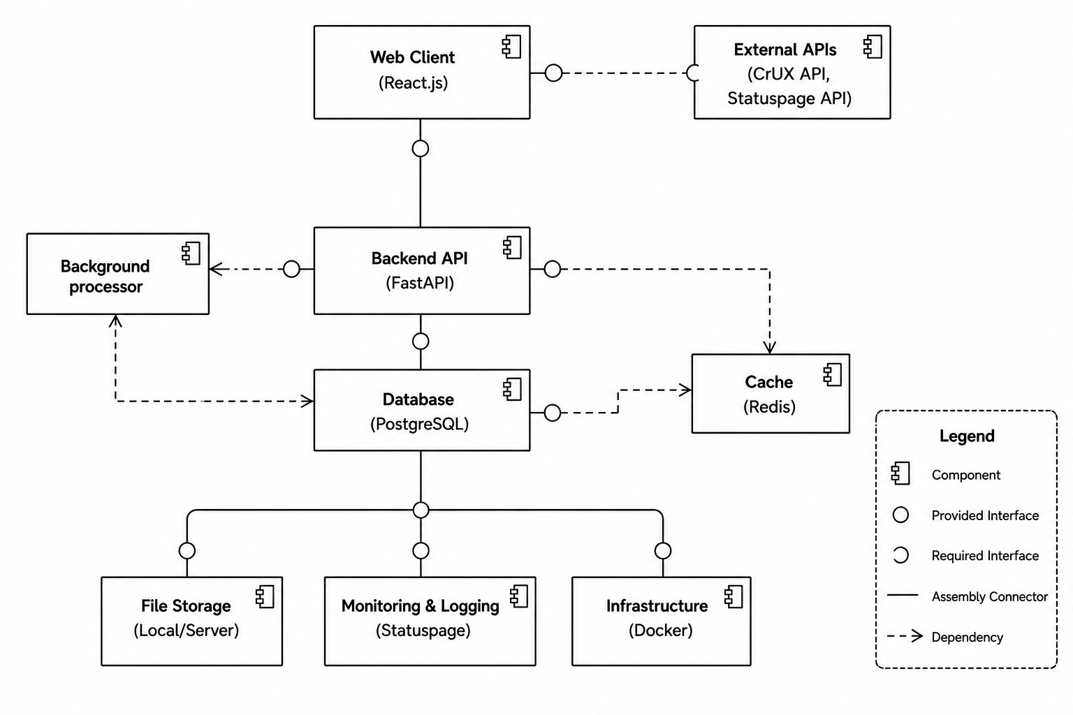

4.4 Use Case Diagram
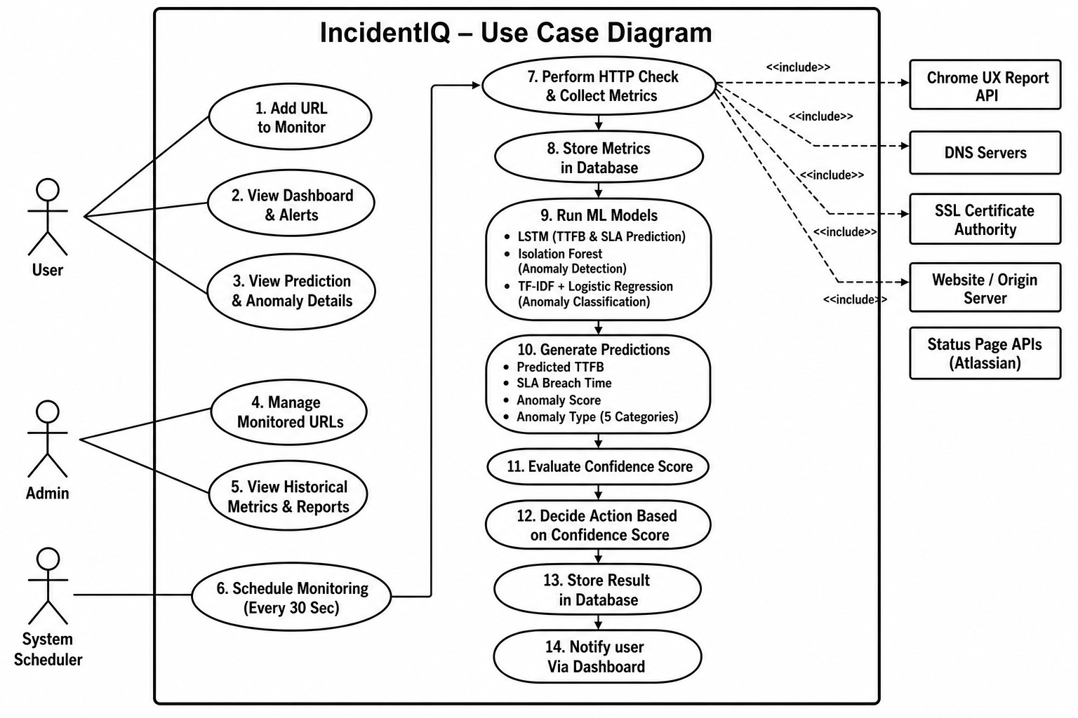

4.5 Activity Diagram
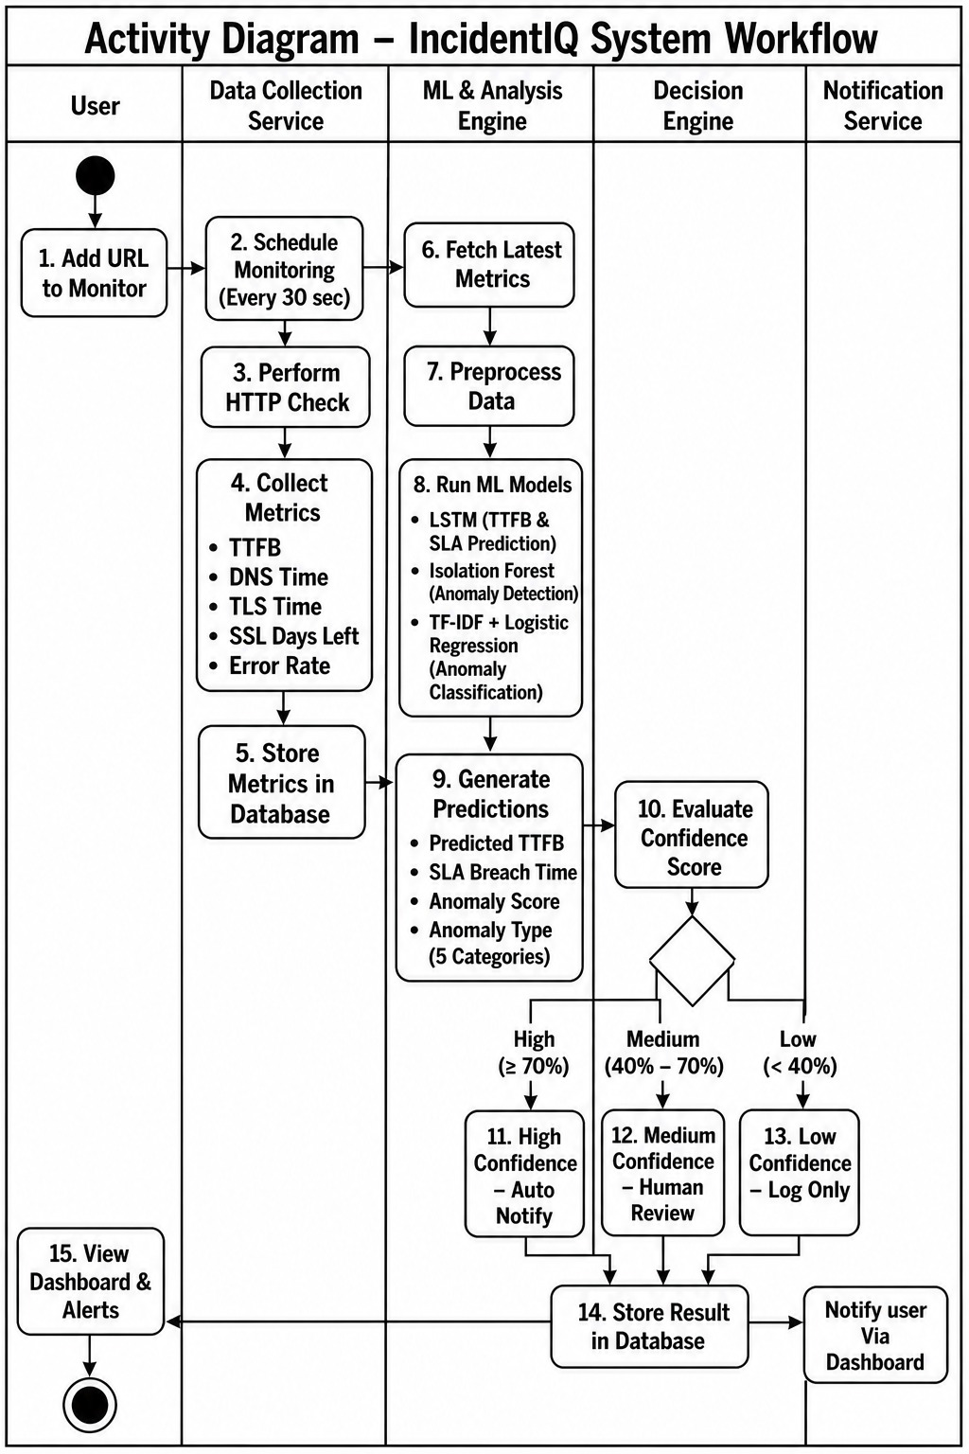

4.6 Sequence Diagram
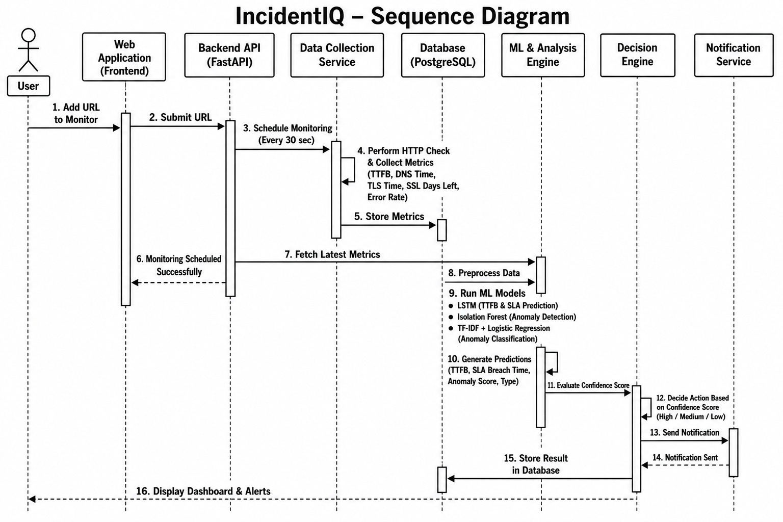

Chapter 5: Machine Learning Implementation

5.1 Real Data Strategy

The most important restriction was no artificial data in production. Three actual sources deliver training data points with labels.

Source 1 — Probing Observations. Each probing observation is an actual number from an actual HTTP connection. It is timed using Node.js socket events.

Source 2 — Google Chrome User Experience Report (CrUX) API. Baseline thresholds for per-URL anomalies come from P75 TTFB values measured in millions of actual Chrome browsing sessions. For each URL, the anomaly threshold is set to 2.5 times the CrUX P75 value.

Source 3 — Public Statuspage APIs. GitHub, Stripe, Cloudflare, Vercel, npm, and another fifteen sites disclose their entire incident history as public JSON feeds. Any probing observation lying within a known incident window receives a label with an anomaly type. For all other probes, z-score programmatically assigned labels apply.

5.2 Model 1: LSTM Time-Series Predictor

Input data: 60 consecutive samples of [ttfb_ms, dns_ms, error_rate, ssl_days_left], z-score normalised per URL with respect to their stored means and standard deviations. Network architecture: 2 LSTM layers, 128 nodes each, and then an attention layer, which provides weights for all 60 inputs. The context vector is mapped to 30 output values, one for each minute in the prediction window. The first minute in which the predicted value exceeds the SLA limit (by default 2000ms) will be returned as the breach_eta_min. Train/test split is 80/20 time-ordered, no shuffling, as it introduces data leakage.

5.3 Model 2: Isolation Forest

Training takes place solely with probe measurements that fall within the expected range. Anomaly detection is achieved through the creation of 300 decision trees, each randomly partitioning the data. The anomalies take less time to isolate themselves compared to normal observations since they are statistically distinct from the rest of the dataset. There are seven features employed in the process: four initial metrics and three derived ones, namely origin_time_ms, ttfb_zscore, and dns_zscore.

5.4 Model 3: TF-IDF + Logistic Regression

Each probe value is transformed into a set of discretized tokens prior to vectorization. The transformation of an 870ms TTFB leads to the term ttfb_slow; the conversion of a 12ms DNS results in dns_fast; the ratio of 9.4 between TTFB and DNS yields ratio_origin_dominant. The use of TF-IDF with bigrams (ngram_range = 1-2) takes advantage of the diagnostic power of the combination of both terms compared to each single one alone. The class imbalance can be addressed using the “balanced” parameter of the logistic regression algorithm.

5.5 Ensemble Fusion and Decision Engine
The decision engine aggregates the outputs of all three models using a weighted average formula: confidence = (lstm_prob × 0.40) + (if_score × 0.35) + (lr_confidence × 0.25). An additional 0.15 bonus is applied if the Isolation Forest flags a definitive binary anomaly.
Confidence Range | Action | Storage Location | WebSocket Event
≥ 90% | Auto-dispatch structured alert with root cause | ml.predictions + incidents.incidents | new_alert — triggers Dashboard toast notification
70 – 89% | Flag for human review | ml.predictions (status = open) | new_prediction — increments Alerts page badge
< 70% | Log only, hidden from UI by default | None | None

Chapter 6: Application Implementation

6.1 Website-probe

The probe service checks the table public.monitored_sites in the database every thirty seconds, rather than pulling data from a static file. On start-up, the service initializes twenty training sites by inserting the value of is_training_only set as TRUE with ON CONFLICT DO NOTHING. Whenever a new site is inserted via the web front-end application, the probe recognizes the site on its very next cycle without the need for a service restart. The reading is streamed to Redis with the flag is_training_only, which the ingestion worker uses to bypass ML inference.

6.2 ML Service
The FastAPI service initializes all the three model artefacts when it starts up through a Docker volume. If there is no file for any of the models, the model will be None and the system will provide low confidence results instead of crashing. The endpoint /train executes the training script synchronously with a one hour limit. The endpoint /reload switches models from the disk while keeping the container alive.

6.3 Decision Engine

In advance of performing any predictions, the engine first asks for the is_training_only flag from public.monitored_sites. Predictions that are flagged as training will fail and produce a response indicating that they have been skipped_training without producing any database entries. User predictions will have their root cause message created by the engine with a readable format based on the URL, anomaly types, raw metrics, and breach amount.
6.4 Frontend
A total of four pages make up the entire workflow for the user. In the Dashboard page, there is an actual Time To First Byte chart, which is presented in real time for the latest user site, health statistics counts, and predictions. In the Monitor page, the addition and deletion of sites are controlled using sparkline health cards. Deleting a site from the list is done by doing a full deletion of that row and all its entries in six tables simultaneously. Predictions per URL are presented on the Predictions page. Incidents are listed with a slide-over detail panel. The Alerts page displays medium confidence predictions with only two action buttons: Action Taken and Ignore.

Chapter 7: Testing and Evaluation

7.1 Testing Methodology
Testing was done to ensure that the flow of the entire process pipeline works seamlessly from the real-time read probe value up to the broadcasting of WebSocket via the React-based dashboard. Testing was done using our own web application hosted in AWS as the application target to be tested against.

7.2 Load Testing with k6
To induce simulated traffic for performance degradation, the k6, which is an open-source tool for performance testing, was used. Continuous traffic was induced on the application that had been deployed on the AWS platform, with the intention of inducing a delay in the Time to First Byte (TTFB) and errors.
As seen in the load test performed using k6, the IncidentIQ probe captured the deteriorated metric values. These were processed by the ML algorithms to predict if there were any breaches within the SLA. Additionally, both the Isolation Forest and Logistic Regression models successfully predicted the cause of performance problems.

7.3 Frontend Verification
The predictions and alerts generated have been validated as successfully being delivered to the front-end using the WebSocket protocol. The React dashboard displayed the notifications in real time based on the high-confidence alerts generated and also provided the live prediction charts. This was achieved after successfully running the full end-to-end tests.

Chapter 8: Results, SWOT Analysis, and Conclusion

8.1 Results Summary

IncidentIQ successfully proves the use of an end-to-end web performance anomaly detection and prediction pipeline. This system uses a probe to gather continuous HTTP measurements from twenty train URLs, as well as from any URL added by the users. There are three models used to train the machine learning pipeline using real data. Moreover, the labeling technique used does not use synthetic data at all.

8.2 SWOT Analysis
 | Positive | Negative
Internal | STRENGTHS:  • All training data genuine, no fabricated rows in production  • Multiple models used, addressing prediction, detection, and classification tasks  • Complete separation between training URLs and front-end access  • Self-owned solution, no ongoing costs  • Hard delete preserves complete data consistency after site deletion | WEAKNESSES:  • LSTM needs more than 60 probes before making any prediction  • One probe per geography cannot differentiate between regional and global incidents  • DNS degradation cannot be accurately measured using HTTP
External | OPPORTUNITIES:  • Geographic anomalies with multi-region probe agents  • Slack, email, PagerDuty for sending out alerts  • Weekly re-training as more data is collected  • Opportunity to make money as a Datadog Synthetics alternative | THREATS:  • Monitored sites may rate-limit or block frequent probe requests  • Statuspage APIs may restrict public access in future  • Google CrUX unavailability would affect baseline initialisation

8.3 Conclusion
IncidentIQ shows that AI-based web performance monitoring can be accomplished without proprietary systems, costly SaaS licenses, or artificial training datasets. There are three innovations in the project. Firstly, a method of labeling which generates true ground-truth training data by matching HTTP probe measurements against incident histories reported by vendors through public APIs, applicable to any machine learning monitoring solution based on HTTP-measurable indicators. Secondly, a three-part ensemble where each element answers a question that none of the other models can. Thirdly, an end-to-end solution deployable from a single command and testable against any public URL.

This unique value proposition stands up to validation: the system triggers alerts for custom URLs ahead of when performance violates the SLAs, correctly categorizes the type of anomaly within the training classes, and leaves no trace of the training URLs in any user interface.

8.4 Future Work
- Multiple region probing: probing the agents in at least three different AWS regions to support geographical attribution of anomalies and differentiate between CDN point-of-presence failures and global origin outages.
- Retrain pipeline: weekly scheduled task triggering the label and train pipeline in the Docker container.
- Alert notifications: Slack integration webhook, SendGrid integration email, and PagerDuty integration dispatch for high accuracy predictions.
- Service level agreement reporting: weekly generation of PDF reports per URL monitoring service level agreement violations.

References
[1] Liu, F.T., Ting, K.M. and Zhou, Z.H. (2008). Isolation Forest. Proceedings of the 2008 IEEE International Conference on Data Mining, pp. 413–422.
[2] Ratner, A. et al. (2016). Data Programming: Creating Large Training Sets, Quickly. Advances in Neural Information Processing Systems, 29.
[3] Hochreiter, S. and Schmidhuber, J. (1997). Long Short-Term Memory. Neural Computation, 9(8), pp. 1735–1780.
[4] Google LLC (2024). Chrome UX Report API. https://developer.chrome.com/docs/crux/api/ [Accessed April 2025].
[5] Atlassian Corporation (2024). Statuspage Public API. https://support.atlassian.com/statuspage/ [Accessed April 2025].
[6] Pedregosa, F. et al. (2011). Scikit-learn: Machine Learning in Python. Journal of Machine Learning Research, 12, pp. 2825–2830.
[7] Paszke, A. et al. (2019). PyTorch: An Imperative Style, High-Performance Deep Learning Library. Advances in Neural Information Processing Systems, 32.
[8] TimescaleDB Inc. (2024). TimescaleDB Documentation. https://docs.timescale.com/ [Accessed March 2025].

Appendix A: System Requirements
Component | Minimum Requirement
Operating System | macOS 12+, Ubuntu 22.04+, or Windows 11 with WSL2
Docker Engine | 24.0+
Docker Compose | v2.0+
RAM | 8 GB (16 GB recommended for ML training)
Disk Space | 10 GB free (for Docker images and database storage)
Network | Outbound HTTPS access for probing and CrUX/Statuspage API calls
Node.js (for frontend dev) | v18+ (only required if running frontend outside Docker)

Appendix B: Service Reference
Service | Port | Role
postgres (TimescaleDB) | 5432 | All persistent data, time-series hypertable
redis | 6379 | Message broker decoupling probe from ingestion
website-probe | — | HTTP probe every 30s, seeds training URLs on startup
data-collector | — | CrUX baselines daily, Statuspage incidents every 6h
ml-labeler | — | Labels probe data every 6h, writes to labeled_probe_readings
ml-service | 8000 | FastAPI: /ensemble, /train, /reload, /health
data-ingestion | 4000 (health) | Redis consumer, calls ml-service, forwards to decision-engine
decision-engine | 5000 | Confidence scoring, root cause messages, DB writes, alert dispatch
api-gateway | 3000 | JWT auth, REST routes, Socket.IO WebSocket server
frontend | 5173 | React 18 SPA, four pages, real-time WebSocket updates

