**RESULTS**

**RESULTS OF ALGORITHMS:**

**Logistic Regression:**

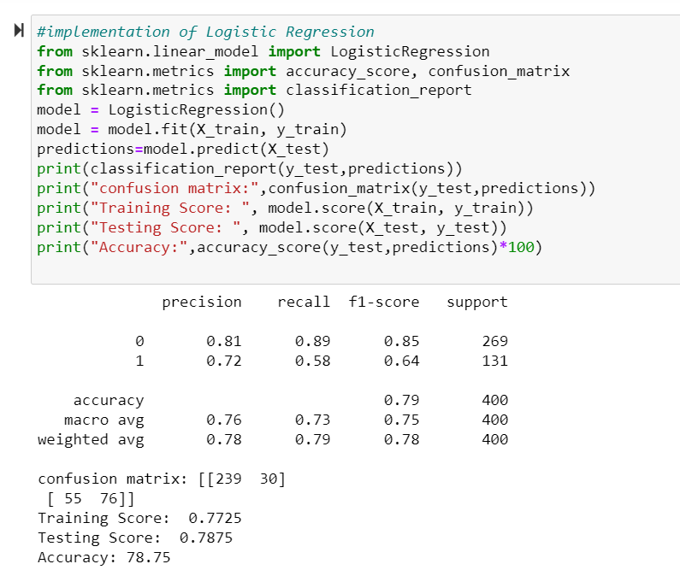

**Knn:**

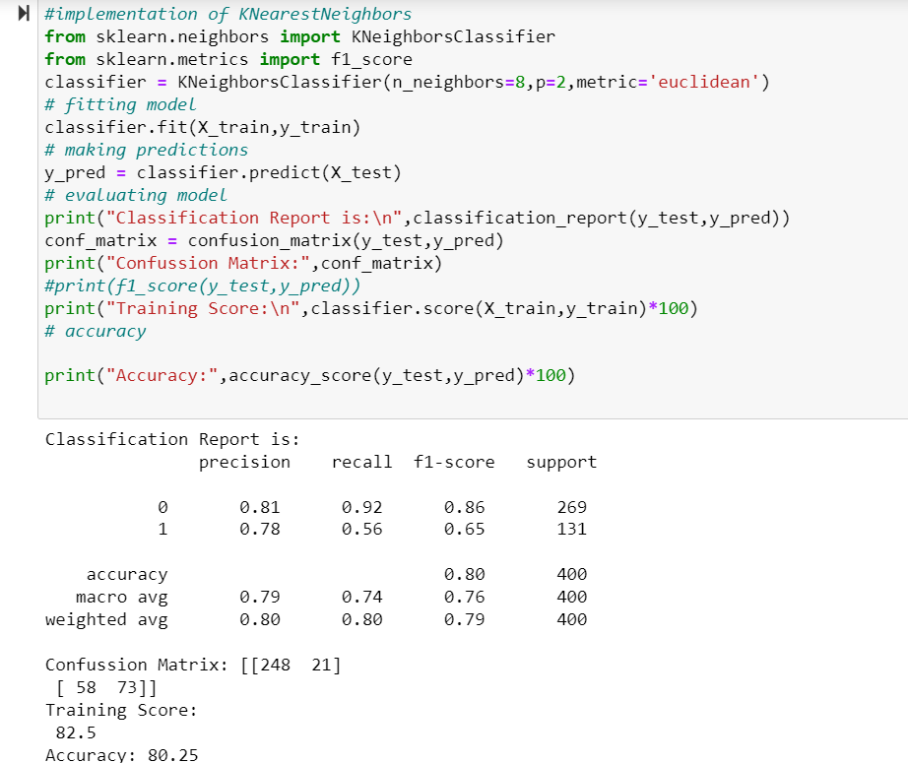

**Support Vector Machine:**

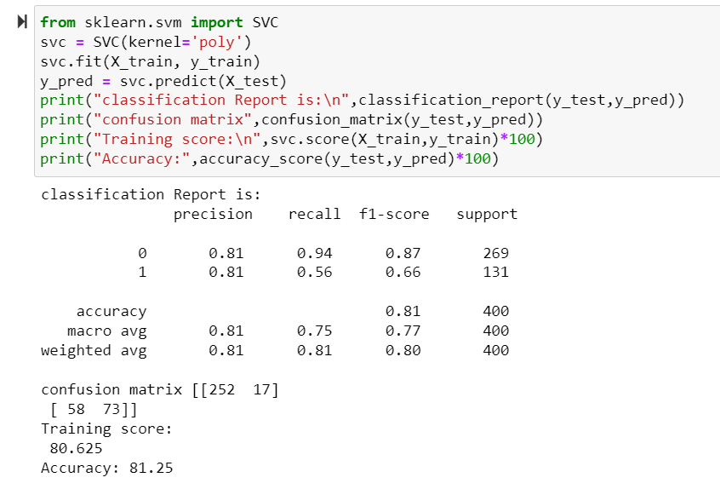

**Naive Bayes:**

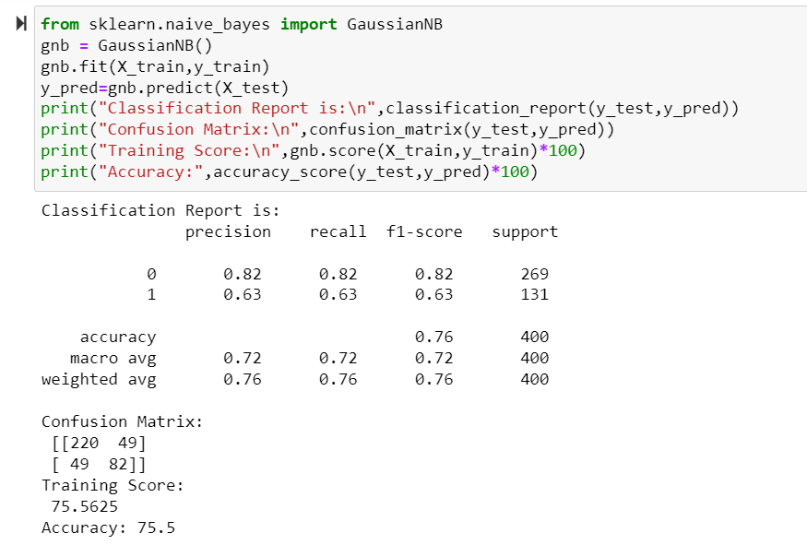

**Decision Tree:**

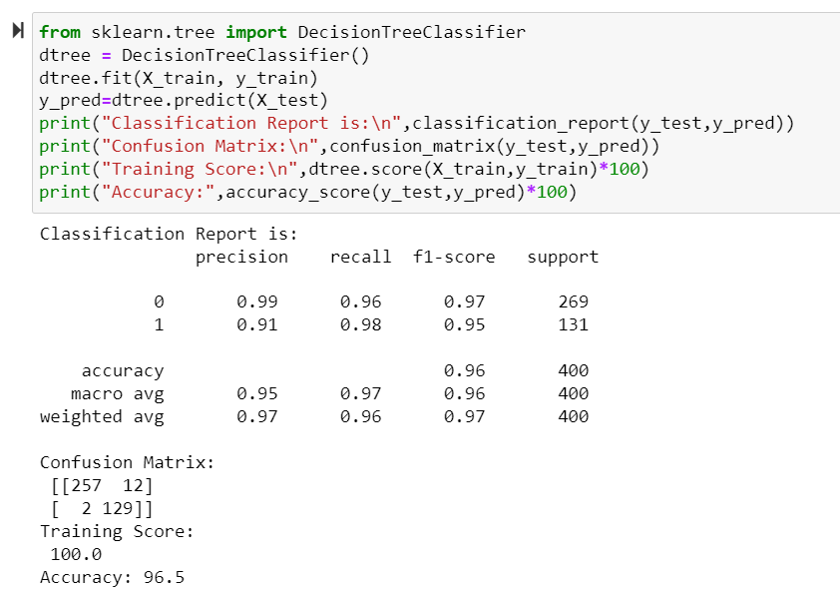

**Random Forest:**

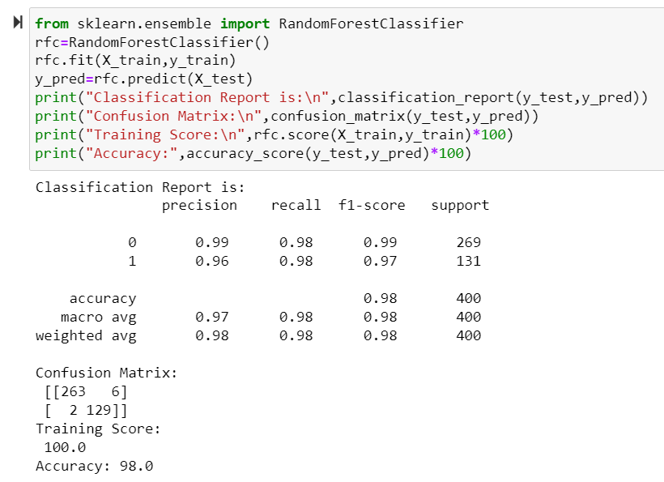

**Predict Diabetes through Web Application:**

**Case1:** Outcome Negative(i.e A person not having Diabetes)

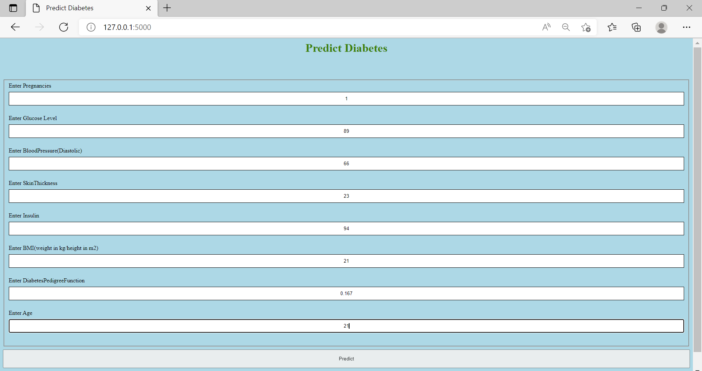

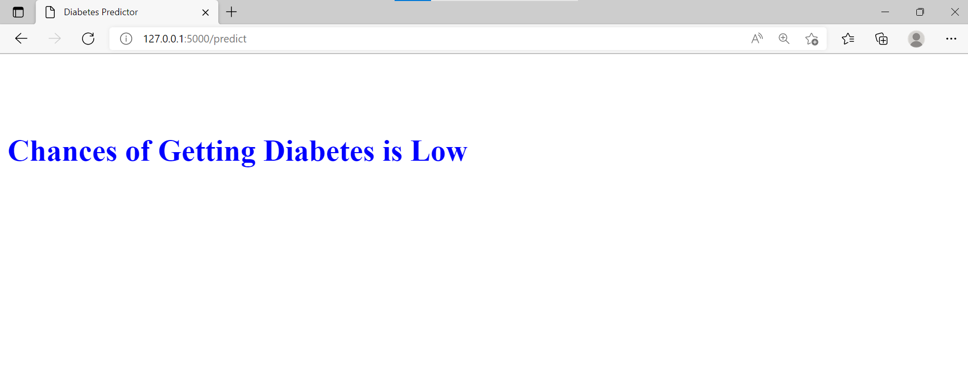

**case2:**Outcome Positive(I.e, A person having Diabetes):

