LumenAI | Software Requirement Specification
Version ID Date: 27/10/2026
Document ID: SWD/LumenAI/SRS-001
Version ID: 1.0

Revision History

Doc. Ver. | Date | Author | Reviewer | Description of Revision
1.0 | 27/10/2026 | Md. Abdul Kahhar Siddiki Shan | Jishnu Sardar | Initial version, prepared from the system implemented on branch dev

Contents
1. Introduction 4
2. Overall Description 7
3. Functional Requirements 12
4. User Interface 35
5. Non-Functional Requirements 41
6. Design Constraints 46
7. Software Quality Attributes 47
8. User Interface 49
9. Other Requirements 50
10. Prioritization and Release Plan 52
11. Acceptance Scenarios 53

- Introduction
1.1 Purpose
The purpose of the Software Requirements Specification is to define the functional and non-functional requirements of LumenAI, an AI-assisted recruitment and interview platform developed as part of the BJIT AI Trainee Programme. It establishes a common understanding of the system's capabilities, constraints and quality expectations among the developer, the reviewers and the testers.
The requirements reflect the system as implemented on repository branch dev (October 2026). Each requirement is traceable to the implementation and, where available, to an automated test case. Requirements that have not yet been implemented are identified as open items.
1.2 Scope
The following capabilities are within the scope of this release:
- Preparation of job descriptions through an AI assistant that draws on the organisation's own documents (retrieval-augmented generation), followed by human approval and publication on Blogger.
- Collection of applications through a Google Form or manual upload, automated reading and screening of each CV against the job requirements with supporting quotations, scoring and shortlisting.
- Interview scheduling and the preparation and dispatch of invitations containing a private join link and a calendar invitation.
- Conduct of video interviews (LiveKit) with a call chat, an identity check, a live transcript (Deepgram) and a private AI Helper for the interviewer.
- Post-interview analysis comprising question-and-answer grading by six graders with a scorecard, CV claim verification, interview quality assessment, a consolidated assessment report and the recording of the hiring decision by a person.
- A talent pool for the rediscovery of strong past candidates, together with a dashboard, system settings and a workflow log.
The following items are outside the scope of this release, either by design or because they are addressed elsewhere:
- Automated hiring decisions, which are excluded by design: the AI provides recommendations only and all decisions remain with a person.
- Candidate accounts, onboarding, offer letters and payroll.
- Multi-organisation (multi-tenant) operation, mobile applications and interview languages other than English.
- Integration with Google Meet, which does not expose individual participant audio to third-party applications; LiveKit is used instead.
1.3 Intended Stakeholder
- Interviewer / HR (recruiter): The primary user, responsible for preparing jobs, screening CVs, conducting interviews and recording decisions.
- Candidate: Applies through the Google Form and joins the interview through a private link; has access only to the candidate's own call page.
- BJIT mentors and reviewers: Evaluate the project, its requirements and its progress.
- Developer (trainee): Designs, builds and maintains the system in accordance with these requirements.
- Testers: Verify the system against the acceptance criteria and the referenced test cases.
1.4 References
Reference | Location
Project brief / requirement specification (BJIT) | Issued by BJIT to the trainee (features F1–F11)
BJIT Academy Requirement Analysis Q&A | Trainer answers to the requirement questions (25–28 September 2026)
Mentor's review schedule | Daily review items and milestones M1–M4 (5 October 2026)
Work breakdown structure (WBS v1.5) | Trainee's estimation sheet (28 September 2026)
README | Repository root: README.md
Architecture diagrams (final) | docs/architecture/LumenAI_Final_High_Level_Architecture, _Detailed_Architecture, _LangGraph_Workflows (.drawio / .svg)
LangGraph workflow diagrams | docs/architecture/langgraph/ (one file per workflow group)
Workflows generated from the code | docs/architecture/LumenAI_Workflows_From_Code.md (scripts/print_workflows.py)
Automated tests | backend/tests/ (36 files, 332 test cases)
IEEE Std 830-1998 | IEEE Recommended Practice for Software Requirements Specifications

1.5 Definitions, Acronyms, and Abbreviations
Term/Acronym | Definition
AI Helper | A private assistant for the interviewer during the call that suggests questions with model answers and responds to the interviewer's questions.
ATS | Applicant Tracking System; in LumenAI, the proportion of a job's keywords present in a CV.
Checkpointer | The LangGraph mechanism that stores a paused workflow in PostgreSQL so that it can resume after a restart.
CV | Curriculum vitae (résumé).
F1–F11 | Feature numbers of the project brief: F1–F6 core, F7–F10 stretch and F11 innovation.
Interrupt | A LangGraph pause that waits for a person's response (Yes / No, Send, include / exclude).
JWT | JSON Web Token; the signed authentication token of an interviewer.
Knowledge base | The collection of organisational documents (past job descriptions and policies) used for retrieval-augmented generation.
LangGraph | A library that executes AI workflows as graphs of steps, supporting loops, parallel steps and pauses.
LLM | Large Language Model; Google Gemini in LumenAI.
MCP | Model Context Protocol; enables the AI chat agent to call tools exposed by separate MCP servers.
OCR | Optical character recognition; the extraction of text from a scanned PDF, performed once by Gemini's vision capability.
RAG | Retrieval-augmented generation; similar documents are retrieved through embeddings and supplied to the AI.
ReAct agent | An AI agent that selects a tool, evaluates the result and selects again until it can respond.
SMTP / .ics | The e-mail transfer protocol, and the calendar invitation file attached to the interview invitation.
SRS | Software Requirements Specification.
STT | Speech-to-text; live transcription by Deepgram.

1.6 Document Overview
Section 2 describes the product as a whole: its context, functions, users, constraints, assumptions, deviations from the project requirements, technical platform, external interfaces and the apportioning of requirements between releases.
Section 3 specifies the functional requirements feature by feature, each with its actors, acceptance criteria, limitations and the automated test that verifies it. Section 4 lists the screens of the system and illustrates the main ones.
Sections 5 to 9 specify the non-functional requirements: performance, safety and security, design constraints, software quality attributes (including measurable targets), interface rules and other requirements such as privacy and data retention.
Section 10 explains how the requirements were prioritised and how they map to the project milestones. Section 11 gives acceptance scenarios for the main flows in Given / When / Then form.
- Overall Description
2.1 Overview
Product perspective: LumenAI is a new, self-contained web application. A React frontend communicates with a FastAPI backend; AI processing is performed by seven LangGraph workflows and one ReAct chat agent, and all data is persisted in PostgreSQL. The system depends on external services: Google Gemini (AI), Deepgram (speech-to-text), LiveKit Cloud (video), Google Forms and Drive (applications), Blogger (job publication) and SMTP (e-mail). Two MCP servers (recruitment and Blogger) provide the tools of the chat agent. Docker Compose starts the database, the backend, the web server and both MCP servers with a single command.
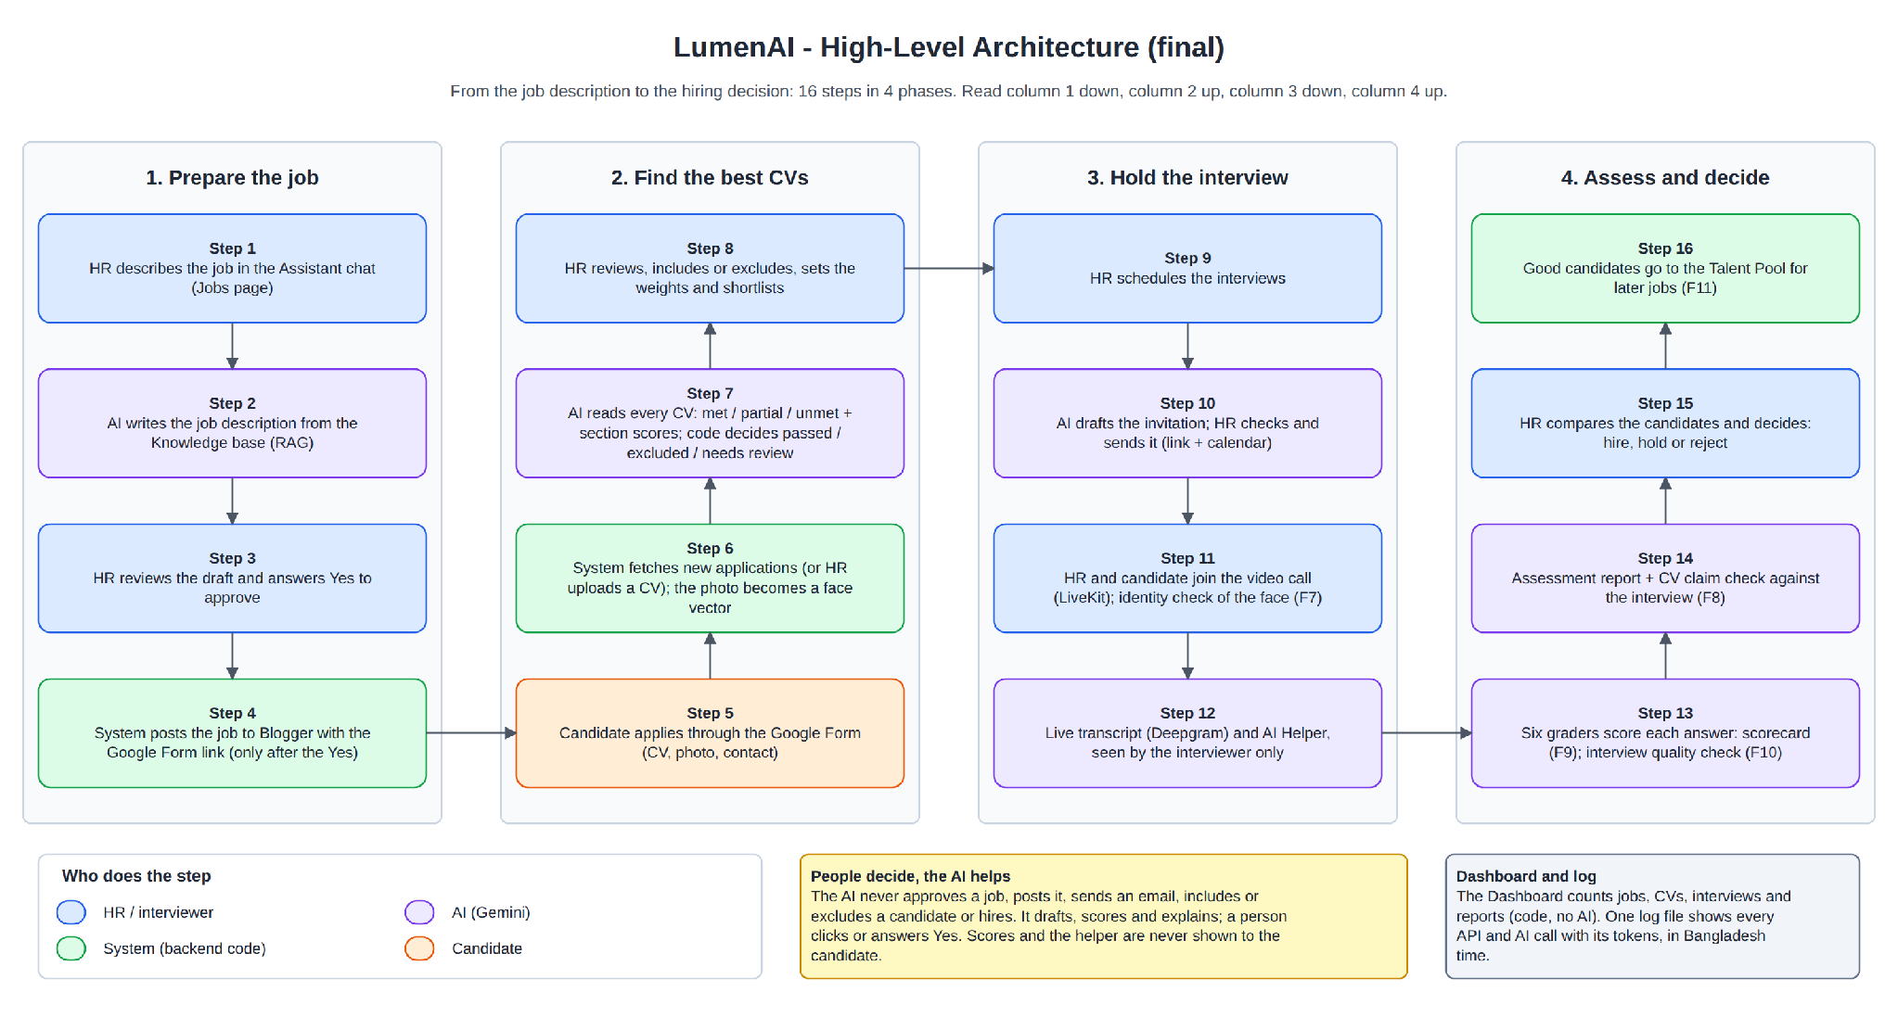
Figure 1 – High-level architecture of LumenAI
Product functions: The system supports sixteen steps organised in four phases: preparation of the job (chat, AI draft, approval and publication); identification of the best CVs (application, retrieval, AI screening governed by a fixed rule in code, review and shortlisting); the interview (scheduling, invitation, video call with identity check, live transcript and AI Helper); and assessment and decision (six graders and scorecard, quality assessment, final report with claim verification, decision and talent pool).
User characteristics: Interviewers and HR staff are office users of a web browser and are not expected to have knowledge of AI or programming; all error messages are therefore expressed in plain language. Candidates require only a private link and a computer or mobile device with a camera, a microphone and a stable internet connection.
Constraints: The AI must not approve, publish, send, include, exclude or hire on its own authority. The mandated technology stack is FastAPI, LangGraph, PostgreSQL and React. The free Gemini quota limits the number of AI calls per minute. Interviews are conducted in English.
Assumptions and dependencies: Valid credentials and settings for the external services are provided in the .env file and the secrets folder and are never stored in the source code. The Google Form collects the CV, a photograph and contact details. The interviewer and the candidate join the call from separate browsers or devices. Only fictitious candidate data is used during development and testing.
Deviations from the project requirements: The implementation differs from the project requirements in the following respects:
- Video platform: The mentor's schedule names Google Meet; LiveKit Cloud is used because Google Meet does not provide individual participant audio, which speaker-attributed transcription requires.
- Transcription notice: The project brief (F4, N18) requires visible consent handling. The notice was removed from the candidate's page by decision of the developer; the item remains open and requires the mentor's confirmation (LUM_OTH_004).
- Scoring weights: The trainer's answer (Q22) states that the AI determines the weights. The implementation applies default weights of 50/30/20 that the interviewer adjusts; AI-proposed weights are not implemented.
- Resumption after restart: The trainer's answer (Q45) requires long-running work to resume without repeating completed steps. Paused workflows resume from the checkpointer; analyses that were running are restarted from the beginning (LUM_NFR_002).
- Screening time frame: The trainer confirmed a time limit for screening 20 CVs (Q23) without stating the value; no target is therefore specified (section 5.1).
- Chat and transcript: Call chat messages are kept separately and are not included in the transcript or its download, by decision of the developer.
2.2 Technical platform
- Backend: Python 3.11, FastAPI, Uvicorn, SQLModel, Pydantic, Alembic, PyJWT
- AI: LangGraph (with the PostgreSQL checkpointer), Google Gemini (generateContent, embeddings), MCP (FastMCP), LangChain MCP adapters, langchain-google-genai
- Frontend: React 19, Vite, plain CSS, LiveKit React components, nginx
- Database: PostgreSQL 16 (SQLite in automated tests only)
- Documents and vision: pypdf, python-docx, antiword, OpenCV (YuNet and SFace face models)
- External services: Gemini API, Deepgram, LiveKit Cloud, Google Forms and Drive API, Blogger API, SMTP
- Runtime: Docker Compose (db, api, web, blogger-mcp, recruitment-mcp; optional tunnel) on Linux containers, hosted on Windows or Linux
- Development tools: Git and GitHub Desktop, pytest, Node.js / npm, draw.io, Redmine
2.3 Hardware Interfaces
Interface | Description
Interviewer and candidate devices | A computer or mobile device with a current web browser, a camera and a microphone. The browser grants camera and microphone access to the call page; LumenAI has no dedicated hardware and no direct hardware interface.
Server host | Any Windows or Linux machine able to run Docker Compose. The database, backend, web server and MCP servers run as Linux containers; disk storage holds the database volume, the uploaded CVs and photographs, and the log file.
Face comparison | Performed on the server with OpenCV models (YuNet and SFace) on the CPU; no GPU or camera access on the server is required.

2.4 Software Interfaces
Interface | Purpose and data exchanged
Google Gemini API | Generation (generateContent) for drafts, screening, grading and reports, embeddings for the Knowledge base, and vision for OCR of scanned CVs. Candidates' e-mail addresses and telephone numbers are never sent.
Deepgram (live speech-to-text) | Receives 16 kHz, 16-bit mono audio of each participant separately and returns sentences with end-of-speech markers; no audio is stored.
LiveKit Cloud | Video and audio of the call; the backend issues a short-lived access token for each participant.
Google Forms and Google Drive API | Read-only retrieval of form responses, CVs and photographs through a service account.
Blogger API (through the Blogger MCP server) | Publication of an approved job post; invoked only by backend code after a person's approval.
Recruitment MCP server | Exposes the recruitment tools (jobs, candidates, Knowledge base) to the AI chat agent.
SMTP server (for example Gmail) | Dispatch of invitation e-mails with an .ics calendar attachment; without SMTP settings, invitations are saved as drafts.
PostgreSQL 16 | Persistent storage of all application data and the LangGraph checkpoints; schema changes are applied with Alembic migrations.

2.5 Communications Interfaces
- Browser to system: HTTPS (HTTP on a local machine) to the nginx web server, which serves the React application and forwards /api requests to the backend.
- Live transcription: the browser streams microphone audio to the backend over a WebSocket (/api/sessions/{id}/stt for the interviewer, /api/join/{token}/stt for the candidate); the backend forwards it to Deepgram over a secure WebSocket.
- Video: the browsers connect directly to LiveKit Cloud over WebRTC (signalling over a secure WebSocket).
- Backend to MCP servers: MCP over HTTP inside the Docker network; only known MCP host names are accepted.
- Backend to external APIs: HTTPS for Gemini, Google Drive, Blogger and Deepgram checks; SMTP with STARTTLS (port 587) or SSL (port 465) for e-mail.
- Optional public access: a tunnel container provides a temporary public https:// address for demonstrations.

2.6 Apportioning of Requirements
The core features (F1–F6) form a complete, usable hiring flow and are delivered first. The stretch features (F7–F10) and the innovation feature (F11) build on the core and can be moved to a later version without breaking it if the project is delayed.
The following improvements are deferred to a future version: deployment on a fixed public address with a verified Google application; measurement of AI quality against interviewers' own ratings; additional transcript languages, starting with Bangla; vector search (pgvector) for a larger Knowledge base; resumption of long analyses from a checkpoint instead of from the start; and chatbot answers drawn from policies with the source document quoted.
Dependencies. The features depend on one another as follows:
Feature | Depends on
Job approval and publication (F1) | Job preparation; a Google Form link for the job
CV collection (F1) | An approved job
CV screening and shortlisting (F1, F2) | CV collection
Scheduling and invitation (F3) | A shortlist
Video interview and identity check (F3, F7) | A scheduled interview; the candidate's photograph for the identity check
Live transcript and AI Helper (F3, F4) | A live call
Answer analysis and scorecard (F5, F9) | An ended call with a transcript
CV claim verification (F8) | A screened CV (its text) and an ended interview
Interview quality assessment (F10) | A finished answer analysis and the transcript
Consolidated assessment and decision (F6) | CV screening and answer analysis
Talent pool (F11) | A past candidate added by the interviewer from the assessment report

- Functional Requirements
3.1 Overview
The table below summarises the main features of the system. Each feature is described in the subsections that follow, together with its actors and requirements. Requirement identifiers use the prefix LUM_; the test case identifier refers to the automated test in backend/tests that verifies the requirement.
Serial No | Main Features | Description
1 | Authentication and accounts | Interviewer accounts, e-mail and password authentication, JWT, first-run setup
2 | Job preparation (F1) | AI chat drafts the job from the Knowledge base (RAG); Knowledge base view and search
3 | Job approval and publication (F1) | Yes / No approval; Blogger publication through an MCP tool after explicit human approval
4 | CV collection (F1) | Google Form and Drive retrieval, manual upload, storage of CV and photograph
5 | CV screening, scoring and shortlisting (F1, F2) | AI reading of each CV under a fixed decision rule; weighted score; human include / exclude; shortlist
6 | Scheduling and invitation (F3) | Suggested times, AI-drafted invitation, revision on request, dispatch with a calendar invitation
7 | Video interview and identity check (F3, F7) | LiveKit call, call chat, candidate profile, face comparison confirmed by a person
8 | Live transcript and AI Helper (F3, F4) | Per-participant microphone streams to Deepgram; private question assistant
9 | Answer analysis and scorecard (F5, F9) | Question–answer pairing, six parallel graders, requirement coverage, six-dimension scorecard
10 | CV claim verification (F8) | Comparison of CV claims with the candidate's own statements; follow-up questions
11 | Interview quality assessment (F10) | Speaking time, coverage, low-signal questions, consistency; fact-based improvements
12 | Consolidated assessment and decision (F6) | Single report, comparison, CV / interview weighting, hire / hold / reject recorded by a person
13 | Talent pool (F11) | Retention of past candidates, skill-only matching, AI-drafted invitation, unsubscribe
14 | Dashboard, settings and logging | Counts and funnel, connection checks, AI model selection, workflow log, single log file

3.1.1. Authentication and accounts
Access to the system is restricted to interviewers. The first account is created on an empty database; subsequent accounts are created by an authenticated interviewer.
Actors: Interviewer / HR.

Requirements
REQUIREMNT ID | Requirement Description | Acceptability/  Completion Criteria | Limitations/  Constraints | Test case Identifier
LUM_AUTH_001 | The system shall present a first-run form on an empty database for the creation of the first interviewer account. | The first-run form is available only once and is refused thereafter. | Single organisation only. | test_login.py::test_first_account_is_created_on_an_empty_database; test_the_first_run_screen_works_only_once
LUM_AUTH_002 | The system shall authenticate an interviewer by e-mail and password and issue a signed JWT valid for TOKEN_HOURS (default 10). | Valid credentials return a token; invalid credentials return 401; expired or foreign tokens are rejected. | Password reset by e-mail is not provided. | test_login.py::test_right_email_and_password_give_a_token; test_wrong_email_or_password; test_expired_token_is_not_valid
LUM_AUTH_003 | The system shall allow an authenticated interviewer to add and remove accounts and to change the interviewer's own password. | Accounts are listed, added and removed; a password changes only when the current password is supplied. | No roles other than interviewer. | test_login.py::test_a_logged_in_interviewer_registers_and_removes_accounts; test_change_password
LUM_AUTH_004 | The system shall require a valid token for every interviewer API, with the exception of login, health and the candidate join routes. | Requests without a valid token receive 401. | - | test_access.py::test_not_logged_in_is_rejected; test_health_and_login_are_public

3.1.2. Job preparation in the AI chat (F1)
The interviewer describes the position in the chat. A ReAct agent (LangGraph) selects MCP tools; the job description workflow retrieves the two most similar past job descriptions and three policies (RAG), drafts the description, validates it in code and revises it once where required.
Actors: Interviewer / HR; AI chat agent; Gemini.

Requirements
REQUIREMNT ID | Requirement Description | Acceptability/  Completion Criteria | Limitations/  Constraints | Test case Identifier
LUM_JOB_001 | The system shall draft a job profile (title, required and preferred skills, years of experience, qualifications and description) from a short prompt and the Knowledge base. | The draft identifies the organisational documents used; nothing is saved without the interviewer's request. | Quality depends on the Gemini model; at most one revision. | test_job_description_graph.py::test_the_ai_is_given_the_company_documents; test_steps_of_the_workflow
LUM_JOB_002 | The system shall validate every draft in code: a title, at least one required skill, a length of 80–260 words and no salary information unless requested in the prompt. | A failing draft is returned to the AI once; remaining issues are shown to the interviewer. | - | test_job_description_graph.py::test_the_check_finds_plain_problems; test_a_bad_draft_goes_back_to_the_ai_once
LUM_JOB_003 | The system shall regenerate a draft on request, using the requested change and the previous draft. | The new draft reflects the requested change. | - | test_job_description_graph.py::test_generate_again_follows_the_change_request
LUM_JOB_004 | The system shall store organisational documents (past job descriptions and policies) supplied through the chat, together with an embedding, and present them in the Knowledge base tab (cards, view, search, removal). | PDF, DOCX, DOC and TXT files up to 5 MB are read; the full text is stored; search returns similar documents with a match level. | Upload is available through the chat only; search scans all documents of a type. | test_company_documents.py::test_add_list_and_remove; test_search_finds_the_similar_job_and_the_policy; test_card_preview_and_the_whole_text
LUM_JOB_005 | The system shall retain the conversation history (PostgreSQL thread) and provide the model with the 30 most recent messages, with a maximum of 16 steps per message. | A previous conversation can be resumed; a failed run starts a new thread. | 180 seconds per message. | test_assistant.py::test_the_chat_has_langgraph_memory; test_the_model_sees_only_the_newest_messages; test_an_earlier_chat_can_be_continued

3.1.3. Job approval and publication (F1)
The AI is limited to submitting requests. It creates a Yes / No question; an affirmative response from a person approves the job, and a second approves its publication. The publication workflow pauses (LangGraph interrupt) until the response is given and persists across restarts.
Actors: Interviewer / HR; AI chat agent; Blogger (through the Blogger MCP server).

Requirements
REQUIREMNT ID | Requirement Description | Acceptability/  Completion Criteria | Limitations/  Constraints | Test case Identifier
LUM_POST_001 | The system shall require the interviewer's explicit approval on a question card before a job is approved or published. | A negative response leaves the job unchanged; an edited job cannot be published on the basis of an earlier approval. | - | test_assistant.py::test_write_approve_and_post_with_a_yes_each_time; test_no_means_nothing_happens; test_an_edited_job_is_not_posted_by_an_old_yes
LUM_POST_002 | The system shall withhold the publication tool (publish_blog_post) from the AI; only backend code may invoke it after approval. | The agent cannot access the publication tool; publication is not available through the API. | - | test_assistant.py::test_the_assistant_cannot_reach_the_posting_tool; test_job_posting.py::test_posting_is_not_possible_through_the_api
LUM_POST_003 | The system shall publish only approved jobs that have an https:// application form link; the post shall contain the job title, the approved description and an application button. | A draft job or a missing link is refused with an explanation. | The Blogger authorisation expires weekly while the Google application is in Testing mode. | test_job_posting.py::test_only_an_approved_job_can_be_posted; test_assistant.py::test_a_post_needs_the_form_link; test_job_posting.py::test_the_blog_post_gets_the_job_title_and_the_link
LUM_POST_004 | The system shall record every publication attempt with its outcome (published, or failed with the reason) without disclosing credentials. | A failed attempt is stored with its reason. | - | test_job_posting.py::test_a_failed_post_is_saved_with_the_reason; test_blogger_problems_are_explained_and_secrets_never_shown

3.1.4. CV collection (F1)
Candidates apply through the job's Google Form, submitting a CV, a photograph and contact details. The interviewer checks for and retrieves new responses; CVs may also be uploaded manually.
Actors: Candidate; interviewer / HR; Google Forms and Drive.

Requirements
REQUIREMNT ID | Requirement Description | Acceptability/  Completion Criteria | Limitations/  Constraints | Test case Identifier
LUM_CV_001 | The system shall count new form responses without downloading them and shall retrieve up to ten CVs (with photographs) per request, creating one candidate record for each. | Columns are identified by their titles; a checkpoint advances so that processed rows are not read again. | Requires a Google service account with access. | test_candidates.py::test_the_check_counts_new_answers_and_downloads_nothing; test_only_a_few_cvs_are_downloaded_per_click; test_the_checkpoint_moves_forward_and_old_rows_are_not_read_again
LUM_CV_002 | The system shall accept manual upload of a CV (PDF, DOCX or DOC, up to 5 MB) with an optional photograph for an approved job. | Invalid or damaged files are refused with an explanation. | - | test_candidates.py::test_manual_upload_saves_the_file_and_the_person; test_bad_uploads_are_refused
LUM_CV_003 | The system shall flag irregular responses (missing CV, invalid file) for review rather than discard them. | The response is displayed with a warning. | - | test_candidates.py::test_problems_are_flagged_for_a_person; test_unusual_rows_get_a_warning
LUM_CV_004 | The system shall delete a candidate's CV, photograph and all associated screening, interview and report data when the candidate is deleted. | No data relating to the candidate remains. | - | test_candidates.py::test_deleting_a_candidate_removes_the_file; test_assessments.py::test_deleting_the_candidate_deletes_the_assessment

3.1.5. CV screening, scoring and shortlisting (F1, F2)
Each CV is screened in the background, one at a time. The file is read in code; a scanned PDF of insufficient quality is read once by the AI. A single AI call builds the candidate profile and assesses every requirement as met, partially met or unmet, with a supporting quotation. A fixed rule in code determines the outcome: passed, excluded or needs review. A second AI call rates skills, experience and qualifications; the quotations are verified in code and a weighted score is calculated. The workflow then pauses for the interviewer's decision.
Actors: System (background worker); Gemini; interviewer / HR.

Requirements
REQUIREMNT ID | Requirement Description | Acceptability/  Completion Criteria | Limitations/  Constraints | Test case Identifier
LUM_SCR_001 | The system shall assess every requirement with a quotation from the CV and shall discard any quotation that does not appear in the CV. | Each requirement is shown as met, partially met or unmet with evidence; fabricated evidence is not accepted. | Years of experience are derived from the AI's reading of the CV. | test_screening.py::test_met_partially_met_and_unmet; test_meaning_counts_and_invented_evidence_does_not
LUM_SCR_002 | The system shall apply a fixed rule in code: a missing mandatory requirement results in exclusion; an unassessed mandatory requirement results in review; otherwise the candidate passes. A CV with a reading problem shall never be excluded. | The same CV and job always produce the same outcome. | - | test_screening.py::test_passed_excluded_and_needs_review; test_a_cv_with_a_reading_problem_is_never_excluded
LUM_SCR_003 | The system shall combine section scores (0–100) using per-job weights (default 50/30/20) that total 100, and shall recalculate scores without the AI when the weights change. | The weighted score and its breakdown are displayed; recalculation requires no AI call. | Weights are set by the interviewer; AI-proposed weights (trainer Q22) are not implemented. | test_scoring.py::test_weighted_score; test_weights_must_add_up_to_100; test_new_weights_recalculate_without_the_ai
LUM_SCR_004 | The system shall withhold the candidate's e-mail address and telephone number from the AI. | Contact details are removed before every AI call. | - | test_screening.py::test_the_ai_never_sees_email_or_phone
LUM_SCR_005 | The system shall allow the interviewer to include or exclude any candidate, with an optional note, and to revise that decision later; the decision shall be processed through the paused workflow. | The decision is stored with its author and time; it can be reversed. | - | test_hr_decision.py::test_include_an_excluded_candidate_and_undo; test_a_decision_without_a_paused_run_still_goes_through_the_workflow
LUM_SCR_006 | The system shall shortlist included candidates in descending order of final score, either by rule or manually. | Candidates who are later excluded or deleted are removed from the shortlist. | - | test_shortlist.py::test_highest_final_score_first; test_excluded_later_is_taken_off
LUM_SCR_007 | The system shall pause and retry screening when the free AI quota is exhausted. | Progress is displayed; pending CVs are queued again after a restart. | One CV is processed at a time. | test_hr_decision.py::test_the_free_quota_wait; test_progress_while_screening
LUM_SCR_008 | The system shall read a scanned CV through OCR once when the text cannot be extracted, and shall refer CVs that are empty, unreadable or not in English to a person for review. | Such CVs are marked needs review with the reason; they are never excluded automatically. | English CVs only (trainer Q44). | test_screening.py::test_a_scanned_pdf_is_read_by_the_ai_once; test_cv_reading.py::test_english_check; test_screening.py::test_when_the_ai_cannot_read_the_scan_a_person_looks
LUM_SCR_009 | The system shall calculate an ATS-style match score (0–100) as the share of the job's keywords found in the CV, in addition to the section scores. | The ATS score is shown with the matched and missing keywords. | Keywords are generated once per job. | test_screening.py::test_ats_match_score

3.1.6. Interview scheduling and invitation (F3)
The interviewer schedules an individual candidate or the entire shortlist. The invitation workflow (LangGraph) instructs the AI to draft the e-mail with a {join_link} placeholder, validates the draft in code, saves it and pauses until the interviewer selects Send.
Actors: Interviewer / HR; Gemini; SMTP; candidate (recipient).

Requirements
REQUIREMNT ID | Requirement Description | Acceptability/  Completion Criteria | Limitations/  Constraints | Test case Identifier
LUM_INV_001 | The system shall permit scheduling only for shortlisted candidates and only at a future time, and shall issue a private join link for each interview. | Past times and non-shortlisted candidates are refused. | - | test_interviews.py::test_only_shortlisted_candidates_in_the_future; test_schedule_writes_a_draft_with_the_private_link
LUM_INV_002 | The system shall have the AI draft the invitation without access to the e-mail address, and shall validate the placeholder, the exact date, the absence of fabricated links or addresses and the length; after two unsuccessful attempts a standard text shall be used. | An invalid draft is returned once; a standard text is used when no valid draft is produced. | - | test_interviews.py::test_the_ai_never_gets_the_email_address; test_the_check_sends_a_bad_draft_back_once; test_when_the_ai_cannot_write_a_standard_text_is_used
LUM_INV_003 | The system shall send no invitation until the interviewer selects Send; the e-mail shall include a calendar invitation, and a rescheduled time shall update the same calendar event. | The workflow waits for the interviewer and waits again after sending. | A single sender address (the SMTP account in .env). | test_interviews.py::test_the_workflow_waits_for_the_person_and_waits_again_after_sending; test_a_new_time_updates_the_same_calendar_event
LUM_INV_004 | The system shall regenerate the invitation on request; where a change is specified (free text, or Shorter / Friendlier / More formal), the AI shall revise the e-mail as currently displayed, and otherwise shall produce a new draft. | The requested change is applied; the join link is never disclosed to the AI; the same validation is applied. | Effectiveness depends on the model's adherence to the request. | test_interviews.py::test_write_again_with_a_change_improves_the_text_on_the_page; test_write_again_with_ai
LUM_INV_005 | The system shall suggest interview times for the shortlist within working hours (excluding the lunch break, weekends and existing commitments), fill one validated invitation template for each candidate and, on Send all, dispatch all unsent drafts. | No interviews overlap; an invalid template is refused before any candidate is scheduled. | - | test_schedule_all.py::test_suggest_times_for_the_whole_shortlist; test_slots_skip_lunch_and_move_to_the_next_day; test_a_broken_invitation_is_refused_before_anyone_is_scheduled; test_write_again_with_a_change_improves_the_invitation_for_everyone

3.1.7. Video interview and identity check (F3, F7)
The interviewer starts the LiveKit call and the candidate joins through the private link. Both participants can exchange chat messages. In the interviewer's room, the identity check compares a single camera image with the application photograph using OpenCV; the interviewer confirms or rejects the result.
Actors: Interviewer / HR; candidate; LiveKit Cloud; OpenCV.

Requirements
REQUIREMNT ID | Requirement Description | Acceptability/  Completion Criteria | Limitations/  Constraints | Test case Identifier
LUM_CALL_001 | The system shall allow the interviewer to start the call and the candidate to join with a name and a valid link; ending the call shall close it for both participants. | Join tickets are signed; the start time is preserved when a participant rejoins. | A LiveKit Cloud address is required. | test_video_call.py::test_the_interviewer_starts_and_the_candidate_joins; test_end_closes_the_call_for_both
LUM_CALL_002 | The system shall provide a chat for both participants during the call and close it when the call ends. | Empty or excessively long messages are refused. | - | test_call_chat.py::test_both_sides_chat_while_live; test_the_chat_closes_at_the_end
LUM_CALL_003 | The system shall present to the candidate only the candidate's own interview and shall never display scores, notes, the AI Helper or analysis. | The join page returns only the job title, name, time, duration and status. | - | test_interviews.py::test_the_candidate_page_shows_only_their_interview
LUM_CALL_004 | The system shall report the identity check as confident match, low confidence, no match or no face found, require a person to confirm or reject it, and never store the camera image. | Two different people are distinguished; no comparison is made without a photograph. | Accuracy is lower in poor lighting and for some groups; the result is advisory only. | test_identity.py::test_the_face_is_compared_and_a_person_decides; test_without_a_photo_nothing_is_compared; test_access_privacy_and_deletion
LUM_CALL_005 | The system shall reconnect automatically after a brief network interruption. | The call shows a reconnecting state and resumes; the transcript stream reconnects after three seconds. | Not covered by an automated test. | Manual check

3.1.8. Live transcript and AI Helper (F3, F4)
Each browser streams its own microphone over a dedicated WebSocket to Deepgram, so the speaker of every sentence is known. The interviewer's AI Helper suggests questions with model answers and responds to questions, drawing on the job, the CV, the transcript and organisational notes.
Actors: Interviewer; candidate; Deepgram; Gemini.

Requirements
REQUIREMNT ID | Requirement Description | Acceptability/  Completion Criteria | Limitations/  Constraints | Test case Identifier
LUM_STT_001 | The system shall produce transcript sentences from both microphones with the speaker and the start and end times. | The transcript shows who spoke and when; it can be downloaded. | English only; recognition errors may affect the analysis. | test_transcript.py::test_both_microphones_give_sentences_with_speaker_and_time; test_download_has_only_the_transcript
LUM_STT_002 | The system shall discard a sentence of five or more words that repeats at least 80 % of the other participant's sentence within six seconds (echo suppression). | Speech of the other participant captured by a microphone is discarded. | Heuristic; a question repeated by the candidate may be discarded. | test_transcript.py::test_the_echo_guard_drops_the_other_persons_voice
LUM_STT_003 | The system shall accept transcription only while the call is live and only with a valid key or join token. | Requests at other times or with invalid credentials are refused. | - | test_transcript.py::test_only_while_live_and_only_with_the_right_key
LUM_STT_004 | The system shall provide the interviewer, and only the interviewer, with suggested questions and model answers and with answers to chat questions, citing the organisational note used and never disclosing the candidate's e-mail address to the AI. | Sources are verified in code; fabricated sources are removed. | - | test_interview_helper.py::test_suggest_questions_with_model_answers; test_no_matching_document_and_made_up_sources; test_only_the_interviewer_and_fair_questions

3.1.9. Answer analysis and scorecard (F5, F9)
After the call, the Q&A analysis workflow pairs questions and answers by line number (the candidate's words are copied by code), links them to the job requirements, runs six graders in parallel (relevance, accuracy with RAG, completeness, articulation, problem solving and depth), verifies quotations and builds the six-dimension scorecard in code.
Actors: Interviewer; Gemini.

Requirements
REQUIREMNT ID | Requirement Description | Acceptability/  Completion Criteria | Limitations/  Constraints | Test case Identifier
LUM_QA_001 | The system shall start the analysis only after the call has ended and the candidate has spoken; the analysis shall run in the background while the page polls for the result. | The request returns immediately; the result is shown on completion; the reason is shown on failure. | - | test_qa_analysis.py::test_only_the_interviewer_and_only_after_the_call; test_when_the_ai_fails_the_reason_is_shown
LUM_QA_002 | The system shall grade every answer with six graders (integers 0–100), each with a verified quotation and its transcript time; the accuracy grader shall use organisational documents. | Grades lie within 0–100; quotations are present in the transcript. | - | test_qa_analysis.py::test_the_answers_are_graded; test_grades_are_whole_numbers_from_0_to_100; test_accuracy_uses_company_documents
LUM_QA_003 | The system shall produce a scorecard of six dimensions (technical competency, communication, relevance, problem solving, depth and alignment), each with a score, a rationale and evidence; the interview score shall be their average and shall be kept separate from the CV score. | Six dimensions are shown with evidence links. | Only the spoken words are assessed, never voice or appearance. | test_qa_analysis.py::test_the_interview_scorecard_has_six_dimensions_with_evidence; test_fair_grading_rules_are_in_the_prompts
LUM_QA_004 | The system shall grade only job-related exchanges, excluding small talk, shall split a question that asks several things into separate questions, and shall suggest a follow-up question for weak answers. | Small talk is marked and not scored; multi-part questions appear as separate rows; follow-up suggestions are shown. | - | test_qa_analysis.py::test_code_checks_the_ais_answer; test_the_answers_are_graded

3.1.10. CV claim verification (F8)
From the assessment report, the claim check compares the concrete claims of the CV with the candidate's statements in the interview. It is implemented as sequential Python steps without LangGraph: loading of inputs, extraction of claims (AI), verification of CV quotations, comparison of claims (AI) and verification of interview quotations.
Actors: Interviewer; Gemini.

Requirements
REQUIREMNT ID | Requirement Description | Acceptability/  Completion Criteria | Limitations/  Constraints | Test case Identifier
LUM_CLM_001 | The system shall classify each claim as supported, possible contradiction, unverified or not discussed, with the CV quotation, the candidate's own words and their time, and a neutral follow-up question. | Claims without a matching CV quotation are discarded. | A maximum of eight claims. | test_claims.py::test_claims_are_compared_with_the_interview; test_made_up_cv_quotes_are_dropped_and_failures_are_explained
LUM_CLM_002 | The system shall report a contradiction only when supported by the candidate's own words, replace accusatory wording with neutral text, and never alter a score or decision on the basis of a claim. | Without evidence, a claim is classified as not discussed. | - | test_claims.py::test_a_contradiction_needs_the_candidates_own_words; test_access_privacy_and_fair_wording

3.1.11. Interview quality assessment (F10)
The assessment evaluates the interview process rather than the candidate. It is implemented as sequential Python steps: the AI grades each interviewer question; code measures speaking time, requirement coverage, low-signal answers and consistency across the job's interviews; the AI proposes improvements and code retains only those supported by a measured fact.
Actors: Interviewer; Gemini.

Requirements
REQUIREMNT ID | Requirement Description | Acceptability/  Completion Criteria | Limitations/  Constraints | Test case Identifier
LUM_IQ_001 | The system shall present five scores (question relevance, competency coverage, answer signal, speaking balance and consistency) and an overall quality score equal to their average. | Speaking time and consistency are calculated in code. | Consistency requires at least two analysed interviews for the job. | test_interview_quality.py::test_the_interview_process_is_assessed; test_talk_time_and_consistency_are_counted_by_code
LUM_IQ_002 | The system shall retain only recommendations supported by a measured fact, remove wording that judges a person, and generate recommendations in code when none remain. | Unsupported or judgemental recommendations are removed. | - | test_interview_quality.py::test_every_recommendation_needs_a_measured_fact; test_access_privacy_and_fair_rules

3.1.12. Consolidated assessment and decision (F6)
The assessment workflow evaluates strengths, weaknesses, evidence gaps and areas to explore in parallel, validates every quotation (with up to two repair attempts followed by removal), calculates the overall score in code and produces a summary. The decision is recorded exclusively by a person.
Actors: Interviewer / HR; Gemini.

Requirements
REQUIREMNT ID | Requirement Description | Acceptability/  Completion Criteria | Limitations/  Constraints | Test case Identifier
LUM_ASM_001 | The system shall produce one report per candidate combining the CV score and the interview score into an overall score, with a default CV weight of 40 % that can be changed per job. | The report shows the components of every score. | Requires a CV score and a completed Q&A analysis. | test_assessments.py::test_the_report_combines_cv_and_interview; test_the_interviewer_changes_the_weight_of_a_job
LUM_ASM_002 | The system shall support every strength and weakness with a quotation from the CV or the candidate's answers, and shall repair or remove unsupported items. | Every item has a verified basis. | - | test_assessments.py::test_quotes_without_proof_are_repaired_or_removed; test_every_area_to_explore_has_a_checked_basis
LUM_ASM_003 | The system shall allow only a person to record hire, hold or reject, and shall support comparison of a job's candidates and export of the report as PDF and HTML. | No decision is recorded by the AI. | - | test_assessments.py::test_only_a_person_decides

3.1.13. Talent pool (F11)
Strong past candidates are retained from their assessment report. For a new job, code identifies pool candidates whose CV demonstrates the required skills (required skills carry double weight); the talent invitation workflow drafts a personalised e-mail that a person reviews and sends.
Actors: Interviewer / HR; past candidate; Gemini.

Requirements
REQUIREMNT ID | Requirement Description | Acceptability/  Completion Criteria | Limitations/  Constraints | Test case Identifier
LUM_TP_001 | The system shall match candidates using only the job's skills and the CV text; name, gender, age, nationality and address shall not affect the match. | Counterfactual tests produce identical matches. | - | test_talent_pool.py::test_the_match_ignores_who_the_person_is; test_required_skills_weigh_more_and_the_filters_work
LUM_TP_002 | The system shall have the AI draft the invitation without access to scores, decisions or the address, validate the draft in code, and send it only on a person's instruction to the stored address with an application link and an unsubscribe link. | A standard text is used after two unsuccessful attempts; the job title always appears in the subject. | - | test_talent_pool.py::test_the_ai_drafts_and_a_person_sends; test_the_standard_text_is_used_when_the_ai_fails_twice
LUM_TP_003 | The system shall revise the displayed draft for a single candidate on request (free text, Shorter or Very short). | The previous draft is used; links and numbers are removed before it is supplied to the AI. | - | test_talent_pool.py::test_write_again_improves_the_previous_draft
LUM_TP_004 | The system shall never invite candidates who have unsubscribed, whose retention period (POOL_KEEP_DAYS, default 365) has expired, or who have already applied for the job. | Such candidates are not listed and sending is refused. | - | test_talent_pool.py::test_unsubscribed_people_are_never_invited_again; test_expired_entries_are_not_suggested

3.1.14. Dashboard, settings and logging
The dashboard summarises jobs, CVs, interviews and reports through calculations in code. The settings page verifies each external service and allows the interviewer to select a permitted AI model. Every workflow run and every AI call is logged.
Actors: Interviewer / HR.

Requirements
REQUIREMNT ID | Requirement Description | Acceptability/  Completion Criteria | Limitations/  Constraints | Test case Identifier
LUM_SYS_001 | The system shall display summary tiles, the hiring funnel, score bands, items requiring attention and AI runs per stage, for one job or for all jobs. | Figures reflect the candidate records; no AI is used. | - | test_dashboard.py::test_the_funnel_and_the_tiles_follow_the_candidate
LUM_SYS_002 | The system shall verify the AI, e-mail, video, speech-to-text, Google Drive and Blogger connections without storing credentials, and shall allow selection of a model listed in LLM_MODEL_CHOICES. | Each check returns a plain-language result; only permitted models are accepted. | - | test_ai_connection.py::test_check_endpoint; test_llm_model.py::test_the_interviewer_chooses_an_allowed_model
LUM_SYS_003 | The system shall record every workflow run (stage, outcome, error and duration) and list it on the settings page. | Every run is recorded. | - | test_workflow_runs.py::test_every_run_is_logged

- User Interface
All interviewer screens share a common sidebar (Dashboard, Jobs, Candidates, Interviews, Reports, Talent Pool, Settings). Candidates have access only to the join page and, for talent pool e-mails, the unsubscribe page.
UI No. | UI Name | Related Function Req ID | Description | Test case Identifier
LUM_UI_001 | Login / first run | LUM_AUTH_001–004 | E-mail and password login; first-run form on an empty database | test_login.py
LUM_UI_002 | Dashboard | LUM_SYS_001 | Summary tiles, funnel, score bands, attention list, per-job table, AI runs | test_dashboard.py
LUM_UI_003 | Jobs: Chat with the AI | LUM_JOB_001–005, LUM_POST_001–004 | Chat with attachments, tool names and Yes / No question cards | test_assistant.py
LUM_UI_004 | Jobs: Jobs tab | LUM_POST_003–004 | Saved jobs and their posts, filters and a next-step action | test_jobs.py
LUM_UI_005 | Jobs: Knowledge base tab | LUM_JOB_004 | Document cards, full-text view, search with match level, removal | test_company_documents.py
LUM_UI_006 | Candidates | LUM_CV_001–004, LUM_SCR_001–007 | Retrieval and upload, screening results with quotations, weights, include / exclude, shortlist | test_candidates.py, test_screening.py
LUM_UI_007 | Interviews and invitation editor | LUM_INV_001–005 | Individual and bulk scheduling, invitation editor with change request, Send / Send all | test_interviews.py, test_schedule_all.py
LUM_UI_008 | Interview room (interviewer) | LUM_CALL_001–004, LUM_STT_001–004 | Video, live transcript, AI Helper, chat, candidate profile, identity check | test_video_call.py, test_transcript.py
LUM_UI_009 | Candidate join page | LUM_CALL_001–003 | Name, video, own microphone and chat only | test_interviews.py::test_the_candidate_page_shows_only_their_interview
LUM_UI_010 | Interview analysis | LUM_QA_001–003, LUM_IQ_001–002 | Questions and answers with grades and quotations, scorecard, interview quality tab | test_qa_analysis.py, test_interview_quality.py
LUM_UI_011 | Assessment report | LUM_ASM_001–003, LUM_CLM_001–002, LUM_TP_001 | Scores, strengths and weaknesses, claims to follow up, decision, talent pool card | test_assessments.py, test_claims.py
LUM_UI_012 | Reports (comparison) | LUM_ASM_003 | Ranked comparison of a job's candidates and the CV / interview weight | test_assessments.py
LUM_UI_013 | Talent pool | LUM_TP_001–004 | Past candidates for a job, filters, invitation drafts and pool list | test_talent_pool.py
LUM_UI_014 | Settings | LUM_SYS_002–003 | Connection checks, AI model, accounts and workflow log | test_ai_connection.py, test_workflow_runs.py
LUM_UI_015 | Unsubscribe page (public) | LUM_TP_004 | Confirmation that the person no longer wishes to receive talent pool e-mails | test_talent_pool.py

4.1 Screen Illustrations
The figures below illustrate the main screens. All data shown is fictitious. Placeholders mark screenshots that are still to be inserted.
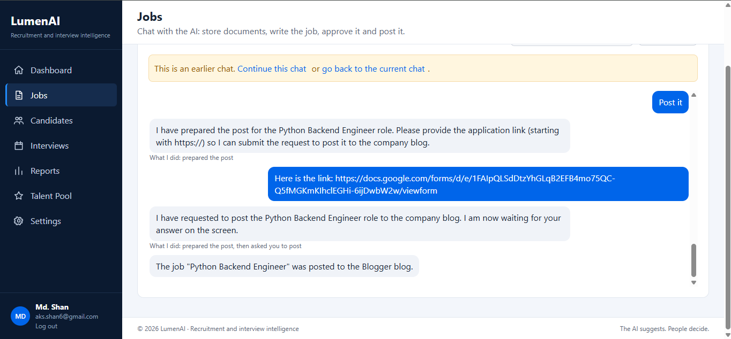
Figure 2 – Jobs: chat with the AI, with the Yes / No approval card (LUM_UI_003)
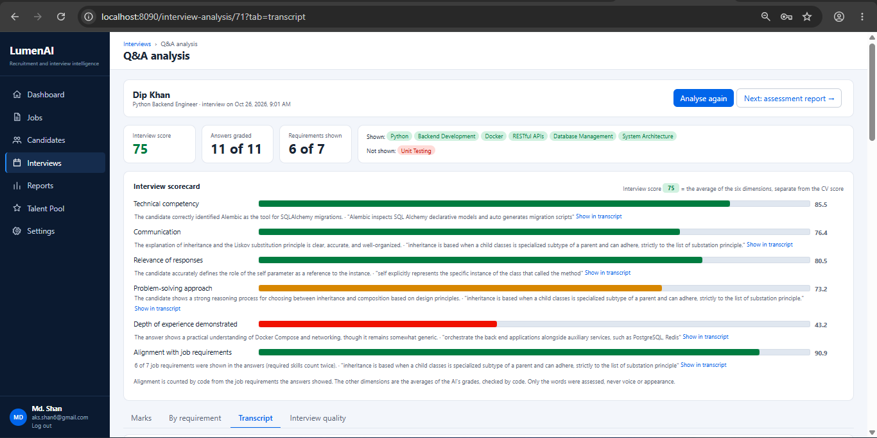
Figure 3 – Candidates: screening result with quotations and score breakdown (LUM_UI_006)
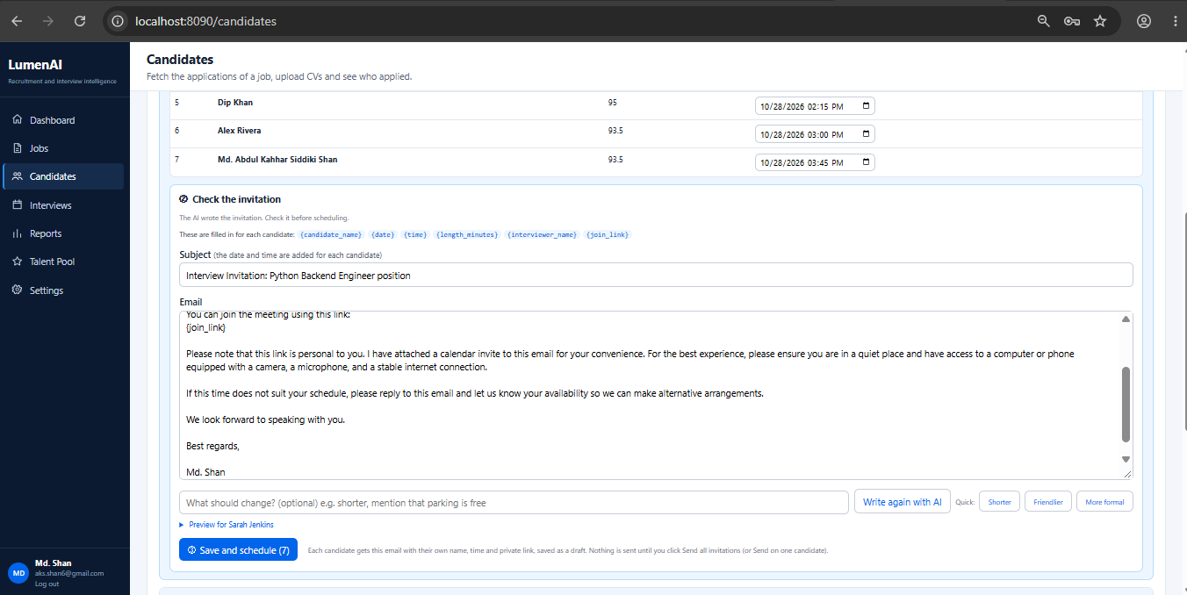
Figure 4 – Invitation editor with the Write again box (LUM_UI_007)
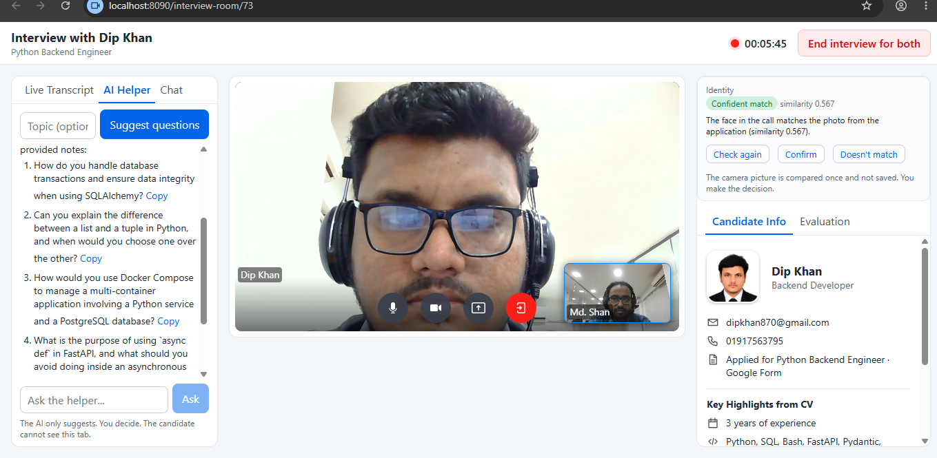
Figure 5 – Interview room for the interviewer: live transcript and AI Helper (LUM_UI_008)
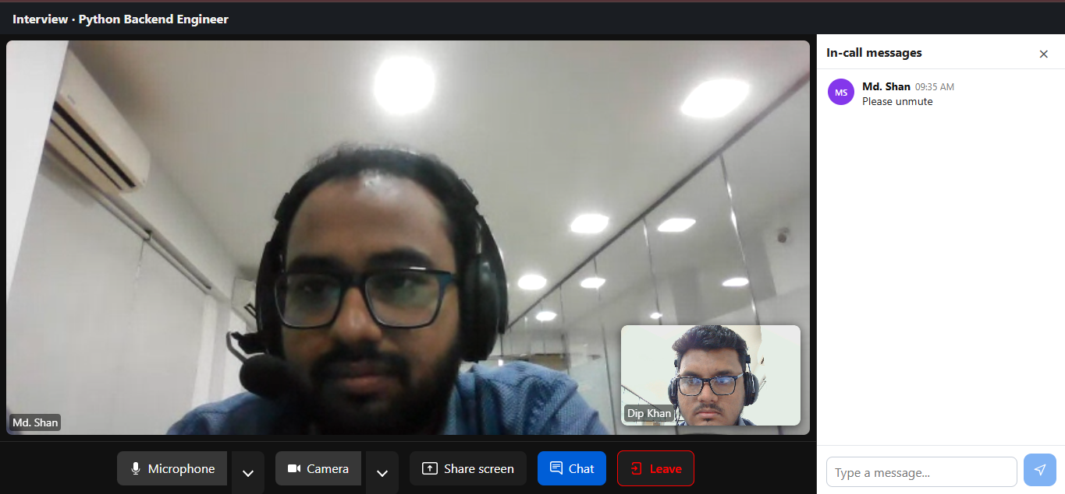
Figure 6 – Candidate join page: video and chat only (LUM_UI_009)
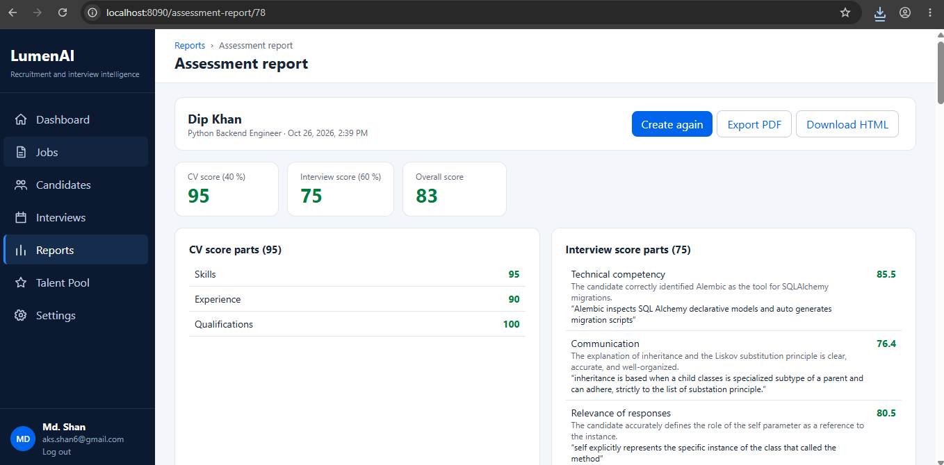
Figure 7 – Assessment report and scorecard (LUM_UI_011)
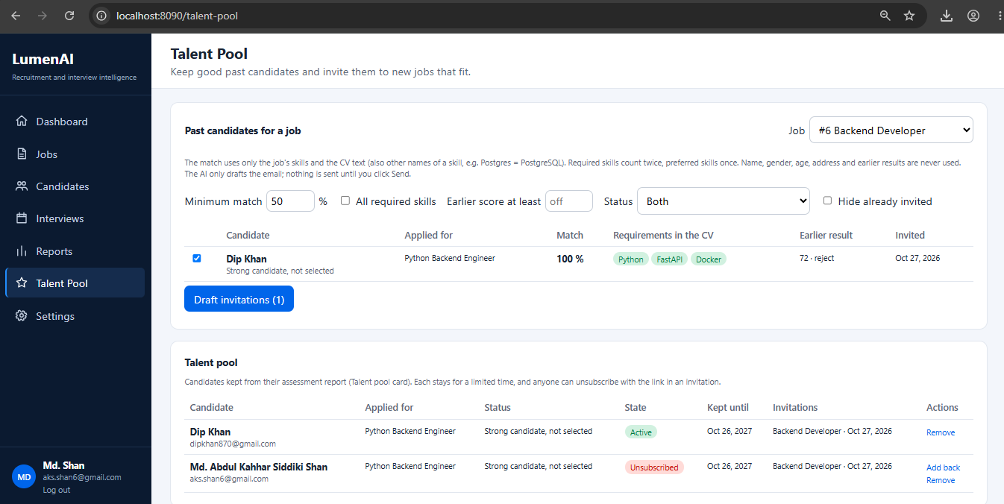
Figure 8 – Talent pool: matching and invitation draft (LUM_UI_013)

- Non-Functional Requirements
REQUIREMNT ID | Requirement Description | Acceptability/  Completion Criteria | Limitations/  Constraints | Test case Identifier
LUM_NFR_001 | The system shall respond immediately (HTTP 202) to long-running AI tasks (screening, Q&A analysis, assessment, claim verification and quality assessment) and process them in the background, with the page polling every three seconds. | The request returns without waiting for the AI. | In-progress work is lost if the process stops and is restarted at the next start-up. | test_qa_analysis.py::test_the_answers_are_graded
LUM_NFR_002 | The system shall resume paused workflows from the PostgreSQL checkpointer after a restart, restart running analyses and re-queue pending CVs. | No pending question or decision is lost. | Partially meets trainer Q45: running analyses restart from the beginning rather than from the last completed step. | test_hr_decision.py::test_a_decision_without_a_paused_run_still_goes_through_the_workflow
LUM_NFR_003 | The system shall write the backend and both MCP servers to a single log file using Bangladesh time, and shall log the tokens (input, output and thinking) of every AI call. | Entries in logs/lumenai.log show local time and token counts. | Embedding calls do not report token counts. | test_logging.py::test_log_lines_are_saved_in_a_file; test_log_time_is_shown_in_bangladesh_time; test_ai_connection.py::test_gemini_uses_its_own_address_and_logs_the_thinking
LUM_NFR_004 | The system shall read every setting from .env and shall start the database, backend, web server and both MCP servers with a single command (docker compose up). | The application starts with one command on a new machine with a completed .env file. | - | test_health.py::test_health

5.1 Performance Requirements
No load test has been performed; the figures below are the limits configured in the implementation. The trainer confirmed that screening of 20 CVs has a time frame (Q23) without stating its value; response-time targets are therefore to be agreed with the reviewers.
AI calls: each call has a 90-second timeout; on a rate-limit or temporary error, the call is retried after 2, 4, 8 and 16 seconds; an invalid JSON response is requested once more.
AI chat: a maximum of 16 model and tool steps and 180 seconds per message; the model receives the 30 most recent messages. MCP tool calls from backend code time out after 45 seconds.
Throughput: CVs are screened sequentially by a single background worker, a design choice dictated by the free Gemini quota; up to ten CVs are retrieved per request.
Capacity: the system serves a single organisation; the Knowledge base search scans all documents of a type in Python, which is suitable for a library of hundreds rather than thousands of documents.
Degradation: when an external service fails (Gemini, Deepgram, SMTP or Blogger), the affected step fails with a plain-language reason, the remainder of the application continues to operate and the user may retry. Without SMTP, invitations are saved as drafts.
Resource utilisation: uploaded files are limited to 5 MB; CV text is truncated to 15,000 characters and documents to 400 words before being supplied to the AI.
5.2 Safety Requirements
REQUIREMNT ID | Requirement Description | Acceptability/  Completion Criteria | Limitations/  Constraints | Test case Identifier
LUM_SAF_001 | The system shall not permit the AI to approve, publish, send, include, exclude, confirm identity or hire; each action shall require a person's explicit instruction. | Each such action originates from a person's request or from a paused workflow resumed by a person. | - | test_assessments.py::test_only_a_person_decides; test_assistant.py::test_no_means_nothing_happens
LUM_SAF_002 | The system shall verify that every quotation provided by the AI appears in the CV or the transcript (at least two words), and shall otherwise remove or repair it. | No unverified quotation is displayed. | - | test_scoring.py::test_an_invented_quote_is_removed; test_assessments.py::test_quotes_without_proof_are_repaired_or_removed
LUM_SAF_003 | The system shall never assess voice, accent, confidence, appearance or personal characteristics, and every grading prompt shall contain the fairness rules. | The prompts contain the fairness rules; judgemental wording is removed. | - | test_qa_analysis.py::test_fair_grading_rules_are_in_the_prompts; test_assessments.py::test_fair_rules_are_in_every_prompt
LUM_SAF_004 | The system shall never display scores, notes, the AI Helper or analysis to the candidate. | Candidate routes return only data relating to the candidate's own call. | - | test_interviews.py::test_the_candidate_page_shows_only_their_interview
LUM_SAF_005 | The system shall present the identity check and the CV claim verification as advisory results in neutral language, subject to confirmation by a person. | No candidate is rejected automatically. | Face recognition accuracy varies. | test_identity.py::test_the_face_is_compared_and_a_person_decides; test_claims.py::test_access_privacy_and_fair_wording

5.3 Security Requirements
- Credentials are held only in the .env file and the secrets folder; they are never written in source code, logged or displayed.
- Passwords are stored as salted PBKDF2-SHA256 hashes; authentication issues an HS256-signed JWT with an expiry time.
- Interviewer routes require a valid token; candidates can reach only their own call through a private join token.
- Log entries contain identifiers and events only, never names, CV text or credentials.
REQUIREMNT ID | Requirement Description | Acceptability/  Completion Criteria | Limitations/  Constraints | Test case Identifier
LUM_SEC_001 | The system shall require a valid JWT for all interviewer API routes and shall reject expired tokens and tokens signed with another key. | Requests without a valid token receive 401. | - | test_access.py::test_bad_token_is_rejected; test_login.py::test_token_signed_with_another_key_is_not_valid
LUM_SEC_002 | The system shall store passwords only as salted PBKDF2-SHA256 hashes. | No plain-text password exists in the database. | - | test_login.py::test_the_password_is_saved_as_a_hash
LUM_SEC_003 | The system shall not write credentials, names or CV text to the log or include them in error messages. | Errors are plain-language sentences; the log contains no personal text. | - | test_logging.py::test_the_log_has_no_private_text; test_job_posting.py::test_blogger_problems_are_explained_and_secrets_never_shown
LUM_SEC_004 | The system shall never supply candidates' e-mail addresses or telephone numbers to the AI. | Contact details are removed before every AI call. | - | test_screening.py::test_the_ai_never_sees_email_or_phone; test_interviews.py::test_the_ai_never_gets_the_email_address
LUM_SEC_005 | The system shall accept only files of permitted types and sizes and shall connect only to known MCP server hosts. | Invalid files and unknown hosts are refused. | - | test_candidates.py::test_bad_uploads_are_refused; test_mcp_http.py::test_an_unknown_host_name_is_refused

- Design Constraints
- The mandated technology stack is FastAPI (backend), LangGraph (AI workflows), PostgreSQL (database) and React (frontend).
- LangGraph is applied where a workflow pauses for a person, executes AI calls in parallel or contains loops; strictly sequential processes (CV claim verification and interview quality assessment) are implemented in plain Python.
- The code follows a simple, maintainable structure: each feature folder contains models, schemas, routers and services, and routers only validate requests and delegate to services.
- Google Gemini is used on the free tier, which requires a minimal number of AI calls per CV, a single screening worker and retry on rate limits.
- LiveKit Cloud provides video, since Google Meet does not expose individual participant audio to the application.
- Publication on Blogger requires a Google OAuth refresh token, which expires weekly while the application is in Testing mode.
- The system is deployed with Docker Compose; all settings are read from .env and credentials are never committed to the repository.
- Only fictitious candidate data is used during development and testing.
- The system supports two roles only, interviewer and candidate (trainer Q18), and one-to-one interviews (Q26); CVs and interviews are in English (Q44).
- Long-running workflow state must persist and resume after a restart (trainer Q45); paused workflows use the LangGraph PostgreSQL checkpointer.

- Software Quality Attributes
REQUIREMNT ID | Requirement Description | Acceptability/  Completion Criteria | Limitations/  Constraints | Test case Identifier
LUM_QUA_001 | Testability: every feature shall be covered by automated tests that run offline with substitute AI, speech, Drive and Blogger providers. | All 332 tests pass on SQLite, and on PostgreSQL with a newly created test database. | The tests verify integration and rules, not the quality of AI judgements. | backend/tests (all files)
LUM_QUA_002 | Maintainability: all sixteen backend features shall follow the same folder structure, and the workflow diagrams shall be generated from the code. | The output of print_workflows.py matches the diagrams. | - | scripts/print_workflows.py
LUM_QUA_003 | Usability: every error shall be reported in plain language together with the recommended action. | No stack traces or raw service errors are displayed. | - | test_ai_connection.py::test_failure_reason_is_shown; test_assistant.py::test_a_failure_is_shown_in_plain_words
LUM_QUA_004 | Traceability: every score shall show its components and supporting evidence, and every run shall be recorded in the workflow log. | The report and scorecard display the breakdown and quotations. | - | test_assessments.py::test_the_report_shows_the_parts_behind_the_scores

Measurable targets. The following targets state the quality attributes in measurable terms (Planguage style: tag, scale, meter and the minimum level that must be reached).
Tag | Scale | Meter | Must | Status
QuoteVerification | Share of AI quotations shown to the interviewer that appear in the CV or the transcript | Automated tests (test_scoring.py, test_assessments.py) | 100 % | Met in the automated tests
CandidatePrivacy | Responses of candidate routes that contain scores, notes, AI Helper output or analysis | Automated tests (test_interviews.py) | 0 | Met in the automated tests
ContactDetailsToAI | AI requests that contain a candidate's e-mail address or telephone number | Automated tests (test_screening.py, test_interviews.py) | 0 | Met in the automated tests
HumanDecision | Approve, publish, send, include, exclude and hire actions that originate from a person | Automated tests (test_assistant.py, test_assessments.py) | 100 % | Met in the automated tests
Testability | Automated tests passing offline with substitute AI, speech, Drive and Blogger providers | Full pytest run | 100 % | Met: 332 of 332 tests pass
ScreeningTime | Time to screen 20 CVs (trainer Q23) | Timed run with live Gemini | To be agreed with the reviewers | Not yet measured

- User Interface
The following rules apply to every screen of the system.
UI No. | UI Name | Related Info No. | Description | Notes | Test case Identifier
LUM_UIR_001 | Sidebar navigation | LUM_UI_002–014 | A single sidebar with Dashboard, Jobs, Candidates, Interviews, Reports, Talent Pool and Settings | Consistent layout on every interviewer screen | Manual check
LUM_UIR_002 | Confirmations | LUM_POST_001, LUM_SCR_005 | Destructive or outward-facing actions (delete, publish, send, reinstate) require confirmation | AI-initiated actions appear as Yes / No cards | test_assistant.py::test_no_means_nothing_happens
LUM_UIR_003 | Progress of long-running work | LUM_NFR_001 | Running work displays its status and the page refreshes every three seconds | The reason is displayed on failure | test_qa_analysis.py::test_when_the_ai_fails_the_reason_is_shown
LUM_UIR_004 | Evidence alongside AI results | LUM_SAF_002 | Quotations and transcript time links accompany grades, claims and strengths | Links navigate to the transcript | test_assessments.py::test_interview_quotes_link_to_the_transcript
LUM_UIR_005 | Private interviewer panels | LUM_SAF_004 | The AI Helper, notes and analysis appear only on interviewer screens | Never shown on the candidate page | test_interviews.py::test_the_candidate_page_shows_only_their_interview

- Other Requirements
REQUIREMNT ID | Requirement Description | Acceptability/  Completion Criteria | Limitations/  Constraints | Test case Identifier
LUM_OTH_001 | Privacy: deletion of a candidate shall remove the candidate's files, photograph, transcript, analysis, reports and talent pool entry. | No data relating to the candidate remains. | - | test_candidates.py::test_deleting_a_candidate_removes_the_file; test_talent_pool.py::test_deleting_the_candidate_deletes_the_pool_entry
LUM_OTH_002 | Consent: candidates shall be informed that the photograph they submit is used for the identity check, and every talent pool e-mail shall contain an unsubscribe link. | The notice appears on the application form; the unsubscribe link works without authentication. | The photograph notice is maintained in the Google Form text, not generated by the system. | test_talent_pool.py::test_unsubscribed_people_are_never_invited_again
LUM_OTH_003 | Data retention: talent pool entries shall expire after POOL_KEEP_DAYS (default 365 days). | Expired entries are not suggested. | - | test_talent_pool.py::test_expired_entries_are_not_suggested
LUM_OTH_004 | Open item (project brief F4, N18): the candidate's call page shall display a visible notice that the interview is transcribed. | The notice is shown before the microphone is streamed. | Not implemented: removed by decision of the developer; requires the mentor's confirmation. | To be defined
LUM_OTH_006 | Privacy: the system shall not store raw audio or video of the interview (trainer Q7); only the transcript text is saved. | No audio or video file is written by the backend. | - | Code review
LUM_OTH_005 | Open item: a complete end-to-end run shall be performed with all live services (Gemini, Deepgram, Drive, Blogger, SMTP and LiveKit) in a single session. | The full flow from job prompt to decision operates with live services. | Not yet performed in a single session. | Manual end-to-end test

- Prioritization and Release Plan
10.1 Choice of Prioritization Method
The requirements were prioritised with the MoSCoW method, following the tiers of the project brief: F1–F6 are core (Must have), F7–F10 are stretch (Should have) and F11 is the innovation feature (Could have). The platform features (authentication, dashboard, settings and logging) are Must have, because every other feature depends on them.
MoSCoW was chosen because the brief already defines these tiers and because it is simple to apply within a fixed training schedule. Numeric methods, such as cost–value ranking or the hundred-dollar test, were not used, since the project has a single developer and a fixed set of reviewers rather than several competing stakeholder groups.
Feature | Priority | Requirements
Authentication and accounts | Must | LUM_AUTH_*
Job preparation, approval and publication (F1) | Must | LUM_JOB_*, LUM_POST_*
CV collection (F1) | Must | LUM_CV_*
CV screening, scoring and shortlisting (F2) | Must | LUM_SCR_*
Scheduling, invitation and video interview (F3) | Must | LUM_INV_*, LUM_CALL_001–003, LUM_CALL_005
Live transcript and AI Helper (F4) | Must | LUM_STT_*
Answer analysis (F5) | Must | LUM_QA_001, LUM_QA_002, LUM_QA_004
Consolidated assessment and decision (F6) | Must | LUM_ASM_*
Identity check (F7) | Should | LUM_CALL_004
CV claim verification (F8) | Should | LUM_CLM_*
Interview scorecard (F9) | Should | LUM_QA_003
Interview quality assessment (F10) | Should | LUM_IQ_*
Talent pool (F11) | Must | LUM_TP_*
Dashboard, settings and logging | Must | LUM_SYS_*, LUM_NFR_*

10.2 Release Plan
The release plan follows the milestones of the mentor's review schedule. Each milestone delivers a working part of the flow, so that the reviewers can see the output, including the user interface, at each step.
Milestone | Scope | Requirements and status
M1 – 9 October 2026 | Job description → publication → CV collection → screening → semantic ranking | LUM_JOB_*, LUM_POST_*, LUM_CV_*, LUM_SCR_*. Status: Implemented
M2 – 15 October 2026 | Scoring → selection → scheduling → link → join → interview user interface | LUM_SCR_003–006, LUM_INV_*, LUM_CALL_*. Status: Implemented (LiveKit in place of Google Meet)
M3 – 19 October 2026 | Interview → transcription → Q&A analysis → requirement mapping → AI evaluation | LUM_STT_*, LUM_QA_*. Status: Implemented
M4 – 27 October 2026 | End-to-end demonstration with consolidated assessment, report, comparison and the stretch and innovation features | LUM_ASM_*, LUM_CLM_*, LUM_IQ_*, LUM_TP_*, LUM_SYS_*. Status: Implemented; a complete run with all live services in one session is open (LUM_OTH_005)

- Acceptance Scenarios
The scenarios below describe the expected behaviour of the main flows in Given / When / Then form. They complement the automated tests referenced in section 3 and serve as the basis for the manual end-to-end test (LUM_OTH_005).

Publish a job only after approval (LUM_POST_001, LUM_POST_003)
- Given an approved job with an https:// application form link
- When the AI asks to publish the job and the interviewer answers Yes on the question card
- Then the backend publishes the post on Blogger and records the outcome
- And an answer of No leaves the job unpublished and unchanged

Screen a CV under the fixed rule (LUM_SCR_001, LUM_SCR_002)
- Given a job with mandatory requirements and a collected CV
- When the screening runs in the background
- Then every requirement is assessed with a quotation that is found in the CV
- And a missing mandatory requirement leads to exclusion, which the interviewer may reverse

Send an invitation (LUM_INV_001, LUM_INV_003, LUM_INV_004)
- Given a shortlisted candidate and a future interview time
- When the AI drafts the invitation and the interviewer asks for a shorter version
- Then the new draft is written from the previous draft with the requested change
- And nothing is sent until the interviewer selects Send; the e-mail carries the private link and a calendar invitation

Keep the candidate's page private (LUM_SAF_004, LUM_CALL_003)
- Given a candidate who joins the call with a valid private link
- When the interviewer uses the AI Helper and writes notes during the call
- Then the candidate's page shows only the video, the chat and the candidate's own interview
- And no score, note, suggestion or analysis is ever returned to the candidate

Analyse the interview (LUM_QA_001, LUM_QA_002, LUM_SAF_003)
- Given an ended call in which the candidate has spoken
- When the interviewer starts the analysis
- Then each job-related answer is graded by six graders, each grade supported by a verified quotation
- And voice, accent, confidence and appearance are never assessed

Record the decision (LUM_ASM_003, LUM_SAF_001)
- Given a completed assessment report for a candidate
- When the interviewer records hire, hold or reject
- Then the decision is saved with the interviewer as its author
- And the AI cannot record a decision on its own

