
Semantic annotations tool for EIS publications
This tool is a research effort for annotating text and tabular information in a pdf document via crowdsourcing. It also facilitate a user to annotate tabular information using DataCube RDF vocabulary. This tool transforms selected pdf table info into data cube RDF. |  |  |  |  | 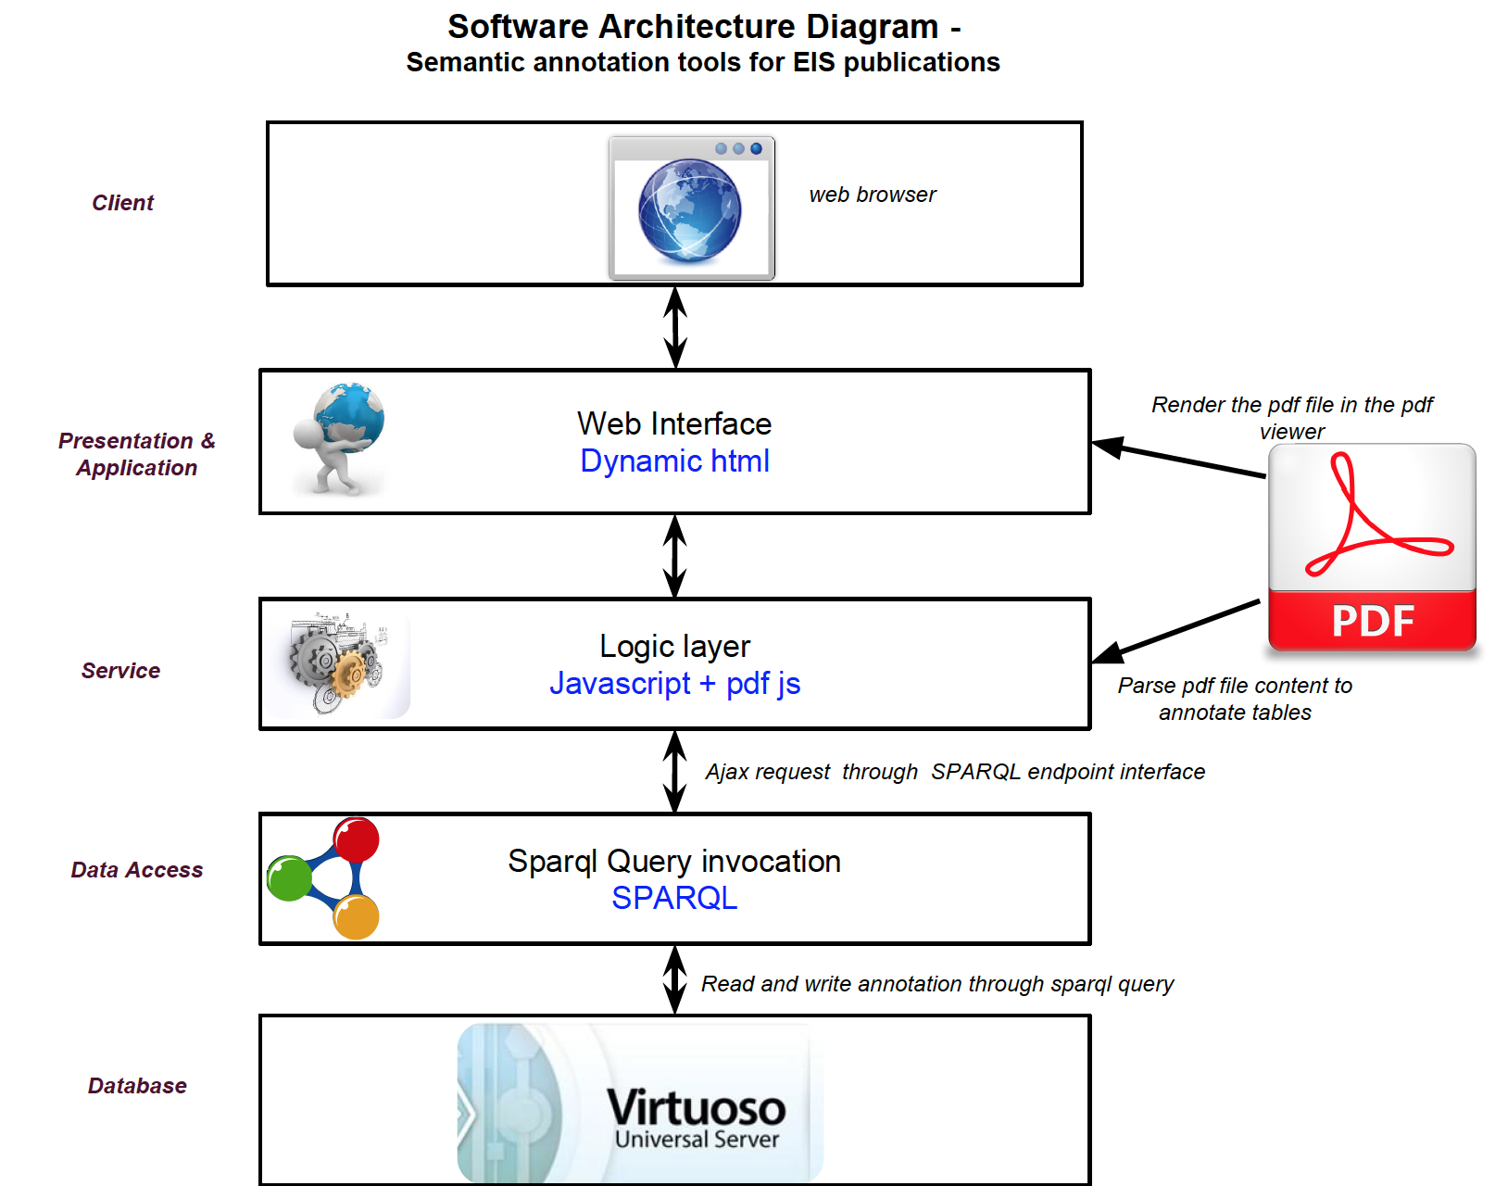  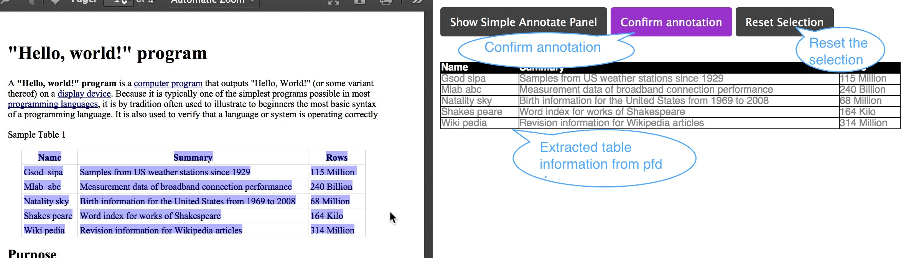
Annotation window
DataCube RDF segment of transformed table info
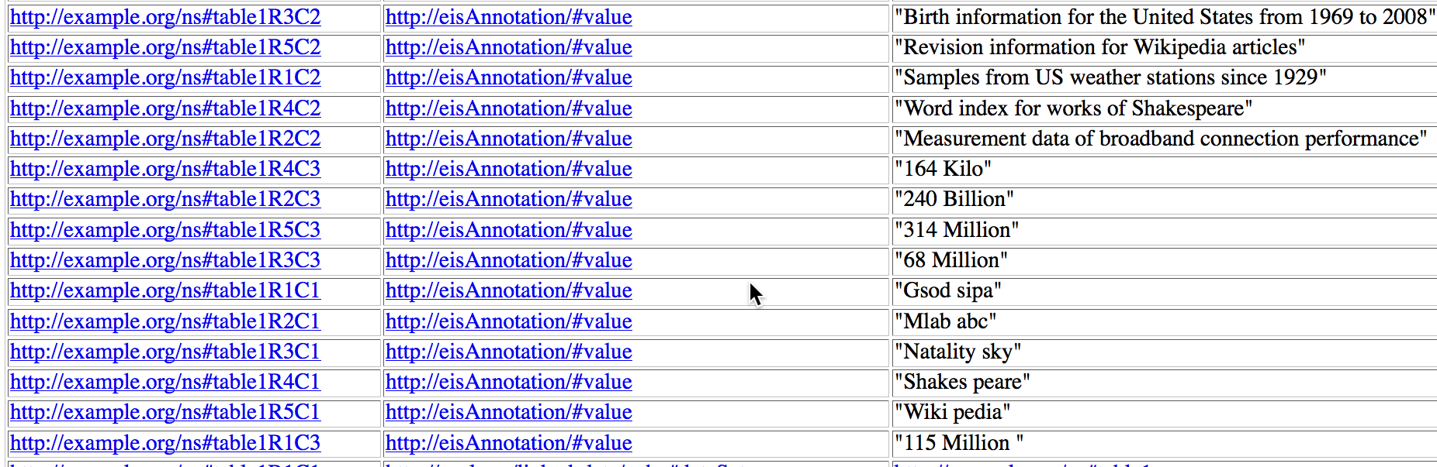   |  |  |  |  | Setup / Installation process
- Install virtuoso universal server
- Download the code from git repo
- In the downloaded directory open the index.html in any browser.
- For details set up please follow the git hub link section in the bottom.
Representation of cell in the data cube |  |  |  |  |   Virtuoso setting
For example, in data cube the cell - “Birth information for the United States from 1969 to 2008” , has been represented in the following way.
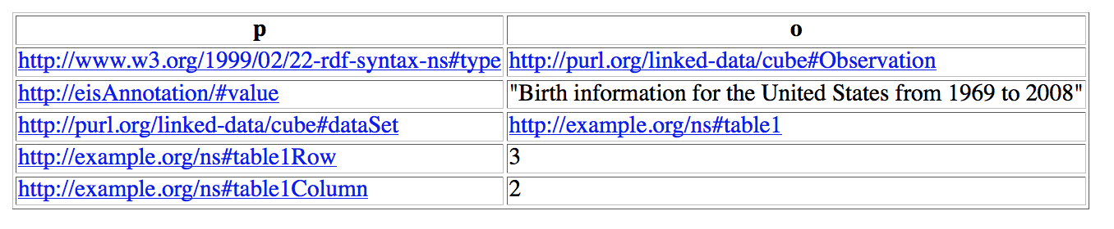

- Make sure that virtuoso endpoint is listening at http://localhost:8890/
- Login as admin (user: dba, pass: ***) in the
backend (http://localhost:8890/conductor/)
- Update write permission settings for user : sparql
- Enable CORS for the Data Access of JS client
  Technology used |  |  |  |  |   VM settings
- VirtuosoUniversal Server
- SPARQL as a query
- JavaScript + Html
- Pdf.js as rendering
- Qunit as JavaScript test environment
- DataCube (http://www.w3.org/TR/vocab-data-cube/)
VM Name : Ubuntu-sciPubAnn
OS: Ubuntu 12.04 LTS (32 bit)
RAM: 3.9 GB
CPU: Intel® Core™ i7-4770 CPUs @3.40GHz
HDD: 4.2 GB ( possible increase)
Physical work station |  |  |  |  |   Project's Git hub links
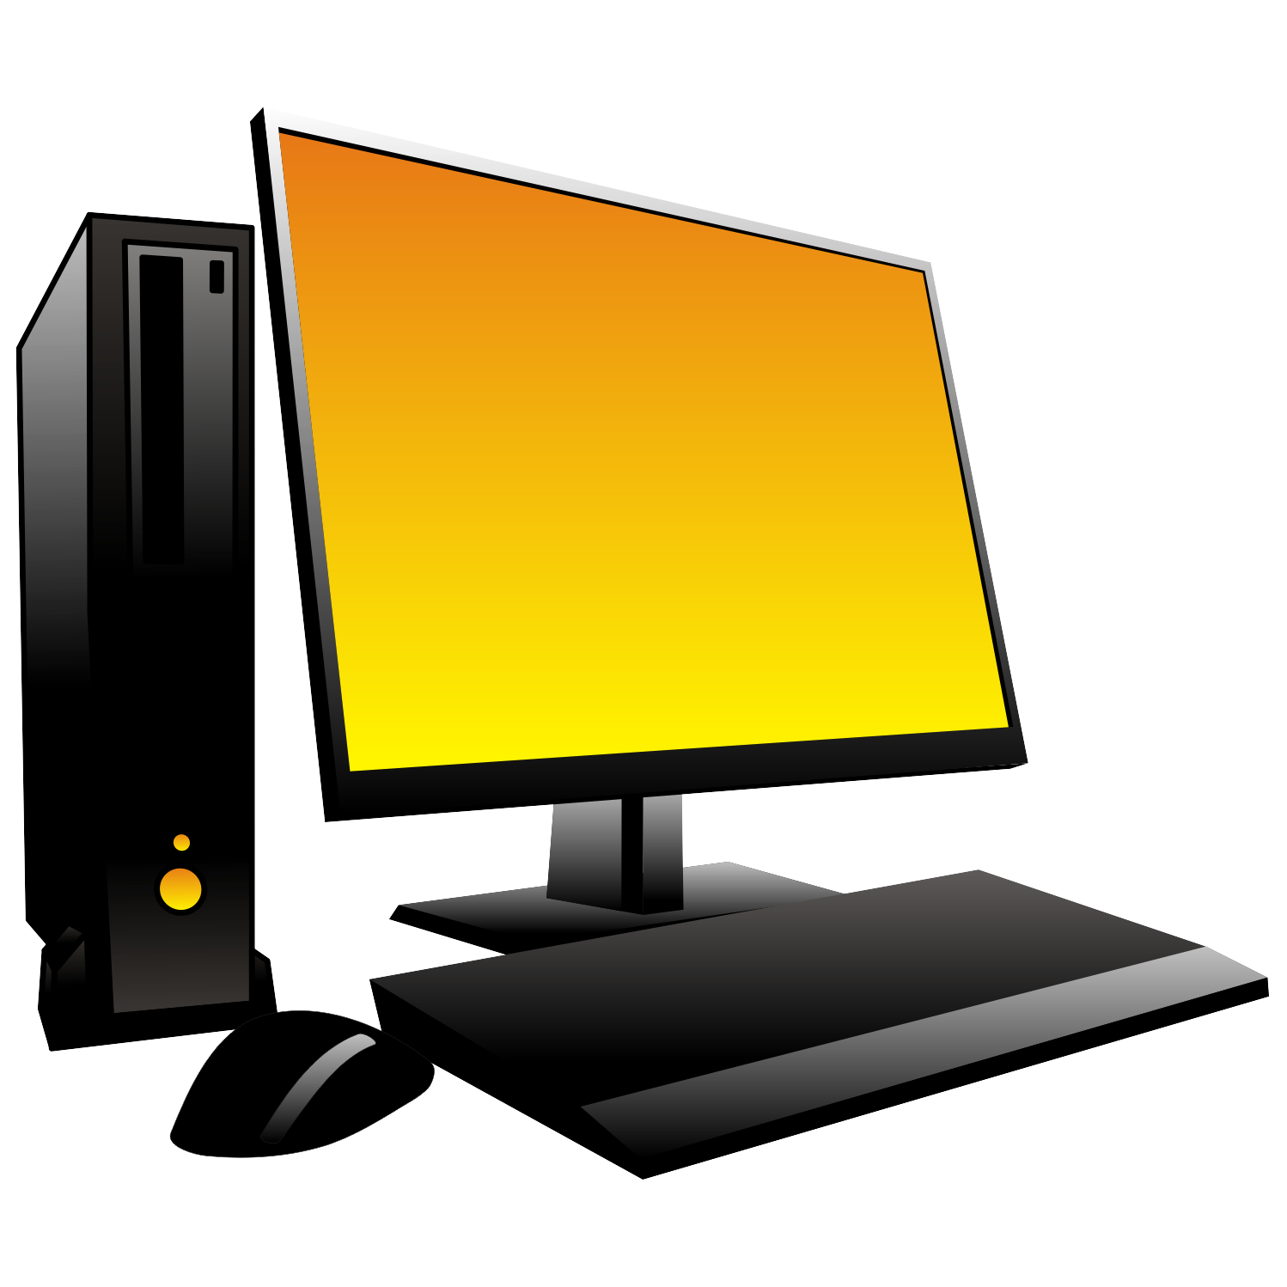 |  | Hostname: EIS-02  Description: Physical PC at Uni Bonn  OS: Windows 7 Enterprise SP1 64bit  RAM: 16 GB (14 GB Free)  CPU: Intel Core i7-4770 @3.4GHz  HDD: (C:) 240 GB & (L:) 930 GB  IP Address: 131.220.153.88
- Code link:
https://github.com/saifulnipo/eis-semantic-annotation
- Documentation link :
https://github.com/saifulnipo/eis-semantic-annotation/wiki
- Release note :
https://github.com/saifulnipo/eis-semantic-annotation/releases
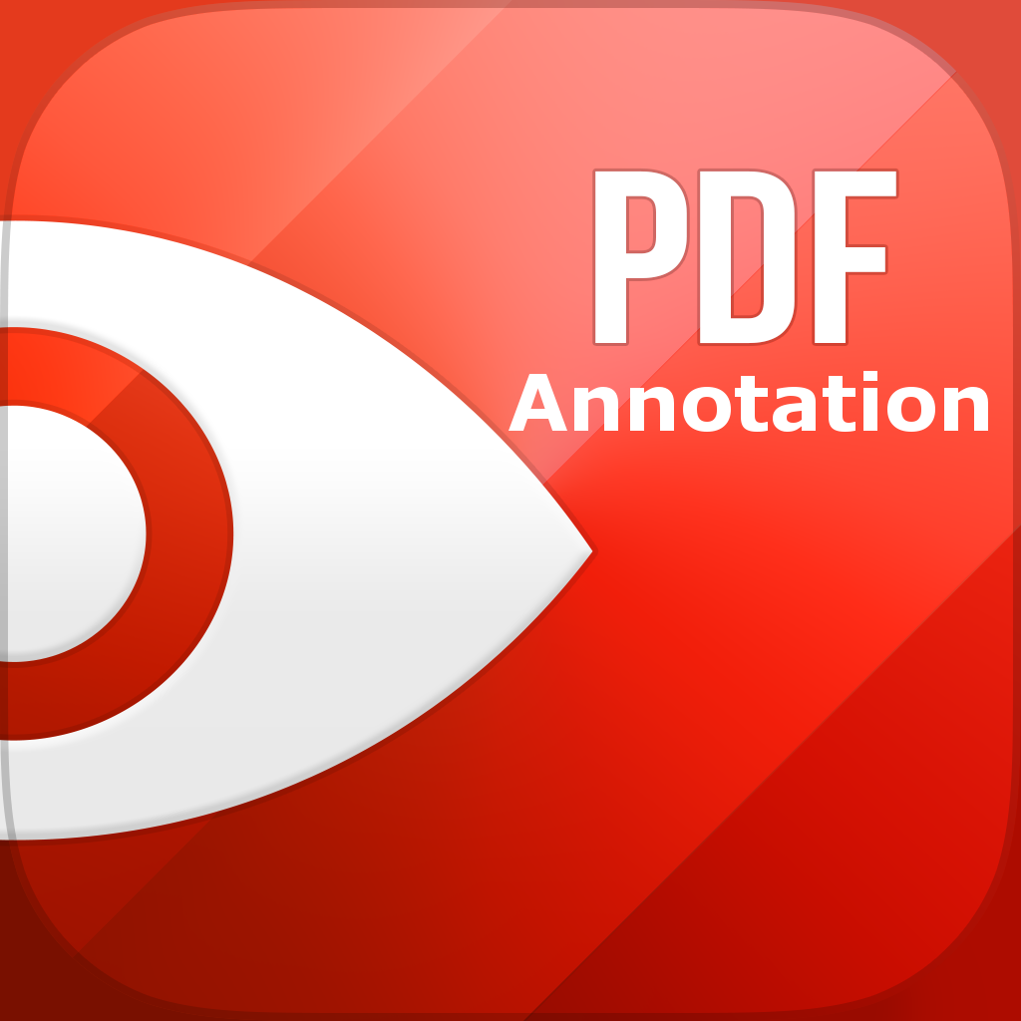


EIS Lab | Presented by:  AQm Saiful Islam  (islam@informatik.uni-bonn.de)  Seyidov Mir sattar  (sattar.seyidov@gmail.com)

