S.

**Ain Shams University**

**Faculty of Computer & Information Sciences**

**Scientific Computing Department**

**Handwritten Signature Identification and Verification**

**By**

**SC_34**

|  |  |  |
| --- | --- | --- |
| **ID** | **Name** | **No** |
| 20191700047 | أحمد عبدالجواد رمضان عبدالجواد | 1 |
| 20191700225 | خالد شريف عبداللطيف عبد المجيد عزام | 2 |
| 20191700284 | سعد وليد سعد على ابوحسن | 3 |
| 20191700785 | يوسف محمد جمعه محمد | 4 |
| 20191700138 | امير ممدوح حلمى شاكر | 5 |
| 20191700397 | عمر أحمد الشناوى عبدالحميد | 6 |

**Data preparation**

1. Read image paths using the **OS** library while ignoring **CSV** files at stage 1.
2. Passed the paths to OpenCV to read images and resize them based on the technique we are going to use.
   * **Stage 1**
     1. **HOG** model image sizes were (64, 128, 1)
     2. **CNN** model image sizes were (128, 128, 1)

* **Stage 2**
  1. **BOW** model image sizes were (128, 128, 3)
  2. **Siamese** model image sizes were (128, 128, 3)

1. Created labels for CNN model at stage 1, labels were one hot encoded (e.g [0, 0, 0, 1, 0] for personD ), labels for the **HOG** model were a number between 0 and 4, the same technique were used in **BOW**, but classes were either 0 or 1.
2. Same methods were used in Stage 3 but additionally text files were read corresponding to each image in the data set, and images were resized to (300,300).

**Models and Techniques**

1. **Signature Identification (Stage 1)**

For the First Stage, The task was to apply image classification on signatures to **Identify** who it belongs to. We used two different models for that task.

* 1. **CNN – Model**

We applied simple **CNN** architecture consisting of 4 convolution layers and 1 pooling layer, followed by 2 fully connected layers.

**The full Architecture is:**

|  |  |  |  |  |  |
| --- | --- | --- | --- | --- | --- |
| **Layer** | **# filters/ neurons** | **Filter Size** | **Stride** | **Size of feature map** | **Activation Function** |
| Input | - | - | - | 128 x 128 x 1 | - |
| Conv 1 | 32 | 5x5 | 2 | 62 x 62 x 32 | ReLU |
| Conv 2 | 32 | 5x5 | 1 | 58 x 58 x 32 | ReLU |
| Max Pool 1 | - | 3x3 | 1 | 19 x 19 x 32 | - |
| Conv 3 | 32 | 5x5 | 2 | 8 x 8 x 32 | ReLU |
| Conv 4 | 32 | 5x5 | 1 | 4 x 4 x 32 | ReLU |
| FC 1 | - | - | - | 512 | ReLU |
| FC 2 | - | - | - | 128 | ReLU |
| FC 3 | - | - | - | 5 | Softmax |

**Performance Measures**

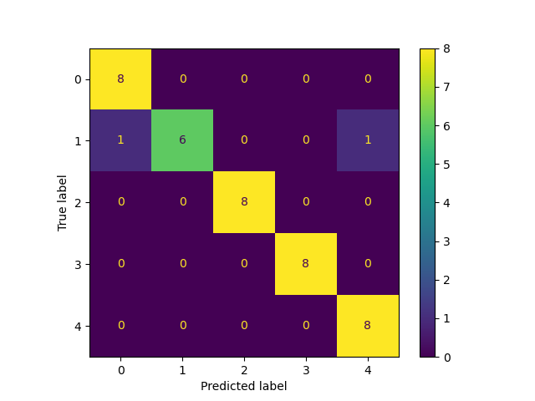

|  |  |  |
| --- | --- | --- |
| **-** | **Accuracy** | **Time** |
| **Training** | .985 | 51.47 s |
| **Testing** | .95 | 22.19 s |

* 1. **HOG – Model**

We applied **Histogram of Oriented Gradients** to extract features from images and then used these features to feed **Logistic Regression** model to classify them.

**HOG** basically is a feature descriptor that extracts the most important information about the image, specifically the edges and its direction, these are extracted by calculating the gradient in the **X** and **Y** directions then calculating the magnitude to find it is orientation, then it builds a histogram that shows the distribution of the data.

* + 1. **Performance Measures**

|  |  |  |
| --- | --- | --- |
| **-** | **Accuracy** | **Time** |
| **Training** | 1.0 | 2.04 s |
| **Testing** | .975 | 2.47 s |

* + 1. **Confusion Matrix**

1. **Signature Verification (Stage 2)**

For the Second Stage, The task was to apply image classification on the signatures of each person to **Verify** whether it is forged or real. We used two different models for that task.

* 1. **BOW – Model**

We applied 5 **Bag of Word** models, a model for each person. To extract features from images then feed these features to **Logistic Regression** model to classify them.

**Bag of Visual Words** basically is a technique to describe images and compute the similarity between them. At first, we use feature descriptors like **SIFT** on all our images to extract a list of descriptors of our dataset. Then we stack these descriptors and feed that stack to **K-mean** model to group these descriptors into **K** visual words. Then we build a histogram for these visual words by checking the appearance of the visual word in each image and our dictionary. Finally, this dictionary is fed to **Logistic Regression** model to classify them.

* + 1. **Performance Measures**

|  |  |  |  |
| --- | --- | --- | --- |
| **-** | **-** | **Accuracy** | **Time** |
| **Model A** | Training | 1.0 | 9.97 s |
| Testing | 1.0 | 0.06 s |
| **Model B** | Training | 1.0 | 4.48 s |
| Testing | .75 | 0.06 s |
| **Model C** | Training | 1.0 | 3.6 s |
| Testing | .75 | 0.04 s |
| **Model D** | Training | 1.0 | 11.01 s |
| Testing | .875 | 0.06 s |
| **Model E** | Training | 1.0 | 7.54 s |
| Testing | 1.0 | 0.07 s |

* + 1. **Confusion Matrix**

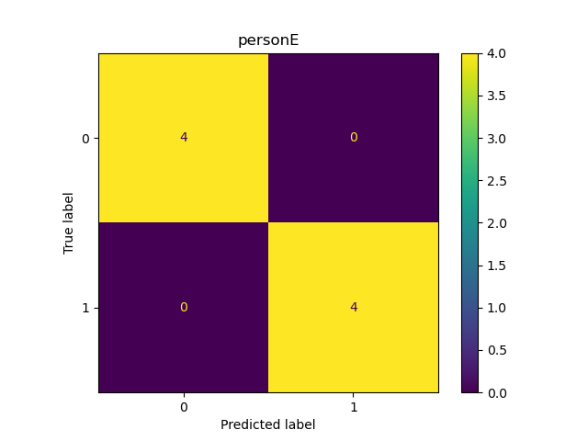

* 1. **Siamese – Model**

We applied one **Siamese** model to verify the Signatures of the 5 person. And Classify whether the signature is forged or real.

**Siamese** model is based on Triplet loss, the model takes 3 images as input ( anchor, positive, negative) images, and there is and encoder which extract the encodings of the images, and the goal is to maximize the difference between the distance between the anchor and negative image and the distance between the anchor and positive image.

* + 1. **Performance Measures \*\***

|  |  |  |
| --- | --- | --- |
| **-** | **Accuracy** | **Time** |
| **Training** | .84 | 2 s |
| **Testing** | .86 | 0.02 s |

* + 1. **Confusion Matrix**

**Train** **Test**

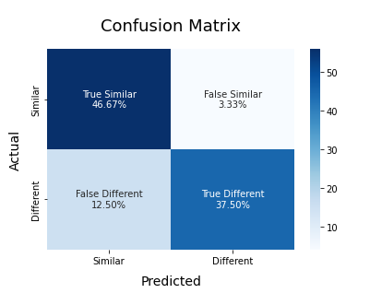

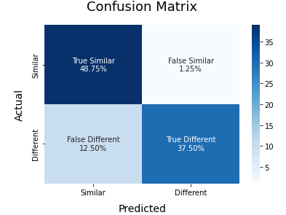

1. **Signature Detection (Stage 3)**

For the Third Stage, The task was to detect the signatures from different documents. We used **Faster R-CNN**.

* 1. **Faster R-CNN – Model**

**Performance Measures**

