**Instruction to run application on any local machine**

1. Clone the below Git branch in local pc.

<https://github.com/AKSpringBoot/Springboot.git>

1. Import the project as a Maven in any IDE.
2. Once done, run SpringBoot Application as Java Application.
3. Now go on any browser and run the below URL

<http://localhost:8083/swagger-ui/index.html#/>

1. Post that both the API are exposed

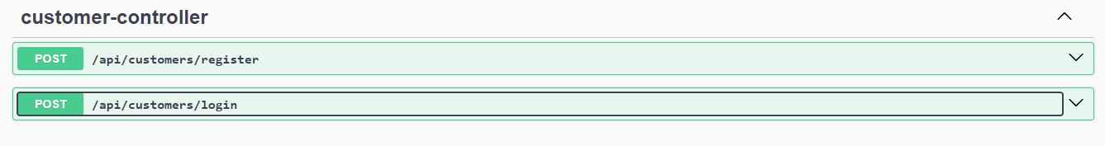

1. Now you are good to register a customer and also try to login in the same.