Creating an IAM (Identity and Access Management) user in AWS allows you to securely manage access to AWS services and resources for individuals within your organization. Here's a step-by-step guide on how to create an IAM user:

1. **Sign in to the AWS Management Console:** Open your web browser and navigate to the AWS Management Console at https://console.aws.amazon.com/. Sign in using your AWS account credentials.
2. **Open the IAM Console:** Once you're logged in, navigate to the IAM service by typing "IAM" in the search bar at the top of the AWS Management Console and selecting the IAM service from the search results.
3. **Navigate to Users:** In the IAM dashboard, select "Users" from the left sidebar menu. This will show you a list of IAM users in your AWS account.

1. **Click on "Add user":** To create a new IAM user, click on the "Add user" button at the top of the Users page.

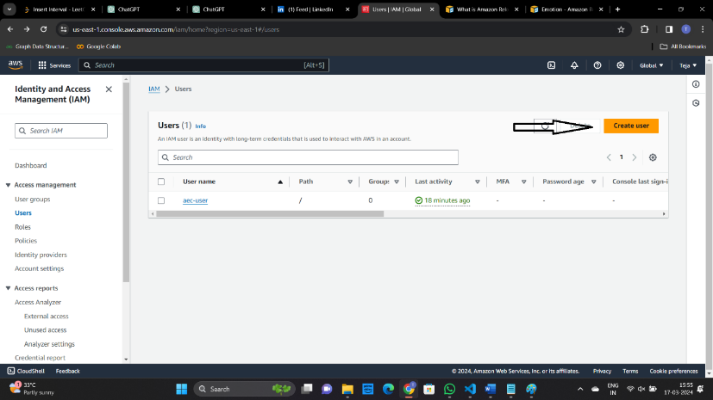

1. **Enter User Details:**

* User Details: Enter the username for the new IAM user. You can also choose to enable programmatic access (for AWS CLI, SDK, etc.) and/or AWS Management Console access (for logging in to the AWS Management Console).

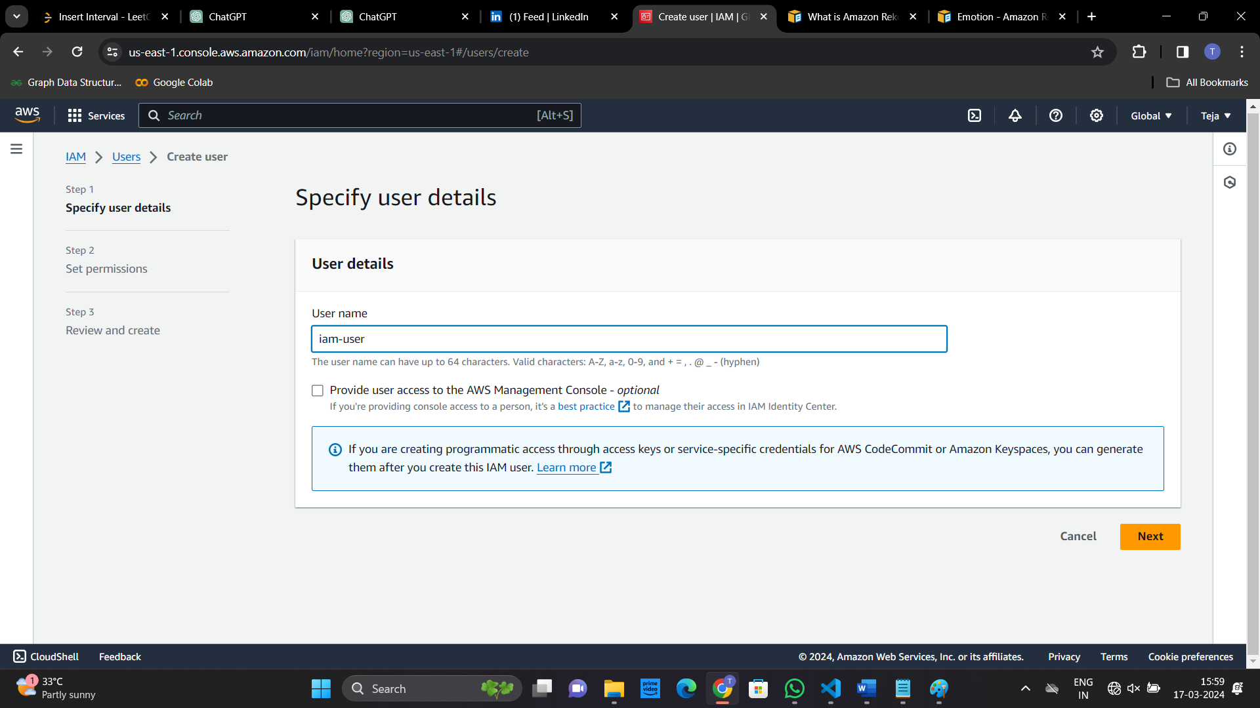

* Access type: Choose between "Programmatic access", "AWS Management Console access", or both, depending on your requirements.

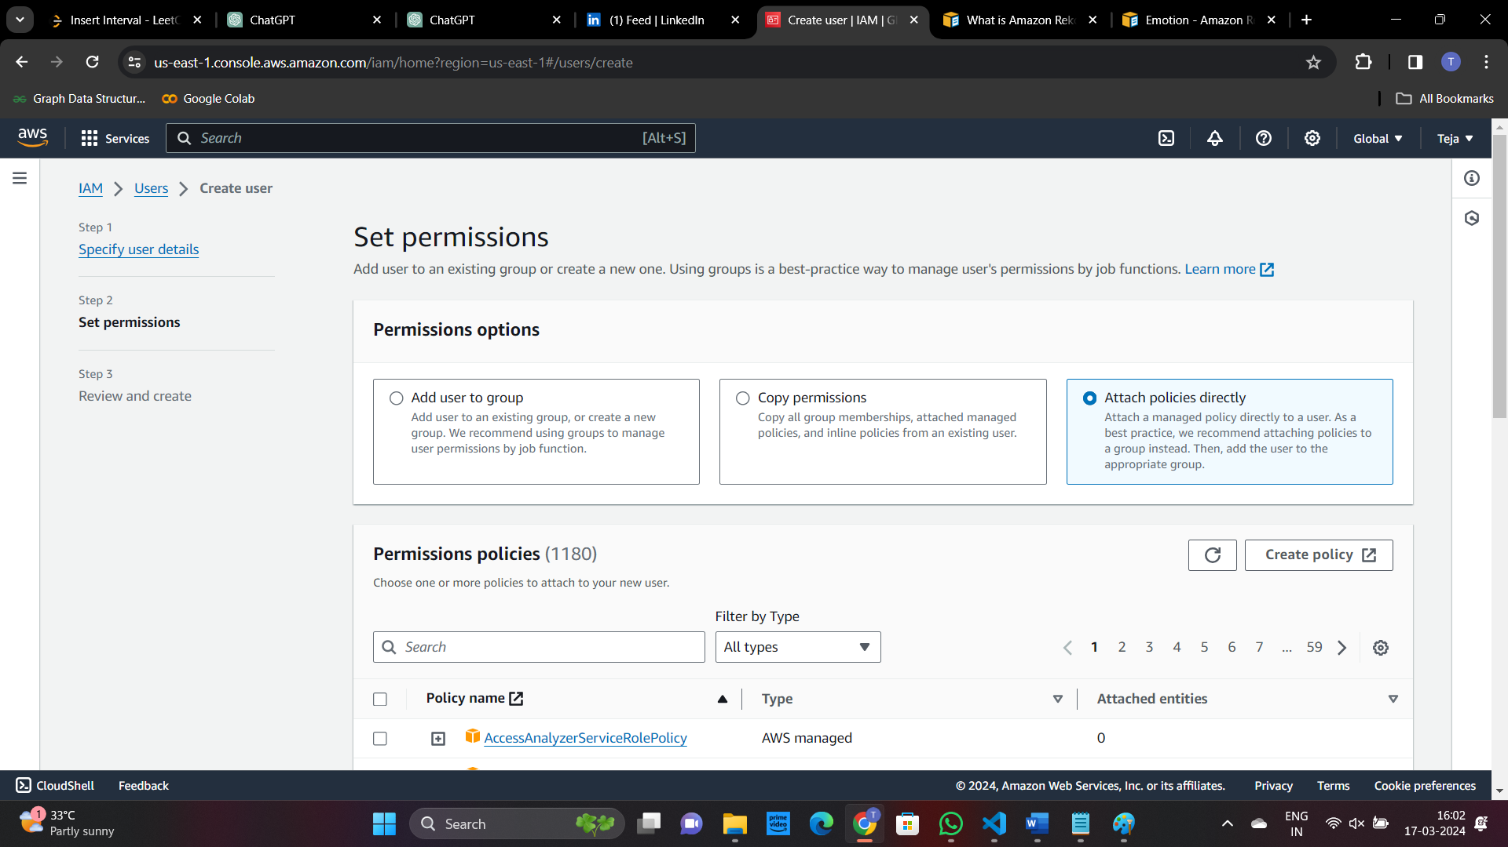

* Console password: If you selected "AWS Management Console access", set a password for the IAM user. You can either auto-generate a password or set a custom one.

* Require password reset: Optionally, you can choose to require the IAM user to reset their password at the next sign-in.

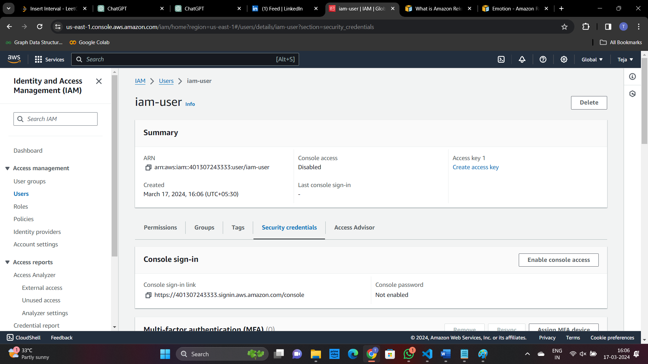

Click check box then next then create user and download the access key and secret access key

Review and Create:

Review the user details, permissions, and policies attached. Once you're satisfied, click on the "Create user" button.

Save User Credentials:

After the user is created, you will be provided with the user's access key ID and secret access key if you selected "Programmatic access". Make sure to save these credentials securely as they are required for programmatic access to AWS services via the AWS CLI, SDKs, etc.

Once the IAM user is created, they can use their credentials to access AWS resources according to the permissions granted to them. It's essential to follow security best practices, such as regularly reviewing user permissions and rotating access keys, to maintain a secure AWS environment.

Amazon Rekognition (AMS SSPS)

Amazon Rekognition makes it easy to add image and video analysis to your applications using proven, highly scalable, deep learning technology that requires no machine learning expertise to use. With Amazon Rekognition, you can identify objects, people, text, scenes, and activities in images and videos, as well as detect any inappropriate content. Amazon Rekognition also provides highly accurate facial analysis and facial search capabilities that you can use to detect, analyze, and compare faces for a wide variety of user verification, people counting, and public safety use cases.

With Amazon Rekognition Custom Labels, you can identify objects and scenes in images that are specific to your business needs. For example, you can build a model to classify specific machine parts on your assembly line or to detect unhealthy plants. Amazon Rekognition Custom Labels takes care of the model development heavy lifting for you, so no machine learning experience is required. You simply need to supply images of objects or scenes you want to identify, and the service handles the rest.