1. **Arithmetic Operators:**

**File Name:** Arithmetic.java  
class Arithmetic{

    public static void main(String[] args){

        int a=Integer.parseInt(args[0]);

        int b=Integer.parseInt(args[1]);

        System.out.println("Sum of "+a+" and "+b+" is "+(a+b));

        System.out.println("Difference of "+a+" and "+b+" is "+(b-a));

        System.out.println("Product of "+a+" and "+b+" is "+(a*b));

        System.out.println("Division of "+a+" and "+b+" is "+(b/a));

        System.out.println("Modulus of "+a+" and "+b+" is "+(b%a));

        System.out.println("Modulus of "+a+" and "+b+" is "+(b%a));

        System.out.println("Increment of "+a+ " is "+(++a));

        System.out.println("Decrement of "+b+ " is "+(--b));

    }

}

**Output:**

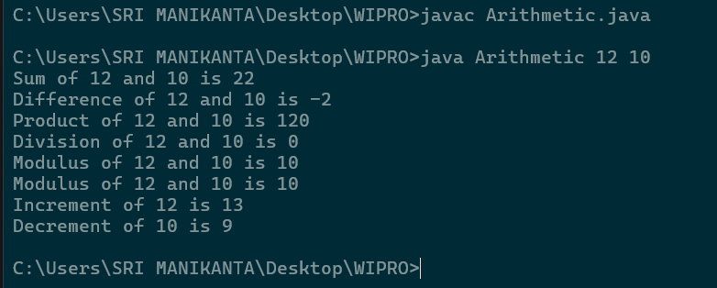

1. **Logical Operations:**

**File Name:** Logical.java

class Logical{

    public static void main(String[] args){

        boolean a=true;

        boolean b=false;

        System.out.println("Logical AND of "+a+" && "+b+" is "+(a&&b));

        System.out.println("Logical OR of "+a+" || "+b+" is "+(a||b));

        System.out.println("Logical NOT of "+a+" is "+(!a));

    }

}

**Output:**

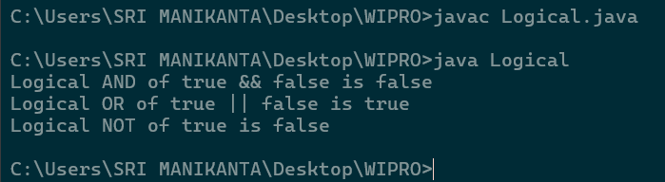

1. **Bitwise Operations:**

**File Name:** Bitwise.java

class Bitwise{

    public static void main(String[] args){

        int a=Integer.parseInt(args[0]);

        int b=Integer.parseInt(args[1]);

        System.out.println("Bitwise AND of "+a+" & "+b+" is "+(a&b));

        System.out.println("Bitwise OR of "+a+" | "+b+" is "+(a|b));

        System.out.println("Bitwise XOR of "+a+" ^ "+b+" is "+(a^b));

        System.out.println("Bitwise NOT of "+a+" is "+(~a));

    }

}

**Output:**

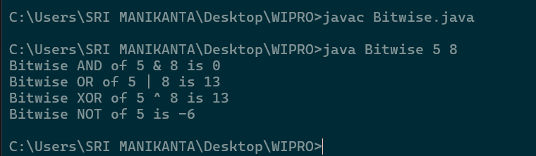

1. **Shift Operations:**

**File Name:** Shift.java

class Shift{

    public static void main(String[]args){

        int x=16,y=8;

        System.out.println("Rightt Shift of "+x+" x>>3 is "+(x>>3));

        System.out.println("Left Shift of "+y+" y<<4 is "+(y<<4));

    }

}

**Output:**

