Table

Style 1:

Table

|  |  |  |  |  |  |
| --- | --- | --- | --- | --- | --- |
|  |  |  |  |  |  |
|  |  |  |  |  |  |

Table

Style 2:

|  |  |  |  |  |
| --- | --- | --- | --- | --- |
| 1 |  |  |  |  |
| 2 |  |  |  |  |
| 3 |  |  |  |  |
|  | | | | |

Table

Style 3:

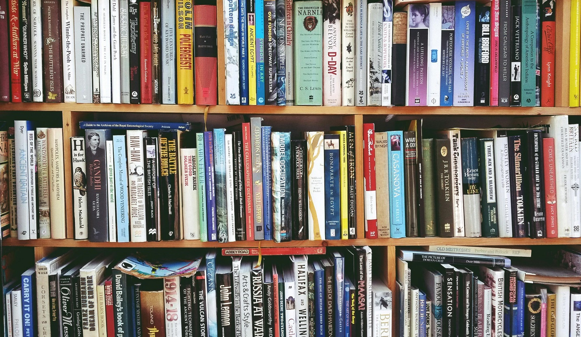

Figure

***Benzene***