**User Manual**

**EECS2311 Software Development Project**

**Group 14**

Adil Hashmi ( [adilhashmi.w@gmail.com](mailto:adilhashmi.w@gmail.com) )

Alexander Arnold ( [alex290@my.yorku.ca](mailto:alex290@my.yorku.ca) )

Boho Kim ( [kimboho614@gmail.com](mailto:kimboho614@gmail.com) )

Kanwarjot Bharaj ( [kjsingh76@gmail.com](mailto:kjsingh76@gmail.com) )

Stanley Ihesiulo ( [stanihe1901@gmail.com](mailto:stanihe1901@gmail.com) )

**Table of Contents**

Table of Contents - - - - - - - - **2**

1. About TAB2XML - - -- - - - - - **3**
2. System Requirements - - - - - - - **4**
3. Installing TAB2XML using Gradle - - - - - **5**
4. How to use TAB2XML - - - - - - - **10**
5. Input Requirements - - - - - - - **13**

## **1 – About TAB2XML**

1-1 Product Name and Intended Use

TAB2XML is a tool designed to convert musical tablature in a text format into MusicXML, a popular open-source file format used for exchanging digital sheet music. TAB2XML is currently a simple java-based application with more features being added every week.

1-2 Features of Product

This product is able to convert tablature of following instruments : Guitar, Drum, Bass

* Note: Since the product has not been implemented fully, instruments that the product can convert are limited, as of now. Reference How to Use.

## **2 – System Requirements**

|  |  |
| --- | --- |
| Available Disk Space | 50 MB |
| RAM | 256 MB |
| Java version | Java 15 |
| Operating System | Windows, MacOS, any platform with gradle |

## **3– Installing TAB2XML using Gradle**

TAB2XML is built as a Gradle project and thus should work on any IDE of your choice. However, we will only go over how to run the program using the IntelliJ and Eclipse IDE.

1. IntelliJ
2. We first need to clone the project from the online GitHub repository onto our local device. To do that, firstopen IntelliJ. At the top right, select File > New > Project from Version Control

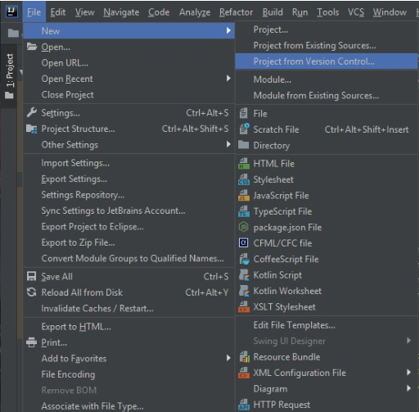

1. This will direct you to a window which prompts you to enter a repository URL. Enter the link <https://github.com/Stan15/TAB2XML> as the URL, and select a directory where the project should be saved.

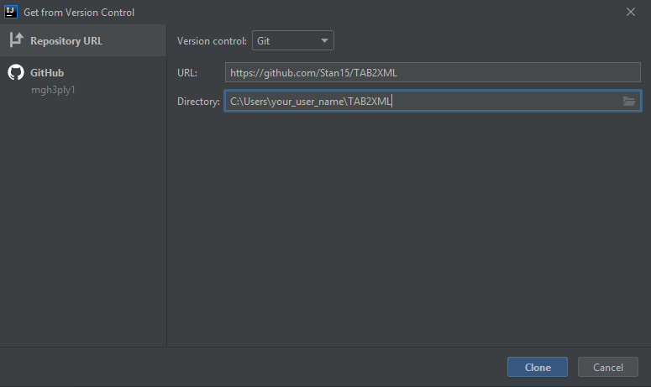

1. Once the project opens, click the Gradle toolbar on the right side of your screen.

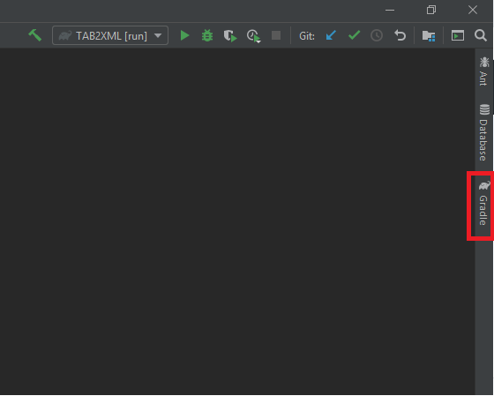

1. When the toolbar opens, click Tasks > build, and then right click “build” and the following dialog should pop up. Click “Run TAB2XML [build]”

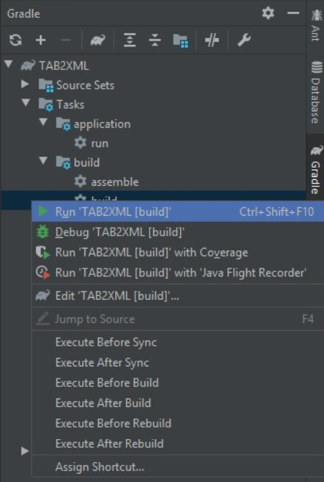

1. Finally select Tasks > application, and then right click the run task and select Run ‘TAB2XML [run]’. The program will now launch.
2. Eclipse
3. Like with IntelliJ, we want to clone the project from the GitHub repository. To do this, we select File > Import.

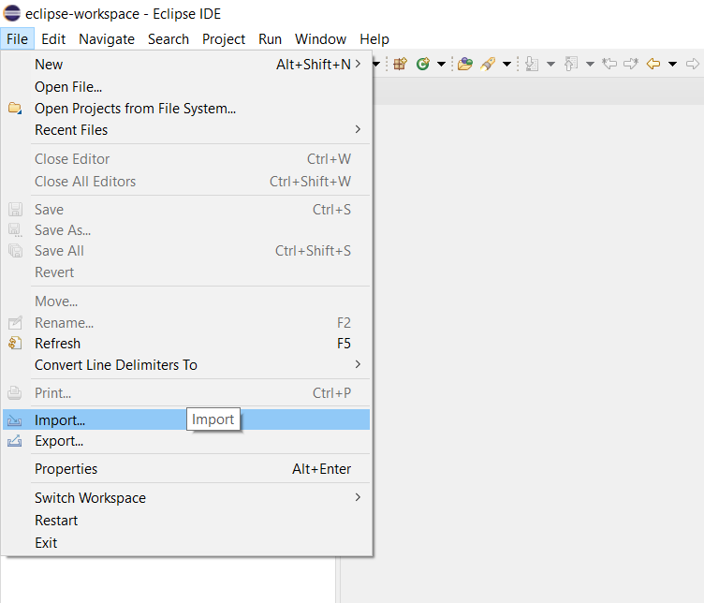

1. This will take you to a new window like the one below. Under the Git folder, click Projects from Git (with smart import)

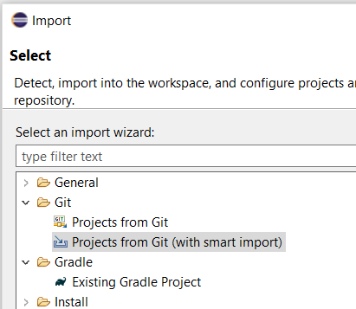

1. Next, click Clone URI

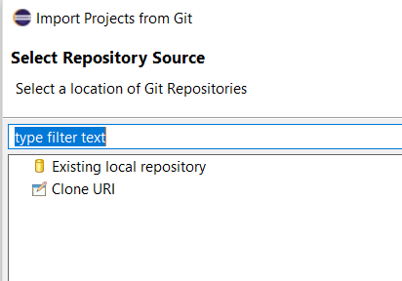

1. This will take you to a window where you are prompted to input a URI. Paste in the link <https://github.com/Stan15/TAB2XML> and click proceed with the steps (clicking next) until you see the finish button. Click on that.

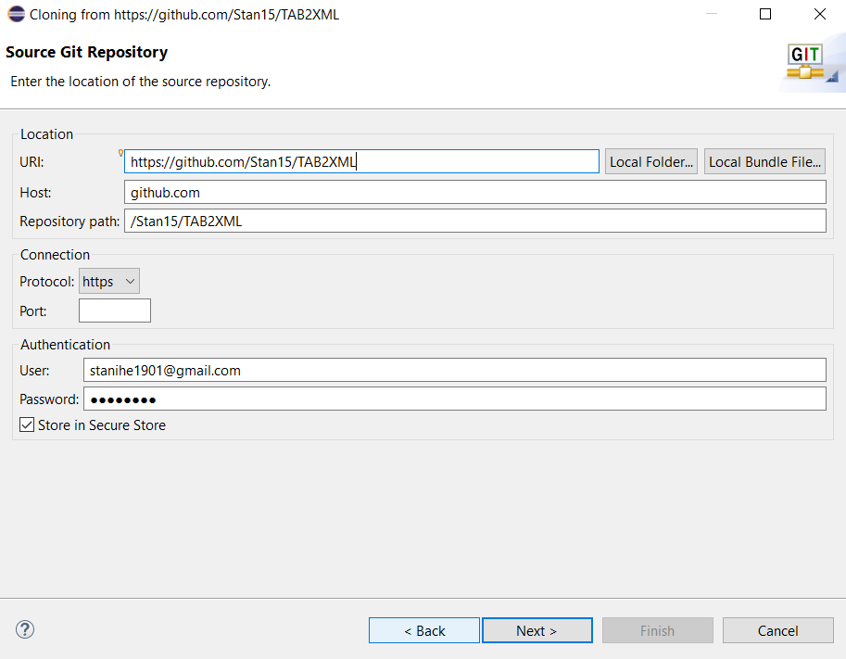

1. Now we have imported the project onto our local device, we want import it again as a Gradle project. Repeat step 1. When you get to the view shown in step 2, instead of clicking projects from Git, click Existing Gradle project. Proceed till you come to this page.

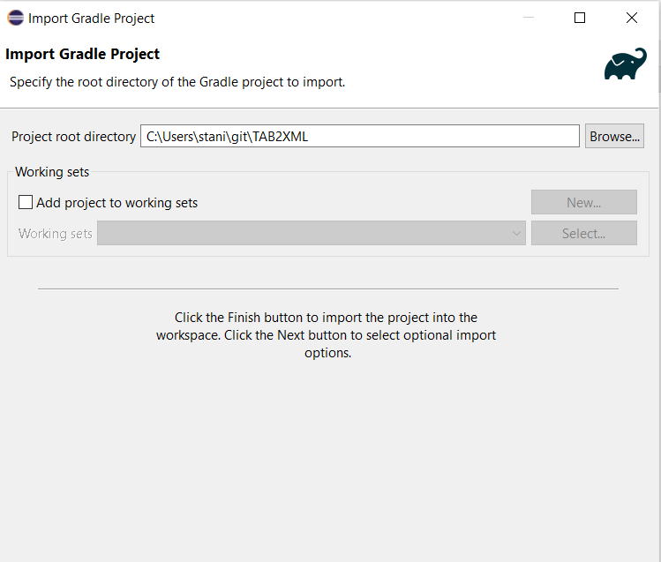

1. Specify the path of the Git project you cloned in the previous steps and click finish.
2. Click on the “Gradle tasks” icon on the right of your screen

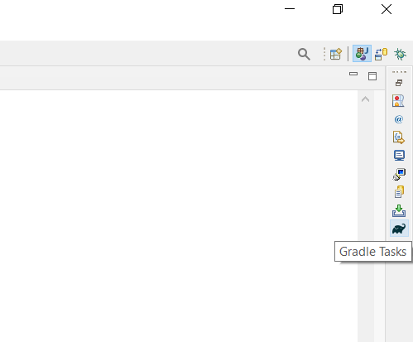

1. Double click on the Gradle “build” task at TAB2XML > build > build

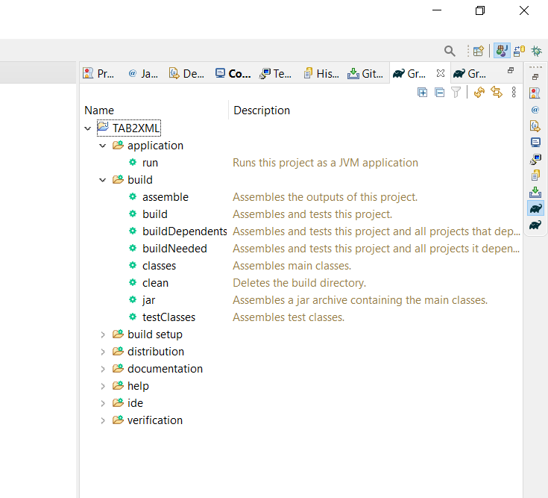

1. Finally, click on the run task on TAB2XML > application > run

## **4– How to use TAB2XML**

1. When you run the program, you will be able to see a text field at the center of screen (**Figure1**). This is where you paste in your tablature txt file.

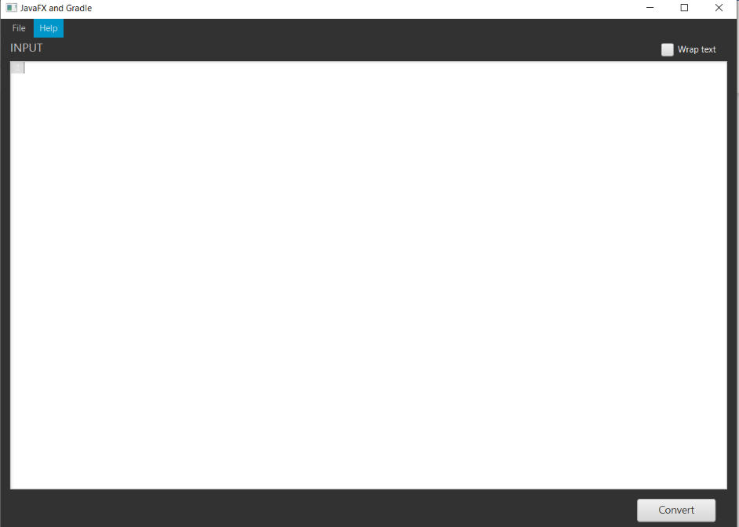

**Figure 1**

1. To put your input, click file-open and choose your file, or copy and paste your text file in text field.
2. Once you put your text input, system tells which information is not able to recognized and which information should be fixed for appropriate converting. It shows message when the mouse pointer hovers over it.

* Blue highlight: “This text can’t be understood.” (**Figure 2**).

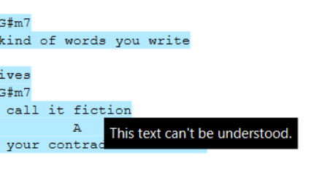

**Figure 2**

* Yellow highlight: “A guitar measure should have 6 lines.” (**Figure 3**).

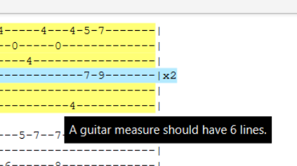

**Figure 3**

* Red highlight: “This annotation is either unsupported or invalid”

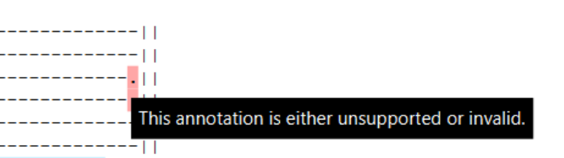

**Figure 4**

Note: Notations which program can support are limited, as of now. It will be updated gradually.

Note: When you load your file (not copying and paste), there may not be highlights. It will be updated.

1. For proper expected result, just be sure if there is no yellow highlight in your guitar tablature. Blue highlight outside tablature can be ignored.

* How to fix :

Be sure the number of lines of instrument is right.

Remove all unrecognizable notations in tablature and replace with dash ‘-’.

Remove all texts which is placed around score bars except for key notation.

(How to fix instruction video: <https://drive.google.com/file/d/174oWzswHkvnTvyask_AUpYKRjKmuz3_m/view?usp=sharing>)

If you removed all yellow and red highlight, it is ready to be converted.

(If there is no yellow and red highlight in score bars information, you can skip this step)

1. Click the “Convert” button. This opens new window for some option(**Figure5**).

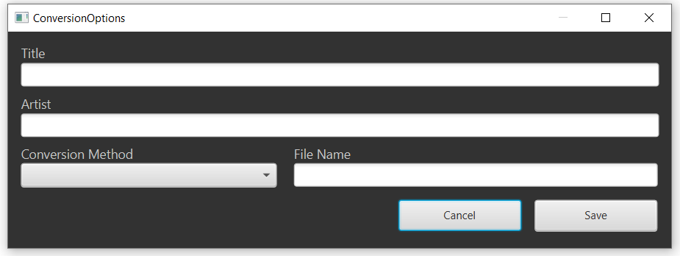

Figure 5

Title – You can set the title of song.

Artist – You can set the artist name.

Conversion Method – You can choose your score type. Piano or Tablature type.

File Name – You can name your file.

* Note: All of functions has not been implemented. It will be updated gradually.

If you set all of them, click save button.

1. If you set all of them, click save button. Navigate to the location where you want to save your converted file and save it. You can also change file name.(**Figure 6**)

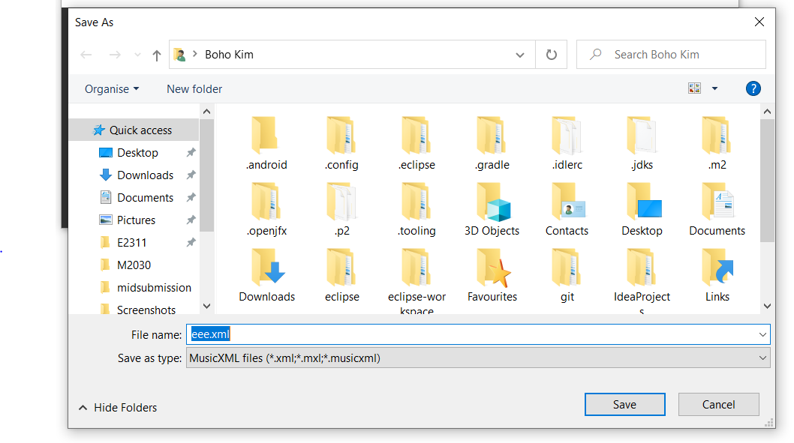

Figure 6

## **5– Input Requirements**

For Guitar:

Some sample tablature text files that meet the below requirements can be found in the project folder in the directory TAB2XML/src/test/resources/test_tab_files. The tablature file input into the program must meet the following requirements:

1. The tablature file must start with a vertical line after the string name.
2. Each group of measures must be separated by a blank line.
3. you may not have text by the side of a measure which itself is not a measure.
4. The line names must all be lower caps, except for the E string which can be lower caps to distinguish the lower e string from the upper E string.

Note: Information of other instruments will be updated gradually.