**Minor Project Report: Car Racing Game Using Python**

**Submitted by:**  
Ashwin Kumavat  
Roll No: 2021UG4029

**Submitted to:**  
Dr. Shivang Tripathi

**Project Overview**

This report documents the development and completion of my minor project titled "Car Racing Game," created using Python and the Pygame library. The project features a competitive car racing game where the player competes against a bot-controlled car. The game's difficulty escalates over 10 levels, each introducing more challenging AI behaviour to enhance player engagement and skill development.

**Project Objectives**

1. **Build an Engaging Game Environment**: Create a responsive, visually appealing game environment.
2. **Implement Player Controls**: Enable smooth, intuitive controls for the player’s car.
3. **Develop Bot AI**: Program the bot car to simulate competitive behaviour with increasing difficulty.
4. **Introduce Level Progression**: Design a progressive difficulty system across 10 levels.
5. **Enhance UI and Graphics**: Add graphics and design elements for a polished look.
6. **Ensure Game Stability**: Perform thorough testing to guarantee smooth gameplay.

**Project Development Phases**

**1. Game Environment Setup**

* **Tools and Libraries**: The game is built using Python with the Pygame library for graphical support.
* **Environment Design**: Created a basic race track layout with boundaries, start/finish lines, and checkpoints for smooth navigation.

**2. Player Car Controls**

* **Functionality**: Configured key controls for forward movement, backward movement, and steering, creating a realistic feel for the player's car.
* **Testing**: Ensured responsive and lag-free control over various terrain sections of the track.

**3. Bot Car AI**

* **Initial Setup**: Developed basic movement logic for the bot, which involves following the track path while avoiding collisions.
* **Difficulty Scaling**: Enhanced the bot's speed and navigation with each level, using adaptive algorithms to simulate a progressively challenging opponent.

**4. Level Progression & Difficulty Scaling**

* **Dynamic Level Progression**: Each time the player wins a level, the game automatically progresses to the next level, adjusting the bot's difficulty.
* **Complexity Enhancements**: Introduced increasingly aggressive manoeuvres and optimized pathfinding for the bot at higher levels.

**5. Graphics and UI Design**

* **Visual Aesthetics**: Enhanced visual appeal through UI elements like scoreboard, health bars, and progress indicators.
* **Game Assets**: Used custom-designed icons, background textures, and car models for an immersive experience.

**6. Testing and Debugging**

* **Methodology**: Conducted testing across multiple devices and resolutions to ensure stability and responsiveness.
* **Bug Fixes**: Addressed minor issues related to control lag, collision detection, and boundary constraints to ensure a seamless player experience.

**Key Learnings and Challenges**

1. **Game AI Development**: Designing a bot with adaptive intelligence was challenging, particularly with real-time decision-making.
2. **Level Progression Logic**: Implementing a smooth transition between levels while ensuring the bot’s difficulty scaled accurately required extensive testing and iteration.
3. **Performance Optimization**: Adjusting graphical elements and handling memory management in Pygame was essential to avoid lags, especially at higher levels.

**Conclusion**

The Car Racing Game project was successfully developed to meet the objectives set out at the beginning. It offers an engaging and challenging experience for players, with 10 levels of progressive difficulty. This project strengthened my skills in Python programming, game design principles, and AI logic, which were instrumental in overcoming the challenges faced during development.

**Report Attachments**

1. **Project Code**: Available on [GitHub](https://github.com/ashwinkumavat/car-racing-game)
2. **Screenshots**: Sample images are embedded above and also available in the GitHub repository.  
     
   Gameplay screenshot:

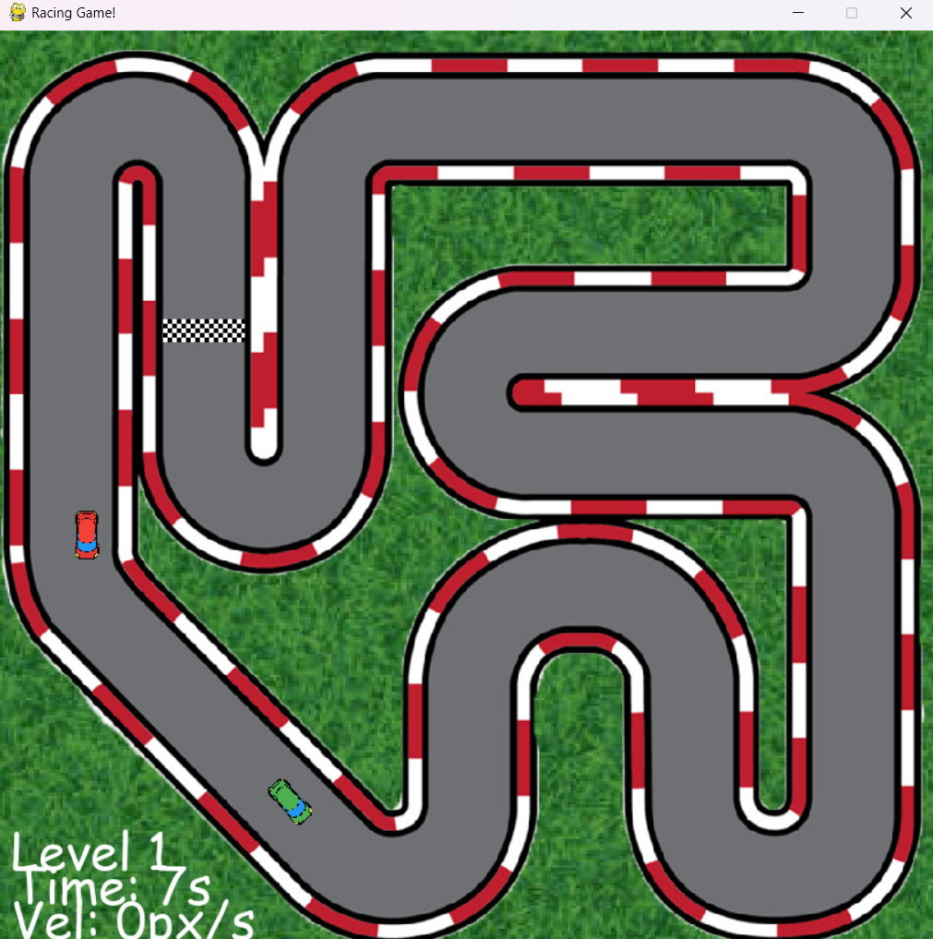

**Acknowledgment**  
I would like to extend my gratitude to Dr. Shivang Tripathi for his valuable guidance and support throughout this project.

**Best regards,**  
Ashwin Kumavat  
2021UG4029