Aaron Kellan-Fernandez

**Description:**  
This screenshot shows the initial state of the **WPF Register Student** program before any course registrations.

* The **comboBox (dropdown menu)** is empty, indicating no course has been selected yet.
* The **listBox** (displaying registered courses) is currently empty.
* The **textBox** for **Total Credit Hours** is set to **0**, showing that no courses have been registered yet.
* The **"Register for this course"** button is enabled, allowing the user to register a course once selected.

This confirms that the program starts with a **clean state** and is ready for user interaction.

**Description:**  
This screenshot captures the **successful registration** of a course in the **WPF Register Student** program.

* The **comboBox** shows that "IT 145" was selected.
* The **confirmation message box** states: *"You have successfully registered for IT 145."*
* The **listBox** (registered courses list) now displays **"IT 145"**, confirming that the course was added.
* The **textBox** for **Total Credit Hours** has updated to **3**, reflecting that one course (worth 3 credits) has been registered.

This verifies that the **program correctly registers a selected course** and updates the UI accordingly.

**Description:**  
This screenshot demonstrates that the **WPF Register Student** program correctly allows multiple course registrations while enforcing the **9-credit hour limit**.

* The **comboBox** shows "IT 201" as the last selected course.
* The **listBox** now displays three registered courses:
  + IT 145
  + IT 200
  + IT 201
* The **textBox** for **Total Credit Hours** has updated to **9**, confirming that three courses (each worth 3 credits) have been registered.
* The **"Register for this course"** button appears enabled, but the user will not be able to register for additional courses beyond this point.

This confirms that the program correctly tracks multiple registrations and **updates total credit hours accordingly**.

Description:

This screenshot demonstrates the duplicate course registration prevention feature in the WPF Register Student program.

The comboBox shows "IT 201" as the selected course.

The user attempted to register for "IT 201" again, even though it was already registered.

A message box appears stating: "You have already registered for this course," preventing the duplicate registration.

The listBox still correctly displays the previously registered courses:

IT 145

IT 200

IT 201

The textBox for Total Credit Hours remains at 9, ensuring that duplicate courses do not affect the credit count.

This confirms that the program correctly enforces the one-time registration rule for each course.

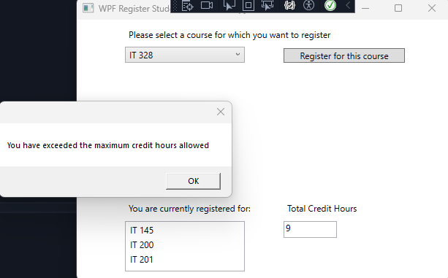

**Description:**  
This screenshot demonstrates the **maximum credit hour enforcement** in the **WPF Register Student** program.

* The **comboBox** shows "IT 328" as the selected course.
* The user attempted to **register for a fourth course**, which would exceed the **maximum allowed 9 credit hours**.
* A **message box appears** stating: *"You have exceeded the maximum credit hours allowed,"* preventing the registration.
* The **listBox** correctly shows only the previously registered courses:
  + IT 145
  + IT 200
  + IT 201
* The **textBox** for **Total Credit Hours** remains at **9**, ensuring that no additional credits are counted beyond the limit.

This confirms that the program correctly prevents students from registering for more than **three courses (9 credit hours total)**.

**Description:**  
This screenshot demonstrates the **error handling for an empty course selection** in the **WPF Register Student** program.

* The **comboBox** is empty, meaning no course was selected.
* The user attempted to click **"Register for this course"** without choosing a course.
* A **message box appears** stating: *"Please select a course to register,"* preventing the action.
* The **listBox** remains empty, confirming that no course was accidentally registered.
* The **textBox** for **Total Credit Hours** stays at **0**, ensuring no unintended changes occurred.

This confirms that the program correctly prevents users from registering without selecting a course, maintaining **data integrity and preventing crashes**.

**Source Code:**private void button_Click(object sender, RoutedEventArgs e)

{

if (comboBox.SelectedItem == null)

{

MessageBox.Show("Please select a course to register.");

return;

}

choice = (Course)(this.comboBox.SelectedItem);

try

{

if (choice.IsRegisteredAlready())

{

MessageBox.Show("You have already registered for this course");

}

else if (totalCreditHours + 3>9)

{

MessageBox.Show("You have exceeded the maximum credit hours allowed");

}

else

{

choice.SetToRegistered();

listBox.Items.Add(choice.getName());

totalCreditHours += 3;

textBox.Text = totalCreditHours.ToString();

MessageBox.Show("You have successfully registered for " + choice.getName());

}

}

catch (Exception ex)

{

MessageBox.Show("An unexpected error occurred: " + ex.Message);

}

}