**Creating EC2 instance:**

* Amazon has pre-installed image called AMI (Amazon Machine Image)
* We can customize our own AMI. We can create AMI from a running instance

**AMI:**

* It is like a template contains the information to launch the server like OS, volumes etc.

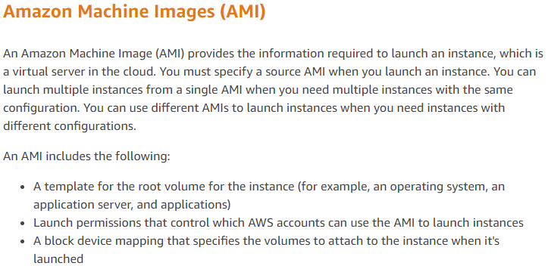

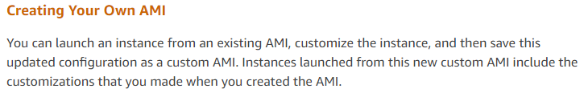

* EBS (Elastic Block Storage)
* Tag is to define the instances. To find out which machine is used for which purpose
* Security group, we need to define how to access the instance. If we want to access any software inside the instance through http/https, we need to define that in security group
* If we want our instance to be pinged, to check the instance is up or not, we need to give ICMP – ipv4 for that
* If we give custom, we can set up only the range of ips to access the instance. Inside organisation, we can set up to access the instance only from some range of ips
* We can also define the connection type as SSH or http or telnet etc
* Key.pem we can use in git bash to login
* We need to convert it into .ppk to use with putty





* We can use any of the above commands to connect the instance
* We can use either -l to give the username of give username@ip

**Elastic IP:**

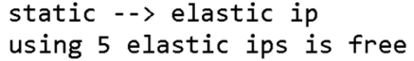

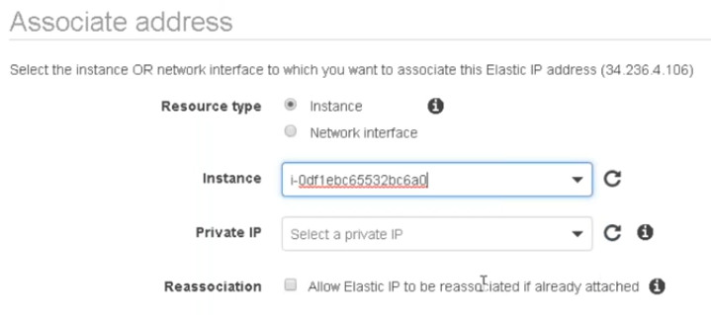

* After creating elastic ip, we can assign it to the instance as above
* We can also assign password to root account and allow to login with root directly. But it is not recommended
* In security group, outbound means the restriction to access any website or wget or curl or something from the instance. This we won’t give any restrictions
* And inbound is to access something to the instance
* By default, http port is 80 and https is 443