Inside the instance, install httpd and start it

* **Sudo yum install httpd -y**
* **Service httpd start**

Then insert something into **/var/www/html/index.html**

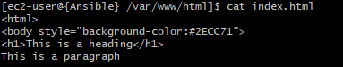

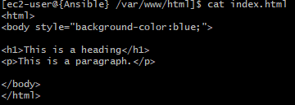

* We can access it by using server IP