**Artifactory:**

* We can get this tool from jfrog.com, this is the company where the tool comes from
* It is open source free tool, licensed version is also available
* It is binary code repository. Nexus also does the same job
* Username is admin and password is password

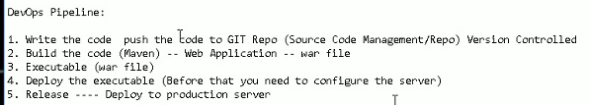

* Git actually takes text and artifactory generally takes binary
* It is meant for binary repo, that’s why we use this instead of git repo. It has types of projects which helps us to store the files like snapshot and release versions
* Artifactory support many types of executables like .exe, .jar, .war, .apk etc…
* Container is we may put the war file there
* We can configure it on multiple servers or multiple data centres
* We can create artifactory on standalone server or cloud or even on our laptop
* We need to install jdk for artifactory
* There should be artifactory plugin available in Jenkins. Artifactory is not the default one. So we need to install manually
* Go to configuration settings and we need to add artifactory server url and credentials.

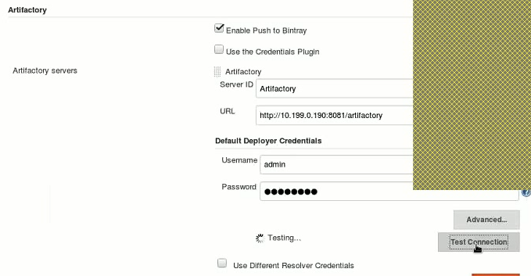

* We can even test the connection
* url is be like <http://ip:8081/artifactory>

**create a maven project:**

* create a webapp maven archetype project. configure the git repo at the same location of ppom.xml. commit them and push it to remote repo
* create a job with SCM by giving the credentials as well

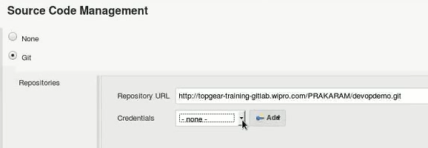

* And build goal also

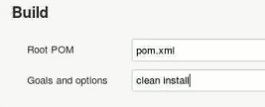

* Clean cleans the old data and install
* And then under post build actions, we need to give the artifactory server to deploy there

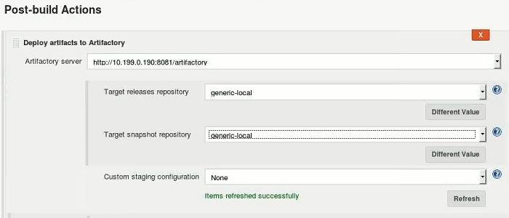

* Just refresh it, we can able to get the repositories. URL will be there by default
* Under global configure security, enable the security, select Jenkins own user database. Then matrix-based security, select all anonymous users
* Now, we can build the job, it will copy the war file to artifactory and places generic-local
* We can go to the location where we installed jfrog and go to the tomcat directory which we installed under this and go to conf folder and edit the server.xml file. We can find the port number for artifactory
* We have to stop and start the tomcat again
* Inside bin directory, we can find startup.sh
* Kill all the tomcat services, stop artifactory, start tomcat and access it
* **Service artifactory stop**
* **Service artifactory status**
* It’s not the artifactory configuration, its tomcat inside the artifactory
* When we are changing the port in server.xml, make sure we down the tomcat or restart it after changing it
* If proxy is giving problem, we can disable it in browser settings
* We need to select bypass proxy while jenkins configuration
* The drawback of this is we don’t know what the packages are brought into this artifactory

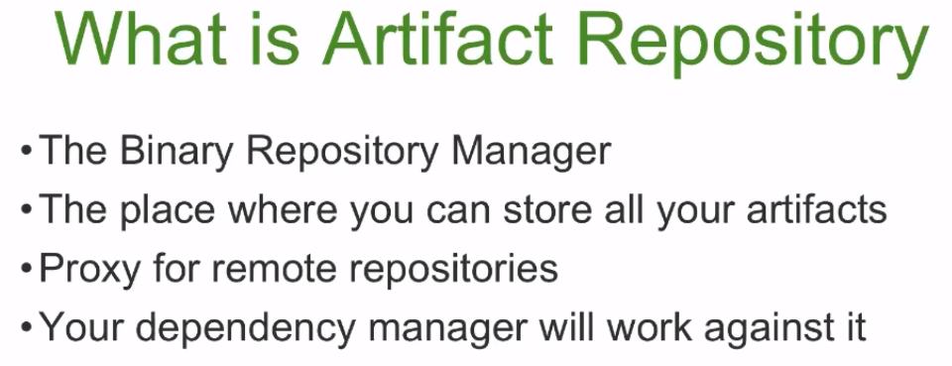

* Newgate, maven, ruby etc… all can work with artifactory, that’s why it is called a universal artifactory repository manager

We can setup an artefact using set me up option

Then we can select the package type and repository type

We can also give the credentials

