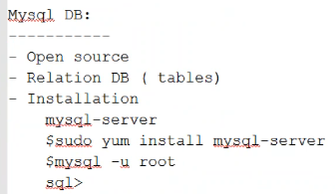

* Install, create and taking backup of DB we will be doing

Mysql - -version

* Sudo /etc/init.d/mysqld status 🡪 to check the status
* Sudo /etc/init.d/mysqld start 🡪 to start the DB
* Mysql -u root 🡪 to connect the DB
* Show databases; 🡪 to check the DBs
* Create database DB1; 🡪 to create the DB
* Use DB1; 🡪 to get into DB1

Mysql runs on 3306 port by default

* Netstat -n | grep 3306 🡪 to check if the port is open

Taking backup



* Mysql -u <username> -p<password> 🡪 to login
* $ mysqldump -u leadapp -pleadapp DB1 > DB1.sql 🡪 to take the backup
* $ mysqldump -u leadapp -pleadapp DB1 < DB1.sql 🡪 to load the sql backup file

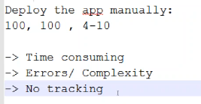

* Our job is to automate the deployment

