**Sample pod:**

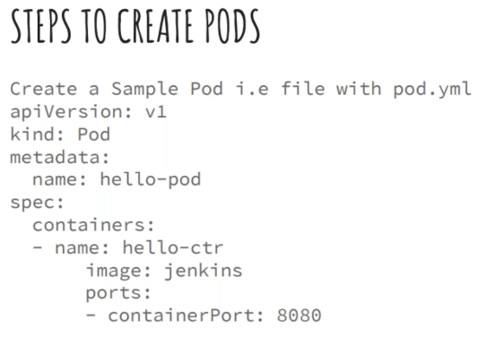

In master create an yml file as above

Now, run the below command

* Kubectl apply -f pod.yml

Now, we can see the pods with below commands

* Kubectl get pods
* Kubectl get pods -o wide 🡪 for more details

Below command to check the nodes

* Kubectl get nodes

To delete the yml

Kubectl delete -f pod.yml

Below is the command to check the system pods

* Kubectl get pods –all -namespaces
* Kubectl get pods –all -namespaces 🡪 to check the in-depth details on where the pods are running

Kubernetes won’t run if any of the system pod is not running

If we check the docker images, we can see many images which are kubernetes related images

In yaml file, kind is about which kind we want to build

Metadata is about our pod. Like what it all contains

Spec is that we tell kubernetes api manager, what has to be done

If there any port required for image, we need to mention that also

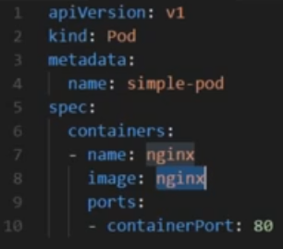

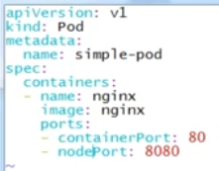

If we want to expose the pod, then we need to add nodeport as above

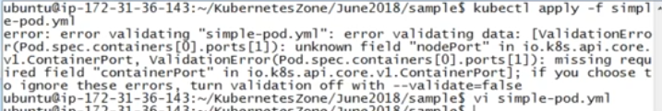

But kubernetes can’t understand the nodeport because of the apiversion, so we need to be careful while using the apiversion

* Kubectl expose pod <pod name> --port=80 –target-port=8080 –name=nginix-expose

We get the below error if we run above command

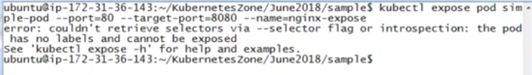

So, we need to create labels