Website Automation Project Requirement

# General Information

## Description

In this project, you will create a UiPath process that performs two stages. We require you to extract the data based on the given requirements to an excel sheet and then send out an email with the extracted excel document to our email ID.

**Project Requirements**

## Robot Steps

1. Open <https://www.barfoot.co.nz/>
2. Navigate to the **Buy** section



1. Click on **Residential**
2. Navigate to **Filters**



1. Add the following filters under **Residential Tab**
   * **Location:** New Lynn
   * **Property types:** House
   * **Bedrooms:** 2
   * **Bathrooms:** 1
   * **Sort properties by:** Lowest price

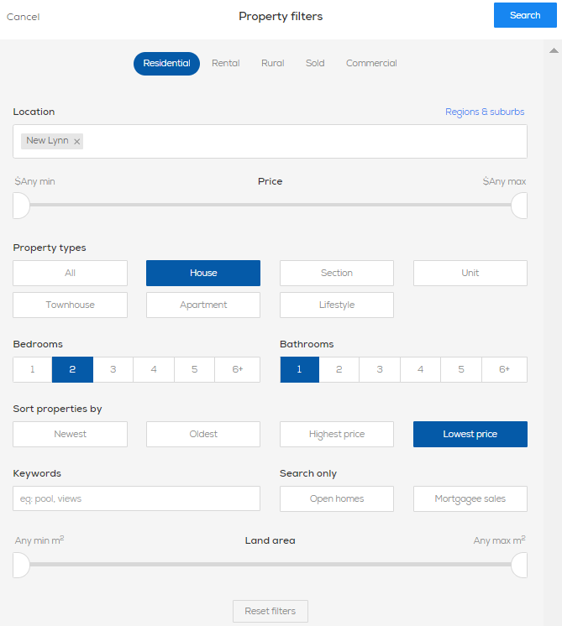

1. Use [Data Scraping](https://docs.uipath.com/studio/docs/about-data-scraping) to document all the search results and save them to an excel file called **sale_result.xlsx**
2. Navigate to the **Rent** section



1. Click on **All Rentals**
2. Navigate to **Filters**



1. Add the following filters under **Rental Tab**
   * **Location:** City Centre
   * **Property types:** Apartment
   * **Bedrooms:** 2
   * **Bathrooms:** 1
   * **Furnished/Unfurnished:** Furnished
   * **Search Only:** Available now
   * **Sort properties by:** Lowest price

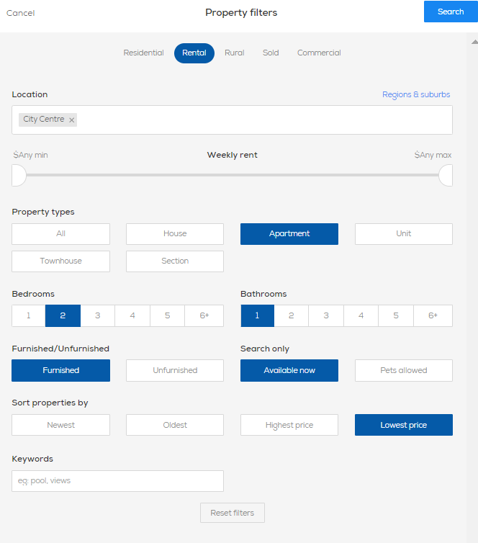

1. Use [Data Scraping](https://docs.uipath.com/studio/docs/about-data-scraping) to document all the search results and save them to an excel file called **rent_result.xlsx**
2. Send an email with the **sale_result.xlsx** and **rent_result.xlsx** attached as an attachment to email.