Git clone <https://github.com/AKs1190/Docker-Zero-to-Hero.git>

Docker build -t aks1105/web-python-image .

Docker image push aks1105/web-image-python

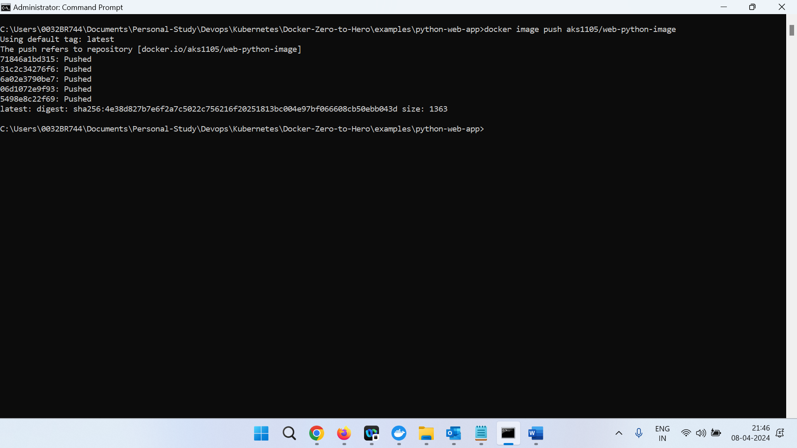

kubectl run my-pod --image=aks1105/web-image-python --dry-run=client -o yaml > pod.yaml

kubectl apply -f pod.yaml

kubectl get pods my-pod -o wide

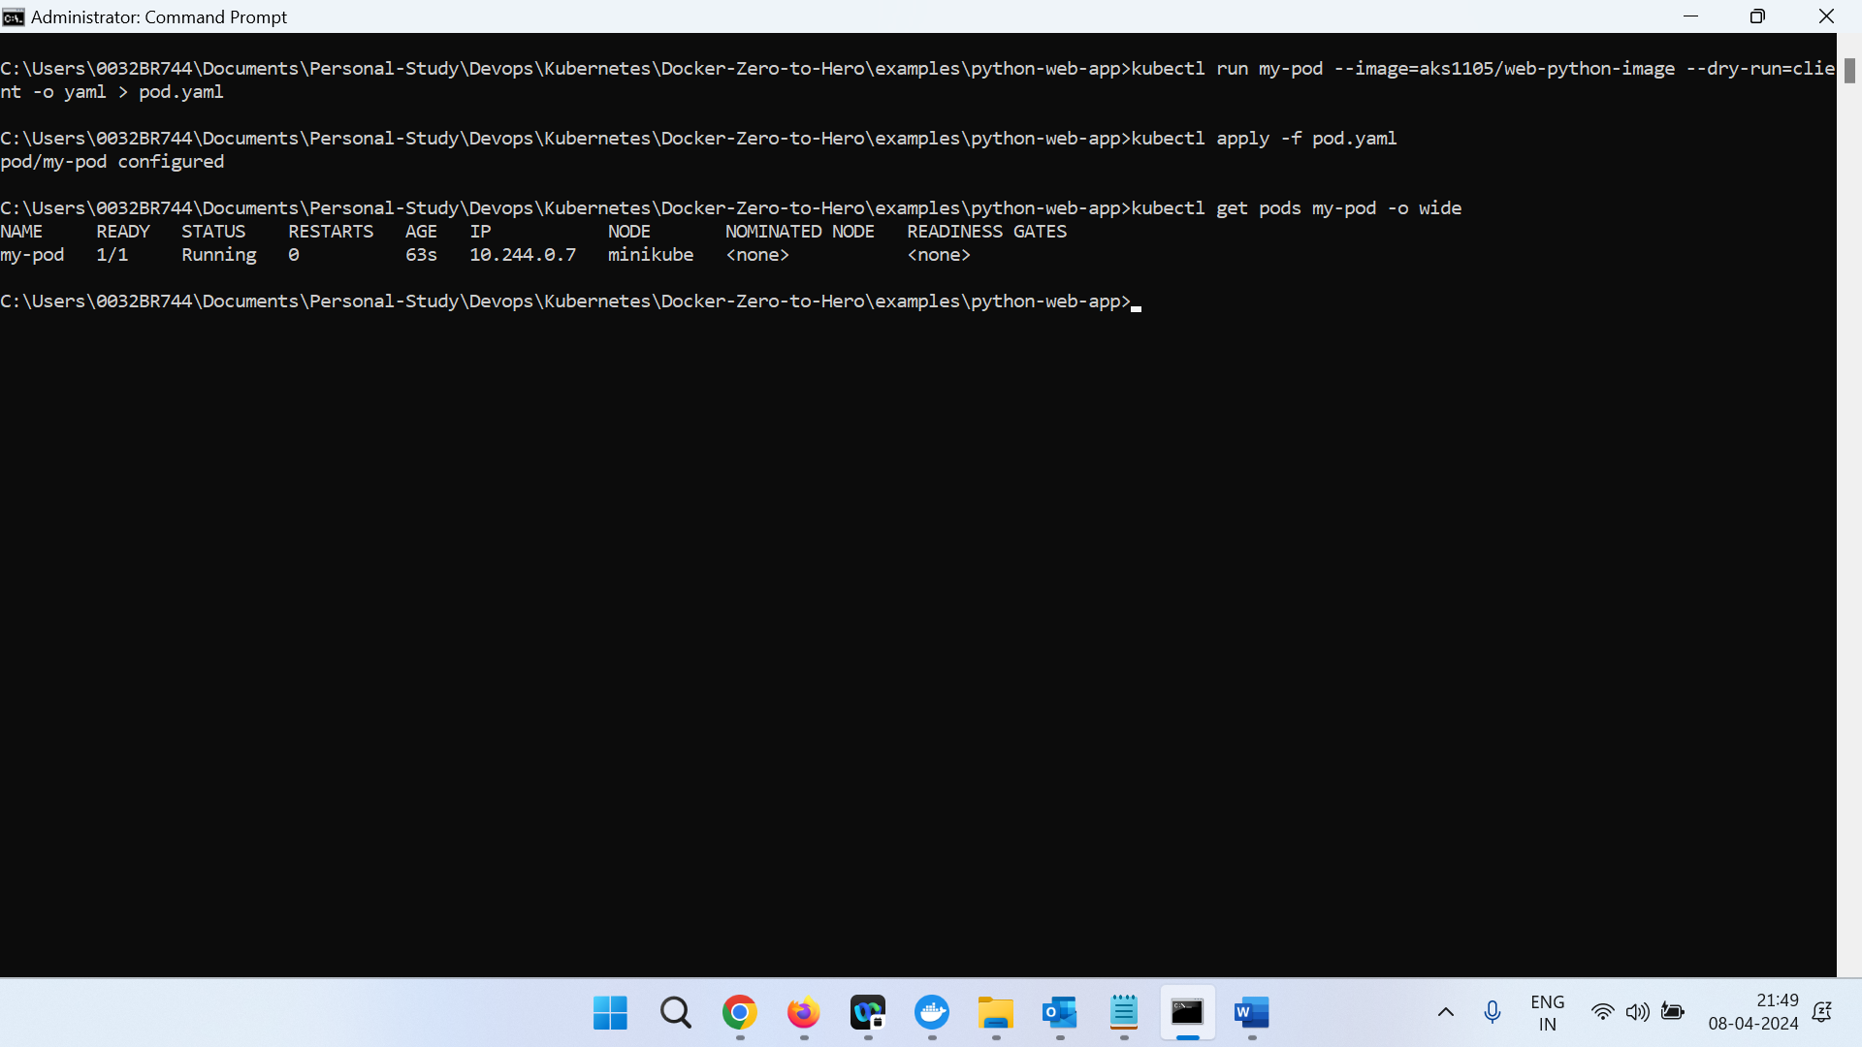

Minikube ssh

Curl -L curl -L <http://10.244.0.7:8000/demo>

kubectl create deployment my-app-deploy --image=web-python-image --dry-run=client -o yaml > my-app-deploy.yaml

kubectl create service nodeport my-app-service --tcp=3007:8000 --dry-run=client -o yaml > my-app-service.yaml

kubectl get svc

Minikube ssh

Minikube ip 🡪 to get public ip of cluster

Minikube service –all

Minikube service my-app-service –url

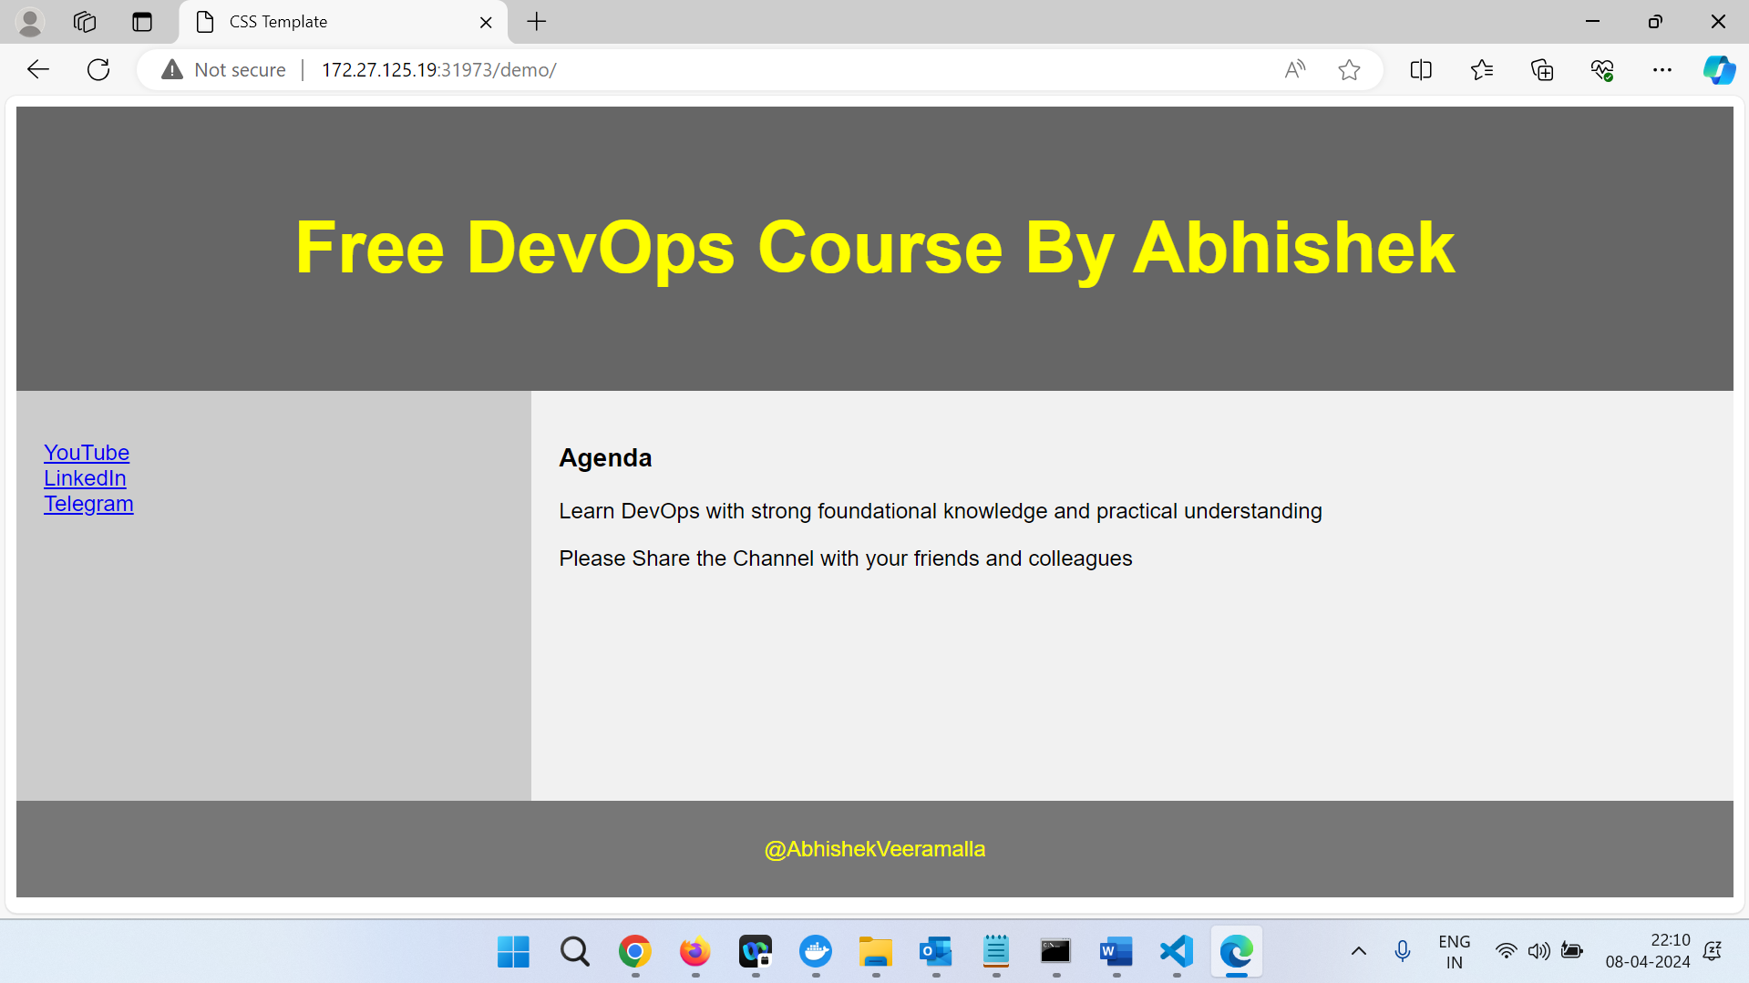

Change service type from nodeport to loadbalancer

kubectl apply -f my-app-service.yaml

kubectl get svc

external ip should be pending

To check LB install kubeshark

curl -LO <https://github.com/kubeshark/kubeshark/releases/download/v52.2.1/kubeshark.exe>

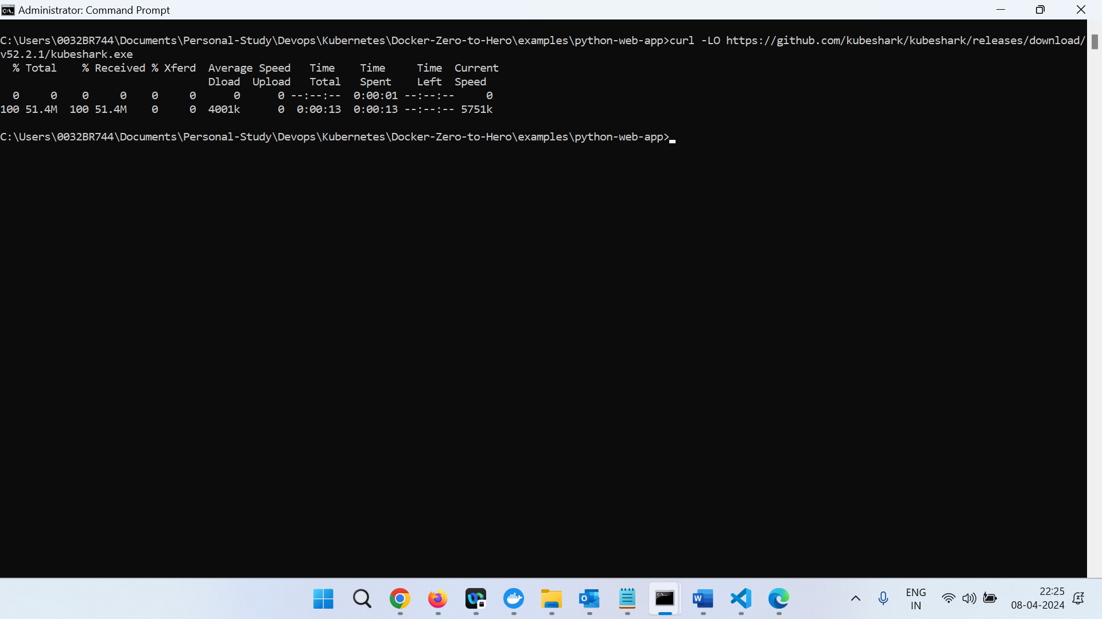

kubeshark tap

<http://localhost:8899>

Filter : http and request.path == "/demo"