git clone <https://github.com/LondheShubham153/reddit-clone-k8s-ingress.git>

docker build -t aks1105/reddit-app .

Docker push image aks1105/reddit-app

Create test pod to check if able to fetch image from dockerhub

kubectl run my-pod --image=aks1105/reddit-app --dry-run=client -o yaml > my-pod.yaml

kubectl apply -f my-pod.yaml

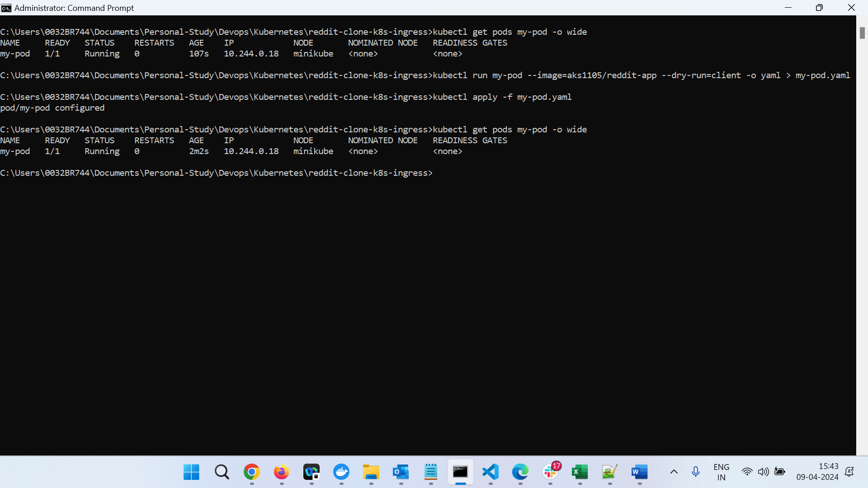

Minikube ssh

Curl -L http:// 10.244.0.18:3000

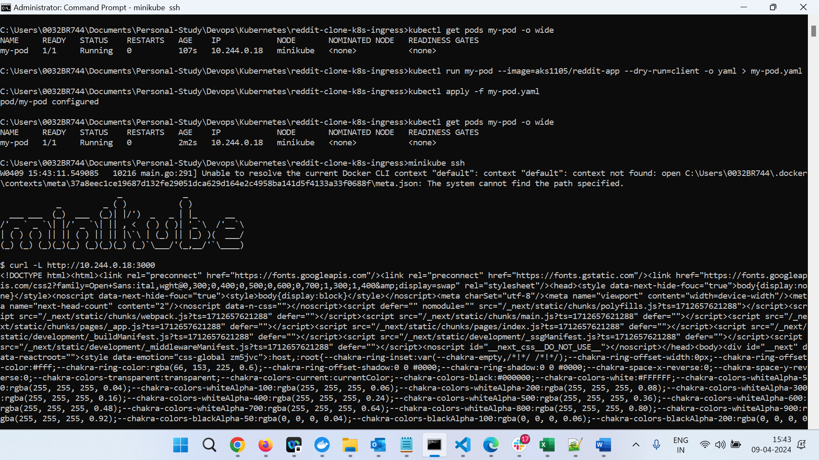

Delete test pod

Kubectl delete pod my-pod

Update image name in deployment.yaml

kubectl apply -f deployment.yml

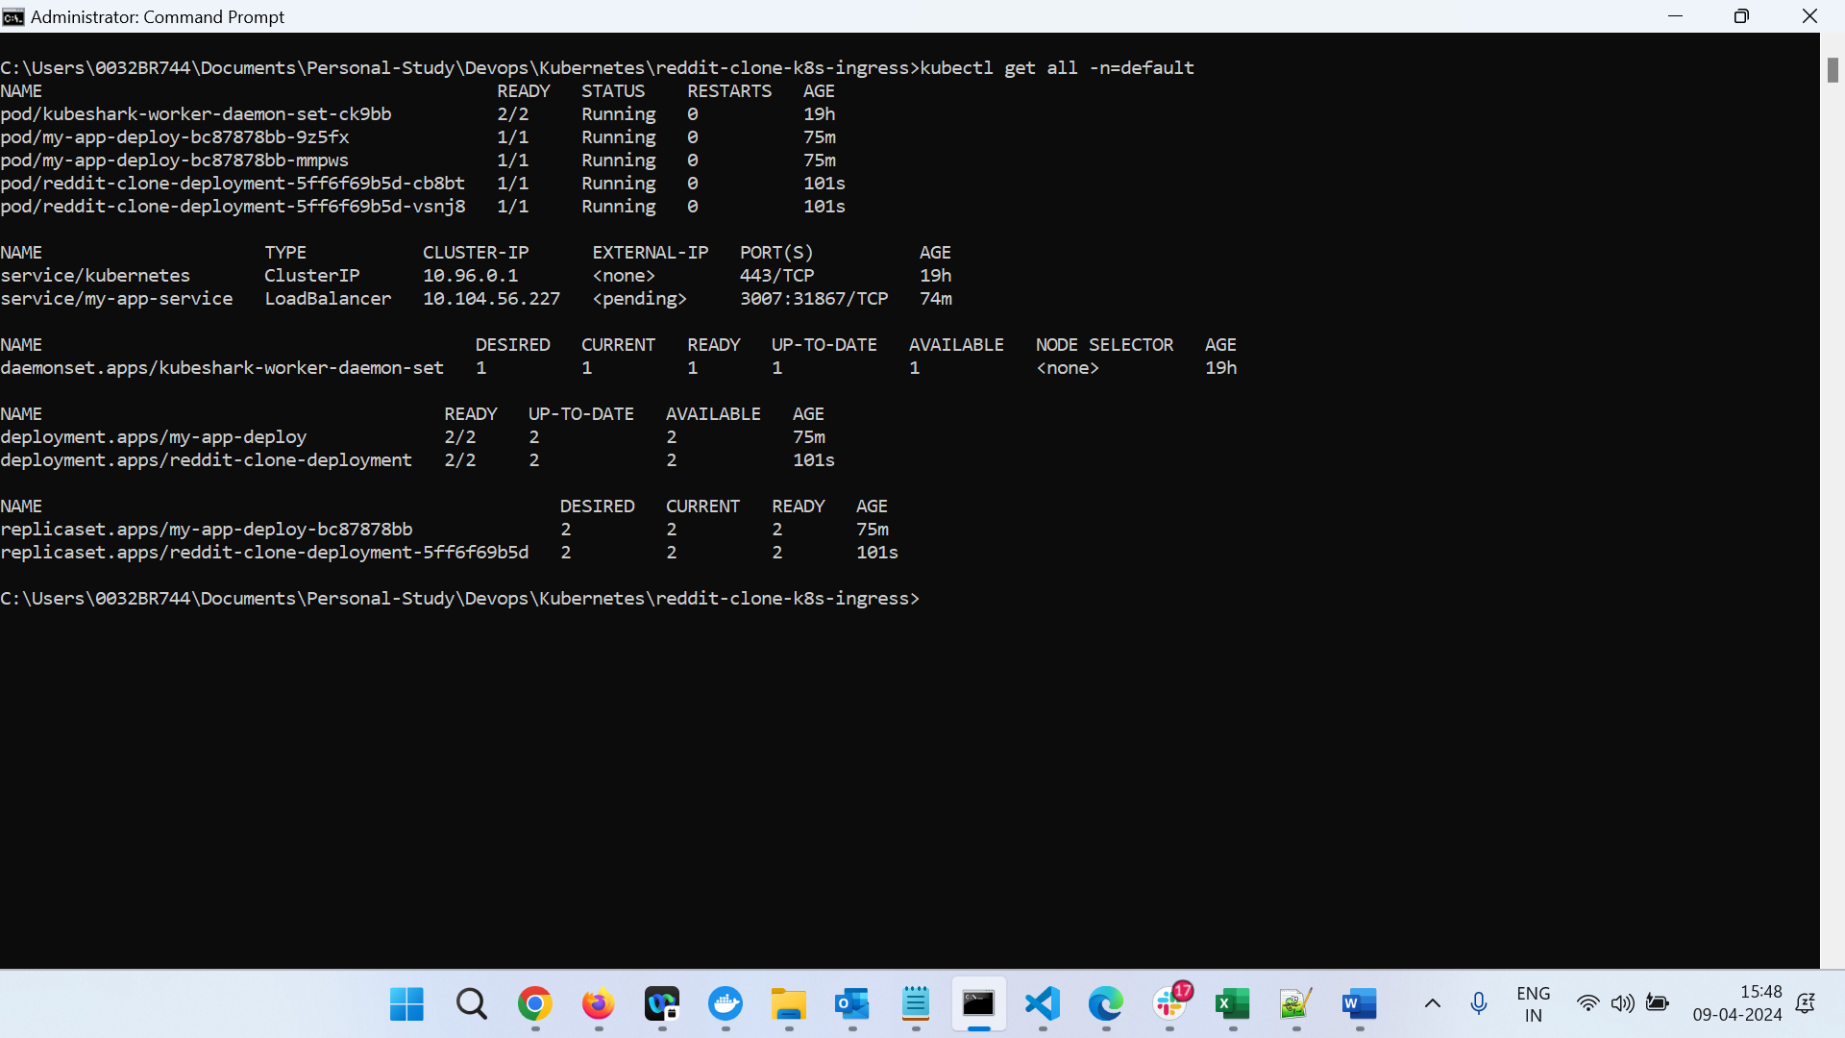

kubectl apply -f service.yml

kubectl get svc

Minikube ip :

<http://172.27.125.19:32233/>

enable ingress controller for minikube

minikube addons enable ingress

kubectl apply -f ingress.yml

Kubectl get ing

Minikube tunnel to get external ip

