- Identify which general testing techniques you will be using - bolded items in Module 07 General Program Testing Techniques
Structural (White-Box) Testing Techniques Code coverage testing, Control flow testing, Data flow testing
- Create a Test Set - Write down the entries you will use for testing. Testing cases: inputs of 5, 6, -1 and then 6, 0, 2
- Test The Program - Test the program using your Test Set.
- Identify Errors –
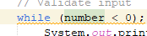 Error 1, infinite while loop, code coverage testing, still printed “invalid input” even when input was positive

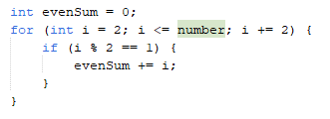 error 2, unneeded if statement ,control flow testing, even sum would not add up would return 0, error because even sum would not add, the if statement was always incorrect
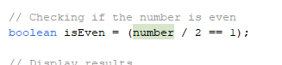 error 3, isEven only returns true if the number input is 2. Covererage flow testing? Testing with input 6 returned odd number when 6 is even. Error because is even will always be false if the input is not 2.
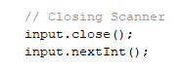 error 4 extra scanner input, code coverage testing, code would throw exception, is an error because it cant read from a closed scanner.

- Fix Errors - Fix the syntax and logical errors.
Error 1: removed semicolon
Error 2: removed if statement
Error 3: used “number % 2 == 0” instead of “number/2 == 1”
Error 4: removed extra input.nextInt(); line after closing scanner
attached .java file with fixed code

